LOKI Testing Dataset
This document outlines all of the features of the LOKI testing dataset for use by Biofilter and BioBin. This is a very limited dataset designed to allow the easy production of models in order to check validity of the methods.

SNPs
There are 2 chromosomes, 1 and 2, that contain all of the genetic information. Chromosome 1 is 80 base pairs long, and chromosome 2 is 30 base pairs long. On each chromosome, SNPS occur every seven base pairs, and are numbered sequentially starting with “rs1” on chromosome 1 and “rs21” on chromosome 2. See the diagram below:
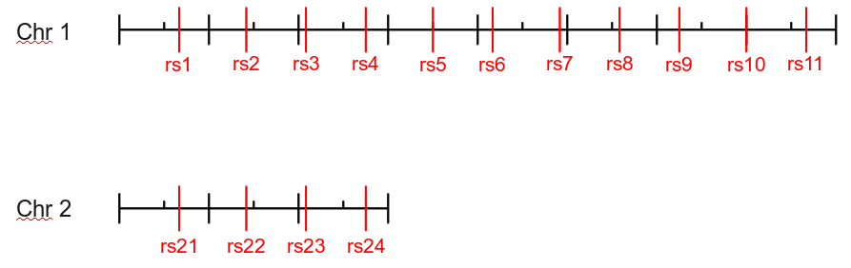
Additionally, those SNPs with an RS number divisible by 4 (rs4, rs8, rs24) are marked as “Not Validated” in the SNP dataset.

Merged SNPs
All of the SNPs on chromosome 1 have an associated “old” RS number that has been merged that can be obtained simply by adding 100 to the current RS number. As an example, RS102 is the same SNP as RS2.

SNP Roles
In LOKI 2.0, the role of a SNP is determined by both the SNP and the gene containing the SNP. There are 3 available roles in LOKI 2.0, which are described in the table below:
Role Name | Role Description | Coding | Exon
exon | Test Exon | 1 | 1
regulatory | Test Regulatory | 0 | 1
intron | Test Intron | 0 | 0

To determine the role of a SNP in a given gene, add together the RS number and the gene number (G4 has a gene number of 4), and the remainder when divided by 3 will give the role of the SNP in the gene (0 = exon, 1 = regulatory, 2 = intron). For example, RS6 in Gene 5 will have a role of “intron” (6 + 5 = 11; 11/3 = 3r2; 2 => intron). Note that roles are only defined for SNPs and genes that contain them; the role of RS1 in Gene 4 is undefined because Gene 4 does not contain RS1 in any population (see below).

Genes
There are 6 genes available in the test dataset, with names “G#”, where “#” is the gene number (from 1-6). The boundaries of the genes are defined for two populations, the default population (which can be identified by the empty string) and “plus5”. The “plus5” boundaries are shifted by 5 base pairs over the default population. The boundaries are given in the table below, and illustrated in the diagram:
Gene | Chromosome | Population
Gene | Chromosome | NO-LD |  | PLUS5
Gene | Chromosome | Start | End | Start | End
G1 | 1 | 5 | 15 | 10 | 20
G2 | 1 | 25 | 35 | 30 | 40
G3 | 1 | 45 | 55 | 50 | 60
G4 | 1 | 65 | 75 | 70 | 80
G5 | 1 | 30 | 50 | 35 | 55
G6 | 2 | 10 | 20 | 15 | 25

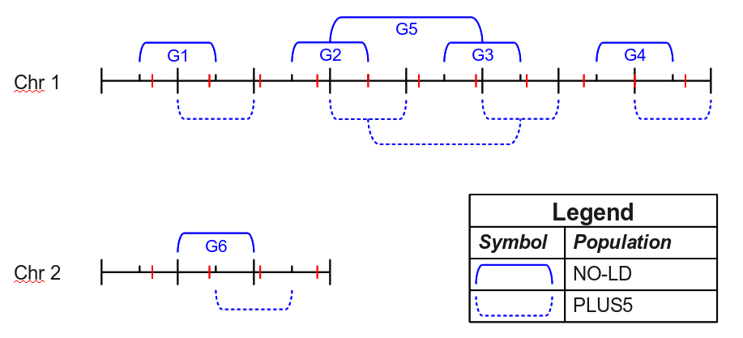

Gene Aliases
Each gene in the dataset also has the unique alias of “R#”, which is equivalent to “G#”. Additionally, there is a single ambiguous alias of “G23”, which refers to both “G2” and “G3”. Th table below lists all of the available aliases:
Alias | Gene(s)
R1 | G1
R2 | G2
R3 | G3
R4 | G4
R5 | G5
R6 | G6
G23 | G2,G3

Pathways
The test dataset has 4 pathways from two sources. The source names are “test_S1” and “test_S2” (abbreviated in the diagram as “S1” and “S2”). The four pathways are P1, P2, P3, and P4. P1 and P2 are both from S1, and P1 is the parent pathway of P2, with a relationship type of “is_a”. P3 and P4 come from S2, and P3 “regulates” P4. The gene containment is shown in the diagram below, but of note is that P4 is identical to P1 in the genes it contains.
