Biofilter User’s Guide

version 3.0.0

The information contained in this document is the sole property of the lab of Dr. Marylyn Ritchie Unauthorized reproduction is prohibited. Last updated Decembre 29, 2025

Table of Contents

Introduction 6
What is Biofilter? 6
Why use Biofilter? 6
Library of Knowledge Integration (LOKI) 6
Knowledge Sources 7
Data Types 8
Analysis Modes 9
Filtering 9
Annotation 9
Modeling 10
Primary and Alternate Input Datasets 10
Identifiers 11
Installation & Setup 12
Prerequisites 12
Platforms 12
Installing Biofilter 12
Compiling Prior Knowledge 12
LOKI Build Script Options 13
Updating & Archiving Prior Knowledge 15
LD Profiles 15
Using Biofilter 16
Configuration Options 16
--help / HELP 16
--version / VERSION 16
--report-configuration / REPORT_CONFIGURATION 16
--report-replication-fingerprint / REPORT_REPLICATION_FINGERPRINT 17
--random-number-generator-seed / RANDOM_NUMBER_GENERATOR_SEED 17
Prior Knowledge Options 17
--knowledge / KNOWLEDGE 17
--report-genome-build / REPORT_GENOME_BUILD 17
--report-gene-name-stats / REPORT_GENE_NAME_STATS 17
--report-group-name-stats / REPORT_GROUP_NAME_STATS 17
--allow-unvalidated-snp-positions / ALLOW_UNVALIDATED_SNP_POSITIONS 17
--allow-ambiguous-snps / ALLOW_AMBIGUOUS_SNPS 17
--allow-ambiguous-knowledge / ALLOW_AMBIGUOUS_KNOWLEDGE 18
--reduce-ambiguous-knowledge / REDUCE_AMBIGUOUS_KNOWLEDGE 18
--report-ld-profiles / REPORT_LD_PROFILES 18
--ld-profile / LD_PROFILE 18
--verify-biofilter-version / VERIFY_BIOFILTER_VERSION 18
--verify-loki-version / VERIFY_LOKI_VERSION 18
--verify-source-loader / VERIFY_SOURCE_LOADER 18
--verify-source-option / VERIFY_SOURCE_OPTION 18
--verify-source-file / VERIFY_SOURCE_FILE 18
--user-defined-knowledge / USER_DEFINED_KNOWLEDGE 19
--user-defined-filter / USER_DEFINED_FILTER 19
Primary Input Data Options 19
--snp / SNP 19
--snp-file / SNP_FILE 19
--position / POSITION 19
--position-file / POSITION_FILE 19
--region / REGION 19
--region-file / REGION_FILE 19
--gene / GENE 20
--gene-file / GENE_FILE 20
--gene-identifier-type / GENE_IDENTIFIER_TYPE 20
--allow-ambiguous-genes / ALLOW_AMBIGUOUS_GENES 20
--gene-search / GENE_SEARCH 20
--group / GROUP 20
--group-file / GROUP_FILE 20
--group-identifier-type / GROUP_IDENTIFIER_TYPE 20
--allow-ambiguous-groups / ALLOW_AMBIGUOUS_GROUPS 21
--group-search / GROUP_SEARCH 21
--source / SOURCE 21
--source-file / SOURCE_FILE 21
Alternate Input Data Options 21
--alt-snp / ALT_SNP 21
--alt-snp-file / ALT_SNP_FILE 21
--alt-position / ALT_POSITION 21
--alt-position-file / ALT_POSITION_FILE 21
--alt-region / ALT_REGION 21
--alt-region-file / ALT_REGION_FILE 22
--alt-gene / ALT_GENE 22
--alt-gene-file / ALT_GENE_FILE 22
--alt-gene-search / ALT_GENE_SEARCH 22
--alt-group / ALT_GROUP 22
--alt-group-file / ALT_GROUP_FILE 22
--alt-group-search / ALT_GROUP_SEARCH 22
--alt-source / ALT_SOURCE 22
--alt-source-file / ALT_SOURCE_FILE 22
Positional Matching Options 23
--grch-build-version / GRCH_BUILD_VERSION 23
--ucsc-build-version / UCSC_BUILD_VERSION 23
--coordinate-base / COORDINATE_BASE 23
--regions-half-open / REGIONS_HALF_OPEN 23
--region-position-margin / REGION_POSITION_MARGIN 23
--region-match-percent / REGION_MATCH_PERCENT 23
--region-match-bases / REGION_MATCH_BASES 23
Model Building Options 24
--maximum-model-count / MAXIMUM_MODEL_COUNT 24
--alternate-model-filtering / ALTERNATE_MODEL_FILTERING 24
--all-pairwise-models / ALL_PAIRWISE_MODELS 24
--maximum-model-group-size / MAXIMUM_MODEL_GROUP_SIZE 24
--minimum-model-score / MINIMUM_MODEL_SCORE 24
--sort-models / SORT_MODELS 24
Output Options 24
--quiet / QUIET 24
--verbose / VERBOSE 24
--prefix / PREFIX 25
--overwrite / OVERWRITE 25
--stdout / STDOUT 25
--report-invalid-input / REPORT_INVALID_INPUT 25
--filter / FILTER 25
--annotate / ANNOTATE 25
--model / MODEL 25
--paris / PARIS 25
Input File Formats 26
Configuration Files 26
SNP List Input Files 27
Position Data Input Files 27
Region Data Input Files 28
Gene and Group List Input Files 28
Source List Input Files 29
User-Defined Knowledge Input Files 30
Output File Formats 31
Configuration Report 31
Gene and Group Name Statistics Reports 31
LD Profiles Report 32
Invalid Input Reports 32
Analysis Outputs 32
Example Knowledge 36
Example Commands 38
Filtering Examples 38
Example 1: Filtering a list of SNPs by a genotyping platform, where input1 is the first list of SNPs and input2 is the list of SNPs on the genotyping platform 38
Example 2: Output a list of SNPs from a genotyping platform that correspond to a list of genes. 39
Example 3: Input a list of groups, output regions within those groups. 40
Example 4: Output a list of all genes within a data source. 40
Example 5: Start with a list of genes, output all the genes within particular groups. 41
Example 6: Start with genes associated with a pathway or group, output genes within that group that overlap with an input list of genes. 42
Example 7: Starting with a list of genes, determine genes are within a group 42
Annotation Examples 42
Example 1: Annotating a SNP with gene region information. 42
Example 2: Annotating SNPs with location information. 43
Example 3: Map a SNP to the groups and sources where the SNP is present 44
Example 4: Annotating a base pair region with the list of SNPs in that region. 44
Example Filtering followed by annotation 45
Example 1: Input a SNP list and map SNP positions to regions 45
Example 2: Map SNPs to groups and filter on the source. 45
Example 3: Testing overlap of SNP and region lists, outputting regions 46
Example 4: Testing overlap of gene and source lists, outputting regions 46
Example 5: Filter gene list based on sources, and output regions 47
Example 6: Output of genes found in pathway based input, filtered by genotyping platform 47
Example 7: Output of genes annotated by group found in pathway based input, filtered by genotyping platform 48
Example 8: Genes within data sources from a list of input genes filtered by genotyping platform, output regions 48
Example 9: Find overlap between two SNP lists and map the overlapping SNPs to the genes. 49
Example 10: Find overlapping SNPs between the two lists and map the overlapping SNPs to the genes, regions, groups and the sources. 49
Example 11: Mapping regions to genes using Biofilter based on percent of overlap 50
Example 12: Mapping regions to genes using Biofilter based on base pair overlap 51
Example 13: Annotating a list of gene symbols with SNPs, regions, groups, and sources, using Biofilter 51
Modeling Example 52
. 52
Step 1 52
Step 2 53
Step 3 54
Changes in Biofilter 2.0 Modeling 54
Appendix 1: Ambiguity in Prior Knowledge 56
Ambiguity Reduction Heuristics 57
Ambiguity Options 57
Gene Ambiguity Examples 57
Example 1: cyan 57
Example 2: magenta 58
Example 3: yellow 58
Example 4: gray/black 58
Protein Identifiers 59
Protein Ambiguity Examples 60
Example 1: orange 60
Example 2: indigo 60
Example 3: violet 60
Appendix 2: LD Profiles 61
Installing LD Spline 61
Generating LD Profiles 61
Population Build Script Options 62
Appendix 3: PARIS 63
PARIS Inputs 63
PARIS Outputs 64
PARIS Example 65
Additional PARIS Options 65
--region-position-margin / REGION_POSITION_MARGIN 65
--region-match-percent / REGION_MATCH_PERCENT 65
--region-match-bases / REGION_MATCH_BASES 65
--paris-p-value / PARIS_P_VALUE 65
--paris-zero-p-values / PARIS_ZERO_P_VALUES 65
--paris-max-p-value / PARIS_MAX_P_VALUE 66
--paris-enforce-input-chromosome / PARIS_ENFORCE_INPUT_CHROMOSOME 66
--paris-permutation-count / PARIS_PERMUTATION_COUNT 66
--paris-bin-size / PARIS_BIN_SIZE 66
--paris-snp-file / PARIS_SNP_FILE 66
--paris-position-file / PARIS_POSITION_FILE 66
--paris-details / PARIS_DETAILS 67

Introduction

What is Biofilter?
Biofilter is a software tool that provides a convenient single interface for accessing multiple publicly available human genetic data sources. These sources include information about the genomic locations of SNPs and genes, as well as relationships among genes and proteins such as interaction pairs, pathways and ontological categories. Biofilter will cross-reference all of this prior biological knowledge in several different ways, with any number of combinations of input data.

Why use Biofilter?
While genome-wide association studies (GWAS) have been used to identify genetic variants that contribute to disease susceptibility on a single-variant single-phenotype level, other approaches can be used to investigate the association between genetic and phenotypic variation. Use of the software tool Biofilter is one such example of a complementary but alternate approach. Biofilter allows users to work with a range of types and formats of data, including SNPs, copy number variant (CNV), and gene location information, along with a repository of diverse biological knowledge distilled from multiple external databases. Via Biofilter, users can annotate data or results with relevant biological knowledge for analysis and interpretation. Biofilter also allows users to filter data based on biological criteria, allowing users to harness information from multiple sources for the reduction of data for analysis.
Finally, Biofilter can be used to generate biological-information derived pairwise interaction models for reducing the computational and statistical burden of large-scale interaction data analysis, while also providing a biological foundation to support the relevance of statistically significant results. The use of Biofilter may help to elucidate a new picture of the relationship between genetic architecture and complex phenotypic outcomes such as the presence or absence of disease.

Library of Knowledge Integration (LOKI)
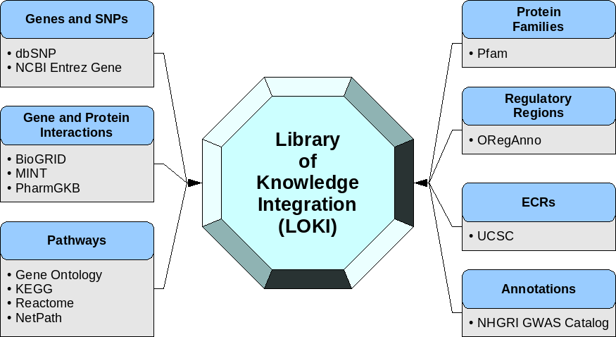
Rather than issuing queries in real-time to a series of external databases, Biofilter consults a local database called the Library of Knowledge Integration, or LOKI. This local repository contains all the knowledge from bulk downloads of the raw data from each external source.

LOKI must be generated on the local system before Biofilter can be used, but because the resulting knowledge database is a single local file, Biofilter itself does not require an internet connection to run. The process of building LOKI requires a relatively large amount of time and disk space to complete, but only needs to be done occasionally to incorporate updated data files from the various sources.

Knowledge Sources

Source | URL | Summary
BioGRID | http://thebiogrid.org | BioGRID is a repository with genetic and protein interaction data from model organisms and humans used by Biofilter for linking  position and region data to interaction information.
NCBI dbSNP | http://www.ncbi.nlm.nih.gov  /snp | A database of SNPs and multiple small-scale variations including insertions, deletions, microsatellites and non-polymorphic variants. This resource includes a complete list of known human SNPs and their base pair positions relative to the human reference genome. Biofilter uses the data of dbSNP in two ways: connecting SNP identifiers (RS numbers) of dbSNP to genomic  positions and connecting retired identifiers to current identifiers.
NCBI Gene  / “Entrez” | http://www.ncbi.nlm.nih.gov  /gene | Entrez is a search engine that allows users to search many discrete health sciences databases at the NCBI. The database provides an extensive list of known human genes, their beginning and ending base pair positions, and many alternate names and cross-referenced database identifiers. This data is used to connect  gene symbols to their genomic regions, and to connect equivalent gene symbols and identifiers to each other.
Gene Ontology | http://www.geneontology.org | The Gene Ontology database defines terms representing gene product properties, such as cellular components, molecular function, and biological processes, within a hierarchical tree of  ontology groups and related proteins.
NHGRI GWAS  Catalog | http://www.genome.g ov  /gwastudies | The NHGRI GWAS Catalog provides associations between SNPs and various phenotypes which were discovered via genome-wide  association studies (GWAS).
MINT | http://mint.bio.uniroma2.it  /mint/Welcome.do | The Molecular Interaction database contains experimentally verified protein-protein interactions from the scientific literature, which are used in Biofilter for linking position and region data to  interacting protein pairs.
NetPath | http://www.netpath.org | The NetPath database consists of curated human signaling  pathways which are used by Biofilter.
OregAnno | http://www.oreganno.org  /oregano | The Open REGulatory ANNOtation database is used by Biofilter  for curation information about known regulatory elements from the scientific literature.
Pfam | http://pfam.sanger.ac.uk | The Pfam database is a large collection of protein families. The annotation of data respective to proteins within Biofilter is based  on the information from Pfam.
PharmGKB | http://www.pharmgkb.org | Biofilture currently uses this database for pathway based data, future releases of Biofilter will also include gene-drug  associations and pharmacological association study results.
Reactome | http://www.reactome.org  /ReactomeGWT/entrypoint.html | Biofilter uses the information contained in Reactome to establish  pathway and network relationships between genes.
UCSC  genome browser | http://genome.ucsc.edu | This source provides access to a growing database of genomic sequence and annotations for a wide variety of organisms, currently we use the UCSC for location information for  evolutionary conserved regions (ECRs) for Biofilter and to acess OregAnno’s regulatory region data.

Data Types
Biofilter can work with and understand the relationships between six basic types of data:

SNP
Specified by an RS number, i.e. “rs1234”.
Used to refer to a known and documented SNP whose position can be retrieved from the knowledge database.

Position
Specified by a chromosome and basepair location, i.e. “chr1:234”.
Used to refer to any single genomic location, such as a single nucleotide polymorphism (SNP), single nucleotide variation (SNV), rare variant, or any other position of interest.

Region
Specified by a chromosome and basepair range, i.e. “chr1:234-567”.
Used to refer to any genomic region, such as a copy number variation (CNV), insertion/deletion (indel), gene coding region, evolutionarily conserved region (ECR), functional region, regulatory region, or any other region of interest.

Gene
Specified by a name or other identifier, i.e. “A1BG” or “ENSG00000121410”. Used to refer to a known and documented gene, whose genomic region and associations with any pathways, interactions or other groups can be retrieved from the knowledge database.

Group
Specified by a name or other identifier, i.e. “lipid metabolic process” or “GO:0006629”.
Used to refer to a known and documented pathway, ontological group, protein interaction, protein family, or any other grouping of genes, proteins or genomic regions that was provided by one of the external data sources.

Source
Specified by name, i.e. “GO”.
Used to refer to a specific external data source.

Some of these data types are closely related, but behave in slightly different ways. For example a SNP and a position may be interchangeable in most cases, but not always: some RS numbers have no known genomic position while some have more than one, and any given genomic position could be associated with more than one RS number, or none at all. Similarly, some genes have no confirmed genomic region while some have several, and a given region might overlap or contain one gene, or many, or none.

The order in which these types have been listed is also significant: it is the sequence in which data can be cross-referenced within Biofilter. For example, a SNP (or RS number) and a gene have no direct relationship, but a SNP may have a known genomic position (or several), and that position may lie within a known region which is associated with a particular gene. To complete the chain, a gene may be associated with one or more groups of various types (interactions, pathways, etc.), and each of those groups was provided from a particular external data source.

Analysis Modes
Biofilter has three primary analysis modes which each make use of the available biological knowledge in slightly different ways.

Filtering
The most straightforward of Biofilter’s primary functions is, as the name implies, filtering. Given any combination of input data, Biofilter can cross-reference the input data using the relationships stored in the knowledge database to generate a filtered dataset of any supported type (or types).

For example, a user can provide a list of SNPs (such as those covered by a genotyping platform) and a list of genes (such as those thought to be related to a particular phenotype) and request a filtered set of SNPs. Biofilter will use LOKI’s knowledge of SNP positions and gene regions to filter the provided SNP list, removing all those that are not located within any of the provided genes.

The output data type does not necessarily have to be the same data type(s) provided as input. For example, a user can provide a list of SNPs and a list of groups and request the set of genes that match both lists. In this case, there is no input set of genes to use as a starting point so Biofilter will check all known genes found in the knowledge database. The result is a list of only the genes which include at least one of the specified SNPs, and are a part of at least one of the specified groups.
Finally, filtering is not limited to a single data type: Biofilter can also identify all of the unique combinations of data types which jointly meet the provided criteria. For example, given a list of SNPs and genes, Biofilter can produce a filtered set of SNP-gene pairs. The result is every combination of SNP and gene from the two lists where the SNP is within the gene.

Annotation
Biofilter can also annotate any of the supported data types with respect to any of the others. Like filtering, the annotations are based on the relationships stored in the knowledge database; unlike filtering, any data which cannot be annotated as requested (such as a SNP which is not located within any gene) will still be included in the output, with the annotation columns of the output simply left blank. Put another way, the difference between filtering and annotation is that filtering does not allow any blanks.

For example, a list of SNPs can be annotated with positions to generate a new list of all the same SNPs, but with extra columns containing the chromosome and genomic position for each SNP (if any). Any SNP with multiple known positions will be repeated, and any SNP with no known position will have blanks in the added columns.

Similarly, those same SNPs can be annotated with gene information; the result is similar, except that the added column contains the name of the gene containing the SNP’s position. In this case a blank value can mean two things: either the SNP does not fall within any known gene region, or the SNP has no known position with which to search for gene regions.

Annotations can also be generated for combinations of data types, or for data types which were not provided as input. In these cases the annotation will be for the output of a filtering analysis. For example, suppose the user provides a list of SNPs and a list of groups, and then requests an annotation of genes to regions. Since no genes were provided as input, Biofilter will first perform a filtering analysis to identify all genes which contain at least one of the provided SNPs, and are also part of at least one of the provided groups. This filtered set of genes will then appear in the first column of the annotation output, followed by each gene’s genomic region (if any).

Modeling
The last of Biofilter’s primary analysis modes is a little different from filtering and annotation. In addition to simply cross-referencing any given data with the other available prior knowledge, Biofilter can also search for repeated patterns within the prior knowledge which might indicate the potential for important interactions between SNPs or genes.

The key idea behind this analysis is that any pathway, ontological category, protein family, experimental interaction, or other grouping of genes or proteins implies a relationship between each of those genes or proteins. If the same two genes appear together in more than one grouping, they’re likely to have an important biological relationship; if they appear in multiple groups from several independent sources, then they’re even more likely to be biologically related in some way. Biofilter has access to thousands of such groupings and can analyze all of them to identify the pairs of genes or SNPs appearing together in the greatest number of groupings and the widest array of original data sources. These pairs can then be tested for significance within a research dataset, avoiding the prohibitive computational and multiple-testing burden of an exhaustive pairwise analysis.

Biofilter can take any combination of input data and use it to focus the search for likely pairwise interaction models. For example, a user can provide a list of SNPs and request gene-gene models; Biofilter will then only consider models in which both genes contain at least one of the specified SNPs.

The models suggested by Biofilter are also ranked in order of likelihood, using an “implication index.” This score is simply a combination of two tallies: the number of original data sources which contained the pair, and the number of different groups among those sources. For example a score of “2-3” indicates that the model appears in three different groups, and those groups originated with two different sources.

Since the interaction models are based on genes appearing together in multiple groups, Biofilter performs all model-building analyses by first generating gene-gene models. These baseline models can then be converted into models of any type by expanding each side independently, just like in a filtering analysis. For example if the user requests SNP models, Biofilter will take each baseline gene-gene model, separately map the two genes to all applicable SNPs, and then return all possible pairings between those two sets of SNPs.

Primary and Alternate Input Datasets
So far, the descriptions and examples of Biofilter’s various analysis modes have implied that all user input exists in a single dataset. However, Biofilter can support two independent sets of user input data. These two datasets are used for slightly different things depending on the context, and so whenever input data is provided to Biofilter, the user must specify which dataset it should be added to. For this purpose

there are corresponding primary and alternate input options for each type of data: “SNP” and “ALT_SNP”, “REGION” and “ALT_REGION”, and so on.

In a filtering analysis, only the primary input dataset is used; any alternate input data has no effect.

In an annotation analysis, the primary and alternate input datasets are used separately on the two sides of the annotation. For example, if a user annotates SNPs with genes then the primary input data is used to limit which SNPs are annotated at all, while the alternate input data is used to limit which genes can be considered for annotation. Put another way, this means that if a SNP cannot be linked with the primary input data then it will not appear at all in the annotation output (even with blank annotation columns); likewise if a gene cannot be linked with the alternate input data then it will not appear as an annotation for any SNP, even if its genomic region does contain the SNP’s position.

In a modeling analysis, the primary and alternate input datasets are used similarly to annotation, with one extra option. By default, both parts of a model must match the primary input data in order for that model to be generated. If there is any alternate input data, then one of the two parts of the model must also match the alternate input. For example, the user could provide SNP list A as primary input and SNP list B as alternate input, and then request SNP models. Biofilter would then only generate SNP-SNP models in which both SNPs appear in list A, and at least one of them also appears in list B. With the ALTERNATE_MODEL_FILTERING option, the effect of the primary input is relaxed a bit so that it only applies to one part of the model, while the alternate input applies to the other. In this case, Biofilter would generate SNP-SNP models where one SNP is in list A and the other SNP is in list B.

Identifiers
Any given gene or group might go by many different names in different contexts, and Biofilter/LOKI accommodate this. For example, a single gene (let’s say “alpha-1-B glycoprotein”) might have one ID number assigned by NCBI’s Entrez Gene database (“1”), a different identifier assigned by Ensembl (“ENSG00000121410”), another one from HGNC (“5”), plus any number of symbolic abbreviations (A1BG, A1B, ABG, GAB, HYST2477).

Just as a single gene can have more than one name, there are also names which are known to be associated with more than one gene; these names are considered ambiguous. For example, although A1B is an alias of the gene A1BG, it is also an alias of the gene SNTB1 (syntrophin, beta 1). Therefore if A1B appears in an input gene list file, Biofilter will not inherently recognize which gene the user intended to include. Likewise if A1B were to appear within the bulk biological data downloaded for LOKI, then Biofilter might not recognize which gene is actually part of some pathway.

Rather than attempting to compromise on a “one size fits all” approach to this ambiguity, Biofilter and LOKI support multiple interpretations of any ambiguity that was encountered while compiling the knowledge database. Each of these interpretations comes with a slightly different trade-off between false-positives and false-negatives, and the interpretation most appropriate to the task can be selected by the user at run-time. This is covered in greater detail in a later section, but it is important to bear in mind that ambiguity will be a part of relating and cross-referencing data across multiple independent sources. Biofilter’s results can change depending on the users choice for handling ambiguity.

Installation & Setup

Prerequisites
The following prerequisites are required to compile the LOKI database and run Biofilter:

- Python, version 3.10 or later
- Python module “apsw” (Another Python SQLite Wrapper)
- SQLite, version 3.6 or later

The dependency on SQLite is typically satisfied via the apsw Python module, which includes an embedded SQLite library. In most cases, no system-wide SQLite installation is required.
If optional components such as LD Spline are used (see below), the SQLite development headers may also be required. These are not bundled with apsw. If in doubt, consult your system administrator.

Platforms
Biofilter was developed in Python, and should therefore run on Linux, Mac OS X or Windows.

Installing Biofilter
To install Biofilter into your Python environment, run:
pip install biofilter-loki
This command installs both the Biofilter and LOKI components, along with
all required dependencies.
After installation, the following command-line tools will be available:
- biofilter — main Biofilter command-line interface
- loki-build — utility for building and updating the LOKI knowledge database
Verify the installation:
biofilter --version
loki-build --version

Compiling Prior Knowledge
The LOKI prior knowledge database must be generated before Biofilter can be used.
This is accomplished using the loki-build command installed with Biofilter.
To build or update a knowledge database, run:
loki-build --verbose --knowledge loki.db --update
This command downloads and processes data from all supported knowledge sources
and stores the resulting SQLite database in the file loki.db.
It is recommended to name the knowledge database file using a date-based
convention, for example:
loki-20251010.db

Resource Requirements
The update process may take several hours depending on:
- Internet connection speed
- CPU performance
- Filesystem performance
Typical resource usage includes:
- 10–100 GB of temporary disk space (e.g. /tmp on Linux)
- 5–50 GB for the final SQLite knowledge database file
Adequate free disk space should be ensured before starting the build process.

By default, the LOKI build script will delete all sources’ bulk data downloads after they have been processed. If the knowledge database will be updated frequently, it is recommended to keep these bulk files available so that any unchanged files will not need to be downloaded again. This can be accomplished with the “--archive” option.

LOKI Build Script Options
--help
Displays the program usage and immediately exits.

--version
Displays the software versions and immediately exits. Note that LOKI is built upon SQLite, which will also report its own software versions.

--knowledge Argument: <file> Default: none
Specifies the prior knowledge database file to use.

--archive Argument: <file> Default: none
Shorthand for specifying the same file as both the “--from-archive” and “--to-archive”.

--from-archive Argument: <file> Default: none
An archive of downloaded bulk data from a previous run of the LOKI build script. The bulk data files available for download from each source will be compared against those found in the archive, and only files which have changed will be downloaded. If not specified, the script will start from scratch and download everything.

--to-archive Argument: <file> Default: none
A file in which to archive the downloaded bulk data for a later run of the LOKI build script. If not specified, the script will reclaim disk space by deleting all original data after processing it.

--temp-directory Argument: <directory> Default: platform-dependent
The directory in which to unpack the “--from-archive” (if any) and then download new bulk data. If not specified, the system’s default temporary directory is used.

--list-sources Arguments: [source] […] Default: none
List the specified source module loaders’ software versions and any options they accept. If no sources are specified, all available modules are listed.

--cache-only Argument: none
Causes the build script to skip checking any knowledge sources for available bulk data downloads, allowing it to function without an internet connection. Instead, only the files already available in the provided “--from-archive” file will be processed. If any source loader module is unable to find an expected file (such as if no archive was provided), that source loader will fail and no data will be updated for that source.

--update Arguments: [source] […] Default: all
Instructs the build script to process the bulk data from the specified sources and update their representation in the knowledge database. If no sources are specified, all supported sources will be updated.

--update-except Arguments: [source] […] Default: none
Similar to “--update” but with the opposite meaning for the specified sources: all supported sources will be updated except for the ones specified. If no sources are specified, none are excluded, and all supported sources are updated.

--option Arguments: <source> <options> Default: none
Passes additional options to the specified source loader module. The options string must be of the form “option1=value,option2=value” for any number of options and values. Supported options and values for each source can be shown with “--list-sources”.

--force-update Argument: none
The build script will normally only update from a sources if it detects that an update is necessary, either because new data files have been downloaded from the source or because the source’s loader module code has been updated. With this option, the build script will update all specified sources, even if it believes no update is necessary.

--finalize Argument: none
Causes the build script to discard all intermediate data and optimize the knowledge database (after performing an “--update”, if any). This reduces the knowledge database file size and greatly improves its performance, however it will no longer be possible to update the file with any new source data.

--no-optimize Argument: none
Instructs the build script to skip the database optimization and compacting step that it normally performs after completing all source updates. This may be useful if you know you will be updating additional sources later, since the optimization can take some time and will have to be done again anyway after the next update.

--verbose Argument: none
Prints additional informational messages to the screen; this is the default setting.

--quiet Argument: none
Suppresses additional informational messages; the opposite of verbose.

--test-data Argument: none
Switches the build script into test mode, in which it uses an alternate set of source loader modules. These sources do not contain actual biological knowledge; instead, they specify a minimal simulated set of knowledge which can be easily visualized and used to test and understand the functionality of LOKI and Biofilter. Knowledge database files created in test mode cannot be updated in the standard mode, and vice versa. Refer to the Example Knowledge section for more information.

Updating & Archiving Prior Knowledge
It is important to note that the various data sources integrated into LOKI can publish updated data at any time, according to their own schedules. This new data will not be available to Biofilter until the LOKI prior knowledge database is updated or regenerated. We recommend that users become familiar with how often the data sources are updated and plan to update LOKI accordingly, preferably at least once every few months.

If a given set of analyses need to be repeatable or verifiable, such as those published in a manuscript, we recommend storing an archived version of the LOKI knowledge database from the time of the analyses. These archived versions of the database can then be used to repeat or augment an analysis based on exactly the same prior knowledge, regardless of any updates that may have occurred in various data sources afterwards. For this purpose it may be useful to include the date in the filename of each newly compiled version of LOKI in order to carefully distinguish between older versions.

LD Profiles
Biofilter and LOKI allow for gene regions to be adjusted by the linkage disequilibrium (LD) patterns in a given population. When comparing a known gene region to any other region or position (such as CNVs or SNPs), areas in high LD with a gene can be considered part of the gene, even if the region lies outside of the gene’s canonical boundaries.

LD profiles can be generated using LD Spline, a separate software tool bundled with Biofilter. For more information about LD Spline, for details on generating and using LD profiles, see Appendix 2.

Using Biofilter
Biofilter is executed from a command-line terminal using the biofilter command and specifying the desired inputs, outputs, and optional settings. All options may be provided directly on the command line (for example, biofilter --option-name) or placed in one or more configuration files, whose filenames are then supplied as command-line arguments (for example, biofilter analysis.config).
Providing options directly on the command line is often convenient when developing or testing an analysis. However, for final or production runs, the use of configuration files is strongly recommended, as they provide a permanent and explicit record of all analysis parameters.
Any number of configuration files may be specified. When multiple configuration files are used, options defined in later files override those defined in earlier files. Options provided directly on the command line always take precedence over options specified in configuration files.
The available options are the same no matter where they appear, but are formatted differently. Options on the command line are lower-case, start with two dashes and may contain single dashes to separate words (such as “--snp-file”), while in a configuration file the same option would be in upper-case, contain no dashes and instead use underscores to separate words (i.e. “SNP_FILE”). Many command line options also have alternative shorthand versions of one or a few letters, such as “-s” for “--snp-file” and “--aag” for “--allow-ambiguous-genes”.
All options are listed here in both their command line and configuration file forms. If an option allows or requires any further arguments, they are also noted along with their default values, if any. Arguments which are required are enclosed in <angle brackets>, while arguments which are optional are enclosed in [square brackets].

Many options have only two possible settings and therefore accept a single argument which can either be “yes” or “no” (or “on” or “off”, or “1” or “0”). Specifying these options with no argument is always interpreted as a “yes”, such that for example “VERBOSE yes” and “VERBOSE” have the same meaning. However, omitting such options entirely may default to either “yes” or “no” depending on the option.

Configuration Options

--help / HELP
Displays the program usage and immediately exits.

--version / VERSION
Displays the software versions and immediately exits. Note that Biofilter is built upon LOKI and SQLite, each of which will also report their own software versions.

--report-configuration / REPORT_CONFIGURATION
Argument: [yes/no] Default: no
Generates a Biofilter configuration file which specifies the current effective value of all program options, including any default options which were not overridden. This file can then be passed back in to Biofilter again in order to repeat exactly the same analysis.

--report-replication-fingerprint / REPORT_REPLICATION_FINGERPRINT
Argument: [yes/no] Default: no
When used along with REPORT_CONFIGURATION, this adds additional validation options to the resulting configuration file. These extra options specify all relevant software versions as well as a fingerprint of the data contained in the knowledge database file. When re-running a configuration file with these extra replication options, Biofilter will use them to ensure that neither Biofilter itself nor the LOKI knowledge database file have been updated since the original analysis; this in turn ensures that the re-run analysis will produce the same (or compatible) results as the original.

--random-number-generator-seed / RANDOM_NUMBER_GENERATOR_SEED
Argument: <seed> Default: none
Sets the random number generator seed value. For modes which involve randomization (such as PARIS), the output will be different every time unless the seed value is kept consistent. If left blank (the default), the seed value itself is randomized on each execution of the program.

Prior Knowledge Options

--knowledge / KNOWLEDGE
Argument: <file> Default: none
Specifies the LOKI prior knowledge database file to use. If a relative path is provided it will be tried first from the current working directory, and then from the location of the Biofilter executable itself.

--report-genome-build / REPORT_GENOME_BUILD
Argument: [yes/no] Default: yes
Displays the build version(s) of the human reference genome which was used as the basis for all genomic positions in the prior knowledge database (such as for SNP positions and gene regions). Any position or region data provided as input must be converted to the same build version in order to match correctly with the prior knowledge.

--report-gene-name-stats / REPORT_GENE_NAME_STATS
Argument: [yes/no] Default: no
Generates a report of the gene identifier types available in the knowledge database.

--report-group-name-stats / REPORT_GROUP_NAME_STATS
Argument: [yes/no] Default: no
Generates a report of the group identifier types available in the knowledge database.

--allow-unvalidated-snp-positions / ALLOW_UNVALIDATED_SNP_POSITIONS
Argument: [yes/no] Default: yes
Allows Biofilter to make use of all SNP-position mappings available in the knowledge database, even ones which the original data source identified as un-validated. When disabled, only validated positions are considered.

--allow-ambiguous-snps / ALLOW_AMBIGUOUS_SNPS
Argument: [yes/no] Default: no
Allows Biofilter to make use of all SNP-position mappings available in the knowledge database, even when the same SNP is believed to have multiple positions. When disabled, only SNPs with single, unambiguous positions are considered.

--allow-ambiguous-knowledge / ALLOW_AMBIGUOUS_KNOWLEDGE
Argument: [yes/no] Default: no
Allows Biofilter to make use of all potential gene-group mappings in the knowledge database, even if the gene was referred to with an ambiguous identifier. This will likely include some false-positive associations, but the alternative is likely to miss some true associations.

--reduce-ambiguous-knowledge / REDUCE_AMBIGUOUS_KNOWLEDGE
Argument: [no/implication/quality/any] Default: no
Enables a heuristic algorithm to attempt to resolve ambiguous gene-group mappings in the knowledge database. This option’s argument is optional and defaults to ‘any’, which applies all heuristics together.

--report-ld-profiles / REPORT_LD_PROFILES
Argument: [yes/no] Default: no
Generates a report of the LD profiles available in the knowledge database. See Appendix 2 for details.

--ld-profile / LD_PROFILE
Argument: [ldprofile] Default: none
Specifies an alternate set of gene region boundaries which were pre-calculated by LD Spline to account for a population-specific linkage disequilibrium profile. When omitted or supplied with no argument, the default profile (containing the original unmodified gene boundaries) is used.

--verify-biofilter-version / VERIFY_BIOFILTER_VERSION
Argument: <version> Default: none
Ensure that the current version of Biofilter is the same as the one specified. This option is added automatically to configuration files generated with REPORT_REPLICATION_FINGERPRINT.

--verify-loki-version / VERIFY_LOKI_VERSION
Argument: <version> Default: none
Ensure that the current version of LOKI is the same as the one specified. This option is added automatically to configuration files generated with REPORT_REPLICATION_FINGERPRINT.

--verify-source-loader / VERIFY_SOURCE_LOADER
Arguments: <source> <version> Default: none
Ensure that the knowledge database file was generated with the specified version of a source data loader module. Can be used multiple times to specify versions for different sources. This option is added automatically to configuration files generated with REPORT_REPLICATION_FINGERPRINT.

--verify-source-option / VERIFY_SOURCE_OPTION
Arguments: <source> <option> <value> Default: none
Ensure that the knowledge database file was generated with the specified option value supplied to a source data loader module. Can be used multiple times to specify different options, or options for different sources. This option is added automatically to configuration files generated with REPORT_REPLICATION_FINGERPRINT.

--verify-source-file / VERIFY_SOURCE_FILE
Arguments: <source> <file> <date> <size> <md5> Default: none
Ensure that the knowledge database file was generated with the specified source data file. Can be used multiple times to specify different files, or files for different sources. This option is added automatically to configuration files generated with REPORT_REPLICATION_FINGERPRINT.

--user-defined-knowledge / USER_DEFINED_KNOWLEDGE
Argument: <file> Default: none
Adds a user-defined knowledge source (one per file) containing any number of user-defined pathways or other gene groupings.

--user-defined-filter / USER_DEFINED_FILTER
Argument: [no/group/gene] Default: no
Applies the user-defined knowledge as if it were a group filter (analogous to the GROUP or GROUP_FILE options) or gene filter (analogous to the GENE or GENE_FILE options). As a group filter, all groups which contain at least one gene which is also in a user-defined group will be loaded; as a gene filter, all genes which are in any user-defined group will be loaded.

Primary Input Data Options

--snp / SNP
Arguments: <snp> [snp] […] Default: none
Adds (or intersects) the specified set of SNPs to (or with) the primary input dataset. SNPs must be provided as integer RS numbers with an optional “rs” prefix.

--snp-file / SNP_FILE
Arguments: <file> [file] […] Default: none
Adds (or intersects) the set of SNPs read from the specified files to (or with) the primary input dataset. Files must contain a single column formatted as in the SNP option.

--position / POSITION
Arguments: <position> [position] […] Default: none
Adds (or intersects) the specified set of positions to (or with) the primary input dataset. Positions must be provided as 2 to 4 fields separated by colons: “chr:pos”, “chr:label:pos” or “chr:label:ignored:pos”. Chromosomes may have an optional “chr” prefix.

--position-file / POSITION_FILE
Arguments: <file> [file] […] Default: none
Adds (or intersects) the set of positions read from the specified files to (or with) the primary input dataset. Files must contain 2 to 4 columns formatted as in the POSITION option, but separated by tabs instead of colons.

--region / REGION
Arguments: <region> [region] […] Default: none
Adds (or intersects) the specified set of regions to (or with) the primary input dataset. Regions must be provided as 3 or 4 fields separated by colons: “chr:start:stop” or “chr:label:start:stop”. Chromosomes may have an optional “chr” prefix.

--region-file / REGION_FILE
Arguments: <file> [file] […] Default: none
Adds (or intersects) the set of regions read from the specified files to (or with) the primary input dataset. Files must contain 3 or 4 columns formatted as in the REGION option, but separated by tabs instead of colons.

--gene / GENE
Arguments: <gene> [gene] […] Default: none
Adds (or intersects) the specified set of genes to (or with) the primary input dataset. The specified genes will be interpreted according to the GENE_IDENTIFIER_TYPE option.

--gene-file / GENE_FILE
Arguments: <file> [file] […] Default: none
Adds (or intersects) the set of genes read from the specified files to (or with) the primary input dataset. Files must contain 1 or 2 columns separated by tabs. For 1-column files, genes are interpreted according to the GENE_IDENTIFIER_TYPE option. For 2-column files, the first column specifies the gene identifier type by which the second column will be interpreted.

--gene-identifier-type / GENE_IDENTIFIER_TYPE
Argument: [type] Default: -
Specifies the identifier type with which to interpret all input gene identifiers. If no type or an empty type is provided, all possible types are tried for each identifier. If the special type “-“ is provided (the default), identifiers are interpreted as primary gene labels.

--allow-ambiguous-genes / ALLOW_AMBIGUOUS_GENES
Argument: [yes/no] Default: no
When enabled, any input gene identifier which matches multiple genes will be interpreted as if all of those genes had been specified. When disabled (the default), ambiguous gene identifiers are ignored.

--gene-search / GENE_SEARCH
Argument: text Default: none
Adds (or intersects) the matching set of genes to (or with) the primary input dataset. Matching genes are identified by searching for the provided text in all labels, descriptions and identifiers associated with each known gene.

--group / GROUP
Arguments: <group> [group] […] Default: none
Adds (or intersects) the specified set of groups to (or with) the primary input dataset. The specified groups will be interpreted according to the GROUP_IDENTIFIER_TYPE option.

--group-file / GROUP_FILE
Arguments: <file> [file] […] Default: none
Adds (or intersects) the set of groups read from the specified files to (or with) the primary input dataset. Files must contain 1 or 2 columns separated by tabs. For 1-column files, genes are interpreted according to the GENE_IDENTIFIER_TYPE option. For 2-column files, the first column specifies the gene identifier type by which the second column will be interpreted.

--group-identifier-type / GROUP_IDENTIFIER_TYPE
Argument: [type] Default: -
Specifies the identifier type with which to interpret all input group identifiers. If no type or an empty type is provided, all possible types are tried for each identifier. If the special type “-“ is provided (the default), identifiers are interpreted as primary group labels.

--allow-ambiguous-groups / ALLOW_AMBIGUOUS_GROUPS
Argument: [yes/no] Default: no
When enabled, any input group identifier which matches multiple groups will be interpreted as if all of those groups had been specified. When disabled (the default), ambiguous group identifiers are ignored.

--group-search / GROUP_SEARCH
Argument: text Default: none
Adds (or intersects) the matching set of groups to (or with) the primary input dataset. Matching groups are identified by searching for the provided text in all labels, descriptions and identifiers associated with each known group.

--source / SOURCE
Arguments: <source> [source] […] Default: none
Adds (or intersects) the specified set of sources to (or with) the primary input dataset.

--source-file / SOURCE_FILE
Arguments: <file> [file] […] Default: none
Adds (or intersects) the set of sources read from the specified files to (or with) the primary input dataset.

Alternate Input Data Options

--alt-snp / ALT_SNP
Arguments: <snp> [snp] […] Default: none
Adds (or intersects) the specified set of SNPs to (or with) the alternate input dataset. SNPs must be provided as integer RS numbers with an optional “rs” prefix.

--alt-snp-file / ALT_SNP_FILE
Arguments: <file> [file] […] Default: none
Adds (or intersects) the set of SNPs read from the specified files to (or with) the alternate input dataset. Files must contain a single column formatted as in the SNP option.

--alt-position / ALT_POSITION
Arguments: <position> [position] […] Default: none
Adds (or intersects) the specified set of positions to (or with) the alternate input dataset. Positions must be provided as 2 to 4 fields separated by colons: “chr:pos”, “chr:label:pos” or “chr:label:ignored:pos”. Chromosomes may have an optional “chr” prefix.

--alt-position-file / ALT_POSITION_FILE
Arguments: <file> [file] […] Default: none
Adds (or intersects) the set of positions read from the specified files to (or with) the alternate input dataset. Files must contain 2 to 4 columns formatted as in the POSITION option, but separated by tabs instead of colons.

--alt-region / ALT_REGION
Arguments: <region> [region] […] Default: none
Adds (or intersects) the specified set of regions to (or with) the alternate input dataset. Regions must be provided as 3 or 4 fields separated by colons: “chr:start:stop” or “chr:label:start:stop”. Chromosomes may have an optional “chr” prefix.

--alt-region-file / ALT_REGION_FILE
Arguments: <file> [file] […] Default: none
Adds (or intersects) the set of regions read from the specified files to (or with) the alternate input dataset. Files must contain 3 or 4 columns formatted as in the REGION option, but separated by tabs instead of colons.

--alt-gene / ALT_GENE
Arguments: <gene> [gene] […] Default: none
Adds (or intersects) the specified set of genes to (or with) the alternate input dataset. The specified genes will be interpreted according to the GENE_IDENTIFIER_TYPE option.

--alt-gene-file / ALT_GENE_FILE
Arguments: <file> [file] […] Default: none
Adds (or intersects) the set of genes read from the specified files to (or with) the alternate input dataset. Files must contain 1 or 2 columns separated by tabs. For 1-column files, genes are interpreted according to the GENE_IDENTIFIER_TYPE option. For 2-column files, the first column specifies the gene identifier type by which the second column will be interpreted.

--alt-gene-search / ALT_GENE_SEARCH
Argument: text Default: none
Adds (or intersects) the matching set of genes to (or with) the alternate input dataset. Matching genes are found by searching for the provided text in all labels, descriptions and identifiers of each known gene.

--alt-group / ALT_GROUP
Arguments: <group> [group] […] Default: none
Adds (or intersects) the specified set of groups to (or with) the alternate input dataset. The specified groups will be interpreted according to the GROUP_IDENTIFIER_TYPE option.

--alt-group-file / ALT_GROUP_FILE
Arguments: <file> [file] […] Default: none
Adds (or intersects) the set of groups read from the specified files to (or with) the alternate input dataset. Files must contain 1 or 2 columns separated by tabs. For 1-column files, genes are interpreted according to the GENE_IDENTIFIER_TYPE option. For 2-column files, the first column specifies the gene identifier type by which the second column will be interpreted.

--alt-group-search / ALT_GROUP_SEARCH
Argument: text Default: none
Adds (or intersects) the matching set of groups to (or with) the alternate input dataset. Matching groups are found by searching for the provided text in all labels, descriptions and identifiers of each known group.

--alt-source / ALT_SOURCE
Arguments: <source> [source] […] Default: none
Adds (or intersects) the specified set of sources to (or with) the alternate input dataset.

--alt-source-file / ALT_SOURCE_FILE
Arguments: <file> [file] […] Default: none
Adds (or intersects) the set of sources read from the specified files to (or with) the alternate input dataset.

Positional Matching Options

--grch-build-version / GRCH_BUILD_VERSION
Argument: <version> Default: none
Specifies the GRCh# reference genome build version of input positions or regions data. If this build version differs from the build version of the LOKI knowledge database, the input data will have liftOver applied automatically to make it compatible with LOKI. If no build is specified, input data is assumed to already be on the same build version as LOKI.

--ucsc-build-version / UCSC_BUILD_VERSION
Argument: <version> Default: none
Specifies the UCSC hg# reference genome build version of input positions or regions data. If this build version differs from the build version of the LOKI knowledge database, the input data will have liftOver applied automatically to make it compatible with LOKI. If no build is specified, input data is assumed to already be on the same build version as LOKI.

--coordinate-base / COORDINATE_BASE
Argument: <offset> Default: 1
Specifies the index of the first basepair on a chromosome, which would usually either be 0 or 1. This setting applies to positions or regions data provided as input or generated as output.

--regions-half-open / REGIONS_HALF_OPEN
Argument: [yes/no] Default: no
Specifies whether the end position of a region interval is considered to be outside the region. If yes, the region is a “half open interval” in that it includes its start position but not its end position; if no (the default), the region is a “closed interval” in that it includes both its start and end positions. This setting applies to regions data provided as input or generated as output.

--region-position-margin / REGION_POSITION_MARGIN
Argument: <bases> Default: 0
Defines an extra margin beyond the boundaries of all genomic regions within which a position will still be considered a match with the region. With no suffix or a “b” suffix the margin is interpreted as basepairs; with a “kb” or “mb” suffix it is measured in kilobases or megabases, respectively.

--region-match-percent / REGION_MATCH_PERCENT
Argument: <percentage> Default: 100
Defines the minimum proportion of overlap between two regions in order to consider them a match. The percentage is measured in terms of the shorter region, such that 100% overlap always implies one region equal to or completely contained within the other. When combined with REGION_MATCH_BASES, both requirements are enforced independently. For this reason, the default value for REGION_MATCH_PERCENT is ignored if REGION_MATCH_BASES is used alone.

--region-match-bases / REGION_MATCH_BASES
Argument: <bases> Default: 0
Defines the minimum number of basepairs of overlap between two regions in order to consider them a match. With no suffix or a “b” suffix the overlap is interpreted as basepairs; with a “kb” or “mb” suffix it is measured in kilobases or megabases, respectively. When combined with REGION_MATCH_PERCENT, both requirements are enforced independently.

Model Building Options

--maximum-model-count / MAXIMUM_MODEL_COUNT
Argument: <count> Default: 0
Limits the number of models that will be generated, in order to reduce processing time. A value of 0 (the default) means no limit.

--alternate-model-filtering / ALTERNATE_MODEL_FILTERING
Argument: [yes/no] Default: no
When enabled, the primary input dataset is only applied to one side of a generated model, while the alternate input dataset is applied to the other. When disabled (the default), the primary input dataset applies to both sides of each model.

--all-pairwise-models / ALL_PAIRWISE_MODELS
Argument: [yes/no] Default: no
When enabled, model generation results in all possible pairwise combinations of data which conform to the primary and alternate input datasets. Note that this means the models have no score or ranking, since the prior knowledge is not searched for patterns. When disabled (the default), models are only generated which are supported by one or more groupings within the prior knowledge database.

--maximum-model-group-size / MAXIMUM_MODEL_GROUP_SIZE
Argument: <size> Default: 30
Limits the size of a grouping in the prior knowledge which can be used as part of a model generation analysis; any group which contains more genes than this limit is ignored for purposes of model generation. A value of 0 means no limit.

--minimum-model-score / MINIMUM_MODEL_SCORE
Argument: <score> Default: 2
Sets the minimum source-tally score for generated model; a model must be supported by groups from at least this many sources in order to be returned.

--sort-models / SORT_MODELS
Argument: [yes/no] Default: yes
When enabled (the default), models are output in descending order by score. When combined with MAXIMUM_MODEL_COUNT, this guarantees that only the highest-scoring models are output. When disabled, models are output in an unpredictable order.

Output Options

--quiet / QUIET
Argument: [yes/no] Default: no
When enabled, no warnings or informational messages are printed to the screen. However, all information is still written to the log file, and certain unrecoverable errors are still printed to the screen.

--verbose / VERBOSE
Argument: [yes/no] Default: no
When enabled, informational messages are printed to the screen in addition to warnings and errors.

--prefix / PREFIX
Argument: <prefix> Default: “biofilter”
Sets the prefix for all output filenames, which is then combined with a unique suffix for each type of output. The prefix may contain an absolute or relative path in order to write output to a different directory.

--overwrite / OVERWRITE
Argument: [yes/no] Default: no
Allows Biofilter to erase and overwrite any output file which already exists. When disabled (the default), Biofilter exits with an error to prevent any existing files from being overwritten.

--stdout / STDOUT
Argument: [yes/no] Default: no
Causes all output data to be written directly to the screen rather than saved to a file. On most platforms this output can then be sent directly into another program.

--report-invalid-input / REPORT_INVALID_INPUT
Argument: [yes/no] Default: no
Causes any input data which was not understood by Biofilter to be copied into a separate output report file. This file also includes comments describing the error with each piece of data.

--filter / FILTER
Argument: <type> [type] […] Default: none
Perform a filtering analysis which outputs the specified type(s). If a single type is requested, the output will be in exactly the same format that Biofilter requires as input for that data type; additional types are simply appended left-to-right in the order requested.

--annotate / ANNOTATE
Argument: <type> [type] […] [:] <type> [type] […] Default: none
Perform an annotation analysis which outputs the specified type(s). The starting point for the annotation is the first specified type (or, if a colon is used, the combination of types before the colon); all additional types are optional and will be left blank if no suitable match can be found.

--model / MODEL
Argument: <type> [type] […] [:] [type] […] Default: none
Perform a modeling analysis which generates models of the specified type(s). If a colon is used, the types before and after the colon will appear on the left and right sides of the generated models, respectively; with no colon, both sides of the models will have the same type(s).

--paris / PARIS
Argument: [yes/no] Default: no
Performs PARIS analysis using the provided SNP or position association test results and LD block regions. See the PARIS Appendix for more information.

Input File Formats
For all input files in Biofilter, lines beginning with the symbol “#” will be ignored. This is useful for placing comments within input files that will not be a part of the analysis.

Configuration Files
Any option which can be used on the command line can also be used in a configuration file. Each option must appear as the first item on a line, and any arguments to that option must be separated by whitespace (any number of tabs or spaces).

If an argument to an option must itself contain spaces (for example a multi-word gene or group identifier), the argument may be enclosed with “double quotes” to prevent the additional words in the argument from being interpreted as a separate arguments. If an argument must itself contain double quotes, they must be escaped with a backslash, \”like so\”.

There is also one extra option which may only be used in a configuration file: INCLUDE. This option requires one or more filename arguments and causes Biofilter to read each specified file as an additional configuration file. Included files are processed in full before any other options in the original configuration file. For example, if file A includes file B and both files specify the same option, then the option’s setting or value from file A will always override the one from file B, even if it appears before the INCLUDE instruction. Included configuration files may also include further files; there is no limit to this recursion, except that any loops (i.e. A includes B which includes A) will raise an error.

This example configuration file was generated by the REPORT_CONFIGURATION option, with everything else left at default values:
REPORT_CONFIGURATION REPORT_REPLICATION_FINGERPRINT REPORT_GENOME_BUILD REPORT_GENE_NAME_STATS REPORT_GROUP_NAME_STATS ALLOW_UNVALIDATED_SNP_POSITIONS ALLOW_AMBIGUOUS_KNOWLEDGE REDUCE_AMBIGUOUS_KNOWLEDGE GENE_IDENTIFIER_TYPE ALLOW_AMBIGUOUS_GENES GROUP_IDENTIFIER_TYPE ALLOW_AMBIGUOUS_GROUPS REGION_POSITION_MARGIN REGION_MATCH_PERCENT REGION_MATCH_BASES
yes no no no no yes no no
-
no
-
no 0
100.0
0

MAXIMUM_MODEL_COUNT ALTERNATE_MODEL_FILTERING ALL_PAIRWISE_MODELS MAXIMUM_MODEL_GROUP_SIZE MINIMUM_MODEL_SCORE SORT_MODELS
QUIET VERBOSE PREFIX OVERWRITE STDOUT
REPORT_INVALID_INPUT
0
no no 30
2
yes no no
biofilter no
no no

SNP List Input Files
SNP input files only require one column listing the RS number of each SNP, which may optionally begin with the “rs” prefix. If all inputs and outputs only deal with SNPs, then these RS numbers will all be used as-is. If any additional columns are included, they will be stored and returned via the “snp_extra” output column.

If any part of the analysis involves any other data types, however, then the provided RS numbers will have to be mapped to positions using the prior knowledge database. In this case a single RS number may correspond to multiple genomic positions, or it may have no known position (at least on the current genomic reference build). For these reasons it may be preferable to provide positions directly, if available, rather than relying on SNP identifiers.

Example:

#snp rs123 456  rs789 | extra first snp second snp third snp

Position Data Input Files
The input file format for position data is similar to the MAP file format used in PLINK (pngu.mgh.harvard.edu/~purcell/plink/data.shtml#map). Up to four primary data columns are allowed, separated by tab characters:
- Chromosome (1-22, X, Y, MT)
- RS number or other label
- Genetic distance (ignored by Biofilter)
- Base pair position
If all four of these columns are provided, then any additional columns will be stored and returned via the “position_extra” output column.

Since the genetic distance column is not used by Biofilter, it may be omitted entirely for a three-column format (equivalent to PLINK’s --map3 option). The label column may also be omitted for a two-column format including only the chromosome and position; in this case a label of the form “chr1:2345” will be automatically generated. Note that if the label column is used, it does not necessarily have to be a known SNP’s RS number; whatever arbitrary label is provided will be used by Biofilter to refer to the position whenever it appears in any output file.

Example:

#chr 7  7  3 | label rs123 rs456 rs789 | distance  -  -  - | pos 24966446  24962419  29397015 | extra  first position second position third position

Region Data Input Files
The file format for region input data is similar to that of positional data. Up to four primary data columns are allowed, separated by tab characters:
- Chromosome (1-22, X, Y, MT)
- Gene symbol or other label
- Base pair start position
- Base pair stop position
If all four of these columns are provided, then any additional columns will be stored and returned via the “region_extra” output column.
As with positional data, the label column does not necessarily have to be a known gene symbol, and can be omitted entirely. If the column is omitted then a label of the form “chr1:2345-6789” will be generated automatically; if labels are provided, then Biofilter will use them to refer to the regions whenever they appear in any output file.

Example:

#chr 7  7  3 | label THSD7A OSBPL3 RBMS3 | start 11410061  24836158  29322802 | stop 11871823  25019759  30051885 | extra  first region second region third region

Gene and Group List Input Files
Like the SNP input file format, a gene or group input file may simply be a single column of identifiers. Unlike the SNP file format, gene or group input files may alternatively include two columns separated by a tab character; in this case, the first column lists the type of the identifier which is in the second column on the same line, and any additional columns after these two will be stored and returned via the “gene_extra” or “group_extra” output columns.

The GENE_IDENTIFIER_TYPE and GROUP_IDENTIFIER_TYPE options specify the default type for any user-provided gene or group identifiers, respectively. This applies to any identifiers given directly via the GENE or GROUP options, and any identifiers listed in single-column gene or group list input files. These options do not apply to two-column gene or group input files, since those files specify their own identifier types in the first column.

An empty identifier type (a blank in the first column of a two-column gene input file, or a GENE/GROUP_IDENTIFIER_TYPE option with no argument) causes Biofilter to attempt to interpret the identifier using any known type. The special identifier type “-” instead causes Biofilter to interpret identifiers as primary labels of genes or groups, and the special type “=” accepts the gene_id or group_id output values from a previous Biofilter run.

It is important to recall that gene and group identifiers can vary in their degree of uniqueness. For analyses that depend on a gene’s genomic region (such as comparisons with SNPs or other positions) it may be preferable to provide the regions directly rather than relying on gene identifiers. If a single identifier matches more than one gene or group, Biofilter will ignore it unless the appropriate ALLOW_AMBIGUOUS_GENES or ALLOW_AMBIGUOUS_GROUPS option is used.

Examples:
#gene THSD7A OSBPL3 RBMS3

#namespace symbol  entrez_gid ensemble_gid | name THSD7A 26031  ENSG00000144642 | extra first gene  second gene third gene

Source List Input Files
Since the knowledge sources in LOKI all have single, unique names, there are no identifier types to consider. Source input files simply contain a single column with the name of a source on each line.

Note that sources play a slightly different role in Biofilter than in LOKI. When building the prior knowledge database, every source is relevant because they all contribute a different set of knowledge to the final product: many sources provide groupings of genes or proteins (pathways, interactions, etc), while others provide information about genes or SNPs themselves (such as their regions or boundaries, alternate names, etc). In Biofilter, however, sources are only considered in connection with groups; providing a source list to focus a Biofilter analysis is therefore exactly the same as providing a group list which includes every group from the source(s) in the source list. In particular, the sources which LOKI used to define basic SNP and gene information (such as “dbsnp” or “entrez”) are not relevant to Biofilter since those sources generally do not define any groupings of genes; consequently, using any of those sources as inputs to Biofilter will generally result in no output.

Example:
#source netpath

User-Defined Knowledge Input Files
In addition to the gene groupings which are compiled into LOKI from each external source, you may also specify your own custom gene groupings for use in your specific analysis. These custom groups are provided in a user-defined knowledge input file, which begins with a single header line identifying the user-defined source as a whole, followed by any number of sections which each describe one gene group within the source.

The source header line must begin with a single word which serves as the source’s shorthand label, analogous to “biogrid”, “netpath”, etc. This is the label that will be output in the “source” column of any results which involve this user-defined source, and which may be used as a source filter. Any additional words on this source header line will be stored as a longer description of the source.

Each group section must begin with a section header line. The section header line must begin with the word “GROUP”, followed by a single word which serves as the group’s shorthand label. Any additional words on this section header line will be stored as a longer description of the group.

Each line after a group section header, and before the next group section (identified by a line beginning with the word “GROUP”), may contain any number of gene identifiers which will be assigned to this group. These gene identifiers will be interpreted according to the GENE_IDENTIFIER_TYPE option.

Example:
cancer My custom cancer gene sets GROUP lung My lung cancer genes A1BC
D2EF
GROUP liver My liver cancer genes G3HI
J4KL M5NO

Output File Formats

Configuration Report
The format of a configuration output file is, by design, identical to a configuration input file. The details of that format can be found in the corresponding section of the previous chapter.

Note however that the INCLUDE instruction is not relevant for configuration output files because the structure of inclusions is not preserved internally. This means that even if the configuration file(s) provided to Biofilter include other configuration files, the report generated by the REPORT_CONFIGURATION option will not contain any INCLUDE instructions. Instead, all options from all included files will be merged into a single reported configuration.

Gene and Group Name Statistics Reports
These reports list all of the types of identifiers available for genes or groups, respectively, along with some statistics about their overall uniqueness. For example

#type symbol entrez_gid refseq_gid refseq_pid ensembl_gid ensembl_pid hgnc_id mim_id hprd_id vega_id mirbase_id unigene_gid uniprot_gid uniprot_pid  pharmgkb_gid | names 91687  62977  48880  35719  50159  31225  33036  15446  18065  17572  1523  25016  101047  105084  27062 | unique 89417  62977  48880  35719  50098  31225  33036  15446  18065  17545  1523  24131  101047  98839  27062 | ambiguous 2270  0  0  0  61  0  0  0  0  27  0  885  0  6245  0
The labels in the first column are the identifier types themselves; these are the values which can be used with the GENE_IDENTIFIER_TYPE option or in the first column of a two-column gene list input file. The second column shows the total number of distinct identifiers of that type which are found in the prior knowledge database file; for example, there are 91,687 different “symbol” identifiers, which are symbolic abbreviations of genes (i.e. “A1BG”). The second and third columns break that total down into the number which are associated with only one gene (unique identifiers) and the number which are associated with multiple genes (ambiguous identifiers).

The names of the identifier types are defined by LOKI, and generally correspond to the organization or project which assigns that type of name, followed by the particular kind of thing being named. For example “entrez_gid” refers to the numeric gene numbers assigned by NCBI’s Entrez Gene database, while “ensembl_pid” refers to protein identifiers assigned by Ensembl.

LD Profiles Report
This report lists the LD profiles available in the knowledge database. If LD Spline has not been used to calculate LD-adjusted gene boundaries, then only the default profile with canonical gene boundaries will be shown.

Invalid Input Reports
If the REPORT_INVALID_INPUT option has been enabled, then any user input data which cannot be parsed or understood by Biofilter will appear in one of these report files. A separate file is generated for each type of input (SNP, position, region, etc.), and for each invalid input line, that entire line will be copied to the corresponding report file preceded by a comment line describing the error. For example, the SNP input file on the left will yield the invalid SNP report file on the right:

#snp rs12 rs34 chr5:678  rs90 | # invalid literal for long() with base 10: 'chr5:678' chr5:678
One of the inputs was not understood as a valid RS number, but the other three were parsed successfully and added to the input dataset.

Analysis Outputs
Filtering, annotation and modeling analyses always return one or more tab-separated columns, but the number and contents of those columns can vary. Each analysis mode allows the user to exactly specify the desired output columns.

In the simplest case, the user can request one of the six data types which Biofilter also takes as input: SNP, position, region, gene, group or source. The output will then contain one or more columns describing the specified data type, in exactly the same format as Biofilter requires for input of the same type. For example, SNP output produces a single column of RS numbers, position output produces three columns (chromosome, label, position), and so on. More than one basic type can also be output together (and is required for annotation and modeling analyses), in which case the columns corresponding to any additional types are simply appended in order to the final output. For example, the analysis options on the left will produce the output columns on the right:

FILTER position | chr position pos
FILTER gene snp | gene snp
ANNOTATE gene region | gene chr region start stop
MODEL gene | gene1 gene2 score
Note that there are two different places Biofilter could draw from when outputting any given type of data: one of the user input datasets, or the prior knowledge database. If an output type is requested which was not provided as input then the choice is clear, and Biofilter will produce the requested output based on the data contained in the knowledge database. For any data type which was provided as input,

however, Biofilter will pull any corresponding output columns from the input data rather than the knowledge database.

This means, for example, that if regions are supplied as input and both “gene” and “region” are requested as output, then the result may not be as expected. The output will list both genes and regions, and the genes in the first column will indeed be the ones whose genomic region matched one of the provided input regions. However, the region shown next to each gene will not be that gene’s region, as one might hope; it will instead be the user-provided input region which matched the gene’s region.

Biofilter provides additional output options to deal with situations such as these. The six basic types will suffice for most use cases, but they are actually only shorthand for their respective sets of individual output columns. For more particular use cases there are a few additional shorthand types (such as “generegion”), and any single output column may also be requested individually. This includes each separate column from any of the six data type outputs (such as “region_chr” which is the first of four columns included in the “region” output type), as well as some columns which are not included in any of the shorthand sets.

Biofilter currently supports the following outputs:

snp | Shorthand for: snp_label
snp_id | The SNP’s RS number, with no prefix; if an input SNP was merged, the current (new) RS number is shown
snp_label | The SNP’s RS number, with “rs” prefix; if an input SNP was merged, the user-provided (old) RS number is shown
snp_extra | Any extra columns provided in the SNP input file
position | Shorthand for: position_chr , position_label , position_pos
position_id | An arbitrary unique ID number for the position; can be used to  distinguish unlabeled positions with identical genomic locations
position_label | The provided (or generated) label for an input position, or the RS number (with “rs” prefix) for a SNP position from the  knowledge database
position_chr | The position’s chromosome number or name
position_pos | The position’s basepair location
position_extra | Any extra columns provided in the position input file
region | Shorthand for: region_chr , region_label , region_start ,  region_stop
region_id | An arbitrary unique ID number for the region; can be used to distinguish unlabeled regions with identical genomic start and  stop locations
region_label | The provided (or generated) label for an input region, or the  primary label for a region from the knowledge database
region_chr | The region’s chromosome number or name
region_start | The region’s basepair start location
region_stop | The region’s basepair stop location
region_extra | Any extra columns provided in the region input file

generegion | Shorthand for: region_chr , gene_label , region_start , region_stop  Similar to “region” except that only gene regions from the knowledge database are returned, even if the user also provided  input regions
gene | Shorthand for: gene_label
gene_id | An arbitrary unique ID number for the gene; can be used to  distinguish genes with identical labels
gene_label | The provided identifier for an input gene, or the primary label  for a gene from the knowledge database
gene_description | The gene’s descriptive text from the knowledge database, if any
gene_identifiers | All known identifiers for the gene, of any type; formatted as  “type:name|type:name|…”
gene_symbols | All known “symbol”-type identifiers (symbolic aliases) for the  gene, formatted as “symbol|symbol|…”
gene_extra | Any extra columns provided in the gene input file
upstream | Shorthand for: upstream_label , upstream_distance
upstream_id | An arbitrary unique ID number for the closest upstream gene
upstream_label | The primary label for the closest upstream gene
upsteam_distance | The distance to the closest upstream gene
upsteam_start | The closest upstream gene’s basepair start location
upsteam_stop | The closest upstream gene’s basepair stop location
downstream | Shorthand for: downstream_label , downstream_distance
downstream_id | An arbitrary unique ID number for the closest downstream gene
downstream_label | The primary label for the closest downstream gene
downstream_distance | The distance to the closest downstream gene
downstream_start | The closest downstream gene’s basepair start location
downstream_stop | The closest downstream gene’s basepair stop location
group | Shorthand for: group_label
group_id | An arbitrary unique ID number for the group; can be used to  distinguish groups with identical labels
group_label | The provided identifier for an input group, or the primary label  for a group from the knowledge database
group_description | The group’s descriptive text from the knowledge database, if  any
group_identifiers | All known identifiers for the group, of any type; formatted as  “type:name|type:name|…”
group_extra | Any extra columns provided in the group input file
source | Shorthand for: source_label
source_id | An arbitrary unique ID number for the source; included for  completeness
source_label | The source’s name
gwas | Shorthand for: gwas_trait , gwas_snps , gwas_orbeta ,  gwas_allele95ci , gwas_riskAfreq , gwas_pubmed
gwas_rs | The RS# which led to the GWAS annotation match
gwas_chr | The chromosome on which the GWAS match was found
gwas_pos | The basepair location at which the GWAS match was found
gwas_trait | The GWAS annotation’s associated trait or phenotype
gwas_snps | The full list of SNPs in the GWAS association

gwas_orbeta | The odds ratio or beta of the GWAS association
gwas_allele95ci | The allele 95% confidence interval of the GWAS association
gwas_riskAfreq | The risk allele frequency of the GWAS association
gwas_pubmed | The PubMedID of the GWAS association

Inspection of Biofilter’s source code may reveal additional supported columns. They are not documented here because they are only used for internal or debugging purposes and may change or disappear in a future release; use them at your own risk.

Example Knowledge
In order to provide examples of filtering, annotation, and model building commands for Biofilter 2.0, we have provided a simulated LOKI database. This simulated database contains three fictitious sources (named “light”, “paint” and “spectrum”) which define eleven pathways (named “red”, “green”, “blue”, “gray”, “cyan”, “magenta”, “yellow”, “gray”, “orange”, “indigo”, “violet”), linked to 13 genes and 21 SNPs.
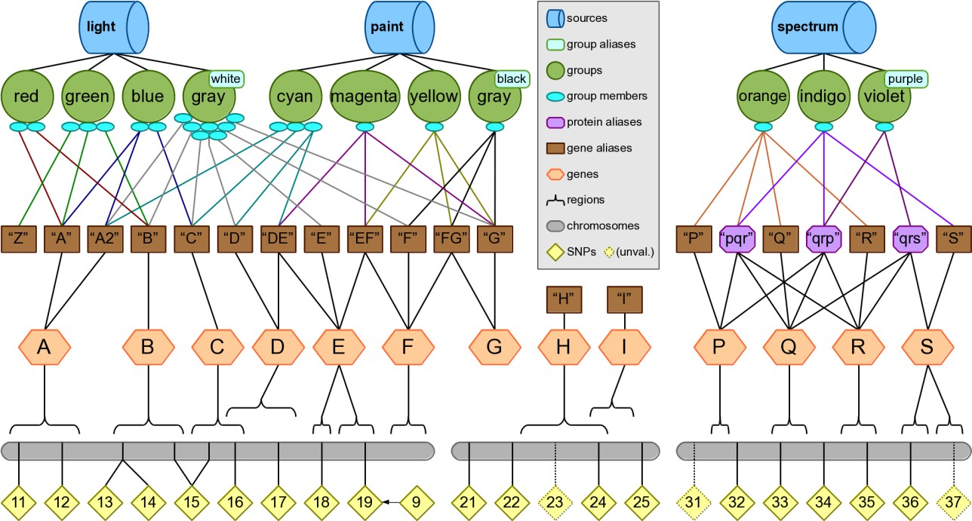
This simulated knowledge is intended to provide easily-understood examples of Biofilter’s functionality without relying on real-world cases which might become outdated. Many important concepts and edge cases are represented here, such as two groups with the same primary label (“gray”) which can only be differentiated by their aliases (“white” and “black”), some genes with multiple aliases (i.e. “A” and “A2”), and some aliases referring to multiple genes (i.e. “DE” could be gene D or gene E).

The groups from the “paint” and “spectrum” sources demonstrate many varieties of ambiguity. These are discussed in depth in Appendix 1, but for the examples in this chapter we will assume strict ambiguity options. We can then simplify the diagram of the knowledge by showing associations between groups and genes without the messy intermediate layer of aliases; in the resulting diagram below, the dotted lines indicate associations which will be ignored by default, but may appear if the ambiguity settings are changed.

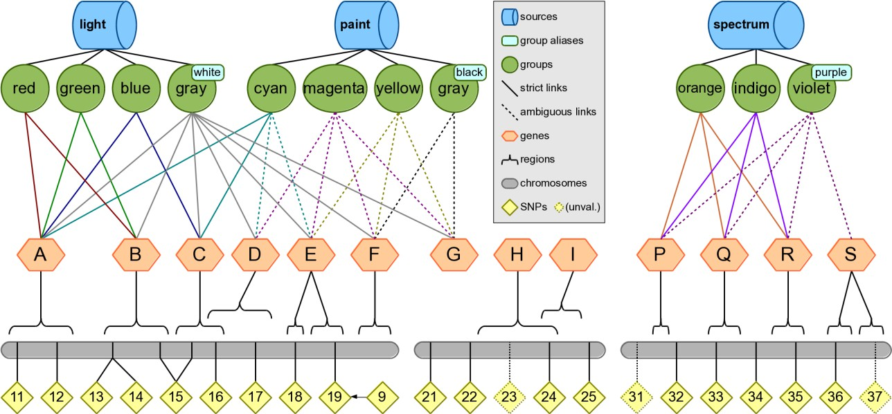
In order to reproduce the following examples using your own copy of Biofilter, you must run the
“loki-build.py” script using the “--test-data” option; refer to the Installation & Setup section for details.

Example Commands

Filtering Examples

Example 1: Filtering a list of SNPs by a genotyping platform, where input1 is the first list of SNPs and input2 is the list of SNPs on the genotyping platform.
Input files:

input1 | input2
#snp rs9 rs11 rs12 rs13 rs14 rs15  rs16 | #snp rs14 rs15 rs16 rs17 rs18 rs19
Configuration:
KNOWLEDGE test.db SNP_FILE input1 SNP_FILE input2 FILTER snp
Output:
#snp rs9 rs14 rs15 rs16
Note: The lists of input SNPs are checked against a dbSNP list of SNP ID’s that have been merged, and any outdated RSIDs are updated with the new RSID. In the example knowledge, rs9 has been merged into rs19; this is why rs9 appears in the output.

Example 2: Output a list of SNPs from a genotyping platform that correspond to a list of genes.
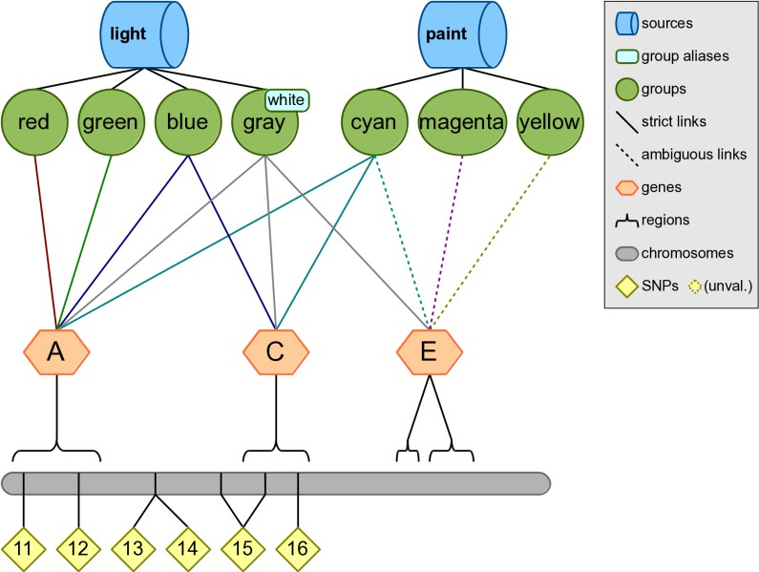

Input files:

input1 | input2
#snp rs11 rs12 rs13 rs14 rs15  rs16 | #gene A  C E
Configuration:
KNOWLEDGE test.db SNP_FILE input1 GENE_FILE input2 FILTER snp
Output:
#snp rs11 rs12 rs15 rs16

Example 3: Input a list of groups, output regions within those groups.
Configuration:
KNOWLEDGE test.db
GROUP red green cyan magenta orange indigo FILTER region
Output:

#chr 1  1  1  3  3  3 | region A  B C P Q  R | start 8  28  54  14  28  44 | stop 22  52  62  18  36  52

Example 4: Output a list of all genes within a data source.
Configuration:
KNOWLEDGE test.db SOURCE light FILTER gene
Output:
#gene A
B C D E F G

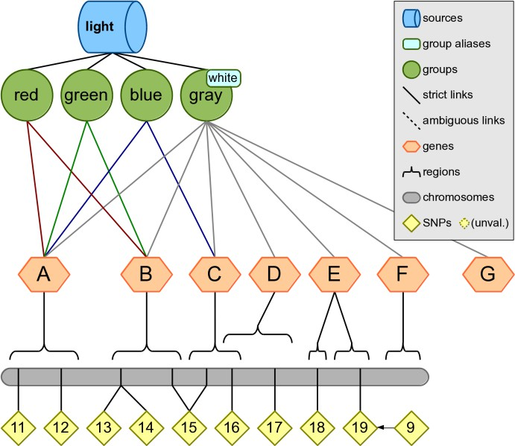

Example 5: Start with a list of genes, output all the genes within particular groups.
Input files:

input1 | input2
#group red green cyan magenta  orange indigo | #gene A  C E P R
Configuration:
KNOWLEDGE test.db GROUP_FILE input1 GENE_FILE input2 FILTER region
Output:

#chr 1  1  3  3 | region A  C P R | start 8  54  14  44 | stop 22  62  18  52

Example 6: Start with genes associated with a pathway or group, output genes within that group that overlap with an input list of genes.
Configuration:
KNOWLEDGE test.db GENE P Q R
FILTER gene snp region group source
Output:

#gene Q  Q R  R | snp rs33 rs33 rs35  rs35 | chr 3  3  3  3 | region Q  Q R  R | start 28  28  44  44 | stop 36  36  52  52 | group orange indigo orange  indigo | source spectrum spectrum spectrum  spectrum

Example 7: Starting with a list of genes, determine genes are within a group.
Configuration:
KNOWLEDGE test.db GENE A C E H P Q R
GROUP cyan
FILTER gene group
Output:

#gene A  C | group cyan cyan

Annotation Examples

Example 1: Annotating a SNP with gene region information.
Configuration:
KNOWLEDGE test.db SNP rs11 rs24 rs99 ANNOTATE snp region

Output:

#snp rs11 rs24 rs24 rs99 | chr 1  2  2 | region A  H I | start 8  22  38 | stop 22  42  48
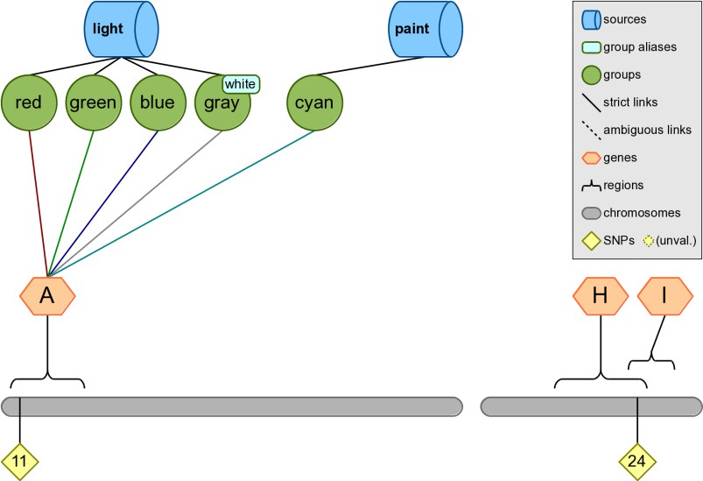

Example 2: Annotating SNPs with location information.
A user can provide Biofilter with a list of SNPs as an input and map those SNPs to the corresponding chromosome and base pair location (if any) as shown in the example below.

Configuration:
KNOWLEDGE test.db SNP rs11 rs24 rs99
ANNOTATE snp position
Output:

#snp rs11 rs24  rs99 | chr 1  2 | position rs11 rs24 | pos 10  40

Example 3: Map a SNP to the groups and sources where the SNP is present.
Biofilter can be used to map a list of SNPs, or a single SNP, to the groups and sources where those SNPs are present.

Configuration:
KNOWLEDGE test.db SNP rs11 rs24 rs99
ANNOTATE snp group source
Output:

#snp rs11 rs11 rs11 rs11 rs11  rs24 rs99 | group red green blue gray cyan | source light light light light paint

Example 4: Annotating a base pair region with the list of SNPs in that region.
A region can be supplied to Biofilter, with an output of the SNPs known to be in that region. Configuration:
KNOWLEDGE test.db REGION 1:1:60
ANNOTATE snp region
Output:

#snp rs11 rs12 rs13 rs14 rs15 rs15 rs16  rs16 | chr 1  1  1  1  1  1  1  1 | region A  A B B B C C  D | start 8  8  28  28  28  52  54  58 | stop 22  22  52  52  52  62  62  72

Example Filtering followed by annotation

Example 1: Input a SNP list and map SNP positions to regions.
Configuration:
KNOWLEDGE test.db
SNP rs11 rs12 rs13 rs14 rs15 rs16 FILTER region
Output:

#chr 1  1  1  1 | region A  B C D | start 8  28  54  58 | stop 22  52  62  72
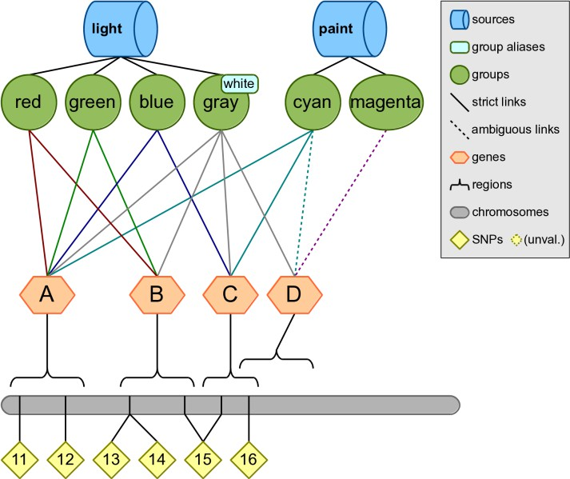

Example 2: Map SNPs to groups and filter on the source.
Configuration:
KNOWLEDGE test.db SOURCE paint
FILTER snp group source

Output:

#snp rs11 rs12 rs15 rs16 | group cyan cyan cyan cyan | source paint paint paint paint

Example 3: Testing overlap of SNP and region lists, outputting regions.
Input files:

input1 | input2
#snp | #chr | region | start | stop
rs14 | 1 | A | 8 | 22
rs15 | 1 | B | 28 | 52
rs16 | 1 | C | 54 | 62
rs17 | 1 | D | 58 | 72
rs18
rs19
Configuration:
KNOWLEDGE test.db SNP_FILE input1 REGION_FILE input2 FILTER region
Output:

#chr 1  1  1 | region B  C  D | start 28  54  58 | stop 52  62  72

Example 4: Testing overlap of gene and source lists, outputting regions.
Configuration:
KNOWLEDGE test.db GENE A C E G P R
SOURCE spectrum FILTER region

Output:

#chr 3  3 | region P  R | start 14  44 | stop 18  52

Example 5: Filter gene list based on sources, and output regions.
Configuration:
KNOWLEDGE test.db GENE A C E G P R
SOURCE paint spectrum FILTER gene source region
Output:

#gene A  C P  R | source paint paint spectrum  spectrum | chr 1  1  3  3 | region A  C P  R | start 8  54  14  44 | stop 22  62  18  52

Example 6: Output of genes found in pathway based input, filtered by genotyping platform.
Configuration:
KNOWLEDGE test.db
SNP rs11 rs12 rs13 rs14 GENE A C E G P R
GROUP cyan yellow FILTER region
Output:

#chr 1 | region A | start 8 | stop 22

Example 7: Output of genes annotated by group found in pathway based input, filtered by genotyping platform.
Configuration:
KNOWLEDGE test.db
SNP rs11 rs12 rs13 rs14 rs16 rs17 rs18 GENE A C E G P R
GROUP cyan yellow FILTER gene group
Output:

#gene A  C | group cyan  cyan
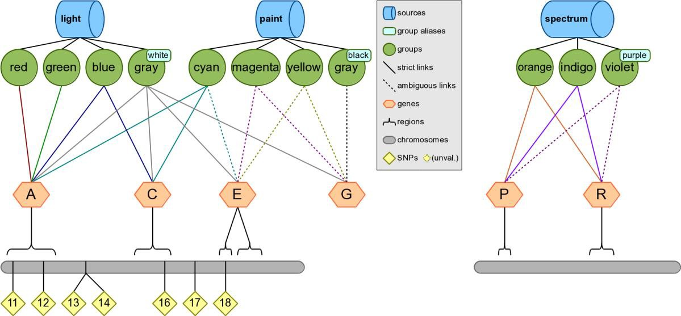

Example 8: Genes within data sources from a list of input genes filtered by genotyping platform, output regions.
Configuration:
KNOWLEDGE test.db
SNP rs11 rs12 rs13 rs14 rs16 rs17 rs18 GENE A C E G P R
SOURCE paint spectrum FILTER region

Output:

#chr 1  1 | region A  C | start 8  54 | stop 22  62

Example 9: Find overlap between two SNP lists and map the overlapping SNPs to the genes.
Input files:

input1 | input2
#snp rs11 rs12 rs13 rs14 rs15  rs16 | #snp rs14 rs15 rs16 rs17 rs18  rs19
Configuration:
KNOWLEDGE test.db SNP_FILE input1 SNP_FILE input2
FILTER snp gene region
Output:

#snp rs14 rs15 rs15 rs16  rs16 | gene B  B C C  D | chr 1  1  1  1  1 | region B  B C C  D | start 28  28  54  54  58 | stop 52  52  62  62  72

Example 10: Find overlapping SNPs between the two lists and map the overlapping SNPs to the genes, regions, groups and the sources.
Configuration:
KNOWLEDGE test.db
SNP rs11 rs12 rs13 rs14 rs15 rs16 SNP rs14 rs15 rs16 rs17 rs18 rs19 FILTER snp gene region group source

Output:

#snp rs14 rs14 rs14 rs15 rs15 rs15 rs15 rs15 rs15 rs16 rs16 rs16  rs16 | gene B  B B B B B C C C C C C  D | chr 1  1  1  1  1  1  1  1  1  1  1  1  1 | region B  B B B B B C C C C C C  D | start 28  28  28  28  28  28  54  54  54  54  54  54  58 | stop 52  52  52  52  52  52  62  62  62  62  62  62  72 | group red green gray red green gray blue gray cyan blue gray cyan  gray | source light light light light light light light light paint light light paint  light

Example 11: Mapping regions to genes using Biofilter based on percent of overlap.
Regions such as copy number variations can be mapped to genes using Biofilter, carried out based on percent of overlap of the genes with the CNV region or based on the number of base pairs overlapped.

For reference, here are the boundary positions for the genes in chromosome 1:

#chr 1  1  1  1  1  1  1 | gene A  B C D E E  F | start 8  28  54  58  78  84  94 | stop 22  54  62  72  82  92  98
Configuration:
KNOWLEDGE test.db REGION 1:1:60
REGION_MATCH_PERCENT 50
FILTER gene
Output:
#gene A
B C

This output indicates that at least 50% of genes A, B, and C fall within the first 60 bases of the first chromosome. Both genes A and B match 100% of the region while gene C matches 75%.

Example 12: Mapping regions to genes using Biofilter based on base pair overlap.
The genes overlapping region based on number of base-pair overlap can also be determined via Biofilter. Configuration:
KNOWLEDGE test.db REGION 1:1:60
REGION_MATCH_BASES 10
FILTER gene
Output:
#gene A
B
This output uses the region-match-bases argument to specify that Biofilter should filter genes that only match a minimum of 10 bases within the given input region.

Example 13: Annotating a list of gene symbols with SNPs, regions, groups, and sources, using Biofilter.
Configuration:
KNOWLEDGE test.db GENE A B C D E
FILTER gene snp region group source
Output:

#gene A  A A A A A A A A A B B B  B | snp rs11 rs11 rs11 rs11 rs11 rs12 rs12 rs12 rs12 rs12 rs13 rs13  rs13 rs14 | chr 1  1  1  1  1  1  1  1  1  1  1  1  1  1 | region A  A A A A A A A A A B B B  B | start 8  8  8  8  8  8  8  8  8  8  28  28  28  28 | stop 22  22  22  22  22  22  22  22  22  22  52  52  52  52 | group red green blue gray cyan red green blue gray cyan red green  gray red | source light light light light paint light light light light paint light light  light light

B B B B B C C C C C C D D  E E | rs14 rs14 rs15 rs15 rs15 rs15 rs15 rs15 rs16 rs16 rs16 rs16 rs17  rs18 rs19 | 1  1  1  1  1  1  1  1  1  1  1  1  1  1  1 | B B B B B C C C C C C D D  E E | 28  28  28  28  28  54  54  54  54  54  54  58  58  78  84 | 52  52  52  52  52  62  62  62  62  62  62  72  72  82  92 | green gray red green gray blue gray cyan blue gray cyan gray gray  gray gray | light light light light light light light paint light light paint light light  light light

Modeling Example
Here we present an example with two sources and eight pathways shown in the below figure, to explain how Biofilter can generate pairwise SNP-SNP and Gene-Gene models. In further sections we explain other options for how model generation can be performed in Biofilter 2.0.
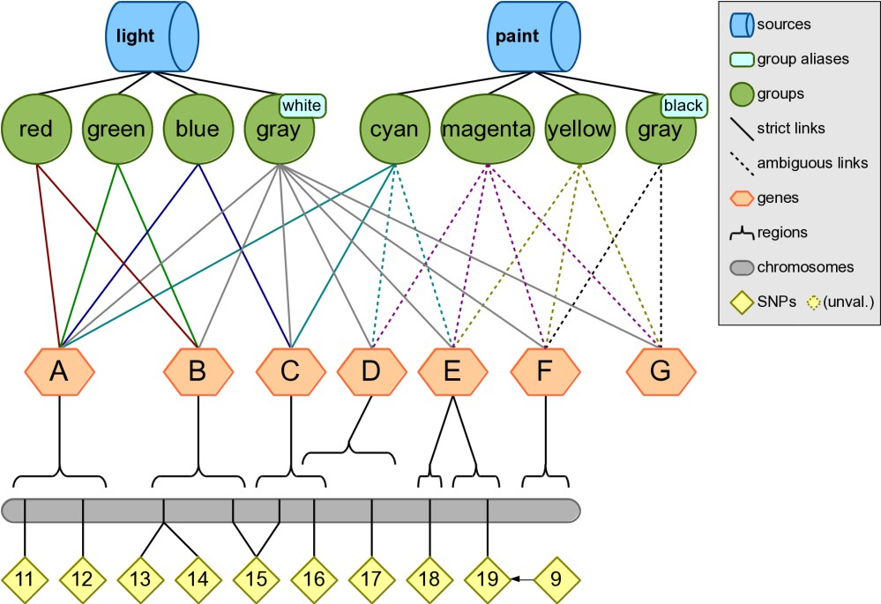

Step 1
Map the input list of SNPs to genes within Biofilter; for this example, we will use all of the SNPs on the first chromosome. Note that Gene F does not contain any SNPs.

Configuration:
KNOWLEDGE test.db
SNP 11 12 13 14 15 16 17 18 19
FILTER gene
Output:
#gene A
B C D E

Step 2
Connect, pairwise, the genes that contain SNPs in the input list of SNPs. Configuration:
KNOWLEDGE test.db GENE A B C D E
MODEL gene
Output:

#gene1 A | gene2 C | score(src-grp) 2-3
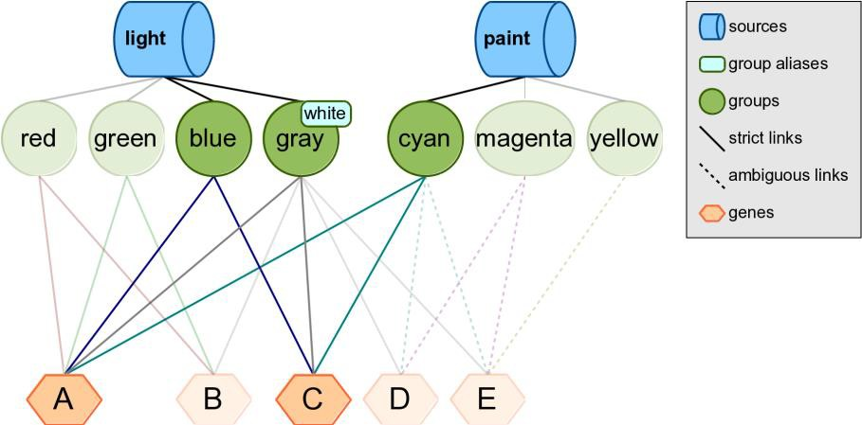
Biofilter has determined that genes A and C are found together in three groups across two sources. In other words, both the light and paint sources contain groups—blue, gray, and cyan—that suggest a relationship between genes A and C.

This relationship is summarized by the implication score “2-3,” which gives the number of sources followed by the number of groups which support this gene model. Each time the same pairwise model of genes is found in another source, the left-hand index of the implication score for that pairwise model increases by one; each time it is found in another group from the same source, the right-hand index increases by one.

Step 3
Break down the gene-gene models into all pairwise combinations of SNPs across the genes within sources light and paint.

Configuration:
KNOWLEDGE test.db SOURCE light paint MODEL snp
Output:

#snp1 rs11 rs11 rs12 rs12 | snp2 rs15 rs16 rs15 rs16 | score(src-grp) 2-3  2-3  2-3  2-3
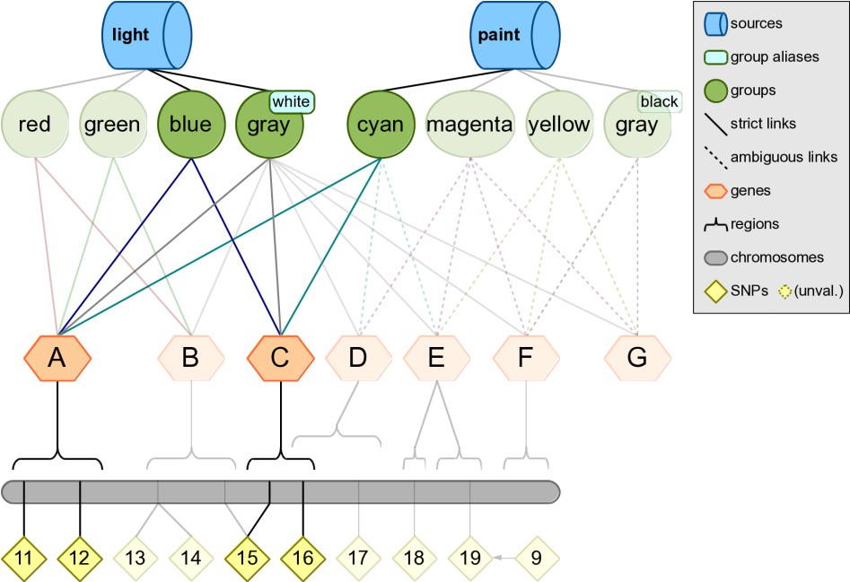

Changes in Biofilter 2.0 Modeling
Although this three-step strategy will work in the new version of Biofilter, the strategy can be simplified. Biofilter 2.0 will automatically generate gene models prior to generating SNP models and

there is no need to specify that step separately. It is possible to generate the SNP models with a single command.

Configuration:
KNOWLEDGE test.db
SNP 11 12 13 14 15 16 17 18 19
MODEL snp
Output:

#snp1 rs11 rs11 rs12  rs12 | snp2 rs15 rs16 rs15  rs16 | score(src-grp) 2-3  2-3  2-3  2-3

Appendix 1: Ambiguity in Prior Knowledge
When an ambiguous gene or group identifier appears in a user input file, Biofilter has two straightforward options: either include all genes or groups with which the identifier is associated, or none of them.

When processing the bulk downloads from prior knowledge sources, however, the situation can become more complicated. This is due to the fact that in many cases, the data provided by a source is formatted in a way which allows multiple identifiers to be provided for the same member of a group. Ideally all such identifiers are known to refer to the same single gene, but occasionally this is not the case.
Sometimes one of the identifiers is an alias of more than one gene, making it inherently ambiguous; other times, even if every identifier refers to only one gene, they might not all agree on which gene that is.

The testing knowledge included with Biofilter contains several examples of these kinds of situations, depicted in the diagram below. Note that this diagram reflects the fact that there may be multiple names for the same gene (i.e. “D” and “DE” both refer to gene D), and some names may be associated with multiple genes (i.e. “DE” refers to both genes D and E).
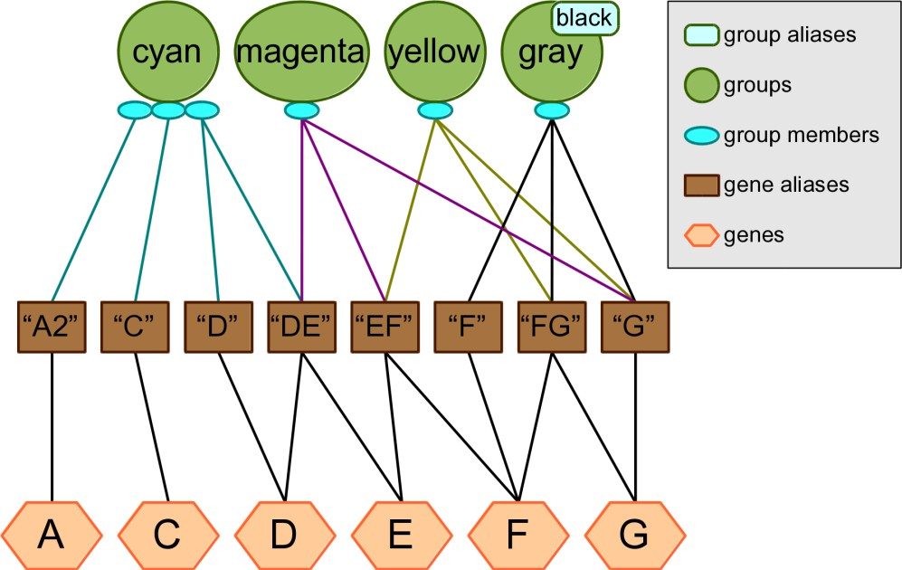

The “cyan” group contains three genes, of which the third is ambiguous because we are given two identifiers for it, but one of them refers to two different genes. The “magenta”, “yellow” and “gray/black” groups each contain only one gene, but in each case we are given three different names for that gene which agree or disagree with each other in varying ways. Because of the ambiguity in the provided identifiers, the genes which are considered members of these groups will appear to vary depending on the user’s choice for the ALLOW_AMBIGUOUS_KNOWLEDGE and REDUCE_AMBIGUOUS_KNOWLEDGE options.

Ambiguity Reduction Heuristics
Biofilter and LOKI currently support two heuristic strategies for reducing ambiguity. These strategies make what is essentially an educated guess about what the original data source intended by the set of identifiers it provided. The first heuristic is called “implication” and it rates the likelihood of each potential gene being the intended one by counting the number of identifiers which implicate that gene. The second heuristic, called “quality,” is similar except that it also considers the number of genes that each identifier refers to as a measure of that identifier’s quality; a high-quality identifier (which refers to only one or two genes) is then given more weight than a low-quality identifier (which refers to many genes).

In practice, these two heuristic strategies will often produce the same results; in fact, when using real data from our real prior knowledge sources, we have yet to find a case where they do not reach the same conclusion. It is possible that such a case will arise in the future, however, so the “magenta”, “yellow” and “gray/black” groups in the testing knowledge have been specially crafted to highlight these potential differences.

Ambiguity Options
The REDUCE_AMBIGUOUS_KNOWLEDGE option tells Biofilter which heuristics, if any, should be employed to mitigate ambiguity in the prior knowledge database. The permissible values for this option are the name of any of the heuristic strategies, or “no” or “any”. When set to “no” then no attempt is made to reduce ambiguity and all genes which are implicated by any of the provided identifiers are considered equally likely interpretations. When set to “any” then all heuristics are attempted simultaneously and the winner(s) from each one collectively become the preferred choices.

The ALLOW_AMBIGUOUS_KNOWLEDGE option tells Biofilter what to do when it has more than one “best guess” interpretation for an ambiguous member of a group. If no heuristics were used then this occurs for all cases of ambiguity, but it should also be noted that any heuristic strategy might be only partly successful. For example, if a given set of identifiers collectively refer to three different genes and the heuristic(s) can only eliminate one of them, then the other two remain equally likely possibilities. In cases like this, the user’s choice for ALLOW_AMBIGUOUS_KNOWLEDGE determines the result: when disabled (the strict option) none of the possible genes will be considered a member of the group, but when enabled (the permissive option) the most-likely possibilities will all be included, without any of the less-likely possibilities.

Gene Ambiguity Examples

Example 1: cyan
The “cyan” group is a typical case of ambiguity which can be fully resolved by either of the heuristic strategies. Its first two members (genes A and C) are unambiguous and will always be included, but the correct third member of the group is open to interpretation.

The implication heuristic will declare D as the correct interpretation since it is implicated by both of the provided identifiers, while gene E is only implicated by one of them.

The quality heuristic will also choose D, but its reasoning is a little more involved. The “DE” identifier refers to two different genes, so it gets a quality score of 1/2 or 0.5; the “D” identifier, on the other hand, gets a quality score of 1 because it refers to only one gene. Gene E therefore receives only 0.5 points, while gene D wins with 1.5 total points.

Because the ambiguity can be fully resolved by either heuristic, the ALLOW_AMBIGUOUS_KNOWLEDGE option will only have an effect if no heuristics are used at all. In that case, the group will contain all four possible genes (A, C, D and E) if the option is enabled, but only A and C if it is disabled.

Example 2: magenta
The “magenta” group demonstrates ambiguity which can only be resolved by the implication heuristic: gene E is implicated by two identifiers (“DE” and “EF”) while genes D, F and G are each only implicated by one identifier.

The quality heuristic will discard genes D and F (0.5 points each), but cannot pick a winner between E and G because they both have a score of 1.0: gene E gets 0.5 each from the “DE” and “EF” identifiers, while gene G gets 1 full point from “G”.

With no heuristics, the ALLOW_AMBIGUOUS_KNOWLEDGE option will either include all four genes or none of them. With the quality heuristic, it can either include both winners (E and G) or nothing. With the implication heuristic it has no effect here, since the ambiguity was eliminated with that strategy.

Example 3: yellow
The “yellow” group demonstrates ambiguity which can only be resolved by the quality heuristic: gene G wins with a score of 1.5 (0.5 from “FG” plus 1.0 from “G”).

The implication heuristic will discard gene E (implicated by only one identifier), but cannot choose between F and G because they are implicated by two identifiers each: “EF and “FG”, or “FG and “G”.

With no heuristics, as always ALLOW_AMBIGUOUS_KNOWLEDGE will either include every possibility or none of them. With the implication heuristic it can either include both F and G or nothing, and with the quality heuristic it has no effect.

Example 4: gray/black
The “gray/black” group is an example of ambiguity which cannot be resolved by either heuristic: genes F and G are entirely comparable, both being referenced by one specific identifier plus one (shared) ambiguous identifier. No matter which heuristic is used, if any, this group will always contain both F and G if ALLOW_AMBIGUOUS_KNOWLEDGE is enabled, or neither if it is disabled.

Protein Identifiers
So far, our depiction of ambiguity in the knowledge database has implied that groups always contain genes. This allows for the convenient assumption that when we are given more than one identifier for something in a group, we are expecting all of those identifiers to refer to one (and only one) gene.

The reality is, of course, a little more complicated: some sources provide groups which actually contain proteins. In order to make this knowledge compatible with the rest of the prior knowledge, LOKI must translate these protein references into genes, but this breaks that convenient assumption. If a group contains genes then we can reasonably expect each member of the group to be a single gene, but if the group contains proteins, then we must be prepared for a single protein-member to correspond to many genes.

To account for this, LOKI differentiates between identifiers which refer directly to genes (such as symbolic abbreviations or Entrez Gene ID numbers) and identifiers which refer to proteins (such as UniProt ID numbers) that may in turn correspond to many genes.

If any of the identifiers provided for one member of a group is a protein identifier, LOKI disregards any non-protein identifiers. If there is only one protein identifier, then LOKI considers all genes which correspond to that protein to be members of the group, with no ambiguity. If there are multiple protein identifiers then there may be ambiguity if they do not correspond to the same set of genes.

Since protein identifiers are expected to correspond to multiple genes, the concept of an identifier’s “quality” no longer has meaning; consequently, whenever protein identifiers are involved, the implication and quality heuristic strategies become functionally equivalent. In both cases, a gene’s likelihood of being associated with a group is proportional to the number of protein identifiers which implicated it. When no heuristics are used, then all genes which are implicated by any of the protein identifiers are considered equally likely to belong in the group.

The testing knowledge included with Biofilter also contains several examples of groups with protein identifiers:
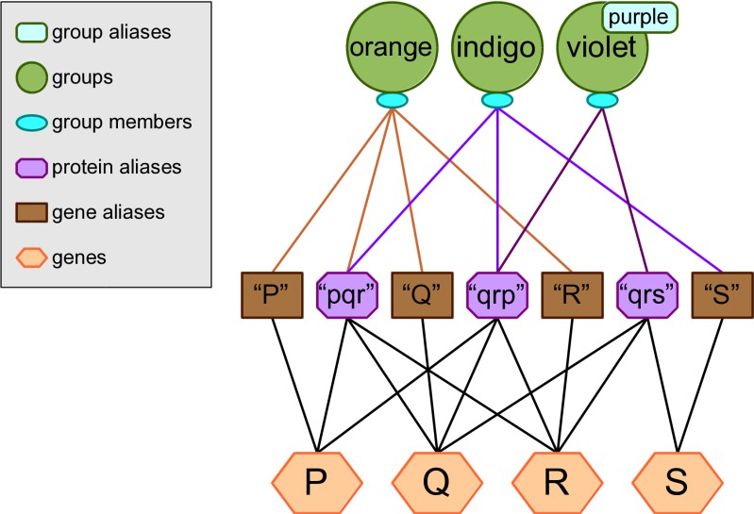

Protein Ambiguity Examples

Example 1: orange
The “orange” group contains a simple, unambiguous use of protein identifiers. No matter what options are used, this group will always contain the genes P, Q and R.

Example 2: indigo
The “indigo” group demonstrates a more complicated but still unambiguous situation. The two protein identifiers agree with each other, so the group will always contain the genes P, Q and R no matter what options are used. However there is an extraneous gene identifier which is ignored, even though it does not appear to match the protein identifiers. In practice, this is rarely the case; when a source provides both protein and gene identifiers, the latter usually agree with the former.

Example 3: violet
In the “violet” group the two protein identifiers only partly agree: both of them correspond to genes Q and R, but one of them also matches P while the other also matches S.

If ALLOW_AMBIGUOUS_KNOWLEDGE is enabled then all four genes will be included in the group. If it is disabled, then any heuristic strategy will include genes Q and R but not P or S. If no heuristics are used either, then the group will appear empty.

Appendix 2: LD Profiles
Each LD profile is defined by two things: a reference population whose particular LD patterns are relevant to the user’s analysis, and a threshold value to specify what the user considers “high LD.” Every LOKI knowledge database file begins with a default, unnamed LD profile which contains the canonical gene region boundaries and therefore has no reference population or LD threshold. All other LD profiles are calculated based on these original boundaries, which means whenever the LOKI knowledge database is updated, the LD profiles must also be re-calculated to incorporate any changes in the original gene region boundaries.

In order to generate LD profiles, Biofilter is distributed with a separate software tool called LD Spline. This tool can use specific LD measurements from the HapMap project to extrapolate more general LD patterns, which can in turn be used to calculate LD profiles containing adjusted gene region boundaries. More information about LD Spline is available from www.ritchielab.psu.edu.

Installing LD Spline
LD Spline is written in C and must therefore be compiled for your local computing environment before it can be used. To do this automatically as part of the Biofilter installation process, simply use the
“--ldprofile” option:

python setup.py install --ldprofile

This will compile and install the “ldspline” executable, along with a few supporting scripts which automate the process of generating and storing LD profiles in LOKI.

Generating LD Profiles
The LOKI prior knowledge database file must be generated before the LD adjustment can be done; refer to the Biofilter installation instructions for details on this procedure. Once the knowledge file is available, use the “buildPopulations.py” script to generate additional LD profiles. For example:

buildPopulations.py --db loki.db --populations CEU,YRI --dprime 0.6,0.7
--rsquared 0.8,0.9

This will generate 8 additional LD profiles for use in LOKI and Biofilter: four each for the CEU and YRI populations, of which two represent the LD pattern using D’ thresholds of 0.6 and 0.7 and the other two use the R² metric with thresholds of 0.8 and 0.9. Note that building LD profiles may take quite some time; plan for at least 2 hours per population when run on a local disk, or twice that on a networked filesystem (such as GPFS). The build process also requires ~2 GB of RAM and some temporary disk space in the working directory: allow for 10 GB, plus another 10 GB per population.

With the modified knowledge database file, Biofilter can then make use of the alternate gene regions via the LD_PROFILE option:

biofilter --knowledge loki.db –-ld-profile CEU-RS0.80

The “--report-ld-profiles” option can be used to list the LD profiles available in a LOKI database file:
biofilter --knowledge withld.db –-report-ld-profiles

#ldprofile  CEU-DP0.60 CEU-DP0.70 CEU-RS0.80 CEU-RS0.90 YRI-DP0.60 YRI-DP0.70 YRI-RS0.80 YRI-RS0.90 | description  no LD adjustment  CEU population from HapMap with dprime cutoff 0.6 CEU population from HapMap with dprime cutoff 0.7 CEU population from HapMap with rsquared cutoff 0.8 CEU population from HapMap with rsquared cutoff 0.9 YRI population from HapMap with dprime cutoff 0.6 YRI population from HapMap with dprime cutoff 0.7 YRI population from HapMap with rsquared cutoff 0.8 YRI population from HapMap with rsquared cutoff 0.9 | metric  dprime dprime rsquared rsquared dprime dprime rsquared rsquared | value  0.6  0.7  0.8  0.9  0.6  0.7  0.8  0.9

Population Build Script Options
--help
Displays the program usage and immediately exits.

--populations
A comma-separated list of 3-letter HapMap population identifiers (i.e. “CEU”, “JPT”, “YRI”, etc.)

--rsquared
A comma-separated list of R² threshold values (between 0 and 1) for which to generate LD profiles.

--dprime
A comma-separated list of D’ threshold values (between 0 and 1) for which to generate LD profiles.

--liftover
The location of UCSC’s liftOver utility, which is needed to convert HapMap’s LD measurements to the current reference genome build. If omitted, liftOver must be available on the path.

--ldspline
The location of the LD Spline utility, which will be installed by the Biofilter installer if given the “--ldprofile” option. If omitted, ldspline must be available on the path.

--poploader
The location of the pop_loader helper script, which will be installed by the Biofilter installer if given the “--ldprofile” option. If omitted, pop_loader must be available on the path.

--db
The LOKI prior knowledge database file in which to generate LD-adjusted gene regions. The database must already contain the canonical gene regions.

--keep-data
Generating LD profiles requires many intermediate files such as original LD data from HapMap and extrapolated LD data from LD Spline. By default these intermediate files are deleted after use; if this option is specified, they will be left in place.

Appendix 3: PARIS
Biofilter now incorporates the PARIS algorithm, which stands for Pathway Analysis by Randomization Incorporating Structure. This analysis uses a randomized permutation test to indicate whether significant SNP associations are statistically over-represented in a pathway or other gene grouping, accounting for population-specific genetic structure. Further details about the design and behavior of the PARIS algorithm can be found in these publications:
- Yaspan, et al. 2011. Genetic analysis of biological pathway data through genomic randomization. Hum Genet. May;129(5):563-71.
- Butkiewicz and Cooke Bailey, et al. 2016. Pathway analysis by randomization incorporating structure—PARIS: an update. Bioinformatics. In Press.

PARIS Inputs
The first kind of input data that PARIS requires is SNPs or positions, including their p-values from a prior association test. These can be provided using Biofilter's regular SNP or POSITION options (or their _FILE counterparts), along with two "extra" columns specifically for PARIS: the chromosome of the marker, and its p-value from the association test results.

For SNPs, the input format might therefore look like this:

#rs rs123 rs456  rs789 | chr 1  7  9 | pval 0.1234  1.3e-5  0.5678
For position input, the extra columns can only be recognized when the position data is provided in full-width format, which is a 4-column .map file format. The resulting input for PARIS might look like this:

#chr 1  7  9 | label rs123 rs456  rs789 | ignored  -  -  - | position 123456789  456456456  987654321 | chr 1  7  9 | pval 0.1234  1.3e-5  0.5678
Note that this does imply a duplication of the "chr" column for positional input to PARIS; this is a result of PARIS' unified "extra" columns processing and backwards compatibility with PARIS v1.0 inputs. The purpose of the extra chromosome column for SNP input was to allow for specificity when dealing with SNPs that are mapped to more than one chromosome, by specifying which instance should be considered for the analysis. This feature can be disabled with the PARIS_ENFORCE_INPUT_CHROMOSOME option, in which case the second chromosome column of the positional input format is ignored and may be filled with any placeholder, such as "-".

The other kind of input data that PARIS requires are the LD blocks of the population being studied. These are input using the regular REGION_FILE options, with no extra columns required. A few pre-called LD block files, based on HapMap population data.

PARIS Outputs
The PARIS module is invoked using the PARIS option. This will produce an output file <prefix>.paris-summary which lists information about each analyzed pathway, its feature profile in terms of the PARIS algorithm, and PARIS' permutation-derived p-value for the significance of the results in that pathway.
For example:

group path:hsa00010 path:hsa00020  … | desc | genes 61  30 | features 168  58 | simple 110  30 | (sig) 2  1 | complex 58  28 | (sig) 9  2 | pval 0.877  0.894
The first three columns of this output specify the pathway or other gene group that has been analyzed, including its label, longer description (if any) and the number of genes it contains. The next five columns reflect the group's "fingerprint" for the purposes of PARIS analysis, including the total number of genomic features that it covers, the breakdown of how many of those features were simple (containing only one input SNP) or complex (an LD block containing multiple input SNPs), and the portion of those subtotals which were significant according to their association p-values provided along with the input SNPs or positions. The final column is the PARIS p-value, which reflects the probability of a randomized gene grouping with the same feature fingerprint containing at least as many significant features as the original.

In addition to this summary output, the PARIS_DETAILS option will produce an output file
<prefix>.paris-detail which is broken into separate sections for each analyzed pathway or other gene grouping. Within each section, the PARIS algorithm is applied separately to the individual genes in that pathway, with a similar output format:

Pathway Investigation: path:hsa00010 Glycolysis / Gluconeogenesis
genes 61 | features 168 | simple 110 | (sig) 2 | complex 58 | (sig) 9 | pval 0.877
Gene Breakdown: path:hsa00010
gene PCK1 PFKP LDHA ALDH9A1  … | features 3  29  1  5 | simple 3  23  0  3 | (sig) 0  1  0  0 | complex 0  6  1  2 | (sig) 0  0  1  1 | pval 1  0.573  < 0.001  0.108
This can help to identify, for example, if a strong pathway-level signal is being driven by only one or a few genes, or if strong signals in several pathways are all driven by the same shared gene.

PARIS Example
Putting it all together, a simple PARIS run might look like this:

biofilter --knowledge loki.db –-snp-file my_CEU_study.snps –-region-file ld_CEU_b38.regions –-paris –-paris-details –-prefix my_CEU_study

In this example, two output files would be generated: my_CEU_study.paris-summary and
my_CEU_study.paris-detail.

Additional PARIS Options
This section describes the standard configuration options that have a special significance when running a PARIS analysis, as well as the PARIS-specific options that have no meaning for Biofilter's other modes (such as filtering, annotation and model building).

--region-position-margin / REGION_POSITION_MARGIN
Argument: <bases> Default: 0
This option influences the step of the PARIS algorithm which matches input SNPs or positions to LD block regions. With a positive value, this option will cause PAIRS to consider a SNP or position to be part of a complex LD feature even if it is some distance outside the boundaries of that feature region.

--region-match-percent / REGION_MATCH_PERCENT
Argument: <percentage> Default: 100 See below.

--region-match-bases / REGION_MATCH_BASES
Argument: <bases> Default: 0
These two options influence the step of the PARIS algorithm which matches features (both simple and complex) to gene regions. The default behavior of the original PARIS algorithm was to consider a feature to be covered by a gene (and thus its pathways) if the feature and the gene region shared at least one base pair; this behavior can be replicated by setting REGION_MATCH_BASES to 1. A higher value will require more overlap between the feature and the gene region to be considered a match, and a negative value can be used to allow some margin between a feature region and a gene (i.e. two regions can "match" with "-100 bases" if the end of one is within 100 basepairs of the beginning of the other).
Alternatively, REGION_MATCH_PERCENT can specify the portion of the smaller region that must be covered by the larger region.

--paris-p-value / PARIS_P_VALUE
Argument: <p-value> Default: 0.05
This option controls the p-value threshold of the association testing results input that PARIS will consider to be significant.

--paris-zero-p-values / PARIS_ZERO_P_VALUES
Argument: [ignore/insignificant/significant] Default: ignore
This option tells PARIS what to do with inputs that report a p-value of zero. The default behavior is to 'ignore' them, as if the SNP or position was not part of the input at all. Alternatively, PARIS can treat them as if they are 'significant' (which may be appropriate if the prior testing can produce p-values

below the machine precision threshold, which would then "round down" to zero), or PARIS can consider them 'insigifnicant' (which may be more appropriate if the prior test can encounter an error condition which manifests as a p-value of zero).

--paris-max-p-value / PARIS_MAX_P_VALUE
Argument: <p-value> Default: none
This option serves as a run-time speed optimization by specifying the highest permutation derived p-value that PARIS could yield which would have any meaning. Because of the way PARIS' permutation testing is implemented, the analysis can be cut short as soon as it is determined that a gene or pathway is going to end up higher than this threshold. For example, with a setting of 0.5, PARIS can stop early and report a p-value of ">= 0.5" without spending the extra time to determine if it would have been 0.51, or 0.75, or 0.99, etc.

--paris-enforce-input-chromosome / PARIS_ENFORCE_INPUT_CHROMOSOME
Argument: [yes/no] Default: yes
In addition to their association test p-value results, PARIS expects input SNPs or positions to have a second extra column which specifies their chromosome. In keeping with the behavior of PARIS v1, this extra chromosome column will be used to filter out any SNPs that are found on a different chromosome in the LOKI knowledge database. By disabling this option, the extra chromosome column will be ignored (and can be left blank) and PARIS will process SNPs on whatever chromosome it believes they are found on.

--paris-permutation-count / PARIS_PERMUTATION_COUNT
Argument: <count> Default: 1000
By default, PARIS will perform 1000 permutations of each analyzed gene or pathway, which yields a p-value precision of 1 / 1000 or 0.001. The number of permutations can be changed using this option to yield a different precision, at the cost of higher running time for more permutations.

--paris-bin-size / PARIS_BIN_SIZE
Argument: <size> Default: 10000
When PARIS permutes a gene or pathway, it must randomly replace all of its features with other features of similar size (which is measured in terms of the number of input SNPs or positions within the feature, not the total chromosomal region size in basepairs). To determine the eligible candidates for this replacement, PARIS will sort all features by their size and then divide them into some number of "bins" such that each bin contains approximately 10000 features. This option can be used to change the target number of features per bin, which will in turn change the number of candidate replacements for each feature during the permutation step.

--paris-snp-file / PARIS_SNP_FILE
Arguments: <file> [file] […] Default: none
See below.

--paris-position-file / PARIS_POSITION_FILE
Arguments: <file> [file] […] Default: none
These two options serve as run-time memory usage optimizations by allowing PARIS to read and summarize the input SNP or position data on the fly, instead of having to load it completely into memory using Biofilter's standard input options (SNP, SNP_FILE, POSITION or POSITION_FILE).

--paris-details / PARIS_DETAILS
Argument: [yes/no] Default: no
By default, PARIS will only generate "summary" output of the permutation results of each analyzed pathway. With this option enabled, PARIS will also generate a "details" output which further breaks down the analysis into each individual gene of each analyzed pathway.

