Incorporating Hotspots into genetic simulation.

It has been suggested that recombination hotspots have arisen as a side effect of evolution and that these hotspots have played an important role in the development of LD as we currently see it.

Since fall of 2008, genomeSIMLA has had the potential for skewing the genetic distance without affecting physical position. This was a side-effect of our new cross-over mechanism, and seemed like a source of interesting potential.

To programmatically introduce regions of increased and decreased recombination rates, a python script was written which applies a sinusoidal function to determine the the recombination adjustment.

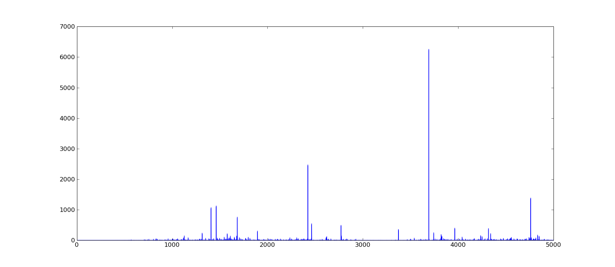
The function is pretty simple:
f(x) = abs( tan(x * rnd()) * sin(x) )

The tangent simply amplifies the effects of the sin and the random draw distorts the highly reliable pattern, giving us a much more natural series of occasional spikes on an relatively flat background.
The chart above shows one the distributions. The locus index is represented on the X-Axis while the multiplicative adjustment is represented on the Y-Axis.

To dampen these massive signals, the log of the adjustment was taken when the value was greater than 1.0. The chart below shows the recombination frequencies before and after adjustment at each locus where blue represents the modified genetic distance (and green is the original).

This is obviously too extreme, but it can be used to see how drastic the effects are on a simulation.

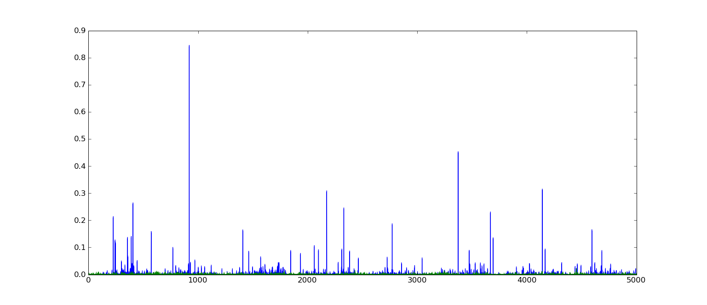
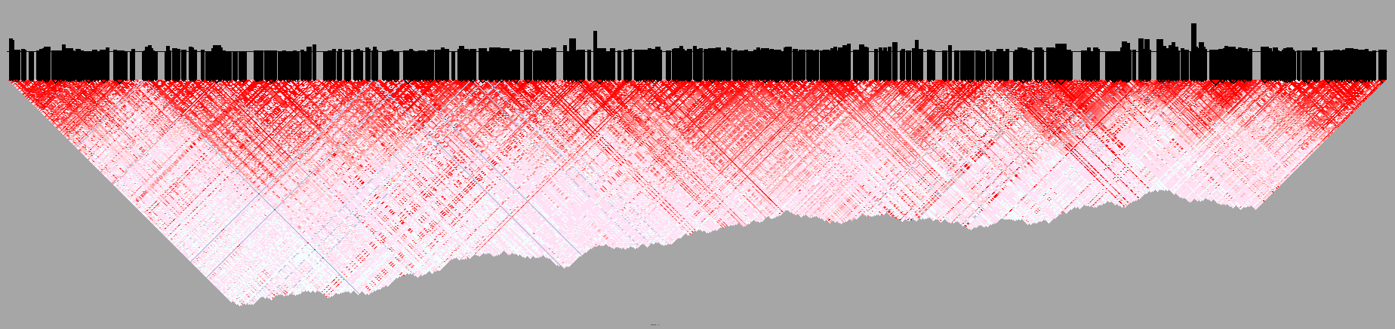
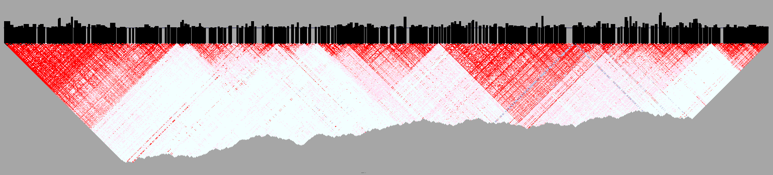
These two were taken from the same locus with the except of the adjusted genetic distances (bottom). These represent sampled LD at generation 900, where fixed alleles and block counts were very close.

Inferring Recombination from Hapmap
In order to adjust our map distances in a way that helps us generate LD patterns that are more similar to those found in a given hapmap population, we produce a simple distribution of LD values which arise from constant genetic distances.

To build the distribution, we start with a single chromosome with a length of 0.5 centimorgans. I believe this is the maximum distance hapmap carries when calculating pairwise LD. If this isn’t true, we can simply extend the length of our seed chromosome to match the maximum distance we wish to capture.

This chromosome is advanced using genomeSIMLA to some number of generations and complete pairwise LD is produced. We then build our distribution by mapping LD -> distance. This will actually be a set of bins containing vectors of each distance for each possible value of LD up to a certain precision (i.e. DPrime 0.7912 would be rounded off to 0.79 and we would have 100 bins at 1/100 precision).

From this distribution, we estimate the likelihood for a given DP using any number of solutions. Basically, we perform one query to obtain our estimated distance based on a given DPrime value.

Then, we scan the LD files associated with a given population. walking stepwise SNP by SNP

