Performance profile for MiniCraft

1. SceneManager::_renderScene() is being executed by so many times during a frame with the Compositor system.This problem has been point out in the OGRE 2.0 pdf which is published in the below post:

<http://www.ogre3d.org/forums/viewtopic.php?f=25&t=75459>

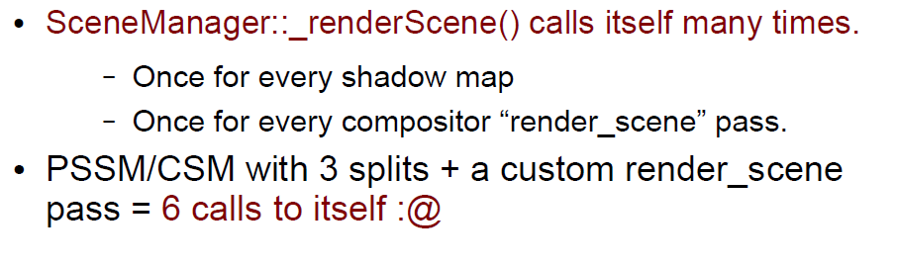

Below is a debug profile in MiniCraft, when disable all compositors, _renderScene() would be executed 2 times, but terribly increasing to ~10 with all compositors(that is, 3 post effect) on.This should be optimized on my own at some time!

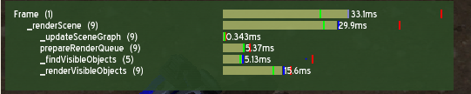

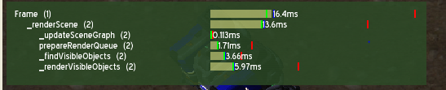

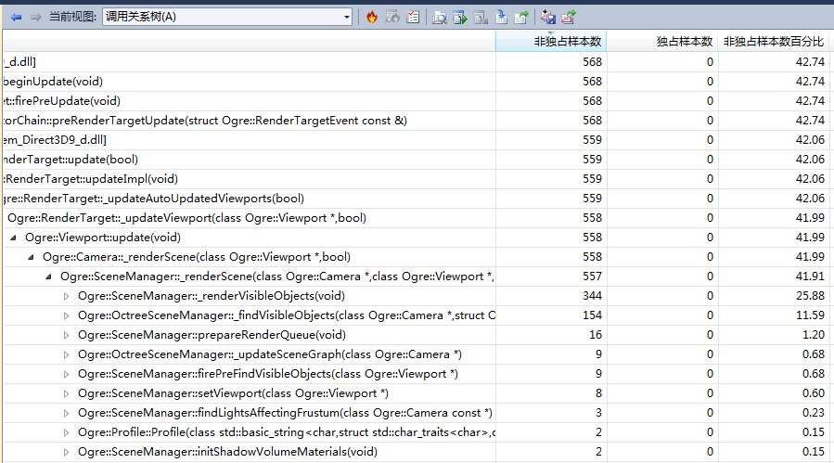

1. Recast updating procedure is a huge monster too.

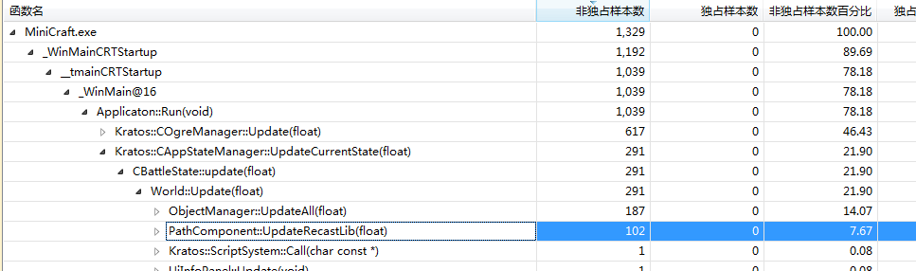

Totally 18 agents in this test, that is not much, considering SC2’s hundreds of units, though Recast says it support at most 100 agents.

1. We certainly know that scene query should be guilty. With 18 units, EACH ONE would use octree tree scene query to find if there’s any target enemies EACH FRAME.

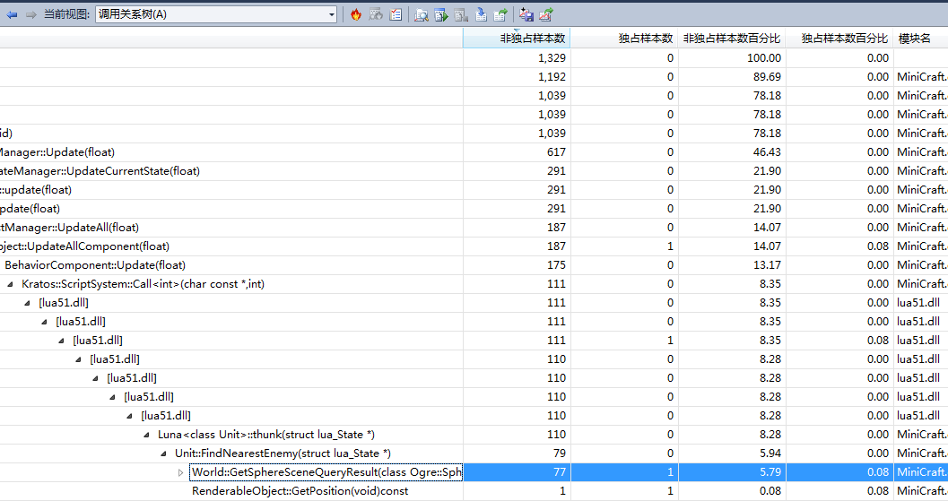

1. D3D shader compiler problem. It takes a long time to compiler all d3d shaders at app initiation time. Consider to use offline precompiler method.

<http://www.ogre3d.org/forums/viewtopic.php?f=1&t=62044>

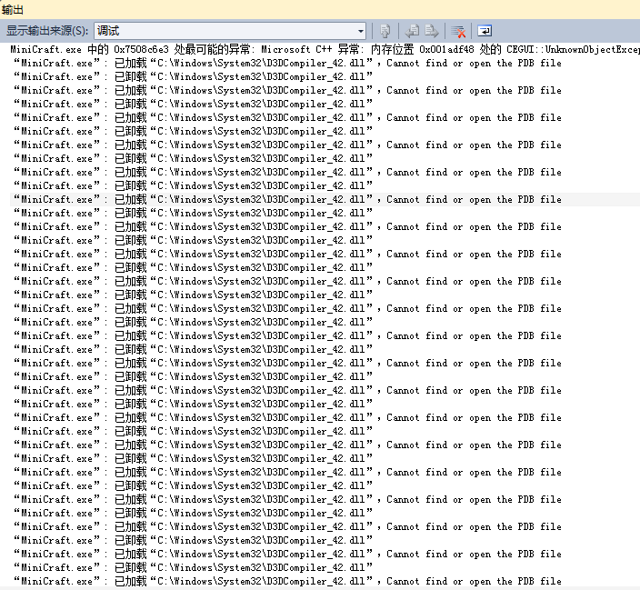

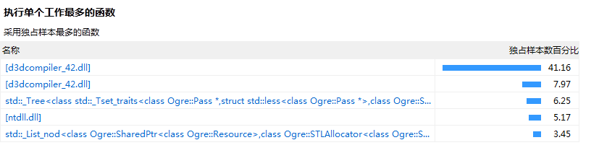

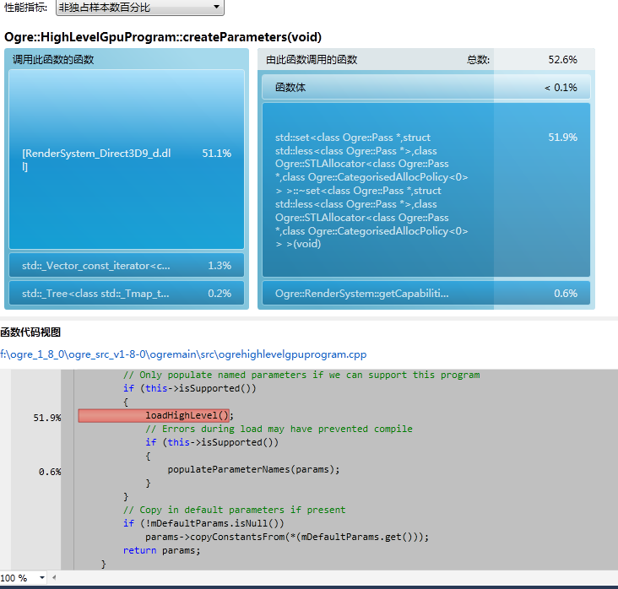

1. Here is my test for SW skinning and HW skinning (100 units, same animation, release mode, DX9 with no instancing):

HW:

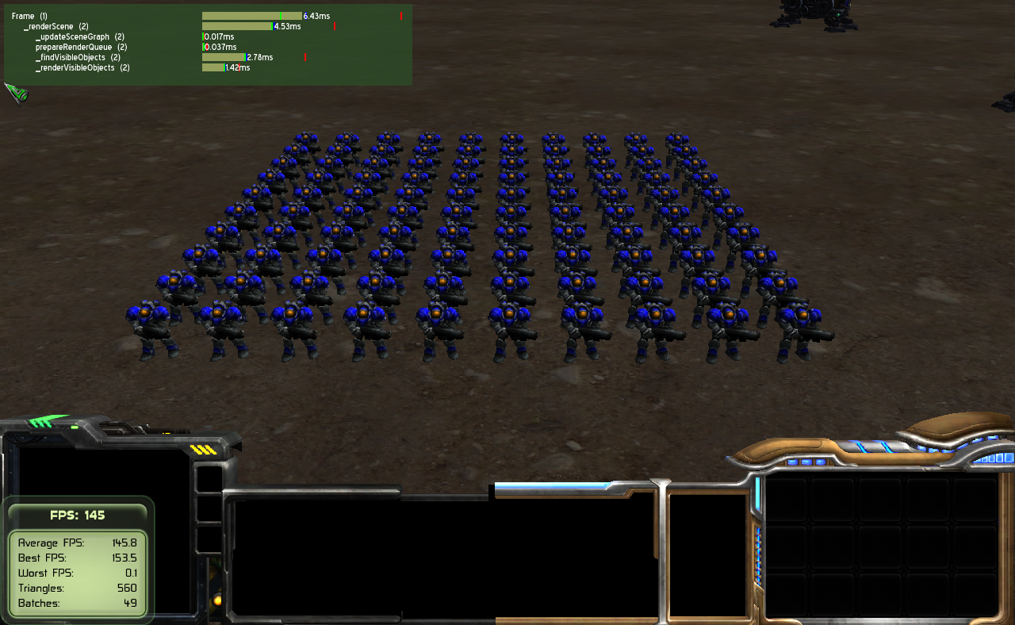

SW:

