O2C · TIME MODULE · FOR REVIEW

Scope and integration
What the module does, what it deliberately does not do, every piece of data fetched live from Oracle Fusion as a screen loads, how time is prepopulated, the complete status and flag model, exactly what is posted back to Oracle Project Costing, and the end-to-end flow with every status transition.
Version 2.0 | Prepared 05-Aug-2026 | Source: REQ-PACK-TIME-001 v0.3 | Branch O2C_Time_Integration

Scope
Oracle Time & Labor is being replaced for project time capture and approval. Oracle remains the system of record for costing: we capture and approve time, then post approved hours to Project Costing.

In scope
- All reference data read live from Fusion at page load — project, POET, task, allocation, rate, work schedule, shift pattern, calendar and absence (§2).
- Time capture — day-wise entry per project and WBS task, multiple lines per day, quarter-hour granularity.
- Prepopulation from allocation percentage and from approved absences (§3.1).
- Approval — day, week and project-month, with reason and remarks on rejection, and an undo for a decision taken by mistake.
- Manager override of hours with the employee’s original value retained.
- Retro adjustments on a closed month, as a matched reversal and re-entry.
- Cut-off enforcement — weekly (employee) and delivery (manager), with automatic defaulting at each.
- Leave-loss / cover identification for absence on billable allocation.
- Month confirmation to the O2C accrual interface.
- Post to Oracle Project Costing via unprocessedProjectCosts (§4).
- Own sign-in and roles — employee, contractor, manager, finance administrator.

Out of scope
- Payroll — entirely out of scope. No hours are transferred to Global Payroll, nothing is written to elementEntries, no Payroll Time Type is resolved and no payroll reference data is read.
- Salary hold — removed from scope for now. The module does not signal, hold or release anyone’s pay. A week that missed the weekly cut-off is still marked Defaulted and locked, and DEFAULTED_BY still records whether the employee or the manager missed it — but nothing downstream follows from that.
- Daily and monthly scheduled sync — out of scope. There is no batch extract and no staged copy of Fusion data. Everything is fetched when a screen needs it. The existing extract feature is being removed (§2.3).
- Invoice generation and revenue calculation.
- Writing to Project Costing beyond the unprocessed-cost post — costing, burdening and accounting stay Oracle’s.
- Absence creation. Absences are read from Absence Management and shown read-only; never created or amended here.
- Calendar and shift authoring. Read from Fusion; no maintenance screen.
- Period control screen. Periods and cut-offs are reference data, exposed read-only.
- Mobile — phase 2.
- Fusion credentials in the browser (NFR-005). The screens do read Fusion live (§2) — what is barred is the client holding a credential to do it. Every call is either made server-side or forwarded by a server-side proxy that attaches the credential, so nothing secret reaches the browser. Which of those two, see §2.4.
- Timesheet upload (CSV in). Download exists; upload is on hold by decision.
Under discussion — independence from OTL. Whether this module should be fully independent of Oracle Time & Labor, or continue to interoperate with it, is not yet decided. The build reflects that: the push of approved time into OTL exists in the design but is on hold and nothing is sent (§3.5). The Project Costing post in §4 does not depend on OTL either way, so the decision can be taken without reworking it.

Inbound integration — everything live from Fusion
One mechanism, not two. All reference data is fetched from Fusion at the point the screen needs it, by REST where a REST resource exists and by a direct BIP report call over SOAP where it does not. Nothing is extracted to a local copy first and nothing is read from a staged table.

2.1 What is fetched, and why
# | Data | Source | What it is, and why we need it
INT-002 | Projects the person may charge to | GET /fscmRestApi/…/projectLaborResources  GET …/projects | The projects a person is a labour resource on, with number, name, customer and project manager. Why: it is the Project picker, and the project manager on it is who the week routes to for approval. Live, so a new assignment is chargeable the same day.
INT-002 | Tasks / WBS and chargeability | GET …/projects/{ProjectId}/child/Tasks  GET …/projectFinancialTasks | The task breakdown under a project, and whether each task is chargeable and billable. Why: hours are booked against a task, not a project — the task is the “T” of POET and decides whether the time is billable.
INT-002 | POET completion — expenditure type and expenditure organization | GET …/expenditureTypes  expenditure organization from the person’s assignment | Expenditure type classifies the work for costing; expenditure organization is the unit that incurs the cost. Why: Project Costing rejects a cost whose POET is incomplete. Without these two nothing can be posted at all.
INT-003 | Allocation / assignment | GET …/projectResourceAssignments  GET …/personAssignmentLaborSchedules | Who is assigned to which project, at what percentage, over which dates. Why: the allocation percentage is what the timesheet is prepopulated from, it drives the “My allocation” panel, and it decides whose time a given manager sees. personAssignmentLaborSchedules is additionally the only source of a per-POET percentage split.
INT-010 | Rate — cost and bill rate | GET …/rateSchedules | The rate schedule that applies to the resource on the project. Why: needed to value hours for the accrual figure. Not sent to Costing — Oracle applies its own rates — so this is for our own reporting, and reading it live avoids holding a stale rate over a rate change.
INT-004 | Work schedule and shift pattern | GET /hcmRestApi/…/workforceScheduleDefinitions, …/workforceScheduleShifts  BIP runReport where REST cannot answer — see 2.2 | The shift a person works on a given day, the pattern behind it, and the standard hours it implies. Why: the read-only Shift row on the timesheet, and the standard hours per day that prepopulation multiplies by the allocation percentage. Without it every seeded figure is wrong.
INT-005 | Calendar by location and calendar events | Calendar events / work-schedule exceptions  BIP runReport | Public holidays and non-working days for the person’s location, and dated calendar events. Why: a non-working day is not prepopulated and is tinted on the grid; a holiday in one location is a working day in another, so this must be resolved per person, not globally.
INT-006 | Absence  for the person, for the dates on screen | GET /hcmRestApi/…/absences  filtered by person and by the date range being viewed | Approved absence per person per date, with type and duration. Why: leave appears as read-only hours so the week reconciles to standard hours, and absence on a billable allocation is what triggers leave-loss. The query must be keyed on the person and the date. A scheduled extract cannot answer “is this person on leave on this date” for a date it did not cover, and leave is booked continuously — so a copied answer is wrong for exactly the days a timesheet is about.

2.2 REST or BIP — how each call is made
The choice is not a preference. Where Fusion exposes a REST resource that answers the question, we call it. Where it does not, we call the BIP report directly — SOAP runReport against ExternalReportWSSService, response decoded and used immediately. A BIP report called live is still a live read; what is being removed is the extract-to-a-table-and-read-it-later pattern, not BIP itself.
Oracle’s own REST documentation states that a person’s assigned work schedule is not a first-class REST resource, so the work-schedule and shift-pattern reads are the ones most likely to need BIP. The delivered views HTS_WORKERS_WITH_SHIFTS_V and HTS_SCHEDULES_DAY_SHIFT_VIEW already return the worker × day × shift shape the grid needs.

2.3 What is being removed
The current build extracts Fusion master data on a schedule into local cache tables and reads those. That feature is being removed. No daily sync, no monthly master sync, no staged copy.
Three consequences to confirm before build.(a) Prepopulation moves from a monthly batch to page load. Today a scheduled job builds every employee’s month in advance by walking the cached allocations. With no cache there is nothing to walk, so the week must be built when the employee first opens it. That is consistent with fetching as needed, and it means opening a month for the first time is slower than opening it again. (b) Fusion availability becomes a hard dependency. With a cache, a pod outage was invisible to the employee. Without one, a timesheet cannot be opened while Fusion is unreachable. Whether that is acceptable is a business call. (c) Sign-in still needs to know who people are. Identity, the manager hierarchy and the finance-administrator login are not in the list above, and sign-in cannot wait on a Fusion round trip — the administrator is a real login who need not exist as a worker in HCM at all. A decision is needed on whether worker identity remains local.

2.4 Where the call is made from — open
Two placements satisfy the constraint above, and they are not equivalent.
Placement | What it gives | What it costs
From the page, through the server-side proxy | Already proven — the Fusion backend is configured and answers today. Nothing new to install, and the credential is attached by the server, never by the client. | Data fetched this way does not pass through the rules in the database, so nothing validates it. Workable only if what the user picked is written back with the entry — which is what the POET snapshot in 3.1 does.
From the database, server-side | One path for screens, defaulting and validation alike; every rule keeps working unchanged. | Requires outbound HTTPS from the database — a privilege grant and a network rule that have not been requested or proven on this environment. Until they are, this option is not known to be available.

Either satisfies NFR-005. The choice decides how much of the rule enforcement can stay in the database, so it should be settled before the live reads are built — open item 22.

The time module — prepopulation, status and flags

3.1 What is prepopulated, how, and when
Two passes, in this order, when the month is opened.

Pass 1 — allocated project time
Step | Rule
Skip the day | if it is a non-working day for that person’s location — weekend or holiday. Nothing is seeded, not even a zero. Saturday and Sunday still appear as blank, enterable cells.
Hours | standard hours for that day × allocation % ÷ 100, rounded to the nearest quarter hour. A null allocation percentage is treated as 100. An 8-hour day at 50% seeds 4.00.
Task | the project’s first chargeable WBS task in sort order — see the question below. If the project has none, nothing is seeded for that allocation and the reason is recorded as an exception, visible rather than silent.
Marking | the row is stamped SOURCE = 'Prepopulated' and ENTRY_TYPE = 'Actual'.
Idempotent | an existing row for the same week × project × task × day is never overwritten, so re-opening a month never destroys typed hours.

Question for functional — how should hours spread across tasks? A project has four chargeable tasks and the person is allocated 100%.
What the build does today: it seeds one line only — the first chargeable WBS task in sort order — carrying the whole apportioned figure. On an 8-hour day that is 8.00 against one task, not 2.00 against each of four. Allocation percentage apportions between projects, never between tasks within a project, because Fusion holds the allocation per project and it carries no task-level split.
What we need confirmed: is one seeded line correct, with the employee moving hours onto the right tasks themselves — or should the figure be divided across the chargeable tasks? If it should divide, we need the rule for how: evenly, or by a weighting Fusion does not currently supply. Note that personAssignmentLaborSchedules can carry a per-POET percentage split, which is the only place a task-level weighting could legitimately come from.
Our recommendation: keep one line. An evenly divided figure looks authoritative and is almost always wrong, and a wrong number that has been pre-filled is less likely to be corrected than a blank one.

Pass 2 — approved absences
Approved absences are written as read-only leave rows at their own duration, against a common LEAVE task, marked IS_LEAVE = 'Y'. Allocation percentage is not applied — leave is whole. The absence is read live for that person and those dates (§2.1).
The leave row is written into the timesheet rather than merely displayed, because leave hours feed the week total, the leave-loss calculation and the accrual figures — a display-only overlay would leave all three short.
Open. An entry requires a project, so a leave row must attach to one of the person’s allocations. An employee with no active allocation has nowhere to hang their leave and the row is dropped silently. Needs a rule: the organization project, the last allocation held, or reported as an exception.

Pass 1 also runs at these points
Trigger | What it covers
Employee opens a month | Builds that person’s weeks for that month from data fetched at that moment. The primary path.
Weekly cut-off | An unsubmitted week is auto-submitted with default hours, marked Defaulted, and locked against further employee edits.
Delivery cut-off | A week the manager never decided is marked Defaulted. It is not locked.

The two cut-off runs are the only remaining scheduled work, and they process time already captured rather than fetching reference data. They are independent of each other and of any other job.

3.2 Status — one set, one flow
Six statuses, and the same six everywhere. There is not a separate scheme for a day, a week and a month — whichever you are looking at, it is in exactly one of these.
Status | Means
Not yet submitted | with the employee; still theirs to change
Submitted | with the manager, awaiting a decision; frozen to the employee
Approved | decided and accepted
Rejected | sent back with a reason; with the employee again
Defaulted | a cut-off filled it in because nobody did
Overridden and approved | the manager changed the hours and accepted them

The same six describe a single date, a week, or a whole month — the transitions do not change with the level. Approving one date and approving a week are the same transition applied to a different amount of the timesheet, which is why there is one flow in 7.2 rather than three.
Month confirmation is not a seventh status. Confirming a month is an event, recorded once in OC_TS_MONTH_CONFIRM together with how it was confirmed — normally, as an advance closure, or after being reopened. It leaves the weeks Approved. Anything needing to know whether a month has gone out should ask that table, not read it off a status.
“Closed” is gone. The model ends at Approved. This is a build change as well as a documentation one — the value is still permitted by a database constraint and still written by the confirm step, and both need amending (open item 7).
The schema still holds these separately. There are distinct columns for the week, the day, the month and a retro adjustment, each with its own permitted values, and the adjustment’s list is worded differently again. Presenting one common set is right for reading and reviewing; making the schema agree with it is a separate change — open item 21.

3.3 Flags
A flag is not a status. Status is where the record has got to; a flag records something that happened on the way and stays true afterwards. Any number apply at once, and a record is never in a flag.
Flag | Column | Set by | Meaning
Defaulted | DEFAULTED_FLAG  DEFAULTED_BY  LOCKED_FLAG | the two cut-off runs | Hours were filled in by a cut-off run rather than by a person. DEFAULTED_BY distinguishes EMPLOYEE — missed the weekly cut-off, which locks the week against further employee edits — from MANAGER, missed the delivery cut-off, which does not lock. The lock is a property of this flag, not a flag of its own. The distinction is kept because it records whose deadline passed, which the audit needs regardless.
Late submission | LATE_SUBMISSION_FLAG | submit, when past the cut-off | The week arrived after the cut-off. A flag, not a status — the week is still Submitted. Never cleared: revoking or resubmitting does not un-happen it.
Advance closure | ADVANCE_CLOSURE_FLAG | advance approval of a future month | The month was closed ahead of its cut-off; defaulted hours in it are treated as approved.
Overridden & approved | OVERRIDDEN_FLAG | manager override | A manager changed the hours and approved them. The employee’s original value is retained in the audit trail. Also a status — see 3.4.
Reversal | HAS_REVERSAL_FLAG | derived automatically | The week contains at least one negative reversal row. Recomputed from the entries, never set by hand.
Adjustment | HAS_ADJUSTMENT_FLAG | derived automatically | The week contains at least one retro adjustment row. Same derivation.

Six flags, and the diagram in 7 shows which event raises each. There is no separate “Locked” flag — locking is what a submitter-side Defaulted does.

3.4 How status and flag relate
- Orthogonal. One status, many flags. A week can be Submitted + Late submission + Adjustment simultaneously.
- Two values are both.Defaulted and Overridden and approved appear as a status and as a flag. The status says what it is now; the flag says it happened at all and survives a later transition — something defaulted and then approved reads Approved with the defaulted flag still set. Whether to keep this duplication is an open item.
- Precedence, when only one label can be shown. The accrual interface and the chips on screen must pick one. Most specific first: row is a Reversal → row is an Adjustment → Advance closure → Overridden & approved → Defaulted → Late submission → none.

Where it is stored
Table | Holds
OC_TS_WEEK | status and all six flags for a week, DEFAULTED_BY, LOCKED_FLAG, submit and approve stamps, reject reason and remarks
OC_TS_ENTRY | status for a single date, from the same set; ENTRY_TYPE (Actual · Default · Reversal · Adjustment), which the reversal and adjustment flags are derived from; IS_LEAVE; SOURCE; the POET as charged
OC_TS_APPROVAL | the decision trail — one row per event: Submit · Resubmit · Approve · Reject · Override · AdvanceApprove · Confirm · Default · Release · Revoke, with actor, granularity and timestamp
OC_TS_AUDIT | value changes with the before-image — Override · Adjustment · Reversal · ManagerEdit · Import · DefaultCorrection
OC_TS_MONTH_CONFIRM | the project-month confirmation and the outbound statuses in 3.5
OC_TS_ADJUSTMENT | retro adjustment lifecycle

Rejection carries a reason — Manager, Client or Absence — and it is mandatory, enforced by a database constraint rather than by the screen. Remarks are free text.

3.5 Outbound destination status
Held on OC_TS_MONTH_CONFIRM, one column per destination, each taking Pending · Success · Failed · Skipped. They are separate on purpose: the destinations fail independently, and a single combined column loses which one needs attention.
Column | Destination | State
ACCRUAL_STATUS | The O2C accrual interface table. The consumer reads from it. | Live. Filled on month confirm.
PARTNER_STATUS | A staging table in our own schema that the accrual module pulls from. It holds three things for a confirmed month: the summary, the complete timesheet employee-wise, and any adjustments. We write it; accrual reads it. Nothing is pushed into accrual’s tables. | Structure pending. The accrual side is defining the shape and that work is in progress, so the columns are not fixed yet. The direct push that previously occupied this column is superseded — see the note below.
OTL_STATUS | Oracle Time & Labor — the push of approved time into OTL. | On hold. Nothing is sent and the column stays Pending. Held pending the decision on independence from OTL (§1). The Project Costing post in §4 does not go through OTL, so time still reaches costing while this is on hold.

This replaces a push with a pull, and most of it already exists.PARTNER_STATUS used to track a direct hand-off that wrote into the main O2C application’s accrual tables. That is superseded: accrual will pull from a table in our schema instead.
Worth knowing before the structure is agreed — the interface behind ACCRUAL_STATUS is already a pull, already day-wise and never rolled up, already carries the Reversal and Adjustment rows with a link back to the adjustment they came from, and already has the claim-a-batch-once bookkeeping a puller needs. So of the three things required, the complete timesheet and the adjustments are in place in some form. The genuine gap is the summary grain — that table holds day rows only.
Which raises the question to settle before the accrual side finalises anything: is this one interface or two? If accrual pulls everything from one place, then ACCRUAL_STATUS and PARTNER_STATUS are tracking the same hand-off and should collapse into one column. If they stay separate, the split needs to be deliberate — for example summary against one and detail against the other — rather than an accident of the push having been replaced. Two pull interfaces for one consumer, filled by the same confirm step, is the shape most likely to drift apart.

What is sent to Oracle Project Costing
Approved hours are posted directly by REST to the Unprocessed Project Costs resource. This supersedes the earlier assumption that costing could only be reached by a scheduled transfer process: the resource accepts a third-party cost by POST, and Fusion’s Import Costs program then turns unprocessed costs into project costs.
POST /fscmRestApi/resources/11.13.18.05/unprocessedProjectCosts

4.1 What we send, and where it comes from
One row per approved entry. POET travels in the ProjectStandardCostCollectionFlexfields child block.
Fusion field | Req | From
BusinessUnitId | yes | the project’s business unit
ExpenditureBatch | yes | generated per confirmed project-month, so a batch is traceable to one confirmation
OriginalTransactionReference | yes | our entry id. The idempotency key — it is what makes a re-post identifiable rather than duplicated
Quantity | yes | the approved hours on the entry
PersonNumber | — | employee id
TransactionSource | — | a third-party source registered in Fusion for this module
TransactionCurrencyCode | — | project currency
… ProjectStandardCostCollectionFlexfields — the POET block
_PROJECT_ID_Display | — | P — project, from the entry
_TASK_ID_Display | — | T — WBS task, from the entry
_EXPENDITURE_TYPE_ID_Display | — | E — expenditure type
_ORGANIZATION_ID_Display | — | O — expenditure organization
_EXPENDITURE_ITEM_DATE | — | the entry date — the day the work happened, not the day it was posted

4.2 What is not sent
- Leave. Rows marked IS_LEAVE = 'Y' are excluded. Absences originate in Absence Management, which already reaches costing — posting them here would double-count.
- Unapproved hours. Only entries whose status is Approved, in a month that has been confirmed.
- Cost and bill rates. We send quantity; Oracle applies rates and burdening.
- Anything to payroll, per §1.

4.3 Reversals and adjustments
A retro adjustment is a matched pair — a negative reversal of the original day and a positive re-entry. Both post as ordinary rows, the negative carrying ReversedOriginalTransactionReference pointing at the entry it offsets. Hours are signed throughout, so the recipient can sum and get the net position with no sign logic.

4.4 Confirming it landed
- POST returns UnprocessedTransactionReferenceId and StatusCode = 'P' (pending).
- Fusion’s Import Costs program converts them to project costs.
- GET …?q=StatusCode='R'&expand=Errors lists rejections with the reason.
- PATCH to correct a rejected row, or DELETE to discard it, then re-process.
Step 3 needs a home: rejections surface in Fusion and somebody has to see them. Recommended — a scheduled read of rejected rows written back to the module, so the Accrual Integration screen shows a failed post instead of it being silently lost.

Open items
# | Item | Needed from
1 | Independence from OTL — decide. The OTL push is on hold meanwhile (§1, §3.5). | functional decision
2 | Task-level spread of prepopulated hours — one line, or divided across chargeable tasks? (§3.1) | functional decision
3 | Whether worker identity stays local now the extract is removed — sign-in cannot wait on Fusion, and the finance administrator is not a worker in HCM (§2.3c) | functional decision
4 | Fusion availability — with no cache, a pod outage stops a timesheet being opened. Acceptable? (§2.3b) | business decision
5 | Where a leave row attaches for an employee with no active allocation — today dropped silently (§3.1) | functional decision
6 | Concurrent 100% allocations on two projects seed 16h/day, uncapped until the 24-hour day rule — correct in Fusion, or cap in the module? | functional decision
7 | Remove Closed from the status set — the database constraint and the confirm step both still use it (§3.2) | build
8 | Keep Defaulted / Overridden as both status and flag, or collapse? | functional decision
9 | Third-party transaction source registered in Fusion, and the ExpenditureBatch naming agreed | Fusion configuration
10 | Expenditure type per project confirmed — this pod has no per-task transaction controls, so one configured value applies to everything | functional decision
11 | Whether a Defaulted week may be confirmed — currently blocked; advance closure is the stated exception | functional decision
12 | Fusion PersonId / AssignmentNumber available to the module — needed for any absence or OTL call keyed on the person | build
13 | “Time Card Required” eligibility read and enforced | functional + build
14 | Rejected-cost read-back so a failed post is visible (§4.4) | build
15 | Period auto-close has no job | build
16 | Session token strengthening before production | build — one line and a grant
17 | Where REVENUE_MODEL and LEAVE_LOSS_FLAG come from — neither is read from Fusion and both are null today, so leave-loss cannot fire for any project (§6.1) | functional decision
18 | Test data prepared for each revenue model — T&M, FCP with and without leave loss, Milestone (§6) — agreed, functional team owns this | functional team — agreed
19 | Structure of the accrual staging table — summary, complete timesheet employee-wise and adjustments, in our schema for accrual to pull (§3.5, §7.3). Being defined on the accrual side, work in progress. | accrual team — then build
20 | One accrual interface or two? The existing interface is already a day-wise pull carrying adjustments, so ACCRUAL_STATUS and PARTNER_STATUS may be tracking the same hand-off. Decide before the structure is fixed (§3.5). | functional + accrual team
21 | Make the schema match the single status set — the week, day, month and retro-adjustment statuses are separate columns with different permitted values today (§3.2) | build
22 | Where the live Fusion call is made from — the page through the server-side proxy, or the database (§2.4). Decides how much rule enforcement can stay in the database; the database option needs a privilege grant that has not been proven here. | build decision — needs a spike

Test data preparation, by revenue model
Agreed: the functional team will prepare the data. Every scenario has to be exercised against each revenue model, because the rules that fire are different for each — and today only one model has data behind it at all.

6.1 The three revenue models, and what each has to exercise
Revenue model | What is different about it | Data needed to exercise it
T&M  Time & Material | Hours are the billable unit. The straightforward path: capture, approve, cost. Leave-loss does not apply. | A project with a manager, at least two chargeable WBS tasks, and resources allocated at 100% and at a part percentage. Absence inside the month, to prove leave shows without triggering leave-loss.
FCP  Fixed Capacity | The only model where leave-loss applies. Absence on a billable allocation is a loss of committed capacity, so PROC-006 / RULE-014 fire — and both gate on revenue model and the leave-loss flag together. This is the richest case and the one most likely to be missed. | A project with revenue model = FCPandleave loss = Yes; an allocated resource with an approved absence on a working day; and a second eligible resource available on the same dates, so cover assignment can be exercised. Also a project with FCP but leave loss = No, to prove the rule declines it.
Milestone | Revenue is not driven by hours. Time is still captured, approved and costed, but nothing about the revenue position follows from the hours. | A project with a manager and chargeable tasks, and an allocated resource. Confirms that capture and the cost post behave identically while no revenue rule engages.

The distinction matters because the leave-loss refusal is explicit: coverage applies only to FCP projects with leave loss set to Yes. Test data that is all T&M will never reach that rule, and test data that is all FCP will never prove the rule declines the others.
Blocker to resolve first — the revenue model has no source.REVENUE_MODEL and LEAVE_LOSS_FLAG are commercial attributes this module owns. They are not read from Fusion and never have been — they were deliberately excluded from the old extract as values the module sets itself, and they are null for every project that arrived that way. With the extract removed and all project data now read live from Fusion (§2), these two have no source at all.
So data cannot be “prepared for each revenue model” until we decide where the value lives. Two options:
(a) Map it from a Fusion attribute. The project resource carries user-definable code and text slots (ProjectCode01 onward) which is exactly where a value like this is normally held. One of them is nominated, the functional team populates it per project, and the module reads it with everything else. Preferred: the data then lives with the project, one place, maintained by the people who own the commercial terms.
(b) Keep it local to this module. A small maintained mapping of project number to revenue model and leave-loss flag. Works, but it is a second place to keep current, and a project whose commercial basis changes in Fusion will not change here.
Until one is chosen, leave-loss cannot fire for any project, because the rule requires a value that nothing sets.

End-to-end flow
Three charts, then the same flow stated precisely — a chart cannot show every transition unambiguously and a review has to be able to check each one. Larger versions, with pan, zoom and SVG/PNG export, are in doc/Time_Module_Architecture.html.

Flow 1 — inbound: what is read, and what it feeds
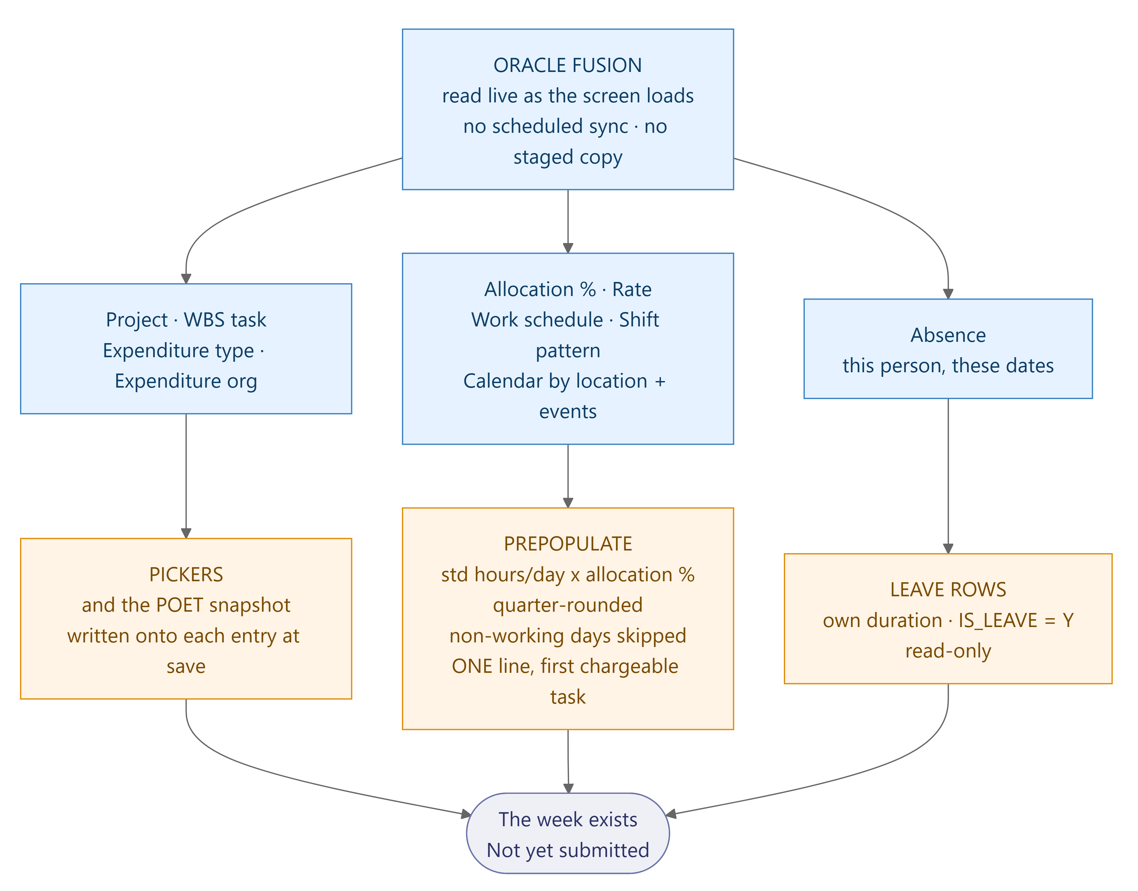
Flow 1 — inbound. Everything read live from Fusion, and what each read feeds.

Lifecycle — status and the flags each event raises
One set of six statuses for everything — there is no separate scheme for a day, a week or a month. Flags are shown against the event that raises them, because a flag is what an event leaves behind, not a place the record sits. Every transition is listed in 7.2.
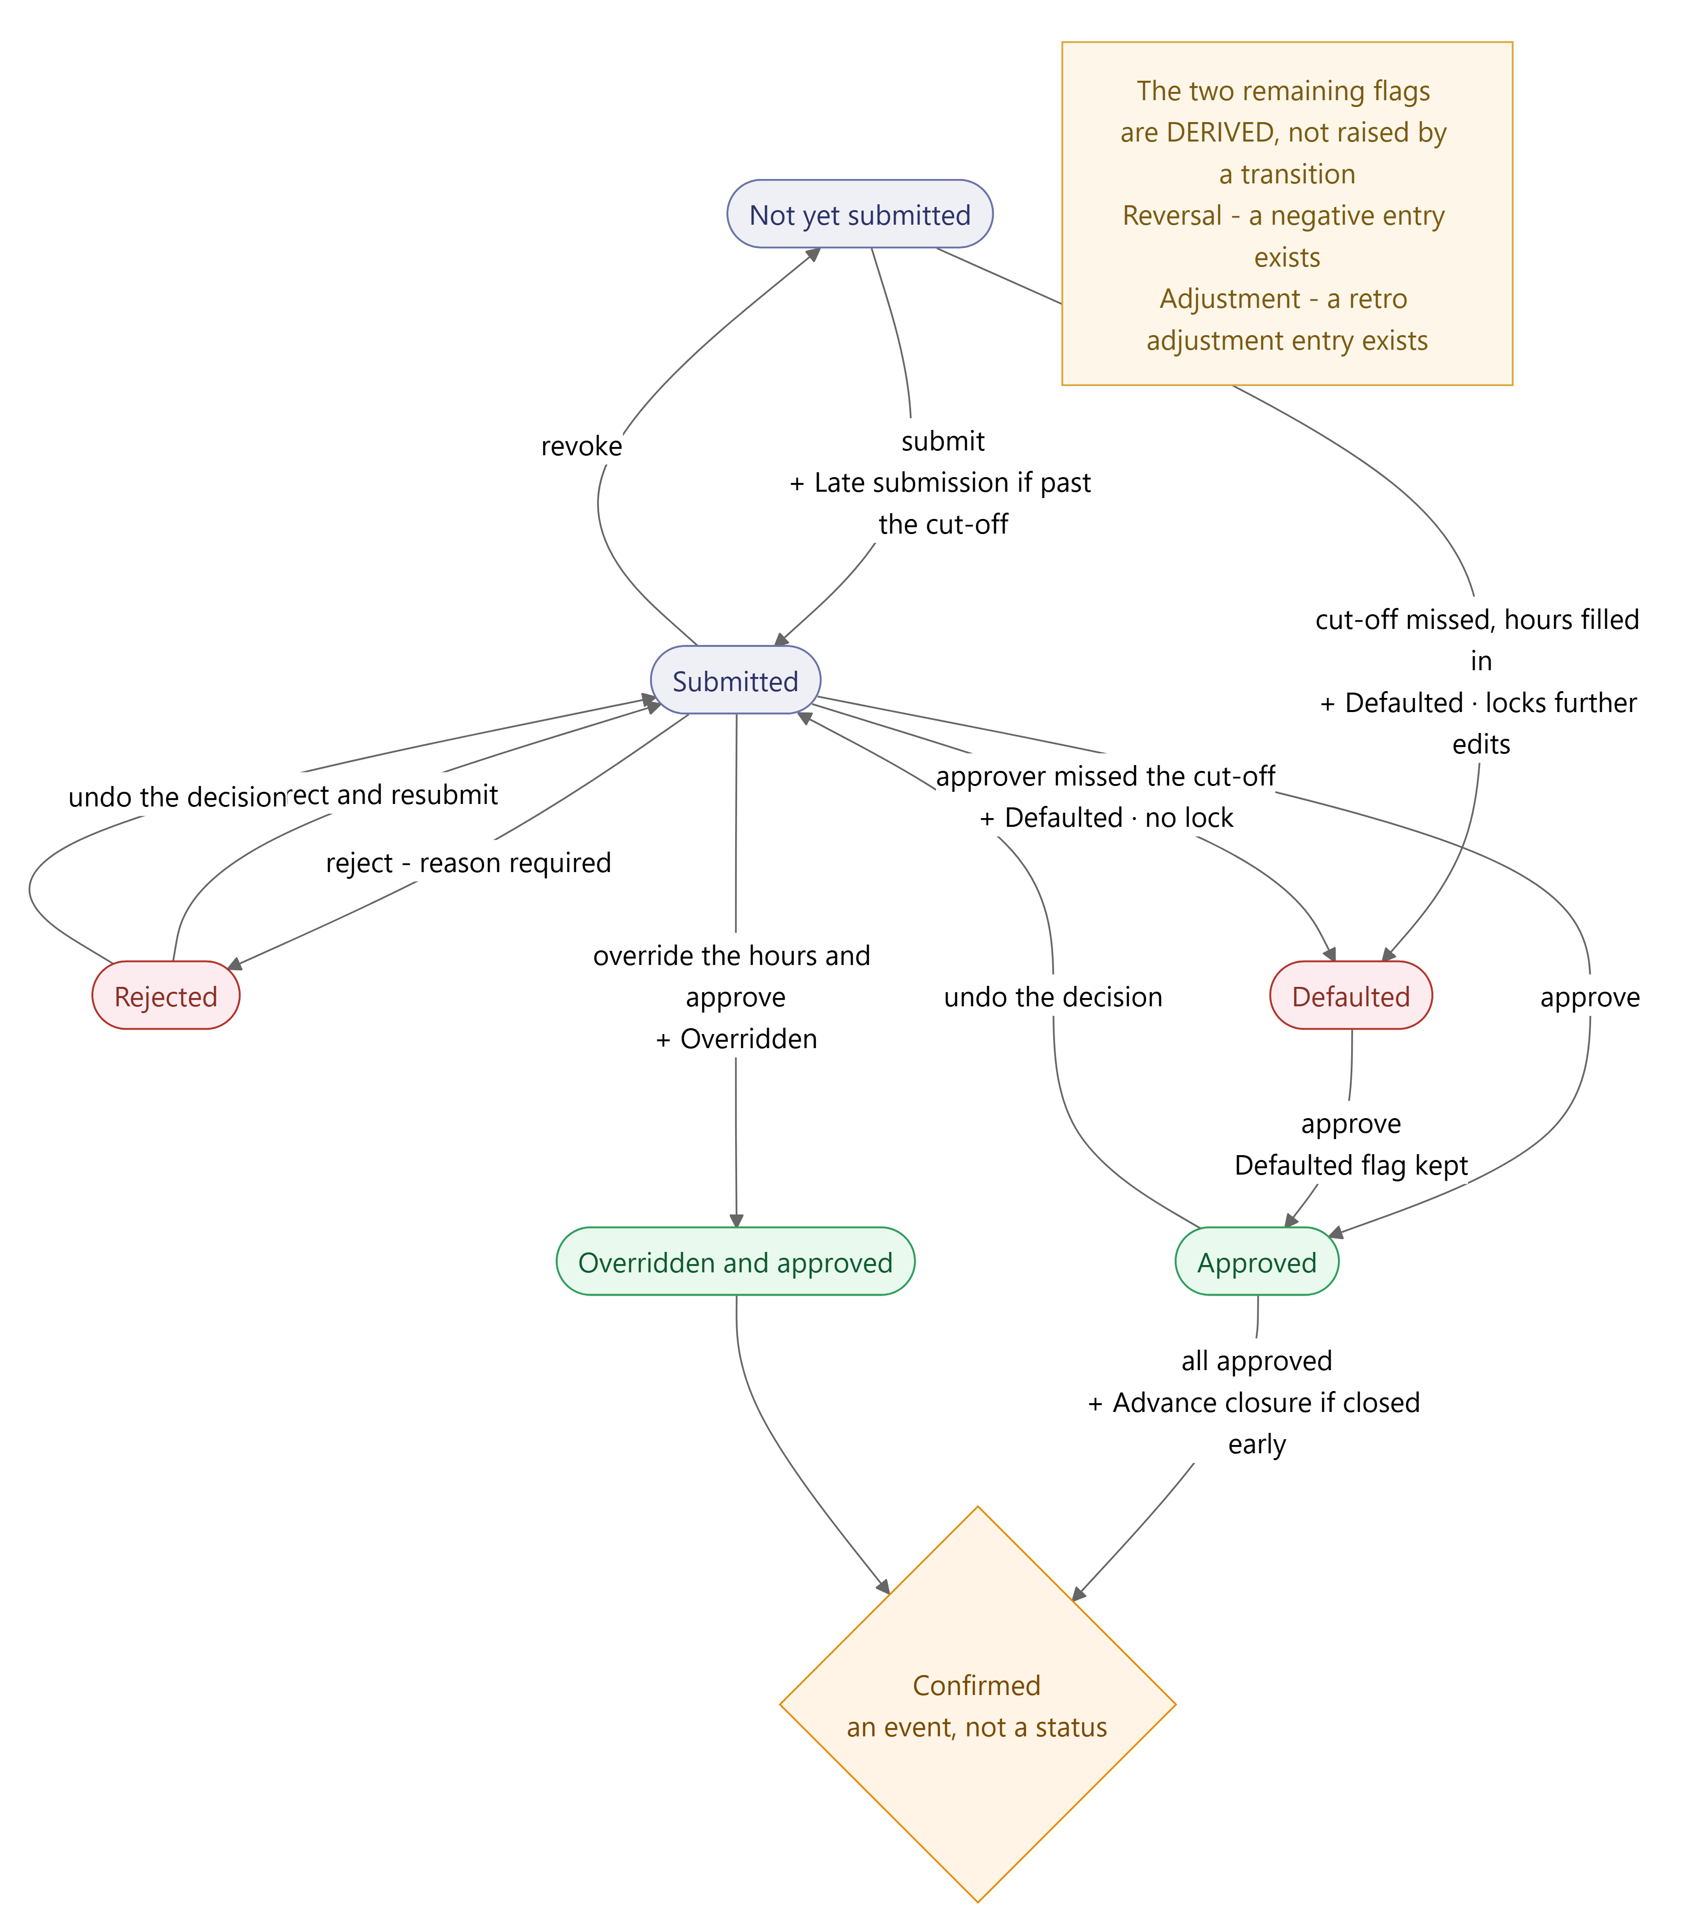
Lifecycle — the six statuses, with the flag each event raises shown on the edge.
The flags each event raises: submitting late raises Late submission; a cut-off raises Defaulted and, if it was the submitter’s deadline, locks further edits; overriding raises Overridden & approved; closing ahead of the cut-off raises Advance closure. Reversal and Adjustment are derived from the entries rather than raised by a transition. Detail in 3.3.

Flow 2 — outbound: what leaves, at which grain, in which order
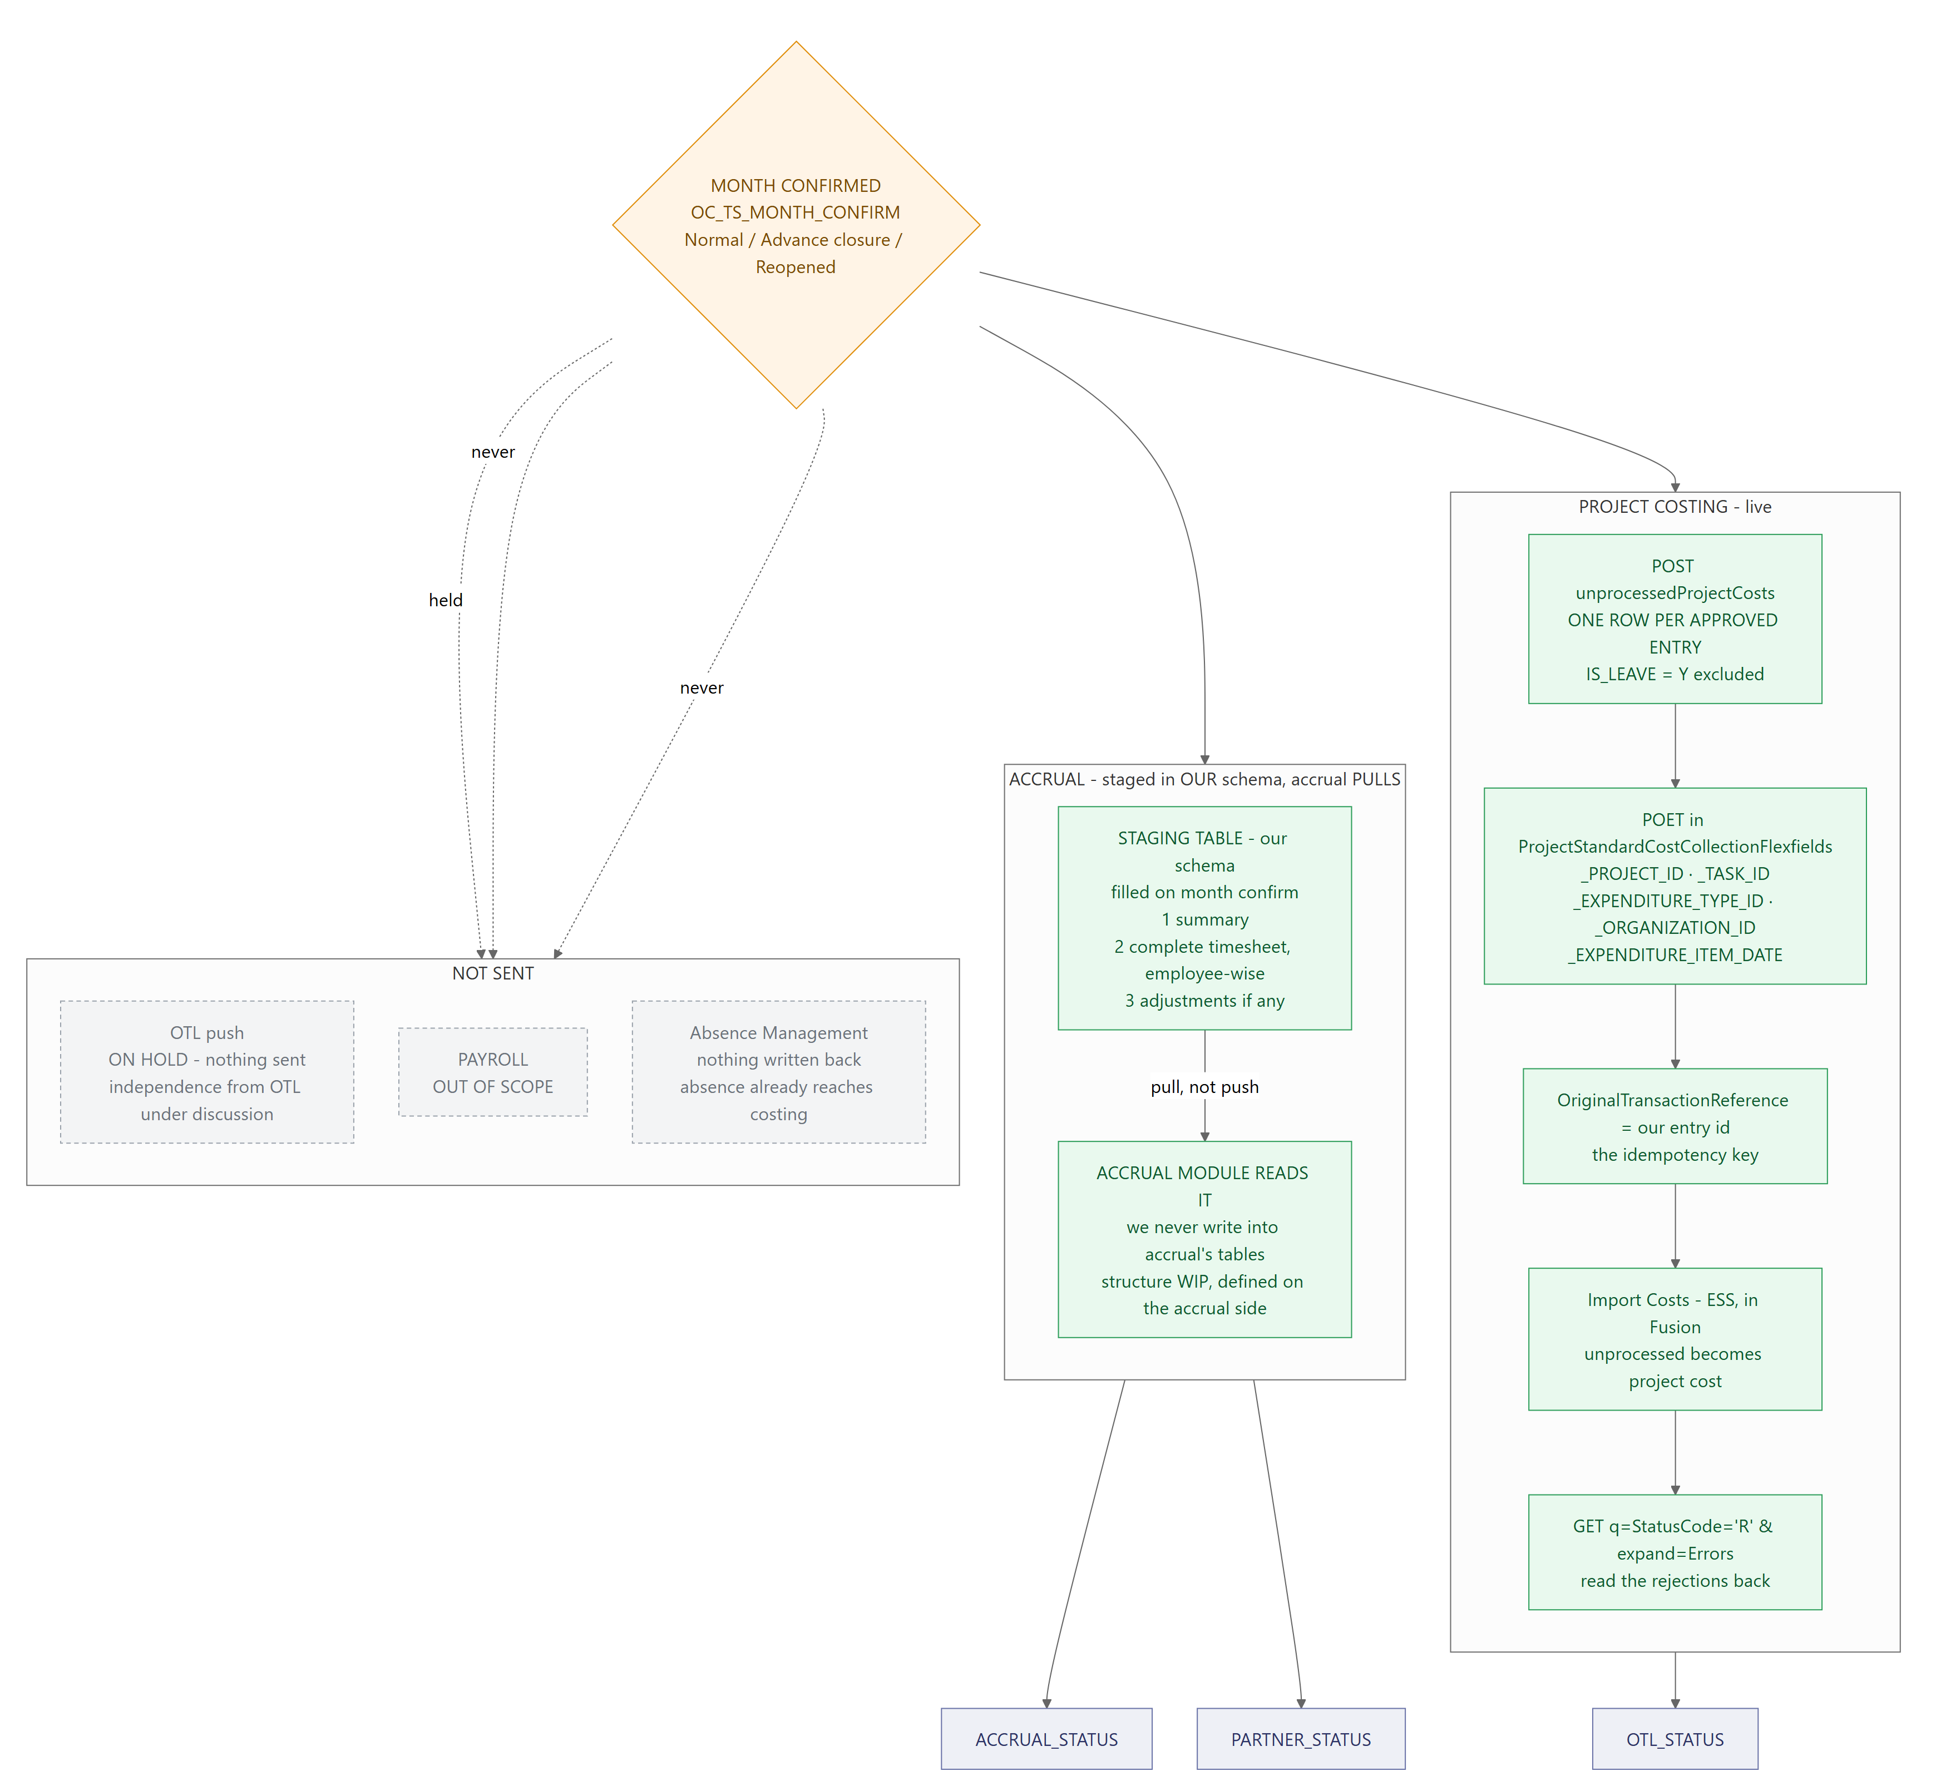
Flow 2 — outbound. What leaves once a month is confirmed, at which grain and in which order.

7.1 Inbound — what is fetched, and what it is used for
Step | Fetched live from Fusion | Used for
1 | Projects the person may charge to | the Project picker; the project manager is the approval route
2 | WBS tasks, chargeable and billable flags | the Task picker; billability of the entry
3 | Expenditure type; expenditure organization from the assignment | completes POET so the cost can be posted at all
4 | Allocation percentage and dates | the multiplier for prepopulation; the “My allocation” panel; whose time a manager sees
5 | Rate schedule | valuing hours for the accrual figure — not sent to Costing
6 | Work schedule and shift pattern | the Shift row; standard hours per day, which every seeded figure depends on
7 | Calendar by location, calendar events | which days are non-working, per person — a holiday in one location is a working day in another
8 | Absence for that person, those dates | read-only leave rows; the trigger for leave-loss on FCP

Then: prepopulate (standard hours × allocation percentage, quarter-rounded, one line on the first chargeable task) → employee edits, with the resolved POET written onto each entry → validate in the database → the week enters the lifecycle below at Not yet submitted.

7.2 Status — every transition
Six statuses, one at a time, the same set at every level. Flags accumulate separately and are shown in the last column.
From | Event | To | Flag effect
Not yet submitted | Employee submits | Submitted | + Late submission if after the weekly cut-off
Not yet submitted | Weekly cut-off job — never submitted | Defaulted | + Defaulted, DEFAULTED_BY = EMPLOYEE; locks the week
Submitted | Manager approves | Approved | —
Submitted | Manager rejects — reason mandatory | Rejected | —
Submitted | Employee revokes their own submission | Not yet submitted | Late submission retained — it did happen
Submitted | Manager overrides the hours and approves | Overridden and approved | + Overridden & approved; original value kept in the audit trail
Submitted | Delivery cut-off job — manager never decided | Defaulted | + Defaulted, DEFAULTED_BY = MANAGER; no lock
Rejected | Employee corrects and resubmits | Submitted | every date in it goes back to awaiting a decision; + Late submission if now past the cut-off
Defaulted | Manager approves | Approved | Defaulted flag kept — it happened
Approved | Manager undoes the decision | Submitted | —
Rejected | Manager undoes the decision | Submitted | —
Approved or Overridden and approved | Month confirmed — RULE-020, every week approved | status unchanged; the month is recorded in OC_TS_MONTH_CONFIRM | + Advance closure if closed ahead of the cut-off

Two transitions are easy to miss and both matter.Rejected → Submitted is the correct-and-resubmit loop, and it puts every date back to awaiting a decision — without that reset the approver could not act on it again. Approved → Submitted is a manager undoing their own decision; it deliberately returns to Submitted and never to Not yet submitted, because the employee did submit and must not be made to send it again.
The same transitions serve a single day. Approving, rejecting or undoing one date uses the rows above — there is no separate day scheme. Two consequences follow from the day and the week sharing them: when every day is approved the week becomes Approved, and any rejected day makes the week Rejected and sends it back. Undoing a day decision recomputes the week from the days that remain.

7.3 Outbound — order and grain
Month confirmation is the single trigger. The two live destinations take different grains, and the accrual pair has an order that is not optional.
# | Destination | Grain | Notes
1 | Project Costing  POST unprocessedProjectCosts | one row per approved entry | POET in the flexfield block; our entry id as OriginalTransactionReference, which is the idempotency key. IS_LEAVE = 'Y' excluded. Fusion’s Import Costs then converts them.
2 | Accrual staging table  in our schema; accrual pulls | three record kinds together: the summary, the complete timesheet employee-wise, and adjustments if any | We fill it on month confirm; the accrual module reads it. Nothing is written into accrual’s own tables. The structure is being defined on the accrual side and is not final — open item 19. See also the note in 3.5 on whether this is one interface or two.
— | OTL push | — | On hold, nothing sent. Costing does not route through OTL, so time still reaches Project Costing while the independence decision is open.
— | Payroll | — | Out of scope.

A Defaulted week currently blocks confirmation, because RULE-020 requires every week to be approved. Advance closure is the stated exception — open item 11.

Supporting detail: doc/Integration_Data_Sourcing_Matrix.md · doc/Time_Module_Architecture.html (data-flow diagram) · doc/Unprocessed_Project_Costs_REST_API.md (full field schema) · doc/STATUS_AND_FLAG_MODEL.md. A Word copy of this document is at doc/O2C_Time_Scope_and_Integration.docx.

