O2C TIMESHEET MODULE

OIC design — monthly and daily master-data load
A source-independent contract between whatever system holds the people, projects and absences and the tables this module runs its rules on. Oracle Fusion is the source today; the design assumes it will not always be.
09 August 2026 | 7 canonical entities | 8 OIC integrations | 1 blocking decision
Read section 2 first. The "standard format" this design needs already exists in the repository twice, and the two versions disagree on four of the five entities. Whichever one OIC is written against, the other silently loses fields. That has to be settled before a single integration is built, and it is a half-day decision, not a redesign.

The shape of the design
Four layers. Only the first knows anything about Oracle.
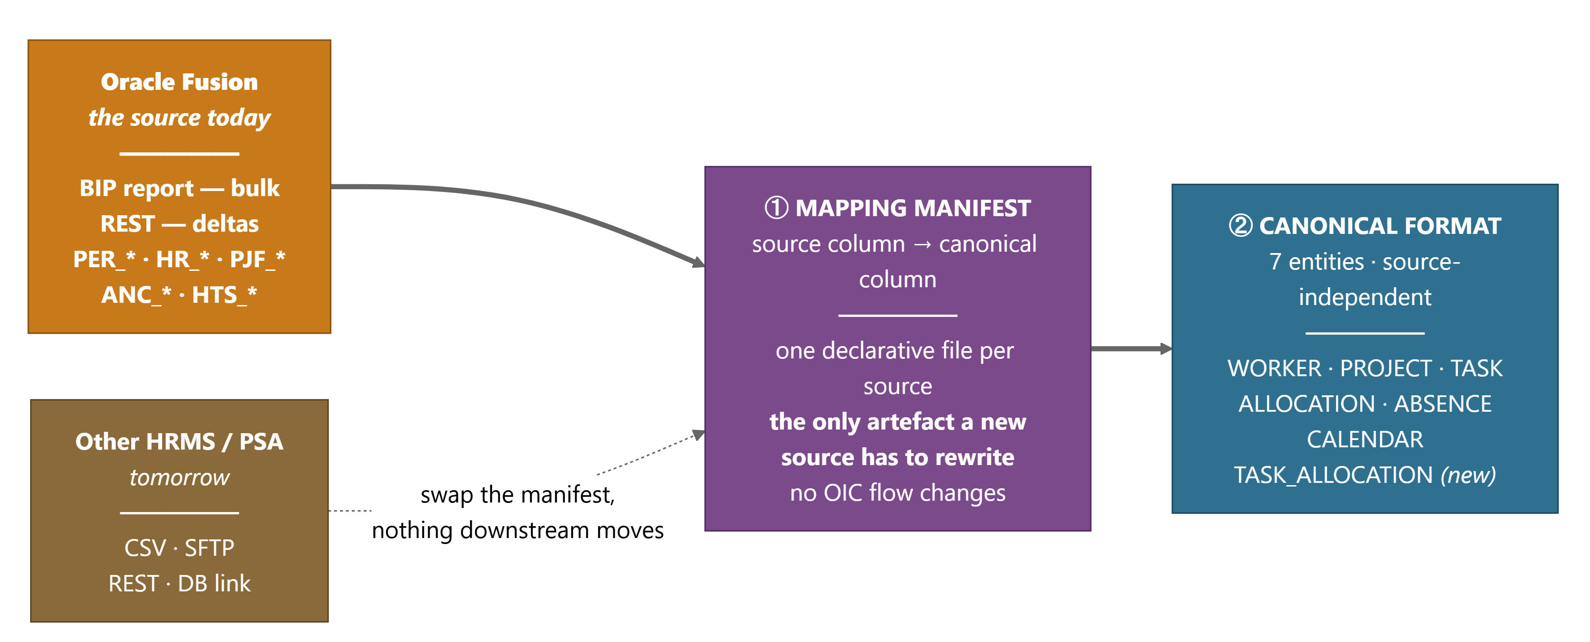
Source independence lives in one artefact — the mapping manifest.
The principle is that the mapping is data, not code. A manifest declares, per entity, which source column feeds which canonical column and what transform applies. Changing source means writing a new manifest and a new extract query. The canonical format, the validation, the loader, the cache and every business rule downstream are untouched.
The alternative — mapping inline inside each OIC integration — is what makes integrations expensive to replace. The source names end up spread across eight flows, and swapping the source means rewriting all eight.
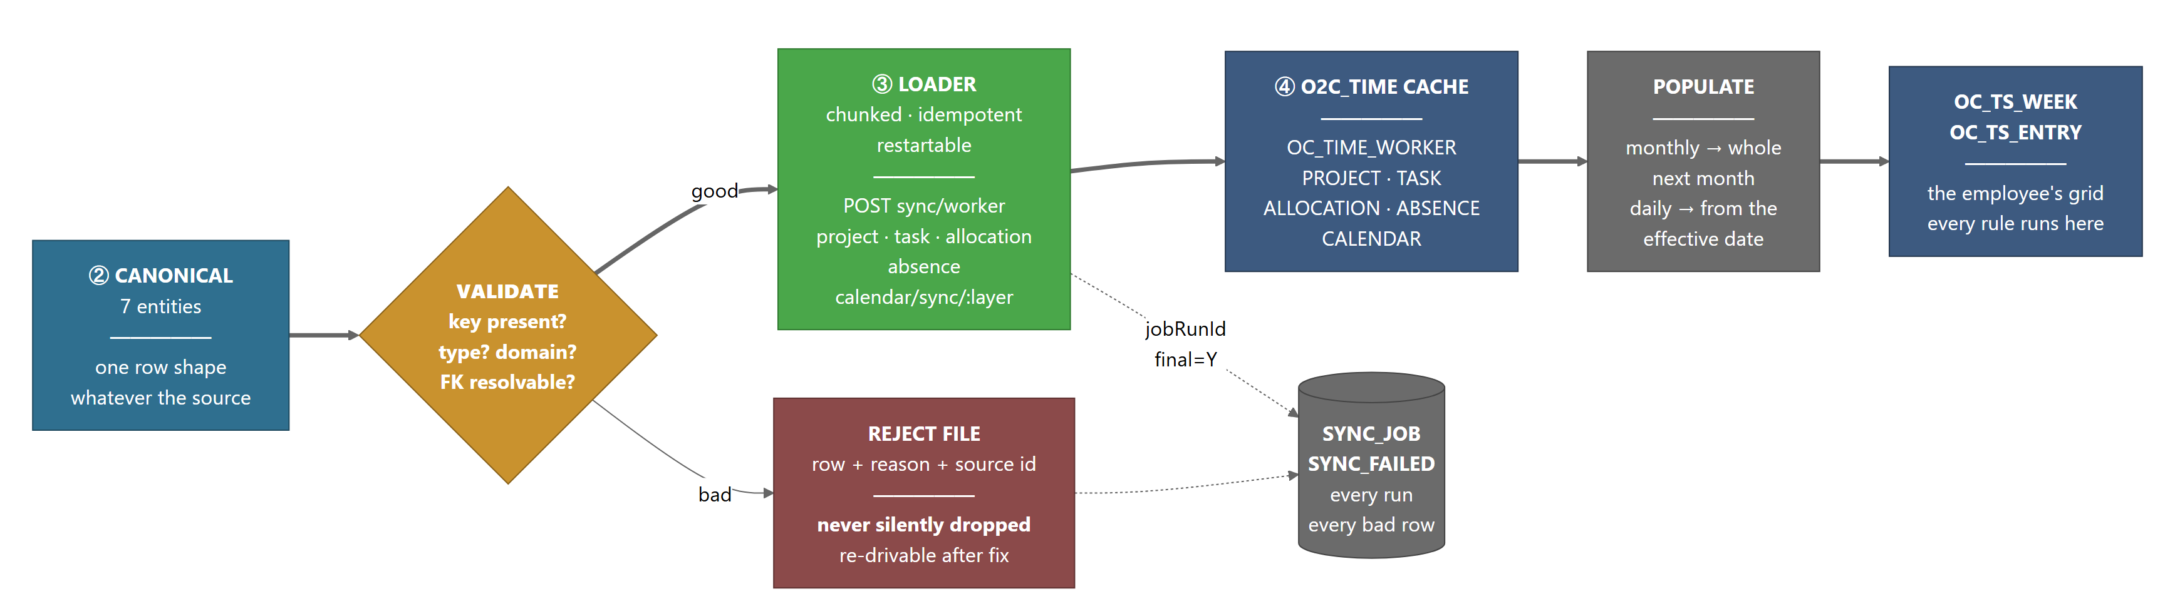
From canonical rows to the employee's grid. The loader is already built.
Layers 3 and 4 exist and work. The ORDS POST sync/* endpoints, the chunking envelope, the job telemetry and the failed-record queue are all in the schema today and have been exercised against the live pod. OIC is not being asked to invent them — it is being asked to feed them.

The blocking finding — there are two contracts, and they disagree
Measured, not asserted. This is the diff between what the extract side produces and what the loader side accepts.
Entity | Extract | Loader | Disagreement
WORKERS | 12 | 12 | identical
PROJECTS | 11 | 9 | extract has PROJECT_TYPE, PROJECT_STATUS, ORGANIZATION; loader has STATUS
TASKS | 12 | 7 | loader ignores PROJECT_ID, WBS_LEVEL, PARENT_TASK_ID, START_DATE, END_DATE
ALLOCATIONS | 9 | 10 | extract has CAP_HOURS, TRACK_TIME_FLAG, STATUS, PROJECT_ID; loader has CLIENT_ROLE, EXPENDITURE_ORG, PO_NUMBER, PO_LINE_NUMBER, PRICE_TYPE
ABSENCES | 6 | 5 | loader ignores ABSENCE_STATUS

ALLOCATIONS is the worst: nine fields on one side, ten on the other, and only five in common. An OIC flow built against the extract shape would post CAP_HOURS and TRACK_TIME_FLAG into a handler that reads neither, and would never populate the five PO and pricing fields the handler is waiting for. Nothing would error. The rows would load and the columns would be null.
There is a second, smaller inconsistency: six endpoints take UPPER_SNAKE field names and calendar/sync/:layer takes camelCase (scopeKey, calDate, isWorkingDay). One convention, please, before anything is generated from the contract.
Recommendation. Take the loader as the authority and correct the extract to match, because the loader is what actually writes the tables and its fields were chosen against the target columns. Then version the result as INBOUND_CONTRACT v1 and make both sides generate from it rather than restate it.

The canonical format
Seven entities. This is the deliverable — the columns a source must supply, whatever the source is.

3.1 Envelope, common to every entity
Field | Meaning
jobRunId | Omit on the first chunk; the loader creates the job and returns it. Pass it back on every later chunk so a multi-chunk load is one job row.
final | Y on the last chunk. Closes the job as Success or Partial.
actor | Who ran it. Lands in CREATED_BY/UPDATED_BY.
traceId | Correlation id, carried through to the failed-record queue.
rows[] | The entity payload below.

3.2 Entity column template
Entity | Natural key | Columns
WORKER  OC_TIME_WORKER  INT-001 | EMPLOYEE_ID | EMPLOYEE_ID, EMPLOYEE_NAME, EMAIL, WORKER_TYPE, BASE_COUNTRY, STD_HOURS_PER_DAY, MANAGER_EMP_ID, LEGAL_EMPLOYER, EXPENDITURE_ORG, HIRE_DATE, TERMINATION_DATE, STATUS
PROJECT  OC_TIME_PROJECT  INT-002 | PROJECT_NUMBER | PROJECT_NUMBER, PROJECT_NAME, PROJECT_ID, CUSTOMER_NAME, PROJECT_MANAGER_ID, TIME_ENTRY_ENABLED, START_DATE, END_DATE, STATUS+ PROJECT_TYPE, ORGANIZATION, REVENUE_MODEL
TASK  OC_TIME_TASK  INT-002 | TASK_ID | PROJECT_NUMBER, TASK_ID, TASK_NUMBER, TASK_NAME, CHARGEABLE_FLAG, BILLABLE_FLAG, EXPENDITURE_TYPE+ WBS_LEVEL, PARENT_TASK_ID, START_DATE, END_DATE
ALLOCATION  OC_TIME_ALLOCATION  INT-003 | PROJECT_NUMBER + EMPLOYEE_ID | PROJECT_NUMBER, EMPLOYEE_ID, ALLOC_PCT, CLIENT_ROLE, EXPENDITURE_ORG, PO_NUMBER, PO_LINE_NUMBER, PRICE_TYPE, START_DATE, END_DATE+ STATUS, TRACK_TIME_FLAG, CAP_HOURS
ABSENCE  OC_TIME_ABSENCE  INT-006 | EMPLOYEE_ID + ABSENCE_DATE + ABSENCE_TYPE | EMPLOYEE_ID, ABSENCE_DATE, ABSENCE_TYPE, DURATION_HOURS, APPROVAL_STATUS+ ABSENCE_STATUS, IS_LOP, IS_MATERNITY
CALENDAR  OC_TIME_CALENDAR  INT-004/005 | LAYER + SCOPE_KEY + CAL_DATE | LAYER(in the URL today), SCOPE_KEY, CAL_DATE, IS_WORKING_DAY, STD_HOURS, HOLIDAY_NAME, SHIFT_CODE
TASK_ALLOCATION  no target table yet | PROJECT_NUMBER + TASK_ID + EMPLOYEE_ID | PROJECT_NUMBER, TASK_ID, EMPLOYEE_ID, ALLOC_PCT, START_DATE, END_DATE — new. Resources are assigned at task level on the current pod and the module has nowhere to put that; prepopulation guesses the first chargeable task instead.

Orange marks a column that exists on one side of the contract and not the other, or that the module needs and neither side supplies. Every one of them is a decision in section 2.

3.3 Domains, so validation can be mechanical
Column | Permitted
WORKER_TYPE | Employee | Contractor
STATUS (worker, project, allocation) | Active | Inactive
CHARGEABLE_FLAG, BILLABLE_FLAG, TIME_ENTRY_ENABLED, IS_WORKING_DAY | Y | N
APPROVAL_STATUS | Approved | Pending — exact case. Fusion says APPROVED; populate_month filters on 'Approved'. The wrong case caches cleanly and then never becomes a timesheet row.
LAYER | CORPORATE | PROJECT | CLIENT | SHIFT
every date | YYYY-MM-DD, string, no time component
DURATION_HOURS | 0–24. Hours, not days. Fusion returns duration in days.
ALLOC_PCT | 0–100 per row; the sum across a worker may exceed 100 and that is a warning, not an error (RULE-001)

Mapping the current source
One manifest, Oracle Fusion. Already written and proven against the pod — this is what a second source would replace.
Canonical entity | Fusion families | Verified volume
WORKER | PER_*, HR_* | 5,976
PROJECT | PJF_* | 423
TASK | PJF_* | 10,534
ALLOCATION | PJF_*, PJR_* | 1,595
ABSENCE | ANC_* | live REST, per person per date
CALENDAR / shifts / patterns / schedules | HTS_* | 150 · 64 · 1,084 · 417 · 2,721
TASK_ALLOCATION | projects/{id}/child/Tasks?expand=LaborResourceAssignments | 65 across 8 projects

Two source-specific traps that belong in the manifest, not in the OIC flow, so they travel with the source rather than with the integration:
- Task-level assignment has two sources on this pod and which one is filled depends on how the resource was added. Tasks?expand=LaborResourceAssignments carries the resource id and percentage; financialProjectPlans → ResourceAssignments carries a display name only. Read the richer one, fall back to the other.
- Fusion REST filters use AND , never ;, and date-range filters must test overlap (endDate >= from AND startDate <= to), not containment, or a record that began before the window is silently dropped.

The two schedules
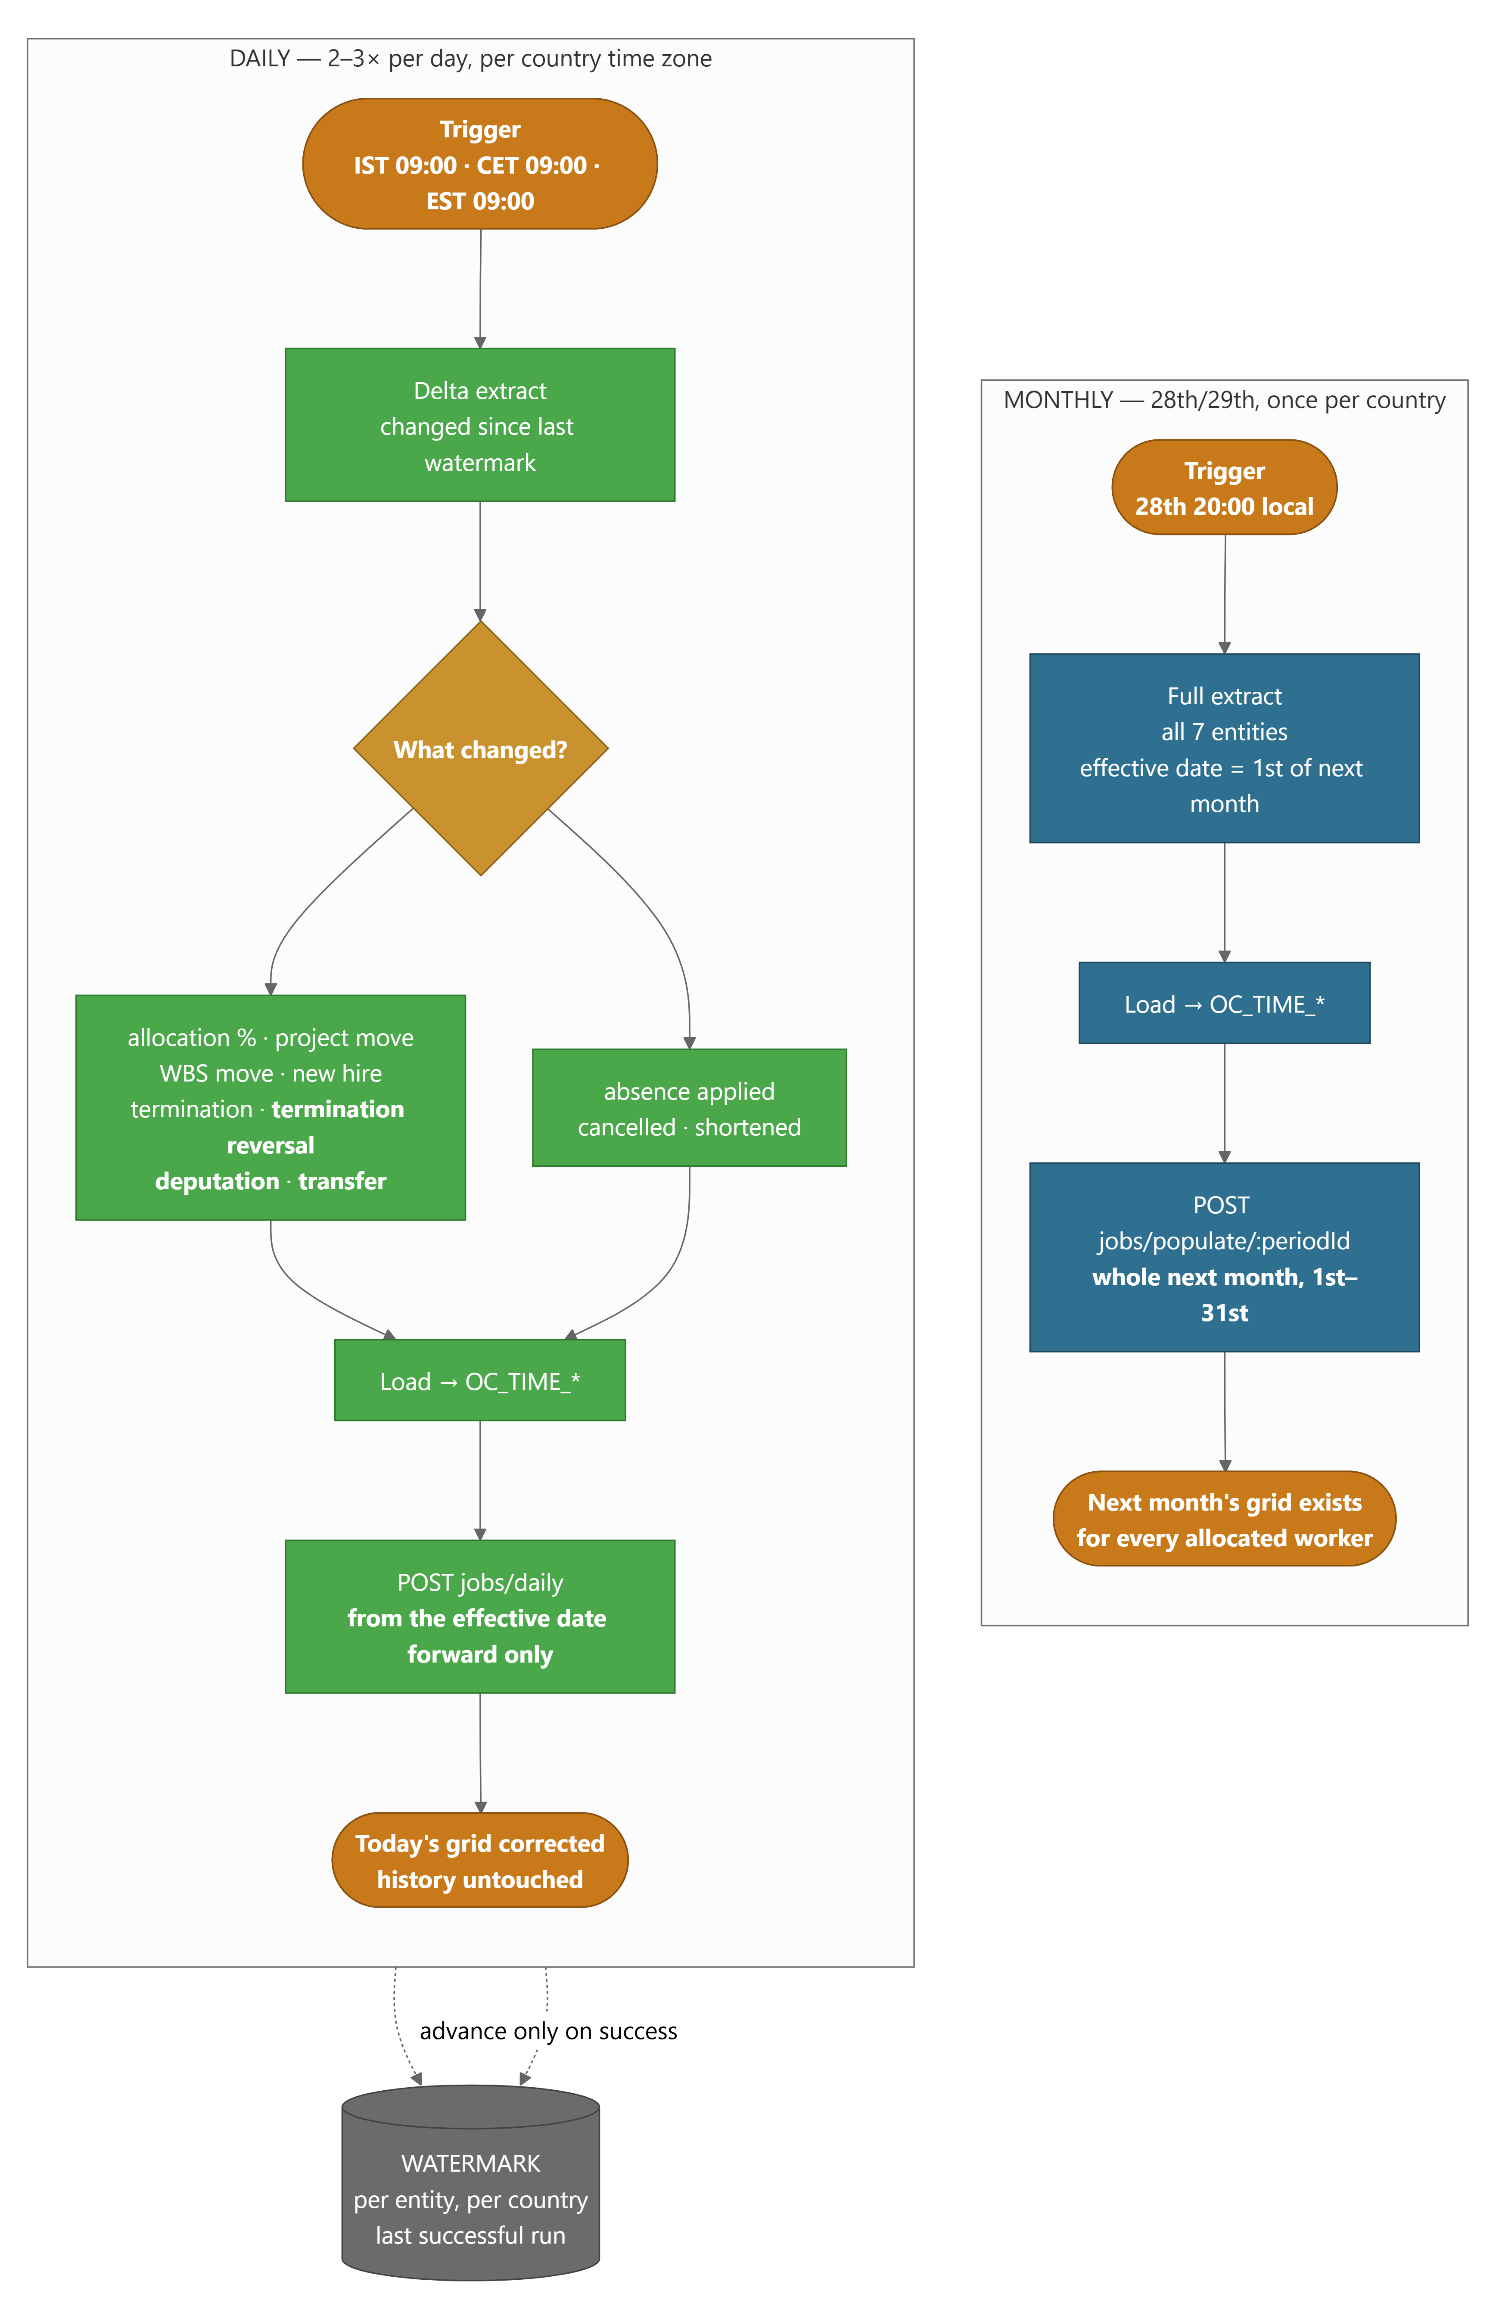
Monthly builds the next month; daily corrects the current one from the effective date forward.
Both come straight from the BRD walkthrough. The monthly job forward-populates the whole of the next month from current allocation. The daily job runs several times a day and applies only what changed, from the effective date forward — it overrides the populated row for those days and leaves history alone.
 | Monthly | Daily
When | 28th/29th, 20:00 local, once per payroll country | 2–3 times a day per country time zone
Scope | Full refresh, all 7 entities | Delta since the last successful watermark
Effective date | 1st of the next month | The change's own effective date
Then calls | POST jobs/populate/{periodId} | POST jobs/daily
Produces | Next month's grid for every allocated worker | Today's grid corrected; history untouched
Handles | Everything | Allocation %, project move, WBS move, new hire, termination, termination reversal, deputation, transfer

Why per country. The walkthrough is explicit: "if you ran this program at 8 in the night in India, US data may not even be inside — you might have to run it 2 or 3 times."OC_TIME_PERIOD is already keyed by PAYROLL_COUNTRY, so the data model supports it. Nothing in the module reads a time zone yet, so the split has to be in the OIC schedule.
The last three triggers are not implemented.populate_daily handles allocation change, project and WBS moves and new hires. Termination reversals, deputations and transfers are named in the BRD and have no code path. They need building before the daily schedule is switched on, or they will silently never apply.

What to build in OIC
# | Integration | Type | Notes
1 | MASTER_MONTHLY | Scheduled | Orchestrator. Calls 2–6 in dependency order, then jobs/populate.
2 | LOAD_WORKER | App-driven | Must run first — every other entity has a worker FK.
3 | LOAD_PROJECT_TASK | App-driven | Project then task; task carries the project FK.
4 | LOAD_ALLOCATION | App-driven | Needs worker and project loaded.
5 | LOAD_CALENDAR | App-driven | Four layers, one call each, precedence set by the trigger.
6 | LOAD_ABSENCE | App-driven | Also callable ad hoc for one person — the timesheet already does this live.
7 | MASTER_DAILY | Scheduled ×3 | Same children, delta mode, per country.
8 | REPROCESS_FAILED | Scheduled | Reads sync/failed, re-drives, closes what now succeeds.

Order is not stylistic.OC_TIME_ALLOCATION has foreign keys to both worker and project, so an allocation row whose worker has not loaded lands in OC_TIME_SYNC_FAILED rather than in the table. The orchestrator must sequence, not fan out.

6.1 Chunking, restart and idempotency
- Chunk at 500 rows. Omit jobRunId on the first call, pass it back on every later one, final=Y on the last. One job row for a 6,000-row load.
- Every endpoint is a MERGE on the natural key, so a replayed chunk changes nothing. Restart is re-running, not unwinding.
- A bad row never aborts the chunk. It goes to OC_TIME_SYNC_FAILED with its reason and the job closes Partial. OIC should treat Partial as a warning with a report, not a failure.
- Watermark per entity per country, advanced only on a clean finish. A Partial must not advance it, or the failed rows are never seen again.

Decisions needed before build
# | Decision | Blocks
1 | Settle the one contract (section 2) and version it | everything
2 | Field naming: UPPER_SNAKE everywhere, including calendar | contract v1
3 | TASK_ALLOCATION — add the seventh entity and its table? | prepopulation accuracy
4 | Where REVENUE_MODEL comes from. Null today, so leave-loss cannot fire for any project | LOAD_PROJECT
5 | EXPENDITURE_TYPE on task and EXPENDITURE_ORG on allocation — needed for POET and the OTL push | outbound, not this
6 | Build the three missing daily triggers (termination reversal, deputation, transfer) | MASTER_DAILY
7 | Does absence stay live-per-page as well as batched? Both is fine; it should be a decision, not an accident | LOAD_ABSENCE
8 | Country list and the run times per country | the schedules

Sections 3 and 4 are generated from db/ords/13_ords_time_admin.sql and integration/bip/extracts.py as they stand on 09-Aug-2026. The volumes in section 4 are live counts from the dev20 pod, not estimates.

