UNIT-I
Cloud Computing Software Security Fundamentals

Cloud Computing Software Security refers to the set of policies, technologies, and controls designed to protect cloud-based systems, data, and infrastructure from internal and external threats.
Security in cloud computing follows a shared responsibility model, where responsibilities are divided between cloud service providers (CSPs) and cloud users.

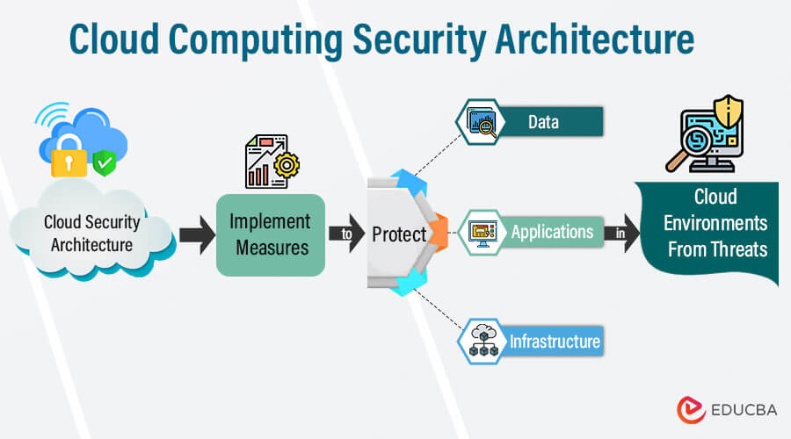

  - Cloud Information Security Objectives, Confidentiality, Integrity, Availability:
The primary goal of cloud security is to ensure that the software and data hosted on a remote, shared infrastructure remain as secure as they would be in a traditional on-premise data.
The primary objective of cloud information security is to ensure protection of data throughout its lifecycle using the CIA Triad.
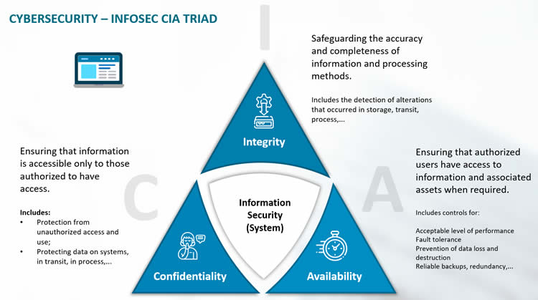

1. Confidentiality
Confidentiality ensures that sensitive information is accessible only to authorized users and is protected from unauthorized disclosure, whether intentional or accidental. In cloud computing, confidentiality is a critical security objective because data is stored and processed outside the organization’s direct control.

Cloud Challenge
In cloud environments, resources are shared among multiple customers using multi-tenancy. Although logical isolation is provided, improper configuration, weak access controls, or vulnerabilities may lead to information leakage, where one tenant gains access to another tenant’s data.

Implementation Mechanisms:
- Encryption (Data at Rest):
Sensitive data stored in cloud databases or storage services is encrypted using strong algorithms such as AES-256, ensuring that even if data is accessed without authorization, it remains unreadable.

AES-256 (Advanced Encryption Standard – 256 bit)
AES-256 is a symmetric key encryption algorithm used to protect sensitive data by converting it into an unreadable format using a 256-bit secret key. It is one of the strongest and most widely accepted encryption standards in cloud computing.
- Access Control:
Identity and Access Management (IAM) enforces who can access data and what actions they can perform. Role-based access and the principle of least privilege prevent unauthorized users from viewing confidential information.
- Traffic Protection (Data in Transit):
Data transmitted over networks is protected using TLS (Transport Layer Security), which encrypts communication between clients and cloud servers, preventing eavesdropping and man-in-the-middle attacks.
Tools to achieve confidentiality:
VeraCrypt, TrueCrypt, GnuPG, xCrypt, CiperSheld

2. Integrity
Integrity involves maintaining the consistency, accuracy, and trust worthiness of data over its entire life cycle. It ensures that data cannot be modified by unauthorized parties.
- Cloud Challenge:
- • Cloud data is stored on remote servers managed by third parties
- • Data is accessed by multiple users and applications
- • Data transfers occur over the internet

- Implementation:
• Hashing
- Uses algorithms like SHA-256
- Verifies data by comparing hash values
• Checksums
- Detects accidental data changes during transmission
• Encryption
- Protects data from unauthorized modification
- Ensures integrity along with confidentiality
• Digital Signatures
- Confirms data authenticity and integrity
- Ensures data is not tampered with
• Access Control
- Role-Based Access Control (RBAC)
- Limits who can modify data

3. Availability
Availability is a guarantee of reliable access to the information by authorized users. This is the most visible objective in Cloud Service Level Agreements (SLAs).

Importance of Availability in Cloud
- Users expect 24×7 access to services
- Downtime causes financial loss and user dissatisfaction
- Critical systems (banking, healthcare, education) depend on high availability

Techniques to Ensure Availability
- Redundancy
  - Multiple servers and data copies
  - Prevents single point of failure
- Load Balancing
  - Distributes traffic across servers
  - Improves performance and uptime
- Failover Mechanisms
  - Automatic switch to backup systems
- Backup and Disaster Recovery
  - Regular data backups
  - Quick service restoration after failure
- Monitoring and Maintenance
  - Continuous system monitoring
  - Early fault detection
1.2 Security Services:
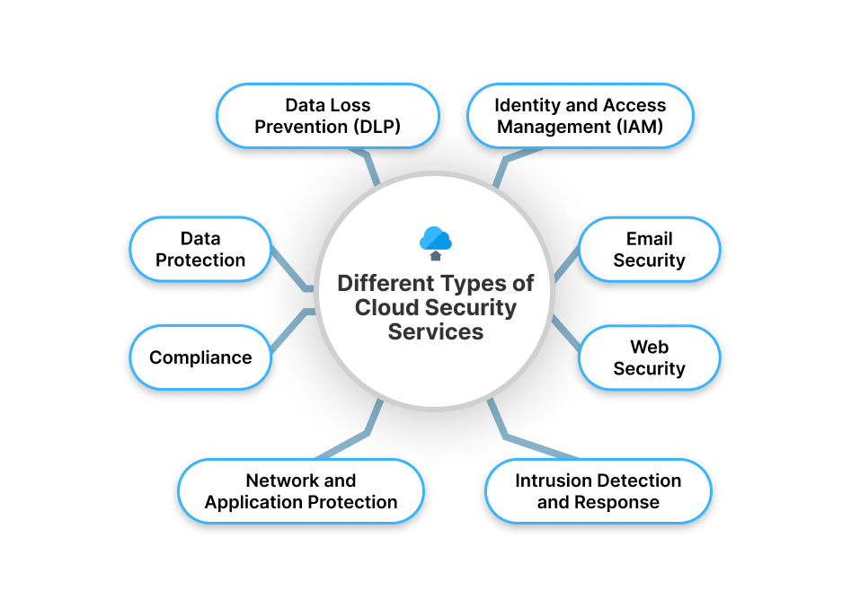

Different Types of Cloud Security Services:

1. Data Loss Prevention (DLP)
Data Loss Prevention protects sensitive data from unauthorized access, leakage, or misuse.
It monitors data stored, processed, and transferred in the cloud.
DLP enforces security policies to prevent accidental or intentional data exposure.
It is commonly used to secure personal, financial, and confidential data.

2. Identity and Access Management (IAM)
IAM controls who can access cloud resources and what actions they can perform.
It manages user identities, authentication, and authorization.
IAM uses roles, permissions, and multi-factor authentication.
It helps prevent unauthorized access and identity misuse.

3. Email Security
Email security protects cloud-based email systems from spam, phishing, and malware.
It filters malicious emails before they reach users.
This service helps prevent data theft and social engineering attacks.
It ensures secure and reliable communication.

4. Web Security
Web security protects cloud websites and applications from cyber threats.
It blocks malicious traffic, unauthorized access, and harmful content.
Web security ensures safe browsing and secure online transactions.
It helps maintain application availability and performance.

5. Intrusion Detection and Response
This service continuously monitors cloud systems for suspicious activities.
It detects security breaches and intrusion attempts in real time.
Automatic responses help minimize damage.
It strengthens overall cloud security posture.

6. Network and Application Protection
This service secures cloud networks and applications using firewalls and security gateways.
It monitors traffic to detect and block attacks.
It protects against network-level and application-level threats.
It ensures safe communication between cloud components.

7. Compliance
Compliance services ensure cloud systems meet legal and regulatory requirements.
They help organizations follow security standards and data protection laws.
Compliance reduces legal risks and improves trust.
It is essential for regulated industries.

8. Data Protection
Data protection ensures data confidentiality, integrity, and availability.
It uses encryption, backups, and access controls.
This service prevents unauthorized data access and loss.
It ensures secure data storage and recovery.
  - Cloud Security Policy Implementation:

- Cloud Security Policy Implementation is the systematic process of creating, applying, and enforcing security rules and controls to protect cloud-based data, applications, and infrastructure. It ensures that cloud usage follows organizational policies, legal regulations, and industry security standards.
- It includes defining access control policies, data protection rules, identity management procedures, encryption standards, and incident response plans. These policies guide how users access cloud services and how data is stored, processed, and shared securely.
- Implementation also involves the use of technical tools such as IAM systems, firewalls, monitoring tools, logging systems, and auditing mechanisms to enforce security rules. Continuous monitoring and regular reviews ensure compliance and risk reduction.

- Policy Definition
Cloud security policies define rules and guidelines for protecting cloud data, users, applications, and infrastructure. These policies are based on organizational needs, legal requirements, and security standards.
- Access Control Implementation
Policies are enforced using identity and access management systems. Only authorized users are allowed to access cloud resources through authentication, authorization, and role-based access control (RBAC).
- Data Protection Policies
Security policies include data encryption, data classification, secure storage, and backup rules to protect sensitive information from unauthorized access and loss.
- Security Controls and Enforcement
Technical controls such as firewalls, monitoring systems, logging, intrusion detection, and auditing tools are used to enforce policies and detect violations.
- Monitoring, Compliance, and Review
Continuous monitoring and regular audits ensure compliance with policies. Policies are updated periodically to address new threats and security requirements.
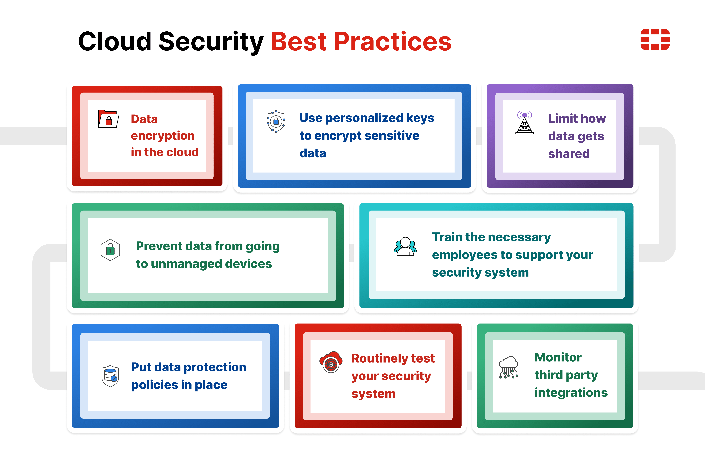

  - Infrastructure Security:

Definition:
- Infrastructure security protects the entire IT environment—both physical and virtual—from attacks, failures, or unauthorized access.
- Ensures confidentiality, integrity, and availability of IT resources.

1. Physical Infrastructure Security:
- Protects servers, data centers, storage devices, and networking equipment.
- Measures:
  - Restricted access (biometrics, keycards)
  - CCTV and security guards
  - Environmental monitoring (fire, water, temperature)
  - Backup power systems (UPS, generators)
- Example: Only authorized staff can enter the server room; UPS prevents downtime during power failure.

2. Network Security:
- Protects the network connecting all devices.
- Measures:
  - Firewalls and VPNs
  - Intrusion detection/prevention systems (IDS/IPS)
  - Network segmentation
  - Continuous monitoring of traffic
- Example: Firewall blocks unauthorized access from the internet.

3. Host and System Security:
- Protects individual servers and computers.
- Measures:
  - Server hardening (disable unnecessary services)
  - Regular OS and software updates
  - Anti-virus/endpoint protection
  - Encryption of sensitive data
- Example: Encrypting financial data stored on servers to prevent theft.

4. Cloud and Virtual Infrastructure Security:
- Protects virtual machines, containers, and cloud resources.
- Measures:
  - Virtual network isolation
  - Identity & Access Management (IAM)
  - Securing hypervisors
- Example: Users have access only to the cloud services they are authorized for.

5. Data Security & Redundancy:
- Ensures data is safe, available, and recoverable.
- Measures:
  - Regular backups and replication
  - Encryption in transit and at rest
  - Disaster recovery planning
- Example: Cloud backup ensures business continues even if local servers fail.

  - Network-level security:
Network-level security refers to the protection of data, devices, and services that operate over a network.
It ensures that data transmitted across networks is secure, authenticated, and protected from attacks.
Focuses on securing communication channels between systems.

1. Access Control & Authentication:
- Only authorized users and devices are allowed to connect to the network.
- Techniques include:
  - User authentication (username/password, MFA)
  - Device authentication (MAC filtering, phone, IoT sensor, laptop)
  - Role-based access control
- Teaching Example: Only registered staff laptops can access the college internal network.

2. Firewalls:
- Firewalls act as a security gate between internal networks and the internet.
- They filter traffic based on rules (IP address, port, protocol, application).
- Types:
  - Network firewalls
  - Application firewalls
- Teaching Example: Firewall blocks unauthorized websites and suspicious traffic.

3. Intrusion Detection and Prevention Systems (IDS/IPS):
- IDS detects attacks and alerts administrators.
- IPS detects and automatically blocks attacks.
- Protect against malware, hacking attempts, and network scanning.
- Teaching Example: System detects a hacking attempt and blocks the IP address.

4. Secure Communication (Encryption & VPN):
- Data is encrypted during transmission to prevent interception.
- Use of:
  - HTTPS
  - SSL/TLS
  - VPNs (Virtual Private Networks)
- Teaching Example: Employees securely access office systems from home using VPN.

5. Network Segmentation:
- Dividing the network into multiple smaller segments (VLANs/subnets).
- Limits the spread of attacks and improves control.
- Teaching Example: Student network separated from administrative network.

  - Host level security:
Host-level security refers to the protection of individual computing systems (hosts) such as servers, desktops, laptops, and virtual machines by securing their operating systems, applications, configurations, and stored data. It ensures that each system connected to the network is independently protected from threats and vulnerabilities..

1. Operating System Security:
- Proper configuration of the operating system to minimize security risks.
- Includes disabling unnecessary services, securing system files, and configuring system permissions.
- Helps reduce the attack surface of the host system.

2. System Hardening:
- Process of strengthening the system by removing unnecessary software, services, and default settings.
- Includes closing unused ports and applying secure configurations.
- Reduces vulnerabilities and improves overall system security.

3. Patch Management and Updates:
- Regular updating of operating systems and installed applications.
- Fixes known security vulnerabilities and bugs.
- Prevents exploitation by attackers using outdated software.

4. Authentication and Access Control:
- Ensures only authorized users can access host systems.
- Uses strong passwords, multi-factor authentication, and role-based access control.
- Prevents unauthorized login and misuse of system resources.

5. Anti-Malware and Endpoint Protection:
- Protects hosts from viruses, ransomware, spyware, and trojans.
- Includes antivirus software and endpoint detection and response (EDR) systems.
- Detects, blocks, and removes malicious software.

6. Data Security on Host Systems:
- Protection of data stored locally on systems.
- Includes disk encryption, secure file permissions, and regular backups.
- Prevents data theft and data loss.

7. Monitoring and Logging:
- Continuous monitoring of system activities.
- Maintenance of system logs for detecting suspicious behavior.
- Supports incident detection and response.

8. Virtual Host Security:
- Security of virtual machines and virtual servers.
- Includes VM isolation, hypervisor security, and secure access policies.
- Prevents unauthorized access between virtual systems.

  - Data Security and Storage Cloud Access: authentication, authorization and accounting:
In cloud environments, data is stored and accessed over the internet, making data security and controlled access extremely important.
Cloud access security is achieved using the AAA security model:
- Authentication – Who you are
- Authorization – What you are allowed to do
- Accounting – What you did

A.Authentication (Identity Verification):
Authentication is the process of verifying the identity of a user, device, or system before allowing access to cloud services.
Methods:
- Username and password
- Multi-Factor Authentication (MFA)
- Biometric authentication
- Digital certificates
- Token-based authentication
Purpose:
- Prevents unauthorized access
- Ensures only legitimate users enter the system
Example:
User must enter password + OTP to access cloud storage.

B. Authorization (Access Rights Control):
Authorization determines what actions a user is allowed to perform after successful authentication.
Mechanisms:
- Role-Based Access Control (RBAC)
- Attribute-Based Access Control (ABAC)
- Policy-based permissions
- Least privilege principle
Purpose:
- Restricts access to sensitive data
- Prevents misuse of resources
Example:
A student can view data, but only an admin can delete data.

C. Accounting (Monitoring & Auditing)
Accounting is the process of tracking and recording user activities in cloud systems.
Functions:
- Logging user access
- Monitoring data usage
- Tracking file operations
- Resource usage reporting
Purpose:
- Enables auditing and compliance
- Helps in incident investigation
- Supports billing and usage management
Example:
System logs who accessed which file and at what time.

Data Security in Cloud Storage:
In cloud computing, data is stored on remote servers and accessed through the internet. Since cloud environments are shared and accessible globally, strong security mechanisms are required to protect sensitive data from cyber threats, unauthorized access, and accidental loss.
1.Data Encryption:
Encryption is the process of converting readable data (plaintext) into an unreadable format (ciphertext) using cryptographic algorithms. Only authorized users with the correct decryption key can access the original data.

Types of Encryption

a) Encryption of Data at Rest
- Protects data stored in cloud databases, storage devices, or backup systems.
- Even if storage devices are stolen or hacked, encrypted data cannot be read.
- Example: Encrypted files stored in AWS S3 or Google Cloud Storage.

b) Encryption of Data in Transit
- Protects data while it is being transferred over the internet.
- Uses secure protocols such as HTTPS, SSL, or TLS.
- Prevents interception or Man-in-the-Middle attacks.

c) Secure Key Management Systems
- Encryption keys must be securely stored and managed.
- Cloud providers use Key Management Systems (KMS).
- Ensures only authorized users can access encryption keys.

2. Secure Storage Management
Secure storage management ensures that data stored in the cloud remains protected and properly controlled.

a) Access-Controlled Cloud Storage
- Uses authentication and authorization mechanisms.
- Only authorized users can access specific files.
- Implements Role-Based Access Control (RBAC).

b) Secure Backups and Replication
- Data is copied to multiple locations.
- Protects against hardware failure and data loss.
- Ensures high availability.

c) Data Classification and Data Isolation
- Data is categorized based on sensitivity (public, private, confidential).
- In multi-tenant environments, data of different users is isolated.
- Prevents data leakage between tenants.

3. Backup and Recovery
Backup and recovery mechanisms protect cloud data from accidental deletion, cyberattacks, or system failures.

a) Regular Automated Backups
- Automatic backups are scheduled periodically.
- Ensures latest data copy is always available.

b) Disaster Recovery (DR)
- Plans and procedures to restore services after disasters.
- Includes backup data centers and failover systems.

c) Data Restoration Mechanisms
- Allows recovery of deleted or corrupted files.
- Ensures business continuity.

