Unit-III
Emerging Trends in Cloud Computing

3.1 Overview of Emerging Trends in Cloud Computing

Cloud computing is rapidly evolving due to advancements in Artificial Intelligence, distributed systems, networking technologies like 5G, and increasing enterprise demand for scalable digital infrastructure. Modern cloud ecosystems aim to provide intelligent, flexible, and globally distributed computing environments
Modern cloud computing is shifting from centralized computing models to distributed intelligent ecosystems. Instead of processing all workloads in centralized data centers, modern cloud architectures distribute computing across multiple locations, devices, and platforms.

Key Drivers of Emerging Trends

1. Agility
Agility refers to the ability of organizations to quickly develop, deploy, and scale applications in response to changing business needs.
- Organizations require rapid application deployment across multiple geographic regions.
- Cloud platforms support microservices architecture, allowing applications to be divided into smaller independent services.
- Containerized deployment ensures applications run consistently across development, testing, and production environments.
Benefits of agility:
- Faster development cycles
- Continuous integration and deployment (CI/CD)
- Rapid scaling of services

2. Intelligence
Modern cloud platforms are increasingly becoming AI-driven infrastructures.
Artificial Intelligence is embedded into cloud systems to automate operations and improve efficiency.
Examples include:
- Automated resource allocation based on workload demand
- Performance optimization using machine learning algorithms
- Predictive maintenance to detect system failures before they occur
- Intelligent monitoring and analytics
Major cloud providers offer built-in AI services through platforms like Microsoft Azure, Amazon Web Services, and Google Cloud Platform.

3. Convergence of Technologies
Another major trend is the integration of multiple advanced technologies with cloud computing.
Modern cloud platforms combine several technology domains, including:
- Cloud Computing – Provides scalable infrastructure and services
- 5G Telecommunications – Enables high-speed, low-latency communication
- Cybersecurity (Zero Trust Architecture) – Ensures secure access and identity-based protection
- Artificial Intelligence and Machine Learning – Enables intelligent automation and predictive analytics
The convergence of these technologies allows organizations to build smart applications, autonomous systems, and real-time analytics platforms.

3.2 Multi-Cloud Environment

Definition
A multi-cloud environment refers to the use of multiple public cloud providers within a single IT architecture. Organizations may simultaneously use services from providers such as Amazon Web Services (AWS), Microsoft Azure, and Google Cloud Platform (GCP).
Unlike Hybrid Cloud, which combines private and public clouds, Multi-Cloud focuses on diversifying across different public cloud vendors.

Benefits of Multi-Cloud

1. Vendor Lock-in Mitigation
Using multiple providers prevents dependency on a single cloud vendor and allows organizations to migrate workloads if pricing or policies change.

2. Disaster Recovery and High Availability
Workloads distributed across different providers improve system resilience. If one provider experiences downtime, services continue running on another platform.

3. Data Sovereignty Compliance
Different providers have data centers in different geographic regions. Organizations can store data in specific regions to comply with national regulations.

4. Best-of-Breed Services
Organizations can select the most advanced services from each provider.

Challenges of Multi-Cloud

1. Complex Orchestration
Managing multiple cloud consoles, APIs, and service models increases operational complexity.

2. Security Fragmentation
Different providers have different Identity and Access Management (IAM) models, making unified security management difficult.

3. Data Transfer Costs
Moving large amounts of data between different cloud providers can lead to high data egress charges.
Example:
- AWS → Compute services
- Azure → Enterprise integration
- Google Cloud → Data analytics and AI
- Example:
Spotify uses multiple cloud services to ensure high availability and performance.

Advantages of Multi-Cloud
- Avoids Vendor Lock-in
Organizations are not dependent on a single cloud provider. They can switch services if pricing or policies change.
- High Availability and Reliability
Applications are distributed across multiple cloud providers. If one cloud fails, another cloud can continue the service.
- Better Performance
Organizations can select the best-performing service from each provider.
- Cost Optimization
Companies can compare prices and choose the most cost-effective services.
- Improved Disaster Recovery
Data stored in multiple cloud platforms helps recover quickly after system failures.

Disadvantages of Multi-Cloud
- Complex Management
Managing multiple cloud platforms, tools, and dashboards increases system complexity.
- Security Challenges
Each cloud provider has different security models and policies, making unified security management difficult.
- Data Transfer Costs
Moving data between different cloud providers can be expensive due to data egress charges.
- Integration Issues
Different cloud platforms may use different APIs and architectures, which makes integration difficult.
- Need for Skilled Professionals
Organizations require experts who understand multiple cloud platforms.

3.3 Omni-Cloud

Definition
Omni-Cloud is an advanced cloud computing approach where multiple cloud environments are integrated into a single unified infrastructure layer. It abstracts the underlying cloud platforms and presents them as one integrated resource pool.
If Multi-Cloud means using multiple clouds independently, Omni-Cloud means integrating them into a seamless ecosystem.

Key Benefits of Omni-Cloud

1. Unified Management
Administrators manage resources across all clouds using a single control interface (Single Pane of Glass).

2. Workload Portability
Applications packaged in containers (such as Kubernetes containers) can move across clouds depending on cost, performance, or availability.

3. Operational Consistency
Developers use the same CI/CD pipeline and DevOps processes across all environments.

Challenges of Omni-Cloud

1. Technology Complexity
Omni-Cloud requires advanced orchestration platforms such as:
- Google Anthos
- Azure Arc
- Red Hat OpenShift
These platforms require specialized skills.

2. Network Synchronization
Maintaining synchronized data across multiple cloud infrastructures requires high-bandwidth networking and efficient replication mechanisms.

Example
Google offers BigQuery Omni, which allows organizations to analyze data stored in AWS or Azure without moving it.

3.4 Blockchain Technology in Cloud

Definition
Blockchain is a distributed digital ledger technology that records transactions securely across multiple nodes in a network.
In cloud computing environments, blockchain provides a decentralized trust layer, enabling secure and transparent transaction management.

Working Principle
- A user initiates a transaction.
- Network nodes verify the transaction.
- Verified transactions are grouped into a block.
- Each block receives a unique cryptographic hash.
- Blocks are linked sequentially to form a chain.
Any modification in previous blocks invalidates the entire chain, ensuring data integrity and immutability.

Benefits of Blockchain in Cloud

1. Data Integrity
Blockchain ensures that stored records cannot be altered once confirmed.

2. Transparent Audit Trail
All transactions are recorded permanently and can be audited easily.

3. Reduced Dependence on Intermediaries
Blockchain allows peer-to-peer verification without centralized authorities.

Challenges of Blockchain in Cloud

Scalability
- Blockchain networks (especially public ones) process transactions much slower than centralized systems.
- Example:
  - Bitcoin processes ~7 transactions per second
  - Traditional systems like Visa handle thousands per second

Why Scalability is a Problem?
- Every transaction must be verified by multiple nodes
- Data is replicated across the entire network
- Consensus mechanisms (like Proof-of-Work) take time

Impact in Cloud:
- Slower application performance
- Not suitable for real-time high-volume systems
- Increased latency

Energy Consumption
- Blockchain systems using Proof-of-Work (PoW) require massive computational power.

Example:
- Bitcoin mining consumes energy comparable to small countries

Why High Energy?
- Complex mathematical puzzles must be solved
- Continuous mining competition among nodes
- Requires powerful hardware (GPUs/ASICs)

Impact in Cloud:
- Increased operational cost
- Not sustainable for large-scale deployment

3.5 Types of Blockchain Technology

Blockchain technology can be classified based on access control, ownership, and participation. Each type is designed for different applications and organizational needs.

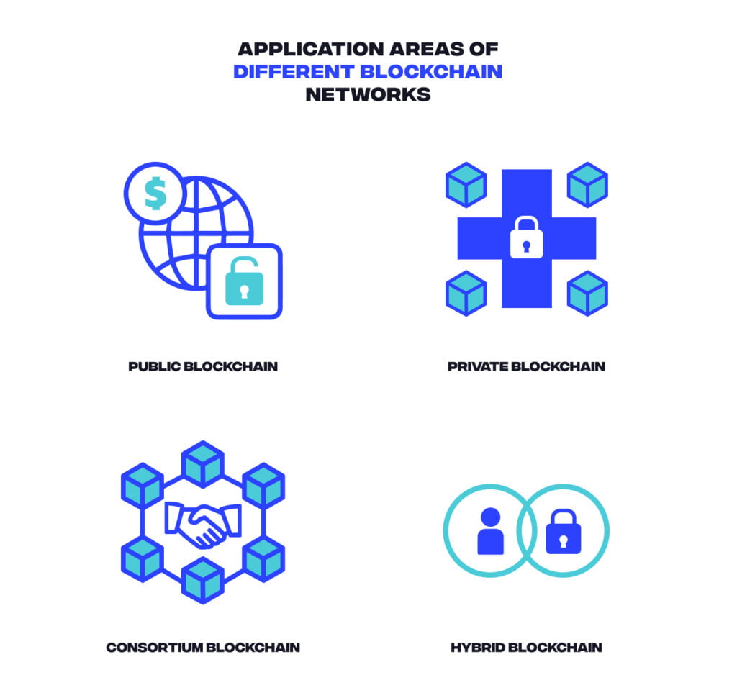

1. Public Blockchain
A Public Blockchain is an open and decentralized network where anyone can join, participate, and view transactions. No central authority controls the system.
Characteristics
- Open access to anyone
- Fully decentralized
- High transparency
- Transactions are verified by network participants
Examples
- Bitcoin
Advantages
- High security due to decentralization
- Transparency of transactions
- Trustless system (no intermediary required)
Disadvantages
- Slower transaction speed
- High energy consumption for mining

2. Private Blockchain
A Private Blockchain is controlled by a single organization. Only authorized users can access the network and perform transactions.
Characteristics
- Permission-based access
- Centralized control by an organization
- Faster transactions compared to public blockchain
Example
- Enterprise solutions built using Hyperledger Fabric
Advantages
- Better privacy and control
- Higher transaction speed
- Suitable for internal business processes
Disadvantages
- Less decentralized
- Requires trust in the controlling organization

3. Consortium Blockchain
A Consortium Blockchain (also called Federated Blockchain) is managed by a group of organizations instead of a single entity.
Characteristics
- Controlled by multiple organizations
- Semi-decentralized system
- Limited access for participants
Examples / Applications
- Banking networks
- Supply chain management systems
- Trade finance platforms
Advantages
- Shared governance among organizations
- Improved efficiency and collaboration
- Better scalability than public blockchains
Disadvantages
- Governance decisions can be complex
- Requires trust between participating organizations

4. Hybrid Blockchain
A Hybrid Blockchain combines features of both public and private blockchains. Some data is kept private while selected information is publicly accessible for transparency.
Characteristics
- Combination of public and private blockchain features
- Controlled access with selective transparency
- High flexibility for enterprises
Applications
- Government services
- Healthcare data systems
- Enterprise supply chain tracking
Advantages
- Balance between transparency and privacy
- Higher security and control
- Suitable for enterprise use cases
Disadvantages
- Complex implementation
- Requires careful governance policies

Basis | Consortium Blockchain | Hybrid Blockchain
Definition | Managed by a group of organizations (not a single entity) | Combination of public + private blockchain features
Control | Shared control among multiple organizations | Controlled by one organization but with some public access
Decentralization | Semi-decentralized (multiple authorities) | Partially decentralized (mix of centralized + public)
Access | Restricted to selected participants (e.g., banks) | Some data is private, some is publicly accessible
Transparency | Limited transparency within the consortium | Selective transparency (public + private data)
Governance | Decisions taken collectively by member organizations | Governance controlled by a single entity with rules for public access
Use Cases | Banking networks, supply chain, trade finance | Government systems, healthcare, enterprise solutions
Flexibility | Less flexible (depends on agreement among members) | More flexible due to mixed architecture
Complexity | Complex due to coordination among organizations | Complex due to integration of two systems

3.6 Cloud Artificial Intelligence (Cloud AI)

Definition
Cloud AI refers to the integration of Artificial Intelligence and Machine Learning capabilities into cloud platforms. It allows organizations and developers to build, train, and deploy intelligent applications using cloud infrastructure without needing expensive hardware or complex setups.
Cloud providers offer AI tools, APIs, and machine learning platforms that can be accessed through the internet.
• AI = Making machines smart
• Cloud = Accessing services via internet
• Cloud AI = Smart services available online

Key Benefits of Cloud AI

1. AI Platforms
AI platforms provide tools to create and deploy machine learning models.
Example:
Developers can train predictive models using AWS SageMaker without managing physical servers.

2. Data Storage and Management
Cloud platforms provide large-scale storage for handling massive datasets required for AI training.
Example:
Companies store big data in cloud data lakes and process it using AI models.

3. Automated Model Building
Cloud AI services provide automated pipelines for building and training models, reducing development time.
Example:
AutoML tools automatically select the best algorithm for a dataset.

4. APIs for AI Services
Cloud platforms provide ready-to-use AI APIs for developers.
Common APIs include:
- Speech recognition
- Image recognition
- Language translation
- Text analysis
Example:
Applications can use image recognition APIs to detect objects in photos.

Benefits of Cloud AI:

1. Cost Efficiency
Organizations do not need to invest in expensive hardware like GPUs or high-performance servers.
Cloud providers such as Amazon Web Services and Microsoft Azure offer pay-as-you-use pricing.
Example:
A startup can use cloud AI services without buying costly infrastructure.

2. Scalability
Cloud AI allows systems to scale resources up or down based on demand.
Example:
An e-commerce website increases AI resources during festive sales and reduces them afterward.

3. Faster Development
Developers can build AI applications quickly using pre-built models and APIs available on platforms like Google Cloud.
Example:
A developer uses an image recognition API to build a face detection app in hours instead of weeks.

4. Accessibility
Cloud AI makes advanced AI tools available to small businesses, students, and startups.
Example:
A small business uses AI chatbots without needing an in-house AI team.

Challenges of Cloud AI

1. Data Privacy Issues
Uploading sensitive data to the cloud may raise security and privacy concerns.
Example:
Healthcare data stored in cloud systems must be protected to avoid misuse.

2. AI Model Bias
Pre-trained AI models may produce biased or unfair results if trained on biased datasets.
Example:
A hiring AI system may favor certain groups due to biased training data.

3. Internet Dependency
Cloud AI requires a stable and fast internet connection.
Example:
If internet connectivity fails, AI-based applications may stop working.

Example Applications

Real-Life Example
- When you use Google Photos, it automatically detects faces → this is AI
- But the processing happens on Google Cloud Platform
So, you are using Cloud AI without realizing it

1. Voice Assistants
Apps like Google Assistant and Amazon Alexa use Cloud AI to:
- Understand your voice
- Answer questions
- Control smart devices
Daily Use:
“Hey Google, what’s the weather today?” → processed in the cloud

2. Navigation & Maps
Google Maps uses Cloud AI to:
- Predict traffic
- Suggest fastest routes
Daily Use:
It shows live traffic and suggests alternate routes when roads are crowded

3. Video Recommendations
Platforms like YouTube and Netflix use AI to:
- Recommend videos/movies
Daily Use:
You see “Recommended for you” based on your watching history

4. Email Spam Filtering
Gmail uses Cloud AI to:
- Detect spam emails
- Filter unwanted messages
Daily Use:
Spam mails automatically go to the spam folder

3.7 Edge Computing

Definition
Edge Computing is a distributed computing model in which data processing occurs close to the source of data generation (such as IoT devices, sensors, cameras, or local servers) rather than sending all the data to centralized cloud servers.

Need for Edge Computing
Traditional cloud computing sometimes faces the following challenges:
- High latency: Delay in sending data to distant cloud servers.
- Bandwidth limitations: Continuous transfer of large data volumes overloads the network.
- Network dependency: Systems depend on constant internet connectivity.
- Data privacy concerns: Sensitive data traveling through networks increases security risks.

Advantages of edge computing:

1. Reduced Latency
Processing data near the source significantly decreases response time.
This is critical for real-time applications like autonomous vehicles, industrial automation, and online gaming.

2. Lower Bandwidth Usage
Instead of sending all data to the cloud, only relevant or processed data is transmitted.
This reduces network congestion and saves bandwidth costs.

3. Improved Data Security & Privacy
Sensitive data can be processed locally instead of being sent over networks.
This minimizes exposure to cyber threats and helps meet data privacy regulations.

4. Increased Reliability
Edge systems can operate even with limited or no internet connectivity.
This ensures continuous service in remote areas or during network outages.

5. Scalability
Adding more edge devices can distribute workloads efficiently.
This avoids overloading central servers and supports system growth.

6. Faster Decision-Making
Real-time analytics at the edge allows immediate actions—important in healthcare monitoring, smart cities, and manufacturing.

7. Cost Efficiency
By reducing cloud storage, bandwidth, and data transmission needs, organizations can lower operational costs.

8. Better Support for AI & IoT Applications
Edge computing enables AI models to run locally on devices, making applications like facial recognition, predictive maintenance, and smart assistants more responsive.

Challenges of Edge Computing

1. Security Risks
Since data is processed on multiple edge devices instead of a centralized system, there are more entry points for cyberattacks. Managing security across many devices becomes difficult.

2. Device Management Complexity
Organizations may need to monitor, update, and maintain thousands of distributed edge devices, which increases operational complexity.

3. Limited Computing Resources
Edge devices often have less storage, processing power, and memory compared to cloud data centers, which can limit performance for heavy applications.

4. High Initial Setup Cost
Deploying edge infrastructure such as sensors, gateways, and local servers requires significant investment in hardware and maintenance.

5. Data Consistency Issues
Since data is processed in different locations, maintaining synchronization and consistency between edge devices and central cloud systems can be challenging.

6. Network Connectivity Problems
Although edge computing reduces cloud dependency, stable network connections are still needed for updates, monitoring, and syncing with central systems.

7. Lack of Standardization
Different vendors use different platforms, protocols, and hardware, making integration and interoperability difficult.

8. Scalability Challenges
As the number of edge devices increases, managing security, performance, and software updates becomes more difficult.

How Edge Computing Works
- Data is generated by IoT devices.
- Processing happens locally at edge nodes.
- Only important data is sent to the cloud.
- Immediate actions are taken at the edge.

Example

1.Smart Cities
Traffic cameras analyze traffic flow locally and automatically control traffic lights to reduce congestion.

2.Autonomous Vehicles
Self-driving cars developed by companies like Tesla process data from sensors and cameras locally to make real-time driving decisions.

Difference Between Omni-Cloud and Traditional Cloud Architecture:
Aspect | Omni-Cloud Architecture | Traditional Cloud Architecture
Definition | Omni-Cloud integrates multiple cloud environments into a single unified platform. | Traditional cloud uses a single cloud provider or centralized infrastructure.
Cloud Providers | Uses multiple cloud platforms simultaneously (AWS, Azure, Google Cloud). | Usually depends on one cloud provider.
Integration | Highly integrated environment where services across clouds work seamlessly. | Limited integration; services are mostly centralized.
Resource Management | Resources are managed through a unified management system across all clouds. | Resources are managed within one cloud environment.
Flexibility | Highly flexible; workloads can move between different clouds easily. | Less flexible; applications are tied to a specific cloud platform.
Scalability | Offers global scalability by using resources from multiple cloud providers. | Scalability depends only on the capacity of the single cloud provider.
Cost Optimization | Workloads can be shifted to the cloud offering the best performance or lowest cost. | Cost depends on the pricing of the single provider.

