UNIT-IV
Resource pooling, Sharing and Provisioning
4.1 Overview of Resource pooling:
Resource pooling is a fundamental characteristic of cloud computing in which a cloud service provider’s computing resources are grouped together and shared among multiple users (tenants) using a multi-tenant model.
In this approach, resources such as processing power, memory, storage, and network bandwidth are dynamically allocated and reallocated according to consumer demand. Users generally do not have control or knowledge of the exact physical location of the provided resources, though they may be able to specify a higher-level location.
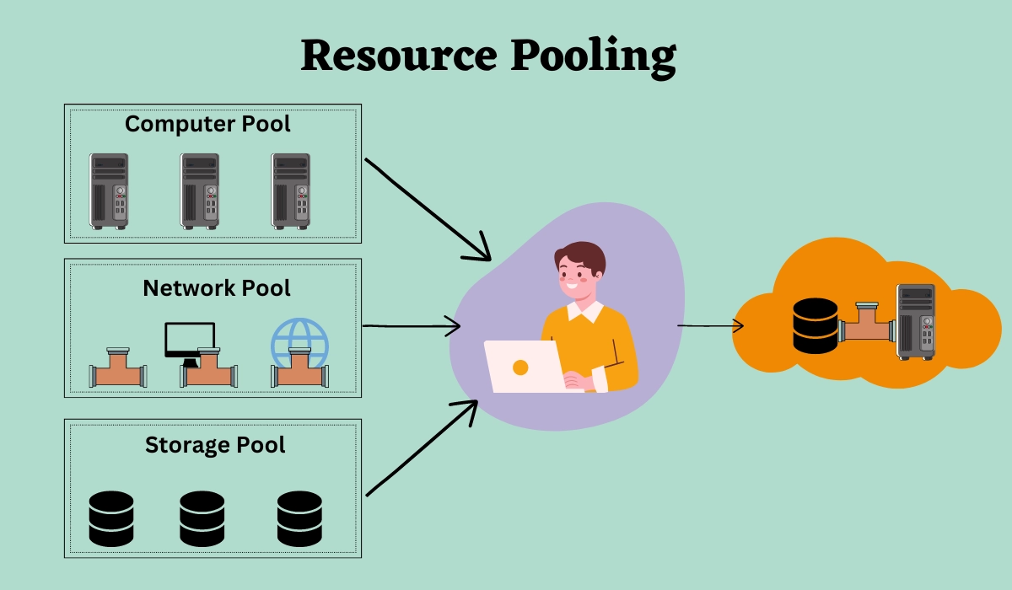

Key Features of Resource Pooling
- Multi-tenancy: Multiple users share the same physical infrastructure securely.
- Dynamic allocation: Resources are assigned and released automatically based on demand.
- Location independence: Consumers are unaware of the exact physical resource location.
- Scalability: Resources can be scaled up or down as required.

Technologies Used
- Virtualization (Virtual Machines, Containers)
- Hypervisors
- Cloud management and orchestration tools
1. Virtualization (Virtual Machines & Containers)
Virtualization allows multiple virtual machines or containers to run on a single physical server. Each virtual environment operates independently, sharing underlying hardware resources. It improves resource utilization, scalability, and isolation between users.

2. Hypervisors
A hypervisor is software that creates, runs, and manages virtual machines. It allocates CPU, memory, storage, and network resources to each VM efficiently. Hypervisors ensure isolation, security, and optimal performance of pooled resources.

3. Cloud Management and Orchestration Tools
These tools control and automate cloud resources from a central platform. They handle provisioning, monitoring, scaling, and load balancing. Orchestration ensures resources are used efficiently and services remain available.

Benefits of Resource Pooling
- Efficient utilization of hardware resources: Minimizes idle CPU, memory, storage, and network capacity by sharing resources among users.
- Cost reduction: Lowers infrastructure and operational costs through shared usage.
- Scalability and flexibility: Resources can be allocated or released quickly based on demand.
- Improved availability: Pooled resources provide better fault tolerance and reliability.
- On-demand service delivery: Users receive resources as needed without physical intervention.

Real-Life Example
- Google Drive / Dropbox
  - Millions of users store files.
  - Storage comes from a shared pool of servers.
  - Each user feels like they have personal storage, but it's actually shared.
4.2 Commoditization of data center:
Commoditization of data centers is the process of designing and operating data centers using standardized, low-cost, and interchangeable hardware and software components, rather than expensive, specialized systems. In cloud computing, data center resources such as servers, storage, and networking are treated as commodities and delivered to users in the form of services, similar to utilities like electricity or water.
Traditionally, data centers relied on branded hardware and customized configurations, which increased cost and complexity. With commoditization, cloud service providers use commodity hardware (standard x86 servers, generic storage devices, and common networking equipment) deployed at a large scale. These components are easy to replace, upgrade, and scale, reducing downtime and maintenance effort.

A key feature of commoditized data centers is high scalability, meaning they can easily grow when needed.
When demand increases, providers simply add more standard servers to handle the load.
There is no need for expensive upgrades to a single system.
Failures are normal, so systems are designed with backup (redundancy).

1. From "Scale-Up" to "Scale-Out"
- Scale-Up (Vertical): Buying a bigger, more powerful, and more expensive server. This creates a "single point of failure"—if the big server dies, the business stops.
- Scale-Out (Horizontal): Using hundreds or thousands of commodity x86 servers (off-the-shelf hardware). If one fails, the software simply moves the task to another identical machine in the pool.

2. Standardized Hardware (White-Box Servers)
Hyperscale providers (like Google, Amazon, and Meta) often bypass traditional big-name brands and use "White-Box" hardware. These are unbranded, standardized servers built using common components (like Intel CPUs and standard RAM).
- Interchangeability: Because the hardware is standardized, a technician can swap parts from different manufacturers without compatibility issues.
- Cost Efficiency: Buying standard hardware in large quantities reduces cost significantly.

3. Software-Defined Everything (SDx)
In a commoditized data center, the "intelligence" is moved from the hardware to the software.
- Software-Defined Storage (SDS): Instead of buying a $100k specialized storage array, you use software to manage a "pool" of cheap hard drives across many servers.
- Impact: More flexible, Easy to scale, Simple to manage and automate.
Aspect | Traditional Data Center | Commoditized Data Center
Hardware | Proprietary, high-cost hardware | Standard, low-cost commodity hardware
Scalability | Limited and complex | Highly scalable and flexible
Cost | High capital and maintenance cost | Reduced infrastructure and operational cost
Maintenance | Difficult and time-consuming | Easy replacement and maintenance
Fault Tolerance | Relies on expensive reliable hardware | Achieved through redundancy and software
Resource Management | Mostly manual | Automated and software-driven
Service Model | Fixed capacity | On-demand, pay-as-you-use

4.3 Standardization, Automation, and Optimization
Standardization, Automation, and Optimization together form the core operational framework of modern cloud data centers. They ensure that resource pooling works efficiently, reliably, and at scale.

1. Standardization (The Foundation)
Standardization is the practice of making all components of the data center uniform and consistent. Without standardization, resource pooling would become complex and unmanageable.

Types of Standardization
- Hardware Standardization:
Using identical server racks, CPUs, memory modules, and storage devices (often called white-box servers). This enables bulk purchasing, easy replacement, and simplified maintenance.
- Software Standardization:
Using consistent operating system images (for example, specific Linux distributions) and standard naming conventions such as app-prod-region-001.
- Process Standardization:
Implementing Policy-as-Code, where security, compliance, networking, and access rules are automatically applied whenever a resource is created.

Why Standardization Matters
Standardization makes the cloud environment predictable and repeatable. If one server’s behavior is known, the behavior of thousands of similar servers can be accurately predicted and managed.

2. Automation (The Engine)
Once the environment is standardized, automation allows software to perform repetitive tasks with minimal human involvement. Automation enables a small team of engineers to manage massive cloud infrastructures.

Key Automation Concepts
- Infrastructure as Code (IaC):
Tools like Terraform or Ansible allow engineers to define infrastructure using code. For example, a script can request 50 servers with predefined configurations, and the system provisions them automatically.
- Auto-Provisioning:
When a user requests a resource, automation handles IP assignment, firewall configuration, operating system setup, and storage attachment within seconds.
- Self-Healing Systems:
If a server fails, automation tools detect the issue, remove the faulty node, and automatically create a replacement without manual intervention.

Benefits of Automation
- Faster service delivery
- Reduced human error
- Lower operational cost
- Improved reliability

3. Optimization (The Brain)
Optimization continuously monitors and analyzes the resource pool to achieve maximum performance at minimum cost and energy usage.

Optimization Techniques
- Rightsizing:
Monitoring workloads to identify over-provisioned resources. For example, if a user allocates 16 GB RAM but only uses 2 GB, the system recommends or automatically moves them to a smaller instance.
- Workload Placement:
Intelligent algorithms decide where workloads should run:
  - Energy Optimization: Consolidating virtual machines onto fewer servers during low usage periods so unused servers can be powered down.
  - Thermal Optimization: Shifting heavy workloads away from overheated areas of the data center to prevent hardware damage.
- Dynamic Scaling:
Automatically adding resources during peak demand and removing them during low demand to balance performance and cost.
4.4 Resource sharing:
Resource sharing in cloud computing refers to the practice of allowing multiple users or applications to use the same physical computing resources such as CPU, memory, storage, and network, while maintaining security and isolation.
In cloud environments, resource sharing is enabled through virtualization and multi-tenancy, where a single physical infrastructure supports many users simultaneously. Each user is given a virtualized view of resources, even though the underlying hardware is shared.

2 Levels of Sharing
Sharing can happen at different layers of the technology stack:
Level | Shared Resources | Description | Example
Hardware Level | CPU, Memory, Storage | Physical resources are shared using virtualization | Multiple VMs on a single physical server
Platform Level | OS, Runtime, Middleware | Same platform is used to develop and run applications | Developers using same cloud platform
Application Level | Application software | One application is shared by many users | Gmail, Google Docs
Data Level | Databases, files | Data is shared with proper access control | Shared company database

How Resource Sharing Works
Resource sharing is made possible by virtualization technologies and multi-tenancy models:
- Virtualization:
  - Physical resources like CPU, memory, and storage are divided into multiple virtual instances.
  - Each user or application receives a virtualized environment that behaves like dedicated hardware, even though it is shared.
- Multi-Tenancy:
  - Multiple users (tenants) share the same hardware infrastructure.
  - Strong isolation mechanisms ensure that one tenant’s workload does not affect others.
- Dynamic Resource Allocation:
  - Resources are assigned based on demand.
  - For example, during peak usage, more CPU cores or memory may be temporarily allocated to high-demand applications.

Benefits of Resource Sharing

1. Efficient Utilization
Resource sharing ensures that servers, storage, and network are used to their full capacity instead of remaining idle.
Multiple users and applications share the same hardware, improving overall efficiency.
Example: In cloud data centers, a single physical server runs many virtual machines for different users at the same time.

2. Cost Savings
Since infrastructure is shared, organizations do not need to purchase separate hardware for each user or application.
This reduces capital costs as well as operational costs like maintenance, electricity, and cooling.
Example: Small companies use cloud services instead of setting up their own data centers, saving huge investment costs.

3. Scalability
Resource sharing allows systems to scale easily according to demand.
Resources can be increased (Scale Up) or more machines can be added (Scale Out) without interrupting services.
Example: During big online sales, e-commerce platforms increase server capacity to handle thousands of users simultaneously.

4. Flexibility
Users can access and adjust resources anytime based on their needs without installing new hardware.
This provides on-demand access and better resource management.
Example: A company can instantly increase storage or computing power in cloud platforms when workload increases.

Challenges of Resource Sharing

1. Performance Interference
In cloud platforms like AWS or Azure, if one company runs a heavy application on a shared server, other users on the same server may experience slow performance.
Example: A website becomes slow because another user is using too much CPU.

2. Security Risks
In a shared cloud environment, multiple companies store data on the same physical server.
If security is weak, one user might access another user's data.
Example: Data leakage due to improper access control.

3. Complex Management
Cloud providers must constantly monitor and allocate resources to many users.
Managing this in real time is complex.
Example: Automatically increasing server capacity during high traffic (like during a sale).

4.5 Resource provisioning:
Resource provisioning is the process of selecting, deploying, and managing resources (CPU, memory, storage, network) from the shared pool to meet a user's specific requirements. The primary goal is to provide the right amount of power at the right time(right resources to right person at right time).

Types of Resource Provisioning
- Static Provisioning:
  - Resources are allocated in advance and remain fixed, regardless of usage.
  - Simple but may lead to underutilization or over-provisioning.
  - Example: Assigning a fixed 8 GB RAM to a virtual machine permanently.
  - Over-provisioning: Allocating more resources than needed, leading to wasted money.
- Dynamic Provisioning:
  - Resources are allocated on-demand based on current workload.
  - Optimizes utilization and reduces costs.
  - Example: Auto-scaling a web server during traffic spikes.
  - Under-provisioning: Allocating too few resources, leading to slow performance or system crashes.

The Provisioning Lifecycle
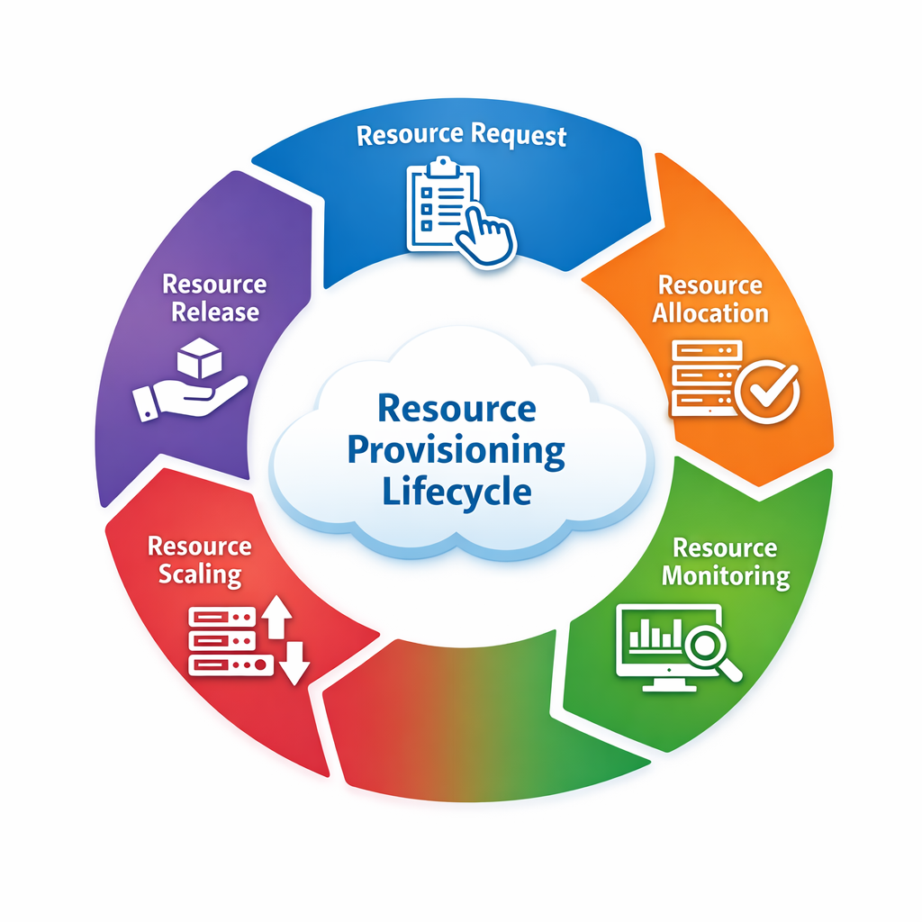

1. Resource Request
A user or application initiates a request for required resources such as CPU, memory, or storage.
The request may be manual or automated through scripts.
The system checks user permissions and resource quotas.
Only valid requests are processed further.

2. Resource Allocation
The system searches the resource pool for available capacity.
Suitable resources are selected and reserved for the user.
Allocation ensures no conflict with other users.
This step guarantees efficient utilization of shared resources.

3. Resource Monitoring
Once deployed, the system continuously monitors performance.
Metrics like CPU usage, memory consumption, and network load are tracked.
Monitoring helps detect issues early.
It provides data for optimization and scaling decisions.

4. Resource Scaling
Resources are adjusted based on workload demand.
If usage increases, resources are scaled up; if it decreases, scaled down.
This can be automatic (auto-scaling) or manual.
Scaling improves performance and reduces unnecessary costs.

5. Resource Release
After completion of tasks, resources are deallocated.
Data is securely removed to maintain privacy and security.
Freed resources are returned to the shared pool.
This makes them available for future requests.

2. Primary Provisioning Strategies
There are three main ways resources are handed out in a cloud environment:
Strategy | Description | Advantages | Best Use Case
Static Provisioning | Resources are allocated in advance and remain fixed regardless of usage | Simple to manage, predictable performance | Company email systems, payroll applications
Dynamic Provisioning | Resources are allocated and adjusted automatically based on real-time demand | Better utilization, cost-efficient, scalable | E-commerce websites during sales, streaming platforms.
User Self-Service Provisioning | Users can directly select and provision resources from a catalog or portal | Fast deployment, flexible, reduces admin effort | Creating test servers, running trial applications.

Modern Delivery Models
Provisioning looks different depending on which layer of the cloud you are using:

1. IaaS (Infrastructure as a Service)
In IaaS, users provision basic infrastructure resources like virtual machines, storage, and networks.
The user has full control over the system, including installing the operating system and applications.
It is like building a system from scratch using raw components.
Example: Creating a virtual server and installing OS manually.

2. PaaS (Platform as a Service)
In PaaS, users provision a ready-made platform or environment for application development.
The cloud provider manages the OS, runtime, and infrastructure.
Users only focus on developing and deploying applications.
Example: Deploying a web application without managing the server.

3. Serverless (FaaS - Function as a Service)
In Serverless, users do not provision any resources manually.
The cloud provider automatically allocates resources when a function is executed and releases them immediately after.
It is highly efficient and cost-effective as you pay only for execution time.
Example: 1.Running a function when a file is uploaded.
2. Sending notifications when a user registers

Benefits

1. Ensures timely resource availability
Resource provisioning makes sure that applications get required resources instantly when needed.
This avoids delays in processing and improves user experience.
It is especially important for high-demand applications.

2. Reduces resource wastage
By allocating resources based on demand, it avoids underutilization.
Unused resources are minimized, which helps in saving cost.
Dynamic provisioning plays a key role in efficient usage.

3. Supports high availability and reliability
Provisioning ensures that systems remain available even during high load or failures.
Resources can be scaled or replaced quickly if needed.
This improves overall system reliability and uptime.

4. Enables efficient multi-tenancy
Cloud providers can serve multiple users (tenants) using the same resource pool.
Provisioning ensures fair and efficient distribution of resources.
It helps in maximizing utilization and performance.

