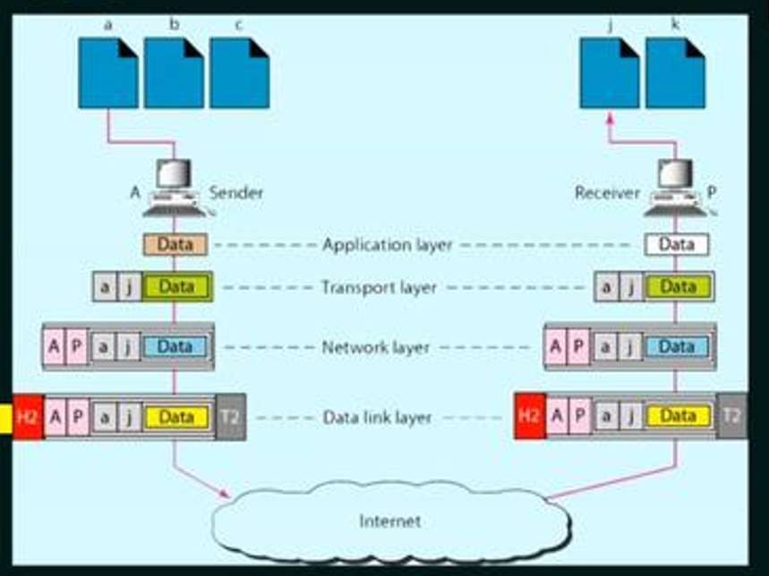
📌 Application Layer, Port Numbers & DNS
- Communication starts at the Application Layer where every service is assigned a port number.
Examples:
  - HTTP → 80
  - HTTPS → 443
  - DNS → 53
  - FTP → 20/21
  - SMTP → 25
- When a user types a domain name (e.g., google.com), the system contacts the DNS server to convert the domain name → IP address.
- After the IP is obtained, the packet moves to the Network Layer, where routing decisions are made based on the destination IP.

📌 ARP (Address Resolution Protocol)
- ARP is used to find the MAC address corresponding to an IP address.
- Operates at the Network Layer (works between Layer 2 and Layer 3).
Case 1: Destination is in the Same Subnet
- Host checks if the destination IP belongs to its own network.
- If YES → ARP request is broadcast to find the destination host’s MAC address.
- ARP reply is unicast from the destination host.
Case 2: Destination is in a Different Subnet
- Host cannot directly reach the destination.
- ARP request is sent to find MAC address of the Default Gateway (router).
- Packet is delivered to the router → router forwards it to the correct network.

📌 Difference Between ARP and RARP
ARP | RARP
Resolves IP → MAC | Resolves MAC → IP
Used by normal hosts during communication. | Used by diskless machines that only know their MAC.
Sends ARP Request broadcast to find MAC. | Sends RARP Request broadcast to find IP.
Part of IPv4 protocol suite. | Mostly obsolete, replaced by BOOTP/DHCP.
Helps deliver packets inside LAN. | Helps assign an IP to a host.

📌 DHCP (Dynamic Host Configuration Protocol)
- DHCP automatically assigns IP address and other configuration parameters to hosts.
- Operates on UDP port 67 (server) and 68 (client).
- Provides:
  - IP address
  - Subnet mask
  - Default gateway
  - DNS server(s)
  - Lease time

📌 Methods of IP Allocation in DHCP
- Automatic Allocation
  - Assigns a permanent IP to a host.
  - Once assigned, the same IP is always given.
- Dynamic Allocation
  - Assigns IP for a limited time (lease).
  - Most commonly used method.
- Manual/Static Allocation (MAC Binding)
  - Admin binds a host’s MAC to a specific IP.
  - DHCP always gives the same IP to that device.

📌 DHCP Operation (DORA Process)
DHCP works in 4 steps called DORA:
1️⃣ DHCP Discover
- Client broadcasts DHCP Discover to find available servers.
- Source: 0.0.0.0
- Destination: 255.255.255.255
2️⃣ DHCP Offer
- DHCP server responds with an Offer containing:
  - Offered IP
  - Subnet mask
  - Lease time
  - Gateway
  - DNS
3️⃣ DHCP Request
- Client sends a broadcast Request confirming it wants the offered IP.
4️⃣ DHCP Acknowledgement
- Server sends DHCP ACK → configuration is finalized.
- Host now starts using the IP.

ICMP :
- ICMP stands for Internet Control Message Protocol.
- It is a network layer protocol used mainly for error reporting and diagnostics.
- When a router or host detects a problem while forwarding an IP packet, it generates an ICMP error message and sends it back to the original sender’s IP address.
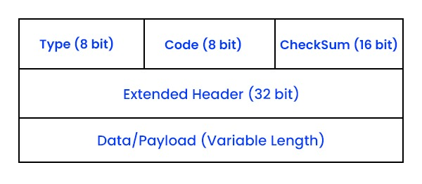
Internet Protocol – IPV4 :

- Internet Protocol (IP) is a network layer (Layer 3) protocol responsible for logical addressing and routing packets across networks so they can travel from a source host to a destination host.
✔️ Characteristics of IP :
- Connectionless → No handshake, packets are independent.
- Unreliable → No acknowledgements.
- Stateless → Routers don’t store session info.
- Best-effort → No guarantees, but efficient.
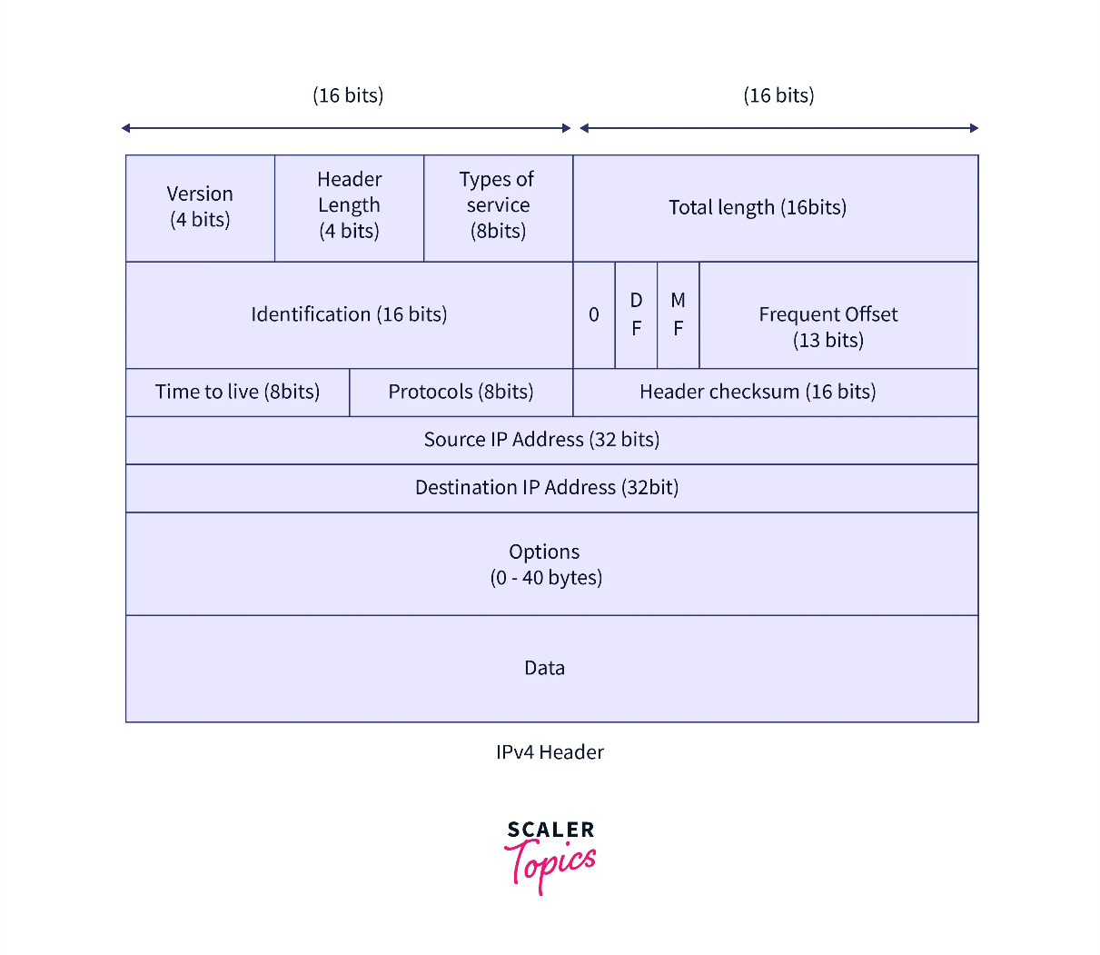

IMP for Numericals :
- HLEN = ( x * 4 )bytes
- TOTAL LEN = x bytes

Field Name | Size | Purpose / Function
Version (VER) | 4 bits | Identifies IP version (IPv4 = 4).
Header Length (IHL/HLEN) | 4 bits | Specifies header size (20–60 bytes). Tells where data begins.
Type of Service (ToS) / DSCP | 8 bits | Specifies priority/QoS: low delay, high throughput, etc.
Total Length | 16 bits | Size of entire packet (header + data). Range: 20–65,535 bytes.
Identification | 16 bits | Used for fragmentation; all fragments of a packet share this ID.
Flags | 3 bits | Controls fragmentation: DF (Don’t Fragment), MF (More Fragments).
Fragment Offset | 13 bits | Indicates fragment’s position in original datagram; used in reassembly.
Time To Live (TTL) | 8 bits | Limits packet lifetime; decremented by each router. Prevents loops.
Protocol | 8 bits | Indicates encapsulated protocol: ICMP(1), TCP(6), UDP(17).
Header Checksum | 16 bits | Error checking for header only; routers verify this.
Source IP Address | 32 bits | IP address of sender.
Destination IP Address | 32 bits | IP address of receiver; used for routing.
Options | 0–40 bytes | Rarely used fields: security, timestamp, record route, etc.
Padding | Variable | Added to make header length a multiple of 32 bits.
Data (Payload) | Variable | Actual content (TCP, UDP, ICMP, etc.) carried by IP.

Routing :
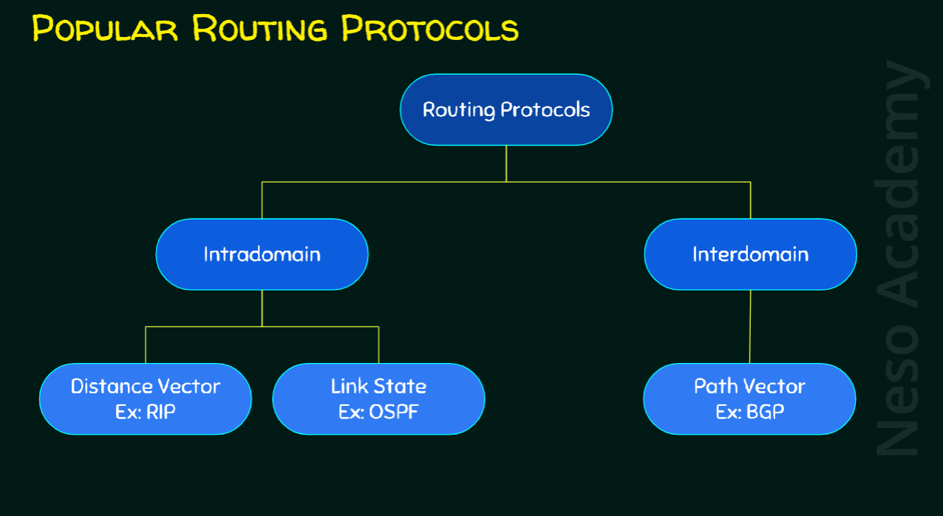

Fragmentation :
- Fragmentation is the process of breaking a large IP packet into smaller packets (fragments) so that they can pass through a network whose Maximum Transmission Unit (MTU) is smaller than the packet size.
- It is required because different networks have different MTU values, and a packet larger than the MTU cannot be transmitted as a whole.

IPv4 Header Fields Involved in Fragmentation (with purpose) :
1. Identification (16 bits)
- A unique number assigned by the sender to each packet.
- Purpose:
  - All fragments of the same original packet carry the same Identification number.
  - Helps the destination host reassemble fragments correctly.

2. Flags (3 bits)
Contains 3 bits: Reserved | DF | MF
- DF (Don't Fragment) bit
  - 1 = do not fragment.
  - 0 = fragmentation allowed.
- MF (More Fragments) bit
  - 1 = more fragments are coming.
  - 0 = this is the last fragment.
Purpose:
Controls whether a packet can be fragmented and indicates if more fragments follow.

3. Fragment Offset (13 bits)
- Indicates the position of the fragment in the original packet.
- Value is in units of 8 bytes (because fragment offset counts 8-byte blocks).
- Purpose:
  - Helps destination reassemble fragments in correct order.

4. Total Length Field
- Shows total length (header + data) of the fragment.
- Purpose:
  - Indicates how big each fragment is.

What is a Router?
- A router is a network layer device that forwards packets from one network to another.
- It uses IP addresses and a routing table to decide where to send packets.
- It connects multiple networks (LAN–LAN, LAN–WAN).

Routing
- Routing is the process of selecting the best path for a packet from source to destination.
- It involves running routing algorithms and building/updating the routing table.

Forwarding
- Forwarding is the process of sending a packet to the correct outgoing interface based on the routing table.
- It is a local, per-packet operation inside a router.

Routing vs Forwarding (Differences)
Routing | Forwarding
Path selection process. | Actual movement of packets.
Creates/updates the routing table. | Uses the routing table to pick the next hop.
Done by routing protocols (RIP, OSPF, BGP). | Done by router hardware quickly.
Network-wide decision. | Local router decision.
Happens occasionally. | Happens for every packet.

Static Routing
- Routes are manually configured by the network admin.
- Do not change automatically if network topology changes.
- Best for small, stable networks.
Dynamic Routing
- Routes are learned automatically using routing protocols.
- Routing tables update whenever topology changes.
- Best for large, changing networks.

Static vs Dynamic Routing (Exam Table)
Static Routing | Dynamic Routing
Manually configured. | Learned automatically.
No control traffic. | Uses control packets.
No CPU overhead. | Higher CPU and memory usage.
Not scalable. | Highly scalable.
Does NOT adapt automatically. | Adapts to failures automatically.

Dynamic Routing Protocols
Two types:
1. Distance Vector Protocols
- Routers share routing tables with neighbors.
- Decision based on distance metric (hop count).
- Examples:
  - RIP (Routing Information Protocol)
  - IGRP
2. Link State Protocols
- Routers flood complete topology information in the network.
- Each router runs Dijkstra’s shortest path algorithm.
- Examples:
  - OSPF (Open Shortest Path First)
  - IS-IS

Distance Vector Protocol (RIP)
- Each router maintains a routing table of distance (hop count) to all networks.
- Periodically shares this table with neighbor routers.
- Based on Bellman–Ford algorithm.
- Maximum hop count = 15, 16 = infinity.

Count-to-Infinity Problem
- In distance vector routing, when a link fails, routers may incorrectly keep increasing hop count for a network, taking a long time to converge.
- They “count” slowly upward until they reach infinity (16).
- This happens because routers trust their neighbors blindly.

Solutions to Count-to-Infinity
1. Split Horizon
- A router does not advertise a route back on the same interface from which it learned it.
Meaning:
If Router A learned about Network N from Router B,
→ A will not send the information about N back to Router B.
This prevents routing loops.

2. Poisoned Reverse (Poisoning)
- Router advertises the route back to the neighbor with metric = infinity (16 in RIP).
- Tells the neighbor:
"Don’t use me for this route — I cannot reach it."
This breaks loops faster than split horizon.

RIP (Routing Information Protocol)
RIP is a distance-vector dynamic routing protocol used in small to medium networks.
Key Features
- Uses distance vector routing based on hop count.
- Maximum hop count = 15 (16 is infinity → unreachable).
- Uses UDP port 520.
- Uses the Bellman–Ford algorithm.
- Periodic routing updates to neighbors only.

Timers in RIP :
Timer Name | Default Value | Meaning / What it Does | Why It Is Used
Update Timer | 30 seconds | Router broadcasts its entire routing table to all neighbors every 30 seconds. | Ensures all routers stay updated with the latest routing information.
Invalid Timer | 180 seconds | If no update is received for a route for 180 seconds, that route is marked invalid and metric is set to 16 (infinity). | Detects route failures; decides how long a route can stay without being refreshed.
Hold-Down Timer | 180 seconds | After a route becomes invalid or shows a worse metric, router enters hold-down state where it ignores all updates for that route unless a better metric is advertised. | Prevents routing loops and unstable fluctuations after a failure.
Flush Timer | 240 seconds | After a route is marked invalid, router waits until 240 seconds to completely remove the route from the table. | Gives routers enough time to propagate failure info before deleting the entry.

RIP messages :
1. Request Message : request for RIP routing table.
2. Response Message : respond with RIP routing table.

Link state protocol continue after computers doc :
We know it comprises of two phases :
    - Reliable transfer
    - Shortest path : For this it uses Dijkstra’s algorithm.
      - Maintains tentaive list.
      - Maintains confirmed list.
      - Both maintain an entry of form (Destination,cost,nextHop)

