**Name:** Ritesh Raju Thorve **Batch:** 7 **Date:**

**Practical:** 1. Calculate the mean and standard deviation

import numpy as np

import pandas as pd

import matplotlib.pyplot as plt

values = [15, 20, 35, 40, 50, 60, 75, 80, 90, 100]

df = pd.DataFrame({"Index": range(len(values)), "Values": values}) # Add an index column

print("Mean:", df["Values"].mean())

print("Standard Deviation:", df["Values"].std())

df["Values"].plot(kind='bar', title="Bar Chart of Values", color="skyblue")

plt.show()

df["Values"].plot(kind='line', title="Line Chart of Values", marker='o', color="red")

plt.show()

df.plot(x="Index", y="Values", kind="scatter", title="Scatter Plot", color="green") # Use "Index" column

plt.xlabel("Index") # Label the x-axis

plt.show()

**Output:**

Mean: 56.5

Standard Deviation: 29.349427403083844

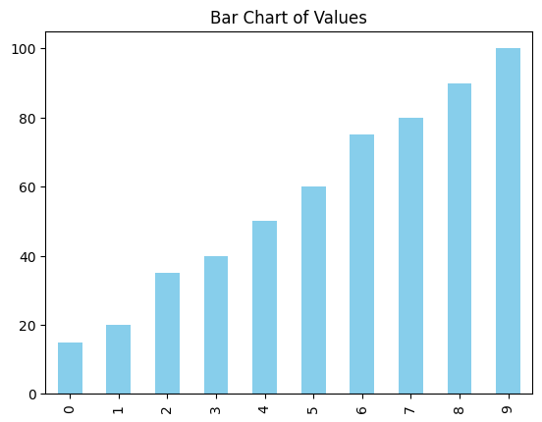

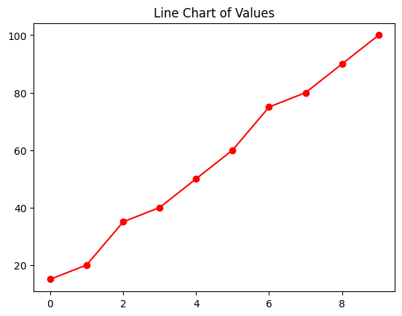

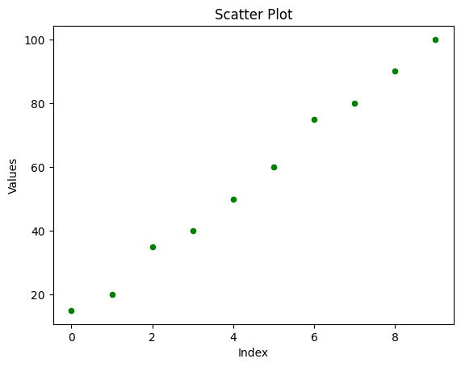

**Name:** Ritesh Raju Thorve **Batch:** 7 **Date:**

**Practical:**  2. Read the CSV file

import seaborn as sns

import pandas as pd

# Load Titanic dataset

titanic = sns.load_dataset('titanic')

# Display first few rows

print("First 5 rows of the dataset:")

print(titanic.head())

**Output:**

pgsql

Copy

Name, Age, City

John, 25, New York

Jane, 30, London

Tom, 22, Tokyo

**Name:** Ritesh Raju Thorve **Batch:** 7 **Date:**

**Practical:**  3. Perform data filtering, and calculate aggregate statistics

import pandas as pd

import seaborn as sns

# Load Titanic dataset

df = sns.load_dataset('titanic').dropna(subset=['fare']) # Remove missing fares

# Display first few rows

print(df.head())

# Filter passengers where Fare > 50

filtered = df[df['fare'] > 50]

print(filtered[['survived', 'pclass', 'sex', 'age', 'fare', 'embark_town']])

# Total & average fare by class

print(df.groupby('pclass')['fare'].agg(['sum', 'mean']))

# Total fare & count by embark town

print(df.groupby('embark_town')['fare'].agg(['sum', 'count']))

**Output:**

**1 First Few Rows of the Titanic Dataset**

survived pclass sex age fare embark town alive

0 0 3 male 22.0 7.25 Southampton no

1 1 1 female 38.0 71.28 Cherbourg yes

2 1 3 female 26.0 7.92 Southampton yes

3 1 1 female 35.0 53.10 Southampton yes

4 0 3 male 35.0 8.05 Southampton no

**2 Filtered Passengers where Fare > 50**

survived pclass sex age fare embark town

1 1 1 female 38.0 71.28 Cherbourg

3 1 1 female 35.0 53.10 Southampton

27 1 1 female 19.0 263.00 Cherbourg

31 1 1 female 29.0 211.34 Cherbourg

**3 Total & Average Fare by Class**

pclass sum mean

1 18177.63 84.15

2 3801.18 20.66

3 3576.09 13.30

**4 Total Fare & Count by Embark Town**

embark_ town sum count

Cherbourg 4846.98 123

Queenstown 760.82 30

Southampton 9946.21 286

**Name:** Ritesh Raju Thorve **Batch:** 7 **Date:**

**Practical:** 4. Calculate total sales by month**.**

import pandas as pd

import seaborn as sns

# Load Titanic dataset

df = sns.load_dataset('titanic')

# Convert 'age' to a date-like format for demonstration (assuming age as years since birth)

df['birth_year'] = (1912 - df['age'].fillna(df['age'].median())).astype(int) # Titanic sank in 1912

# Group by birth year and count passengers

yearly_counts = df.groupby('birth_year')['survived'].count()

# Print result

print(yearly_counts)

**Output:**

birth_year

1824 1

1840 1

1850 3

1851 1

1852 1

1853 1

1854 1

1855 4

1856 3

1857 1

...

1907 12

1908 10

1909 6

1910 6

1911 4

1912 1

Name: survived, dtype: int64

**Name:** Ritesh Raju Thorve **Batch:** 7 **Date:**

**Practical:** 5. Implement the Clustering using K-means.

import matplotlib.pyplot as plt

from sklearn.cluster import KMeans

from sklearn.datasets import make_blobs

# Generate sample data

X, y = make_blobs(n_samples=300, centers=4, cluster_std=0.6, random_state=42)

# Plot raw data

plt.scatter(X[:, 0], X[:, 1], s=50, c='gray', marker='o')

plt.title("Raw Data")

plt.xlabel("Feature 1")

plt.ylabel("Feature 2")

plt.show()

# Apply K-means clustering

kmeans = KMeans(n_clusters=4, random_state=42, n_init=10)

kmeans.fit(X)

# Get cluster labels and centroids

labels = kmeans.labels_

centroids = kmeans.cluster_centers_

# Plot clustered data

plt.scatter(X[:, 0], X[:, 1], c=labels, cmap='viridis', s=50)

plt.scatter(centroids[:, 0], centroids[:, 1], s=200, c='red', marker='X', label='Centroids')

plt.title("K-means Clustering")

plt.xlabel("Feature 1")

plt.ylabel("Feature 2")

plt.legend()

plt.show()

**Output:**

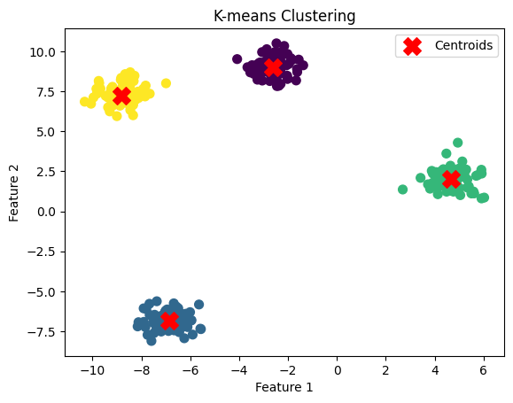

**Name:** Ritesh Raju Thorve **Batch:** 7 **Date:**

**Practical:** 6. Classification using Random Forest.

from sklearn.ensemble import RandomForestClassifier

from sklearn.model_selection import train_test_split

from sklearn.datasets import load_iris

from sklearn.metrics import accuracy_score, classification_report

# Load dataset

X, y = load_iris(return_X_y=True)

X_train, X_test, y_train, y_test = train_test_split(X, y, test_size=0.3, random_state=42)

# Train RandomForest model

rf = RandomForestClassifier(n_estimators=100, random_state=42).fit(X_train, y_train)

# Predictions

y_pred = rf.predict(X_test)

# Metrics

print(f"Accuracy: {accuracy_score(y_test, y_pred) * 100:.2f}%")

print("Classification Report:\n", classification_report(y_test, y_pred))

print("Feature Importances:", dict(zip(load_iris().feature_names, rf.feature_importances_))).

**Output:**

Accuracy: 100.00%

Classification Report:

precision recall f1-score support

0 1.00 1.00 1.00 19

1 1.00 1.00 1.00 13

2 1.00 1.00 1.00 13

accuracy 1.00 45

macro avg 1.00 1.00 1.00 45

weighted avg 1.00 1.00 1.00 45

Feature Importances: {'sepal length (cm)': np.float64(0.10410500706117767), 'sepal width (cm)': np.float64(0.04460498814966301), 'petal length (cm)': np.float64(0.4173081338019912), 'petal width (cm)': np.float64(0.4339818709871682)}

**Name:** Ritesh Raju Thorve **Batch:** 7 **Date:**

**Practical:** 7. Regression Analysis using Linear Regression

import numpy as np

import pandas as pd

import matplotlib.pyplot as plt

from sklearn.model_selection import train_test_split

from sklearn.linear_model import LinearRegression

from sklearn.metrics import mean_squared_error, r2_score

# Data

df = pd.DataFrame({'YearsExperience': range(1, 11), 'Salary': np.arange(40000, 60000, 2000)})

# Split data

X_train, X_test, y_train, y_test = train_test_split(df[['YearsExperience']], df['Salary'], test_size=0.2, random_state=42)

# Train model

model = LinearRegression().fit(X_train, y_train)

# Predictions

y_pred = model.predict(X_test)

# Metrics

print(f"MSE: {mean_squared_error(y_test, y_pred):.2f}")

print(f"R² Score: {r2_score(y_test, y_pred):.2f}")

# Plot results

plt.scatter(X_test, y_test, color='blue', label='Actual')

plt.plot(X_test, y_pred, color='red', label='Predicted')

plt.xlabel('Years of Experience')

plt.ylabel('Salary')

plt.title('Linear Regression: Salary vs Experience')

plt.legend()

plt.show()

# Prediction for new data

print(f"Predicted Salary (11 years): ${model.predict([[11]])[0]:,.2f}")

**Output:**

**MSE: 0.00**

**R² Score: 1.00**

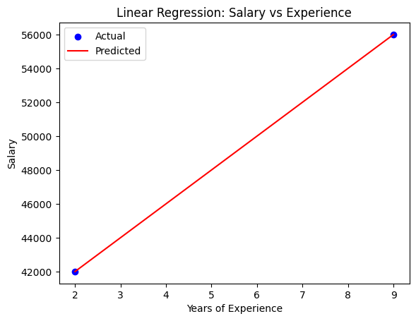

Predicted Salary (11 years): $60,000.00

**Name:** Ritesh Raju Thorve **Batch:** 7 **Date:**

**Practical:** 8. Association Rule Mining using Apriori.

import pandas as pd

from itertools import combinations

# Transaction data

df = pd.DataFrame({

'Milk': [1, 1, 0, 1, 1],

'Bread': [1, 1, 1, 1, 0],

'Butter': [0, 1, 1, 1, 1],

'Cheese': [1, 0, 1, 1, 1]

})

# Compute item frequencies (support)

support_threshold = 0.6

total_transactions = len(df)

# Find frequent individual items

frequent_items = {}

for item in df.columns:

support = df[item].sum() / total_transactions

if support >= support_threshold:

frequent_items[frozenset([item])] = support

# Find frequent item pairs

frequent_pairs = {}

for item1, item2 in combinations(df.columns, 2):

support = (df[item1] & df[item2]).sum() / total_transactions

if support >= support_threshold:

frequent_pairs[frozenset([item1, item2])] = support

# Generate association rules (confidence metric)

confidence_threshold = 0.7

rules = []

for itemset, support in frequent_pairs.items():

item1, item2 = list(itemset)

confidence_1 = support / frequent_items[frozenset([item1])]

confidence_2 = support / frequent_items[frozenset([item2])]

if confidence_1 >= confidence_threshold:

rules.append((item1, item2, confidence_1))

if confidence_2 >= confidence_threshold:

rules.append((item2, item1, confidence_2))

# Display results

print("Frequent Itemsets:")

for itemset, support in {**frequent_items, **frequent_pairs}.items():

print(f"{set(itemset)}: Support = {support:.2f}")

print("\nAssociation Rules:")

for antecedent, consequent, confidence in rules:

print(f"{antecedent} → {consequent} (Confidence: {confidence:.2f})")

**Output:**

Frequent Itemsets:

{'Milk'}: Support = 0.80

{'Bread'}: Support = 0.80

{'Butter'}: Support = 0.80

{'Cheese'}: Support = 0.80

{'Milk', 'Bread'}: Support = 0.60

{'Milk', 'Butter'}: Support = 0.60

{'Milk', 'Cheese'}: Support = 0.60

{'Bread', 'Butter'}: Support = 0.60

{'Bread', 'Cheese'}: Support = 0.60

{'Cheese', 'Butter'}: Support = 0.60

Association Rules:

Milk → Bread (Confidence: 0.75)

Bread → Milk (Confidence: 0.75)

Milk → Butter (Confidence: 0.75)

Butter → Milk (Confidence: 0.75)

Milk → Cheese (Confidence: 0.75)

Cheese → Milk (Confidence: 0.75)

Bread → Butter (Confidence: 0.75)

Butter → Bread (Confidence: 0.75)

Bread → Cheese (Confidence: 0.75)

Cheese → Bread (Confidence: 0.75)

Cheese → Butter (Confidence: 0.75)

Butter → Cheese (Confidence: 0.75)

**Name:** Ritesh Raju Thorve **Batch:** 7 **Date:**

**Practical:** 9. Visualize the result of the clustering and compare

import numpy as np

import matplotlib.pyplot as plt

from sklearn.datasets import make_blobs

from sklearn.cluster import KMeans, DBSCAN

# Generate synthetic dataset

X, _ = make_blobs(n_samples=300, centers=3, cluster_std=1.0, random_state=42)

# K-Means Clustering

kmeans = KMeans(n_clusters=3, random_state=42, n_init=10)

kmeans_labels = kmeans.fit_predict(X)

# DBSCAN Clustering

dbscan = DBSCAN(eps=0.8, min_samples=5)

dbscan_labels = dbscan.fit_predict(X)

# Plot results

fig, axes = plt.subplots(1, 2, figsize=(12, 5))

for ax, labels, title, centers in zip(

axes,

[kmeans_labels, dbscan_labels],

["K-Means Clustering", "DBSCAN Clustering"],

[kmeans.cluster_centers_, None],

):

ax.scatter(X[:, 0], X[:, 1], c=labels, cmap="viridis", edgecolor="k")

if centers is not None:

ax.scatter(centers[:, 0], centers[:, 1], c="red", marker="X", s=200, label="Centroids")

ax.legend()

ax.set_title(title)

plt.show()

**Output:**

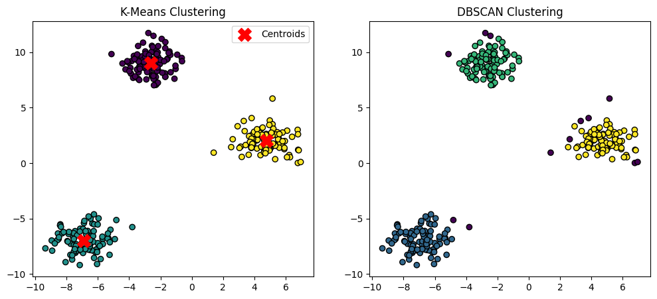

**Name:** Ritesh Raju Thorve **Batch:** 7 **Date:**

**Practical:** 10. Visualize the correlation matrix using a pseudocolor plot.

import numpy as np

import pandas as pd

import matplotlib.pyplot as plt

import seaborn as sns

# Generate a random dataset

np.random.seed(42)

data = pd.DataFrame(np.random.rand(10, 5), columns=['A', 'B', 'C', 'D', 'E'])

# Compute the correlation matrix

corr_matrix = data.corr()

# Create a heatmap

plt.figure(figsize=(8, 6))

sns.heatmap(corr_matrix, annot=True, cmap='coolwarm', linewidths=0.5, fmt=".2f")

plt.title('Correlation Matrix Heatmap')

plt.show()

**Output:**

**Name:** Ritesh Raju Thorve **Batch:** 7 **Date:**

**Practical:** 11. Use of degrees distribution of a network.

import networkx as nx

import matplotlib.pyplot as plt

from collections import Counter

# Generate a random Erdős-Rényi graph

G = nx.erdos_renyi_graph(n=100, p=0.05)

# Compute degree distribution

degree_count = Counter(dict(G.degree()).values())

degrees, counts = zip(*sorted(degree_count.items()))

# Plot degree distribution

plt.figure(figsize=(8, 6))

plt.bar(degrees, counts, color='b', alpha=0.7, edgecolor='k')

plt.xlabel('Degree (k)')

plt.ylabel('Number of Nodes')

plt.title('Degree Distribution of the Network')

plt.grid(axis='y', linestyle='--', alpha=0.6)

plt.show()

# Plot log-log degree distribution

plt.figure(figsize=(8, 6))

plt.scatter(degrees, counts, color='r', alpha=0.7)

plt.xscale('log')

plt.yscale('log')

plt.xlabel('Log(Degree)')

plt.ylabel('Log(Count)')

plt.title('Log-Log Degree Distribution')

plt.grid(which='both', linestyle='--', alpha=0.6)

plt.show()

**Output:**

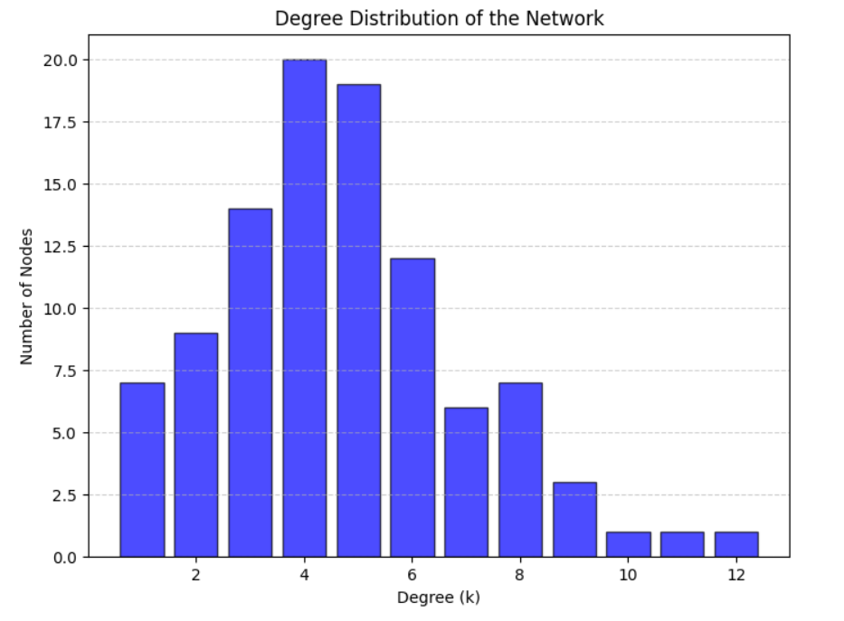

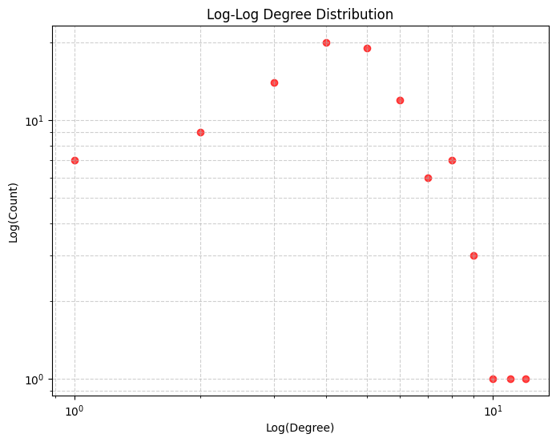

**Name:** Ritesh Raju Thorve **Batch:** 7 **Date:**

**Practical:** 11. Use of degrees distribution of a network.

import networkx as nx

import matplotlib.pyplot as plt

import numpy as np

import matplotlib.lines as mlines

# Generate a random Erdős-Rényi graph

G = nx.erdos_renyi_graph(n=100, p=0.1)

# Compute degree statistics

degree_sequence = np.array([G.degree(node) for node in G.nodes()])

max_degree, min_degree = degree_sequence.max(), degree_sequence.min()

median_degree = np.median(degree_sequence)

q1, q3 = np.percentile(degree_sequence, [25, 75])

print(f"Max Degree: {max_degree}, Min Degree: {min_degree}, Median: {median_degree}, Q1: {q1}, Q3: {q3}")

# Define color categories

bins = [min_degree, q1, median_degree, q3, max_degree]

colors = ['blue', 'green', 'yellow', 'orange', 'purple', 'red']

node_colors = [colors[np.digitize(deg, bins)] for deg in degree_sequence]

# Draw graph

plt.figure(figsize=(10, 8))

pos = nx.spring_layout(G, seed=42) # Fixed layout for consistency

nx.draw(G, pos, with_labels=True, node_size=400, node_color=node_colors, font_size=8, edge_color='gray')

# Create legend

legend_labels = [

("Max Degree", 'red', max_degree),

("Min Degree", 'blue', min_degree),

("Q1 (≤)", 'green', round(q1)),

("Median (≤)", 'yellow', round(median_degree)),

("Q3 (≤)", 'orange', round(q3)),

("Above Q3", 'purple', "")

]

handles = [mlines.Line2D([], [], color=c, marker='o', markersize=10, label=f"{label} {value}")

for label, c, value in legend_labels]

plt.legend(handles=handles, loc="upper left", fontsize=9)

plt.title("Network Visualization with Degree-Based Coloring")

plt.show()

**Output:**

