**Assistant Internal Audit Officer (A-IAO): AI-Powered Smart Governance & Audit Partner**

**Category: Idea / Product (Prototype) (AI Solution for e-governance)**

1. **Introduction**

Governance refers to the way decisions are made, implemented, and monitored in an organization, institution, or government. It includes policies, processes, laws, and structures that ensure accountability, transparency, and participation. Urban areas like in Delhi face challenges like population growth, congestion, infrastructure needs, and service delivery. Governance and e-governance help improve planning and management for policy formulation, accountability, transparency, resource allocation, sustainable development etc. In a government context, governance is about how public resources are managed and how services are delivered to citizens.

1. **The Problem**

Governance processes often face delays due to manual and time-intensive workflows.

● Officers spend long hours reading and interpreting bulky rules, acts, and circulars.

● Policy references are dispersed across multiple documents and portals.

● Drafting audit notes, concurrence reports, or compliance summaries requires expert effort, leading to slower decision-making.

● Lot of dependency on Institutional Memory of the Government officers for addressing issues pertaining to their area of expertise

● These delays increase administrative workload and slow down service delivery.

1. **The Idea – A-IAO**

A-IAO is a digital assistant designed to work like a “smart Assistant to the officer” for governance documents.

● Think of A-IAO as a smart colleague who can:

● Read and understand government files instantly

● Recall rules, guidelines, and statutes accurately

● Generate audit reports and notes in minutes

● Provide consistent, transparent answers

1. **Features of the Prototype developed using this Idea.**

A prototype has been developed by us for Procurement process in a Governemnet Organization.. Government Guidelines, Notices, Circulars, Case Study is preloaded to the system to train the AI model (It is one-time activity). At present the Statue, Act, Ordinance, Minutes of Meeting of Board of Management, Finance Committee etc of Dr B R Ambedkar University Delhi along with GFR 2017, Procurement Manual, CVC guidelines have been uploaded at this system as a training material.

Following four points have been initially addressed in this prototype.

**Search Engine:**

The user can search and seek advice from this AI tool about any rules, regulations, policy decisions taken by Finance Committee, Board of Management, Act, Statute, Ordinances Document of the University. The search is on natural language based for unstructured data.

Trainer: This tool is working as a trainer not only to freshers and junior staff joining the University, however it can also assist senior officers.

**Financial Concurrence**

This tool can help to provide Finance Concurrence to a new proposal initiated by any indenter in line with University delegation of financial powers and GFR rules of the Government of India or any other guidelines, processes documents developed by the University or Government of GNCTD.

**Payment Proposal:**

After the procurement process is initiated and purchase is done, the payment process is to be initiated by the Government Officials. The official while initiating the payment proposal, has to check the documents for multiple points such as procurement date, delivery date, calculate liquidated damages due to late delivery if any, check the satisfactory reports from the indenter, Performance Bank Guarantee and its validity etc. This tool can read the entre document of multiple pages and guidelines and can a prepare a payment proposal which may reduce the time and efforts of the official.

**Internal Auditor:**

The role of an Internal Auditor in procurement within a government organization is critical because procurement involves spending public funds and requires high transparency, accountability, and compliance with strict regulation. The internal auditor has to assess that all procurement activities comply with government procurement laws, regulations, and policies etc (e.g., tendering processes, contract award procedures, supplier selection rules). This tool helps to assess Government e-files and draft a report. This is helpful for internal auditor because it reduces time and increases efficiency and transparency and unbiased.

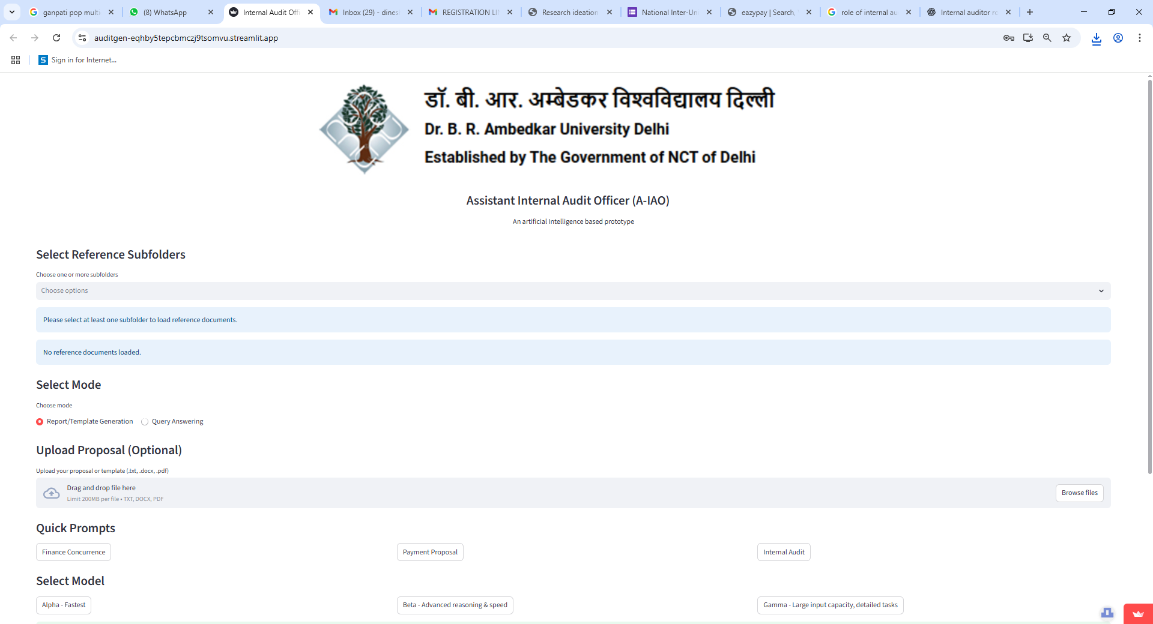

1. **How IT works**

1. Officer uploads a file (proposal, report, policy document)

2. A-IAO reads and checks compliance with all relevant rules

3. A-IAO generates a properly structured audit notes, financial concurrence reports, and compliance summaries.

4. Provides instant answers to queries such as: “Does this comply with GFR 2017 and its specific rules?” or “Which guideline applies here?” Even It can be scaled to reply to CAS promotion related matters in guidelines issued by University Grant commission.

4. Officer reviews and edits as deemed appropriate.

This reduces work from weeks to minutes. In essence, A-IAO is a trusted AI colleague, available 24×7, ensuring faster, fairer, and more transparent workflows.

1. **Why It Matters for Viksit Delhi@2047**

● Efficiency: Cuts processing time from weeks to minutes.

● Transparency: Ensures rules are applied uniformly with proper citations.

● Accessibility: Non-experts can understand and use complex policies.

● Future-Ready: Creates a digital foundation for accountable, citizen-friendly governance aligned with Smart City goals.

1. **What Makes It Unique**

Unlike generic AI chatbots, A-IAO is purpose-built for governance, audit, and finance.

● Produces ready-to-use structured notes in official formats.

● Integrates with existing document repositories.

● Scales to universities, municipalities, and government departments.

● Functions both as a compliance checker and a self-training tool for officers.

1. **Prototype & Technical Build**

We have a working prototype already in place, built as an NLP-powered governance engine.

● Core Tech Stack:

* AI Backend: GPT-based Retrieval-Augmented Generation (RAG) tuned for governance and audit documents.
* Frontend: Streamlit interface with drag-and-drop document upload.
* Document Support: PDF, DOCX, TXT; OCR integration for scanned files.
* Repository: Unified storage via Google Drive.
* API Layer: OpenAI APIs for query answering, citation, and structured output generation.
* Security: End-to-end encryption (256-bit SSL), role-based access, and compliance with IT Act 2000 + Digital India standards.

**Current Capabilities:**

* Natural Language Processing (NLP)-powered policy and guideline search.
* Automated financial concurrence notes, audit reports, and compliance checks.
* Initially developed for procurement processes; scalable to service rules, legal frameworks, and academic regulations.
* Doubles as an internal auditor and knowledge-assistant for officers.

1. **Roadmap**

● Pilot Deployment: University finance/audit systems.

● Scale-Up: Expand to other Government offices of Government of GNCTD and institutions.

● Integration: Connect with e-Governance platforms and Smart City dashboards.

1. **Impact**

● Efficiency: 60%+ reduction in compliance and audit turnaround time.

● Transparency: Every report backed by clear citations and references.

● Sustainability: Supports paperless operations and eco-friendly administration.

● Delhi@2047 Vision: Contributes to inclusive, accountable, and tech-enabled governance.

1. **Team**

● **Principal Ideator**: Shriniketh Deevanapalli, B.E. ENI, BITS Pilani

● **Co-Ideator**: Anup Sharma, B.A. Political Science, Dr B R Ambedkar University Delhi

● **Mentor**: Dr. Dinesh Taneja, Director IT Services, Dr B R Ambedkar University Delhi