SIMATS ENGINEERING
ASSESSMENT TOOL 1 — COMPUTER NETWORKS
QUESTION 3
ARP REQUEST AND ARP REPLY ANALYSIS
Scenario-Based Practical Manual
Course Name: Computer Networks
Course Code: CSA07
Course Outcome: CO3
Software: Cisco Packet Tracer and Wireshark

1. Experiment Overview
This experiment constructs a local area network with hosts connected through a switch. The ARP cache of a host is inspected/cleared, communication is initiated using ping, and ARP traffic is analyzed. The purpose is to demonstrate how a logical IPv4 address is associated with a physical Ethernet MAC address before local frame delivery.

1.1 Aim
To construct and configure a local area network using Cisco Packet Tracer, clear/inspect the ARP cache of a host, initiate communication using ping, and analyze ARP Request and ARP Reply information using Wireshark.

1.2 Objectives
- Construct a switched LAN with two hosts.
- Configure IPv4 addresses and subnet masks.
- Verify connectivity using ping.
- Inspect the ARP cache.
- Force a fresh ARP resolution after cache clearing.
- Identify sender and target MAC/IP addresses.
- Explain the role of ARP in local Ethernet communication.

1.3 Software and Components
Component | Purpose
Cisco Packet Tracer | Create and configure the LAN simulation.
Wireshark | Inspect captured ARP packet fields.
2960-24TT Switch | Provide Layer-2 connectivity.
PC0 and PC1 | Source and destination hosts.

2. Network Topology
The implemented topology contains one 2960-24TT switch and two PCs. Both hosts are in the same 192.168.1.0/24 subnet, so they can communicate directly through the switch without a router.
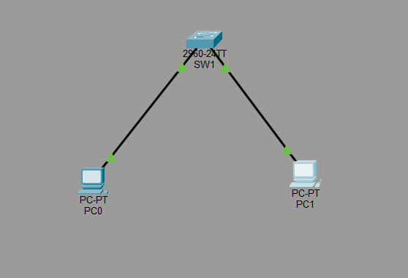
Figure 2.1 — Actual Cisco Packet Tracer topology used for the experiment.

2.1 Addressing Plan
Device | Interface | IPv4 Address | Subnet Mask
PC0 | FastEthernet0 | 192.168.1.10 | 255.255.255.0
PC1 | FastEthernet0 | 192.168.1.20 | 255.255.255.0

3. Implementation and Configuration

3.1 PC0 Configuration
PC0 was configured with IPv4 address 192.168.1.10 and subnet mask 255.255.255.0. The default gateway was left blank because the destination is on the same subnet.
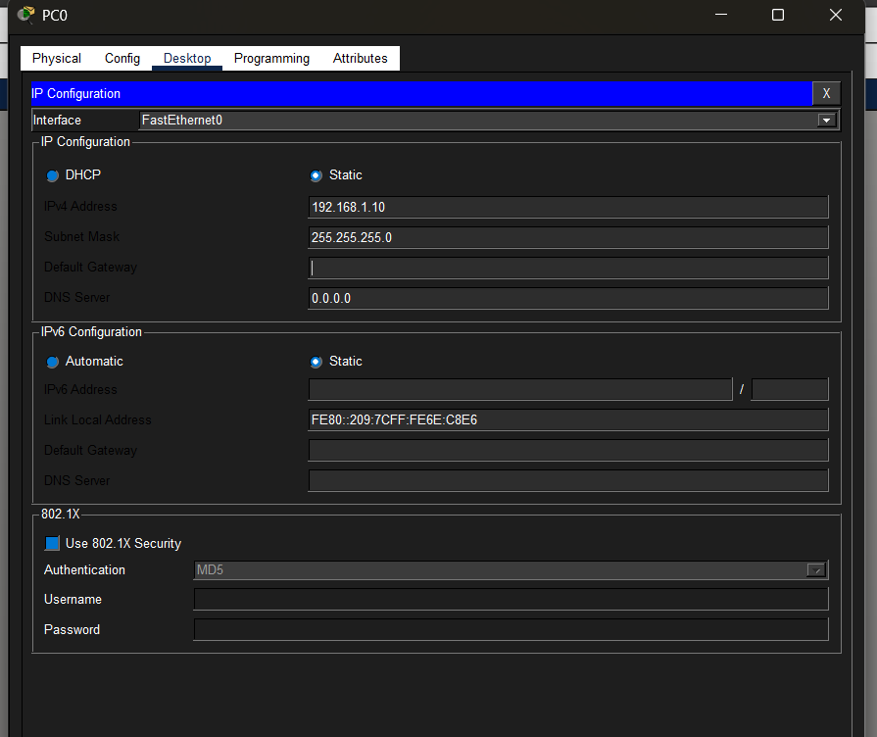
Figure 3.1 — Actual PC0 IP Configuration.

3.2 PC1 Configuration
PC1 was configured with IPv4 address 192.168.1.20 and subnet mask 255.255.255.0.
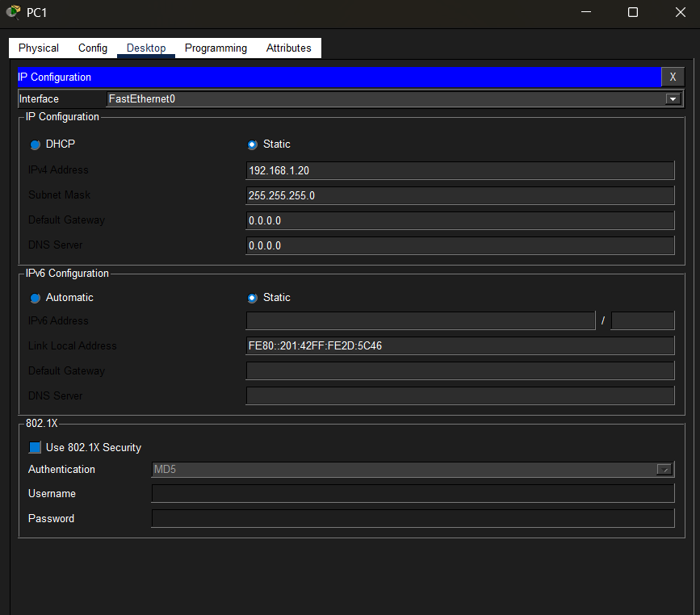
Figure 3.2 — Actual PC1 IP Configuration.

3.3 Connectivity Verification
From PC0, the command ping 192.168.1.20 was executed. The uploaded result shows four replies, zero packet loss, and an average round-trip time of 1 ms.
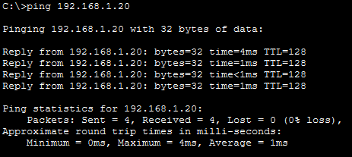
Figure 3.3 — Actual successful ping from PC0 to PC1.

4. ARP Cache Inspection
The command arp -a was executed on PC0. The uploaded result shows a dynamic entry for 192.168.1.20 mapped to 0001.422d.5c46.
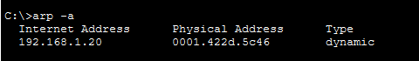
Figure 4.1 — Actual ARP table displayed on PC0.

4.1 Clearing the ARP Cache
To force a fresh address-resolution process, the ARP cache should be cleared before the final ping/capture. Use the following command in PC0's Command Prompt:
arp -d
Then verify the table with arp -a. After the old mapping is removed, run ping 192.168.1.20 again. The source must resolve the destination MAC before normal local communication can proceed.
The uploaded evidence shows the populated ARP table, but it does not contain a screenshot of the cleared table. If the manual is being submitted with step-by-step visual proof, add one screenshot immediately after arp -d and arp -a.

5. Wireshark ARP Analysis
The uploaded Wireshark screenshot shows an actual ARP Request packet. The packet contains Ethernet II information followed by Address Resolution Protocol fields.
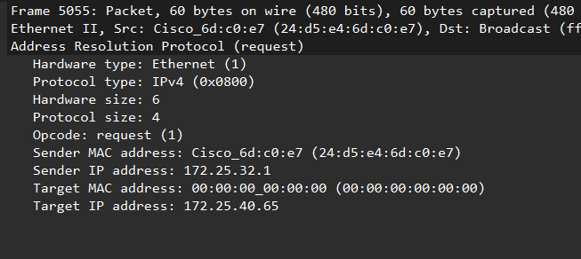
Figure 5.1 — Actual Wireshark ARP Request packet supplied as experiment evidence.

5.1 Observed Packet Fields
Field | Observed value | Interpretation
Hardware Type | Ethernet (1) | The ARP exchange is for Ethernet.
Protocol Type | IPv4 (0x0800) | ARP is resolving an IPv4 address.
Hardware Size | 6 | Ethernet MAC address length is 6 bytes.
Protocol Size | 4 | IPv4 address length is 4 bytes.
Opcode | request (1) | The captured packet is an ARP Request.
Sender MAC | 24:d5:e4:6d:c0:e7 | MAC address shown for the sender.
Sender IP | 172.25.32.1 | Sender IPv4 address shown in this capture.
Target MAC | 00:00:00:00:00:00 | Target MAC is unknown at request stage.
Target IP | 172.25.40.65 | IPv4 address being resolved.

5.2 Important Evidence Consistency Note
The Packet Tracer screenshots use 192.168.1.10 and 192.168.1.20, while the uploaded Wireshark screenshot shows sender 172.25.32.1 and target 172.25.40.65. These values do not match. Therefore, the Wireshark image should be described as the actual ARP evidence supplied, but it should not be claimed to be the exact packet generated by the displayed Packet Tracer 192.168.1.0/24 topology.
For the strongest final submission, repeat the Wireshark capture after clearing the ARP cache and pinging 192.168.1.20, then replace Figure 5.1 with that matching capture. This will make the topology, addressing, ARP table and packet analysis fully consistent.

6. Procedure
- Open Cisco Packet Tracer and place one 2960-24TT switch and two PCs.
- Connect PC0 and PC1 to the switch using Ethernet connections.
- Configure PC0 as 192.168.1.10 with subnet mask 255.255.255.0.
- Configure PC1 as 192.168.1.20 with subnet mask 255.255.255.0.
- From PC0, execute ping 192.168.1.20 and verify successful replies.
- Run arp -a on PC0 and record the learned IP-to-MAC mapping.
- Clear the ARP cache using arp -d.
- Run arp -a again to verify the mapping is removed.
- Start the packet capture and generate traffic by running ping 192.168.1.20.
- Filter the capture using arp.
- Inspect the ARP Request and record sender/target MAC and IP fields.
- Inspect the corresponding ARP Reply and record its sender/target fields.

7. Conceptual Explanation
ARP (Address Resolution Protocol) resolves an IPv4 address to a MAC address on a local network. When PC0 knows that the destination is 192.168.1.20 but does not have a valid MAC mapping, it sends an ARP Request. The request asks which host owns the target IP address.
The request is broadcast on the local Ethernet LAN. PC1, which owns the requested IPv4 address, responds with an ARP Reply containing its MAC address. PC0 can then store the mapping and use the destination MAC when constructing Ethernet frames.

7.1 ARP Message Sequence
- PC0 checks its ARP cache.
- No valid mapping is available.
- PC0 sends an ARP Request.
- PC1 identifies the requested IP address as its own.
- PC1 sends an ARP Reply containing its MAC address.
- PC0 learns the IP-to-MAC mapping.
- Normal local IP communication proceeds using Ethernet frames.

8. Result Analysis
The LAN was successfully implemented in Cisco Packet Tracer. The two hosts were configured in the same subnet and connectivity was verified with four successful ping replies and 0% packet loss. PC0's ARP table contained a dynamic mapping for 192.168.1.20 to 0001.422d.5c46, confirming that the destination MAC had been learned.
The supplied Wireshark evidence contains an ARP Request with opcode 1 and shows sender/target addressing fields. The target MAC is all zeroes because the sender is requesting the MAC corresponding to the target IPv4 address. This is the key mechanism by which ARP supports local Ethernet delivery.

9. Validation Summary
Validation | Evidence | Status
Topology | 2960-24TT switch with PC0 and PC1 | Completed
PC0 addressing | 192.168.1.10 / 255.255.255.0 | Completed
PC1 addressing | 192.168.1.20 / 255.255.255.0 | Completed
Connectivity | 4 received, 0 lost, average 1 ms | Verified
ARP table | 192.168.1.20 → 0001.422d.5c46 | Observed
Wireshark | ARP Request, opcode 1, fields visible | Observed

10. Screenshot Checklist for Final Submission
- Complete Packet Tracer topology.
- PC0 IP Configuration.
- PC1 IP Configuration.
- Successful ping from PC0 to PC1.
- ARP table after the mapping is learned.
- ARP table immediately after clearing the cache (recommended additional screenshot).
- Wireshark ARP Request with expanded fields.
- Wireshark ARP Reply with expanded fields (recommended additional screenshot).

11. Result
The local area network was successfully configured using Cisco Packet Tracer. PC0 and PC1 communicated successfully through the switch, and the ARP table confirmed the learned IP-to-MAC mapping. Wireshark analysis demonstrated the structure of an ARP Request, including Ethernet hardware type, IPv4 protocol type, opcode, sender MAC/IP and target MAC/IP fields. The experiment verifies that ARP provides the address-resolution mechanism required before local Ethernet frame delivery.

12. Conclusion
The experiment demonstrates the relationship between logical IPv4 addressing and physical MAC addressing in a switched LAN. By inspecting the ARP cache and examining an ARP Request in Wireshark, the address-resolution process can be understood at packet level. The successful ping validates the configured LAN, while the ARP evidence explains how the source learns the destination's physical address.

