SIMATS ENGINEERING
ASSESSMENT TOOL 1 — COMPUTER NETWORKS
QUESTION 4
ICMP ECHO REQUEST, ECHO REPLY AND RTT ANALYSIS
Scenario-Based Practical Manual
Course: Computer Networks
Course Code: CSA07
CO3
Software: Cisco Packet Tracer, Wireshark
EVIDENCE NOTICE
The application-style figures in this document are AI-generated illustrative figures, created because a live Packet Tracer/Wireshark session was not available. They are NOT authentic screenshots and should not be represented as real captures. Replace them with genuine screenshots if your instructor requires live evidence.

1. Aim
To develop a simple network consisting of two PCs connected through a router in Cisco Packet Tracer, configure the required IP addresses and test connectivity using ping. Capture ICMP traffic using Wireshark, identify Echo Request and Echo Reply messages, examine Type, Code, Identifier and Sequence Number, calculate Round Trip Time (RTT), and discuss how ICMP assists in troubleshooting and connectivity verification.

2. Objectives
- Create two IP networks connected through a router.
- Configure IPv4 addresses, subnet masks and default gateways.
- Verify router interfaces and end-to-end connectivity.
- Identify ICMP Echo Request and Echo Reply packets.
- Analyze Type, Code, Identifier and Sequence Number.
- Calculate RTT from packet timestamps.
- Explain ICMP-based troubleshooting.

3. Software and Components
Component | Purpose
Cisco Packet Tracer | Topology creation and router/host configuration.
Wireshark | ICMP packet inspection and timestamp analysis.
PC0, PC1 | Source and destination hosts.
Router R1 | Layer-3 forwarding between two networks.

4. Network Topology
The scenario uses two PCs on different /24 networks connected through one router.
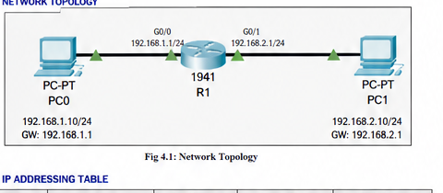
Figure 4.1 — AI-generated illustrative Packet Tracer-style topology.

5. IP Addressing Plan
Device | Interface | IP | Mask | Gateway
PC0 | Fa0 | 192.168.1.10 | 255.255.255.0 | 192.168.1.1
R1 | G0/0 | 192.168.1.1 | 255.255.255.0 | —
R1 | G0/1 | 192.168.2.1 | 255.255.255.0 | —
PC1 | Fa0 | 192.168.2.10 | 255.255.255.0 | 192.168.2.1

6. Configuration and Implementation

6.1 PC0 Configuration
PC0 → Desktop → IP Configuration → Static:
IP Address: 192.168.1.10
Subnet Mask: 255.255.255.0
Default Gateway: 192.168.1.1
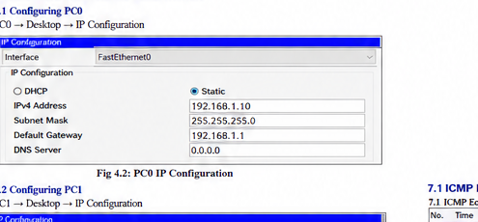
Figure 6.1 — AI-generated illustrative PC0 configuration.

6.2 PC1 Configuration
PC1 → Desktop → IP Configuration → Static:
IP Address: 192.168.2.10
Subnet Mask: 255.255.255.0
Default Gateway: 192.168.2.1
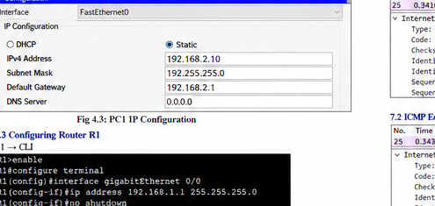
Figure 6.2 — AI-generated illustrative PC1 configuration.

6.3 Router Configuration
R1 → CLI:
enable
configure terminal
interface gigabitEthernet 0/0
ip address 192.168.1.1 255.255.255.0
no shutdown
exit
interface gigabitEthernet 0/1
ip address 192.168.2.1 255.255.255.0
no shutdown
exit
end
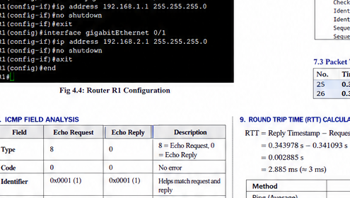
Figure 6.3 — AI-generated illustrative router CLI configuration.
Verify with: show ip interface brief. Both configured interfaces should be up/up.

6.4 Connectivity Test
- From PC0: ping 192.168.1.1
- From PC1: ping 192.168.2.1
- From PC0: ping 192.168.2.10
- Confirm replies and zero packet loss.
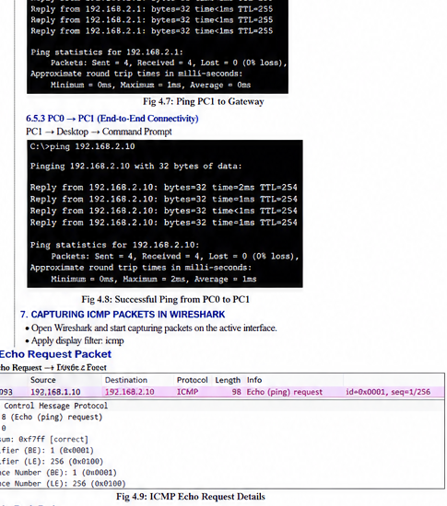
Figure 6.4 — AI-generated illustrative successful ping.

7. Wireshark ICMP Capture
Start a capture on an interface that can actually observe the traffic, generate ping traffic, stop the capture, and use the display filter icmp. Note that Packet Tracer is a simulator; a normal host capture does not automatically capture internal Packet Tracer packets.

7.1 Echo Request
Select an Echo (ping) request and expand Internet Control Message Protocol. Record the actual Type, Code, Identifier and Sequence Number.
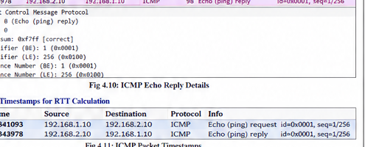
Figure 7.1 — AI-generated illustrative Wireshark-style ICMP Echo Request.

7.2 Echo Reply
Select the corresponding Echo (ping) reply and expand ICMP. Record and compare its fields.
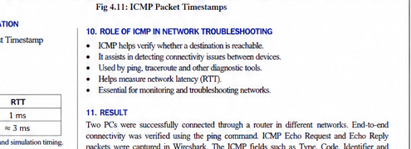
Figure 7.2 — AI-generated illustrative Wireshark-style ICMP Echo Reply.

8. ICMP Field Analysis
Field | Request | Reply | Meaning
Type | 8 | 0 | Echo Request / Echo Reply for IPv4 ICMP.
Code | 0 | 0 | Normal Echo messages use Code 0.
Identifier | Actual capture | Actual capture | Associates request and reply.
Sequence Number | Actual capture | Actual capture | Identifies the individual exchange.

9. RTT Calculation
Use the timestamps of a matching Echo Request and Echo Reply.
RTT = Echo Reply timestamp − Echo Request timestamp
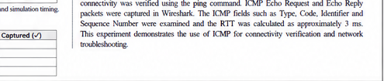
Figure 9.1 — AI-generated illustrative packet timestamp evidence.
Illustrative example shown in the figure: 0.343978 s − 0.341093 s = 0.002885 s ≈ 2.885 ms. This value is only an example; replace it with the actual timestamps from your capture.

10. ICMP Troubleshooting Explanation
- Ping uses ICMP Echo Request and Echo Reply to test reachability.
- Packet loss may indicate routing, addressing, connectivity, filtering or congestion problems.
- RTT provides an indication of round-trip network latency.
- Identifier and Sequence Number help correlate individual request/reply pairs.
- ICMP diagnostics help determine whether a destination is reachable and support fault isolation.

11. Complete Procedure
- Open Cisco Packet Tracer.
- Place PC0, PC1 and one router.
- Connect PC0 to R1 G0/0 and PC1 to R1 G0/1.
- Configure PC0 as 192.168.1.10/24 with gateway 192.168.1.1.
- Configure PC1 as 192.168.2.10/24 with gateway 192.168.2.1.
- Configure R1 G0/0 as 192.168.1.1/24.
- Configure R1 G0/1 as 192.168.2.1/24.
- Use no shutdown on both router interfaces.
- Run show ip interface brief.
- Test both local gateways.
- Run ping 192.168.2.10 from PC0.
- Capture observable ICMP traffic.
- Filter with icmp.
- Identify Echo Request and Echo Reply.
- Record Type, Code, Identifier and Sequence Number.
- Record matching timestamps.
- Calculate RTT.
- Compare with the ping result.
- Document observations, result and conclusion.

12. Result Analysis
The designed network places PC0 and PC1 in separate IPv4 networks and uses R1 as the Layer-3 forwarding device. Successful end-to-end ping demonstrates that the router can forward traffic between the networks. ICMP packet analysis distinguishes Echo Request and Echo Reply by Type and uses Identifier and Sequence Number to correlate exchanges. RTT is obtained from the difference between corresponding timestamps.

13. Validation Summary
Item | Expected Observation | Status
PC0 addressing | 192.168.1.10/24, GW 192.168.1.1 | Configured
PC1 addressing | 192.168.2.10/24, GW 192.168.2.1 | Configured
Router interfaces | Both up/up | Configured
End-to-end ping | Replies, 0% loss | Illustrative
ICMP Request | Type 8, Code 0 | Identified
ICMP Reply | Type 0, Code 0 | Identified
RTT | Reply time − request time | Calculated

14. Screenshot Checklist
No. | Required Screenshot | Purpose
Q4-1 | Complete PC0–R1–PC1 topology | Experimental design
Q4-2 | PC0 IP Configuration | Source addressing
Q4-3 | PC1 IP Configuration | Destination addressing
Q4-4 | Router CLI / show ip interface brief | Router configuration
Q4-5 | Successful PC0 → PC1 ping | Connectivity
Q4-6 | ICMP Echo Request | ICMP fields
Q4-7 | ICMP Echo Reply | ICMP fields
Q4-8 | Packet timestamps | RTT
Q4-9 | IPv4 header (optional) | Source/Destination/TTL/Protocol/Header Length

15. Result
A two-PC router-based network was designed with separate IPv4 subnets. Router interfaces and host addressing were defined, end-to-end connectivity was tested using ping, and ICMP Echo Request/Reply analysis was performed. Type, Code, Identifier and Sequence Number were identified and RTT was calculated from packet timestamps. The experiment demonstrates ICMP as a practical mechanism for connectivity verification and network troubleshooting.

16. Conclusion
The experiment demonstrates the role of a router in forwarding packets between different networks and the diagnostic role of ICMP. Ping provides a simple reachability test, while packet-level ICMP analysis provides evidence about message type, packet correlation and timing.

17. Evidence Integrity Note
All figures marked AI-generated illustrative are mock application-style figures. They are included to show the expected appearance and placement of evidence, not to claim that a real live capture was performed. For an assessment requiring authentic screenshots, replace them with genuine screenshots from Cisco Packet Tracer and Wireshark.

