Deep Learning-Based Intelligent Visual Diagnosis of Tomato Yellow Leaf Curl Virus Using Leaf Images: A Leakage-Aware Framework and Data Audit
Ritesh Dwivedi  Department of CSE  Chandigarh University  Gharuan, Punjab, India  25mds10023@cuchd.in | Dr. Sneha Garg  Department of CSE  Chandigarh University  Gharuan, Punjab, India | Dr. Navneet Kaur  Department of CSE  Chandigarh University  Gharuan, Punjab, India

Abstract—Tomato yellow leaf curl virus (TYLCV) causes severe losses in tomato, and rapid, correct field screening would support timely vector control and removal of infected plants. Deep learning can recognise TYLCV-like symptoms in leaf photographs, but published accuracies are usually measured on lab-background benchmarks with random image-level splits, and little is known about field behaviour. This paper presents a leakage-aware framework for leaf-image TYLCV screening: duplicate-aware data splitting, transfer-learning classifiers with temperature-scaled probabilities and Grad-CAM explanations, a six-level evaluation maturity ladder, and a decision-support layer that connects a screening result to risk, resistance and vector-management information. We report three sets of results. An audit of a public TYLCV image folder (100 photographs) shows that every image is positive, that 91% are lab-style images, that leaf coverage alone separates lab-style from field photographs, and that two photographs occur twice. A controlled experiment on synthetic images shows how a random split inflates accuracy relative to a duplicate-aware split. A simulated benchmark shows that a calibrated model outperforms heuristic and single-factor baselines. No image classifier has yet been trained on real labelled leaf photographs, so we make no claim about field diagnostic accuracy and specify the data and protocol needed to establish it.
Index Terms—tomato yellow leaf curl virus, deep learning, leaf-image diagnosis, data leakage, calibration, explainable AI, domain shift, decision support.
I. INTRODUCTION
Tomato yellow leaf curl virus (TYLCV) is among the most damaging pathogens of tomato; when plants are infected early almost no marketable fruit is produced [1]. The virus is transmitted by whiteflies in a persistent manner [2], can be seed-transmissible [3] and has spread worldwide [4]. With no cure for infected plants, control relies on vector exclusion, resistant cultivars and early removal of infected plants [1], [5], [6], so early detection is the first step. Detection currently depends on trained observers, a scarce and subjective skill, whereas smartphones are widespread. This has motivated deep-learning diagnosis from leaf photographs, with accuracies above 99% on the PlantVillage benchmark [7], [8].
Benchmark accuracy, however, is a poor guide to field performance. The first large study reported a drop to roughly 31% on images taken under other conditions [7]; benchmark backgrounds can leak the class [9], [10]; and field accuracy is lower than benchmark accuracy [11], [12], [13]. For TYLCV we face three further problems: we know of no public leaf-image set with healthy leaves, look-alike disorders, field photographs and molecular confirmation; random image-level splits give optimistic scores when photographs are duplicated; and a classifier answers only whether a leaf looks infected, whereas a grower must decide what to do next, which depends on vector pressure and resistance [14].
This paper contributes: (i) a leakage-aware framework for leaf-image TYLCV screening and an evaluation maturity ladder; (ii) a decision-support prototype, TYLCV-Guard; (iii) an audit of a public TYLCV image folder using real photographs; (iv) a controlled leakage experiment; and (v) a simulated benchmark with sensitivity analyses. *No image classifier was trained or evaluated on real labelled leaf photographs*, because the only real photographs available to us were all positive; the results therefore concern data, evaluation and decision support, not field diagnostic accuracy.
II. RELATED WORK
Plant-disease CNNs, first fine-tuned on leaf images [7], reach very high accuracy on PlantVillage and perform similarly across architectures [8], [15]; tomato studies compare CNNs and visualise symptoms [16]. The lab-to-field gap is the central finding: variety of conditions matters more than image count [11], field-captured training images are needed [17], [18], training should reflect practical variation [13], and PlantVillage backgrounds alone carry class information [9], an instance of shortcut learning [10]. PlantDoc provides harder in-the-wild images [19], and detection of tomato diseases and pests has been shown on field images [20] and in greenhouses with severity estimation [21]. Field use favours small models [22]; modern networks are over-confident, which temperature scaling corrects [23]; Grad-CAM explains decisions [24] but saliency needs validation [25]; and general benchmarks show failure under distribution shift [26]. TYLCV control combines exclusion, resistance and vector monitoring [6], with climate effects [27] and insecticide resistance [14] as complications.
III. FRAMEWORK
A. Duplicate-aware splitting
Each image is hashed (16×16 average hash, 256 bits); images within 12 bits are linked and each connected component is a group. Groups are assigned class by class to training (70%), validation (15%) and test (15%) so that no group is divided. The leak fraction of a split is the share of test images whose group also occurs in training. The 12-bit threshold linked the true duplicates and no unrelated images in the audited folder; a coarser 8×8 hash merged unrelated leaves and was rejected.
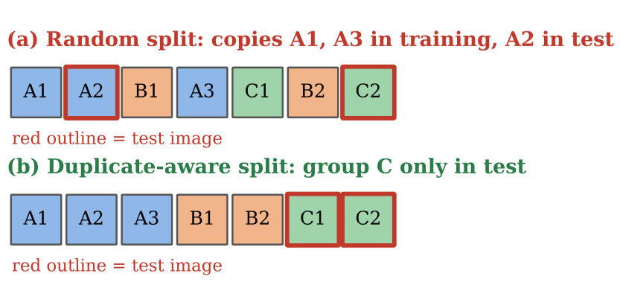
Fig. 1. Random split versus duplicate-aware group split (schematic).
B. Classifier, calibration and explanation
A pretrained CNN (MobileNetV3-Small by default [22]; ResNet-18 [28] and EfficientNet-B0 [29] as baselines) has its last layer replaced by a two-class head. The head is trained for two epochs, then the whole network is fine-tuned at a ten-times lower rate with class-weighted cross-entropy and small colour jitter, because yellowing is the diagnostic cue. The softmax temperature T and the decision threshold τ are fitted on validation data only; probabilities are p̂ = softmax(z/T), and Grad-CAM heat-maps are computed from the last convolutional layer (Fig. 2).
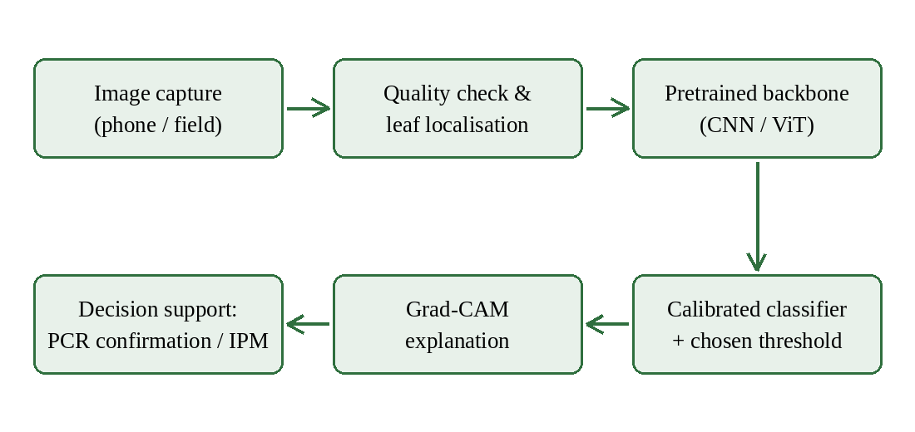
Fig. 2. Reference pipeline for leaf-image TYLCV screening.
C. Maturity ladder
We organise evaluation as six cumulative levels: L1 lab benchmark with random split; L2 duplicate-aware held-out test; L3 external field photographs; L4 hard negatives (healthy and look-alike disorders); L5 PCR/qPCR-confirmed field trial; L6 deployment study. Most published work sits at L1 [7], [8], [15].
D. Decision-support layer
TYLCV-Guard connects a screening result to context. A risk index R = 100·f_T·f_V·f_S·(1 − 0.7p) combines a temperature factor, a saturating whitefly-density factor, a crop-stage factor and the protection p of a resistance stack (×0.25 under exclusion). A stacking planner combines illustrative locus weights as p = min(0.95, 1 − Π(1 − w_j)), weakening Ty-1/Ty-3 under heat and recombinants [5]. A rotation planner avoids repeating a mode of action and excludes failed groups [14]. A calibrated model fits a binomial logistic regression of incidence on logged field trials. All modules are advisory and implemented with the Python standard library; 34 automated tests pass.
E. Implementation
The prototype is a single-page web interface over a JSON API (Python standard library, SQLite, vanilla JavaScript) with modules for risk, stacking, rotation, sequence surveillance, a calibrated model, a field-trial log, a seed-lot register and an optional Leaf-scan path. Leaf scan validates JPEG/PNG input and size, calls a hosted Roboflow workflow or a local PyTorch checkpoint, deletes its temporary file and sanitises errors; credentials come only from environment variables. The hosted path was tested only with a mocked client, because the service was unreachable from our environment. Table I lists the ladder against which results are positioned.
TABLE I
EVALUATION MATURITY LADDER
Level | Requirement
L1 | Lab benchmark, random split
L2 | Duplicate-aware held-out test
L3 | External field photographs
L4 | Hard negatives (look-alikes)
L5 | PCR/qPCR-confirmed field trial
L6 | Deployment study

IV. EXPERIMENTAL DESIGN
Audit. A public Kaggle folder of 100 TYLCV photographs [30] was extracted into an isolated directory and analysed with colour, leaf-coverage, sharpness and average-hash statistics; the licence was not verified. Leakage experiment. Synthetic 64×64 leaf images (70 base images per class, four near-duplicate variants each, weak class signal) were split randomly and with the duplicate-aware split; 1-NN, 5-NN and logistic regression on pixels (20 seeds) and a MobileNetV3-Small trained from scratch to convergence (3 seeds) were evaluated. Simulated benchmark. A field simulator (Gaussian temperature response, Hill vector response, stage and locus effects, region shift, binomial sampling of 100 plants) generated 3,600 fields (2,400 train, 1,200 test; a hot-region test for shift). Single-factor baselines, the heuristic model v1 and the calibrated model v2 were compared by ROC-AUC with 1,000-resample bootstrap intervals. The simulator and the models encode the same qualitative statements from the literature, so the benchmark shows consistency, not truth.
V. RESULTS
A. Audit of the public TYLCV folder
The folder holds 100 images (Table II): 91 lab-style (256×256, plain background), 7 phone photographs (3000×4000) and 2 photographs (960×1280). All are TYLCV-positive, so neither accuracy nor specificity can be estimated. The non-lab photographs show plants in soil with the leaf occupying a small part of the frame (Fig. 3), unlike the lab-style images. Only 2 pairs are closer than 12 bits (next closest: 21 bits): each 960×1280 photograph is a downscaled copy of a phone photograph, so a random split could place one copy in training and one in testing.
TABLE II
AUDIT SUMMARY BY SOURCE (MEANS)
Property | Lab | Phone | Field
Images | 91 | 7 | 2
Leaf coverage | 0.382 | 0.040 | 0.032
Mean saturation | 0.289 | 0.133 | 0.137
Sharpness | 535 | 5129 | 4064
Labels | 100% TYLCV | 100% TYLCV | 100% TYLCV

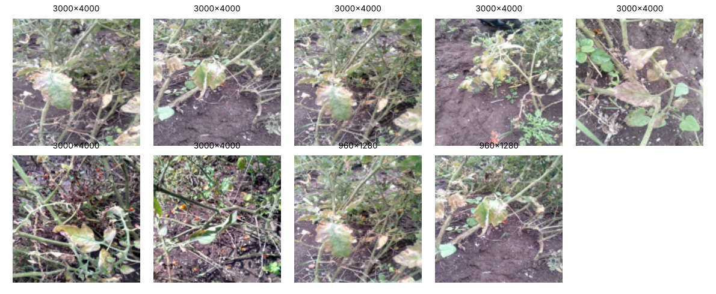
Fig. 3. The nine non-lab photographs of the audited folder (illustration only; dataset licence not verified).
Simple statistics differ strongly between sources (Fig. 4): leaf coverage is 38% for lab-style images but 4% and 3% for the others, and the smallest lab-style coverage (0.223) exceeds the largest non-lab coverage (0.117), so one threshold separates the groups without error. A model trained on lab-style negatives and field positives could therefore exploit frame composition rather than symptoms [9], [10].
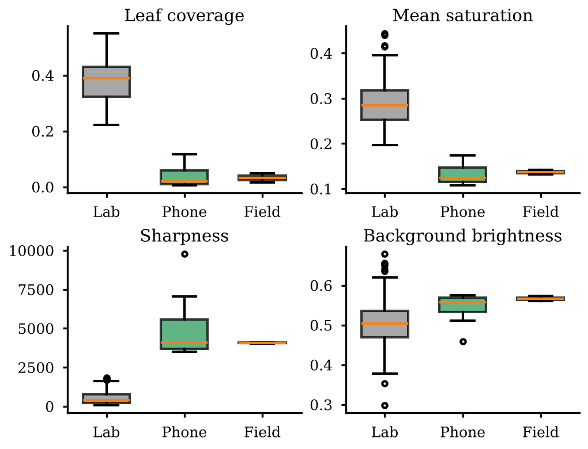
Fig. 4. Low-level image statistics by source group.
B. Leakage experiment
With a random split, 97% of test images had a near-duplicate in training; with the duplicate-aware split the leak fraction fell to 19% (not zero, because some variants differ by more than the hash threshold). Accuracy fell accordingly (Table III, Fig. 5): 1-NN from 0.98 ± 0.02 to 0.60 ± 0.11 and the CNN from 0.90 ± 0.04 to 0.60 ± 0.11. The residual margin above chance (0.5) is consistent with the residual leak fraction and a small genuine signal. The size of the effect is specific to this synthetic setting; what transfers is its direction and the need to report the leak fraction.
TABLE III
TEST ACCURACY, RANDOM VS DUPLICATE-AWARE SPLIT (SYNTHETIC)
Learner | Random | Duplicate-aware
1-NN (pixels) | 0.98 ± 0.02 | 0.60 ± 0.11
5-NN (pixels) | 0.78 ± 0.05 | 0.54 ± 0.11
Logistic (pixels) | 0.94 ± 0.02 | 0.62 ± 0.13
MobileNetV3-S (3 seeds) | 0.90 ± 0.04 | 0.60 ± 0.11

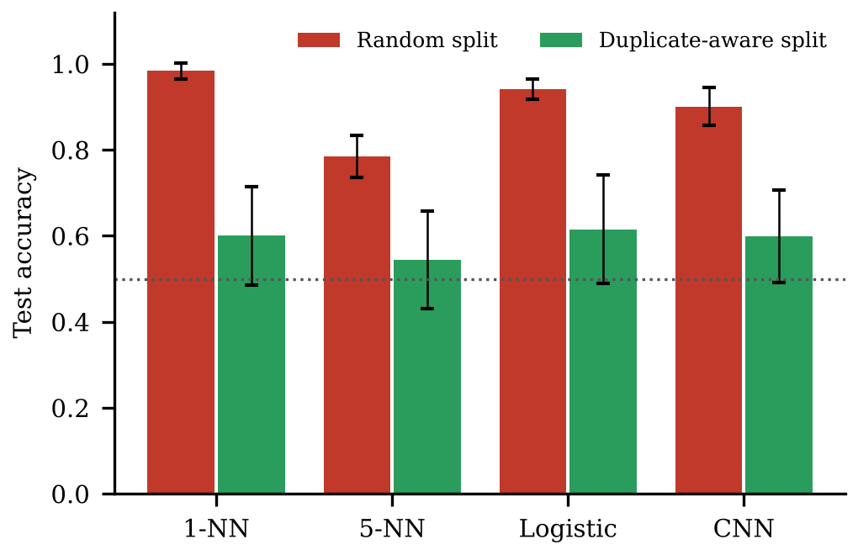
Fig. 5. Effect of near-duplicate leakage on accuracy (chance = 0.5).
C. Simulated benchmark
On 1,200 held-out simulated fields (Table IV, Figs. 6 and 7) single-factor baselines reached AUC 0.635–0.764, the heuristic model 0.930 and the calibrated model 0.980. The mean difference between v2 and v1 was 0.050 (95% bootstrap interval 0.035–0.067); the ordering was unchanged on an unseen hot region and from 10 to 200 plants scored per field. The calibrated model matched v1 with about 30 simulated trials and exceeded it from about 60 (Fig. 8). The comparison favours v1 and v2 over single-factor rules (which ignore resistance and stage) and favours v2 because simulator and model share assumptions.
TABLE IV
OUTBREAK PREDICTION ON SIMULATED FIELDS
Model | AUC | MAE | ECE
Temp-only | 0.635 | 0.126 | 0.069
Whitefly-threshold | 0.736 | 0.125 | 0.041
Env-only (T×WF) | 0.764 | 0.117 | 0.017
v1 (heuristic) | 0.930 | 0.074 | 0.022
v2 (calibrated) | 0.980 | 0.038 | 0.003

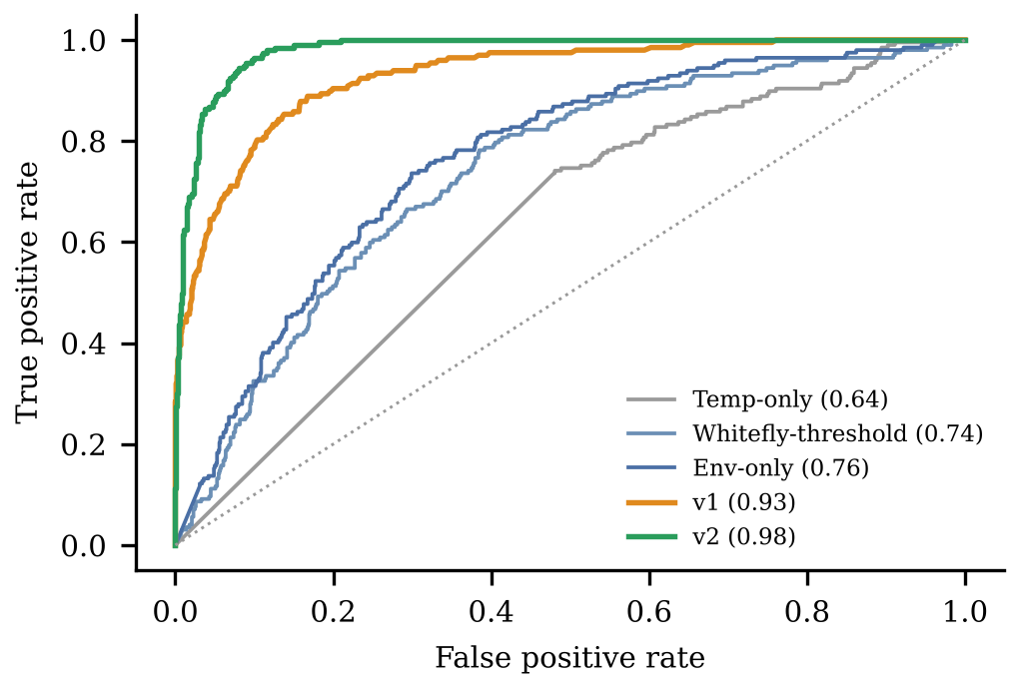
Fig. 6. ROC curves of the risk models on held-out simulated fields (AUC in brackets).
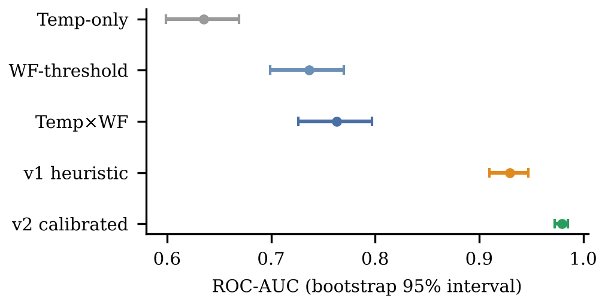
Fig. 7. ROC-AUC with bootstrap 95% intervals (simulated).
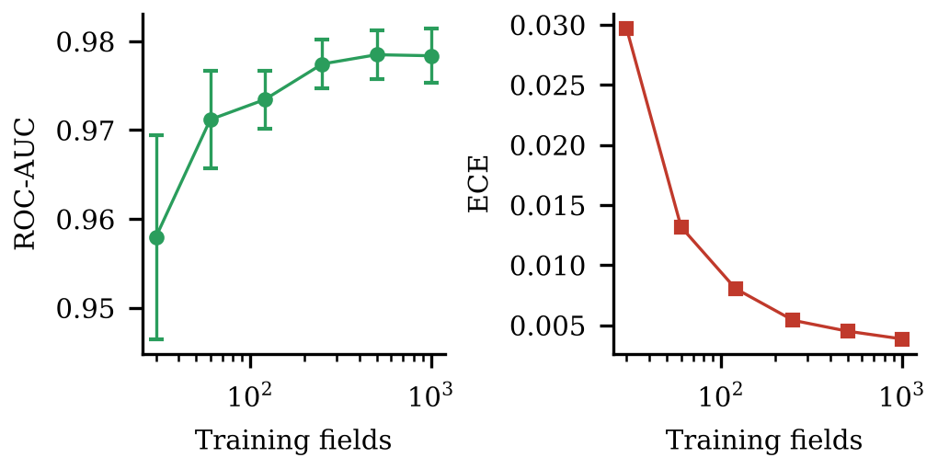
Fig. 8. AUC and calibration error of the calibrated model vs training size (5 seeds).
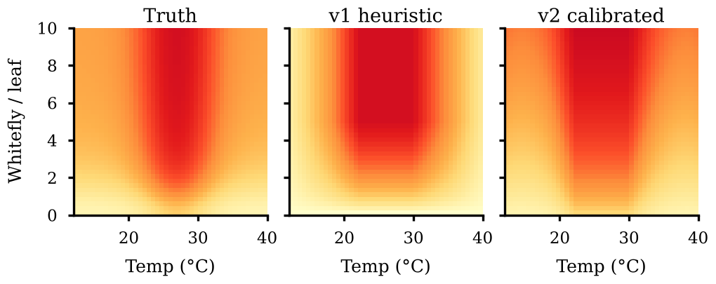
Fig. 9. Risk surfaces (susceptible cultivar, vegetative stage): simulated truth, v1 heuristic and v2 calibrated model.
TABLE V
MODULE BENCHMARKS (SIMULATED; PREVIOUS = LOCUS COUNT, BEST MATCH, ONE GROUP REPEATED)
Module (metric) | Previous | v1 | v2
Stacking rank corr. (hot+recomb.) | 0.85 | 0.99 | 1.00
Best-next-locus acc. (hot+recomb.) | 0.31 | 1.00 | 1.00
Recombinant sensitivity | 0.00 | 0.67 | 0.80
Rotation efficacy (uniform) | 0.04 | 0.39 | 0.39

The stacking planner ranked locus combinations almost perfectly against the simulated truth whereas a locus count did not; a discriminative-k-mer recombinant screen beat a window screen in a hard regime (0.5–16% divergence, 100–600 nt fragments); and rotation planners beat repeating one group but not a fixed round-robin (0.40), so rotation alone does not preserve efficacy. Sensitivity analyses showed that the calibrated model's advantage held when the number of plants scored per field fell from 200 to 10 (AUC 0.984 to 0.945), and that cost-based thresholds fall as missed infections become costlier (0.29, 0.23 and 0.18 for false-negative to false-positive cost ratios of 1, 3 and 10).
VI. DISCUSSION AND LIMITATIONS
The three kinds of evidence support different claims: the audit is real evidence about one dataset; the leakage experiment demonstrates a mechanism on synthetic images; the benchmark is simulation. None establishes the field accuracy of a deep model for TYLCV. The audit shows why benchmark accuracy is unreliable: one statistic separates lab-style from field photographs, and duplicates cross naive splits [7], [9], [26]. A screening result is also only a likelihood: with 95% sensitivity and specificity (hypothetical) the positive predictive value is 50% at 5% prevalence, so results should be read with vector and prevalence context. Limitations: no negatives, no pretrained weights and no reachable hosted service in our environment, so the image classifier is verified for correctness on synthetic data only; the simulator and models share assumptions; heuristic weights and the rotation model are illustrative; the audit covers one folder with nine non-lab images; the leakage experiment has three CNN seeds and residual leakage; and licences were not verified. Saliency maps are used only as one shortcut check [25]. We recommend that TYLCV image studies (1) report data sources, label coverage and the leak fraction and use group-aware splits; (2) evaluate on an external field set and on look-alike negatives before field claims, stating the ladder level reached; (3) report sensitivity and specificity with confidence intervals, calibrated probabilities and the threshold rule rather than accuracy alone; and (4) present results with prevalence and vector context as a prompt for molecular confirmation.
VII. CONCLUSION
We presented a leakage-aware framework, a decision-support prototype and three sets of evidence about data, evaluation and decision support for leaf-image TYLCV screening. An audit of a public folder showed positive-only, mostly lab-style data with duplicates; a controlled experiment showed that random splits inflate accuracy; and a simulation showed that a calibrated model improves on single-factor baselines. The next step is a labelled collection with healthy and look-alike negatives, external field photographs and a PCR-confirmed subset, on which the classifier can be evaluated at levels L2–L5 of the maturity ladder.
TABLE VI
CLAIMS AND THE EVIDENCE BEHIND THEM
Claim | Evidence | Strength
Public folder cannot estimate accuracy | Audit, 100 real photos | Strong; one folder
Lab and field photos differ in simple statistics | Audit, 9 non-lab images | Strong here; few images
Random splits inflate accuracy | Synthetic leakage experiment | Mechanism shown; size not transferable
Calibrated model beats baselines | Simulated benchmark, bootstrap | Holds in simulation only
Rotation planners beat round-robin | Toy resistance model | Not supported
Field accuracy of a deep model for TYLCV | None | Not established

. ACKNOWLEDGMENT
The authors thank the Department of Computer Science and Engineering, Chandigarh University. Code, scripts and results are in the TYLCV-Guard repository; simulated and synthetic data are generated by scripts with fixed seeds; the public photographs are not redistributed.
. REFERENCES
[1] A. Prasad, N. Sharma, G. Hari-Gowthem, M. Muthamilarasan, and M. Prasad, “Tomato yellow leaf curl virus: Impact, challenges, and management,” Trends Plant Sci., vol. 25, no. 9, pp. 897–911, 2020.
[2] H. Czosnek, A. Hariton-Shalev, I. Sobol, R. Gorovits, and M. Ghanim, “The incredible journey of begomoviruses in their whitefly vector,” Viruses, vol. 9, no. 10, p. 273, 2017.
[3] E.-J. Kil et al., “Tomato yellow leaf curl virus (TYLCV-IL): A seed-transmissible geminivirus in tomatoes,” Sci. Rep., vol. 6, Art. no. 19013, 2016.
[4] B. Mabvakure et al., “Ongoing geographical spread of Tomato yellow leaf curl virus,” Virology, vol. 498, pp. 257–264, 2016.
[5] Z. Yan et al., “Resistance to tomato yellow leaf curl virus in tomato germplasm,” Front. Plant Sci., vol. 9, Art. no. 1198, 2018.
[6] M. R. Rojas et al., “World management of geminiviruses,” Annu. Rev. Phytopathol., vol. 56, pp. 637–677, 2018.
[7] S. P. Mohanty, D. P. Hughes, and M. Salathé, “Using deep learning for image-based plant disease detection,” Front. Plant Sci., vol. 7, Art. no. 1419, 2016.
[8] K. P. Ferentinos, “Deep learning models for plant disease detection and diagnosis,” Comput. Electron. Agric., vol. 145, pp. 311–318, 2018.
[9] M. A. Noyan, “Uncovering bias in the PlantVillage dataset,” arXiv:2206.04374, 2022.
[10] R. Geirhos et al., “Shortcut learning in deep neural networks,” Nat. Mach. Intell., vol. 2, pp. 665–673, 2020.
[11] J. G. A. Barbedo, “Impact of dataset size and variety on the effectiveness of deep learning and transfer learning for plant disease classification,” Comput. Electron. Agric., vol. 153, pp. 46–53, 2018.
[12] M. Arsenovic, M. Karanovic, S. Sladojevic, A. Anderla, and D. Stefanovic, “Solving current limitations of deep learning based approaches for plant disease detection,” Symmetry, vol. 11, no. 7, p. 939, 2019.
[13] S. H. Lee, H. Goëau, P. Bonnet, and A. Joly, “New perspectives on plant disease characterization based on deep learning,” Comput. Electron. Agric., vol. 170, Art. no. 105220, 2020.
[14] A. R. Horowitz, M. Ghanim, E. Roditakis, R. Nauen, and I. Ishaaya, “Insecticide resistance and its management in Bemisia tabaci species,” J. Pest Sci., vol. 93, pp. 893–910, 2020.
[15] E. C. Too, L. Yujian, S. Njuki, and L. Yingchun, “A comparative study of fine-tuning deep learning models for plant disease identification,” Comput. Electron. Agric., vol. 161, pp. 272–279, 2019.
[16] M. Brahimi, K. Boukhalfa, and A. Moussaoui, “Deep learning for tomato diseases: Classification and symptoms visualization,” Appl. Artif. Intell., vol. 31, no. 4, pp. 299–315, 2017.
[17] A. Picon et al., “Deep convolutional neural networks for mobile capture device-based crop disease classification in the wild,” Comput. Electron. Agric., vol. 161, pp. 280–290, 2019.
[18] A. Ramcharan, K. Baranowski, P. McCloskey, B. Ahmed, J. Legg, and D. P. Hughes, “Deep learning for image-based cassava disease detection,” Front. Plant Sci., vol. 8, Art. no. 1852, 2017.
[19] D. Singh et al., “PlantDoc: A dataset for visual plant disease detection,” in Proc. ACM India Joint Int. Conf. Data Sci. Manage. Data (CoDS-COMAD), 2020, pp. 249–253.
[20] A. Fuentes, S. Yoon, S. C. Kim, and D. S. Park, “A robust deep-learning-based detector for real-time tomato plant diseases and pests recognition,” Sensors, vol. 17, no. 9, p. 2022, 2017.
[21] P. Wspanialy and M. Moussa, “A detection and severity estimation system for generic diseases of tomato greenhouse plants,” Comput. Electron. Agric., vol. 178, Art. no. 105701, 2020.
[22] A. Howard et al., “Searching for MobileNetV3,” in Proc. IEEE/CVF Int. Conf. Comput. Vis. (ICCV), 2019, pp. 1314–1324.
[23] C. Guo, G. Pleiss, Y. Sun, and K. Q. Weinberger, “On calibration of modern neural networks,” in Proc. Int. Conf. Mach. Learn. (ICML), 2017, pp. 1321–1330.
[24] R. R. Selvaraju et al., “Grad-CAM: Visual explanations from deep networks via gradient-based localization,” in Proc. IEEE Int. Conf. Comput. Vis. (ICCV), 2017, pp. 618–626.
[25] J. Adebayo, J. Gilmer, M. Muelly, I. Goodfellow, M. Hardt, and B. Kim, “Sanity checks for saliency maps,” in Proc. Adv. Neural Inf. Process. Syst. (NeurIPS), 2018, pp. 9505–9515.
[26] P. W. Koh et al., “WILDS: A benchmark of in-the-wild distribution shifts,” in Proc. Int. Conf. Mach. Learn. (ICML), 2021, pp. 5637–5664.
[27] S. Skendžić, M. Zovko, I. P. Živković, V. Lešić, and D. Lemić, “The impact of climate change on agricultural insect pests,” Insects, vol. 12, no. 5, p. 440, 2021.
[28] K. He, X. Zhang, S. Ren, and J. Sun, “Deep residual learning for image recognition,” in Proc. IEEE Conf. Comput. Vis. Pattern Recognit. (CVPR), 2016, pp. 770–778.
[29] M. Tan and Q. V. Le, “EfficientNet: Rethinking model scaling for convolutional neural networks,” in Proc. Int. Conf. Mach. Learn. (ICML), 2019, pp. 6105–6114.
[30] mohammeda5, “Tomato Yellow Leaf Curl Virus Dataset,” Kaggle. [Online]. Available: https://www.kaggle.com/datasets/mohammeda5/tomato-yellow-leaf-curl-virus-dataset

