Deep Learning-Based Intelligent Visual Diagnosis of Tomato Yellow Leaf Curl Virus Using Leaf Images
Submitted in partial fulfillment of the requirements for the award of degree of
MASTER OF ENGINEERING
IN
COMPUTER SCIENCE & ENGINEERING (DATA SCIENCE)
[Institution logo]
Supervisor:  Dr. Sneha Garg (E17633)  Associate Professor | Submitted By:  Ritesh Dwivedi  UID: 25MDS10023
Co-Supervisor:
Dr. Navneet Kaur (E11384)
Professor

DEPARTMENT OF COMPUTER SCIENCE & ENGINEERING
Chandigarh University, Gharuan
November 2026

ACKNOWLEDGEMENT
I express my sincere gratitude to my supervisor, Dr. Sneha Garg, Associate Professor, and my co-supervisor, Dr. Navneet Kaur, Professor, Department of Computer Science & Engineering, Chandigarh University, for their valuable guidance, constant encouragement and constructive suggestions throughout this work. Their support helped me shape the research problem, objectives and methodology presented in this synopsis.
I am thankful to the Head of the Department and all faculty members for providing the facilities and the academic environment needed to carry out this research. I also thank the evaluation committee for their useful comments during the review phases.
Ritesh Dwivedi
UID: 25MDS10023
CERTIFICATE
This is to certify that the dissertation entitled “Deep Learning-Based Intelligent Visual Diagnosis of Tomato Yellow Leaf Curl Virus Using Leaf Images”, Synopsis Viva-Voce examination of Ritesh Dwivedi, UID 25MDS10023, has been held on __________________ and his case for the completion of eligibility for the award of the degree of Master of Engineering - Computer Science Engineering (Data Science).
________________  Signature of Supervisor  Dr. Sneha Garg  Associate Professor  EID: E17633 | ________________  Signature of Co-Supervisor  Dr. Navneet Kaur  Professor  EID: E11384
________________
Signature of Examiner
[Examiner name]
EID: [ID]

CONTENTS
Acknowledgement ii
Certificate iii
List of Figures vi
List of Tables vii
List of Abbreviations viii
CHAPTER 1: INTRODUCTION 1
1.1 Background 1
1.2 Diagnostic Techniques for TYLCV 1
1.3 Deep Learning for Leaf-Image Diagnosis 2
1.4 Calibration and Explainability 3
1.5 Applications of the Research Area 3
1.6 Motivation 3
1.7 Organisation of the Report 3
CHAPTER 2: LITERATURE REVIEW 4
2.1 Review Methodology 4
2.2 Surveys of Deep Learning in Plant Disease Diagnosis 4
2.3 Tomato Leaf Disease Classification 4
2.4 Dataset Bias and Generalisation to the Field 5
2.5 Detection, Segmentation and Severity Estimation 5
2.6 Lightweight Models, Calibration and Explainability 5
2.7 TYLCV Biology and Management Background 5
2.8 Comparative Analysis of Reviewed Literature 6
2.9 Key Findings from the Literature 6
CHAPTER 3: RESEARCH GAPS 8
CHAPTER 4: PROBLEM FORMULATION 10
4.1 Formal Formulation 10
CHAPTER 5: OBJECTIVES 11
CHAPTER 6: METHODOLOGY 12
6.1 Overall Framework 12
6.2 Step 1 – Dataset 12
6.3 Step 2 – Pre-processing and Splitting 13
6.4 Baseline Methods for Comparison 13
6.5 Step 3 – Proposed Model 14
6.6 Step 4 – Calibration, Explanation and Decision Support 14
6.7 Step 5 – Evaluation Protocol and Metrics 15
6.8 Tools and Experimental Setup 16
CHAPTER 7: PROOF OF WORK 17
7.1 Implementation and Project Structure 17
7.2 Testing the Code 18
7.3 Result 1 – Audit of the Available TYLCV Image Data 18
7.4 Result 2 – Decision-Support Modules on a Simulated Benchmark 19
7.5 Result 3 – Status of the Image-Diagnosis Pipeline 22
7.6 Challenges and Risks 22
7.7 Plan for Remaining Work 23
CHAPTER 8: CONCLUSION 24
REFERENCES 25
ANNEXURE I: PLAGIARISM REPORT 28
LIST OF FIGURES
Figure 1.1: Reference pipeline for leaf-image TYLCV screening: capture, quality check, pretrained backbone, calibrated classifier, explanation and decision support 2
Figure 6.1: Proposed methodology: what happens to the data at each step, and where decision support is used 12
Figure 7.1: Project folder structure of the prototype 17
Figure 7.2: Console output of the automated tests 18
Figure 7.3: Audit of the public TYLCV image folder: source composition and label coverage 19
Figure 7.4: ROC and precision–recall curves of the risk models on held-out simulated fields 20
Figure 7.5: Risk surfaces: ground truth, v1 heuristic and v2 calibrated model (heat-maps) 20
Figure 7.6: Recombinant detection sensitivity by parent divergence and fragment length (heat-maps) 21
Figure 7.7: Overall comparison of previous approaches, v1 and v2 on the simulated benchmark (radar chart) 22
LIST OF TABLES
Table 1.1: Main diagnostic techniques for TYLCV and their characteristics 2
Table 2.1: Typical benchmark-style approach and the proposed work 4
Table 2.2: Comparative analysis of reviewed literature 6
Table 3.1: Research gap analysis matrix 9
Table 6.1: Dataset summary 13
Table 6.2: Baseline methods planned for fair comparison 13
Table 6.3: Classifier configuration 14
Table 6.4: Decision-support modules of the TYLCV-Guard prototype 15
Table 6.5: Evaluation protocols 15
Table 6.6: Tools and justification 16
Table 7.1: Audit of the Kaggle TYLCV image folder 19
Table 7.2: Outbreak prediction on simulated fields (outbreak = incidence ≥ 30%; MAE of incidence, lower is better) 20
Table 7.3: Other modules on simulated data 21
Table 7.4: Schedule of remaining work 23
LIST OF ABBREVIATIONS
AUC | Area Under the (ROC) Curve
CAM | Class Activation Map
CNN | Convolutional Neural Network
DL | Deep Learning
ECE | Expected Calibration Error
F1 | Harmonic mean of precision and recall
FPR | False Positive Rate
Grad-CAM | Gradient-weighted Class Activation Mapping
IPM | Integrated Pest Management
MAE | Mean Absolute Error
ML | Machine Learning
MoA | Mode of Action (insecticide group)
PCR | Polymerase Chain Reaction
PR | Precision-Recall
qPCR | Quantitative PCR
RGB | Red-Green-Blue (colour imaging)
ROC | Receiver Operating Characteristic
TPR | True Positive Rate
TYLCD | Tomato Yellow Leaf Curl Disease
TYLCV | Tomato Yellow Leaf Curl Virus
ViT | Vision Transformer
YOLO | You Only Look Once (object detector)

CHAPTER 1
INTRODUCTION
1.1 Background
Tomato (Solanum lycopersicum) is one of the most widely grown vegetable crops in the world, and its production is limited by many diseases. One of the most damaging is tomato yellow leaf curl disease (TYLCD), caused by the begomovirus tomato yellow leaf curl virus (TYLCV). Infected plants show leaflets that curl upward and inward, yellowing at the leaf margins, short internodes and a dwarfed, bushy habit, and they set few flowers and fruits. When plants are infected early, almost no marketable fruit is produced [1].
TYLCV is carried from plant to plant by the whitefly Bemisia tabaci, which takes up the virus while feeding and transmits it in a persistent way [2]. The virus has also been shown to be seed-transmissible in tomato [3]. No cure exists for an infected plant, so control depends on keeping whiteflies away, growing resistant varieties and removing infected plants early [1], [4], [5]. Finding infected plants early is therefore the first step of control. In practice this is done by trained people who walk the field and look at the leaves, and this does not scale to large farms or to farmers without training.
Cameras on phones are cheap and widespread, and deep learning has become good at recognising patterns in photographs. This has led to a large body of work on diagnosing plant diseases from leaf images [6], [7], [8]. This project asks a practical question: how far can a deep-learning model that looks at a photograph of a tomato leaf be trusted to screen for TYLCV, and what does a trustworthy system need beyond the model itself?
1.2 Diagnostic Techniques for TYLCV
Diagnosis can be made at several levels. Table 1.1 gives a short overview. The important point is that visual symptoms are only a screening signal: similar curling and yellowing can be caused by other begomoviruses, nutrient disorders or herbicide injury, so laboratory tests remain the confirmation [1].
Table 1.1: Main diagnostic techniques for TYLCV and their characteristics
Technique | Principle | Resources needed | Typical issues
Visual scouting | Trained observer recognises curling, yellowing, stunting | Trained staff, time | Subjective; scarce skill; look-alike disorders
PCR / qPCR | Detects viral DNA in leaf tissue | Laboratory, reagents | Cost and delay; not usable plant-by-plant in the field
RGB image + deep learning | Model learns the visual pattern from labelled photos | Phone or camera; labelled data; compute | Needs good data; drops in new conditions [6], [9]
Hyperspectral / thermal imaging | Detects physiological change, possibly before symptoms | Special sensors, calibration | Cost; mainly research use [10]
Image + IoT / weather context | Combines photos with sensor and environment data | Sensors, integration | Complex; data quality [11]

1.3 Deep Learning for Leaf-Image Diagnosis
A convolutional neural network (CNN) learns small visual filters that respond to edges, textures and colours, and stacks them so that deeper layers respond to larger patterns such as lesions or curled leaf shapes. Training a deep network from scratch needs very large datasets, so the usual approach is transfer learning: start from a network trained on millions of everyday photographs (ImageNet) and adapt it to leaf images [12], [13]. Common backbones are residual networks [14], the EfficientNet family [15] and small mobile-friendly networks such as MobileNetV3 [16]. Vision transformers split an image into patches and have become a strong alternative [17], [18]. When several leaves or symptoms appear in one photo, object detectors such as Faster R-CNN and YOLO draw boxes around them [19], [20]. Figure 1.1 shows the kind of pipeline used in this work.
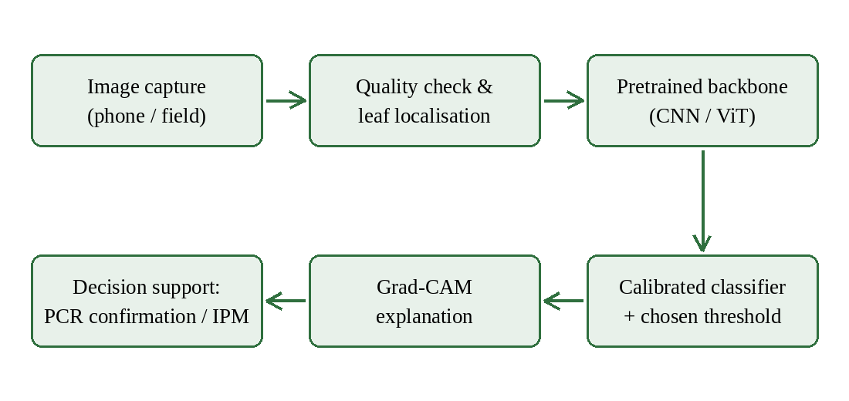
Figure 1.1: Reference pipeline for leaf-image TYLCV screening: capture, quality check, pretrained backbone, calibrated classifier, explanation and decision support
1.4 Calibration and Explainability
A model that outputs “92% TYLCV” is only useful if that number means what it says. Modern deep networks tend to be over-confident, and a simple fix is temperature scaling on a validation set [21]. The second need is explanation. Grad-CAM produces a heat-map showing which parts of the image drove the decision [22]. This matters because networks sometimes learn a shortcut, such as the background of the photo, instead of the disease [23].
1.5 Applications of the Research Area
• Early screening on the farm: a phone photo gives a quick yes/no flag that tells the grower which plants to send for PCR confirmation.
• Scouting support: field workers with little training can record symptomatic plants and locations for later action.
• Disease surveillance: geo-tagged flags can reveal where virus pressure is rising, together with whitefly counts and weather.
• Teaching and extension: heat-maps show students and farmers which leaf features indicate TYLCV.
1.6 Motivation
Three observations motivated this project. First, models reach above 99% accuracy on the popular PlantVillage benchmark [6], [24], yet one of the earliest studies reported that accuracy fell to about 31% on images taken under other conditions [6]. Second, the backgrounds of benchmark photos can leak the class label [25]. Third, when I examined a public TYLCV image set (Chapter 7) it contained only positive images, mostly lab-style photos and some near-duplicate pairs, so it could not support an honest estimate of accuracy. A trustworthy TYLCV screening tool needs better data, stricter evaluation and a link to what the grower does next (vector control, resistant varieties, laboratory confirmation).
1.7 Organisation of the Report
Chapter 2 reviews the literature. Chapter 3 lists the research gaps. Chapter 4 formulates the problem and Chapter 5 states the objectives. Chapter 6 describes the methodology. Chapter 7 presents the proof of work: the implemented prototype, its tests, a dataset audit, benchmark results and the plan for remaining work. Chapter 8 concludes. References and the plagiarism-report annexure follow.
CHAPTER 2
LITERATURE REVIEW
2.1 Review Methodology
I searched for studies on image-based plant disease diagnosis, tomato leaf disease classification, dataset bias and generalisation, detection and severity estimation, lightweight deployment, calibration and explainability, and on TYLCV biology and management. I concentrated on work from about 2016 to 2026 and on tomato. Studies were grouped by theme and compared qualitatively, because they differ in datasets, architectures and evaluation methods, which prevents a formal meta-analysis. Table 2.1 summarises how the proposed work differs from the typical benchmark-style approach, and Table 2.2 compares the studies.
Table 2.1: Typical benchmark-style approach and the proposed work
Aspect | Typical benchmark-style approach [6], [24] | Proposed work
Data | Lab-background leaf photos, one source | Lab, phone and field photos, several sources
Negatives | Other crop-disease classes | Healthy leaves plus look-alike conditions
Splitting | Random split of images | Near-duplicate-aware group split
Testing | Held-out images of the same kind | External field photos from other devices and sites
Outputs | Class label, accuracy | Calibrated probability, threshold, heat-map
Context | Image only | Linked to risk, resistance and vector-management modules

2.2 Surveys of Deep Learning in Plant Disease Diagnosis
Several surveys map the field. Kamilaris and Prenafeta-Boldú reviewed deep learning across agriculture [7]. Reviews focused on plant diseases cover architectures, datasets and open issues [26], [27], [8], [28], and a survey with practical recommendations stresses the tools needed for real deployment [29]. Reviews that include sensing and IoT show a move toward multi-source systems [11]. Across them, the recurring message is that benchmark accuracy is high but evidence of field performance and deployment is limited.
2.3 Tomato Leaf Disease Classification
The first large studies fine-tuned general networks on leaf photographs [13], [6]. A broad comparison of architectures reported success rates above 99% on an open database [24], and a comparison of fine-tuned networks found that several perform similarly well on PlantVillage [12]. Tomato-specific studies compared standard CNNs [30], [31], proposed lightweight CNNs [32], and added attention modules to residual networks [33], [34]. TYLCV is usually just one class among several in these studies, most of which use the PlantVillage tomato classes.
2.4 Dataset Bias and Generalisation to the Field
The central finding of the literature is the gap between laboratory and field. In the first large PlantVillage study, accuracy that was very high on held-out lab images dropped to roughly 31% on images from other conditions [6]. Barbedo showed that dataset size and, above all, variety of conditions decide whether transfer learning generalises [9], and that classifying individual lesions and spots can help [35]. Studies using smartphone images captured in real fields found that field-captured training images are needed [36], [37]. Lee and co-workers argued for training strategies that reflect real variation [38]. Noyan showed that PlantVillage backgrounds alone carry enough information to classify images well above chance [25], an example of the general problem of shortcut learning [23]. The PlantDoc dataset was assembled to provide harder, in-the-wild images [39].
2.5 Detection, Segmentation and Severity Estimation
Object detectors localise symptoms in a scene. A real-time detector for tomato diseases and pests used region-based detectors with several backbones on field images [40], and a greenhouse system combined detection with severity estimation [41]. Detection needs boxes or masks, which are expensive to label; I did not find a TYLCV-specific annotated set of this kind.
2.6 Lightweight Models, Calibration and Explainability
Field use favours small, fast models [16], [29]. Calibrated probabilities are rarely reported in plant-disease studies, although temperature scaling is simple and effective [21]. Saliency maps were used early to inspect tomato classifiers [31] and Grad-CAM is now the standard explanation tool [22]. Saliency is an aid to spot shortcuts, not proof of correctness.
2.7 TYLCV Biology and Management Background
An image model is only one part of TYLCV control. Resistance genes (Ty-1 to Ty-6) introgressed from wild tomato relatives are widely used but are not fully durable [4], [42], [43]. Recombinant viruses and heat can weaken resistance, and geographic spread continues [44], [45], [46]. Whitefly control relies on exclusion nets, mulches and insecticides, and insecticide resistance in B. tabaci is a growing problem [47], [48]. Climate change is expected to alter pest pressure [49]. These facts motivated linking the image model to decision-support modules (Chapter 6).
2.8 Comparative Analysis of Reviewed Literature
Table 2.2: Comparative analysis of reviewed literature
Ref. | Focus | Method and data | Main finding
[6] | Plant disease classification | AlexNet/GoogLeNet transfer learning; PlantVillage (54,306 images, 38 classes) | 99.35% on held-out lab images; about 31% on images from other conditions
[24] | Disease detection and diagnosis | Several CNN architectures; open database, 58 classes | Best model reached 99.53% success on the database
[31] | Tomato disease classification and visualisation | Pretrained CNNs on tomato classes; saliency maps | Visualisation localises symptoms and aids interpretation
[12] | Fine-tuning comparison | Several CNNs fine-tuned on PlantVillage | Fine-tuned networks perform similarly well on this benchmark
[9] | Dataset size and variety | Transfer learning on varied datasets | Variety of conditions matters more than adding similar images
[35] | Lesions and spots | Classification of individual lesions | Can improve robustness over whole-leaf classification
[36] | Smartphone images in the wild | CNNs on mobile-captured field images | Field-captured training images needed for usable accuracy
[37] | Cassava disease | Transfer learning on field images | Shows feasibility with images from real fields
[40] | Tomato disease and pest detection | Region-based detectors, several backbones, field images | Real-time detection of several tomato problems
[41] | Greenhouse tomato diseases | Detection and severity estimation | Combines localisation with severity grading
[33] | Tomato leaf disease | Attention-embedded residual CNN; PlantVillage tomato | Attention helps on the benchmark
[34] | Tomato leaf disease | Residual network with attention module | Reports improved benchmark accuracy
[39] | Visual disease detection dataset | In-the-wild images with annotations | Provides harder test conditions
[25] | Dataset bias | Background-only classification experiment | PlantVillage backgrounds carry class information
[23] | Shortcut learning | General analysis | Networks may exploit spurious cues
[21], [22] | Calibration and explanation | Temperature scaling; Grad-CAM | Reliable probabilities and visual explanations

2.9 Key Findings from the Literature
• Accuracy above 95–99% on lab-background benchmarks is common [6], [24], [12], but it measures capacity, not field performance.
• Generalisation depends on data variety and realistic evaluation more than on the choice of architecture [9], [38].
• Backgrounds can leak labels [25], [23], so explanation checks and external tests are needed.
• TYLCV is usually one class among many; I did not find a field-validated TYLCV study with molecularly confirmed ground truth.
• Calibration, thresholds and links to management decisions are rarely reported [21], [29].
CHAPTER 3
RESEARCH GAPS
After studying the literature in Table 2.2 and auditing one public TYLCV image set (Chapter 7), six research gaps stand out. Each gap is listed with the evidence behind it.
Gap 1: Missing negatives and look-alike conditions.
• The public TYLCV folder I audited contains 100 images, all TYLCV-positive; accuracy, specificity and calibration cannot be estimated from it.
• Public multi-class sets mostly contain fungal or bacterial spots, which look very different from a viral curl [31], [30]; look-alikes such as other begomoviruses, nutrient disorders and herbicide injury are rare.
Gap 2: Lab-background shortcuts and weak field generalisation.
• Accuracy fell from very high to about 31% when conditions changed [6].
• PlantVillage backgrounds alone carry class information [25]; 91 of the 100 images in the audited folder have PlantVillage-style names and the same 256×256 format.
Gap 3: Leakage through near-duplicate images.
• The audit found two pairs of the same photograph stored at different resolutions; a random split would put one copy in training and one in testing.
• Most reviewed studies report a single accuracy on a random split without group-aware splitting.
Gap 4: No calibrated probabilities or validated thresholds.
• Accuracy is reported, but calibration and the choice of operating threshold are rarely examined [21].
Gap 5: Image diagnosis is disconnected from management decisions.
• Reviews call for tools that link diagnosis to recommendations [29], [11]; TYLCV control depends on vector pressure, resistance durability and insecticide resistance [4], [47].
Gap 6: Weak ground truth and reporting.
• Public labels are usually visual, not PCR-confirmed, and most studies report no confidence intervals or external validation.
Table 3.1: Research gap analysis matrix
Research area | Current limitation | What this work does
Data | Positive-only or lab-style sets (Gap 1, 2) | Audits data; requires negatives and field photos; group-aware design
Evaluation | Random split; near-duplicates leak (Gap 3) | Duplicate-aware split; external field set; confidence intervals
Model output | Accuracy only (Gap 4) | Temperature-scaled probability; threshold chosen on validation data
Explanation | Rarely checked for shortcuts (Gap 2) | Grad-CAM and background-only control
Decision context | Image only (Gap 5) | TYLCV-Guard risk, resistance, rotation and surveillance modules
Ground truth | Visual labels (Gap 6) | Protocol requires PCR-confirmed field subset

CHAPTER 4
PROBLEM FORMULATION
4.1 Formal Formulation
Input. An RGB photograph x of a tomato leaf (or leaflet) taken with a phone or camera, optionally with context c (temperature, whitefly density, crop stage, resistance loci of the cultivar).
Output. A calibrated probability p̂(x) = P(TYLCV | x), a binary screening decision ŷ = 1[p̂ ≥ τ] and a heat-map H(x) that explains the decision. With context, a risk index r(c) is reported next to the image result.
Learning task. Given labelled images with labels y ∈ {0, 1} (0 = not TYLCV, 1 = TYLCV), train a classifier with parameters θ by minimising the class-weighted cross-entropy:
L(θ) = −(1/N) Σᵢ w_{yᵢ} [ yᵢ log p_θ(xᵢ) + (1 − yᵢ) log(1 − p_θ(xᵢ)) ] (4.1)
where the weights w₀, w₁ compensate for class imbalance.
Calibration task. On validation logits z, find a temperature T > 0 that minimises the negative log-likelihood of the scaled probabilities, and a threshold τ that maximises F1 on validation data only:
p̂ = softmax(z / T), T⋆ = arg min_T NLL_val(z / T), τ⋆ = arg max_τ F1_val(p̂ ≥ τ) (4.2)
Evaluation task. On a test set that shares no near-duplicate group with the training data, and on an external field set from other sites and devices, report sensitivity, specificity, ROC-AUC and the expected calibration error:
ECE = Σ_b (|B_b| / N) · | acc(B_b) − conf(B_b) | (4.3)
where the predictions are grouped into bins B_b. Group-aware splitting assigns every image to a near-duplicate group g(x) and requires that no group appears in more than one of the training, validation and test sets.
CHAPTER 5
OBJECTIVES
To address the research gaps and solve the problem formulated in Chapter 4, the main objectives of this research are:
1. To study and analyse existing approaches for deep-learning-based leaf-image diagnosis of tomato diseases, with emphasis on TYLCV, and on the management measures that follow a diagnosis.
2. To develop and implement a leaf-image TYLCV screening pipeline with calibrated outputs and visual explanations, together with decision-support modules that connect diagnosis to risk, resistance and vector management.
3. To compare and validate the proposed approach against baseline methods under realistic conditions, using duplicate-aware splits and external field photographs.
CHAPTER 6
METHODOLOGY
6.1 Overall Framework
Figure 6.1 shows the whole method on one page. Read it from top to bottom: leaf photographs go in at Step 1, and a calibrated probability with a heat-map comes out at the bottom. The purple box on the right is the decision-support part (TYLCV-Guard), which supplies risk context to the decision. The grey box lists the methods every result is compared against.
Objective 1 was covered by the literature review and gap analysis in Chapters 2 and 3. Steps 1 to 4 and the decision-support box make up Objective 2 (develop and implement). Step 5 is Objective 3 (evaluate and validate).
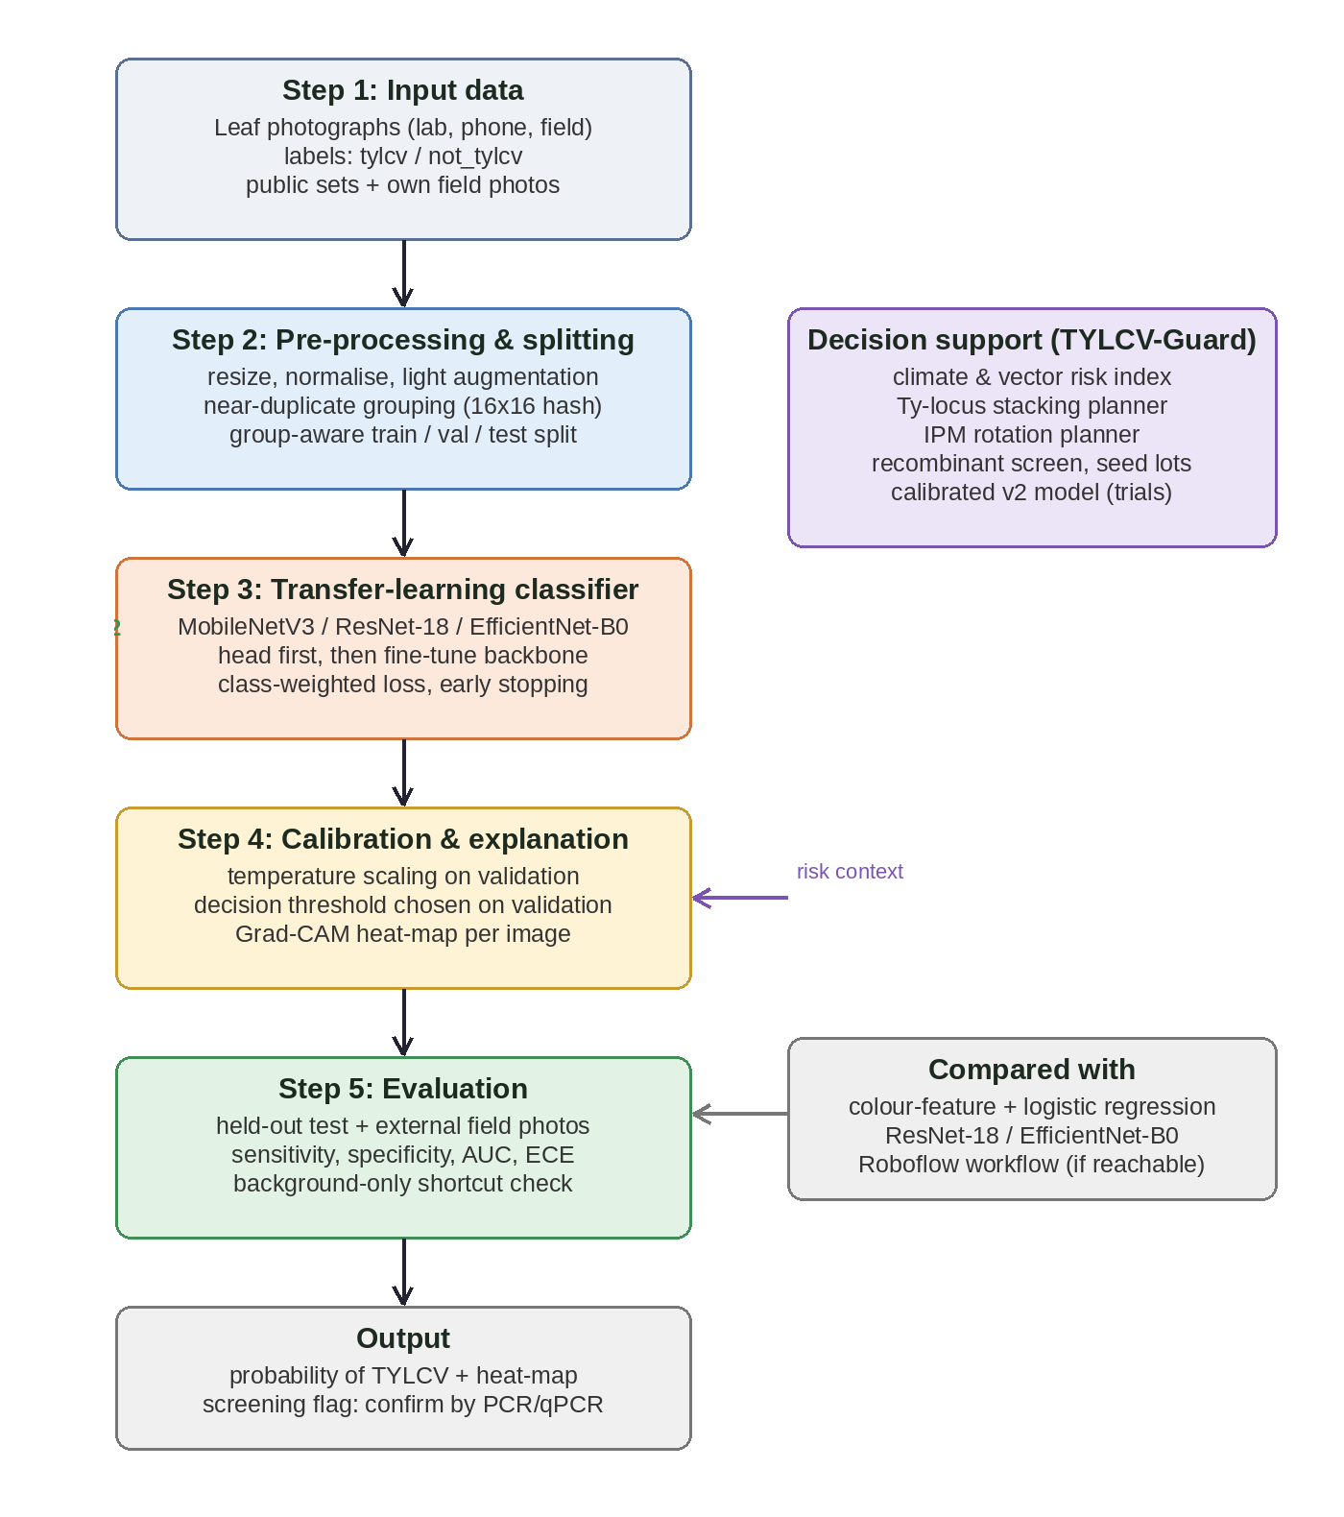
Figure 6.1: Proposed methodology: what happens to the data at each step, and where decision support is used
6.2 Step 1 – Dataset
Table 6.1 lists the data sources. One public Kaggle image folder of TYLCV leaves is available and has been audited (Chapter 7); a second public set is available through a Roboflow Universe project [50], which was not accessible from my development environment. A labelled dataset with healthy leaves and other diseases, and a set of field photos, are required before training and are the next stage of work.
Table 6.1: Dataset summary
Source | Description | Status
Kaggle TYLCV folder [51] | 100 JPEG images of TYLCV leaves/plants: 91 lab-style (256×256), 7 phone photos (3000×4000), 2 field photos (960×1280); no negatives | Audited
Roboflow Universe TYLCV dataset [50] | Public dataset; also reachable through a Roboflow workflow API | Not audited; API not reachable from the dev environment
Labelled tomato leaf set with negatives | Healthy leaves and other tomato diseases (e.g. PlantVillage tomato classes [6]) | To be obtained; licence to be checked
Field photographs | Phone photos of healthy, TYLCV and look-alike plants from several sites | To be collected
Field trials (TYLCV-Guard) | Trial records: site, loci, temperature, whitefly density, stage, incidence | Logging interface implemented

6.3 Step 2 – Pre-processing and Splitting
Resizing and normalisation. Images are resized and centre-cropped to 224 × 224 pixels and normalised with ImageNet statistics. Augmentation. Random crops, flips, rotation and small brightness, contrast, saturation and hue changes are used; colour changes are kept small because yellowing is the diagnostic signal.
Near-duplicate grouping. Each image is converted to a 16 × 16 grey average hash (256 bits). Images whose hashes differ in at most 12 bits are placed in one group. This threshold was checked on the audited folder, where it linked the true duplicate pairs and no unrelated images. A coarser 8 × 8 hash was tried first and wrongly merged unrelated leaves on plain backgrounds, so it was replaced. Group-aware split. Groups are assigned, class by class, to training (70%), validation (15%) and test (15%) sets, so no group crosses sets.
6.4 Baseline Methods for Comparison
Table 6.2: Baseline methods planned for fair comparison
Baseline | Description
Colour-feature + logistic regression | Mean/variance colour statistics and simple texture features; shows how much a trivial model achieves
Background-only classifier | Trained on image borders only; detects shortcut learning [25]
ResNet-18 [14] | Standard fine-tuned residual network
EfficientNet-B0 [15] | Compound-scaled CNN
Roboflow workflow | Existing hosted model on the same test images, if reachable [50]

6.5 Step 3 – Proposed Model
The classifier is a transfer-learning CNN, MobileNetV3-Small by default [16] (ResNet-18 and EfficientNet-B0 are available). Training has two phases: first only the new classification head is trained, then the whole network is fine-tuned at a ten-times lower learning rate [12]. Table 6.3 gives the configuration. If pretrained weights cannot be downloaded the code warns loudly and trains from random initialisation, which is expected to perform much worse.
Table 6.3: Classifier configuration
Item | Setting
Backbone | MobileNetV3-Small (default), ResNet-18, EfficientNet-B0; ImageNet-pretrained
Input | 224 × 224 RGB, ImageNet normalisation
Head | Final linear layer replaced by 2 outputs (not_tylcv, tylcv)
Loss | Class-weighted cross-entropy (Equation 4.1)
Optimiser | AdamW, weight decay 1e-4; head lr 1e-3, then 1e-4 for the full network
Schedule | 2 frozen-backbone epochs, then fine-tuning; early stopping on validation AUC (patience 4)
Seeds | Fixed seeds; at least three seeds planned for the final results

6.6 Step 4 – Calibration, Explanation and Decision Support
Calibration. Temperature scaling is fitted on validation logits and the decision threshold is chosen on validation data (Equation 4.2). Explanation. Grad-CAM heat-maps are produced for each prediction [22], and a background-only baseline checks for shortcuts.
Decision support (TYLCV-Guard). Besides the image model, I built a web application that connects a diagnosis to the actions that follow. Its modules are summarised in Table 6.4. They are advisory and based on assumptions taken from the literature; they are not validated against field data.
Table 6.4: Decision-support modules of the TYLCV-Guard prototype
Module | What it does | Basis
Climate and vector risk index | Daily and seasonal risk from temperature, whitefly density, crop stage, resistance and exclusion | Heuristic from literature [1], [49]
Resistance stacking planner | Scores combinations of Ty loci and suggests the next locus | Heuristic priors [4], [42], [43]
IPM rotation planner | Plans insecticide mode-of-action rotation; excludes failed groups; no product or dose advice | Resistance management [47], [48]
Sequence surveillance | k-mer classification and recombinant screen for user-supplied sequences | Genomic surveillance [44], [46]
Seed-lot register | Status of seed lots and a rule-of-three prevalence bound | Seed transmission [3]
Field-trial log and calibrated model | Logs trials; fits a logistic model of incidence from the data | Learns from data (needs 30+ trials)
Leaf scan | Image screening through a Roboflow workflow or a locally trained model | [50]

6.7 Step 5 – Evaluation Protocol and Metrics
Table 6.5: Evaluation protocols
Protocol | Purpose | Metrics
Duplicate-aware held-out test | Honest in-distribution estimate | Accuracy, sensitivity, specificity, F1, ROC-AUC, PR-AUC, confusion matrix
External field set | Measure domain shift (new device, background, site) | Sensitivity and specificity with 95% confidence intervals
Hard-negative set | Specificity against look-alike conditions | False-positive rate per condition
Calibration check | Are probabilities reliable? | ECE, reliability diagram [21]
Shortcut check | Does the model use leaf or background? | Background-only accuracy; Grad-CAM [22]
Repeated seeds | Training variability | Mean ± standard deviation over seeds

6.8 Tools and Experimental Setup
Table 6.6: Tools and justification
Tool | Use | Why
Python 3.13 | All code | Standard for ML and data science
PyTorch, torchvision | Model training and inference | Pretrained backbones and Grad-CAM hooks
scikit-learn, NumPy, Matplotlib | Metrics and figures | Reproducible evaluation
SQLite + Python standard library | Web application and API | No external dependencies; easy to deploy
Roboflow inference SDK (optional) | Hosted workflow inference | Compare with an existing hosted model
unittest | Automated tests | 34 tests for modules and pipeline

CHAPTER 7
PROOF OF WORK
A working prototype of the platform and the training pipeline has already been built. This chapter shows the code, how it was tested, an audit of the available TYLCV image data, benchmark results for the decision-support modules, and the plan for remaining work. Important: no image classifier has yet been trained or evaluated on real leaf photographs with negatives, because such data was not available; the results below are therefore about the platform, the data and the evaluation design, not about image-diagnosis accuracy.
7.1 Implementation and Project Structure
The prototype is written in Python as the package tylcv-guard. Figure 7.1 shows how it is organised. The main parts are:
• app/risk.py, stacking.py, rotation.py: the risk index, resistance stacking planner and insecticide rotation planner.
• app/seqtools.py, calibrate.py, db.py, server.py: sequence screening, the calibrated model, SQLite storage and the JSON API.
• app/vision.py: Leaf scan through a Roboflow workflow or a locally trained model; credentials are read only from environment variables.
• dl/data.py, model.py, train.py, infer.py: scanning, duplicate-aware splitting, backbones, Grad-CAM, training, evaluation and inference.
• benchmark/ and tools/: a simulator and benchmark producing 15 figures, and a dataset audit tool.
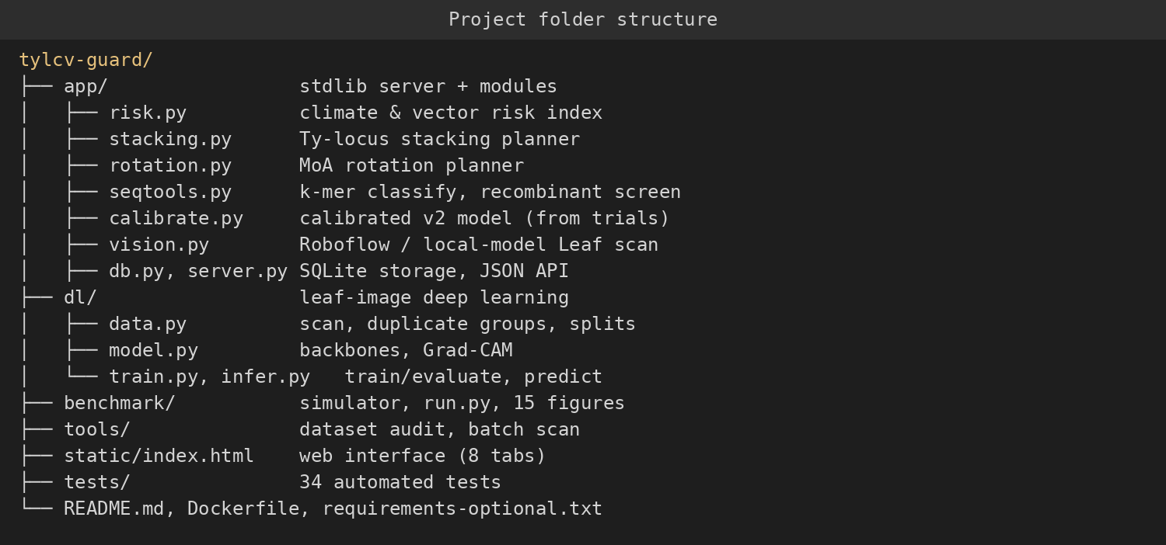
Figure 7.1: Project folder structure of the prototype
7.2 Testing the Code
Automated tests check each module and the pipeline: validation of inputs, monotonic behaviour of the risk index, locus stacking, rotation constraints, sequence classification and recombination screening, database operations, API endpoints, the vision integration with a mocked client, and the deep-learning pipeline. The deep-learning tests use synthetic images only: they show that data scanning, duplicate-aware splitting, training, evaluation, Grad-CAM and inference run end to end and that near-duplicates do not cross splits. They say nothing about accuracy on real leaves. All 34 tests pass (Figure 7.2).
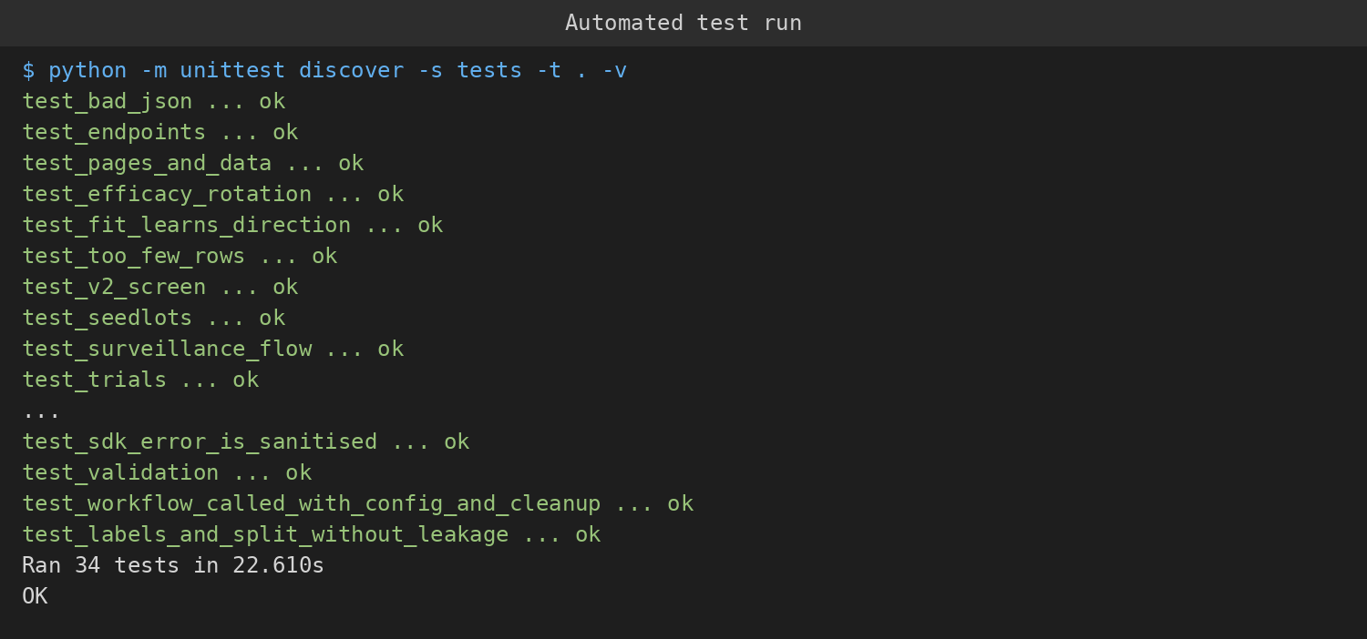
Figure 7.2: Console output of the automated tests
During testing the first version of the duplicate hash (8 × 8 bits) merged unrelated synthetic images into very large groups and left the validation split empty; it was replaced by the stricter 16 × 16 hash described in Chapter 6.
7.3 Result 1 – Audit of the Available TYLCV Image Data
I audited the public Kaggle TYLCV folder [51] before using it. Table 7.1 and Figure 7.3 summarise the findings.
Table 7.1: Audit of the Kaggle TYLCV image folder
Item | Finding
Number of images | 100 JPEG files, none corrupt
Dimensions | 91 images 256×256; 7 images 3000×4000; 2 images 960×1280
Sources (by filename) | 91 PlantVillage-style names; 7 phone-camera names; 2 timestamp names
Exact duplicates | None
Near-duplicates | Two pairs: the same photograph stored at different resolutions
Labels | All 100 images TYLCV-positive; no healthy or other-disease images
Consequence | Accuracy, specificity and calibration cannot be measured; only the 9 non-lab images test field generalisation

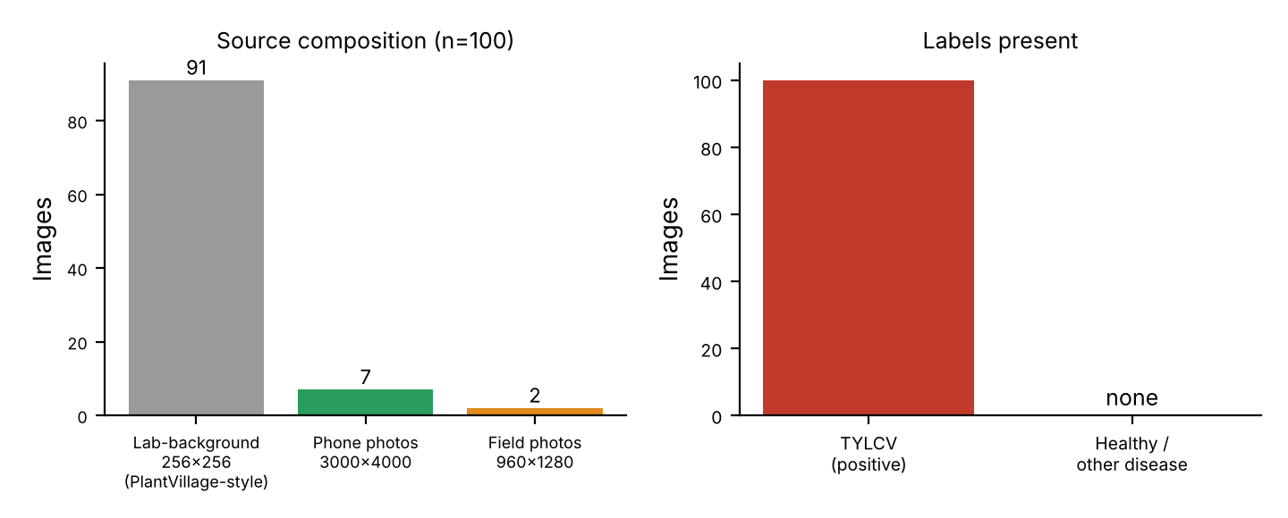
Figure 7.3: Audit of the public TYLCV image folder: source composition and label coverage
This result directly led to the design choices of Chapter 6: duplicate-aware splitting, a requirement for negatives and an external field test set. I make no accuracy claim for any image model on this folder.
7.4 Result 2 – Decision-Support Modules on a Simulated Benchmark
To test the decision-support modules I built a simulator of fields (temperature, whitefly density, crop stage, resistance loci, recombinant pressure, exclusion) with a ground-truth infection process that uses different functional forms from the modules. Previous approaches (temperature-only, whitefly-threshold and temperature × whitefly) were compared with the first heuristic model (v1) and a calibrated model (v2) learned from the simulated trials. All numbers come from simulated data and show how the components behave under assumed rules; they are not evidence of real-world accuracy. Table 7.2 and Figures 7.4–7.7 show the results.
Table 7.2: Outbreak prediction on simulated fields (outbreak = incidence ≥ 30%; MAE of incidence, lower is better)
Model | AUC | Avg. precision | MAE | ECE | AUC (hot, unseen)
Temp-only | 0.635 | 0.222 | 0.126 | 0.069 | 0.666
Whitefly-threshold | 0.736 | 0.314 | 0.125 | 0.041 | 0.732
Env-only (T×WF) | 0.764 | 0.348 | 0.117 | 0.017 | 0.775
v1 (heuristic) | 0.930 | 0.786 | 0.074 | 0.022 | 0.938
v2 (calibrated) | 0.980 | 0.897 | 0.038 | 0.003 | 0.982

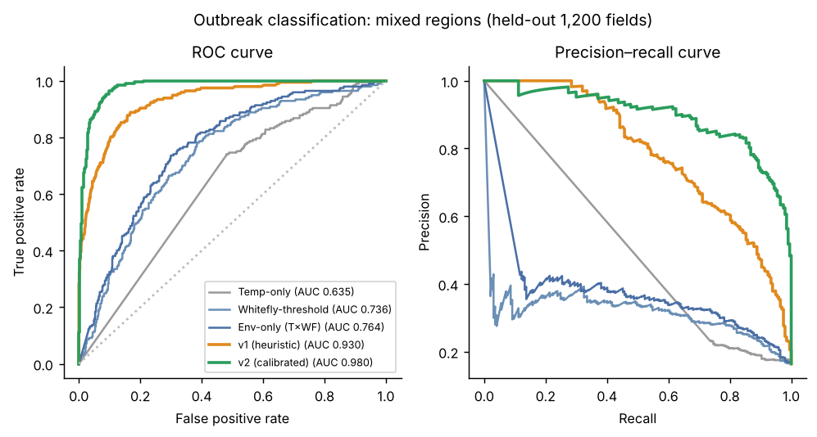
Figure 7.4: ROC and precision–recall curves of the risk models on held-out simulated fields
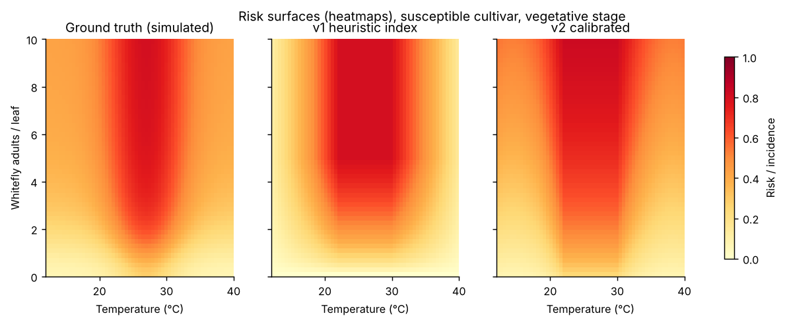
Figure 7.5: Risk surfaces: ground truth, v1 heuristic and v2 calibrated model (heat-maps)
The calibrated model matched the heuristic with about 30 simulated trials (AUC 0.924) and clearly exceeded it from about 60 (AUC 0.969), which shows why logging field trials matters. The advantage of v1 and v2 over the previous approaches comes mostly from including resistance and crop stage, which the previous approaches ignore by construction; this comparison is therefore tilted in their favour.
Table 7.3: Other modules on simulated data
Module | Previous approach | v1 | v2
Recombinant detection (mean sensitivity, ~1% false positives) | 0.00 | 0.67 | 0.80
Rotation: mean efficacy, uniform resistance | 0.04 (one group repeated) | 0.39 | 0.39
Rotation: mean efficacy, two groups already compromised | 0.03 (one group repeated) | 0.35 | 0.35

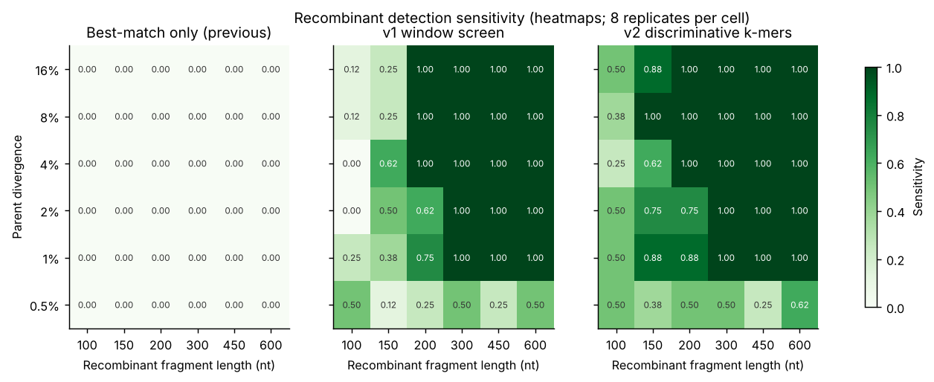
Figure 7.6: Recombinant detection sensitivity by parent divergence and fragment length (heat-maps)
Honest caveats: the rotation planners did not beat a fixed round-robin schedule in the toy model, and every strategy lost efficacy within about 20 sprays, so rotation alone is not sufficient; the recombinant screen fails at 0.5% divergence and for fragments of 100 nt or less; and the simulator shares its qualitative assumptions with v1 and v2.
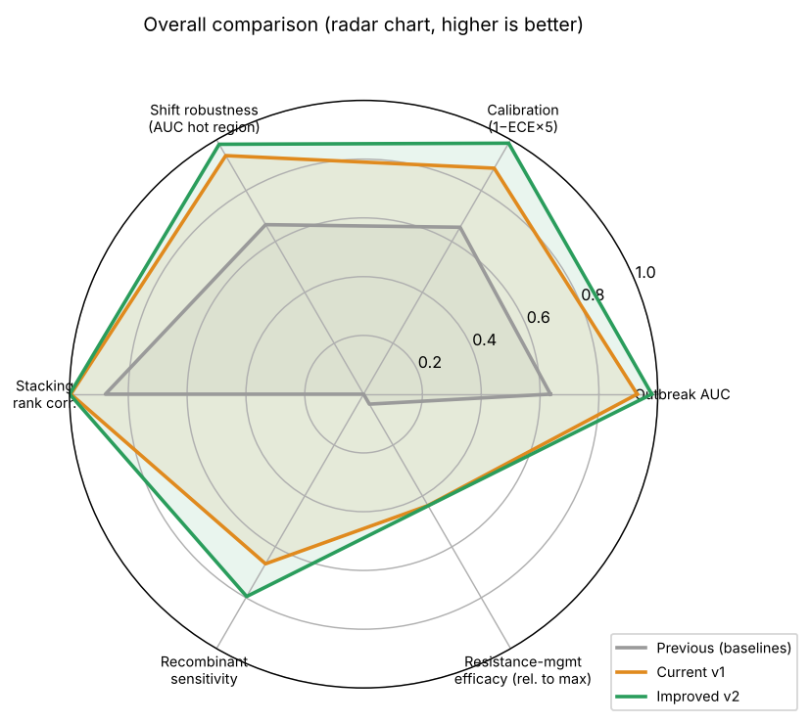
Figure 7.7: Overall comparison of previous approaches, v1 and v2 on the simulated benchmark (radar chart)
7.5 Result 3 – Status of the Image-Diagnosis Pipeline
The deep-learning pipeline is complete and tested on synthetic data, and the Leaf scan integration with the Roboflow workflow was tested against a mocked client because the hosted service was not reachable from the development environment. Real training was blocked by two things: the lack of a labelled set with negatives, and the lack of network access to download pretrained weights. These are listed as risks below. I have deliberately not reported any accuracy for an image model.
7.6 Challenges and Risks
• Data: negatives, look-alike conditions and field photos must be obtained; labels from public sets are visual, not PCR-confirmed.
• Shortcut learning: lab-background data may let the model learn the background; mitigated by external field tests and Grad-CAM.
• Licences: the licences of public datasets must be checked before use or redistribution.
• Compute and weights: training needs pretrained weights and, ideally, a GPU.
• Overclaiming: the simulated benchmark must not be presented as field accuracy; results from real data must be reported separately.
7.7 Plan for Remaining Work
Table 7.4: Schedule of remaining work
Period | Work | Output
Month 1 | Obtain a labelled tomato leaf set with negatives and look-alikes; check licences; collect field photos | Dataset with documented sources
Month 2 | Train baselines and MobileNetV3 / ResNet-18 / EfficientNet-B0 with several seeds; duplicate-aware splits | Test metrics with confidence intervals
Month 3 | External field evaluation, background-only and Grad-CAM shortcut checks, calibration | Domain-shift and calibration results
Month 4 | Integrate the trained model into Leaf scan; compare with the Roboflow workflow; field trial logging | Integrated prototype and comparison
Month 5 | PCR-confirmed subset (if access is available); statistical tests | Validated results
Month 6 | Thesis writing and submission | Final dissertation

CHAPTER 8
CONCLUSION
This synopsis looked at deep-learning-based diagnosis of tomato yellow leaf curl virus from leaf images. The literature review showed that models reach very high accuracy on lab-background benchmarks, but that this does not carry over to field images, that benchmark backgrounds can leak labels, that near-duplicate images can inflate results, and that calibration, thresholds and links to management decisions are rarely addressed. I did not find a field-validated TYLCV study with molecularly confirmed ground truth.
Three objectives were set: to study existing approaches and find their gaps; to develop and implement a screening pipeline with calibrated outputs, explanations and decision-support modules; and to evaluate it under realistic conditions. A working prototype of the platform and the training pipeline has been built and passes 34 automated tests. An audit of a public TYLCV image set showed that it contains only positive images, mostly lab-style photos and near-duplicate pairs, which is why the design uses duplicate-aware splits, negatives and external field tests. Decision-support modules were benchmarked on simulated data, with results that show where they help and where they do not. No accuracy has yet been measured for an image classifier on real data; the next stage will obtain labelled data with negatives, train and evaluate the models with several seeds, test them on external field photos and report honest confidence intervals.
REFERENCES
[1] A. Prasad, N. Sharma, G. Hari-Gowthem, M. Muthamilarasan, and M. Prasad, "Tomato yellow leaf curl virus: Impact, challenges, and management," Trends Plant Sci., vol. 25, no. 9, pp. 897–911, 2020.
[2] H. Czosnek, A. Hariton-Shalev, I. Sobol, R. Gorovits, and M. Ghanim, "The incredible journey of begomoviruses in their whitefly vector," Viruses, vol. 9, no. 10, p. 273, 2017.
[3] E.-J. Kil et al., "Tomato yellow leaf curl virus (TYLCV-IL): A seed-transmissible geminivirus in tomatoes," Sci. Rep., vol. 6, Art. no. 19013, 2016.
[4] Z. Yan et al., "Resistance to tomato yellow leaf curl virus in tomato germplasm," Front. Plant Sci., vol. 9, Art. no. 1198, 2018.
[5] M. R. Rojas et al., "World management of geminiviruses," Annu. Rev. Phytopathol., vol. 56, pp. 637–677, 2018.
[6] S. P. Mohanty, D. P. Hughes, and M. Salathé, "Using deep learning for image-based plant disease detection," Front. Plant Sci., vol. 7, Art. no. 1419, 2016.
[7] A. Kamilaris and F. X. Prenafeta-Boldú, "Deep learning in agriculture: A survey," Comput. Electron. Agric., vol. 147, pp. 70–90, 2018.
[8] A. Abade, P. A. Ferreira, and F. de Barros Vidal, "Plant diseases recognition on images using convolutional neural networks: A systematic review," Comput. Electron. Agric., vol. 185, Art. no. 106125, 2021.
[9] J. G. A. Barbedo, "Impact of dataset size and variety on the effectiveness of deep learning and transfer learning for plant disease classification," Comput. Electron. Agric., vol. 153, pp. 46–53, 2018.
[10] A.-K. Mahlein, "Plant disease detection by imaging sensors – parallels and specific demands for precision agriculture and plant phenotyping," Plant Dis., vol. 100, no. 2, pp. 241–251, 2016.
[11] M. Ouhami, A. Hafiane, Y. Es-Saady, M. El Hajji, and R. Canals, "Computer vision, IoT and data fusion for crop disease detection using machine learning: A survey and ongoing research," Remote Sens., vol. 13, no. 13, p. 2486, 2021.
[12] E. C. Too, L. Yujian, S. Njuki, and L. Yingchun, "A comparative study of fine-tuning deep learning models for plant disease identification," Comput. Electron. Agric., vol. 161, pp. 272–279, 2019.
[13] S. Sladojevic, M. Arsenovic, A. Anderla, D. Culibrk, and D. Stefanovic, "Deep neural networks based recognition of plant diseases by leaf image classification," Comput. Intell. Neurosci., vol. 2016, Art. no. 3289801, 2016.
[14] K. He, X. Zhang, S. Ren, and J. Sun, "Deep residual learning for image recognition," in Proc. IEEE Conf. Comput. Vis. Pattern Recognit. (CVPR), 2016, pp. 770–778.
[15] M. Tan and Q. V. Le, "EfficientNet: Rethinking model scaling for convolutional neural networks," in Proc. Int. Conf. Mach. Learn. (ICML), 2019, pp. 6105–6114.
[16] A. Howard et al., "Searching for MobileNetV3," in Proc. IEEE/CVF Int. Conf. Comput. Vis. (ICCV), 2019, pp. 1314–1324.
[17] A. Dosovitskiy et al., "An image is worth 16×16 words: Transformers for image recognition at scale," in Proc. Int. Conf. Learn. Represent. (ICLR), 2021.
[18] Z. Liu et al., "Swin Transformer: Hierarchical vision transformer using shifted windows," in Proc. IEEE/CVF Int. Conf. Comput. Vis. (ICCV), 2021, pp. 10012–10022.
[19] S. Ren, K. He, R. Girshick, and J. Sun, "Faster R-CNN: Towards real-time object detection with region proposal networks," IEEE Trans. Pattern Anal. Mach. Intell., vol. 39, no. 6, pp. 1137–1149, 2017.
[20] J. Redmon, S. Divvala, R. Girshick, and A. Farhadi, "You only look once: Unified, real-time object detection," in Proc. IEEE Conf. Comput. Vis. Pattern Recognit. (CVPR), 2016, pp. 779–788.
[21] C. Guo, G. Pleiss, Y. Sun, and K. Q. Weinberger, "On calibration of modern neural networks," in Proc. Int. Conf. Mach. Learn. (ICML), 2017, pp. 1321–1330.
[22] R. R. Selvaraju et al., "Grad-CAM: Visual explanations from deep networks via gradient-based localization," in Proc. IEEE Int. Conf. Comput. Vis. (ICCV), 2017, pp. 618–626.
[23] R. Geirhos et al., "Shortcut learning in deep neural networks," Nat. Mach. Intell., vol. 2, pp. 665–673, 2020.
[24] K. P. Ferentinos, "Deep learning models for plant disease detection and diagnosis," Comput. Electron. Agric., vol. 145, pp. 311–318, 2018.
[25] M. A. Noyan, "Uncovering bias in the PlantVillage dataset," arXiv:2206.04374, 2022.
[26] M. H. Saleem, J. Potgieter, and K. M. Arif, "Plant disease detection and classification by deep learning," Plants, vol. 8, no. 11, p. 468, 2019.
[27] J. Liu and X. Wang, "Plant diseases and pests detection based on deep learning: A review," Plant Methods, vol. 17, Art. no. 22, 2021.
[28] M. Shoaib et al., "An advanced deep learning models-based plant disease detection: A review of recent research," Front. Plant Sci., vol. 14, Art. no. 1158933, 2023.
[29] A. Ahmad, D. Saraswat, and A. El Gamal, "A survey on using deep learning techniques for plant disease diagnosis and recommendations for development of appropriate tools," Smart Agric. Technol., vol. 3, Art. no. 100083, 2023.
[30] K. Zhang, Q. Wu, A. Liu, and X. Meng, "Can deep learning identify tomato leaf disease?" Adv. Multimedia, vol. 2018, Art. no. 6710865, 2018.
[31] M. Brahimi, K. Boukhalfa, and A. Moussaoui, "Deep learning for tomato diseases: Classification and symptoms visualization," Appl. Artif. Intell., vol. 31, no. 4, pp. 299–315, 2017.
[32] M. Agarwal, A. Singh, S. Arjaria, A. Sinha, and S. Gupta, "ToLeD: Tomato leaf disease detection using convolution neural network," Procedia Comput. Sci., vol. 167, pp. 293–301, 2020.
[33] R. Karthik, M. Hariharan, S. Anand, P. Mathikshara, A. Johnson, and R. Menaka, "Attention embedded residual CNN for disease detection in tomato leaves," Appl. Soft Comput., vol. 86, Art. no. 105933, 2020.
[34] S. Zhao, Y. Peng, J. Liu, and S. Wu, "Tomato leaf disease diagnosis based on improved convolution neural network by attention module," Agriculture, vol. 11, no. 7, p. 651, 2021.
[35] J. G. A. Barbedo, "Plant disease identification from individual lesions and spots using deep learning," Biosyst. Eng., vol. 180, pp. 96–107, 2019.
[36] A. Picon et al., "Deep convolutional neural networks for mobile capture device-based crop disease classification in the wild," Comput. Electron. Agric., vol. 161, pp. 280–290, 2019.
[37] A. Ramcharan, K. Baranowski, P. McCloskey, B. Ahmed, J. Legg, and D. P. Hughes, "Deep learning for image-based cassava disease detection," Front. Plant Sci., vol. 8, Art. no. 1852, 2017.
[38] S. H. Lee, H. Goëau, P. Bonnet, and A. Joly, "New perspectives on plant disease characterization based on deep learning," Comput. Electron. Agric., vol. 170, Art. no. 105220, 2020.
[39] D. Singh et al., "PlantDoc: A dataset for visual plant disease detection," in Proc. ACM India Joint Int. Conf. Data Sci. Manage. Data (CoDS-COMAD), 2020, pp. 249–253.
[40] A. Fuentes, S. Yoon, S. C. Kim, and D. S. Park, "A robust deep-learning-based detector for real-time tomato plant diseases and pests recognition," Sensors, vol. 17, no. 9, p. 2022, 2017.
[41] P. Wspanialy and M. Moussa, "A detection and severity estimation system for generic diseases of tomato greenhouse plants," Comput. Electron. Agric., vol. 178, Art. no. 105701, 2020.
[42] H. Yamaguchi et al., "An NB-LRR gene, TYNBS1, is responsible for resistance mediated by the Ty-2 begomovirus resistance locus of tomato," Theor. Appl. Genet., vol. 131, pp. 1345–1362, 2018.
[43] U. Gill et al., "Ty-6, a major begomovirus resistance gene on chromosome 10, is effective against Tomato yellow leaf curl virus and Tomato mottle virus," Theor. Appl. Genet., vol. 132, pp. 1543–1554, 2019.
[44] B. Mabvakure et al., "Ongoing geographical spread of Tomato yellow leaf curl virus," Virology, vol. 498, pp. 257–264, 2016.
[45] E. Fiallo-Olivé and J. Navas-Castillo, "Begomoviruses: What is the secret(s) of their success?" Trends Plant Sci., vol. 28, pp. 715–727, 2023.
[46] P. Roumagnac et al., "Establishment of five new genera in the family Geminiviridae," Arch. Virol., vol. 167, pp. 695–710, 2022.
[47] A. R. Horowitz, M. Ghanim, E. Roditakis, R. Nauen, and I. Ishaaya, "Insecticide resistance and its management in Bemisia tabaci species," J. Pest Sci., vol. 93, pp. 893–910, 2020.
[48] R. A. C. Dângelo, M. Michereff-Filho, M. R. Campos, P. S. da Silva, and R. N. C. Guedes, "Insecticide resistance and control failure likelihood of the whitefly Bemisia tabaci (MEAM1; B biotype): A Neotropical scenario," Ann. Appl. Biol., vol. 172, no. 1, pp. 88–99, 2018.
[49] S. Skendžić, M. Zovko, I. P. Živković, V. Lešić, and D. Lemić, "The impact of climate change on agricultural insect pests," Insects, vol. 12, no. 5, p. 440, 2021.
[50] Thesis, "Tomato - Yellow Leaf Curl Virus Dataset," Roboflow Universe, Roboflow, Dec. 2022. [Online]. Available: https://universe.roboflow.com/thesis-okplj/tomato-yellow-leaf-curl-virus
[51] mohammeda5, "Tomato Yellow Leaf Curl Virus Dataset," Kaggle. [Online]. Available: https://www.kaggle.com/datasets/mohammeda5/tomato-yellow-leaf-curl-virus-dataset
ANNEXURE I: PLAGIARISM REPORT
[The institutional plagiarism-check report is to be attached here after the final text is submitted for checking.]

