Deep Learning-Based Intelligent Visual Diagnosis of Tomato Yellow Leaf Curl Virus Using Leaf Images: A Review
Ritesh Dwivedi
Department of CSE
Chandigarh University
Gharuan, Punjab, India
25mds10023@cuchd.in
Abstract—Tomato yellow leaf curl virus (TYLCV) causes severe yield loss in tomato, and timely field diagnosis is a prerequisite for vector control and removal of infected plants. Because its symptoms (upward leaf curling, marginal yellowing, stunting) are visible on leaves, deep-learning analysis of leaf images is an attractive screening route. This paper reviews image-based plant disease diagnosis with convolutional networks, vision transformers and object detectors, with emphasis on tomato and on what is known about TYLCV. We survey datasets, architectures, transfer learning, lightweight and mobile deployment, calibration and explainability, and we compare the evidence across study designs. A recurring finding is that near-perfect accuracy on lab-background benchmarks does not transfer to field images, that benchmark backgrounds can leak class information, and that labels are rarely confirmed by molecular tests. We identify gaps in data, evaluation, calibration, look-alike discrimination and deployment, and we propose an evaluation checklist and research directions for field-ready TYLCV leaf diagnosis.
Index Terms—tomato yellow leaf curl virus, deep learning, convolutional neural networks, transfer learning, plant disease diagnosis, explainable AI, domain shift, precision agriculture.

I. INTRODUCTION
Tomato is one of the most widely grown vegetable crops, and tomato yellow leaf curl virus (TYLCV) is among its most damaging pathogens, capable of causing near-total loss of marketable fruit when plants are infected early [1]. Because the virus is transmitted by whiteflies in a persistent manner and no curative treatment exists, control depends on finding infected plants early so that they can be removed and vector populations managed [1], [2]. In practice, scouting relies on trained observers recognising upward leaf curling, marginal yellowing and stunting, a skill that is scarce and subjective at the scale of commercial production.
Over the last decade, deep learning has changed image-based plant disease diagnosis. Convolutional neural networks (CNNs) trained on leaf photographs reached accuracies above 99% on the PlantVillage benchmark [3], [4], and several surveys now cover the field [5], [6], [7], [8]. Yet the earliest large study already showed a sharp drop when models were tested on images taken under different conditions [3], and later work argues that benchmark performance overstates what can be expected in the field [9], [10], [11].
This paper is a narrative review that asks how far deep-learning leaf-image diagnosis can currently be trusted for TYLCV specifically. We (i) summarise the TYLCV diagnostic problem and the deep-learning toolbox, (ii) review datasets, architectures, training strategies, field generalisation, detection, deployment and explainability, (iii) compare the evidence across study designs, and (iv) identify gaps, challenges and future directions. The scope is roughly 2016–2026 literature on leaf-image classification, detection and explainability, with emphasis on tomato; sources were located through web and library searches and selected for relevance and citation in the field, so this is not a systematic review.
II. BACKGROUND AND RELATED WORK
A. TYLCV Symptoms and the Diagnostic Problem
Infected tomato plants show leaflets that curl upward and inward, yellowing at leaf margins, shortened internodes, a dwarfed bushy habit and reduced flowering and fruit set; severity depends on the plant's age at infection [1]. These cues are visible on leaves, but similar symptoms can arise from other begomoviruses, nutrient disorders, herbicide injury or heat stress, so visual diagnosis is a screening step and molecular tests (PCR/qPCR) remain the confirmatory standard [1]. A useful image-based system therefore has to separate TYLCV from look-alike conditions and from healthy leaves, not merely recognise yellow leaves.
B. Sensing Modalities
RGB imaging with consumer cameras is the cheapest and most scalable modality. Hyperspectral and thermal sensors can detect physiological changes before visible symptoms appear, but cost and calibration demands limit them to research and phenotyping settings [12]. Surveys that fuse imaging with IoT sensors and environmental data point to multi-modal systems as a longer-term direction [13]. Table I summarises the trade-offs.
TABLE I
IMAGING MODALITIES FOR LEAF DISEASE DIAGNOSIS
Modality | Strengths | Limitations
RGB (phone) | Cheap, ubiquitous, field-ready | Symptom-stage only; lighting and background vary
Hyperspectral / thermal | Pre-symptomatic signals [12] | Cost, calibration, throughput
Image + IoT / weather [13] | Context-aware risk and diagnosis | Integration and data-quality burden

C. Deep Learning Building Blocks
Early plant-disease studies fine-tuned general-purpose CNNs on leaf photographs [14], [3]. Residual networks made very deep models trainable [15], compound scaling produced efficient families [16], and mobile-oriented designs such as MobileNetV3 target on-device inference [17]. Vision transformers treat an image as a sequence of patches [18], and hierarchical variants such as Swin Transformer scale to dense tasks [19]. For localisation, two-stage and single-stage detectors, exemplified by Faster R-CNN and YOLO, predict boxes around symptomatic regions [20], [21]. Transfer learning from ImageNet is the default because plant-disease datasets are small relative to the models trained on them [22], [9]. Figure 1 shows a reference pipeline.
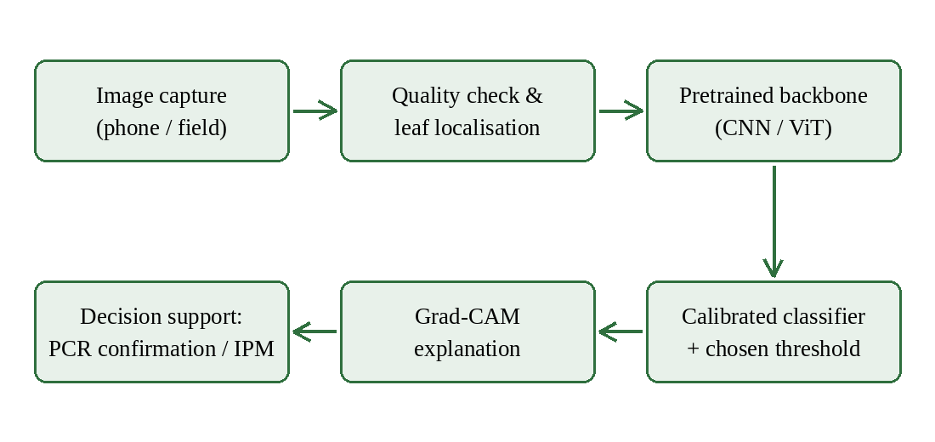
Fig. 1. Reference pipeline for leaf-image TYLCV screening with calibrated outputs and explanations.
D. Calibration and Explainability
A diagnostic score is only useful if its probabilities mean what they say. Modern networks tend to be over-confident, and simple post-hoc temperature scaling on a validation set is an effective remedy [23]. Gradient-based saliency such as Grad-CAM highlights the image regions that drove a decision [24] and has been used to check whether tomato disease classifiers attend to lesions [25].
III. LITERATURE REVIEW
Figure 2 organises the literature along the axes used in this review: the task, the model family, the data, the measures of trust and the deployment route.
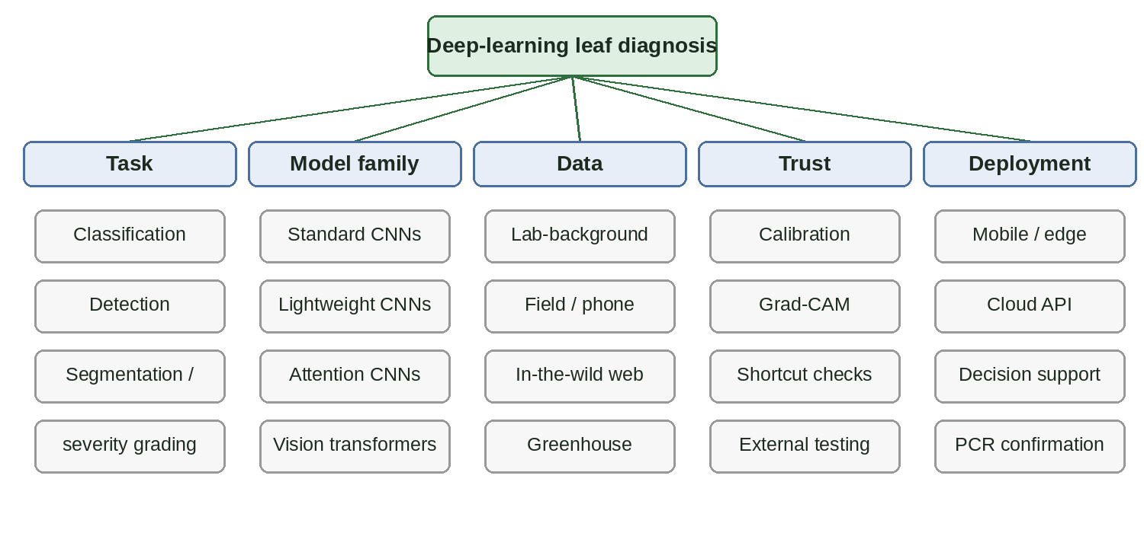
Fig. 2. Taxonomy of deep-learning leaf-image diagnosis used to organise this review.
A. Datasets
PlantVillage is the dominant benchmark: tens of thousands of leaf images across many crop–disease classes photographed in controlled conditions with plain backgrounds [3]. Its convenience produced a large literature but also its main weakness. One analysis showed that PlantVillage backgrounds alone carry enough information to classify images well above chance [11], an instance of the shortcut learning in which networks exploit spurious cues instead of the intended signal [26]. Datasets collected under real conditions are smaller and harder: PlantDoc assembles internet images with annotated bounding boxes for many diseases [27], and cassava studies used field images captured on smartphones [28]. For TYLCV specifically, public sets include a Roboflow Universe dataset [29] and a Kaggle image folder [30]; an inspection of the latter for this review found 100 images, all TYLCV-positive, mostly lab-style photographs. Table II summarises the main dataset types.
TABLE II
DATASET TYPES FOR PLANT DISEASE IMAGE ANALYSIS
Dataset type | Characteristics | Main limitation
PlantVillage [3] | About 54k images, 38 classes, plain lab backgrounds | Background shortcuts [11]
PlantDoc [27] | About 2.6k in-the-wild images, annotated boxes | Small, uneven classes
Cassava field images [28] | Smartphone images from real fields | Single crop
Tomato greenhouse images [31] | Real greenhouse scenes, severity labels | Few diseases; limited public access
TYLCV sets [29], [30] | Public TYLCV image collections | Composition and labels unverified; negatives often missing

B. Tomato Leaf Disease Classification
Many studies classify tomato leaf diseases, almost all on PlantVillage tomato classes, with TYLCV as one class among several. Reported work includes comparisons of standard CNNs [32], [25], lightweight CNNs for modest hardware [33], and attention-augmented networks, including attention-embedded residual networks [34] and squeeze-and-excitation variants [35]. Reported accuracies on this benchmark are uniformly high, which leaves little room to rank methods and little evidence about field behaviour [22], [4]. We did not find, in the sources consulted, a field-validated study dedicated to TYLCV leaf images with molecular ground truth.
C. Generalisation to Field Conditions
The gap between laboratory and field is the central finding of the literature. A network that reached very high accuracy on held-out PlantVillage images dropped to roughly 31% on images collected under different conditions [3]. Studies of dataset size and variety conclude that capturing diverse conditions matters more than adding images of the same kind [9], and that classifying individual lesions and spots can be more robust than classifying whole leaves [36]. Work on smartphone capture in the wild shows that training with field-captured images is needed to approach usable field performance [37], and a cassava study likewise relied on images captured in real fields [28]. A study re-examining plant-disease characterisation argues for training that reflects practical variation rather than single-source benchmarks [10].
D. Detection, Segmentation and Severity
When several symptoms or plants appear in one frame, detection is more informative than classification. A real-time detector for tomato diseases and pests used region-based detectors with several backbones on field images [38], and a greenhouse system combined detection with severity estimation [31]. Detection requires bounding-box or mask annotation, which is costly, and no TYLCV-specific annotated set of this kind was identified here.
E. Training Strategies
Because labelled plant images are limited, training practice largely determines outcomes. Data augmentation (flips, rotations, crops, brightness and contrast changes) is universal, but augmentations must preserve the diagnostic signal: aggressive colour changes can erase the yellowing that distinguishes TYLCV, so hue jitter should be small. Class weighting or resampling addresses imbalance between common and rare classes, and a staged schedule that trains the classifier head first and then unfreezes the backbone at a lower learning rate is a standard way to adapt pretrained networks to small datasets [22], [39]. Reviews of architectures report that the choice among mainstream networks matters less than data quantity, variety and training discipline [39], [9].
F. Lightweight Models and Deployment
Field use favours models small enough for phones or edge devices [17], [40]. Surveys emphasise practical requirements beyond accuracy: latency, connectivity, user interface and recommendations tied to the diagnosis [40], [13]. Reviews also caution that deployment studies remain scarce relative to benchmark studies [7], [8].
G. Explainability and Trust
Saliency maps were used early to inspect tomato disease classifiers [25] and remain the standard tool for spotting shortcut behaviour: a model that attends to the background rather than the leaf is a warning sign [24], [26]. Saliency is a diagnostic aid, not proof of correctness, and should be combined with out-of-domain testing.
H. Look-alike Discrimination
TYLCV is one of several conditions that curl and yellow tomato leaves, and discriminating among them is the clinically relevant task. Multi-class benchmarks include other tomato diseases, but these are mostly fungal or bacterial spots whose appearance differs strongly from a viral curl, so they are easy negatives [25], [32]. Genuinely hard negatives, such as other begomovirus infections, nutrient disorders and herbicide injury, are rare in public data. Detection of subtle or early symptoms may benefit from lesion-level analysis [36] or from non-visible wavelengths [12], but neither has been demonstrated for TYLCV with molecular ground truth.
I. Reported Accuracy and What It Means
Many studies report accuracies above 95% on tomato leaf classification [4], [22], [34]. Such numbers describe performance on images drawn from the same distribution as the training data, with the same backgrounds and often the same capture sessions. They are informative about model capacity, not about whether a farmer's phone photograph taken in a field will be classified correctly [3], [10]. A fair reading of the literature therefore treats benchmark accuracy as an upper bound rather than an estimate.
IV. COMPARATIVE ANALYSIS OF EXISTING RESEARCH
Table III compares the main model families and Table IV compares study designs by what they can and cannot establish. The key distinction is not architecture but evaluation: lab-background benchmarks reward capacity and tuning, whereas field-style, duplicate-aware and externally validated evaluations measure what matters for TYLCV screening.
TABLE III
COMPARISON OF MODEL FAMILIES
Model family | Strengths | Limitations for TYLCV
Standard CNNs [3], [15] | Strong, well understood, easy to fine-tune | Large; benchmark-tuned
Lightweight CNNs [16], [17] | Fast, small; mobile-friendly | Capacity trade-offs; little field evidence
Attention CNNs [34], [35] | Small gains on benchmarks | Gains within benchmark saturation
Vision transformers [18], [19] | Strong general vision results | Data-hungry; little plant field evidence
Detectors [20], [21], [38] | Localise several symptoms per image | Costly box annotation; few TYLCV sets

TABLE IV
COMPARISON OF STUDY DESIGNS
Study design | Typical evidence | Main limitation
Lab-background classification [3], [4], [22] | Very high benchmark accuracy | Background shortcuts; large drop off-distribution [3], [11]
Attention / lightweight CNNs [34], [35], [33] | Small gains over standard CNNs | Gains within benchmark saturation
Detection / severity [38], [31] | Localises symptoms in real scenes | Costly annotation; few TYLCV sets
Field / smartphone capture [37], [28], [9] | Most realistic accuracy | Smaller datasets; lower accuracy
Explainability checks [24], [25] | Exposes shortcuts | Qualitative; not proof

Architectures themselves matter less than data. Comparative fine-tuning studies find that several mainstream networks reach similar benchmark accuracy [22], while studies of data variety find large effects from the diversity of training images [9]. For TYLCV, the available evidence is therefore dominated by benchmark results that do not isolate the virus from look-alike conditions. A second observation concerns reporting: many papers give a single accuracy on a random split, without confidence intervals, external validation, specificity against look-alikes or calibration. Without these, two methods that differ by one percentage point on a saturated benchmark cannot be ranked, and neither can be trusted in the field [23], [8]. Reviews consistently call for standardised protocols and more realistic datasets [7], [6], [40].
V. RESEARCH GAPS
1) Molecularly confirmed labels. Public image sets are commonly labelled by visual inspection; large-scale TYLCV image sets with PCR-confirmed ground truth are, to our knowledge, not publicly available [1], [30].
2) Negatives and look-alikes. Evaluation needs healthy leaves and conditions that mimic TYLCV (other begomoviruses, nutrient and herbicide injury), otherwise specificity is unknown [1], [12].
3) Field generalisation. Accuracy collapses when conditions change [3], [9], and backgrounds leak labels [11], [26].
4) Leakage-aware splitting. Near-duplicate and same-plant images inflate scores unless splits are group-aware; most reviewed studies do not report such precautions.
5) Calibration and thresholds. Most studies report accuracy only, not calibrated probabilities or operating points [23].
6) Early and pre-symptomatic detection. RGB models detect visible symptoms; earlier detection needs richer sensing [12], [13].
7) Deployment evidence. Few studies evaluate end-to-end field use including user decisions [40], [7].
VI. CHALLENGES AND LIMITATIONS
Class imbalance and small field datasets limit training. Symptom expression varies with cultivar, plant age, temperature and co-infections, so appearance is not a stable label [1]. Imaging conditions (illumination, camera, leaf pose) differ between users. Saliency maps can be misleading if over-interpreted [24]. Finally, this review is limited by its narrative design, its reliance on published summaries, and the absence of TYLCV-specific field studies to compare.
VII. FUTURE RESEARCH DIRECTIONS
We propose the checklist in Table V for any TYLCV leaf-image study, and the following directions. First, build a multi-site, multi-device dataset with PCR-confirmed labels, healthy leaves and look-alike negatives. Second, report sensitivity and specificity with confidence intervals on an external field set, using group-aware splits and a decision threshold fixed on validation data. Third, pair accuracy with calibration measures and temperature scaling [23]. Fourth, use Grad-CAM-style checks and background-only control experiments to detect shortcuts [24], [11]. Fifth, evaluate lightweight models on devices [17], [40], and extend to detection and severity grading [38], [31]. Sixth, link diagnoses to vector monitoring and management decisions, so that image screening supports integrated control [1], [2].
The limitations of image-only diagnosis suggest a complementary design: combine a calibrated image classifier with contextual evidence such as whitefly density, weather and local virus prevalence, which together determine the prior probability of infection [13], [1]. In such a system the image model need not be perfect; a positive screen raises the priority of PCR testing and of vector scouting, and a negative screen in a high-risk context should not suppress monitoring. This framing also clarifies the cost of errors: a false negative delays removal of infected plants and allows spread, whereas a false positive costs a laboratory test.
TABLE V
PROPOSED EVALUATION CHECKLIST
Item | Requirement
Labels | PCR/qPCR-confirmed where possible
Negatives | Healthy plus look-alike disorders
Splits | Group-aware; no near-duplicates across splits
External test | Different sites, cameras and backgrounds
Metrics | Sensitivity, specificity, AUC with CIs; calibration
Shortcut checks | Grad-CAM, background-only baseline
Reporting | Threshold fixed on validation data

VIII. CONCLUSION
Deep learning can recognise TYLCV-like symptoms in leaf images, but the evidence that it works in the field is weak. High benchmark accuracies are not reliable guides to field behaviour because of lab backgrounds, label shortcuts, duplicate leakage and the absence of molecularly confirmed negatives. Progress requires better data and stricter evaluation more than new architectures. With group-aware splits, external field tests, calibrated thresholds and explanation checks, image-based screening can become a trustworthy first step ahead of PCR confirmation and vector management.
. REFERENCES
[1] A. Prasad, N. Sharma, G. Hari-Gowthem, M. Muthamilarasan, and M. Prasad, “Tomato yellow leaf curl virus: Impact, challenges, and management,” Trends Plant Sci., vol. 25, no. 9, pp. 897–911, 2020.
[2] Z. Yan et al., “Resistance to tomato yellow leaf curl virus in tomato germplasm,” Front. Plant Sci., vol. 9, Art. no. 1198, 2018.
[3] S. P. Mohanty, D. P. Hughes, and M. Salathé, “Using deep learning for image-based plant disease detection,” Front. Plant Sci., vol. 7, Art. no. 1419, 2016.
[4] K. P. Ferentinos, “Deep learning models for plant disease detection and diagnosis,” Comput. Electron. Agric., vol. 145, pp. 311–318, 2018.
[5] A. Kamilaris and F. X. Prenafeta-Boldú, “Deep learning in agriculture: A survey,” Comput. Electron. Agric., vol. 147, pp. 70–90, 2018.
[6] J. Liu and X. Wang, “Plant diseases and pests detection based on deep learning: A review,” Plant Methods, vol. 17, Art. no. 22, 2021.
[7] A. Abade, P. A. Ferreira, and F. de Barros Vidal, “Plant diseases recognition on images using convolutional neural networks: A systematic review,” Comput. Electron. Agric., vol. 185, Art. no. 106125, 2021.
[8] M. Shoaib et al., “An advanced deep learning models-based plant disease detection: A review of recent research,” Front. Plant Sci., vol. 14, Art. no. 1158933, 2023.
[9] J. G. A. Barbedo, “Impact of dataset size and variety on the effectiveness of deep learning and transfer learning for plant disease classification,” Comput. Electron. Agric., vol. 153, pp. 46–53, 2018.
[10] S. H. Lee, H. Goëau, P. Bonnet, and A. Joly, “New perspectives on plant disease characterization based on deep learning,” Comput. Electron. Agric., vol. 170, Art. no. 105220, 2020.
[11] M. A. Noyan, “Uncovering bias in the PlantVillage dataset,” arXiv:2206.04374, 2022.
[12] A.-K. Mahlein, “Plant disease detection by imaging sensors – parallels and specific demands for precision agriculture and plant phenotyping,” Plant Dis., vol. 100, no. 2, pp. 241–251, 2016.
[13] M. Ouhami, A. Hafiane, Y. Es-Saady, M. El Hajji, and R. Canals, “Computer vision, IoT and data fusion for crop disease detection using machine learning: A survey and ongoing research,” Remote Sens., vol. 13, no. 13, p. 2486, 2021.
[14] S. Sladojevic, M. Arsenovic, A. Anderla, D. Culibrk, and D. Stefanovic, “Deep neural networks based recognition of plant diseases by leaf image classification,” Comput. Intell. Neurosci., vol. 2016, Art. no. 3289801, 2016.
[15] K. He, X. Zhang, S. Ren, and J. Sun, “Deep residual learning for image recognition,” in Proc. IEEE Conf. Comput. Vis. Pattern Recognit. (CVPR), 2016, pp. 770–778.
[16] M. Tan and Q. V. Le, “EfficientNet: Rethinking model scaling for convolutional neural networks,” in Proc. Int. Conf. Mach. Learn. (ICML), 2019, pp. 6105–6114.
[17] A. Howard et al., “Searching for MobileNetV3,” in Proc. IEEE/CVF Int. Conf. Comput. Vis. (ICCV), 2019, pp. 1314–1324.
[18] A. Dosovitskiy et al., “An image is worth 16×16 words: Transformers for image recognition at scale,” in Proc. Int. Conf. Learn. Represent. (ICLR), 2021.
[19] Z. Liu et al., “Swin Transformer: Hierarchical vision transformer using shifted windows,” in Proc. IEEE/CVF Int. Conf. Comput. Vis. (ICCV), 2021, pp. 10012–10022.
[20] S. Ren, K. He, R. Girshick, and J. Sun, “Faster R-CNN: Towards real-time object detection with region proposal networks,” IEEE Trans. Pattern Anal. Mach. Intell., vol. 39, no. 6, pp. 1137–1149, 2017.
[21] J. Redmon, S. Divvala, R. Girshick, and A. Farhadi, “You only look once: Unified, real-time object detection,” in Proc. IEEE Conf. Comput. Vis. Pattern Recognit. (CVPR), 2016, pp. 779–788.
[22] E. C. Too, L. Yujian, S. Njuki, and L. Yingchun, “A comparative study of fine-tuning deep learning models for plant disease identification,” Comput. Electron. Agric., vol. 161, pp. 272–279, 2019.
[23] C. Guo, G. Pleiss, Y. Sun, and K. Q. Weinberger, “On calibration of modern neural networks,” in Proc. Int. Conf. Mach. Learn. (ICML), 2017, pp. 1321–1330.
[24] R. R. Selvaraju et al., “Grad-CAM: Visual explanations from deep networks via gradient-based localization,” in Proc. IEEE Int. Conf. Comput. Vis. (ICCV), 2017, pp. 618–626.
[25] M. Brahimi, K. Boukhalfa, and A. Moussaoui, “Deep learning for tomato diseases: Classification and symptoms visualization,” Appl. Artif. Intell., vol. 31, no. 4, pp. 299–315, 2017.
[26] R. Geirhos et al., “Shortcut learning in deep neural networks,” Nat. Mach. Intell., vol. 2, pp. 665–673, 2020.
[27] D. Singh et al., “PlantDoc: A dataset for visual plant disease detection,” in Proc. ACM India Joint Int. Conf. Data Sci. Manage. Data (CoDS-COMAD), 2020, pp. 249–253.
[28] A. Ramcharan, K. Baranowski, P. McCloskey, B. Ahmed, J. Legg, and D. P. Hughes, “Deep learning for image-based cassava disease detection,” Front. Plant Sci., vol. 8, Art. no. 1852, 2017.
[29] Thesis, “Tomato - Yellow Leaf Curl Virus Dataset,” Roboflow Universe, Roboflow, Dec. 2022. [Online]. Available: https://universe.roboflow.com/thesis-okplj/tomato-yellow-leaf-curl-virus
[30] mohammeda5, “Tomato Yellow Leaf Curl Virus Dataset,” Kaggle. [Online]. Available: https://www.kaggle.com/datasets/mohammeda5/tomato-yellow-leaf-curl-virus-dataset
[31] P. Wspanialy and M. Moussa, “A detection and severity estimation system for generic diseases of tomato greenhouse plants,” Comput. Electron. Agric., vol. 178, Art. no. 105701, 2020.
[32] K. Zhang, Q. Wu, A. Liu, and X. Meng, “Can deep learning identify tomato leaf disease?” Adv. Multimedia, vol. 2018, Art. no. 6710865, 2018.
[33] M. Agarwal, A. Singh, S. Arjaria, A. Sinha, and S. Gupta, “ToLeD: Tomato leaf disease detection using convolution neural network,” Procedia Comput. Sci., vol. 167, pp. 293–301, 2020.
[34] R. Karthik, M. Hariharan, S. Anand, P. Mathikshara, A. Johnson, and R. Menaka, “Attention embedded residual CNN for disease detection in tomato leaves,” Appl. Soft Comput., vol. 86, Art. no. 105933, 2020.
[35] S. Zhao, Y. Peng, J. Liu, and S. Wu, “Tomato leaf disease diagnosis based on improved convolution neural network by attention module,” Agriculture, vol. 11, no. 7, p. 651, 2021.
[36] J. G. A. Barbedo, “Plant disease identification from individual lesions and spots using deep learning,” Biosyst. Eng., vol. 180, pp. 96–107, 2019.
[37] A. Picon et al., “Deep convolutional neural networks for mobile capture device-based crop disease classification in the wild,” Comput. Electron. Agric., vol. 161, pp. 280–290, 2019.
[38] A. Fuentes, S. Yoon, S. C. Kim, and D. S. Park, “A robust deep-learning-based detector for real-time tomato plant diseases and pests recognition,” Sensors, vol. 17, no. 9, p. 2022, 2017.
[39] M. H. Saleem, J. Potgieter, and K. M. Arif, “Plant disease detection and classification by deep learning,” Plants, vol. 8, no. 11, p. 468, 2019.
[40] A. Ahmad, D. Saraswat, and A. El Gamal, “A survey on using deep learning techniques for plant disease diagnosis and recommendations for development of appropriate tools,” Smart Agric. Technol., vol. 3, Art. no. 100083, 2023.

