RESUME

RITESH PANDEY

***GITHUB:-*** [*https://github.com/Ritesh1200*](https://github.com/Ritesh1200)

# PROFILE

An active personality with good grasping ability and responsive nature . Fond of working as an all-rounder in every sector which helps me to increase my stability in every situation.

Also for increasing my knowledge base I want to learn more about new technologies and also want a long term Organization where I will grow into a refined professional with better skills.

# CONTACT

## [Riteshpandey1200@gmail.com](mailto:Riteshpandey1200@gmail.com) +91 7060699351

 Khatima,US Nagar 262308

**HOBBIES**

* Playing volleyball

**SKILLSEDUCATION**

B.tech(CSE) : 78.2% Amrapali group of institutions

Class XII : 76% Shikhsa Bharati school

Class X : 8.2 CGPA Shikhsa Bharati school

# Academic Project

1. **Library Management (using Angular , Express , MongoDb and Node.js)**

It includes managements of all different different department books and management of book issued to student as well as teachers .

<https://librarymanagement1200.herokuapp.com/>

1. **Group Chat (Using React , Express , MongoDB , Node.js)**

It includes creating group and as many as person can join the room . I use socket.io to achive this application .

<https://group-chat1200.herokuapp.com/>

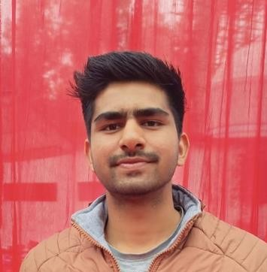

* + ***DSA***
  + ***C***
  + ***JAVA SCRIPT***
  + ***SQL***
  + ***GITHUB***
  + ***JAVA***
  + ***NODE.JS***
  + ***HTML***
  + ***EXPRESS***
  + ***REACT***
  + ***ANGULAR***