**Event Management App**

This document contains sections for:

* Sprint planning and Task completion
* Core concepts used in project
* Demonstrating the product capabilities, appearance, and user interactions.
* Conclusions

The code for this project is hosted at <https://github.com/Akanksha-1312/Event-Mangement-Project>

The project is developed by Akanksha Mishra.

Sprints planning and Task completion

The project is planned to be completed in 1 sprint. Tasks assumed to be completed in the sprint are:

* Creating the flow of the application
* Initializing git repository to track changes as development progresses.
* Writing the Angular program to fulfill the requirements of the project.
* Testing the Angular program with different kinds of User input
* Pushing code to GitHub.
* Creating this specification document highlighting application capabilities, appearance, and user interactions.

Core concepts used in project

* Angular
* Bootstrap
* Postman
* Json-Sever
* TypeScript

Demonstrating the product capabilities, appearance, and user interactions

demonstrate the product capabilities, below are the sub-sections configured to highlight appearance and user interactions for the project:

**login**

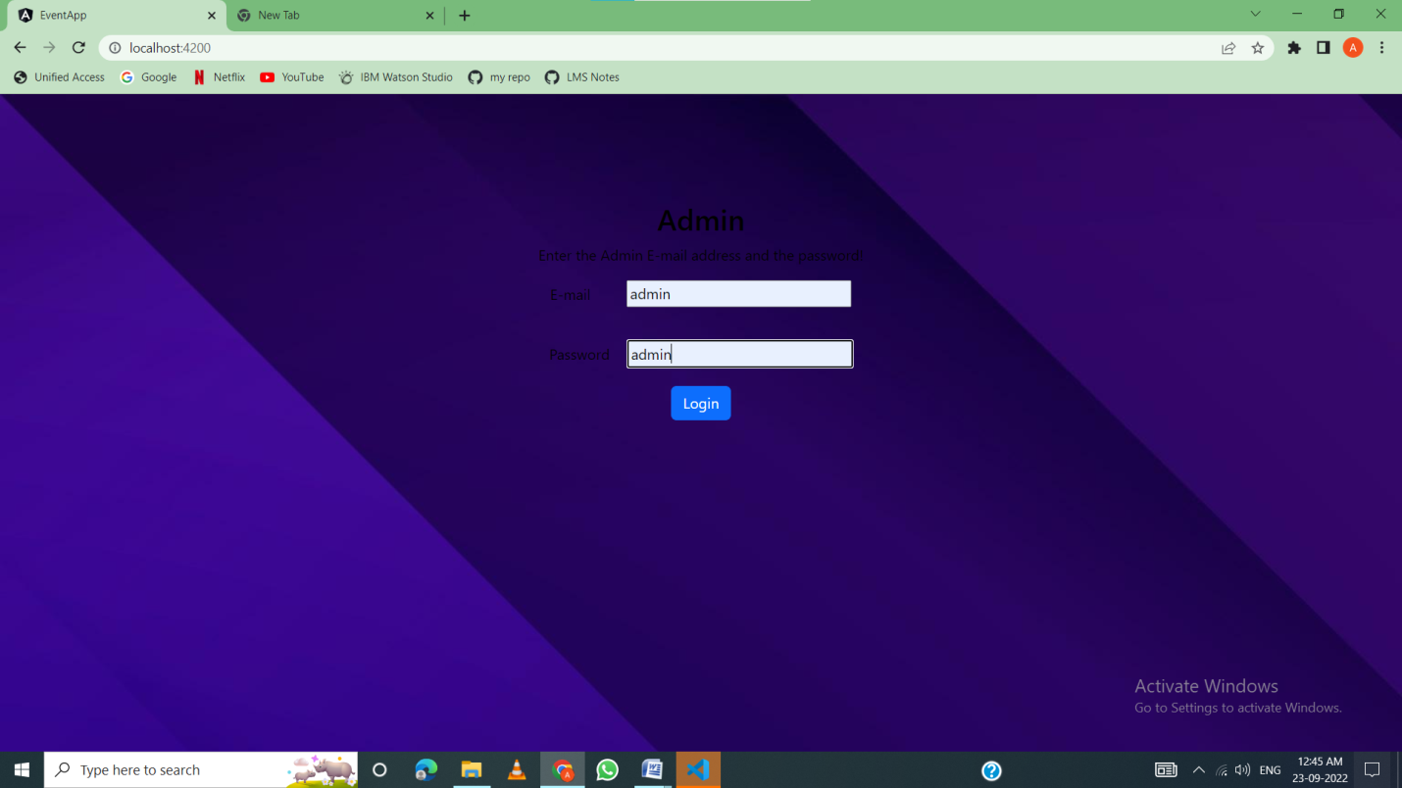

**Home page**

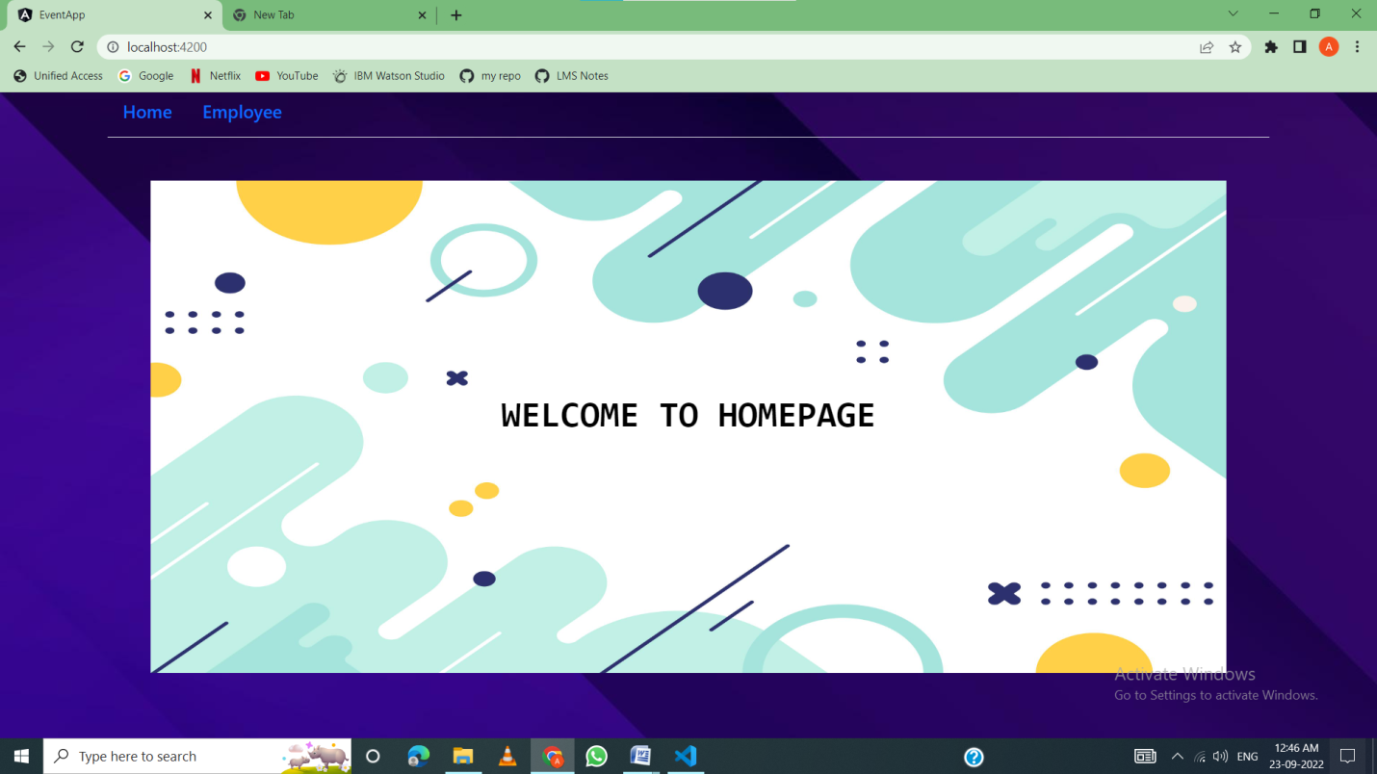

**Employee CRUD**

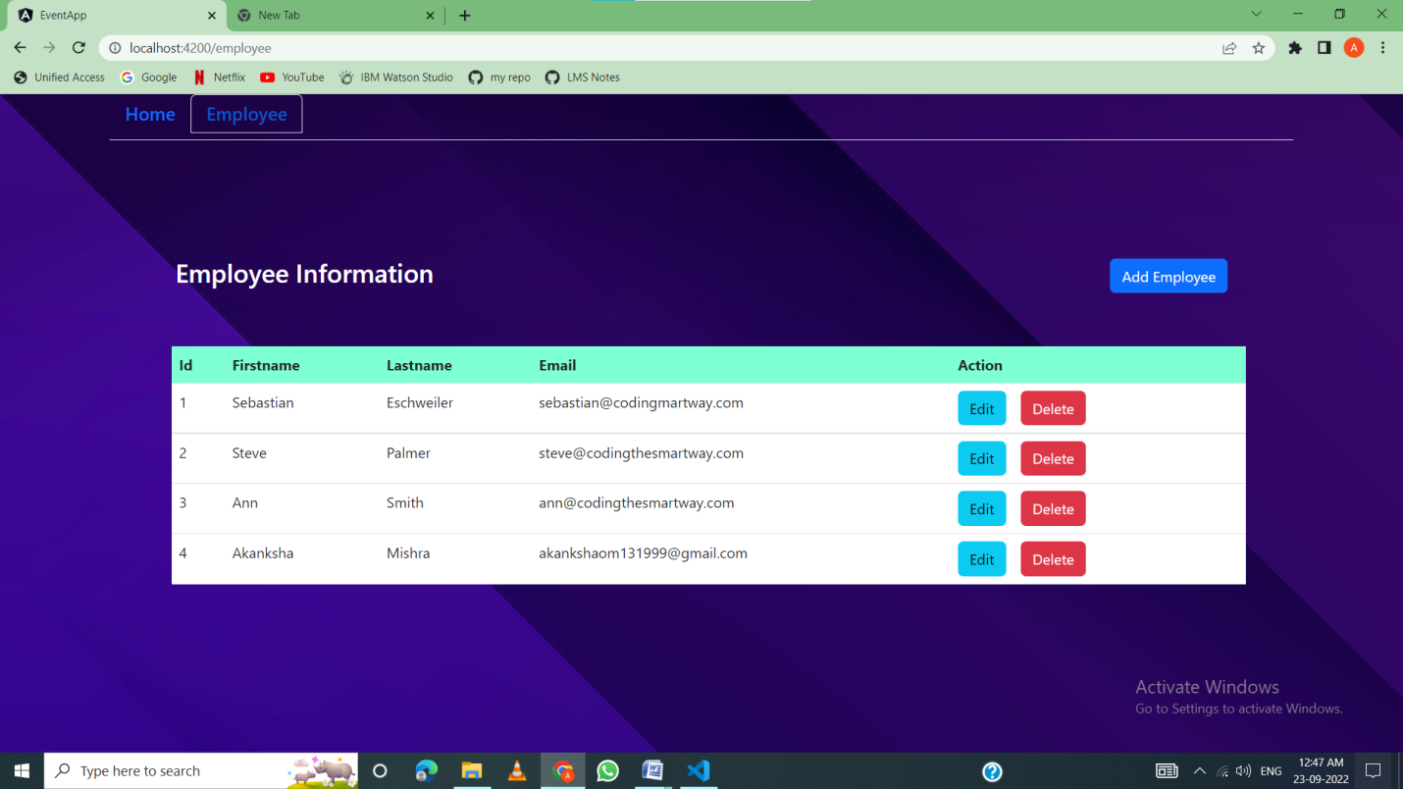

**Add Employee Feature**

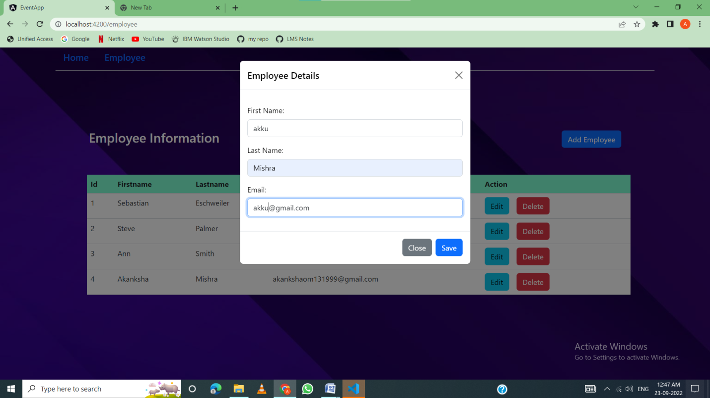

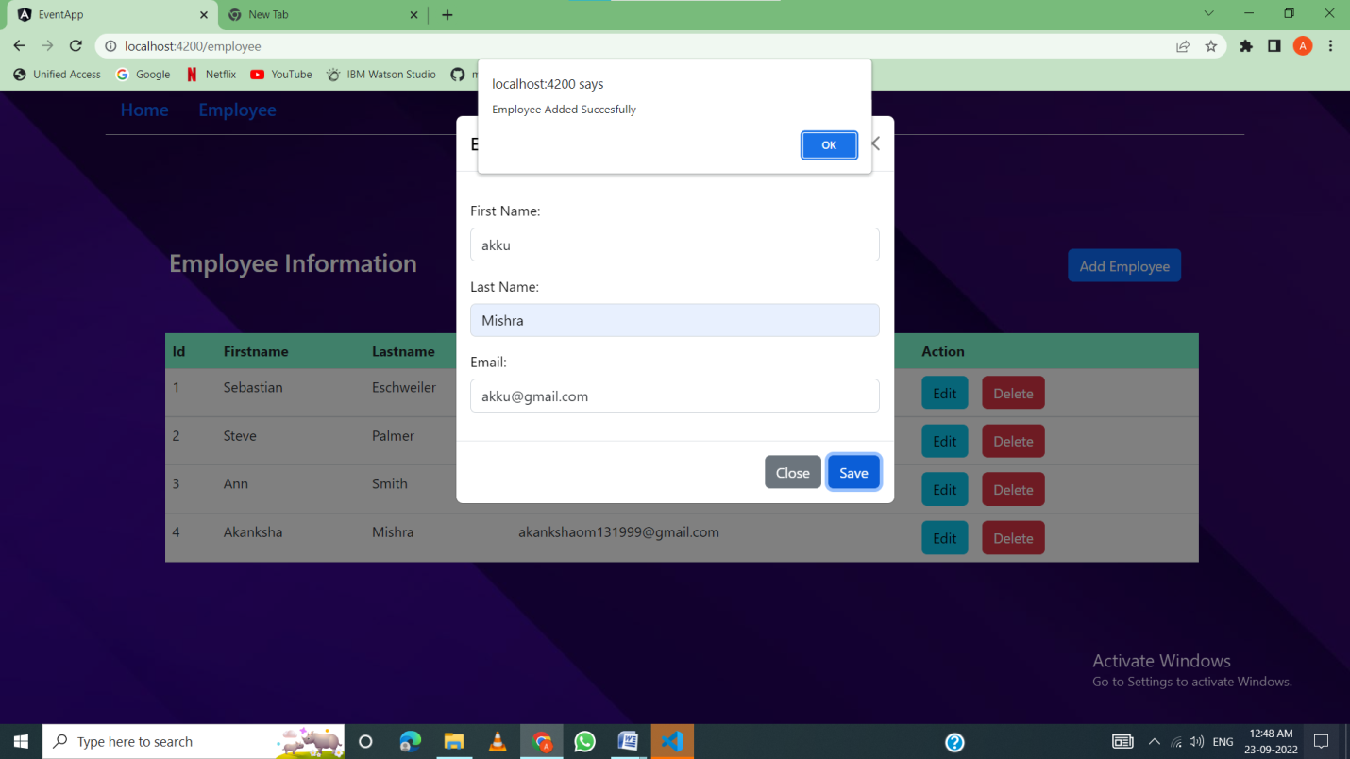

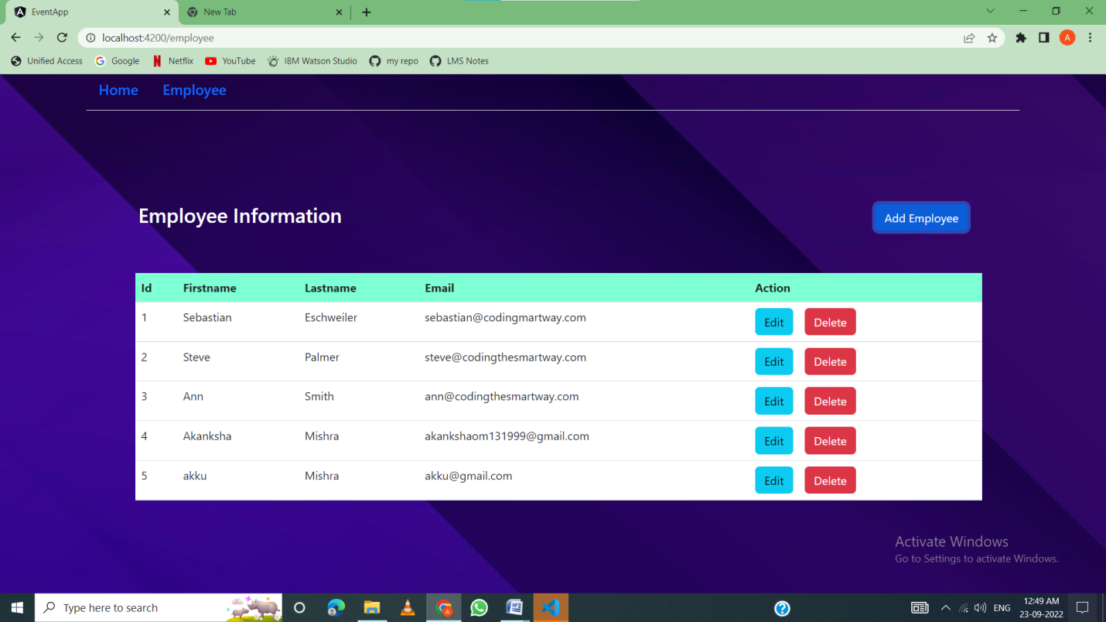

**Edit Feature**

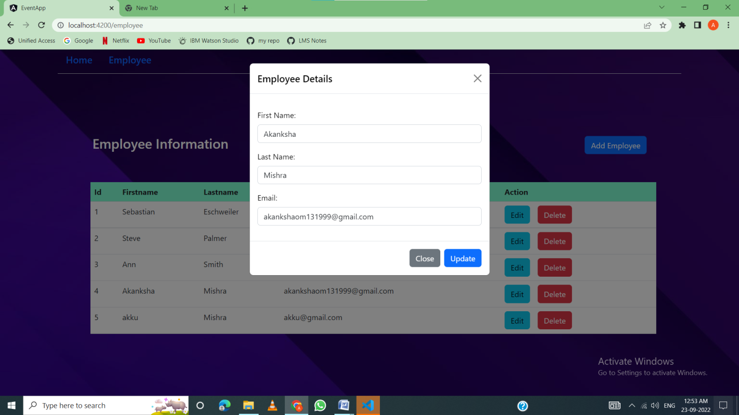

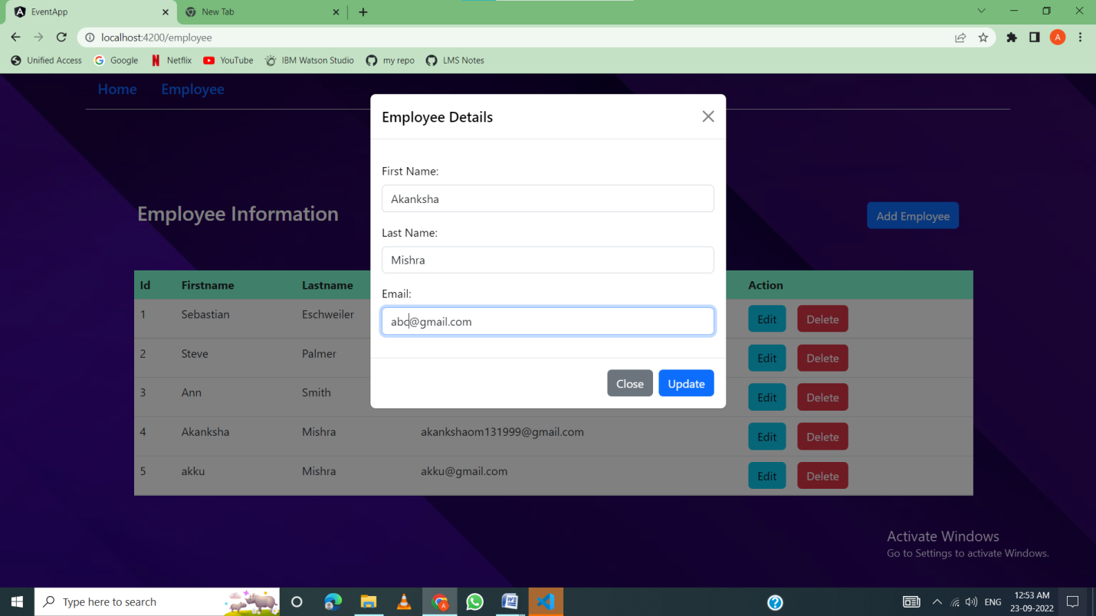

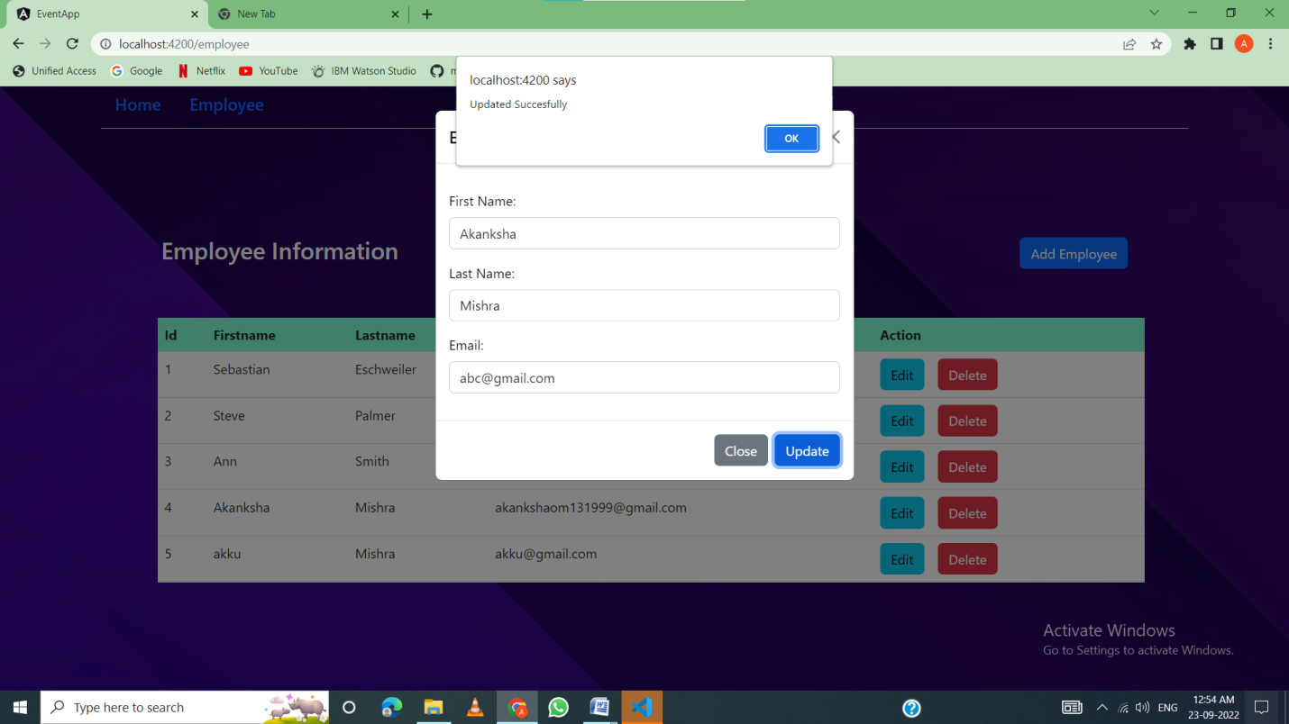

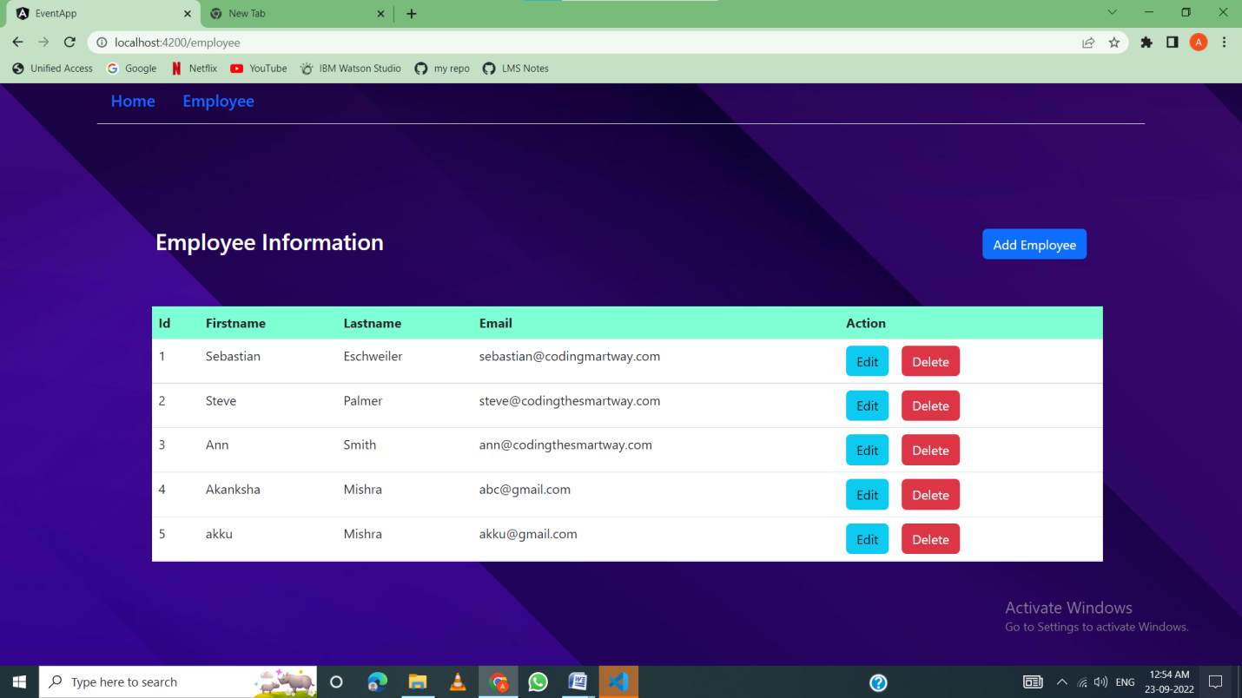

**Delete Feature**

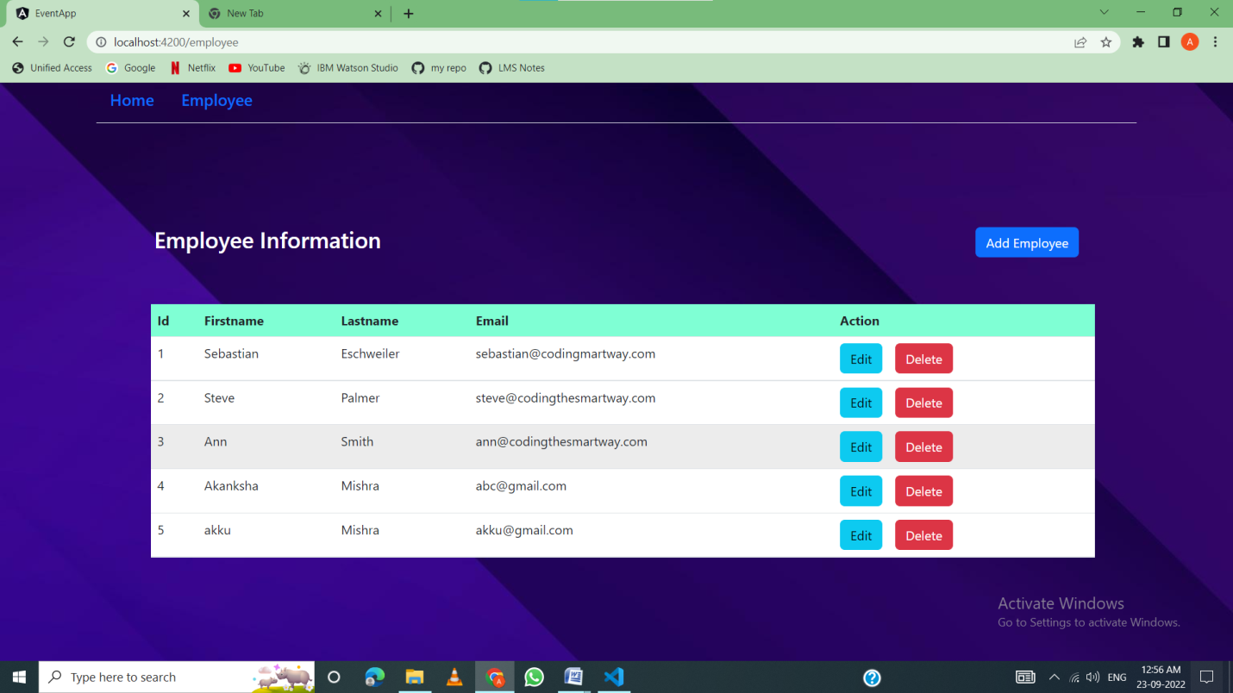

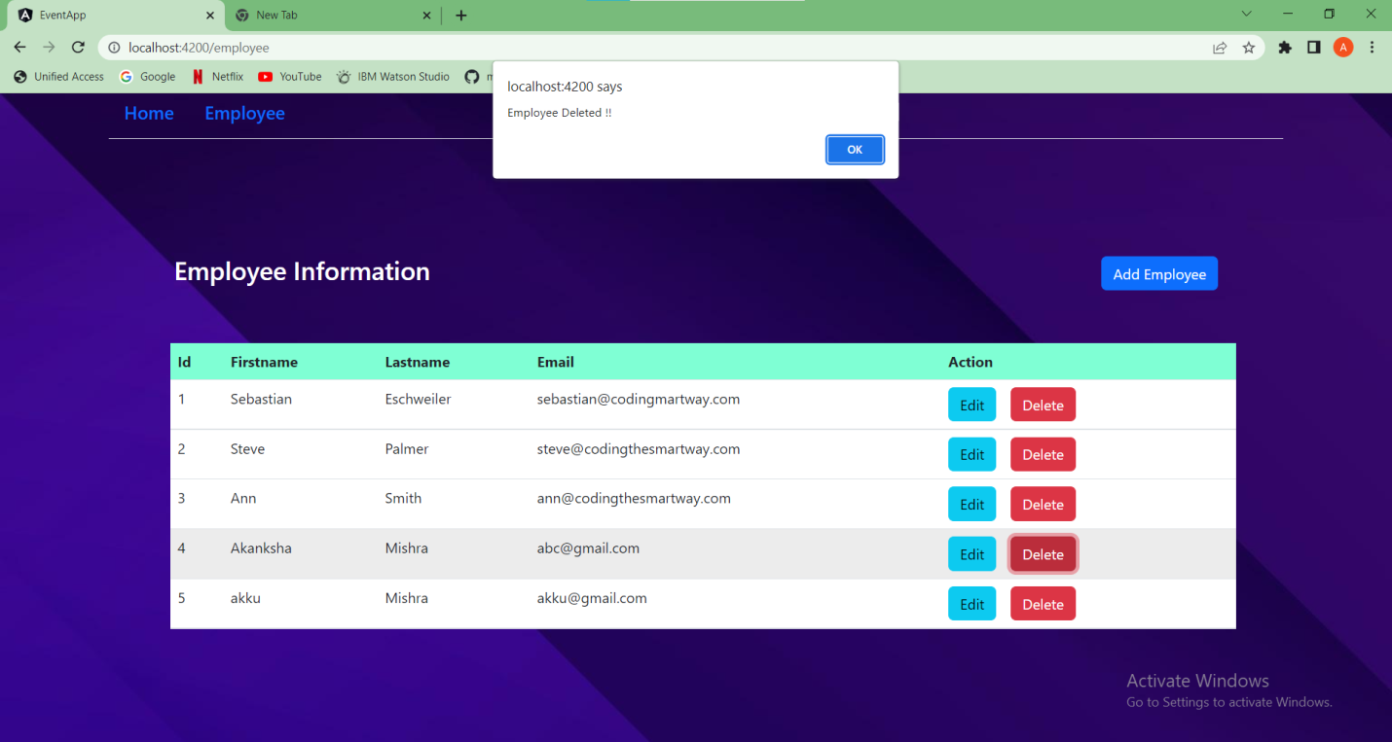

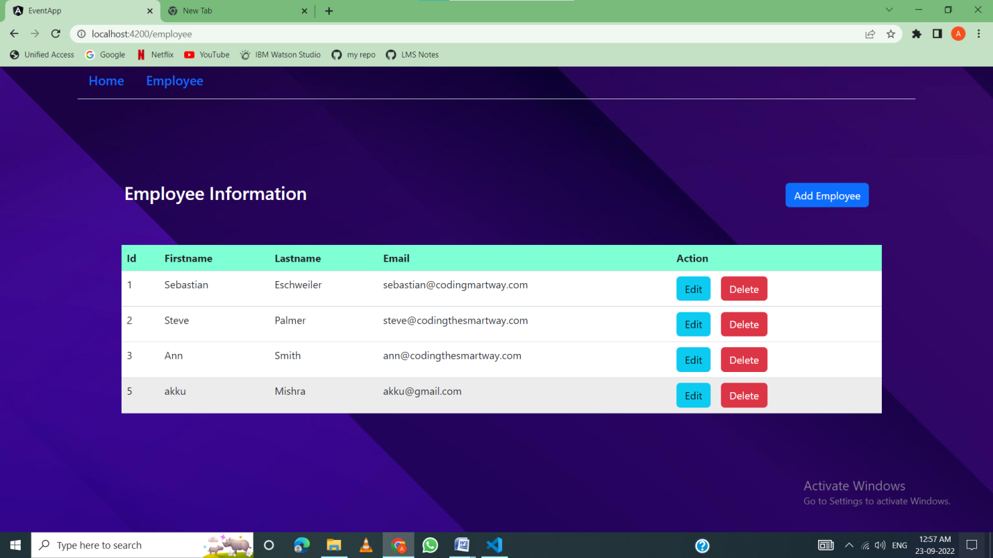

* Database

1) Execute the command given below:  
npm install -g json-server  
  
2) Create a file with the name db.json and add the code given below:

{

  "employees": [

    {

      "id": 1,

      "fname": "Sebastian",

      "lname": "Eschweiler",

      "email": "sebastian@codingmartway.com"

    },

    {

      "id": 2,

      "fname": "Steve",

      "lname": "Palmer",

      "email": "steve@codingthesmartway.com"

    },

    {

      "id": 3,

      "fname": "Ann",

      "lname": "Smith",

      "email": "ann@codingthesmartway.com"

    },

    {

      "id": 5,

      "fname": "akku",

      "lname": "Mishra",

      "email": "akku@gmail.com"

    }

  ]

}

3) Add the code given below in the script section of your package.json file in the root folder of your Angular application  
  
    "json:server": "json-server --watch db.json"  
  
Note: Before executing your Angular Application, run the command given below to start your json server:  
npm run json-server

**Step 6:** Pushing the code to GitHub repository

* Open your command prompt and navigate to the folder where you have created your files.

**cd <folder path>**

* Initialize repository using the following command:

**git init**

* Add all the files to your git repository using the following command:

**git add .**

* Commit the changes using the following command:

**git commit . -m <commit message>**

* Push the files to the folder you initially created using the following command:

**git push -u origin master**

Conclusions

Able to do

* Admin login page where admin can change the password after logging in if he wants to.
* Admin can view a master list of employee details.
* Admin can create, remove, update, or delete employee details.