WRITEUP-----------------------------------

FLOW OF THE PROJECT

Online Examination We have to create Set of REST API

For Admin and Student (Participants) REST API.

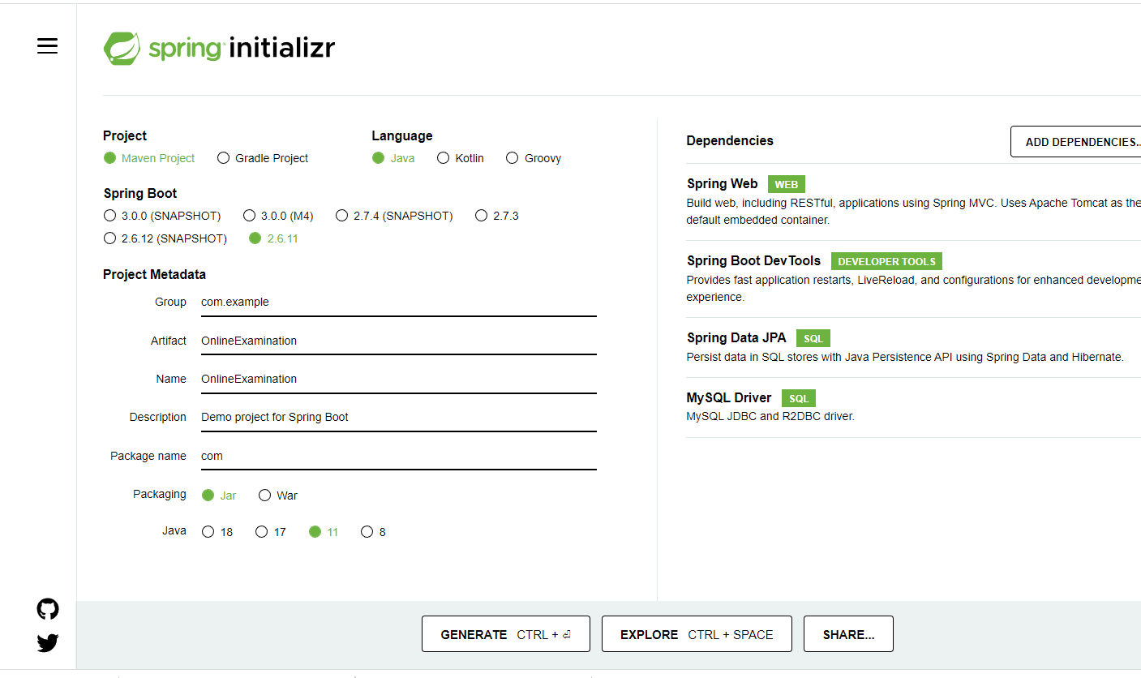

Table --🡪 login -🡪 emailed 🡪 PK

Password

Typeofuser

create table login(

emailed varchar(25) primary key,

Password varchar(25),

Typeofuser enum('admin','participants'));

No signup for admin user only we have to create signin for admin user

Take example username for admin is [admin@gmail.com](mailto:admin@gmail.com) and password is admin@123

<http://localhost:8080/admin/signin>

if username and password correct return successfully done else failure.

<http://localhost:8080/admin/changePassword>

using emaild and new password

new password not equal to old password.

Signup and signin for participants user.

<http://localhost:8080/admin/AddQuestions> Add question details

question table 🡪

qid -🡪 PK with auto-increment

question

op1

op2

op3

op4

CorrectAns

<http://localhost:8080/admin/findQuestionById/1>

<http://localhost:8080/admin/findQuestionById/2>

return question details in json format.

Quiz table 🡪

Qzid 🡪PK

Title 🡪

Subject/Category

Qid 🡪 FK

<http://localhost:8080/admin/createQuize>

we have to pass title, Subject/category, Qid

<http://localhost:8080/admin/checkUserResult>

username/emailid, score , title, standing position

raj, 10, Maths, 1

<http://localhost:8080/participants/signup>

first we have to store the record in login table with emailid,password and typeofuser(roles) is participants.

Then insert the record in participants table.

participants 🡪 table

pi dint auto-increment

fname

lname

age

phonumber

emailid

create table participants(

pid int primary key auto_increment,

fname varchar(25),

lname varchar(24),

age int,

emailid varchar(25),

password varchar(25),

foreign key(emailid) references login(emailid));

<http://localhost:8080/participants/signin>

checking username and password from database if correct return successfully login else return fail.

User quiz

User_quiz table 🡪

Uqid 🡪Pk auto increment

Emailid 🡪FK

Qzid-🡪 FK

QId🡪FK

UserCorrectAns🡪

1, [raj@gmail.com](mailto:raj@gmail.com), 11, 1111, A

<http://localhost:8080/participants/takeQuiz>

user check the result

<http://localhsot:8080/participants/checkResult>

emaildId and title/subject/qzid

Return result in string your score

<http://localhsot8080/participants/checkAllQuizDetails>

send req --🡪 with username and password and roles

check their token

Client Server

JWT

JSON Web token

123abc

Authentication and Authorization

Authentication is use to check our login details and base upon username/emailid/id and password it will allow to access the resources.

Authorization : it will check our role and base upon roles it will allow to access the resources.

If we are normal user we can do login to our laptop to use it but as a normal user roles we can’t install any software in C drive.

If we are admin user use can access all resource base upon our role.

We created 10 rest API

Those rest api we allow to access for authenticate user.

Among that 10 REST API only 6 rest api can be access by normal user and all rest api can be access by admin user.