***Quizkro : Gamified Approach for Enhancing Learning***

# OBJECTIVE

To design, develop, trial, and evaluate a gamified multiple choice quiz software tool, named Quizkro.

# Problem Statement

It is essentially required to assist student for the learning and preparation of different test conducted for admission. However, there exist no such android application to done in interactive & friendly way.

# Reason for Selecting

As per the current scenario, it is hard to evaluate or judge the ones performance. So it become mandatory to use internet and mobile devices to held the quiz for record the performance of students.

# Introduction to the Project

In the higher education sector, it is becoming increasingly important to motivate students to learn because of a number of factors present in their environment that compete against valuable study time and the way the new generation of students learn. Technological changes such as those resulting in increased playing of online games and online socialising have a dual impact on students since they not only take away valuable time from studies; they also affect the way the new generation learn.

Similarly to technological changes altering the way students learn, they can also be used by educators to alter the way subject content is delivered.

A recent trend in using games to influence behaviour is called “gamification.” A popular and broad definition of gamification is “the use of game design elements in non-game contexts”.

The work reported herein forms part of a larger study in which student perspectives on game elements were obtained and analysed, and the results were used to design, develop, trial, and evaluate a gamified multiple choice quiz software tool, named Quizkro. Now we focus our discussion on the use of Quizkro and its evaluation. In particular, we present a gamified learning activity in which Quizkro is used and we evaluate its ability to influence students to become better learners. Our goal is to gauge student enjoyment and engagement with the gamified activity and the impact on learning.

# APPROACH

The gamified quiz software tool, named Quizkro, was developed as a mobile web application. As the tool was relatively simple for undergraduate IT students to use, students were not provided with any substantial training. Although, our tool is not a computer game since it is essentially an educational quiz to which game elements have been added.

Thus, the tool was used in a context aimed at continuously motivating students to revise past course materials taught since the beginning of the semester. In order to motivate students to learn while making the activity enjoyable, Quizkro was embedded in an instructional strategy that included:

(1) short time limits to answer questions to put some moderate pressure on students. (2)Not allowing participation to be voluntary and hence not assessing the activity.

# WORKING

As the focus of this paper is on the use of Quizkro to facilitate the learning activity, we do not describe the development process here. Instead, we describe significant features of Quizkro for students and instructors so that we can elaborate on how they are used as part of the learning activity. The quizzes are synchronised; that is, students have to start the quiz at given time by the instructor. The following sub-sections describe the features for the player role (assumed by the students) and the quiz master role (assumed by the instructor).

**Quizkro Features for the Player Role**

The two main features of Quizkro for students are for them to “play” a quiz and to review their performance on the quiz. There is also a progress bar that decreases as time passes. The objective is for the student to select the correct answer within the time limit (one minute by default).

If a student does not select an answer and time runs out, the student is awarded zero points. If the student selects the correct answer, the number of points he/she is awarded is based on how quickly the answer was selected. The maximum number of points per question is 100 by default. To obtain 100 points for a question, a student must select the correct answer within 10 second.

• **Quizkro Features for the Quiz Master role**

The primary Quizkro feature for the Quiz Master role is to allow instructors to conduct games. This involves starting and ending games. In addition to this feature, Quizkro also facilitates the communication of feedback to students. This is achieved through the leader board feature.



Graph overview of quiz responses (

Quiz Master)

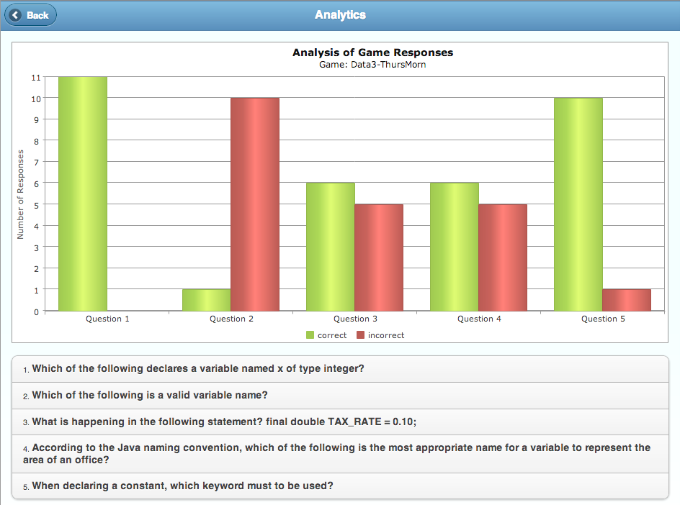

Both the leader board and the overview of quiz response graph (Figure 3) can be used to support broad feedback. The leader board displays individual player performance on the entire quiz. The instructor discussed the results of the quiz with the students.

# Methodology

As Quizkro appeared to be a very simple and intuitive tool to use, students and instructors were not provided with any formal training. Instead, the concept of gamification and Quizkro were discussed and they were given a brief walkthrough of Quizkro (shown screenshots). To support instructors, a member of the project team was present when Quizkro was being used in class for the first time (but not for subsequent times). Students were informed that the number of points awarded was based on how quickly a correct answer was selected. As Quizkro is a mobile web application, students had the option of running in on laptops, computers or mobile devices such as smartphones and tablets. The gamified learning activity was composed of two parts. The first part involved the students “playing” the quiz and in the second part the instructor discussed the results of the quiz with the students.

Gamification has the potential to improve the quality of learning by better engaging students with learning activities. . Our objective in this study is to evaluate a gamified learning activity. The activity made use of a gamified multiple choice quiz implemented as a software tool.

A limitation of the work is that the results are self-reported and the activity was used over a

short period of time. Thus, future work should include longer trial periods and evaluating improvements to learning using alternative approaches to self-reported data.

# Software Requirements

* **Operating System:** Android
* **Toolkit:** Software Development Toolkit(SDK)
* **Platform:** Java and Android
* **Database:** Firebase

# Hardware Requirements

* **2.4 Minimum Version (APIQ)**
* **Smart Phone(Having Android Version 5.0 or above)**

# Future Scope

* It will help a person to know the management of passed year perfectly and vividly.
* It will reduce the cost of collecting the management & collection procedure will go on smoothly.
* The system generates a type of information that can be used for the different purpose.
* It satisfy the user requirement.

# Team Member’s

1. Ritesh Dwivedi