Given the head of a singly linked list, group all the nodes with odd indices together followed by the nodes with even indices, and return *the reordered list*.

The **first** node is considered **odd**, and the **second** node is **even**, and so on.

Note that the relative order inside both the even and odd groups should remain as it was in the input.

**Example 1:**

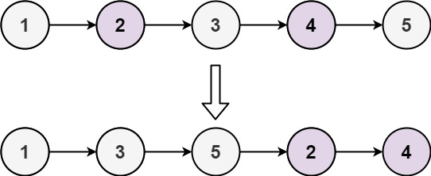

**Input:** head = [1,2,3,4,5]

**Output:** [1,3,5,2,4]

**Example 2:**

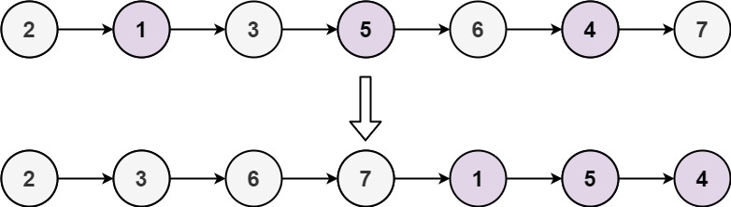

**Input:** head = [2,1,3,5,6,4,7]

**Output:** [2,3,6,7,1,5,4]

**Constraints:**

* The number of nodes in the linked list is in the range [0, 104].
* -106 <= Node.val <= 106

**Follow up:** Could you solve it in O(1) space complexity and O(nodes) time complexity?