**Reverse Linked List**

**Solution**

Given the head of a singly linked list, reverse the list, and return *the reversed list*.

**Example 1:**

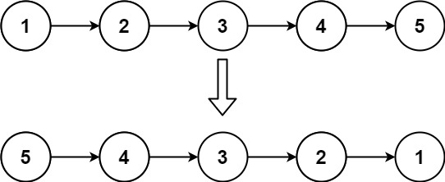

**Input:** head = [1,2,3,4,5]

**Output:** [5,4,3,2,1]

**Example 2:**

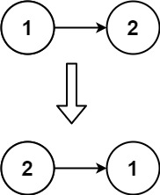

**Input:** head = [1,2]

**Output:** [2,1]

**Example 3:**

**Input:** head = []

**Output:** []

**Constraints:**

* The number of nodes in the list is the range [0, 5000].
* -5000 <= Node.val <= 5000

**Follow up:** A linked list can be reversed either iteratively or recursively. Could you implement both?