Given the head of a linked list, rotate the list to the right by k places.

**Example 1:**

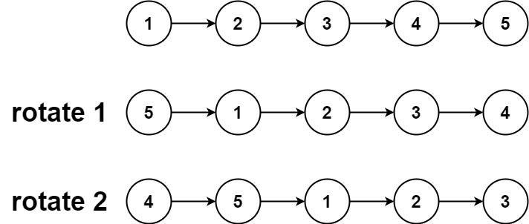

**Input:** head = [1,2,3,4,5], k = 2

**Output:** [4,5,1,2,3]

**Example 2:**

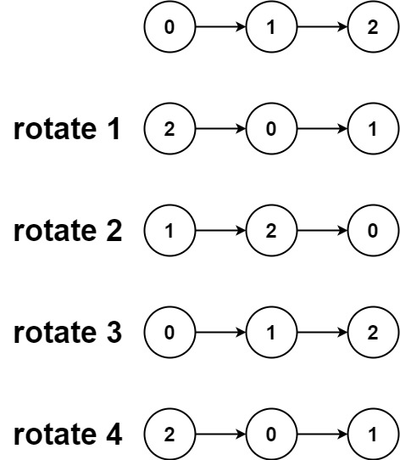

**Input:** head = [0,1,2], k = 4

**Output:** [2,0,1]

**Constraints:**

* The number of nodes in the list is in the range [0, 500].
* -100 <= Node.val <= 100
* 0 <= k <= 2 * 109