LABORATORY REPORT

**Application Development Lab**

**(CS33002)**

**B.Tech Program in ECSc**

Submitted By

**Name:-** RITESH PARVAT

**Roll No:** 2230274



**Kalinga Institute of Industrial Technology**

**(Deemed to be University)**

**Bhubaneswar, India**

Spring 2024-2025

**Table of Content**

|  |  |  |  |  |
| --- | --- | --- | --- | --- |
| **Exp No.** | **Title** | **Date of**  **Experiment** | **Date of**  **Submission** | **Remarks** |
| 1. | To design and develop a professional resume using HTML and CSS. Detailed Procedure: | 07-01-2025 | 14-01-2025 |  |
| 2. |  |  |  |  |
| 3. |  |  |  |  |
| 4. |  |  |  |  |
| 5. |  |  |  |  |
| 6. |  |  |  |  |
| 7. |  |  |  |  |
| 8. |  |  |  |  |
| 9. | Open Ended 1 |  |  |  |
| 10. | Open Ended 2 |  |  |  |

|  |  |
| --- | --- |
| **Experiment Number** | 1 |
| **Experiment Title** | To design and develop a professional resume using HTML and CSS. Detailed Procedure: |
| **Date of Experiment** | 07-01-2025 |
| **Date of Submission** | 14-01-2025 |

1. **Objective:-** To design and develop a professional resume using HTML and CSS. Detailed Procedure:
2. **Procedure:- (Steps Followed)**
3. Open a new project folder and create an `index.html` file for the structure of your resume.
4. Write HTML code for sections: Header (Name, Photo, Contact), Skills, Projects, Work-experience, and Education.
5. Add hyperlinks to Linked In, GitHub, and other online portfolios.
6. Use CSS to apply design elements for proper alignment, spacing, and colors.
7. Make the layout responsive using Flexbox or Grid.
8. Integrate images and video links as required.

7. Test the design across devices.

1. **Code:-**
2. **index.html**

<!DOCTYPE html>

<html lang="en">

<head>

<meta charset="UTF-8">

<meta name="viewport" content="width=device-width, initial-scale=1.0">

<title>Ritesh Parvat - Resume</title>

<link href="https://cdnjs.cloudflare.com/ajax/libs/font-awesome/6.0.0-beta3/css/all.min.css" rel="stylesheet">

<link href="https://cdn.jsdelivr.net/npm/bootstrap@5.3.3/dist/css/bootstrap.min.css" rel="stylesheet"

integrity="sha384-QWTKZyjpPEjISv5WaRU9OFeRpok6YctnYmDr5pNlyT2bRjXh0JMhjY6hW+ALEwIH" crossorigin="anonymous">

<link rel="stylesheet" href="style.css">

</head>

<body>

<div class="a4-container">

<!-- Header Section -->

<header class="header">

<h1>Ritesh Parvat</h1>

<div class="contact-info">

<p class="email">

<i class="fas fa-envelope"></i>

<a href="mailto:ritesh.parvat17@gmail.com">ritesh.parvat17@gmail.com</a>

</p>

<p class="phone">

<i class="fas fa-phone-alt"></i>

+91 8800526625

</p>

<p class="linkedin">

<i class="fab fa-linkedin"></i>

<a href="https://www.linkedin.com/in/ritesh-parvat-a50738169/" target="_blank">LinkedIn Profile</a>

</p>

</div>

<div class="image-container">

<img src="utils/profile.jpg" alt="Profile Picture">

</div>

</header>

<!-- Education Section -->

<section class="education">

<h2 class="heading">EDUCATION</h2>

<hr>

<div class="education-entry">

<div class="institution">

<span class="name">Kalinga Institute of Industrial Technology</span>

<span class="location">Bhubaneswar, India</span>

</div>

<div class="details">

<span class="degree">B.Tech in Electronics and Computer Science Engineering; CGPA: 8.51</span>

<span class="year">2022 - 2026</span>

</div>

</div>

<div class="education-entry">

<div class="institution">

<span class="name">Ashok Memorial Public School</span>

<span class="location">Faridabad, Haryana</span>

</div>

<div class="details">

<span class="degree">CBSE 12th; Percentage: 86%</span>

<span class="year">2021</span>

</div>

</div>

<div class="education-entry">

<div class="institution">

<span class="name">Ashok Memorial Public School</span>

<span class="location">Faridabad, Haryana</span>

</div>

<div class="details">

<span class="degree">CBSE 10th; Percentage: 77%</span>

<span class="year">2019</span>

</div>

</div>

</section>

<!-- Projects Section -->

<section class="projects">

<h2 class="heading">PROJECTS</h2>

<hr>

<ul>

<li>

<h3 class="project-heading">

House Price Prediction

<a href="https://github.com/Ritesh17-stack/House-Price-Prediction" target="_blank">

<i class="fas fa-external-link-alt"></i>

</a>

</h3>

<p class="description">

Developed a pipeline regression model integrated with Flask to predict house prices based on key

features such as area, number of bedrooms and bathrooms, locality, and year built. Implemented

efficient data preprocessing techniques like scaling and one-hot encoding to improve model

accuracy.

</p>

</li>

<li>

<h3 class="project-heading">

Iris Classification

<a href="https://github.com/Ritesh17-stack/House-Price-Prediction" target="_blank">

<i class="fas fa-external-link-alt"></i>

</a>

</h3>

<p class="description">

Developed a machine learning model for Iris Classification using Logistic Regression, applying

feature engineering, model training, and evaluation techniques to predict the species of Iris

flowers based on their petal and sepal measurements. Achieved high accuracy in classification,

demonstrating proficiency in data analysis and model optimization.

</p>

</li>

</ul>

</section>

<!-- Experience Section -->

<section class="experience">

<h2 class="heading">EXPERIENCE</h2>

<hr>

<div class="experience-entry">

<div class="company">

<span class="name">

AI-ML Virtual Internship

<a href="https://drive.google.com/file/d/1yDmjpdOW7_zJhcskaRPqlD8ov8sr6Moy/view"

target="_blank">

<i class="fas fa-external-link-alt"></i>

</a>

</span>

<span class="location">Virtual</span>

</div>

<div class="about">

<span class="company-name">AICTE - Google for Developers</span>

<span class="year">July 2024 - Sep 2024</span>

</div>

<div class="details">

<ul>

<li>Gained hands-on experience in developing AI/ML solutions by working on projects involving

image recognition, object detection, and classification.</li>

<li>Built practical skills in TensorFlow, machine learning workflows, and AI tools.</li>

<li>Enhanced my ability to design, train, and deploy models for real-world applications.</li>

</ul>

</div>

</div>

<div class="experience-entry">

<div class="company">

<span class="name">

Internship Trainee

<a href="https://drive.google.com/file/d/1yDmjpdOW7_zJhcskaRPqlD8ov8sr6Moy/view"

target="_blank">

<i class="fas fa-external-link-alt"></i>

</a>

</span>

<span class="location">Virtual</span>

</div>

<div class="about">

<span class="company-name">Bharat Intern</span>

<span class="year">June 2024 - July 2024</span>

</div>

<div class="details">

<ul>

<li>Gained hands-on experience in feature engineering, model training, and evaluation for

classification tasks.</li>

<li>Designed and implemented robust machine learning pipelines with efficient preprocessing

techniques, including scaling

and one-hot encoding.</li>

<li>Built regression models for predictive analysis and integrated them into web applications

using Flask for real-time

deployment.</li>

<li>Strengthened expertise in data preprocessing, algorithm optimization, and deploying AI/ML

solutions for real-world

scenarios</li>

</ul>

</div>

</div>

<div class="experience-entry">

<div class="company">

<span class="name">

Internship Trainee

<a href="https://drive.google.com/file/d/1yDmjpdOW7_zJhcskaRPqlD8ov8sr6Moy/view"

target="_blank">

<i class="fas fa-external-link-alt"></i>

</a>

</span>

<span class="location">Ahmedabad, Gujarat</span>

</div>

<div class="about">

<span class="company-name">Nippon Signal Co., Ltd.</span>

<span class="year">April 2024 - June 2024</span>

</div>

<div class="details">

<ul>

<li>Acquired in-depth knowledge of CBTC system architecture, functionality, and equipment, including Point Machines,

KLCR, ESP, SPK, Axle Counters, and Balises.</li>

<li>Gained practical understanding of wayside, on-board, and station equipment roles and operations.</li>

<li>Trained in safety protocols, emergency procedures, and effective CBTC system integration with rail networks.</li>

</ul>

</div>

</div>

</section>

<!-- Core Subject Proficiency Section -->

<section class="core">

<h2 class="heading">CORE SUBJECT PROFICIENCY</h2>

<hr>

<ul>

<li>Design and Analysis of Algorithms</li>

<li>Database Management System</li>

<li>Microprocessor & Embedded Systems</li>

<li>Operating Systems</li>

</ul>

</section>

<!-- Skills Section -->

<section class="skills">

<h2 class="heading">SKILLS</h2>

<hr>

<ul>

<li>Programming Languages: C, Java, Python, HTML, CSS, SQL</li>

<li>Developer Tools: Git, VS Code, Jupyter Notebook, MySQL</li>

<li>Frameworks: Flask</li>

<li>Libraries: Pandas, NumPy, Matplotlib, scikit-learn, tensorflow</li>

</ul>

</section>

<!-- Achievements Section -->

<section class="achievements">

<h2 class="heading">ACHIEVEMENTS</h2>

<hr>

<ul>

<li>Built my first AI model during a Generative AI workshop by NxtWave, gaining hands-on experience and

practical knowledge in AI concepts.</li>

</ul>

</section>

</div>

<script src="https://cdn.jsdelivr.net/npm/bootstrap@5.3.3/dist/js/bootstrap.bundle.min.js"

integrity="sha384-YvpcrYf0tY3lHB60NNkmXc5s9fDVZLESaAA55NDzOxhy9GkcIdslK1eN7N6jIeHz"

crossorigin="anonymous"></script>

</body>

</html>

1. **styles.css**

html {

height: 80%;

margin: 0;

}

body {

display: flex;

justify-content: center;

min-height: 100vh;

}

.a4-container {

width: 210mm;

min-height: 297mm;

margin: 20px auto;

padding: 15mm;

background-color: white;

box-shadow: 0 0 10px rgba(0, 0, 0, 0.1);

box-sizing: border-box;

font-size: 10pt;

}

.header {

margin-bottom: 15px;

display: flex;

justify-content: space-between;

gap: 15px;

}

.header-content {

flex: 1;

}

.header h1 {

margin: 0 0 8px 0;

font-size: 18pt;

font-weight: bold;

}

.contact-info {

font-size: 9pt;

margin-left: -557px;

margin-top: 40px;

gap: 4px;

}

.contact-info p {

margin: 0;

display: flex;

align-items: center;

gap: 4px;

}

.image-container {

width: 100px;

height: 100px;

flex-shrink: 0;

}

.image-container img {

width: 100%;

height: 100%;

object-fit: cover;

object-position: center;

}

a {

color: inherit;

text-decoration: none;

}

a:hover {

text-decoration: underline;

}

.heading {

font-size: 12pt;

margin: 8px 0 4px;

font-weight: bold;

}

hr {

border: 0;

border-top: 1px solid black;

margin: 4px 0;

}

ul {

padding-left: 12px;

margin: 5px 0;

}

ul li {

font-size: 9pt;

margin-bottom: 6px;

line-height: 1.3;

}

.education,

.experience,

.projects,

.skills,

.core,

.achievements {

margin-top: 12px;

}

.education-entry,

.experience-entry {

margin-bottom: 10px;

}

.institution,

.company {

display: flex;

justify-content: space-between;

font-size: 10pt;

font-weight: bold;

margin-bottom: 5px;

}

.institution .location,

.company .location {

font-style: italic;

font-weight: lighter;

color: #555;

}

.details,

.about {

display: flex;

justify-content: space-between;

font-size: 9pt;

color: #333;

}

.details .year,

.about .year {

font-style: italic;

}

.project-heading {

font-size: 10pt;

font-weight: bold;

margin-bottom: 3px;

}

.description {

font-size: 9pt;

line-height: 1.3;

}

.projects ul,

.skills ul,

.core ul,

.achievements ul {

list-style-type: none;

padding-left: 0;

}

.skills li,

.core li,

.achievements li {

margin-bottom: 5px;

}

.experience-entry .details ul {

margin-top: 3px;

margin-left:19px;

}

@media print {

body {

background: none;

}

.a4-container {

margin: 0;

padding: 15mm;

box-shadow: none;

width: 210mm;

height: 100px;

}

}

@media screen and (max-width: 210mm) {

.a4-container {

margin: 0;

width: 100%;

min-height: auto;

}

}

.fa-phone-alt {

transform: rotate(90deg);

}

1. **Results/Output:- Entire Screen Shot including Date & Time**

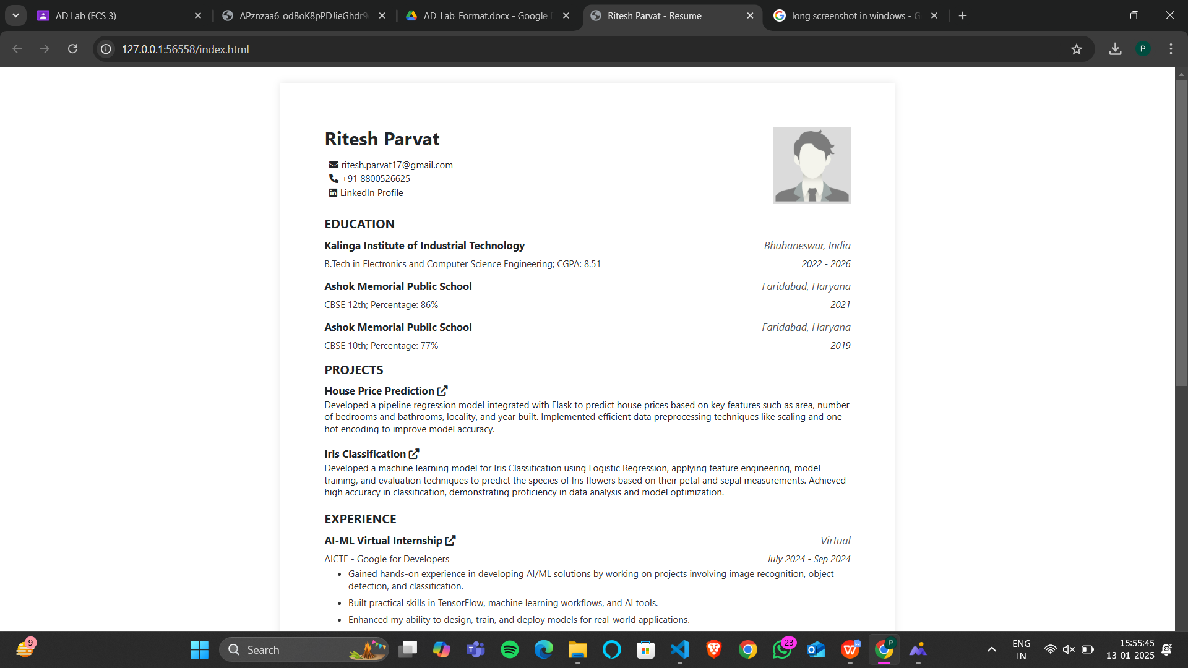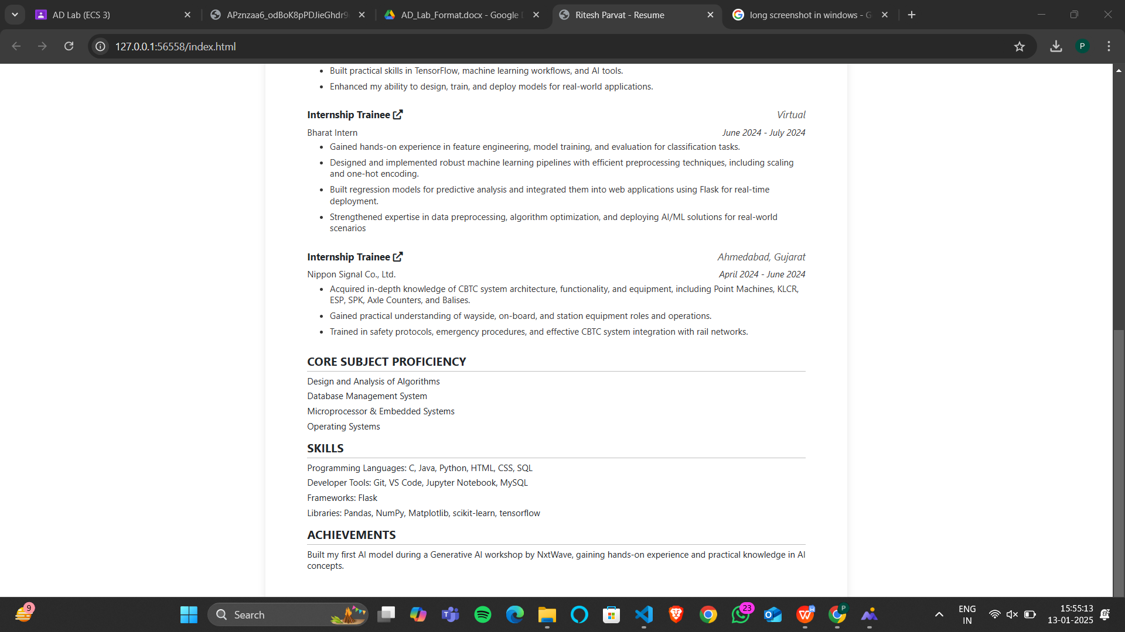

1. **Remarks:-**

|  |  |
| --- | --- |
| Signature of the Student  ____________________  (Ritesh Parvat) | Signature of the Lab Coordinator  _________________________________  (Name of the Coordinator) |