**Role of Brain in Creation of Dreams**

**Ritesh Kumar 201305522**

**1. Introduction :-**

Dreams are a series of thoughts, ideas, images, emotions, and sensations that occur involuntarily in a person's mind during certain stages of sleep. Generally dreams occur in REM stage of the sleep cycle and rarely in N3 stage. It was a topic of debate for quite some time that dreams occur only during the REM stage but research has proved that dreams (less vivid, less memorable) also occur in the N3 stage.

1.1 Interpretation of dreams :-

Our "ancestors" believed that the soul, or some part of it, moves out from the body of the sleeping person and actually visits the places and persons the dreamer sees in their sleep. Sometimes "Morpheus" the god of dreams is said to carry the dreamer. They divided dreams into "good", which were sent by the gods, and "bad", sent by demons.

Then came two views of interpreting dreams - The neuroscientific view and the psychoanalytic view. A neuroscientist is interested in the structures involved in dream production and dream organization and narratability. However, psychoanalysis concentrates on the meaning of dreams and on placing them in the context of relationships in the history of the dreamer.

1.1.1 The neuroscientific view :-

It was not until 1951 that scientists discovered a different way to unravel the complexities of the dreaming process. In 1951 two cases of brain injury were reported that resulted in almost cessation of dreaming. Both the patients had suffered damage to posterior parietal regions, one of them involved predominately the left side of the parieto-occipital area. This was the neurology of dreaming proposed by *George Humphrey* *and* *Oliver Zangwill*.

*Aserinsky* *and Klietman* in 1953 discovered a physiological state which occurs periodically throughout sleep. The state lasts for 1.5 hours and occupies nearly 25% of the sleep hours. This state is characterized by bursts of rapid eye movement, heightened brain activity, paralysis of the body muscles, increased heart rate and breathing. In view of the characteristics the state was hence named REM state and was suspected to be the cause of origin of dreams. The suspicion was practically confirmed by Aserinsky, Klietman and *Dement* by waking people during REM state and on asking if they were dreaming. In 90-95% cases the answer would be a yes, means NREM state causes 5-10% of dreams.

Humphrey and Zangwill's discovery prompted further research involved in REM sleep. It was found that REM is produced by "pons", a small region of cells in the brain stem. The brain stem consists of three parts - the midbrain, pons, and the medulla. The medulla extends in the back as the spinal cord. The pons release acetylecholine which travels to the front part of the brain. The frontal lobe as we know is responsible for emotions, memory, language, and a variety of higher cognitive functions, etc. The frontal lobe consists of dopamine-sensitive neurons. The theory states that - "Cholinergic activation of these parts results in meaningless images that constitute a dream. The brain stem also releases noradrenaline and serotonin that help stop this process."

Another model of dreaming was developed which was not only in agreement to the research till this point but was also more precise and specific as to what parts of brains are active during the process. The Activation-Synthesis model developed by researchers *John Allan Hobson and Robert McCarley* in 1977 is a theory of dreaming and perhaps the most practically demonstrated one due to the best technologies invented and available during that time. The theory states that - "Circuits in the brain are activated during REM sleep. Once activated the areas of the limbic system involved in emotions, sensations, and memories, become active. Specifically the amygdala and hippocampus interpret this internal activity and the attempts create meaning from the signals, which results in dreaming."

1.1.2 The psychoanalytic view :-

*Sigmund Freud*, known as the father of psychoanalysis, is also a neurologist. Freud stated that the true meaning of a dream must be "weeded out" from the dream. In his book The Interpretation of Dreams he states that the content of a dream is generated by the events of the day preceding the dream. According to Freud the motivation of dream content is wish-fulfillment. This can clearly be seen in young children as they think very straightforward for the fulfillment of their wishes that aroused the previous day. This is not so clear in adults as their dreams have been subjected to distortion by their complex thinking.

Much of the Freudian theory had been misinterpreted, not understood and has hence been discarded. *Carl Jung*, one of the best known contributors to dream analysis, believed Freud's theory to be too simplistic and naive. Jung experimentally proved that associating a dream to the day's activities gave insights about the dreamer's mental complex, and not about the meaning of the dream. Jung proposed the subjective approach - every person in the dream represents an aspect of the dreamer. Jung argued that the subjective approach is much more difficult for the dreamer to accept, but that, the dreamer will recognize that the dream characters can represent an unacknowledged aspect of the dreamer.

**2. Sleep – The cause of Dreams :-**

Sleep is a condition of body and mind in which the nervous system is inactive, the eyes closed, the postural muscles relaxed, and consciousness practically suspended. Postural muscles help maintain the postural characteristics of the body against gravity like neck, back, knee, and ankle extensors. Sleep is distinguished from wakefulness by a decreased responsiveness to external stimuli. Sleep is a state that is relatively easy to reverse; this distinguishes sleep from hibernation (state of inactivity) and coma.

How to analyze sleep ? After all, detailed analysis of our own sleep isn't really an option and even if we observe the sleep of others, so much of what they experience like the changes in the functions of their brains and bodies, is not easily seen from the outside. Hence the definition of sleep is tied to the characteristic patterns of “brain waves” and other physiological functions.

Many physiological variables such as our temperature, blood pressure, and levels of oxygen, carbon dioxide, and glucose in the blood remain quite constant during wakefulness and drop during sleep. Other physiological functions such as brain wave activity, breathing, and heart rate are quite variable when we are awake or during REM sleep, but are extremely regular when we are in non-REM sleep. The whole sleep period normally proceeds in the order: N1 → N2 → N3 → N2 → REM.

N1

N3

Also called “light sleep”.

Slow eye movement.

People experience Sleep Starts or Hypnic Jerks while transitioning into stage N1.

Also called “slow wave sleep”.

Dreaming is common < REM sleep.

Dreams are less remembered.

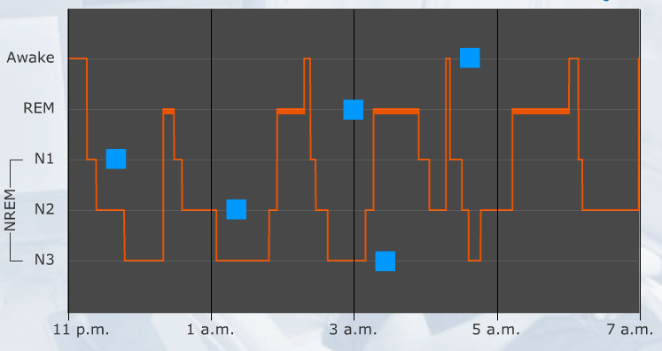

REM

No eye movement.

People experience Sleep Spindles (short bursts - high brain activity), K-complexes (long bursts - last for a 1 sec).

Rapid eye movement.

Body is paralyzed.

Clear **DREAMS**

**3. Active Brain Parts :-**

We henceforth present the diagrammatic representation of the brain parts that are active during the process of dreaming for the theories discussed in Part 1.

3.1 George Humphrey and Oliver Zangwill's theory :-

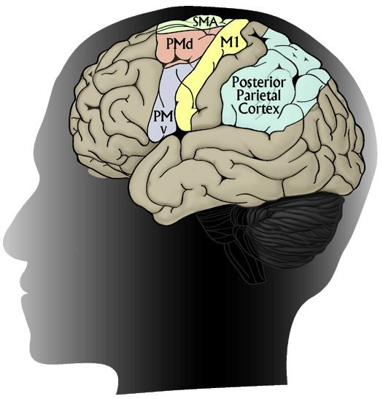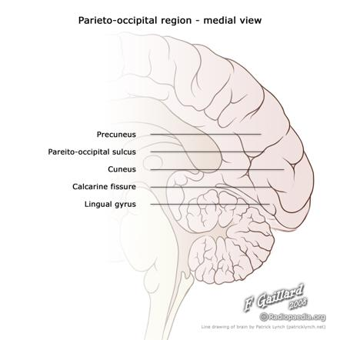

Posterior Parietal Cortex Parieto-occipital region

3.2 Anonymous research extension of the above theory :-

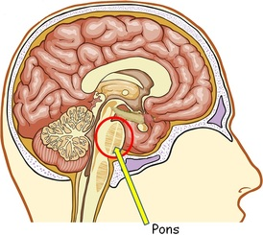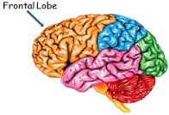

3.3 Activation Synthesis Model :-

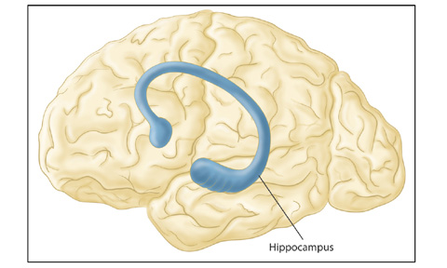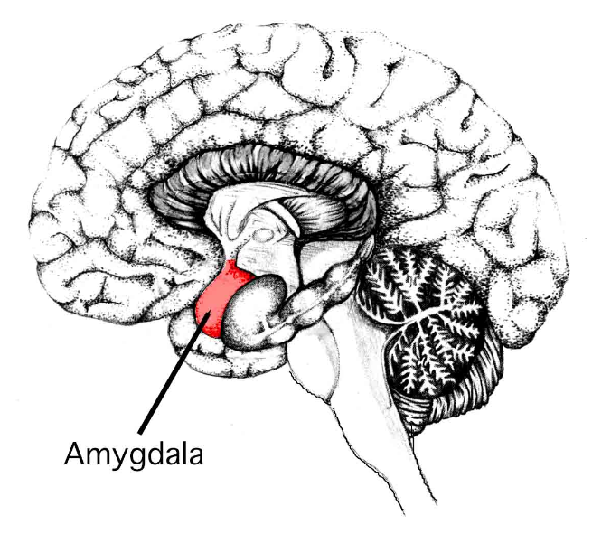

**4. Experiment :-**

The sole question what I have asked myself nearly every time I have had a dream which was extremely impossible and unnatural - "Where did that come from?" This question was answered by *Robert Stickgold* of Harvard Medical School by designing an experiment consisting of two sets of people - one set of people had normal working memory and the other set of people were amnesiacs. Amnesia is whole or partial loss of memory caused by damage to the brain, primarily hippocampus.

The research proposed before this experiment stated that - much of the dream content comes from our recent experiences. Which means that that the dreaming brain draws its fodder from what we call "declarative memory". The declarative memory stores information what we declare to know like the name of your pet, the square of 7, etc. Another kind of memory which relates to the time-stamp of events being pinned is called "episodic memory". Episodic memory consists of events being remembered with respect to the time they occurred, for example - "The day (say, 22 December 2014) you remember terminating your relationship with your loved one."

People suffering from amnesia cannot add new declarative or episodic memories due to damage to their hippocampus. Hence, it concludes that amnesiacs cannot dream, which is quite wrong. Amnesiacs just like people with normal working memory replay their recent experiences while dreaming. The research conducted by Robert Stickgold suggests amnesiacs can dream, but the difference being, they don’t recognize what they are dreaming.

The experimental setup is something like this. The two sets of people were made to play "Tetris" all day long. At night, amnesiacs did not remember playing the game but both sets of people reported seeing bricks falling from a height in their dream. This means that dreams draw content neither from declarative nor episodic memory, but from a totally different kind of memory which amnesiacs also possess. This is termed as "implicit memories". Implicit memories are the ones which scientists can measure even when the individuals are not aware they have them. Such is the case with amnesiacs.

**5. My Thoughts – Because they Matter :-**

Jotting down all my thoughts, feelings, and experiences in the subject of dreaming is a task I love to do. Nearly everyday I got up, sometimes in the morning, sometimes in the midst of the night in my REM state, dreams have left me befuddled. After reading so much material and research papers on the web I now feel less surprised and express greater understanding of the subject and I now better understand the reasons behind getting a specific dream on a particular night.

Summarizing the overall research, the dreams are produced due to chemicals being generated in the occipital lobe which travels towards the frontal lobe and leads to activation of the various parts which then generate signals that are interpreted by the amygdala and hippocampus as meaningless images. This process is explained technically in a detailed way in this paper.

It was overall an amazing experience to read so much about the subject.

Thank you *Kavita Mam*.

**6. References :-**

1. Wikipedia (infinite citations)

2. *Sigmund Freud*. The Interpretation of Dreams.

3. *Robert J Hoss*. The Science of Dreaming.

4. *Antti Revonsuo*. The reinterpretation of dreams, An evolutionary hypothesis of functions of dreaming.

5. *Alan S. Eiser.* Physiology and Psychology of Dreams.

6. *Jessica D. Payne and Lynn Nadel.* Sleep, dreams, and memory consolidation.