Company Financial Data Analysis Report

A) Problem Statement and Dataset

Problem Statement
In today’s dynamic economic environment, analysing the financial health of corporations across various sectors is critical for informed decision-making and strategic planning. This study aims to perform a comprehensive financial analysis of 503 publicly listed companies using real-world data that includes metrics such as Market Capitalization, Price/Earnings Ratio, Dividend Yield, Earnings per Share (EPS), and EBITDA.
The primary objectives of this academic research are:
- To assess the financial performance of companies across different industry sectors.
- To interpret the significance of key financial indicators in evaluating a firm’s profitability and valuation.
- To manage and clean real-world financial data, addressing missing values and inconsistencies.
- To apply analytical techniques for generating insights and identifying top-performing and underperforming firms.
- To compile findings into a structured financial report suitable for academic evaluation and presentation.
This project bridges the gap between theoretical finance concepts and practical application, encouraging critical thinking and data-driven analysis. The results aim to support investment-related discussions and build a foundation for future research in corporate finance and data analytics.

Dataset Description
The dataset employed in this study comprises financial data from 503 publicly listed companies, representing a comprehensive cross-section of the corporate landscape. It has been sourced from DataHub.io - S&P 500 Companies Financials, a reputable and publicly accessible financial data repository.
This dataset contains key financial indicators and company identifiers that are crucial for fundamental analysis. The attributes include:
- Company Name and Symbol: Identification of each publicly listed company.
- Sector: Industry classification enabling sector-wise comparative analysis.
- Stock Price: The most recent market price per share.
- 52-Week High and Low: The highest and lowest stock prices over the past year.
- Price/Earnings (P/E) Ratio: A valuation metric reflecting investor expectations.
- Dividend Yield: An indicator of return on investment through dividends.
- Earnings per Share (EPS): A measure of company profitability.
- Market Capitalization: Total market value of a company’s outstanding shares.
- Price/Sales and Price/Book Ratios: Additional valuation metrics.
- EBITDA (Earnings Before Interest, Taxes, Depreciation, and Amortization): A widely used indicator of operating performance.

The dataset provides a rich foundation for conducting in-depth financial analysis, cross-sector performance comparison, and deriving insights into corporate valuation and profitability. It also presents opportunities to address real-world challenges such as handling missing values, outliers, and data normalization — all critical components in academic research and financial modelling.

B) Implementation

Data Cleaning and Visualization
The dataset was inspected for missing values and inconsistencies. Columns were renamed to remove special characters and spaces. Missing numeric values were filled using median imputation. Categorical columns with missing values, such as 'Sector', were dropped. Data visualization tools like seaborn and matplotlib were used to plot sector distributions, earnings variability, and market trend

EDA and Statistical Analysis
EDA was performed using boxplots, histograms, heatmaps, and scatterplots to understand the relationships between financial metrics. Key insights include:
- Technology and Healthcare sectors dominate in market cap.
- Price/Earnings ratios vary significantly between sectors.
- Companies closer to their 52-week highs tend to have higher valuations.
- Strong correlation exists between Market Cap and Price, and between EPS and Price.

EBITDA and Profitability Analysis
Top 5 Companies by EBITDA:
- Microsoft (Systems Software) - EBITDA: $136,552,000,000.00
- Apple Inc. (Technology Hardware, Storage & Peripherals) - EBITDA: $134,661,000,000.00
- Alphabet Inc. (Class A) (Interactive Media & Services) - EBITDA: $123,470,000,000.00
- Alphabet Inc. (Class C) (Interactive Media & Services) - EBITDA: $123,470,000,000.00
- Amazon (Broadline Retail) - EBITDA: $111,583,000,000.00
Bottom 5 Companies by EBITDA:
- Boeing (Aerospace & Defense) - EBITDA: $-3,991,000,064.00
- Moderna (Biotechnology) - EBITDA: $-2,361,999,872.00
- Albemarle Corporation (Specialty Chemicals) - EBITDA: $-935,078,016.00
- Principal Financial Group (Life & Health Insurance) - EBITDA: $-15,100,000.00
- Incyte (Biotechnology) - EBITDA: $80,491,000.00

C) LinkedIn Engagement
(https://www.linkedin.com/posts/ritesh232_eda-activity-7318312392474480642-jUN6?utm_source=share&utm_medium=member_desktop&rcm=ACoAAD97mvoBpo0NQzkdAJLg2U9-uRDjF_M3WS0 )
The project was shared on LinkedIn to reach a broader audience and demonstrate learning outcomes. It received engagement through likes and comments, helping connect with professionals.
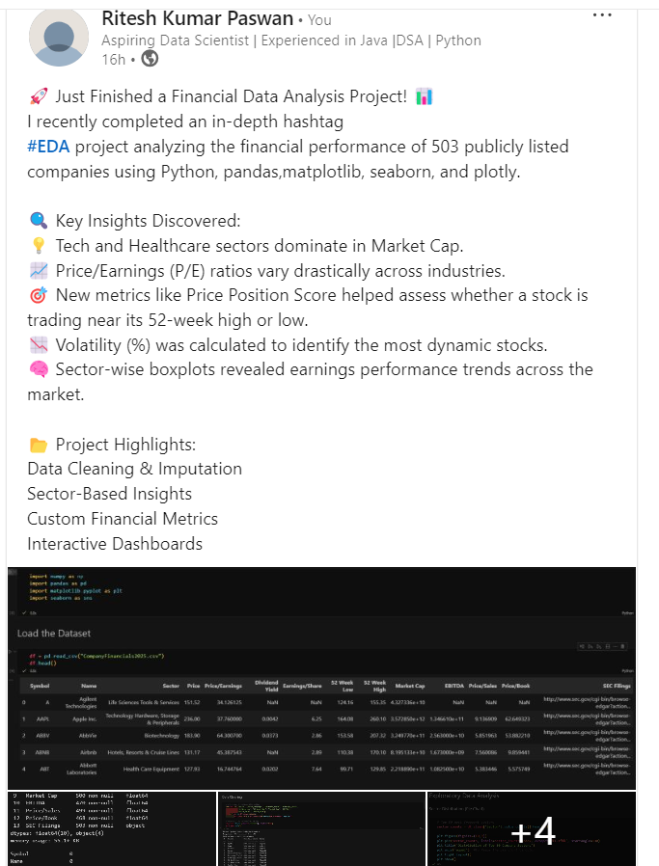
finance and data analytics.

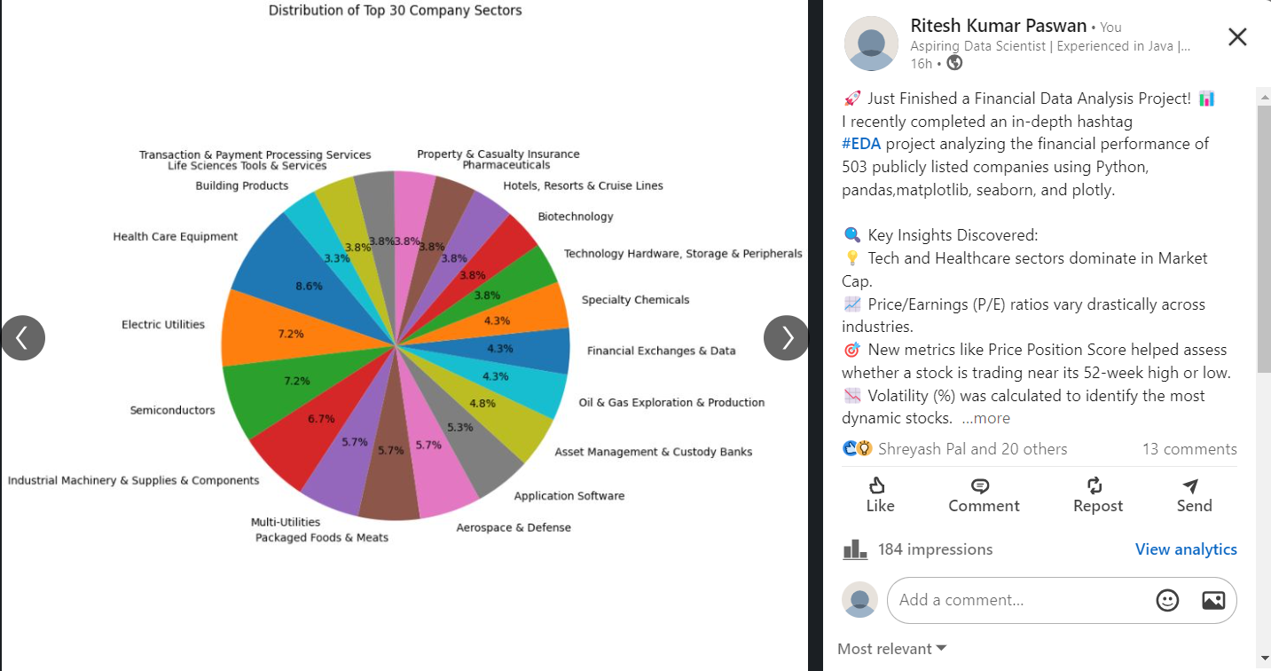

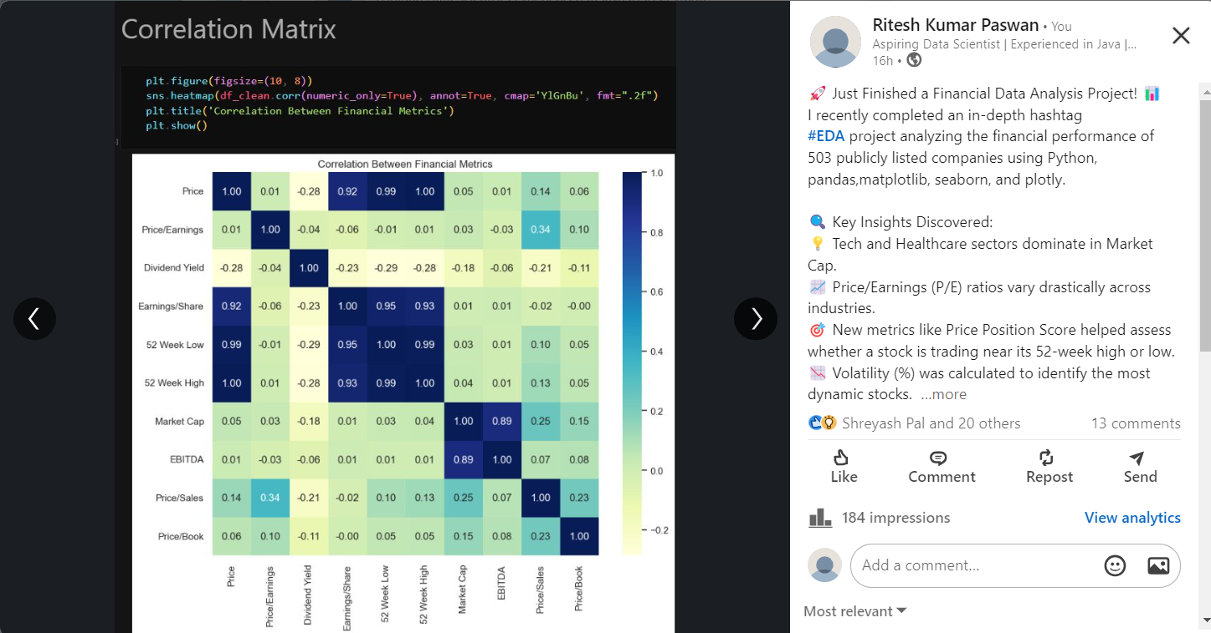

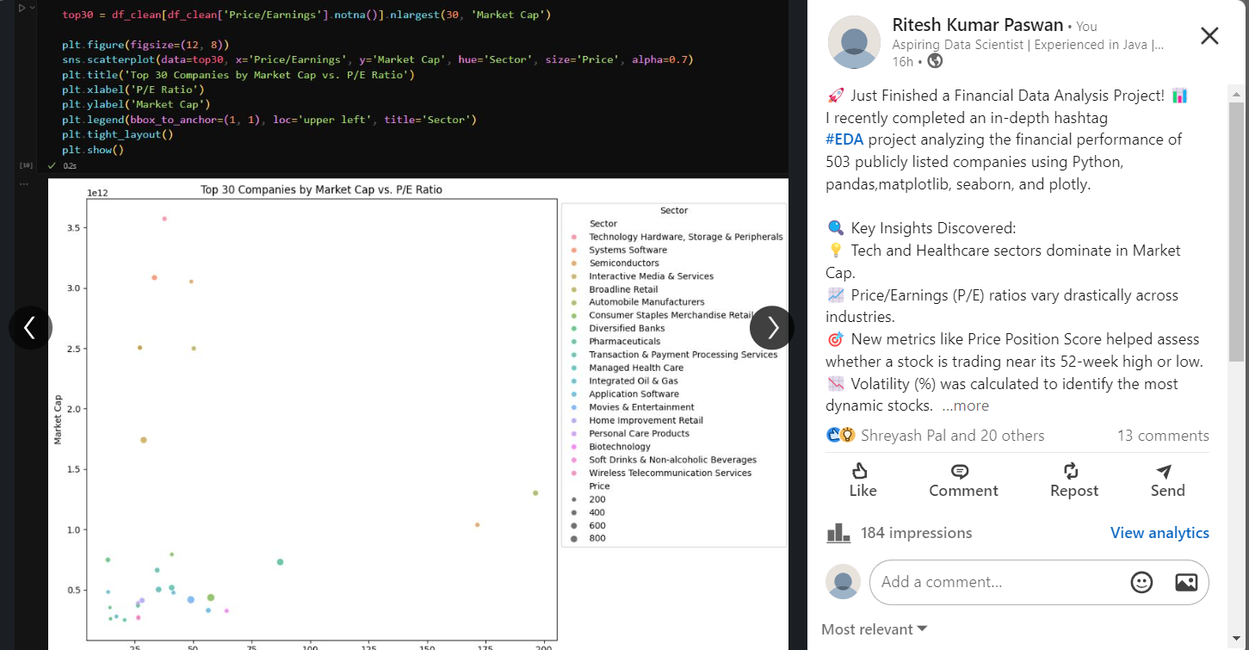

D) GitHub Contributions
The project code and notebook were uploaded to GitHub with regular commits, meaningful messages, and a structured README file. Commits tracked project progress, and branches were used for version control. Pull requests documented additions and updates in various parts of the analysis.
https://github.com/Ritesh2332/Financial_Data_Analysis

