***“MARKSHEET GENERATION”***

A MINI- PROJECT REPORT ON

Submitted in partial fulfillment of the requirements

For the degree of

Bachelor of Engineering

In

Information Technology

by

**Soham Subhash Salkar Roll No.- 18IT1050**

**Riteshkumar Shivkumar Singh Roll No.- 18IT1068**

**Rahul Rajesh Modi Roll No.- 18IT2028**

Supervisor

**Nilima Dongre**



Department of Information Technology

Dr. D. Y. Patil Group’s

**Ramrao Adik Institute of Technology**



Ramrao Adik Institute of Technology

(Affiliated to the University of Mumbai)

Dr. D. Y. Patil Vidyanagar,Sector 7, Nerul, Navi Mumbai 400706.

CERTIFICATE

This is to certify that,Mini Project entitled

“MARKSHEET GENERATOR USING BASH SCRIPTING”

is a bonafide work done by

Student Names

1.Sohm Salkar

2.Riteshkumar Singh

3.Rahul Modi

and is submitted in the partial fulfillment of the requirement for the degree of

Bachelor of Engineering in

Information Technology to the

University of Mumbai

Supervisor

Prof.Nilima M.Dongre

Project Guide Head of the department

Nilima Dongre Dr. Ashish Jadhav

Certificate of Approval by Examiners

This Mini Project report entitled “ MARKSHEET GENERATION ” is a bonafide work done by Student Names under the supervision of Prof.Nilima Dongre approved for the award of Bachelor Degree in Information Technology,

University of Mumbai.

Examiners :

# 1. . . . . . . . . . . . . . . . . . . . . . . . . . . . . . .

2. . . . . . . . . . . . . . . . . . . . . . . . . . . . . . .

Supervisors :

1. . . . . . . . . . . . . . . . . . . . . . . . . . . . . . .
2. . . . . . . . . . . . . . . . . . . . . . . . . . . . . . .

Principal :

. . . . . . . . . . . . . . . . . . . . . . . . . . . . . .

Date :

Place :

# TABLE OF CONTENTS

**Declaration …………….…….………………………………………… I**

**Acknowledgement ……...……………………………………………… II**

**Preface …………….…………………………………………………… III**

**Table of Contents ……………………………………………………… IV**

**Abstract…….....…………………………………………………..…….. V**

**Table of figures ...…………………………………………………….… V**

## DECLARATION

We declare that this written submission represents our ideas in our own words and where others' ideas or words have been included, we have adequately cited and referenced the original sources. We also declare that we have adhered to all principles of academic honesty and integrity and have not misrepresented or fabricated or falsified any idea/data/fact/source in our submission. We understand that any violation of the above will be cause for disciplinary action by the Institute and can also evoke penal action from the sources which have thus not been properly cited or from whom proper permission has not been taken when needed.

**Name and Roll No. of Students Signature**

**1.Soham Salkar(**18IT1050**)**

**2.Riteshkumar Singh(**18IT1068**)**

**3.Rahul Modi(**18IT2028**)**

Date:

Place:

## ACKNOWLEDGEMENT

The project “Marksheet Generator System” is creative work of many minds. A proper synchronization between individual is must for any project to be completed successfully. One cannot imagine the power of the force that guides us all and neither can we succeed without acknowledging it. We take this opportunity to express my profound gratitude and deep regards to our Guide **Nilima Dongre**, Department of the Information Technology Engineering for her or her exemplary guidance, monitoring and constant encouragement throughout the completion of this mini project.

We would like to express our gratitude to **Dr. Ashish Jadhav,** Head of the department, Information Technology Engineering for encouraging and inspiring us to carry out the project in the department lab. We take this privilege to express my sincere thanksare thankful to **Dr. Mukesh D. Patil, Principal RAIT,** for his constant support and motivation.

We also would like to thank all the staff members Department of the Information Technology Engineering for providing us with the required facilities and support towards the completion of the project.

Last but not the least we are thankful to our parents and friends for their constant Inspiration, encouragement and well wishes by which we have made a challenging project.

**Signature**

**Soham Subhash Salkar Roll No.- 18IT1050**

**Riteshkumar Shivkumar Singh Roll No.- 18IT1068**

**Rahul Rajesh Modi Roll No.- 18IT2028**

## PREFACE

We take great opportunity to present this Mini Project report on “MARKSHEET GENERATION**”** and put before readers some useful information regarding our project.

We have made sincere attempts and taken every care to present this matter in precise and compact form, the language being as simple as possible. We are sure that the information contained in this volume certainly prove useful for better insight in the scope and dimension of this project in it true perspective.

The task of the completion of the project though being difficult was made quite simple, interesting and successful due to deep involvement and complete dedication of our group members.

## TABLE OF CONTENTS

**Sr. No. Topic Page No.**

1. **INTRODUCTION………………………………………………………………..10**
   1. **INTRODUCTION TO SCRIPTING LANGUAGES………………………11**
   2. **WHY PARTICULAR SCRIPTING LANGUAGE………………………...11**
   3. **PROBLEM STATEMENT………………………………………………….11**

**1.4 OBJECTIVES………………………………………………………………..11**

1. **LITERATURE SURVEY……………………………………………………….12**
   1. **MOTIVATION………………………………………………………………13**

1. **PROPOSED SYSTEM…………………………………………………………..14**
   1. **INTRODUCTION OF PROPOSED SYSTEM AND**

**ARCHITECTURE …………………………………………………………...15**

* 1. **HARDWARE AND SOFTWARE REQUIREMENTS……………………15**

1. **IMPLEMENTATION……………………………………………………………17** 
   1. **SYSTEM BLOCK DIAGRAM……………….……………………………...18**
   2. **MODULE DESCRIPTION………………………………………………...18**
   3. **CODE………………………………………………………………………….19**

1. **RESULT…………………………………………………………………………...26**

**5.1.1 OUTPUT SNAPSHOTS**

1. **CONCLUSION AND FUTURE SCOPE………………………………………..31**
   1. **CONCLUSION……………………………………………………………….32**
2. **REFERENCES……………………………………………………………………32**

**ABSTRACT**

Our mini-project that we present here today is 'Marksheet Generator System '.

But the question that comes to our mind is what is exactly is a 'Marksheet Generator System '

⦁ WHAT IS Marksheet Generator System?

The Marksheet Generator is flexible for generating progress mark sheet of students. This system is mainly based in the database technology and the CBCGS .The system is targeted to small enterprises, schools, colleges and universities. It can produce sophisticated ready-touse mark sheet, which could be created and will be ready to print. The development of a marksheet and gadget sheet is focusing at describing tables with columns/rows and subcolumn sub-rows, rules of data selection and summarizing for report, particular table or column/row, and formatting the report in destination document. The adjustable data interface will be popular data sources (SQL Server) and report destinations . Marksheet generation system can be used in universities to automate the distribution of digitally verifiable mark-sheets of students. The system accesses the students’ exam information from the university database and generates the gadget-sheet Gadget sheet keeps the track of student information in properly listed manner. The project aims at developing a marksheet generation system which can be used in universities to automate the distribution of digitally verifiable student result mark sheets. The system accesses the students’ results information from the institute student database and generates the mark sheets in Portable Document Format which is tamper proof which provides the authenticity of the document. Authenticity of the document can also be verified easily.

## CHAPTER -1

## INTRODUCTION

#### 1.1 INTRODUCTION TO SCRIPTING LANGUAGES

Usually shells are interactive that mean, they accept command as input from users and execute them. However some time we want to execute a bunch of commands routinely, so we have type in all commands each time in terminal. Shell scripts are similar to the batch file in MS-DOS. Each shell script is saved with .sh file extension eg . myscript.sh A shell script have syntax just like any other programming language. If you have any prior experience with any programming language like Python, C/C++ etc. it would be very easy to get started with it.

#### 1.2 WHY PARTICULAR SCRIPTING LANGUAGE

* There are many reasons to write shell scripts –
* To avoid repetitive work and automation
* System admins use shell scripting for routine backups
* System monitoring
* Adding new functionality to the shell etc.

#### 1.3 PROBLEM STATEMENT

* Prone to costly errors, a single mistake can change the command which might be harmful
* Slow execution speed
* Design flaws within the language syntax or implementation
* Not well suited for large and complex task

#### 1.4 OBJECTIVES

* The command and syntax are exactly the same as those directly entered in
* command line, so programmer do not need to switch to entirely different
* syntax: Writing shell scripts are much quicker

## CHAPTER -2

## LITERATURE SURVEY

#### 2.1 MOTIVATION

Association of digital signature and trusted time stamp: Digital signature algorithm and protocol do no inherently provide the certainty about the date and time at which underlying document was signed .

Non repudiation: In cryptographic context, the word repudiation refers to any act disclaiming responsibility for message. It is used to remove old expired certificates from repository. It is matter for security policy and responsibility of authority to keep old certificates for a period of time if non-repudiation data service is provided .

Unavailability of hardware: Even though the use of QR code in a mark-sheet that possess ability to scan QR code. Also for scanning purpose one must have hardware which adds a cost to system.

Lack of user friendly interface: Due to use of DOS or user interfaces which are not user friendly. It also uses various difficult commands to complete the number of tasks. The existing system fails to provide a good user interface. Also understanding of the user interface of existing system is tedious and time consuming whereas the new system is self-explanatory and easy to use as far as user interface is concerned.

## CHAPTER -3

## PROPOSED SYSTEM

#### 3.1 INTRODUCTION OF PROPOSED SYSTEM AND ARCHITECTURE

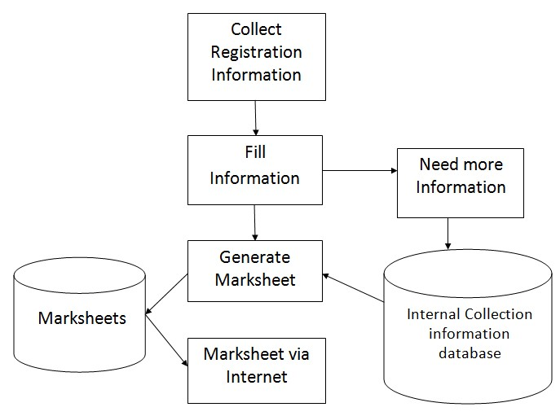

The marksheet generator is to ensure an efficient certificate management using huge data and to provide mark-sheets for credit based grading system (CBGS) in very user friendly manner by not making it very complex.

The system being automated and generalized, the system ensures to reduce manual errors by reducing manual efforts. An added asset to the feature of system is that it aims at improving and easing out the work of the existing system in very sophisticated way. The technology is rapid and able to generate, store & display the mark-sheets of the students. The system provides advance reaction capabilities and automatic operator of the internal calculation based on university rules with the information from the database. It also works with various standards of the mark-sheets.

#### 3.2 HARDWARE AND SOFTWARE REQUIREMENTS

PHP is used for web development works as a server side scripting language and also it is used for general purpose programming. PHP code is interpreted by a web server with the PHP processor generates the resulting page which interprets the PHP code. It also includes interface capacity of command line and can be used standalone graphical application.

In this system input can be marks of the students of their theory exams, practical exams, internal assessment and term work. Grades and pointers of student can be calculated according to rules, formulae and ordinances.

## CHAPTER –4

## IMPLEMENTATION

#### 4.1 SYSTEM BLOCK DIAGRAM

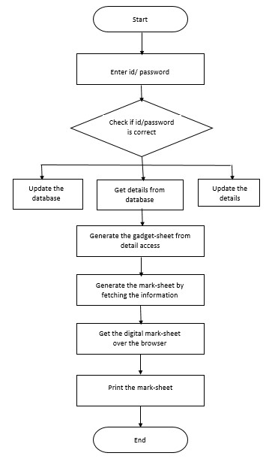

#### 4.2 MODULE DESCRIPTION

**Step 1:** If admin is operating the system, login id and password. If student is operating the system, they can access the system by providing the registration id.

**Step 2:** Check if provided login id and password or registration id is correct, if not go back to step 1 and if correct proceed for the step 3.

**Step 3:** If admin is operating the system, he can access the system by updating the database, changing the data in the database and can get the required information from the database. If students are operating the system, the can only view the data.

**Step 4:** Then system will generate the gadget sheet of all the students and it calculates the grade and grade point of each and every student as per the Credit based grading system (CBCGS).

**Step 5:** Then this system will generate the mark sheet by fetching the grades, pointers and credits from the gadget sheet previously developed.

**Step 6:** Then this information of students’ marks are available to access to students by providing authentication. Admin will get requested mark sheet in PDF mark sheet for printing purpose. And only marks can be accessible to student.

**Steps 7:** These mark sheets then can be made printable by converting it into portable document format.

#### 4.3 CODE

#!/bin/bash

echo Name Of College

read college

echo Semester Number

read sem

while :

do

clear

echo "Select option"

echo "1.Add Marksheet"

echo "2.Update Marksheet"

echo "3.Delete Marksheet"

echo "4.View Marksheet"

echo "5.Exit"

read -p "ENTER YOU CHOICE:-" usr_cmd

clear

case $usr_cmd in

1) echo -----------------------------------

echo '\t Student Mark List'

echo -----------------------------------

echo Enter the Student name

read name

echo Enter the Roll number

read rno

echo Enter the Mark of Subject 1

read m1

echo Enter the Mark of Subject 2

read m2

echo Enter the Mark of Subject 3

read m3

echo Enter the Mark of Subject 4

read m4

echo Enter the Mark of Subject 5

read m5

tot=$(expr $m1 + $m2 + $m3 + $m4 + $m5)

avg=$(expr $tot / 5)

if [ $m1 -ge 35 ] && [ $m2 -ge 35 ] && [ $m3 -ge 35 ] && [ $m4 -ge 35 ] && [ $m5 -ge 35 ]

then

result="pass"

if [ $avg -ge 90 ]

then

grade="S"

elif [ $avg -ge 80 ]

then

grade="A"

elif [ $avg -ge 70 ]

then

grade="B"

elif [ $avg -ge 60 ]

then

grade="C"

elif [ $avg -ge 50 ]

then

grade="D"

elif [ $avg -ge 35 ]

then

grade="E"

fi

else

result="fail"

grade="no grade"

fi

n=$(( $n - 1 ))

echo "

College name :$college

Semester Number :sem $sem

Student Name :$name

Roll Number:$rno

Marks of Subject 1 :$m1

Marks of Subject 2 :$m2

Marks of Subject 3 :$m3

Marks of Subject 4 :$m4

Marks of Subject 5 :$m5

Total :$tot

Average :$avg

Grade :$grade

Result :$result" >$rno-$name.txt

echo SAVED

;;

2)echo "Enter the Roll number to update"

read rno

cat *"$rno"*.txt

rm "$rno"*.txt

echo Enter the Student name

read name

echo Update the Roll number

read rno

echo Update the Mark of Subject 1

read m1

echo Update the Mark of Subject 2

read m2

echo Update the Mark of Subject 3

read m3

echo Update the Mark of Subject 4

read m4

echo Update the Mark of Subject 5

read m5

tot=$(expr $m1 + $m2 + $m3 + $m4 + $m5)

avg=$(expr $tot / 5)

if [ $m1 -ge 35 ] && [ $m2 -ge 35 ] && [ $m3 -ge 35 ] && [ $m4 -ge 35 ] && [ $m5 -ge 35 ]

then

result="pass"

if [ $avg -ge 90 ]

then

grade="S"

elif [ $avg -ge 80 ]

then

grade="A"

elif [ $avg -ge 70 ]

then

grade="B"

elif [ $avg -ge 60 ]

then

grade="C"

elif [ $avg -ge 50 ]

then

grade="D"

elif [ $avg -ge 35 ]

then

grade="E"

fi

else

result="fail"

grade="no grade"

fi

echo "

College name :$college

Semester Number :$sem

Student Name :$name

Roll Number:$rno

Marks of Subject 1 :$m1

Marks of Subject 2 :$m2

Marks of Subject 3 :$m3

Marks of Subject 4 :$m4

Marks of Subject 5 :$m5

Total :$tot

Average :$avg

Grade :$grade

Result :$result" >$rno-$name.txt

echo UPDATED

;;

3)echo "Enter the Roll number or Name to delete"

read rno

rm *"$rno"*.txt

echo DELETED

;;

4)echo "Enter the Roll number or Name to view"

read rno

cat *"$rno"*.txt

;;

5)break;;

esac;

read -p "Hit Enter to Return to Main Menu: " confirm_exit

if [$confirm_exit -eq 6]

then break

fi

done

## CHAPTER –5

## RESULT

#### 5.1.1 OUTPUT SNAPSHOTS

INITIALLY

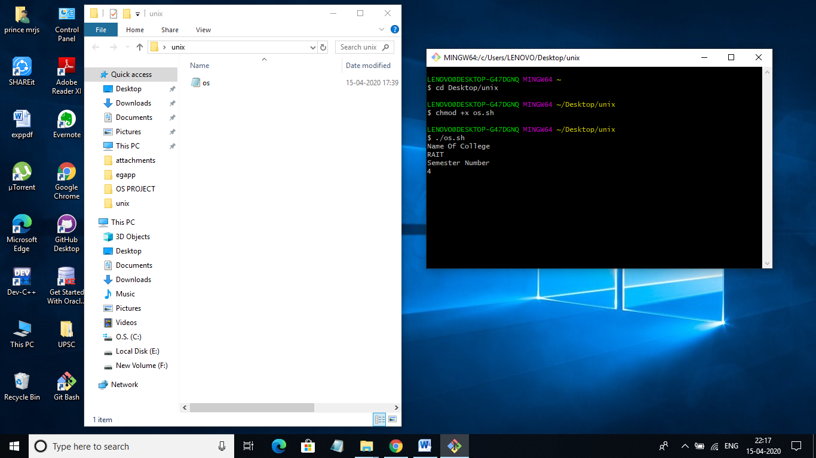

SELECTING OPTION TO ADD MARKSHEET:-

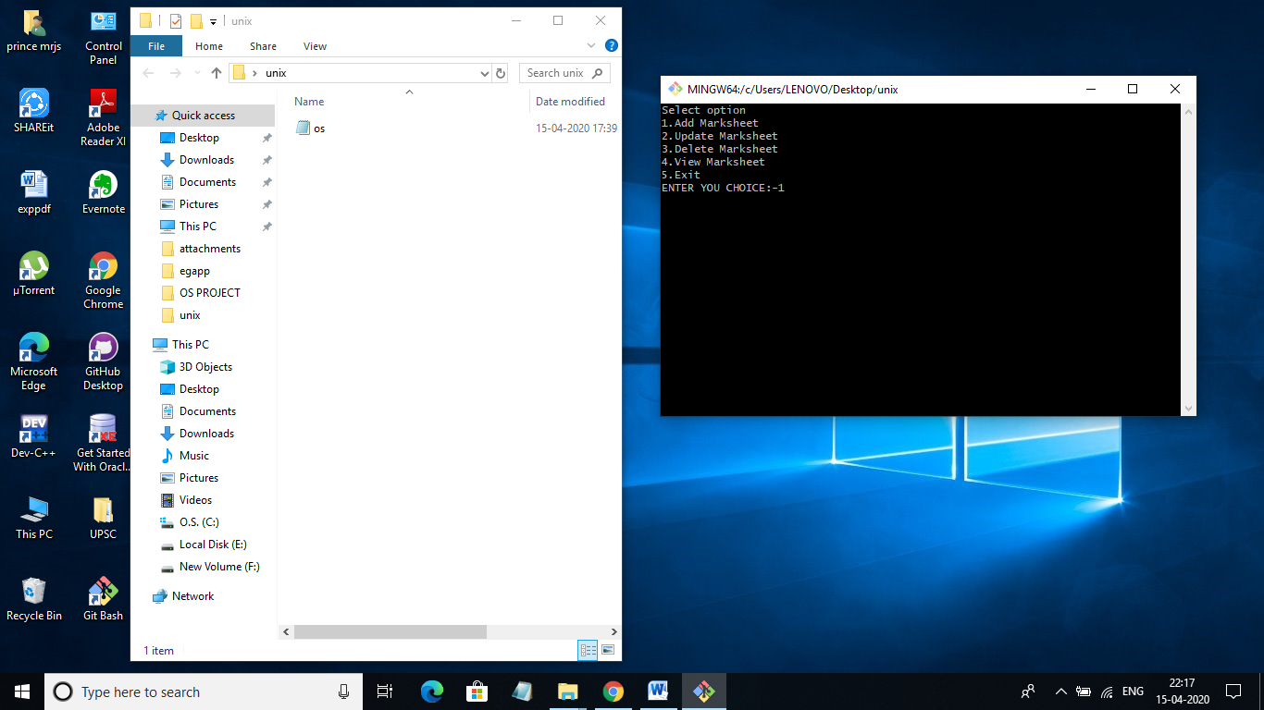

ENTERED DETAILS AND IT SAVED IN FORM OF MARKSHEET:-

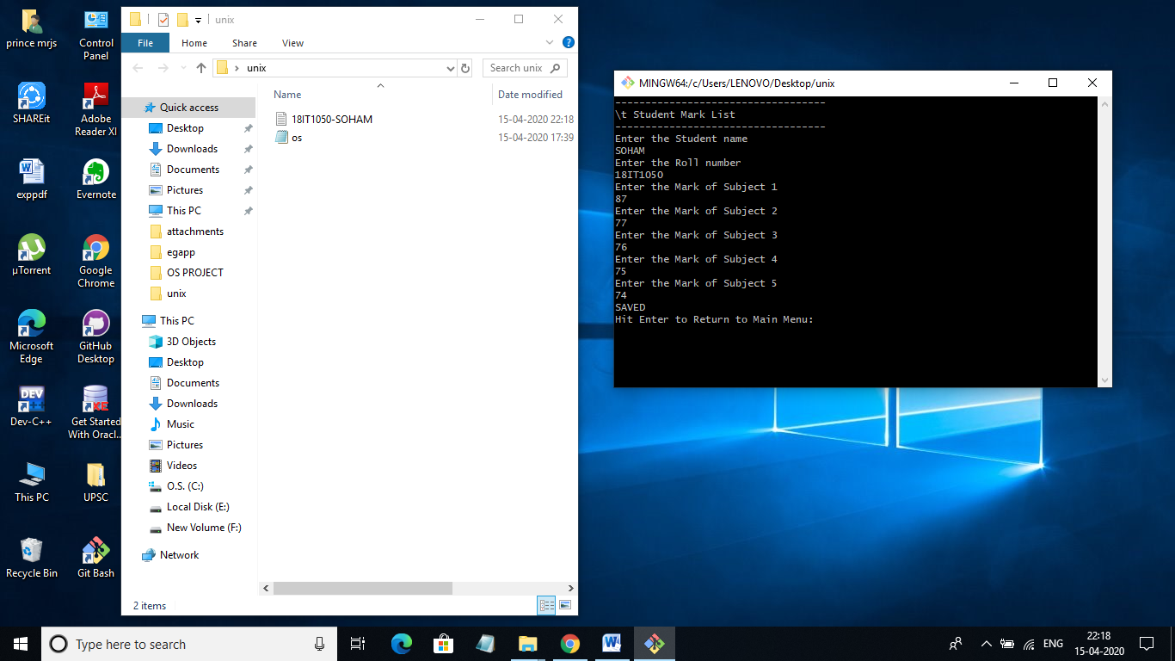

SELECTED THE OPTION TO VIEW MARKSHEET BY ENTERING NAME OR ROLL NO:-

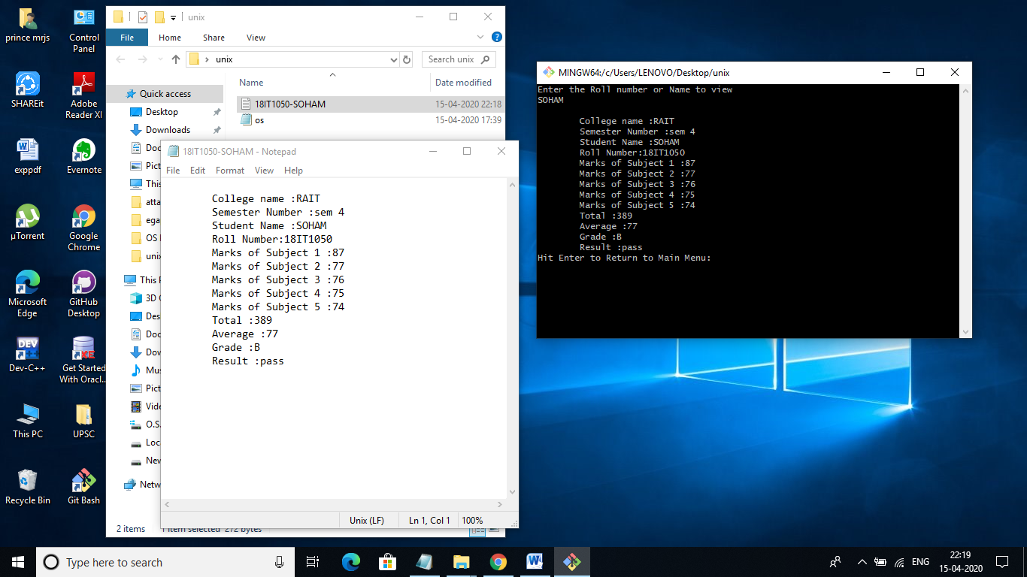

SELECTED OPTION TO UPDATE AND UPDATED THE NAME(SOHAM---->>>RITESH)

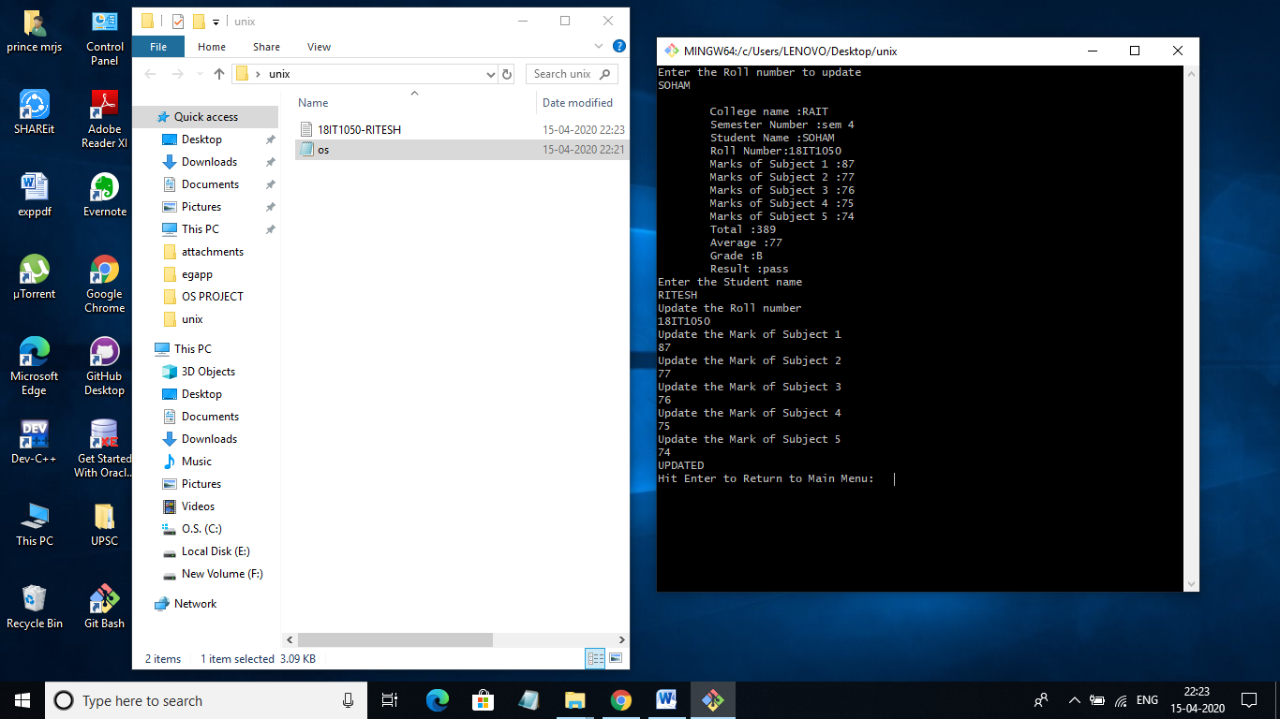

SELECTED OPTION TO DELETE:-

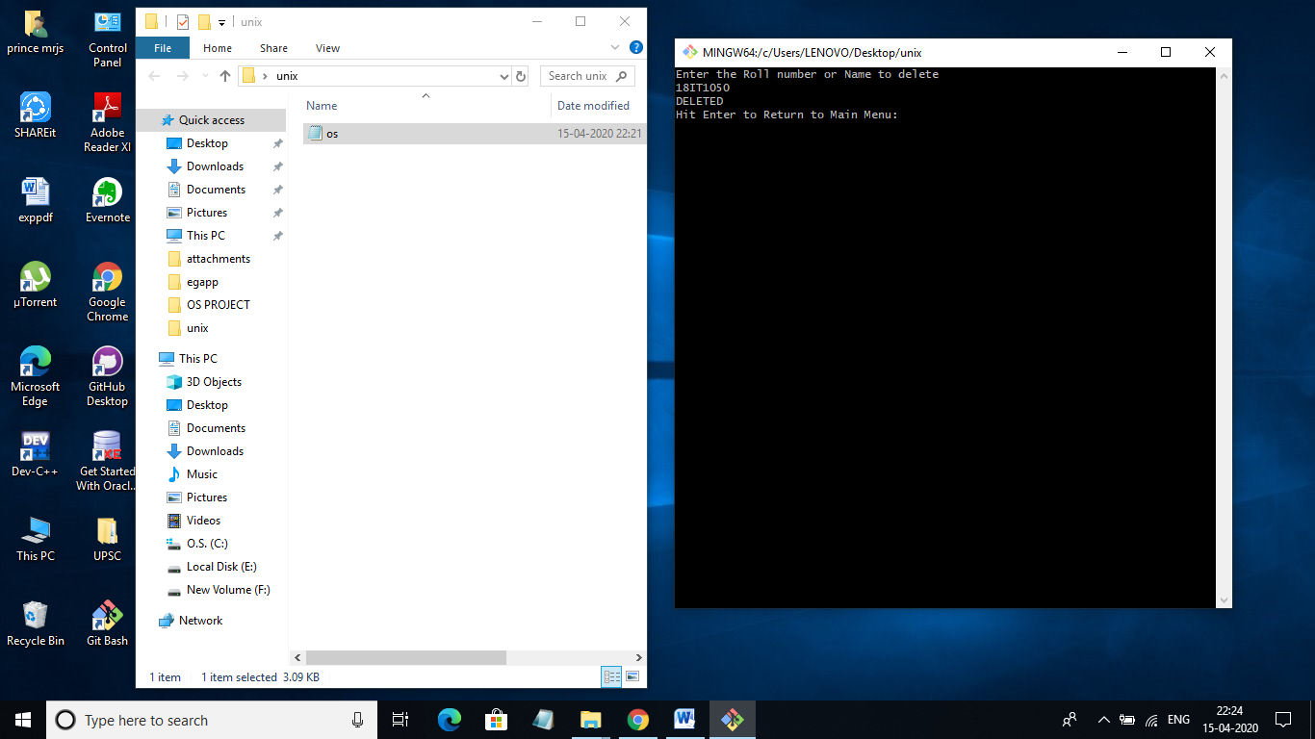

## CHAPTER –6

## CONCLUSION AND FUTURE SCOPE

#### 6.1 CONCLUSION

In the end we would like to conclude that our aim was to make ‘Marsksheet Generator’ using bash script. The Marksheet generator helps to create a marksheet of particular student and saves it in the form of **ROLLNO-NAME.txt** format. This format helps the user to easily view , delete and update using shell. It also has a code to compute average and total and according to it assign grade. Hence it can be great tool in university and schools.

#### 6.2 FUTURE SCOPE

We can try to save the details that are required in excel sheet format. This by further implementation can be incorporated with database and GUI and can be published as a full project.

#### 6.3 REFERENCES

* [**www.google.com**](http://www.google.com/)
* [**www.wikipedia.org**](http://www.wikipedia.org/)
* [**www.studycircle.org**](http://www.studycircle.org/)
* [**www.tutorialpoint.com**](http://www.tutorialpoint.com/)
* [**www.w3schools.com**](http://www.w3schools.com/)
* [**www.youtube.com**](http://www.youtube.com/)
* [**www.academia.edu**](http://www.academia.edu/)