Mini-Project (AY-2024-25)

Synopsis On

Submitted By (Project group members)
Date:

1. Shubham S. Gavade
2. Abhijeet Khomane
3. Purva Patil

Div:A
Title of Project 1: Task management for personal and team(Advanced Jira Reporting Tool).
BlockDiagram: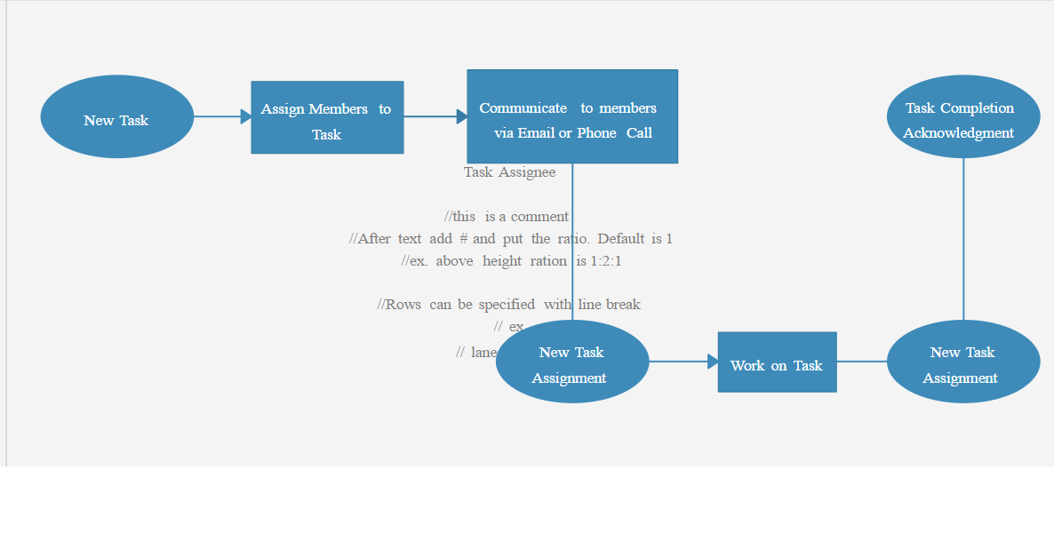
Introduction of project 1:
This project aims to develop a task management application that caters to both personal and team task organization needs. The application will provide a user-friendly interface for creating, assigning, tracking, and managing tasks efficiently. It will incorporate features such as task prioritization, due dates, progress tracking, and collaboration tools to enhance productivity and streamline workflow.
Key Features
- Task Creation and Assignment: Users can create tasks and assign them to team members with clear deadlines and priorities.
- Progress Tracking: Track the progress of individual tasks and overall project status.
- Collaboration: Facilitate team communication and collaboration through comments, file sharing, and notifications.
- Personal Task Management: Allow users to manage their individual tasks and to-do lists effectively.
- Reporting: Generate reports on task progress, team performance, and project milestones.
References:
Software Engineering Principles:
- "Software Engineering" by Ian Sommerville
- "22413 - Software Enginering.pdf" (for specific requirement gathering and design principles)
Database Management: "dbms unit 1.pdf" (for efficient task data storage and retrieval)
User Interface Design:
- General UI/UX design principles (online resources and books)

Synopsis On

Submitted By (Project group members)
Date:

1. Shubham S. Gavade
2. Abhijeet Khomane
3. Purva Patil

Div:A
Title of Project 2:
Block Diagram:
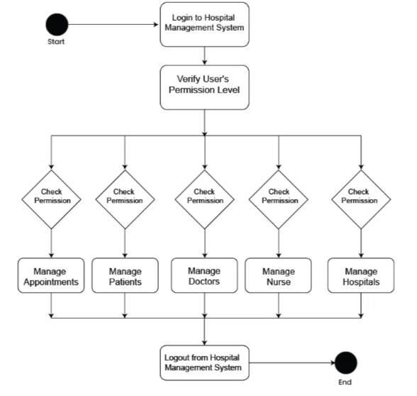

Introduction of project 2:
AI-Powered Hospital Management System
- Core Features:
  - Patient registration, appointment scheduling, EMRs.
  - Doctor management, billing integration.
- AI Integration:
  - Appointment Scheduling: Optimizes slots, minimizes wait times.
  - Disease Prediction: Analyzes data to predict diseases.
  - Treatment Recommendations: Suggests potential treatment options.
- Technologies: Python, Flask/Django, SQLite/PostgreSQL, Scikit-learn.
- Development:
  - Frontend (user interface), Backend (API, database), AI model integration.
- Limitations: Simplified model, basic AI, data dependency.
- Future: Advanced AI, NLP, image recognition, wearable integration.

References:
- WHO, NIH, Stanford AI in Healthcare: For general AI and healthcare information.
- HIMSS: For hospital management systems standards.

Synopsis On

Submitted By (Project group members)
Date:

1. Shubham S. Gavade
2. Abhijeet Khomane
3. Purva Patil

Div:3
Title of Project 3:
Block Diagram:
Introduction of project 3:
References:

