**IONIC SALESFORCE MOBILE OFFLINE STORAGE POC**

**Deployment Guide**

Revision History

|  |  |  |
| --- | --- | --- |
| **Author** | **Revision Number** | **Date** |
| TCSASSEMBLER | 1.0 | 02/05/2016 |
|  |  |  |
|  |  |  |
|  |  |  |

**Contents**

1. Organization of Submission 3

2. Application Setup 3

3. Configuration 3

4. Verification 4

# Organization of Submission

* docs/ DeploymentGuide-ionic.doc – this file, the deployment guide of this app
* ionic – the source code of the ionic app
* README.md – the read me file
* offline-app-demonstration.m4v – the demonstration video file

# Application Setup

* nodejs v5.0+ (with npm) installed <https://nodejs.org/>
* cordova 6.0.0 (***npm install cordova***)
* ionic v1.7.13 (***npm install ionic***)
* please refer to <http://cordova.apache.org/docs/en/5.1.1/guide/platforms/android/index.html> and <http://cordova.apache.org/docs/en/5.1.1/guide/platforms/ios/index.html> to install iOS and android required development platform dependencies
* run commands under {ROOT}/ionic directory

***npm install***

***ionic state reset***

***ionic run ios -target="iPad-Air" or ionic run android***

Note: Currently can not work in android due to issue of salesforce SDK <http://apps.topcoder.com/forums/?module=Thread&threadID=876059&start=0>

# Configuration

Check salesforce SDK configure values in file {ROOT}/ionic/www/bootconfig.json.

|  |  |  |
| --- | --- | --- |
| Name | Description | Sample |
| remoteAccessConsumerKey | Remote access consume key of this app | 3MVG91ftikjGaMd8N0ghDU6FPIenz8JX0z3SQwW47ScwY9cJAZfMnNLxQmRS_t4shwilTcwp7kYsK6AuYB35m |
| oauthRedirectURI | Oauth redirect URI | testsfdc:///mobilesdk/detect/oauth/done |
| oauthScopes | Oauth scopes | ["web", "api"] |
| isLocal | Indicate whether this is a hybrid local app | true |
| startPage | The start page | Index.html |
| errorPage | The error page | error.html |

Check app configure values in file {ROOT}/ionic/www/app/config.js.

|  |  |  |
| --- | --- | --- |
| Name | Description | Sample |
| soups | The soup definitions in local DB | {contact, product, request, sync} |
| syncOptions | The sync options | {mergeMode:'LEAVE_IF_CHANGED',withoutFieldsWhenSyncUp: ['Id', 'OwnerId', 'LastModifiedDate'] } |
| debug | Debug mode | true |
| toastDuration | Toast display duration in ms | 2000 |
| requestStatuses | The statuses of sample request | ['Requested', 'Scheduled', 'Delivered'] |
| dateFormat | The date format in local DB | yyyy-MM-ddTHH:mm:ss.sss |

# Verification

Login as [member@topcoder.com](mailto:member@topcoder.com) / t0pc0d3r and Click “Allow” button

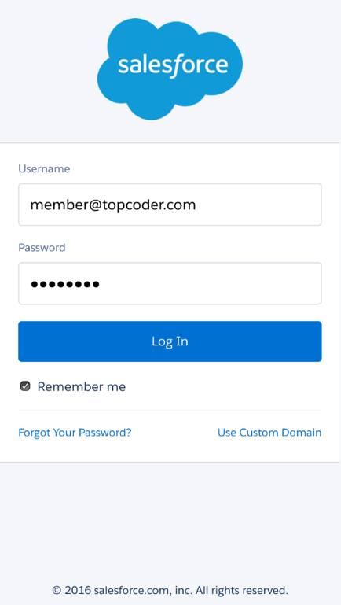

It will redirect to contact list page, and the data will auto download from server when entering this app first time.

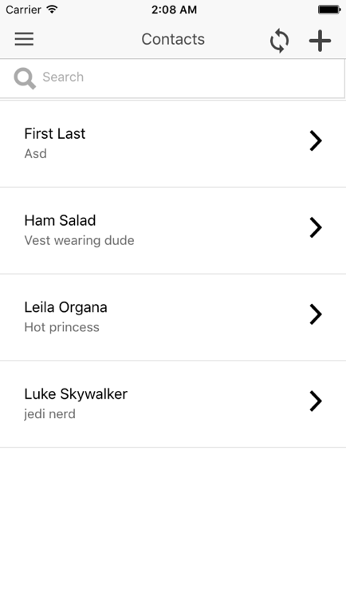

Click left side menu, it can switch between contact, product and sample request page, set pin code, logout or show DB Inspector(used for debug). Click “Pin Code” to set pin code. If already set a pin code, it will popup a dialog to modify it.

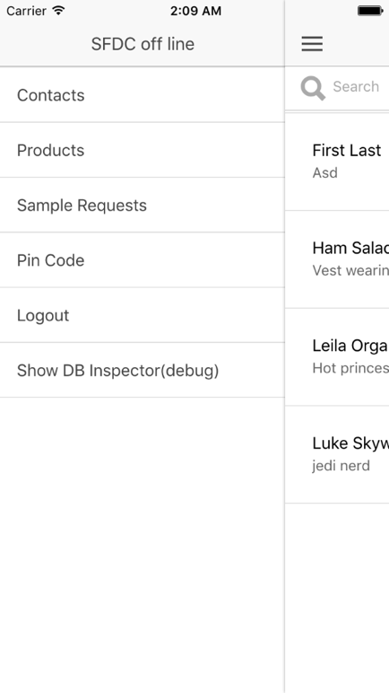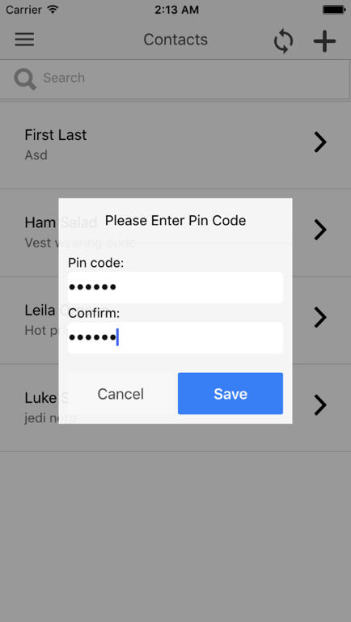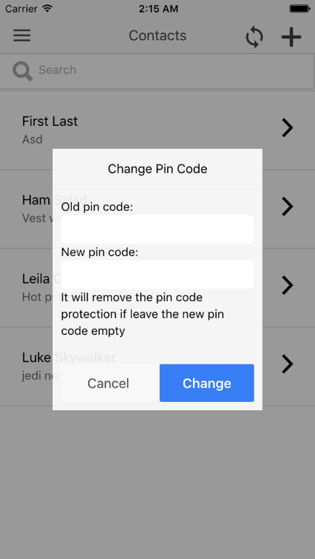

If already set a pin code, it will ask to input pin code when app startup.

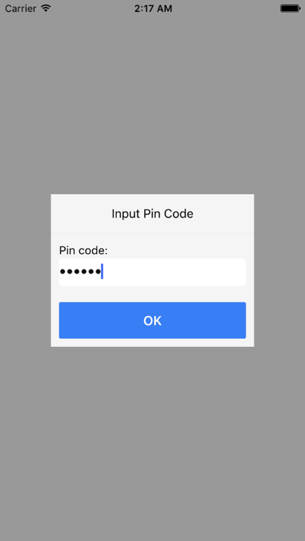

The pages of contact, product and sample request are very similar which all include 4 type pages: list view, detail view, create and edit page.

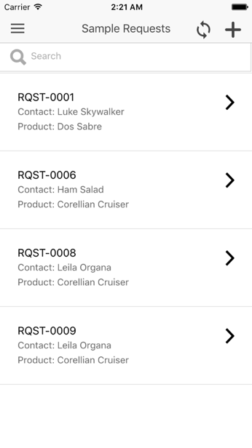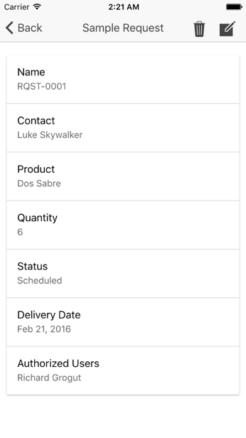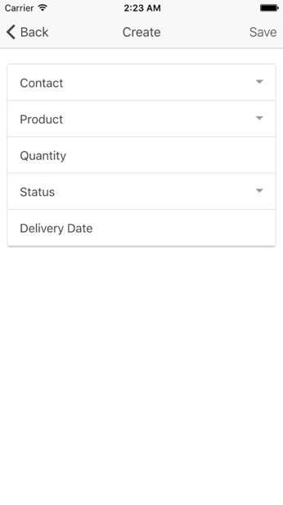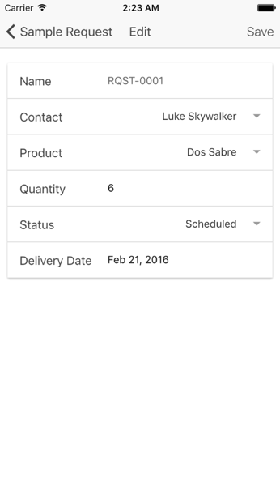

After the record created, deleted or updated, it will show some icons in list page to indicate the state of records.

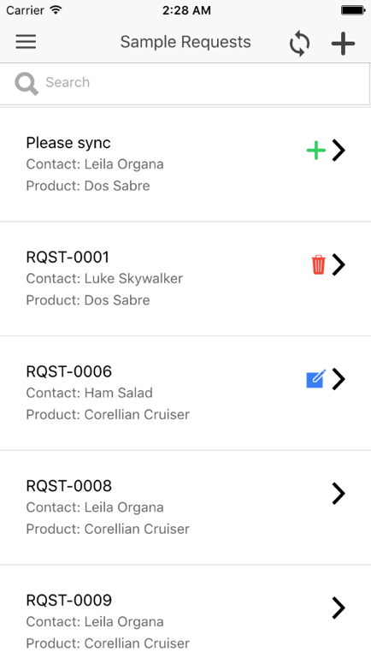

Click sync icon will sync the data with server. Please note that just the sample request supports syncing data bi-directional. The contact and product just sync data download from server, the sample request first sync modified data upload to server, then sync data download from server.

The merge mode of sync is “LEAVE_IF_CHANGED”, so it will not overwrite the updated data.