Restaurant Tipping Data Analysis Report

1. Project Objective
To analyze restaurant tipping behavior using the provided 'tips.csv' dataset. The analysis includes visualizations and basic insights.

2. Dataset
Dataset file: tips.csv
Number of rows: 244
Columns: total_bill, tip, sex, smoker, day, time, size

3. Libraries & Tools
Python, pandas, matplotlib, seaborn, python-docx. Analysis performed in the notebook 'Tips_Analysis.ipynb'.

4. Key Steps Performed
- Loaded dataset using pandas.
- Checked data info and summary.
- Created visualizations: scatter, bar chart, boxplots, scatter (tip percent), correlation heatmap.
- Saved visualization images and created this automated report.
- Generated a Jupyter notebook (.ipynb) that reproduces the analysis.
📸 [Insert Your Lab Snapshot Here — e.g., screenshot of VS Code showing dataset load output]

5. Visualizations (images)
Figure: Scatter Total Tip
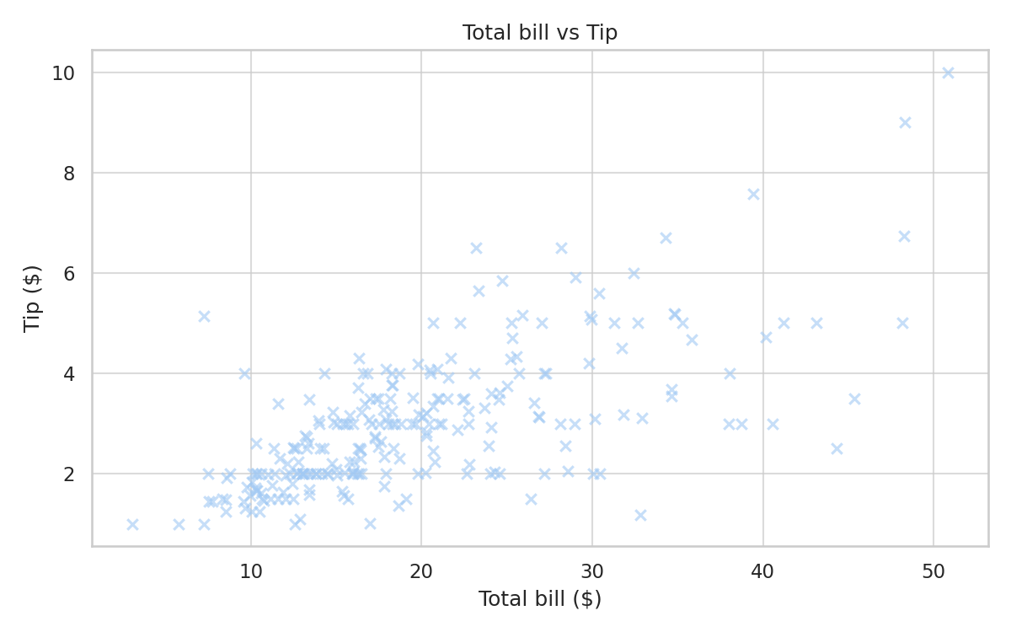
Figure: Avg Tip By Day
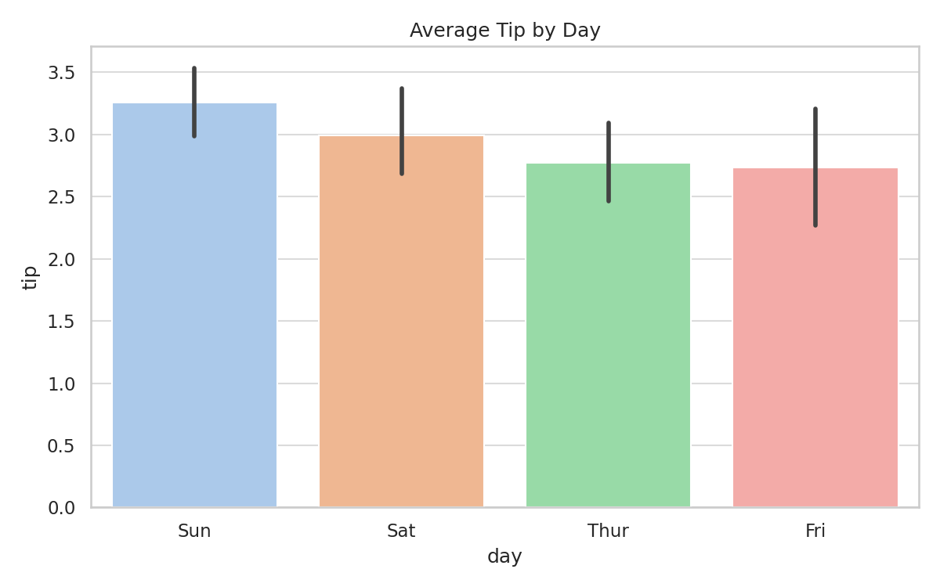
Figure: Tip By Gender
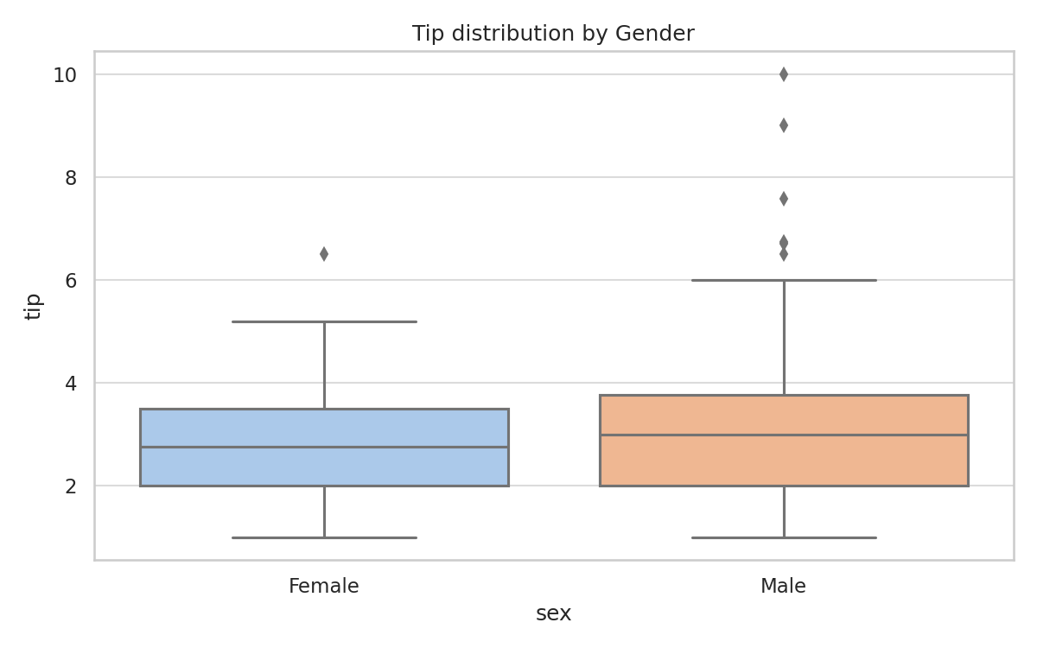
Figure: Tip By Smoker
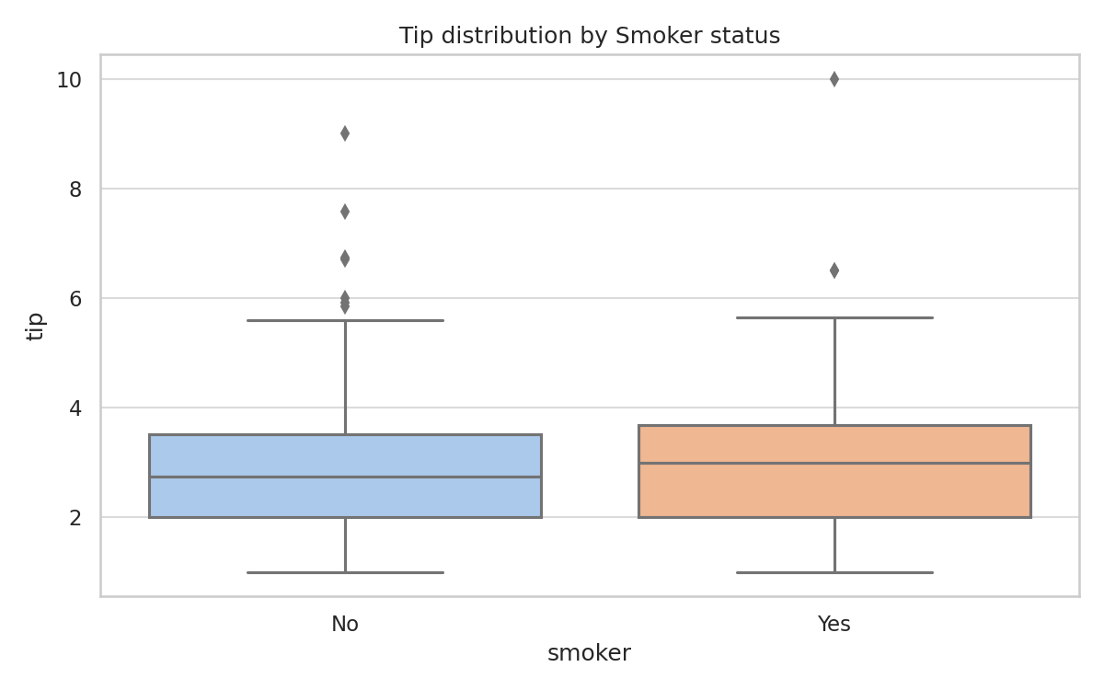
Figure: Tip Percent Vs Total
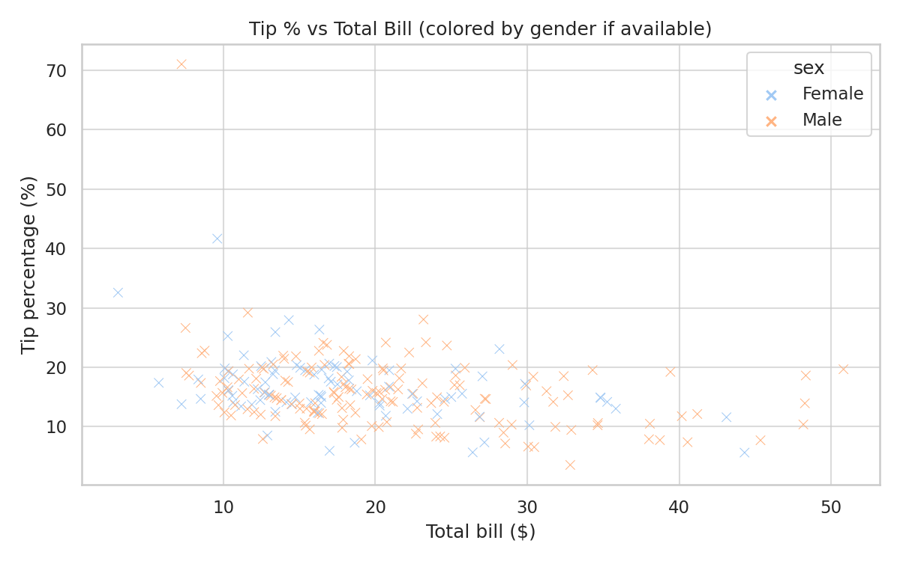
Figure: Correlation Heatmap
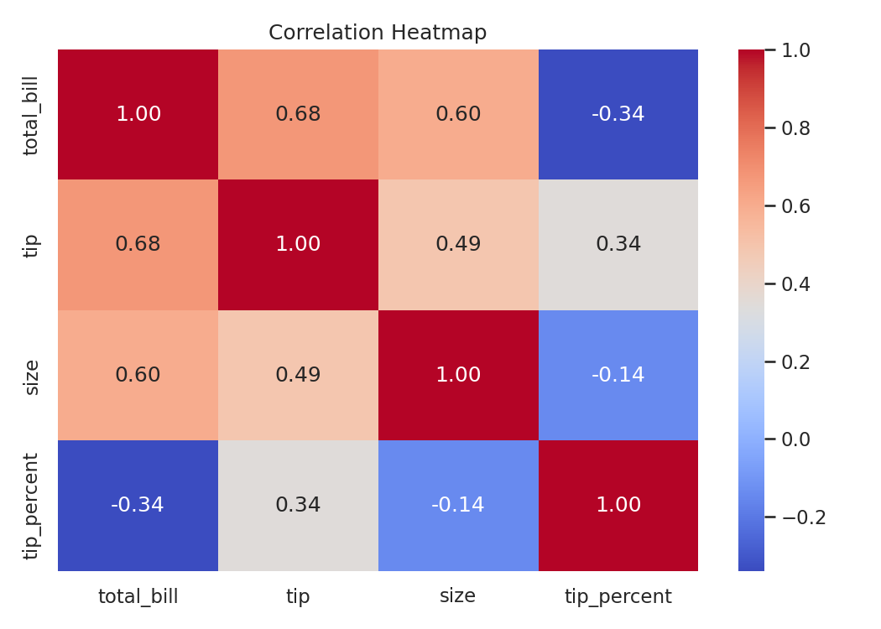

6. Key Insights
- Total bill and tip show a clear positive relationship.
- Average tip varies by day; weekends often show higher average tips.
- Tip % tends to decrease slightly as total bill increases.
- Group size correlates with total bill.
- Correlation matrix shows total_bill and tip are strongly positively correlated.

7. Conclusion
The analysis provides a clear picture of tipping behavior. The notebook 'Tips_Analysis.ipynb' reproduces all steps and plots. Screenshots and visuals demonstrate the practical execution in the lab environment.

