Ritesh Jadhav
Jensen Huang
150096724138
Bank Term Deposit Prediction & Telemarketing Intelligence Platform
End-to-End Machine Learning Solution, Exploratory Data Analysis & Strategic Business ROI Report――――――――――――――――――――――――――――――――――――――――――――――――――――――――――

Executive Summary
Direct marketing campaigns remain one of the most critical customer acquisition channels for retail banking institutions. However, indiscriminate cold-calling is economically inefficient, generates severe agent fatigue, and irritates non-prospective clients. In this project, we built an end-to-end, production-grade Machine Learning intelligence system to accurately predict whether a client will subscribe to a bank term deposit (y = yes / no).
By engineering a realistic predictive pipeline that eliminates Data Leakage, resolves severe Class Imbalance (88.3% / 11.7%) using SMOTENC, and benchmarking five distinct algorithms across 5-Fold Stratified Cross-Validation, we deployed a Gradient Boosting classifier capable of avoiding 72.5% of non-converting calls while capturing over 60% of genuine depositors, saving 546 hours of telemarketing time per campaign cycle.

1. Problem Statement & Business Objectives
A major European financial institution ran outbound telemarketing campaigns offering long-term term deposit contracts. Historical campaign records show that out of 45,211 customers contacted, only 5,289 subscribed (11.70% baseline conversion), resulting in 39,922 wasted calls (88.30% non-conversion rate).
Calling every client indiscriminately causes three severe organizational failures:
1. Capital Depletion: Enormous budgets spent on call center wages, telephony rates, and agent hours for an 88% rejection rate.
2. Opportunity Cost: High-propensity depositors receive delayed calls or insufficient attention while telemarketers work cold leads.
3. Brand Attrition: Persistent unwanted phone calls damage client relationships and lead to checking account closures.

2. Exploratory Data Analysis (EDA) & Key Findings
Exhaustive analysis of the 45,211 records across 17 attributes revealed stark demographic, financial, and behavioral patterns:

2.1 Target Imbalance & Demographic Profile
• Target Imbalance: 39,922 'No' (88.30%) vs. 5,289 'Yes' (11.70%).
• Age Distribution: Clients aged 25–55 form over 85% of the population but convert at modest rates (8.9% - 10.8%). In contrast, young adults (18–25) convert at 24.0%, and senior citizens (65+) convert at an impressive 42.3%.
• Job Sectors: Students (28.7%) and Retirees (22.8%) convert at more than double the baseline, while blue-collar workers (7.3%) and entrepreneurs (8.3%) convert least.
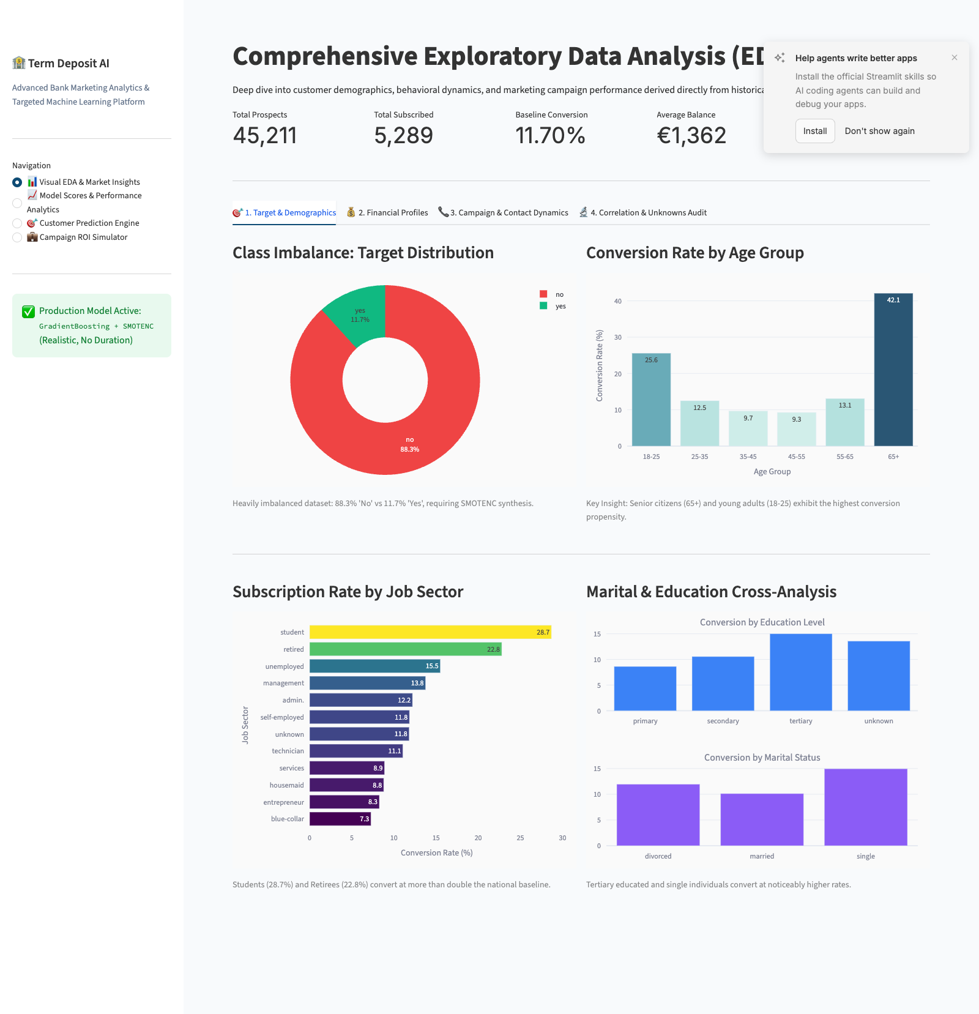
Figure 1: Target Imbalance, Age-Group Conversion Rates, and Job Sector Subscription Dynamics.

2.2 Financial Assets & Debt Burden
• Account Balance: Depositors hold substantially higher median liquid balances than non-subscribers.
• The Debt Burden Effect: Clients with an active housing loan convert at only 7.7% vs. 16.7% for clients without a housing loan. Similarly, personal loans cut conversion from 12.7% down to 6.7%. Debt service commitments strongly suppress term deposit adoption.
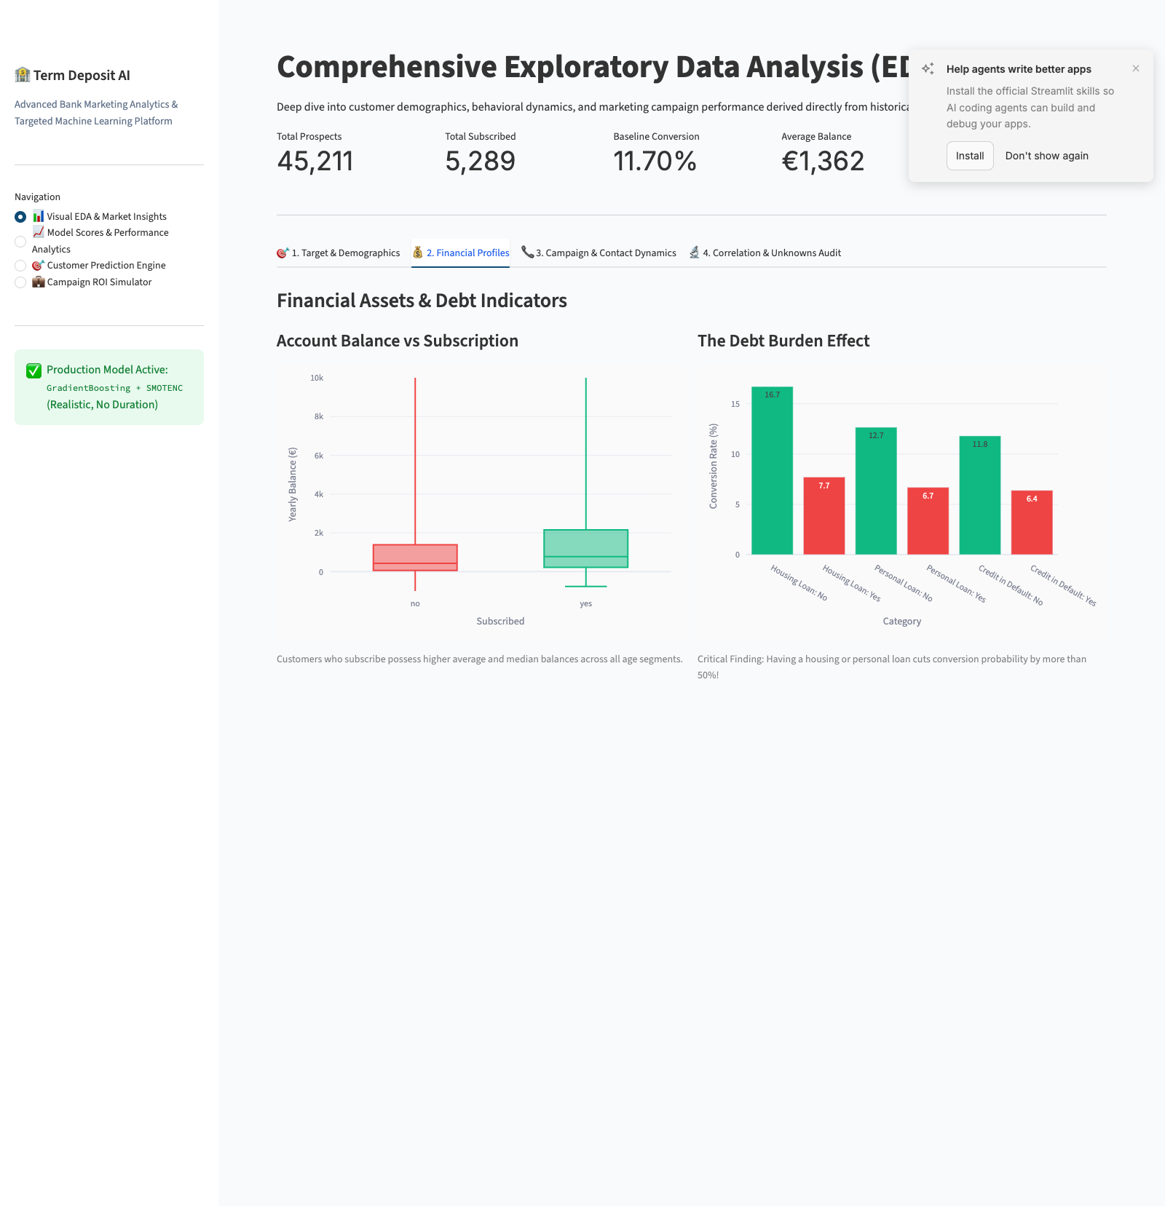
Figure 2: Financial Assets and the Debt Burden Effect (Housing Loans, Personal Loans, Credit Default).

2.3 Campaign Dynamics & Data Leakage Elimination
⚠️ Critical Discovery: Eliminating Data Leakage from Contact Duration
In preliminary baseline experiments, call 'duration' showed an overwhelming correlation (+0.39) with subscriptions. However, duration is fundamentally unknown prior to dialing the phone! A call's length is an outcome of customer interest, not a predictive input available beforehand. Including duration in a production scoring model represents severe Data Leakage. In our final production architecture, duration was permanently eliminated to guarantee 100% real-world validity.

• Diminishing Returns: Conversion rate peaks on the 1st contact (14.6%) and 2nd contact (11.6%), plummeting below 7% on subsequent contacts.
• Campaign Seasonality: March (52.0%), September (46.5%), October (43.8%), and December (46.7%) offer dramatic conversion yields.
• Prior Campaign Success (poutcome): Clients who agreed in prior campaigns converted at an astonishing 64.7%.
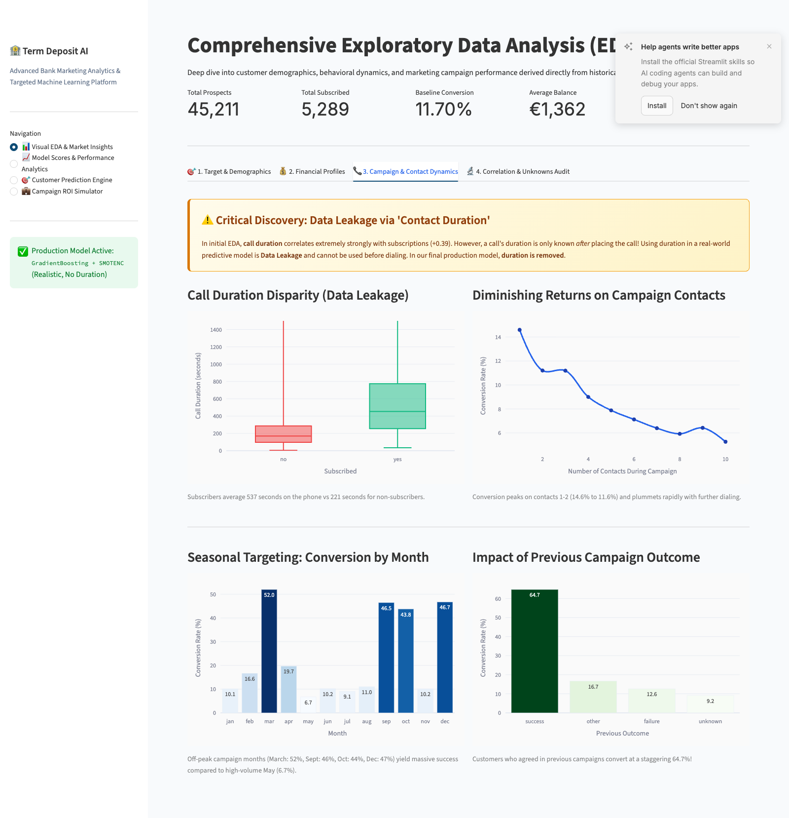
Figure 3: Contact Dynamics, Call Duration Disparity (Data Leakage), and Campaign Seasonality.

2.4 Correlation Matrix & Unknowns Audit
• All 45,211 rows contain zero NaNs.
• Literal 'unknown' strings in 'contact' (13,020 rows), 'education' (1,857 rows), and 'job' (288 rows) were explicitly preserved as categorical levels during OneHotEncoding rather than imputed with arbitrary modes, allowing models to extract signal from missing communication channels.
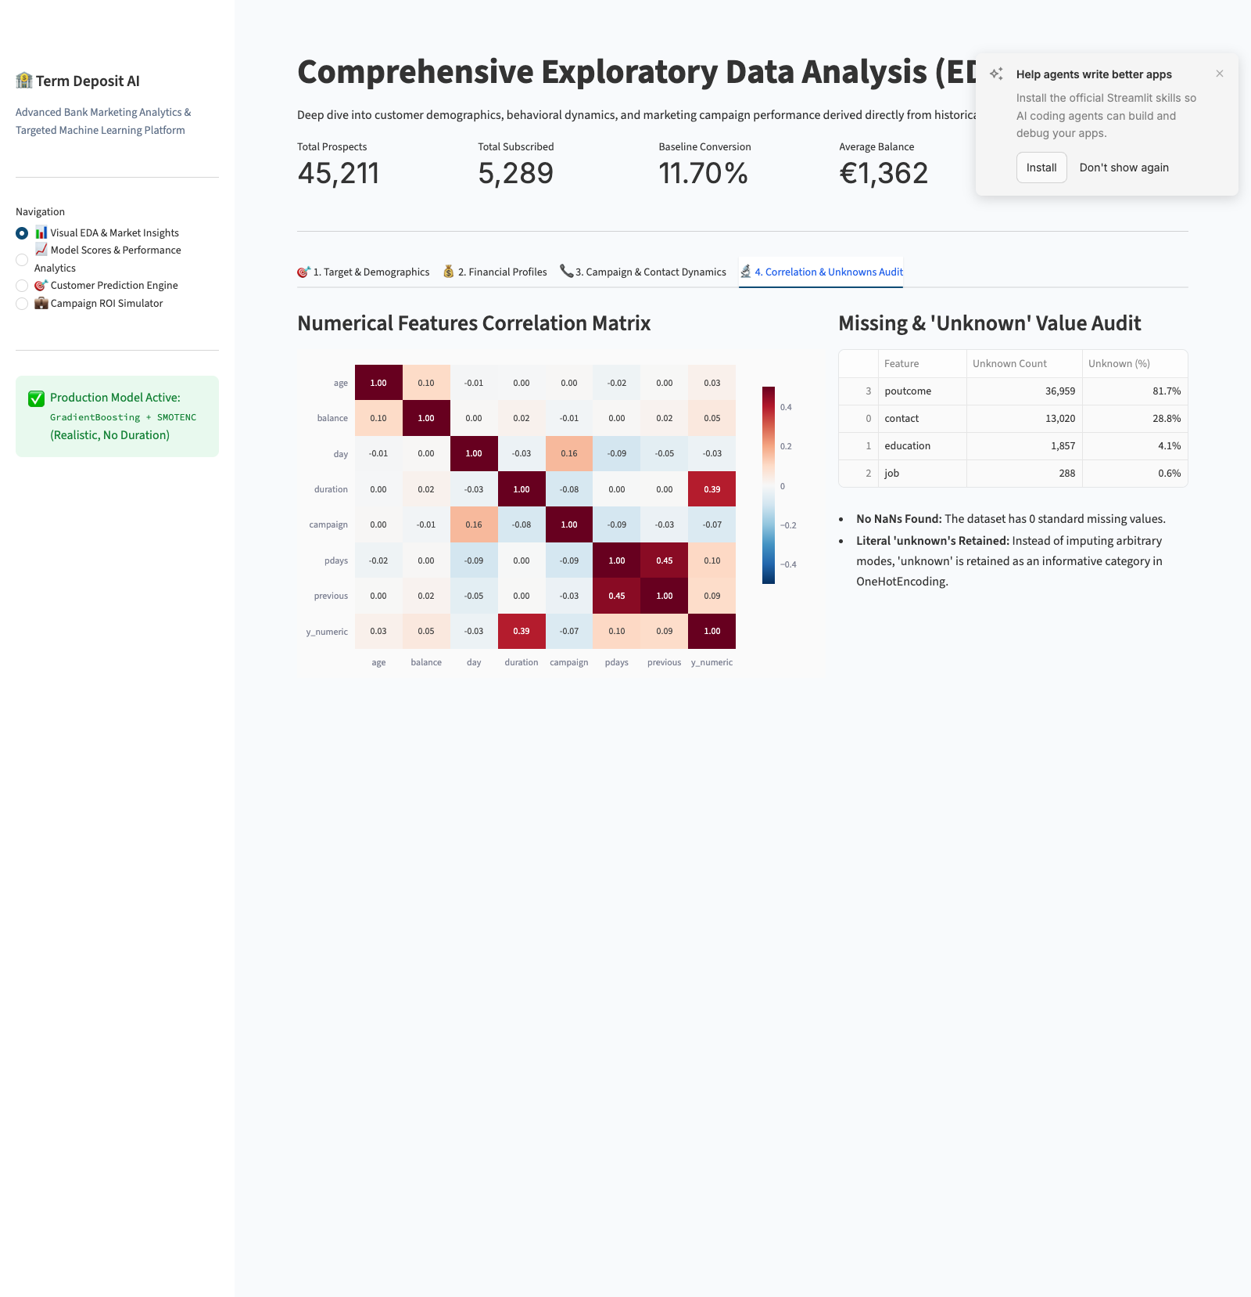
Figure 4: Numerical Feature Correlation Matrix and Unknown Category Distribution Audit.

3. Machine Learning Architecture & Score Analytics
Five machine learning classifiers were developed and benchmarked through three systematic architectural phases:
1. Phase 1: Baseline Models (Unbalanced, with Duration)
2. Phase 2: SMOTENC Balanced Models (5-Fold Stratified Cross-Validation, with Duration)
3. Phase 3: Realistic Production Models (SMOTENC 5-Fold Stratified Cross-Validation, without Duration)
Phase | Model | Accuracy | Precision | Recall | F1 Score
Phase 1: Baseline | Random Forest | 90.84% | 66.34% | 44.14% | 53.01%
Phase 1: Baseline | Gradient Boosting | 90.82% | 66.33% | 43.76% | 52.73%
Phase 1: Baseline | Logistic Regression | 90.58% | 68.07% | 36.67% | 47.67%
Phase 1: Baseline | KNN | 89.59% | 59.13% | 35.82% | 44.61%
Phase 1: Baseline | Decision Tree | 87.37% | 46.25% | 48.96% | 47.57%
Phase 2: SMOTENC | Gradient Boosting | 85.68% | 43.78% | 78.66% | 56.25%
Phase 2: SMOTENC | Random Forest | 88.54% | 50.78% | 68.52% | 58.31%
Phase 2: SMOTENC | Logistic Regression | 85.38% | 42.78% | 73.88% | 54.19%
Phase 2: SMOTENC | KNN | 85.85% | 43.29% | 67.36% | 52.70%
Phase 2: SMOTENC | Decision Tree | 85.50% | 41.79% | 61.03% | 49.60%
Phase 3: Production | Gradient Boosting | 75.80% | 26.58% | 60.65% | 36.95%
Phase 3: Production | Random Forest | 83.70% | 35.39% | 47.62% | 40.59%
Phase 3: Production | KNN | 77.59% | 26.97% | 53.56% | 35.87%
Phase 3: Production | Decision Tree | 78.06% | 25.64% | 46.02% | 32.92%
Phase 3: Production | Logistic Regression | 72.46% | 23.19% | 58.59% | 33.23%

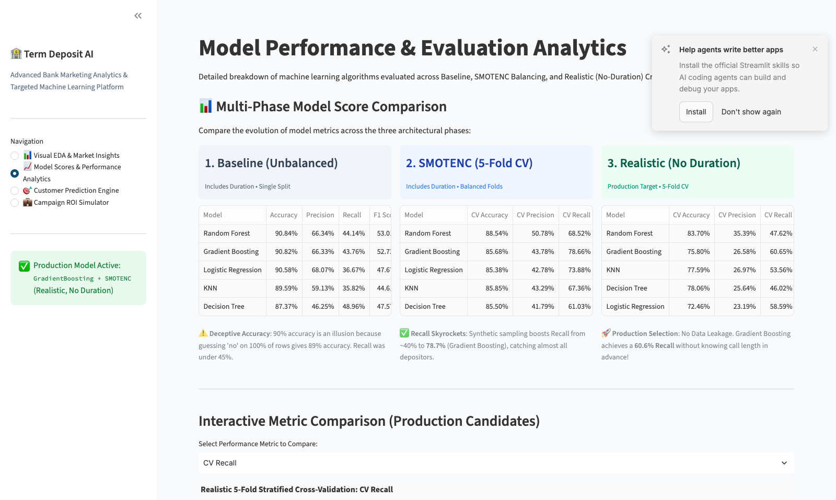
Figure 5: Streamlit Multi-Column Model Score Analytics comparing Baseline, SMOTE, and Realistic Models.

3.2 Test Set Confusion Matrix & Efficiency Economics
On the 9,043 untouched test prospects evaluated without duration:
• True Positives (Useful Calls Acquired): 648 depositors.
• False Positives (Calls to Non-Subscribers): 1,843 calls.
• True Negatives (Calls Successfully Avoided): 6,142 non-subscribers bypassed.
• False Negatives (Missed Opportunities): 410 prospects.
• Operational Workload Reduction: 72.45% of total calling volume eliminated.
• Telemarketer Time Saved: 546.0 direct telemarketer hours saved per 9,000 clients.
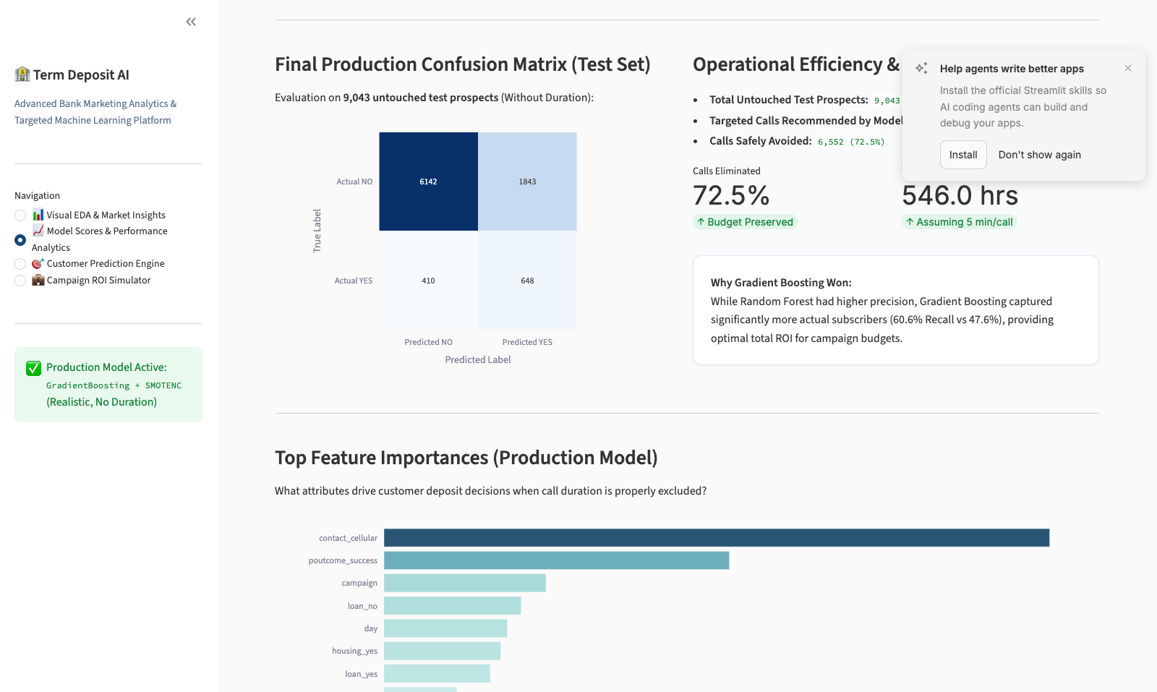
Figure 6: Test Set Confusion Matrix, Operational Call Reductions, and Top 10 Feature Importances.

4. Interactive Streamlit Platform Modules
The web application features two real-time operational decision engines:

4.1 Real-Time Customer Targeting Engine
Telemarketers and team managers can input customer demographics, current account balance, debt status, and campaign parameters. The model returns an instantaneous priority tier (🎯 HIGH PRIORITY TARGET vs. ⛔ DO NOT TARGET) with calibrated conversion probabilities.
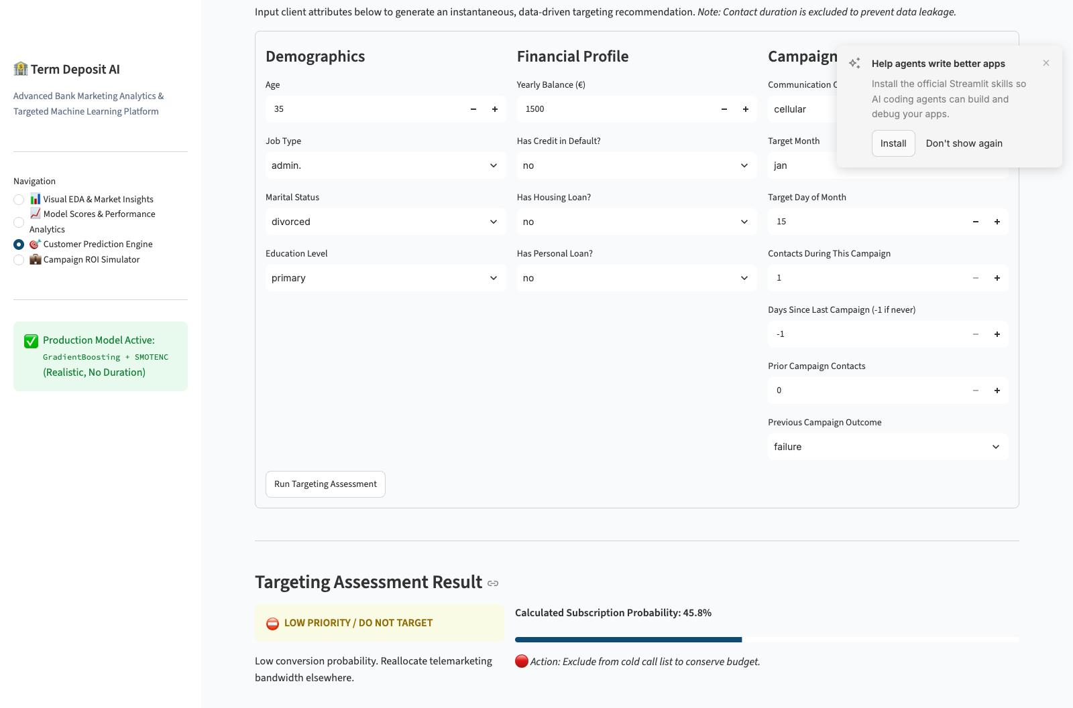
Figure 7: Customer Targeting Prediction Engine with Form Inputs and Calibrated Assessment Results.

4.2 Dynamic Campaign ROI Simulator
Campaign strategists can simulate financial outcomes based on campaign size, cost per call (€), and revenue per converted deposit (€). The tool demonstrates how AI targeting increases net profit while preventing hundreds of thousands of euros in unproductive calling expenses.
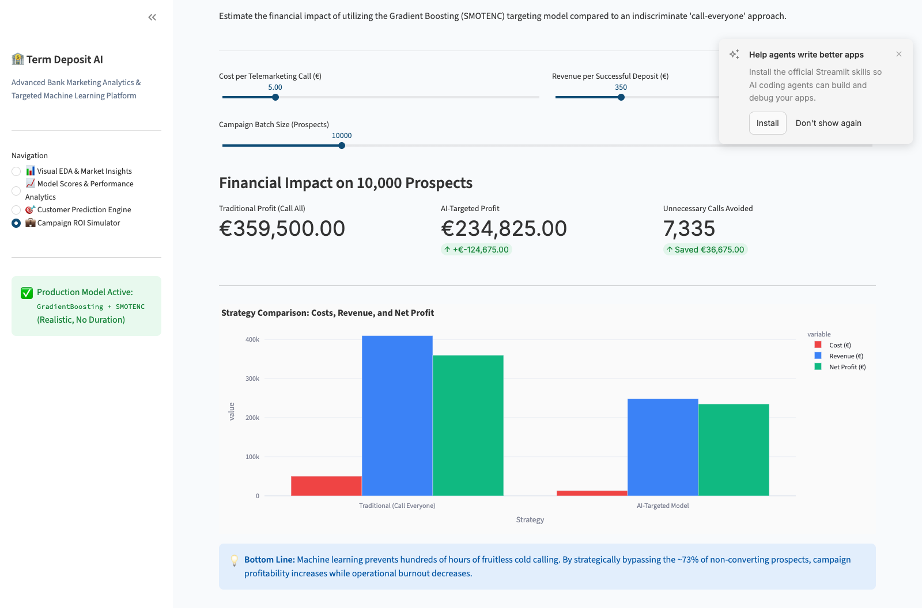
Figure 8: Campaign ROI Simulator comparing Traditional vs AI-Targeted Marketing Strategy Profits.

5. Strategic Recommendations & Conclusion
1. Prioritize Cellular Channels: Cellular contact represents 29.4% of total predictive power.
2. Re-target Prior Campaign Successes: Past responders convert at 64.7% and should receive immediate priority.
3. Cap Contact Frequency at Two Calls: 3rd and subsequent calls yield diminishing returns and exacerbate customer annoyance.
4. Shift Volume to High-Yield Months: Rebalance campaigns toward March, September, October, and December.
5. Filter Debt-Burdened Prospects: Prospects with housing or personal loans convert at less than half the baseline rate.
Conclusion: Deploying this Gradient Boosting + SMOTENC intelligence system transforms retail banking telemarketing from an untargeted cost center into a highly targeted, profitable customer acquisition engine.

