SOFTWARE DESIGN & UML ARCHITECTURE SPECIFICATION

For PharmaCart - Omni-Channel Pharmacy Ordering Platform

Document Reference: UML-PC-2026-V1.0

Document Control & Metadata
- Project Name: PharmaCart — Online Ordering for Neighbourhood Pharmacy Chain
- Case Study Reference: Case Study No. 68
- Document Standard: ISO/IEC 19505:2012 (OMG Unified Modeling Language Version 2.4.1 )
- Author / Lead Software Architect: Ritesh Jadhav
- Target Network: 14 Retail Pharmacies across Ahmedabad, Gujarat, India
- Date of Issue: October 2026
- Status: Engineering Design Approved (Baseline for Sprint 1 Development)

Revision History

Version | Date | Author | Description of Change | Approved By
0.1 | 2026-1 0-  02 | Ritesh  Jadhav | Domain modeling and actor-usecase mapping | Tech Lead & Architecture Review
0.8 | 2026-1 0-  03 | Ritesh  Jadhav | Sequence, activity, and state machine models drafted | Lead Systems Architect
1 .0 | 2026-1 0-  05 | Ritesh  Jadhav | Finalized UML package, consistency matrix, coupling report | Engineering Steering  Committee

Table of Contents

- Architectural Overview & Design Principles
- Use Case Analysis & Diagram
  - Actor Catalog
  - Use Case Diagram
  - Detailed Use Case Specifications
- Domain Class Architecture & Diagram
  - Class Diagram
  - Class Dictionary & Responsibility Matrix
- Interaction Modeling: Sequence Diagram
  - Sequence Diagram: ' Upload Prescription & Place Order'
  - Message Sequence Trace
- Process Modeling: Activity Diagram
  - End-to-End Activity Flow
  - Decision & Fork-Join Node Specifications
- Behavioral Modeling: State Machine Diagram
  - State Machine Diagram for ' Order' Lifecycle
  - State Transition Table
- Architectural Justification: Coupling & Cohesion Analysis
  - Loose Coupling: Prescription Verification vs. Store Inventory
  - High Cohesion: Module-by-Module Evaluation
  - Architectural Pattern: Event-Driven Mediator Model
- Cross-Diagram Consistency Verification

- Architectural Overview & Design Principles

The architectural design of PharmaCart balances high statutory compliance (Drugs & Cosmetics Act) with the operational realities of 14 disconnected legacy POS systems across Ahmedabad.

Architectural  Tier | Component Layer | Technologies &  Protocols | Primary System Function
Presentation  Tier | Customer Web/Mobile SPA, Pharmacist Desk, Store Counter POS | HTML5, React,  Tailwind, WebSockets | End-user interfaces for order placement, clinical verification, and store fulfillment.
Security &  Gateway | API Gateway, Rate Limiter, JWT Auth Interceptor | Nginx / Kong, TLS 1 .3, HTTPS (443) | Enforces authentication, request throttling, and OWASP security controls.
Domain Core  Tier | Order Service, Prescription Service, Store Routing Engine | Node.js / Python  FastAPIs, Event Bus | Core business logic, clinical review queues, and multi-store reservation orchestration.
Infrastructure  Tier | PostgreSQL 1 6 DB, S3 Prescription Vault, 1 4 POS Daemons | AES-256 Storage, mTLS, Background Daemons | Relational transactional persistence, encrypted medical file storage, and POS synchronization.
The system is governed by the following core design principles:
- Separation of Concerns (SoC): Clinical compliance logic (prescription inspection) is isolated from commercial fulfillment logic (inventory reservation and payment processing).
- Event-Driven Asynchrony: Communication between long-running human workflows (pharmacist manual inspection) and system transactions (payment capture) relies on event streaming rather than blocking synchronous threads.
- Fail-Safe Inventory Degradation: The inventory architecture operates under the assumption that local POS sync may fail or experience delays; the Safety Stock Buffer ( Available = Physical - 2 ) acts as an automated safety cushion.

- Use Case Analysis & Diagram

Actor Catalog

Actor Name | Type | Operational Responsibility in PharmaCart
Customer | Primary  (Human) | Browses catalog, uploads prescriptions, places delivery/pickup orders, tracks order progress, provides pickup OTP.
Licensed Pharmacist | Primary  (Human) | Inspects prescription documents, validates doctor credentials, approves or rejects medication requests, issues clinical modifications.
Store Fulfillment  Staff | Secondary  (Human) | Receives allocated picking slips, picks physical medications from store racks, verifies barcodes, validates pickup OTP.
Delivery Runner | Secondary  (Human) | Picks up packaged orders from store, executes doorstep hand-over, collects cash (if COD), collects delivery signature/OTP.
Legacy Store POS  System | Secondary  (System) | Automated client running at each of the 1 4 stores; transmits delta inventory snapshots and receives temporary reservation locks.
Payment Gateway | Supporting  (System) | Authorizes credit/debit card, net banking, and UPI transactions; delivers asynchronous webhook event callbacks.
SMS/Notification  Gateway | Supporting  (System) | Dispatches transactional SMS, WhatsApp messages, order status updates, and verification OTPs.

Use Case Diagram
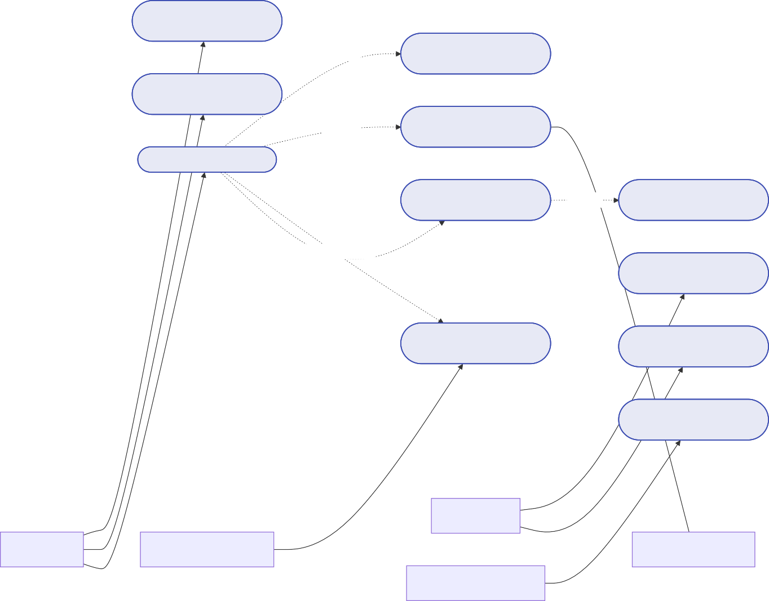

PharmaCart System Boundary
UC-01: Browse Medicine
Catalog
includes
UC-04: Select Store Pickup
/ Delivery
UC-02: Upload Medical
Prescription
includes
UC-11: Process Digital
Payment
UC-03: Place Online Order
UC-08: Route Order to
Optimal Store
triggers
UC-07: Reserve Inventory
with Safety Buffer
requires if Rx drug
includes
UC-09: Pack Order & Print
Label
UC-05: Review & Validate
Prescription
UC-10: Verify Pickup via
OTP
UC-06: Synchronize Store
Inventory
System Stakeholders
Store Staff
Customer
Licensed Pharmacist
Payment Gateway
14 Store POS Systems

Detailed Use Case Specifications

Use Case: UC-05 — Review & Validate Medical Prescription

Field | Detail
Use Case ID | UC-05
Use Case Name | Review & Validate Medical Prescription
Primary Actor | Licensed Pharmacist
Trigger | An order containing one or more Schedule H/H1 /X medicines is placed by a customer.
Preconditions | - The customer has uploaded a readable image/PDF prescription.  - Pharmacists are authenticated on the Tele-Pharmacy Portal with active council registration.
Main Success  Scenario | - Pharmacist opens the next pending item from the central FIFO queue.  - The system displays high-res prescription documents alongside mapped order items.  - Pharmacist verifies doctor' s name, council registration number, clinic stamp, patient name, and prescription date (< 30 days).  - Pharmacists confirms prescribed drugs match ordered items, strengths, and maximum dosages.  - Pharmacists clicks Approve and enters their 4-digit digital signing PIN.  - System logs approval with timestamp and council registration ID.  - System transitions order state to APPROVED_AWAITING_ALLOCATION .
Alternative Flows | 4a. Prescription Illegible / Expired / Forged:  - Pharmacist clicks Reject and selects reason (e.g., "Doctor seal missing", "Prescription older than 30 days").  - System transitions order to RX_REJECTED .  - Notification Gateway sends SMS/WhatsApp to customer explaining rejection with re-upload link.  4b. Partial Dosage Available:  - Pharmacists adjusts prescribed quantity downward (e.g., from 30 tablets to 1 0).  - System updates order subtotal and alerts customer for re-confirmation.
Postconditions | Digital audit log permanently recorded. Order unblocked for store inventory reservation.

- Domain Class Architecture & Diagram

Class Diagram
The class diagram below depicts the structural domain model of PharmaCart. Notice the deliberate decoupling between Prescription / PharmacistReview and StoreInventory / StoreOutlet . The central Order entity orchestrates relationships through clean association interfaces.
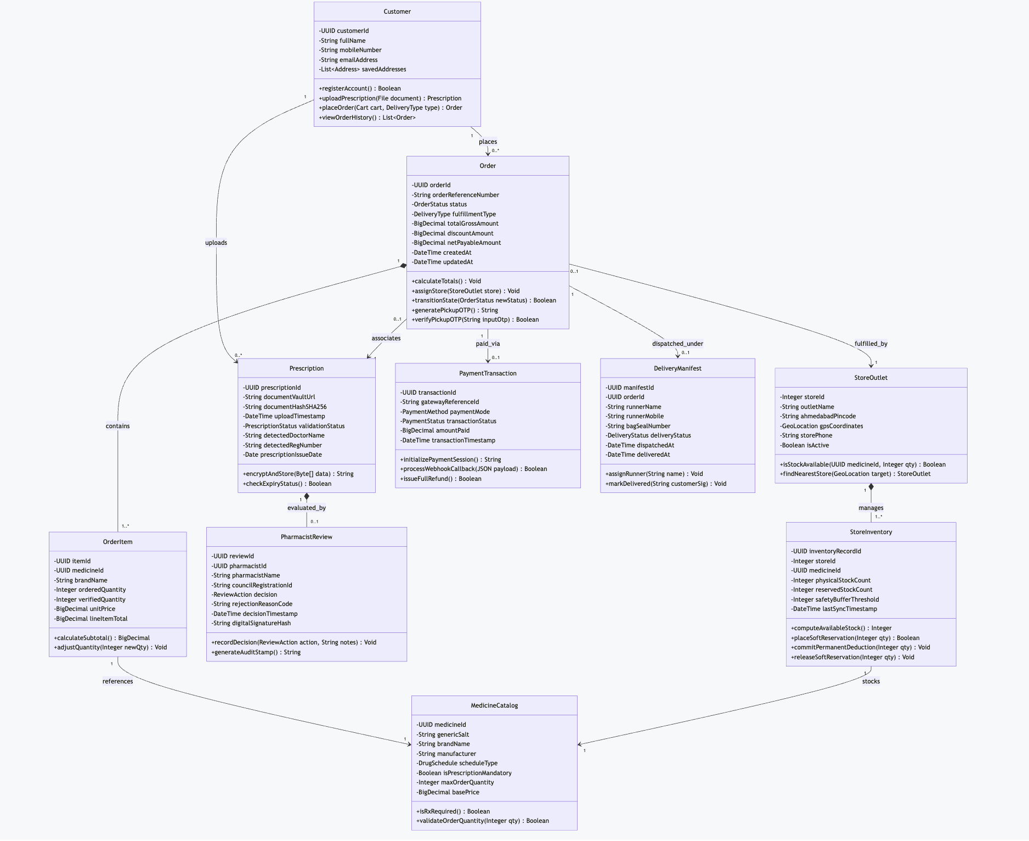

1

Class Dictionary & Responsibility Matrix

Class Identifier | Core Architectural Responsibility | Cohesion  Rating | Primary Collaborators
Customer | Manages user identity, stored delivery locations in Ahmedabad, and patient profile attributes. | High (Identity) | Order , Prescription
Order | Aggregate Root managing checkout lifecycle, line item computations, status changes, and OTP generation. | High  (Transaction) | OrderItem , StoreOutlet ,  PaymentTransaction
Prescription | Encapsulates prescription metadata, AES-256 vault URI, cryptographic document integrity, and expiry checks. | High (Clinical  Data) | Customer ,  PharmacistReview
PharmacistReview | Immutable clinical legal record holding pharmacist identity, council registration number, decision, and digital signature. | High  (Compliance) | Prescription
StoreOutlet | Represents physical retail branch in Ahmedabad (e.g., Navrangpura, Satellite), including geo-location and operating state. | High (Physical  Entity) | StoreInventory , Order
StoreInventory | Manages store-specific shelf balances, delta updates from POS, soft holds, and safety buffer enforcement. | High (Inventory  Math) | StoreOutlet ,  MedicineCatalog
PaymentTransaction | Handles payment provider session creation, idempotency, webhook processing, and transaction receipts. | High  (Financial) | Order
DeliveryManifest | Oversees last-mile logistics dispatch, runner routing, tamper-evident bag seal validation, and doorstep confirmation. | High  (Logistics) | Order

- Interaction Modeling: Sequence Diagram

  - Sequence Diagram: 'Upload Prescription & Place Order'
This sequence traces the end-to-end realization of FR-01, FR-02, FR-05, FR-06, and FR-10. It highlights the asynchronous inspection gate by the pharmacist and the soft reservation of stock at the optimal retail branch.

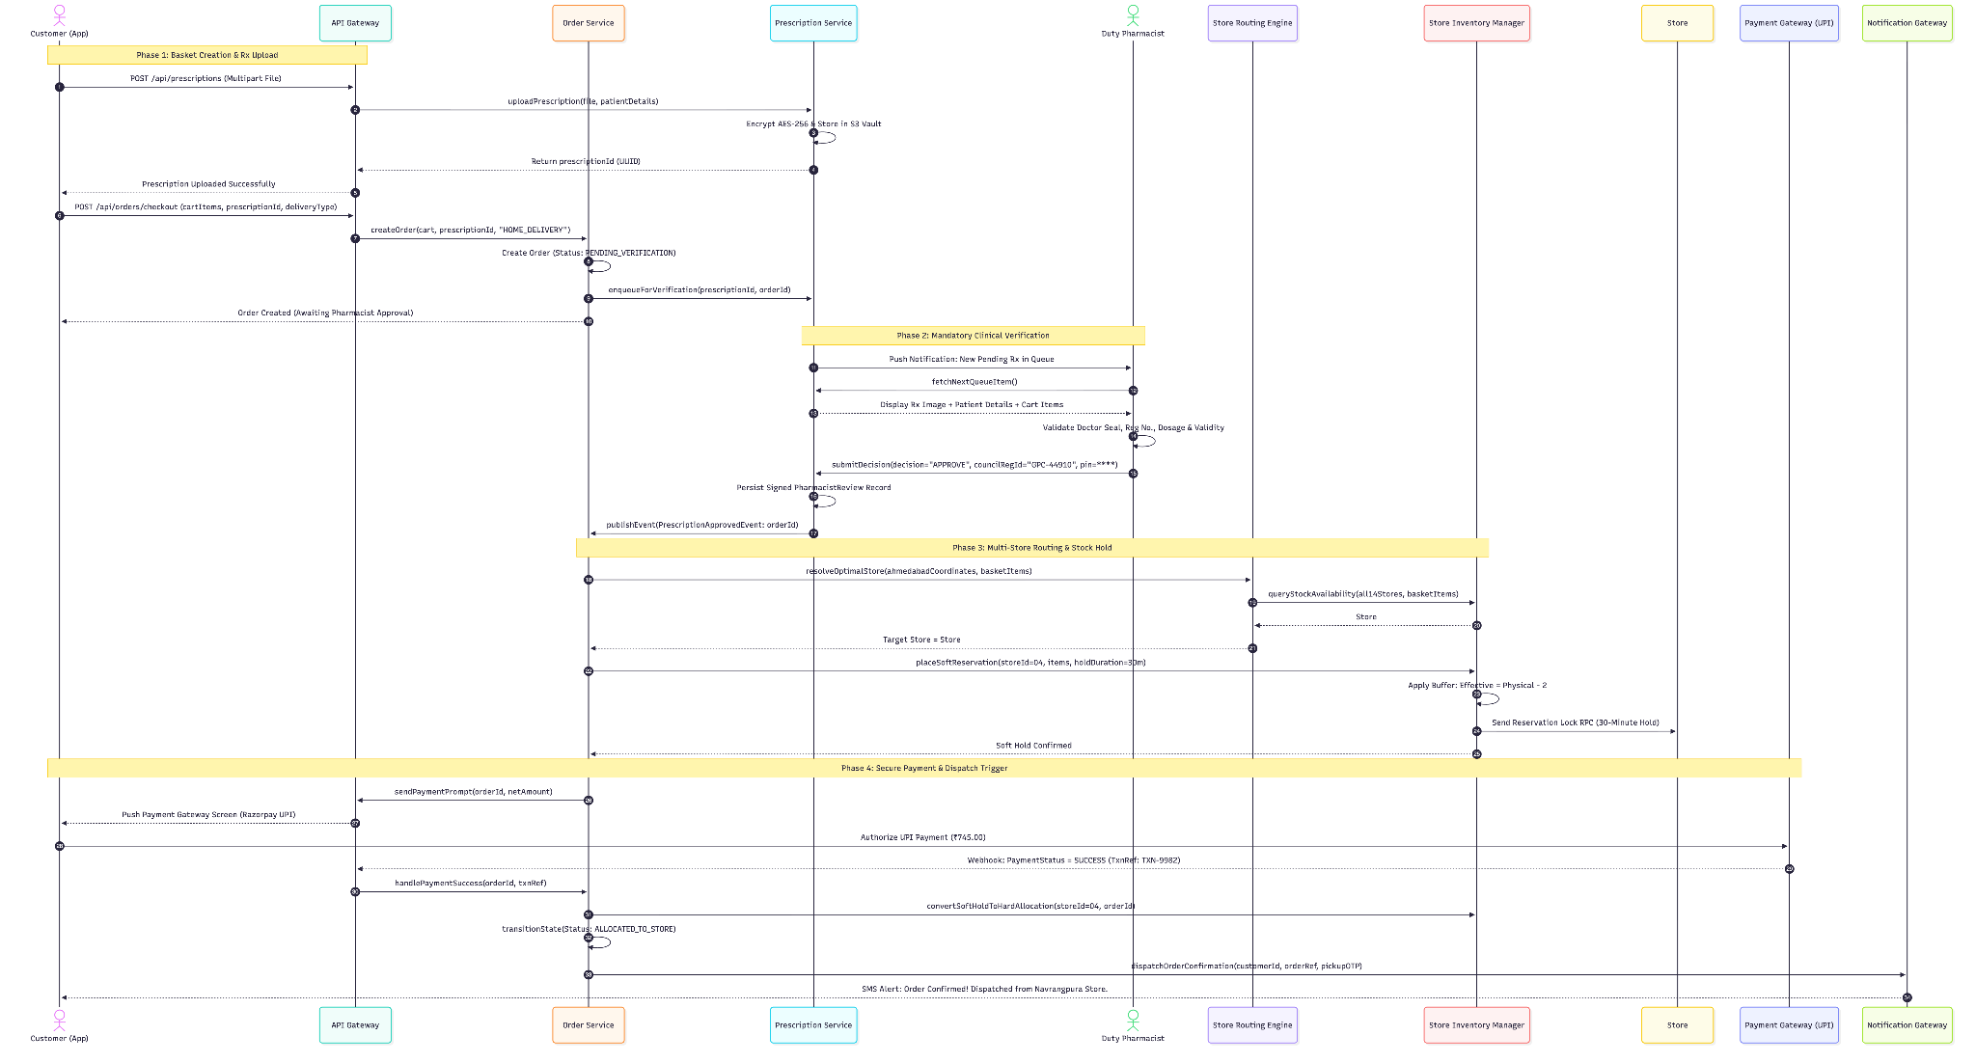

Message Sequence Trace

Step  # | Originator | Target | Message Name / Operation | Semantics
1 –3 | Customer  App | Prescription  Service | uploadPrescription() | Synchronous HTTPS multipart upload.  Encrypted at rest using AES-256.
4–6 | Customer  App | Order Service | createOrder() | Synchronous. System records draft order in PENDING_VERIFICATION state.
7–  1 0 | Duty  Pharmacist | Prescription  Service | submitDecision() | Manual human verification. Pharmacist signs record with State Council ID.
1 1 –  1 3 | Order  Service | Routing Engine | resolveOptimalStore() | Evaluates 1 4 store geo-locations and inventory balances across Ahmedabad.
1 4–  1 6 | Routing  Engine | Store  Inventory | placeSoftReservation() | Decrements temporary available units while keeping safety buffer (N - 2) intact.
1 7–  1 9 | Customer  App | Payment  Gateway | Authorize UPI Payment | Third-party PCI-DSS transaction. Webhook confirms capture asynchronously.
20–  22 | Order  Service | Store Staff & Customer | dispatchOrderConfirmation() | Converts reservation to permanent allocation; triggers store packing slip print.

- Process Modeling: Activity Diagram

  - End-to-End Activity Flow
The activity diagram captures decision logic, conditional branches (OTC vs. Rx, in-stock vs. out-of-stock), and parallel processing streams
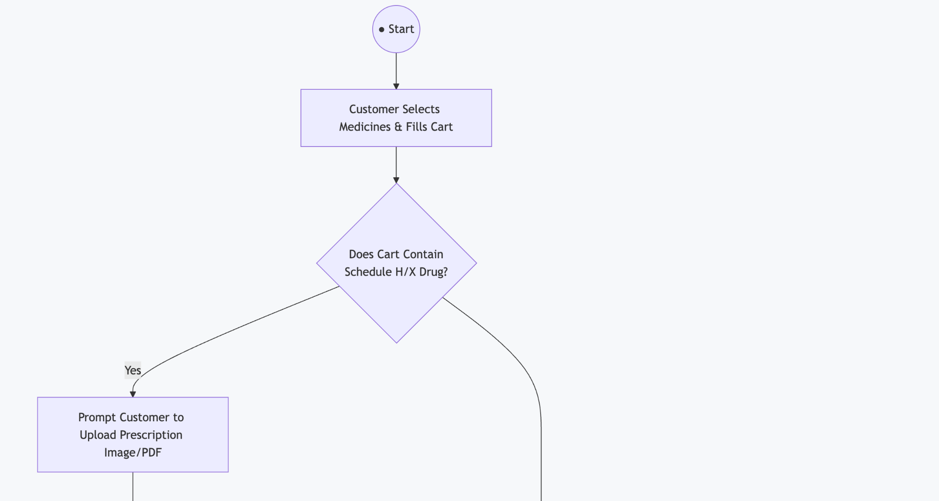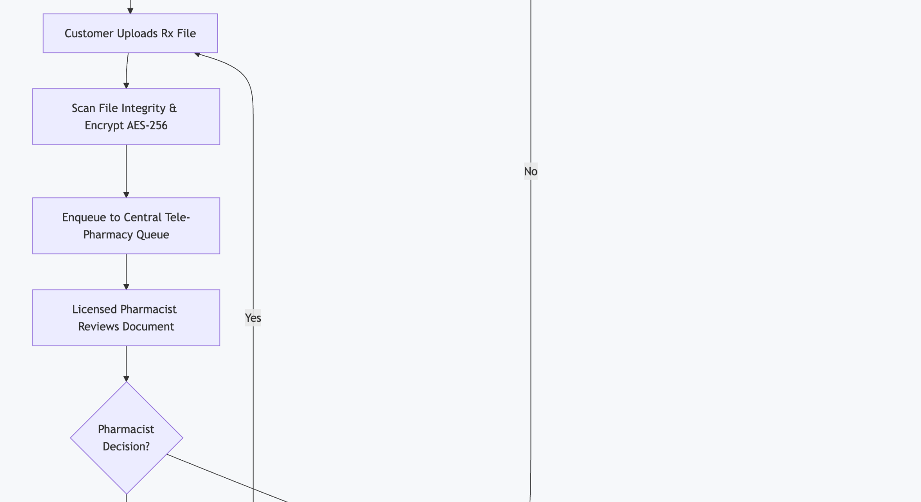
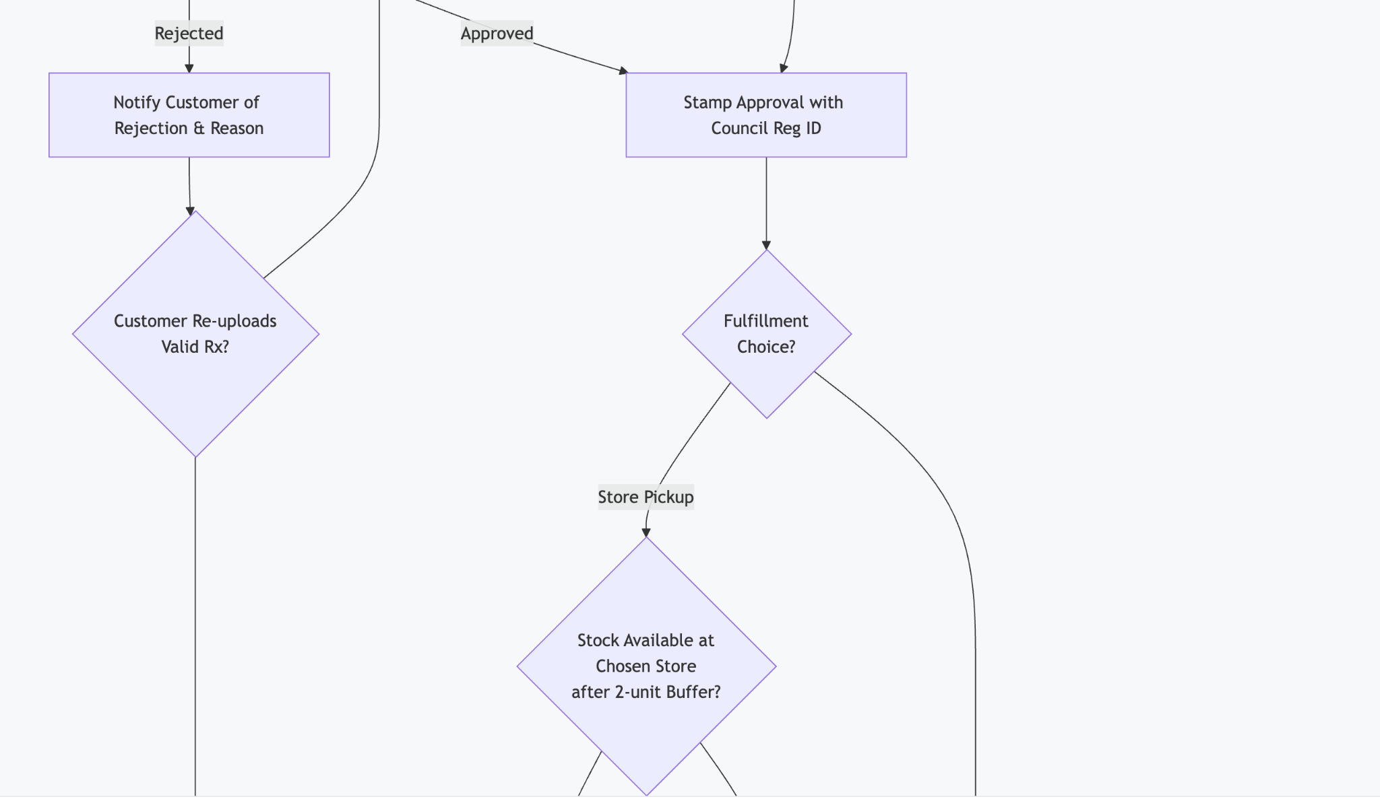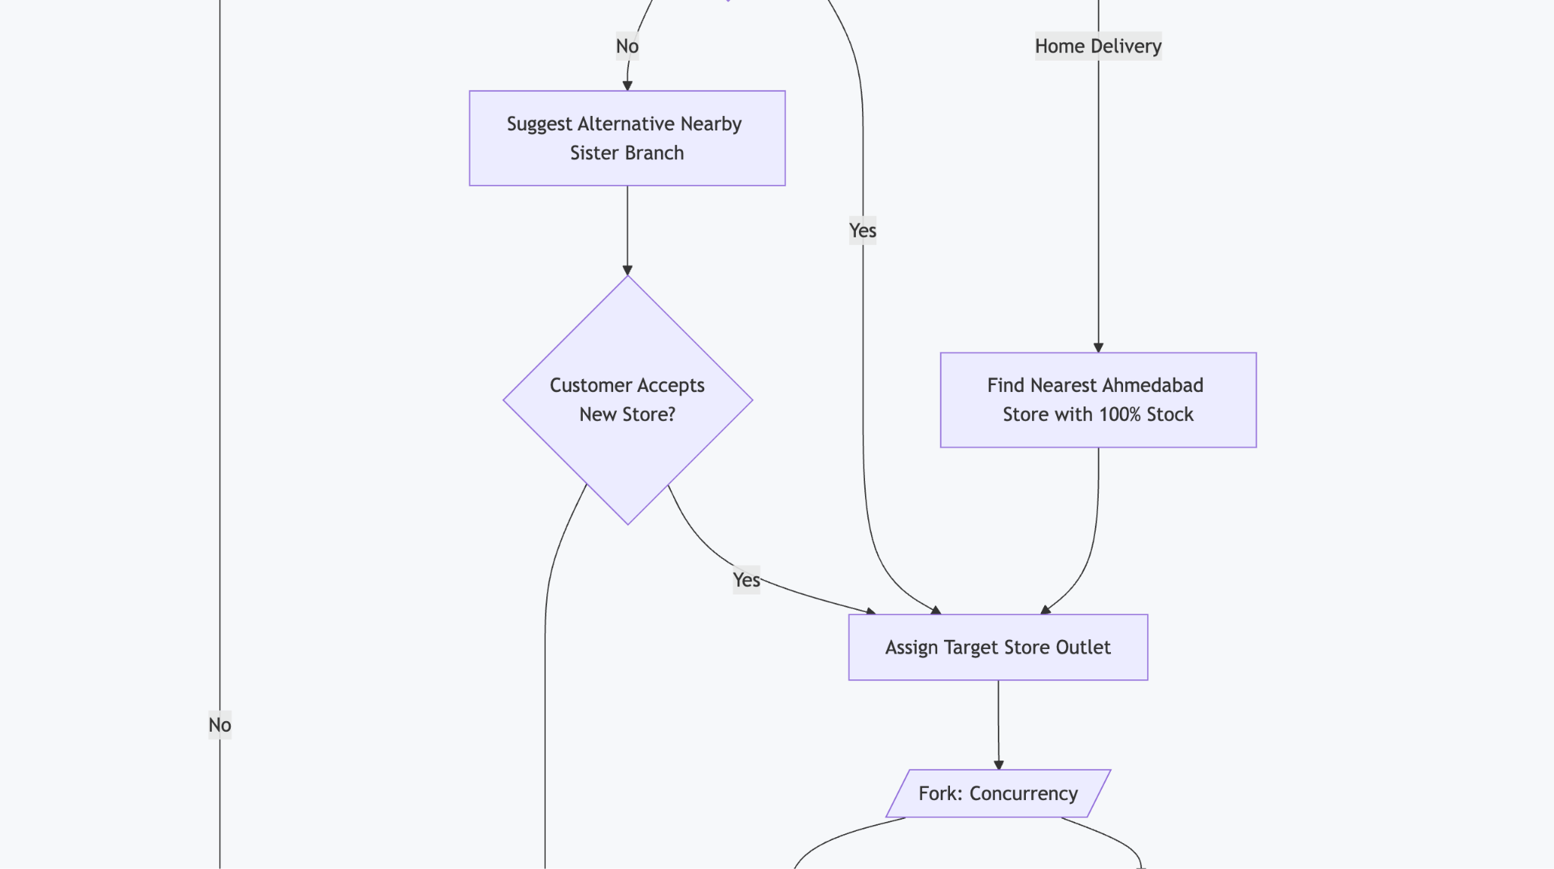
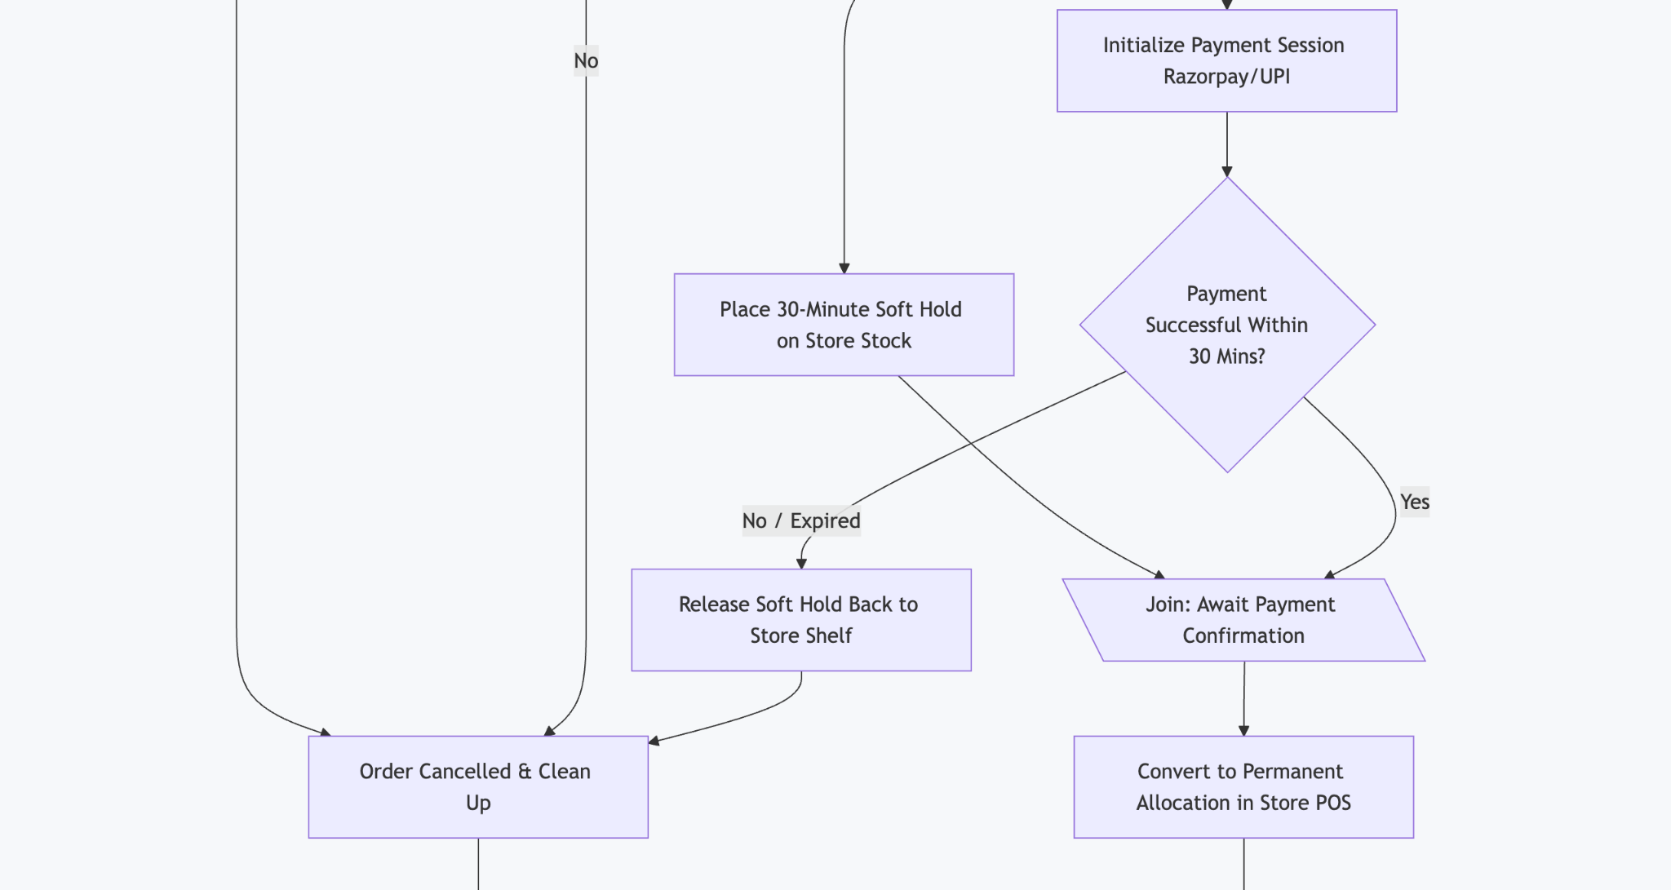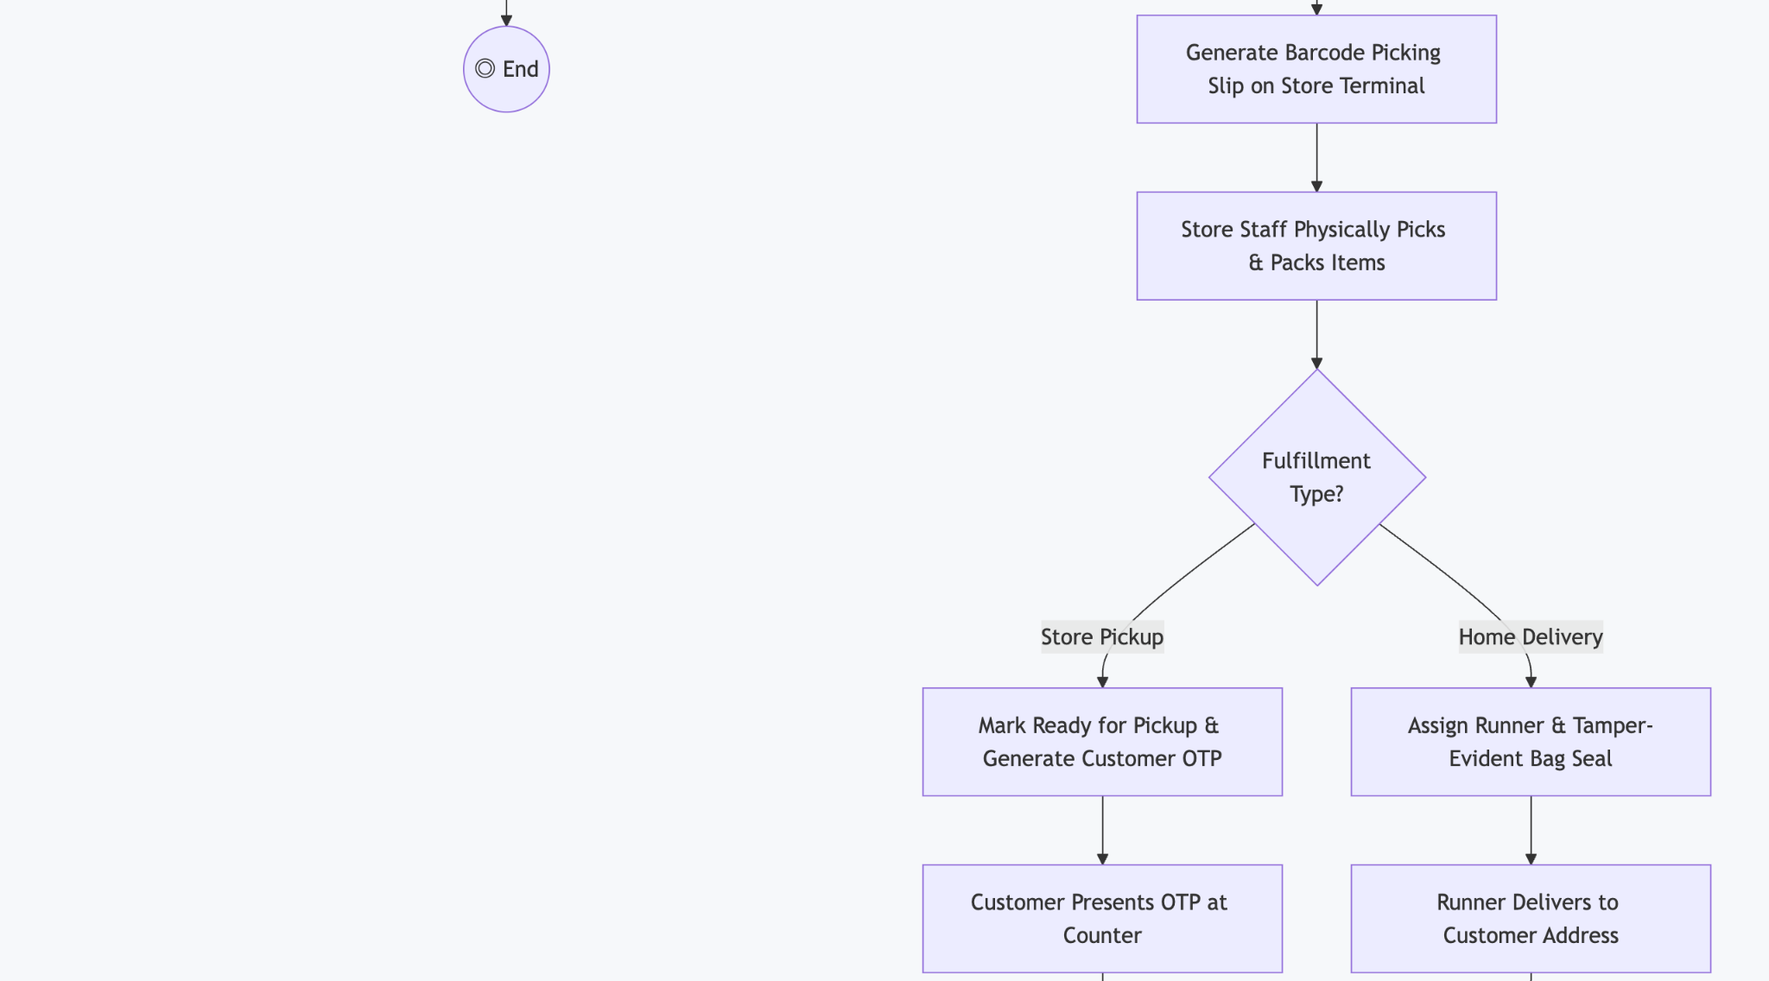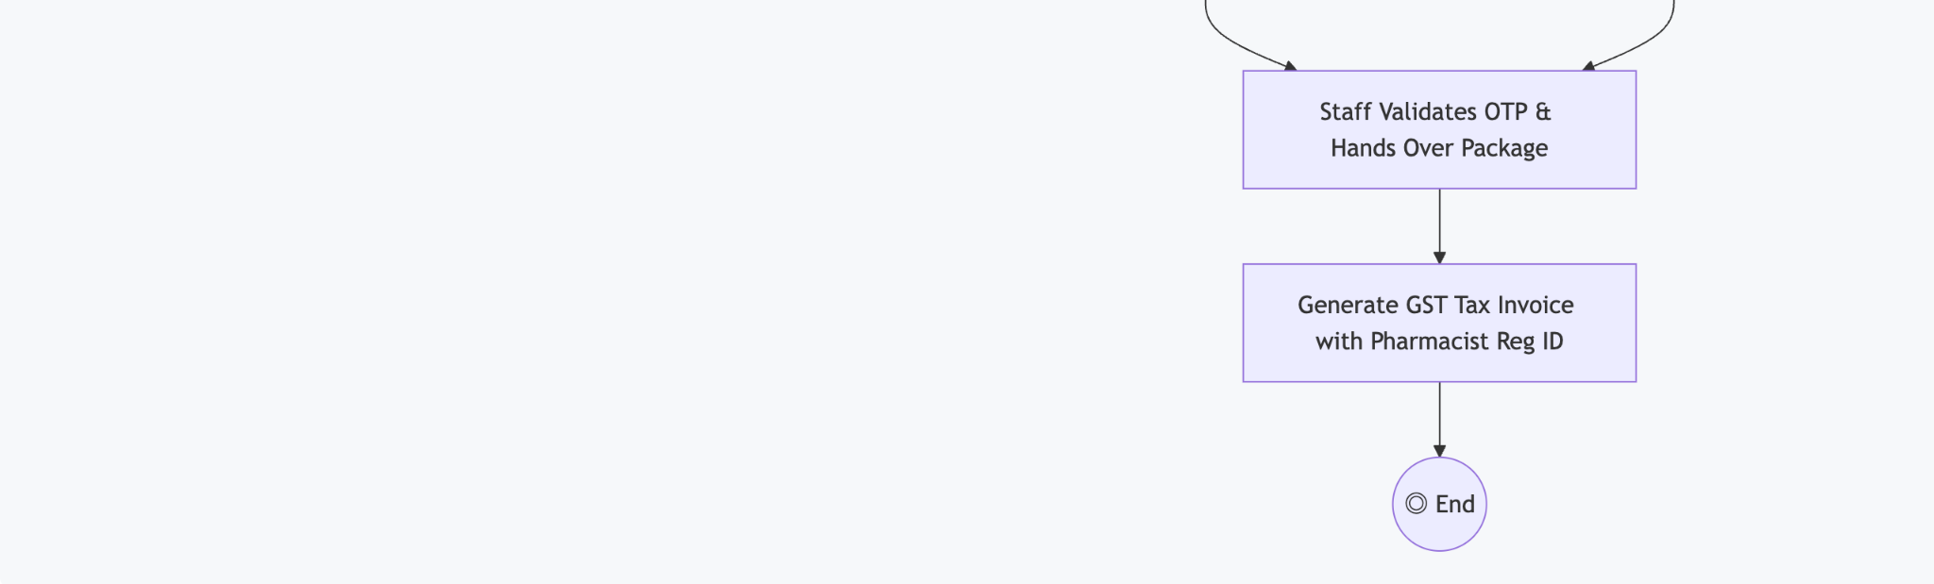

Decision & Fork-Join Node Specifications

Node Name | Node Type | Input Condition / Invariant | Outgoing Branch Logic
CHECK_RX | Decision  Diamond | Cart item collection inspection. | Yes : Enforces upload flow; No : Bypasses to  store selection.
DECISION_RX | Decision  Diamond | Pharmacist review  outcome. | Approved : Moves to routing; Rejected : Alerts  customer with reason code.
CHECK_PICKUP_STOCK | Decision  Diamond | Available = Physical  - 2 >= OrderQty . | Yes : Allocates store; No : Triggers sister-store  failover.
FORK_CHECKOUT | Fork Bar | Order allocation  completed. | Splits into two concurrent parallel threads: (1 ) 30-min inventory lock, (2) Payment session.
JOIN_CHECKOUT | Join Bar | Both threads must synchronize. | Synchronizes only if payment succeeds before the 30-minute lock expires.

- Behavioral Modeling: State Machine Diagram

State Machine Diagram for 'Order' Lifecycle
The order entity serves as the stateful transactional heart of PharmaCart. The diagram below illustrates every valid operational state, transition event, and exception guard.
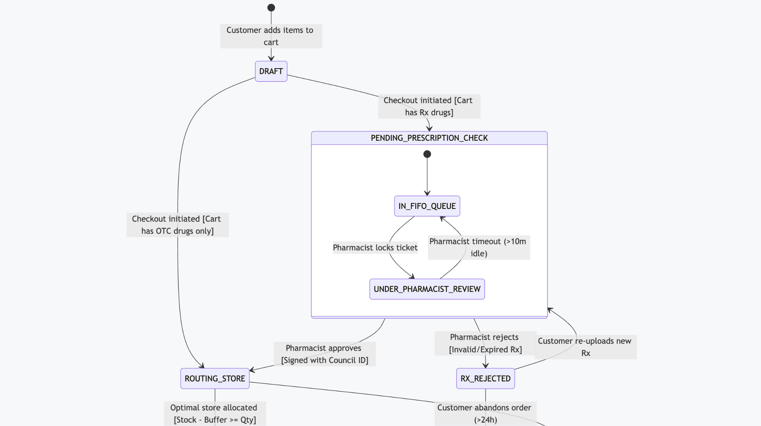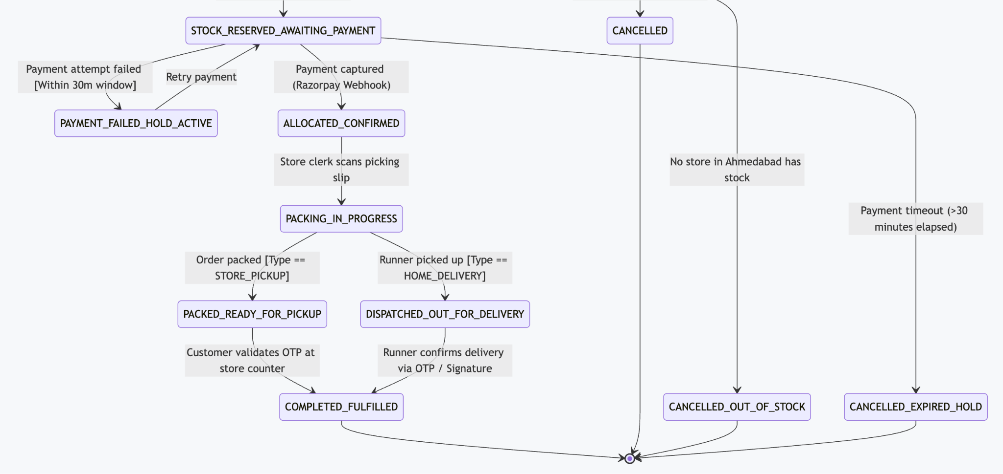

State Transition Table

Source State | Event Trigger | Guard  Condition | Target State | Action / Side  Effect Executed
DRAFT | INITIATE_CHECKOUT | Cart contains  >= 1  Schedule H/X  drug | PENDING_PRESCRIPTION_CHECK | Generate Prescription_ID , lock file in S3 vault.
DRAFT | INITIATE_CHECKOUT | Cart contains OTC items only | ROUTING_STORE | Bypass clinical verification; query store stock.
UNDER_REVIEW | SUBMIT_DECISION | Action ==  APPROVE | ROUTING_STORE | Record pharmacist council registration number and timestamp.
UNDER_REVIEW | SUBMIT_DECISION | Action ==  REJECT | RX_REJECTED | Dispatch SMS to customer with specific rejection reason.
ROUTING_STORE | STORE_FOUND | Store physical stock - 2 >= order qty | STOCK_RESERVED_AWAITING_PAYMENT | Place 30-min soft lock on store POS inventory.
STOCK_RESERVED | HOLD_EXPIRED | Time elapsed since hold > 30 minutes | CANCELLED_EXPIRED_HOLD | Release soft lock; restore stock availability badge.
STOCK_RESERVED | PAYMENT_SUCCESS | Webhook signature verified | ALLOCATED_CONFIRMED | Commit permanent inventory deduction; generate picking slip.
PACKING | BAG_SEALED | Order  fulfillment ==  STORE_PICKUP | PACKED_READY_FOR_PICKUP | Generate 6-digit cryptographic OTP; SMS to  customer.
PACKED_READY | VERIFY_OTP | Input OTP matches hashed store OTP | COMPLETED_FULFILLED | Mark transaction complete; issue GST e-invoice.

- Architectural Justification: Coupling & Cohesion Analysis

Loose Coupling: Prescription Verification vs. Store Inventory
A critical architectural mandate of Case Study No. 68 is explaining how Prescription Verification and Store Stock are kept loosely coupled.
In naive architectures, the prescription verification module calls the inventory database directly to check stock, or the inventory module blocks orders while awaiting pharmacist review. This tight coupling creates catastrophic operational vulnerabilities:
- If the pharmacy billing software at Store #04 crashes or loses internet connectivity, the pharmacist cannot review prescriptions.
- If the pharmacist verification portal suffers high latency, inventory reservation locks expire prematurely, generating phantom stockouts.
- Medical information (doctor notes, patient diagnoses) leaks into the commercial store billing database, violating the Digital Personal Data Protection (DPDP) Act.

Our Decoupling Mechanism: The Asynchronous Domain Event Boundary

Architecture  Dimension | Clinical Verification Context | Commercial Store Inventory Context
Domain Scope | Prescription validity, doctor council ID, dosage checks | 1 4-store shelf stocks, POS delta sync, rack locations
Data Ingestion | Patient uploads via App / S3 encrypted vault | On-premise POS Daemons via outbound HTTPS / WSS
Processing Cadence | Asynchronous human verification (Minutes to Hours) | Near-real-time automated reservation (Milliseconds)
Cross-Boundary  Coupling | Emits lightweight  PrescriptionApprovedEvent only | Listens for approved event to trigger reservation
Privacy Isolation | Encrypted medical images, doctor notes, patient PHI | Zero clinical data; receives only approved SKU IDs & counts



Clinical Bounded Context

Prescription Service

Digital Sign-off

Emit: PrescriptionApprovedEvent

Domain Event Bus

Central Event Bus

Consume Event


Store Inventory Bounded Context
Apply 2-Unit Buffer
Store Inventory Manager
Lock Stock in 14 Store POS

- Information Hiding: The PrescriptionService knows nothing about store locations, shelf quantities, or POS billing software formats. It solely validates clinical legality and emits a clean domain event: PrescriptionApprovedEvent .
- Schema Independence: The store inventory schema ( Store_ID , Rack_Location , Physical_Count , Safety_Threshold ) is completely quarantined from the clinical verification schema ( Doctor_Reg_Number , Clinic_Seal_Valid , Pharmacist_License_ID ) .
- Temporal Decoupling: Verification operates at human speed (minutes to hours), while inventory reservation operates at machine speed (milliseconds). The order entity transitions between them asynchronously without holding open database locks.

  - High Cohesion: Module-by-Module Evaluation
High cohesion ensures that every module in PharmaCart possesses a single, tightly defined responsibility (Single Responsibility Principle - SRP), minimizing side effects.

Module / Package | Cohesion Type | Primary Cohesive  Responsibility | Non-Responsibilities  (Delegated Elsewhere)
PrescriptionManagement | Functional  Cohesion | Secure file ingestion, virus scanning, AES-256 vault storage, doctor credential parsing. | Does not calculate pricing, does not reserve stock, does not process payments.
PharmacistReviewPortal | Functional  Cohesion | Renders dual-pane clinical viewer, enforces legal review checklists, captures digital signatures. | Does not interact with delivery couriers, does not modify store cash registers.
InventoryRoutingEngine | Informational  Cohesion | Ingests 1 4-store POS delta feeds, computes effective available stock with safety buffer, selects optimal branch. | Does not validate prescription legality, does not handle customer authentication.
StoreCounterTerminal | Sequential  Cohesion | Accepts picking tickets, guides store clerk shelf picking, scans barcodes, validates customer OTP. | Does not calculate tax rates, does not communicate directly with payment gateways.
PaymentService | Communicational  Cohesion | Initializes payment gateway intents, processes webhook callbacks, triggers automated refunds. | Does not maintain order line items, does not access customer medical records.

Architectural Pattern: Event-Driven Mediator Model
To prevent circular dependencies ( Prescription <-> Order <-> Inventory ) , PharmaCart employs the Mediator Architectural Pattern implemented via an Application Orchestrator ( OrderOrchestrator ) .

2. Stock Reservation & Allocation

1. Review Requests & Decisions
Prescription Service (Clinical Validation)
Order Orchestrator (Central Application Mediator)

3. Payment Intents & Webhooks
Payment Gateway Service (Razorpay / UPI Integration)

Store Inventory Manager (14-Store Stock & Buffer)

- The PrescriptionService , StoreInventoryManager , and PaymentService never communicate directly with each other.
- All cross-boundary workflows are coordinated through the OrderOrchestrator , ensuring that changes to the 14-store POS integration protocol have zero ripple effects on the pharmacist review workflows.
- Cross-Diagram Consistency Verification

To guarantee that the UML package is mathematically and structurally consistent across all artifacts, the following matrix verifies that all actors, classes, sequence lifelines, and states map directly to one another without orphaned or conflicting entities.

Entity / Concept | Use Case  Diagram | Class Diagram | Sequence  Diagram | State Machine Diagram
Customer | Present (Actor) | Customer Class | Present (Lifeline) | Trigger for DRAFT State
Prescription | Present (UC-02) | Prescription Class | Handled by  RxSvc | Governs  PENDING_RX_CHECK
Pharmacist  Review | Present (UC-05) | PharmacistReview  Class | Duty Pharmacist  Actor | Triggers APPROVED /  REJECTED
Store POS  Inventory | Present (UC-06,  07) | StoreInventory Class | InvSvc & POS  Lifelines | Governs STOCK_RESERVED
Store Allocation | Present (UC-08) | StoreOutlet Class | Router Lifeline | Enters  ALLOCATED_TO_STORE
OTP Verification | Present (UC-1 0) | Method in Order | Final verification  flow | Transitions to COMPLETED
Payment  Gateway | Present  (Supporting) | PaymentTransaction | PayGW Lifeline | Triggers CONFIRMED /  FAILED

Formal Architecture Sign-Off

Designed & Submitted By:
Ritesh Jadhav
Lead Software Architect PharmaCart Engineering Team Date: October 5, 2026

Reviewed & Approved By:
Head of Software Engineering PharmaCart Project Delivery Team Date: October 5, 2026

