**Template for Activity on Gantt chart and Fishbone Diagram**

***GROUP 4***

**Problem Statement for Activity:** Organizing a Sports Event in University

**Team**

| Sr No | Roll No | Name | Role (Designer/Customer) |
| --- | --- | --- | --- |
| 1 | 16 | Ritesh Gorule | Resources and Information |
| 2 | 17 | Ritesh Jha | Resources and Information |
| 3 | 18 | Ritwik Mohanty | Resources and Information |
| 4 | 19 | Riya Amin | Design |
| 5 | 20 | Rohan Jobanputra | Design |

**Tasks to be performed:**

**1. Event Planning**

**2. Venue Selection and Logistics**

**3. Team Recruitment and Training**

**4. Marketing and Promotion**

**5. Sponsors**

**6. Invitations and Ticketing**

**7. Equipment and Facilities Setup**

**8. Event Execution**

**Team Member Allocation Table:**

| **Role** | **Task Description** |
| --- | --- |
| Event Planner | Designs, plans, and orchestrates events, ensuring every detail aligns with the client's vision and objectives. |
| Event Coordinator | Manages logistics, schedules, and on-site operations to execute events seamlessly, making them memorable experiences. |
| Coach & Selectors | Trains athletes, scouts talent, and chooses the best for competitions, fostering excellence in sports. |
| Marketing & Promotion Manager | Creates and implements marketing strategies, raising event awareness and maximizing attendance through effective promotions. |
| Sponsorship Coordinator | Secures valuable sponsorships, nurturing relationships with partners to provide critical support for successful events. |
| Event Ticketing Coordinator | Oversees ticketing processes, ensuring smooth sales, distribution and access management for event attendees. |
| Event Setup Manager | Plans, coordinates, and executes event logistics, ensuring facilities, equipment and decor create a seamless event environment. |

**Gantt chart for task planning:**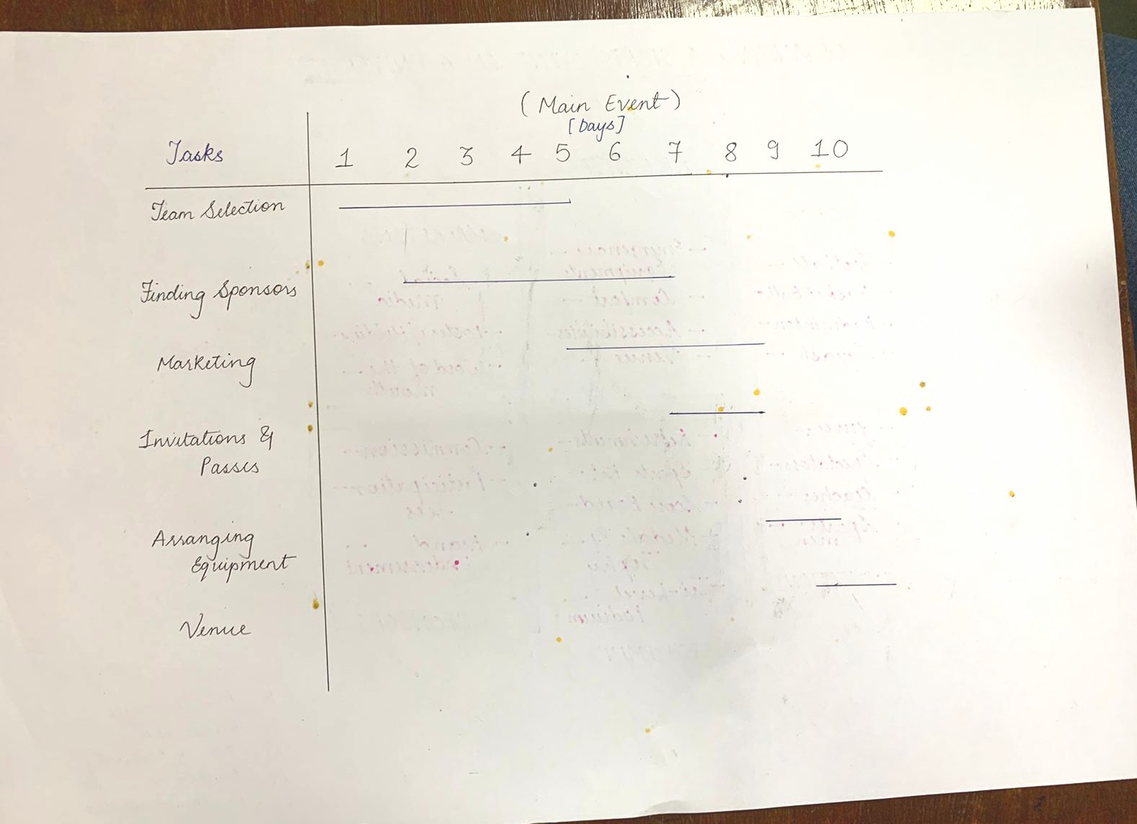

**Gantt chart for student involvement planning:**

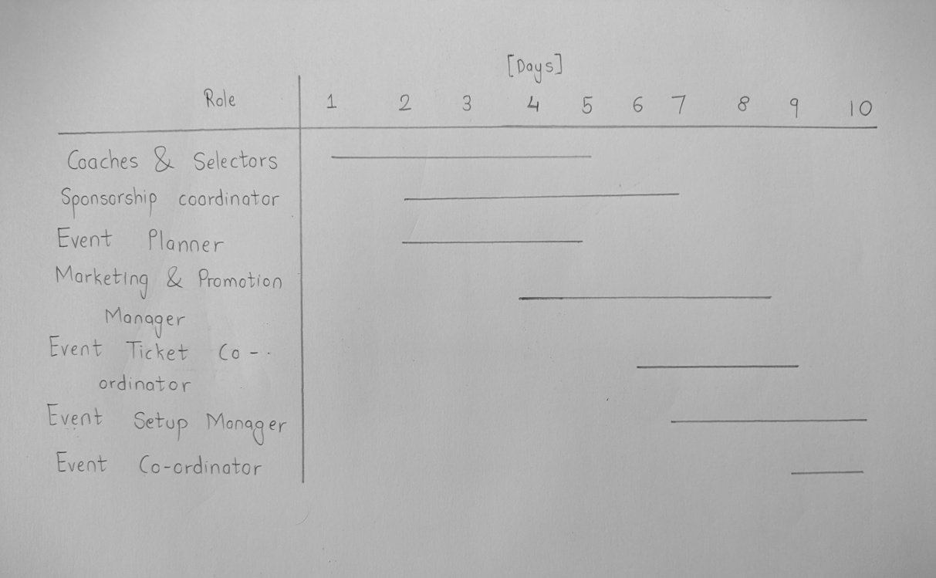

**Fish-Bone diagram for the Activity:**

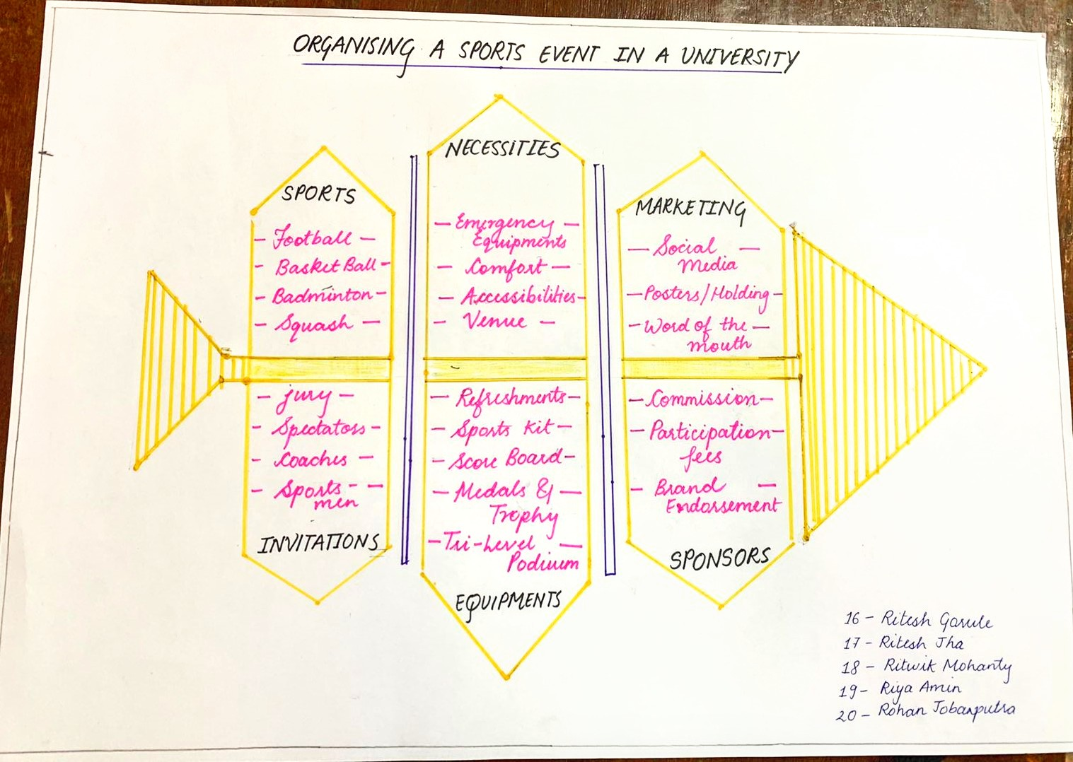

***GROUP 4***

**Observations and Reflections:**

From this project, we discovered that planning carefully and sticking to schedules are super important for success.

We also saw how tasks can depend on each other and that certain tasks are critical for the project's timeline.

We used a special diagram that helped us find the main reasons behind any problems.

It showed us that issues often have many causes, and it's essential to look at the big picture when solving problems.

In the end, this project taught us that we should always try to make things better, work together as a team, and be prepared for unexpected challenges.

These skills aren't just useful for event planning, they can help us in other projects too.