**Template for Arduino and LED Interfacing Activity**

**Statement Given:**

**TaskI:**

Interfacing of LEDs and pattern generation

Use Arduino and LED Board to perform following activities

● Different Patterns of LED on- off sequence and duration of on - off time

**Task II:**

Interfacing and controlling of LEDs using Push switch Button provided on LED board.

● Control LED on/off patterns with push button input.

**Evaluation Criteria:**

1. Connections as per task given,

2. Code for Arduino for the Task.

3. Successful execution of the activities.

**Performance-15 Marks**

**Submission-10 Marks**

**Team**

|  |  |  |  |
| --- | --- | --- | --- |
| **Sr No** | **Roll No** | **Name** | **Work Done** |
| 1 | 16010423075(16) | Ritesh Gorule | Wiring & connections |
| 2 | 16010423076(17) | Ritesh Jha | Coordination & wiring |
| 3 | 16010423077(18) | Ritwik Mohanty | Code application |
| 4 | 16010423078(19) | Riya Amin | Event documentation & filming |
| 5 | 16010423079(20) | Rohan Jobanputra | Code application |

**Fill your details as per following points**

* **Circuit Diagram for the tasks.**

**1)**

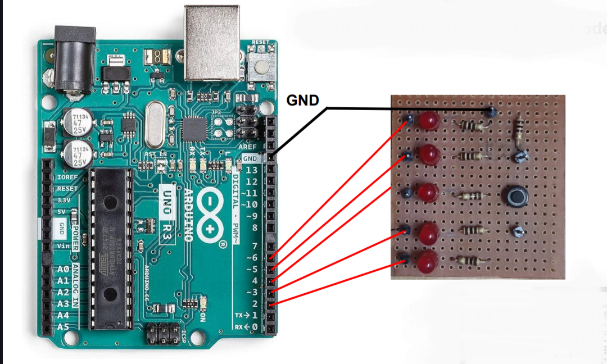

**2)**

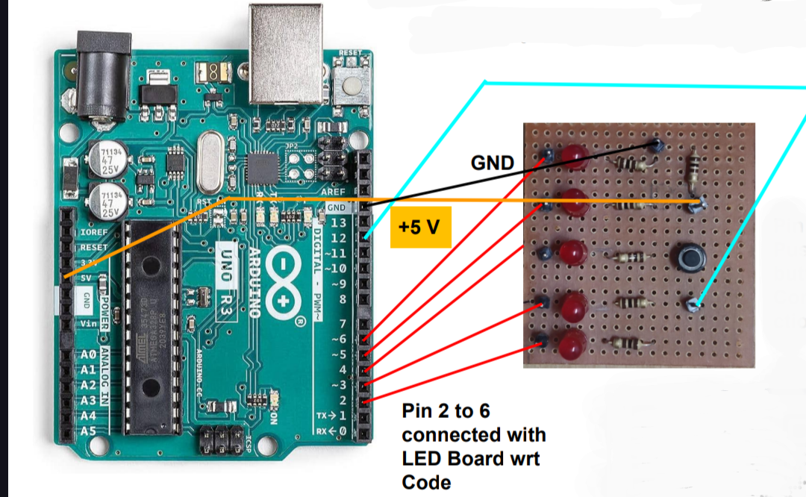

**3)**

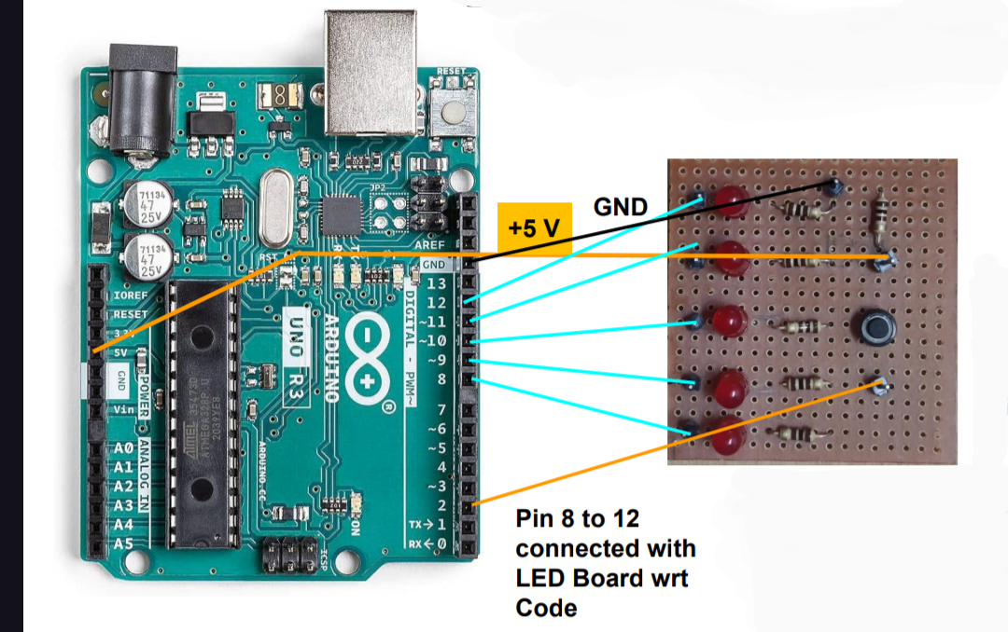

* **Respective codes**

**1)**

void loop()

{

int buttonState = digitalRead(pushButton);

Serial.println(buttonState);

if (buttonState == 0)

{

for (int i = 0; i < numOfLeds; i++) {

digitalWrite(ledPins[i], HIGH);

delay(100); // Wait for 100ms

digitalWrite(ledPins[i], LOW);

}

}

else

{

// Pattern 2: Turn on all LEDs

for (int i = 0; i < numOfLeds; i++) {

digitalWrite(ledPins[i], LOW);

}

delay(500); // Wait for 500ms

}

delay(100);

}

// Define pins for LEDs

const int ledPins[] = {2, 3, 4, 5, 6}; // Change these pins as per your connections

const int numOfLeds = 5;

int pushButton = 12;

void setup()

{

Serial.begin(9600);

pinMode(pushButton, INPUT);

// pinMode(led, OUTPUT);

for (int i = 0; i < numOfLeds; i++) {

pinMode(ledPins[i], OUTPUT);

}

}

**2)**

// Arduino and 5_LED interfacing for Sequence and Pattern generation.

int ledPins[] = {2, 3, 4, 5, 6}; // Define an array of the LED pins

int numLEDs = 5; // Number of LEDs

void setup() {

for (int i = 0; i < numLEDs; i++) {

pinMode(ledPins[i], OUTPUT); // Set LED pins as OUTPUT

}

}

void loop() {

for (int i = 0; i < numLEDs; i++) {

digitalWrite(ledPins[i], HIGH); // Turn the LED on

delay(500); // Wait for 500 milliseconds (0.5 seconds)

digitalWrite(ledPins[i], LOW); // Turn the LED off

}

delay(500); // Wait for 500 milliseconds before starting the sequence again

}

**3)**

int a;

void setup()

{

// put your setup code here, to run once:

pinMode (8, OUTPUT);

pinMode (9, OUTPUT);

pinMode (10, OUTPUT);

pinMode (11, OUTPUT);

pinMode (12,OUTPUT);

pinMode(2,INPUT);

}

void loop() {

// put your main code here, to run repeatedly:

a = digitalRead(2);

if (a==HIGH)

{

digitalWrite(8, HIGH);

digitalWrite(9, LOW);

digitalWrite(10, HIGH);

digitalWrite(11, HIGH);

digitalWrite(12, LOW);

//delay(5000);

}

else

{

digitalWrite(8, LOW);

digitalWrite(9, HIGH);

digitalWrite(10, LOW);

digitalWrite(11, LOW);

digitalWrite(12, HIGH);

digitalWrite(10, LOW);

//delay(2000);

}

}

* **Photo of Actual implementation**

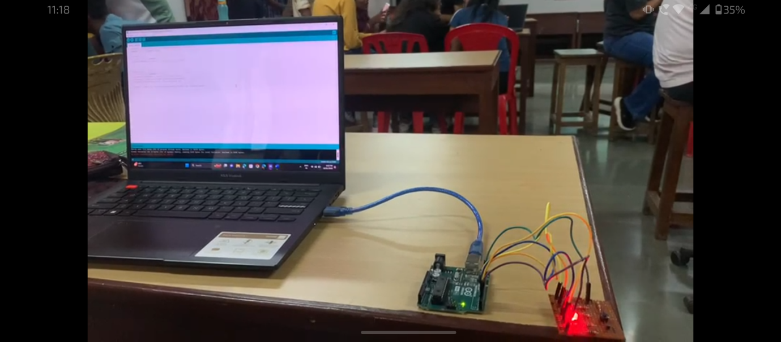

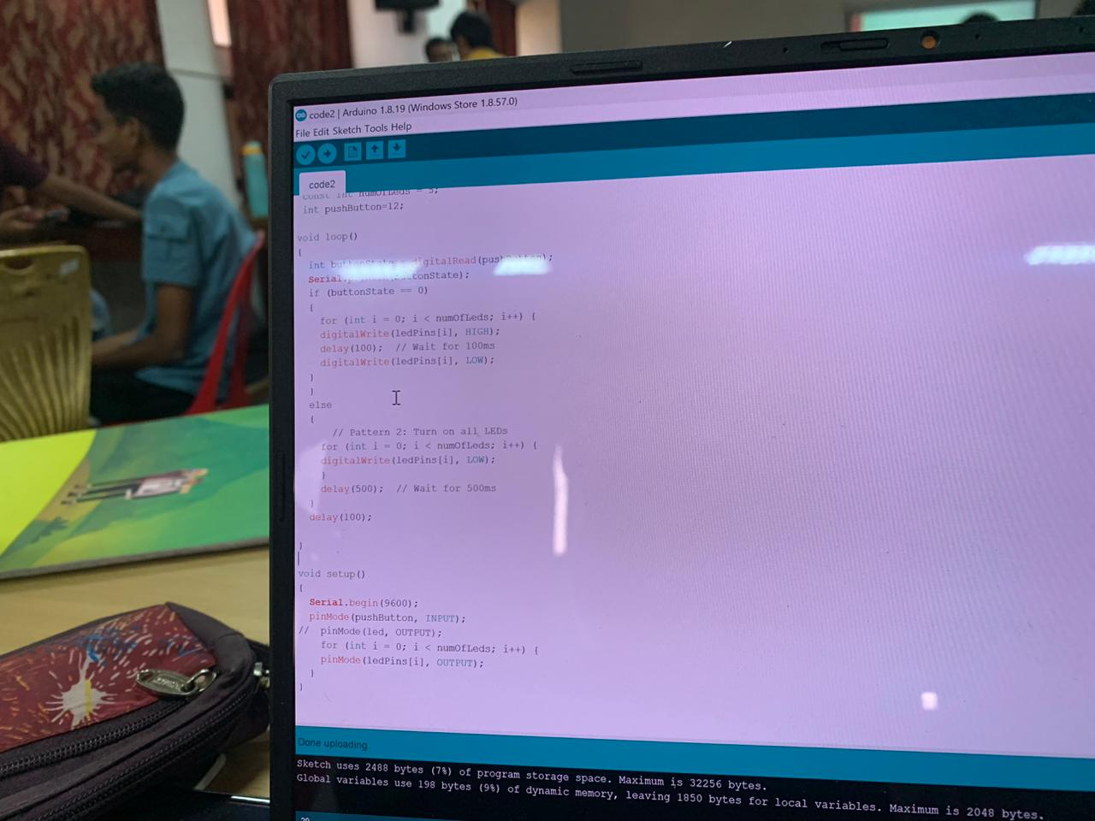

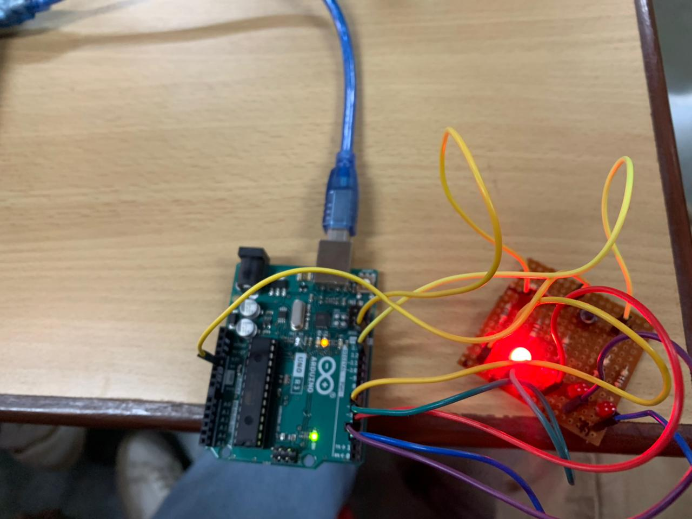

* **Observations , reflection on activity**

Worked with Arduino to control LEDs taught me the basics of coding for hardware.

I learned how to make LEDs light up in order or all at once using loops and if statements.

Adding a button allowed me to change what the LEDs did, and I found out that timing how long the LEDs stayed on or off changed how they looked.

Learnt how to make LED patterns and integration of hardware with software by programming it to perform certain tasks.