**Lab Practical #01:**

Study of basic networking commands and IP configuration.

**Practical Assignment #01:**

1. Perform and explain various networking commands listed below:
   1. ipconfig
   2. ping
   3. getmac
   4. systeminfo
   5. traceroute / tracert
   6. netstat
   7. nslookup
   8. hostname
   9. pathping
   10. arp

## ipconfig

### Description:

Ipconfig (standing for "Internet Protocol configuration") is a console application program of some computer operating systems that displays all current TCP/IP network configuration values and refreshes Dynamic Host Configuration Protocol (DHCP) and Domain Name System (DNS) settings

|  |  |  |
| --- | --- | --- |
| No. | Option | Description |
| 1 | /all | Display Full configuration information |
| 2 | /release | Release the IPv4 address for the specified adapter. |
| 3 | /release6 | Release the IPv6 address for the specified adapter. |
| 4 | /renew | Renew the IPv6 address for the specified adapter. |
| 5 | /renew6 | Renew the IPv6 address for the specified adapter. |

### Implementation:

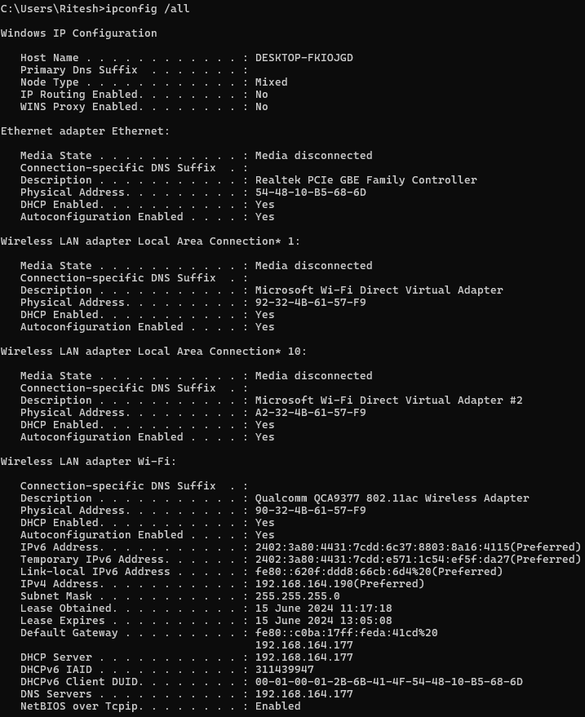

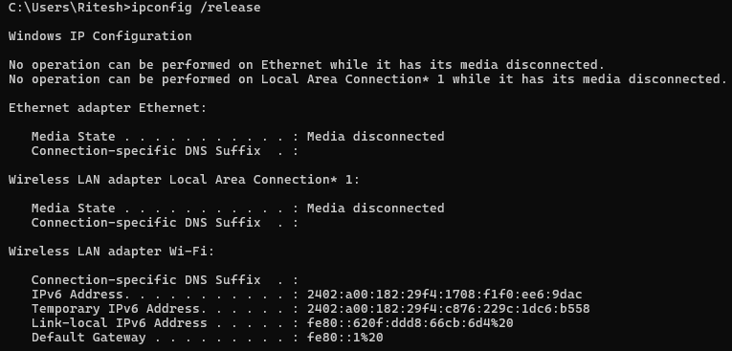

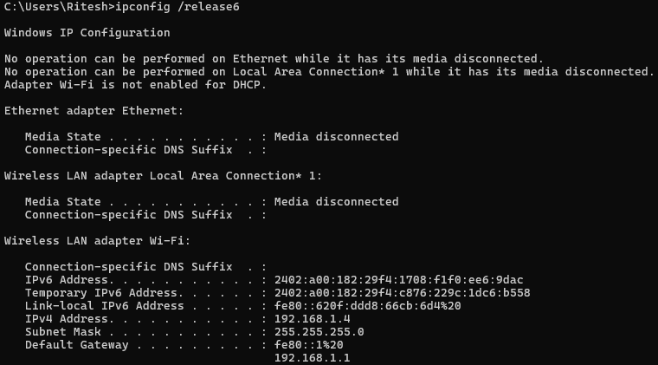

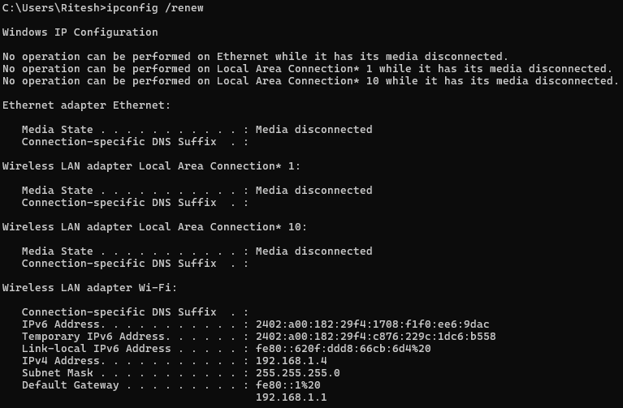

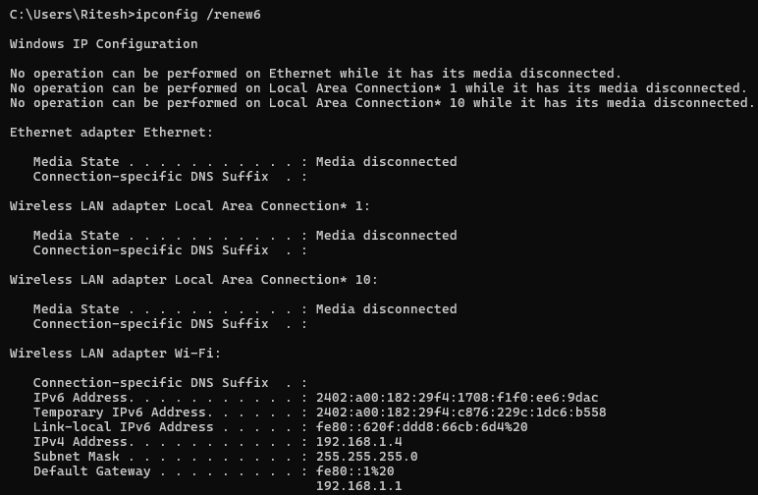

## ping

### Description:

**Ping is a command-line utility, available on virtually any operating system with network connectivity, that acts as a test to see if a networked device is reachable. The ping command sends a request over the network to a specific device.**

|  |  |  |
| --- | --- | --- |
| No. | Option | Description |
| 1 | -a | Resolve addresses to hostnames. |
| 2 | -n count | Number of echo request to send. |
| 3 | -l size | Send buffer size. |
| 4 | -f | Set Don’t Fragment flag in packet (IPv4-only). |
| 5 | -i TTL | Time to live. |

### Implementation:

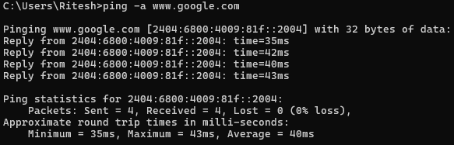

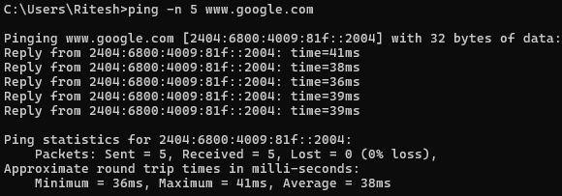

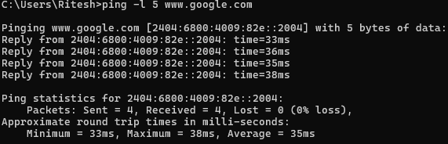

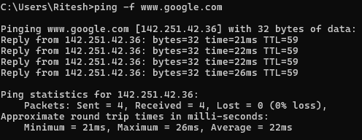

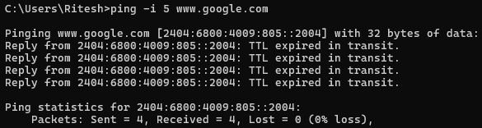

## getmac

### Description:

This tool enables an administrator to display the MAC address for network adapters on a system.

|  |  |  |
| --- | --- | --- |
| **No.** | **Option** | **Description** |
| 1 | /S | Specifies the remote system to connect to. |
| **2** | /U | Specifies the user context under which the command should execute. |
| **3** | /P | Specifies the password for the given user context. Prompts for input if omitted. |
| **4** | /V | Specifies that verbose output is displayed. |
| **5** | /FO | Specifies the format in which the output is to be displayed. Valid values: "TABLE", "LIST", "CSV". |

### Implementation:

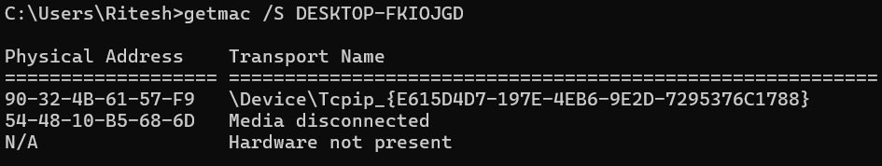

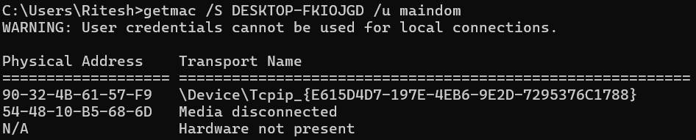

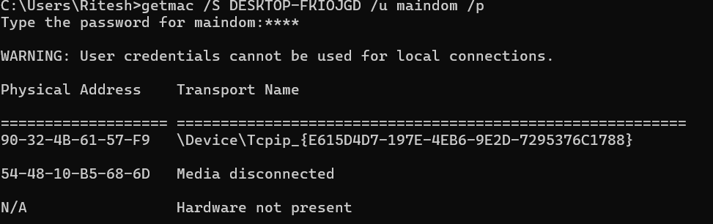

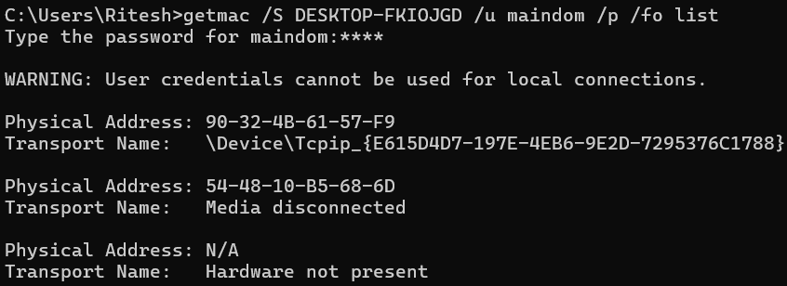

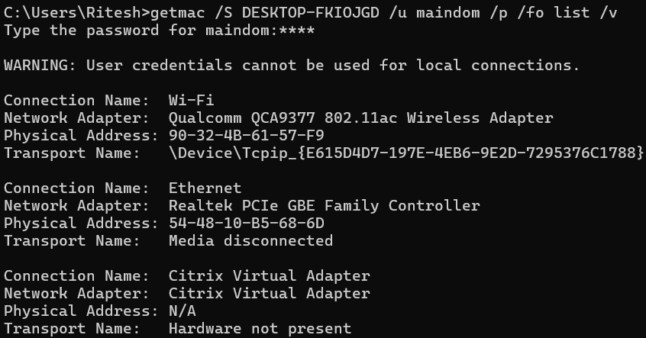

## systeminfo

### Description:

This tool displays operating system configuration information for a local or remote machine, including service pack levels.

|  |  |  |
| --- | --- | --- |
| **No.** | **Option** | **Description** |
| 1 | /s | Specifies the remote system to connect to. |
| **2** | /u | Specifies the user context under which the command should execute. |
| **3** | /p | Specifies the password for the given user context. Prompts for input if omitted. |
| **4** | /fo | Specifies the format in which the output is to be displayed. Valid values: "TABLE", "LIST", "CSV". |
| **5** | /nh | Specifies that the "Column Header" should be displayed in the output. Valid only for "TABLE" and "CSV" formats. |

### Implementation:

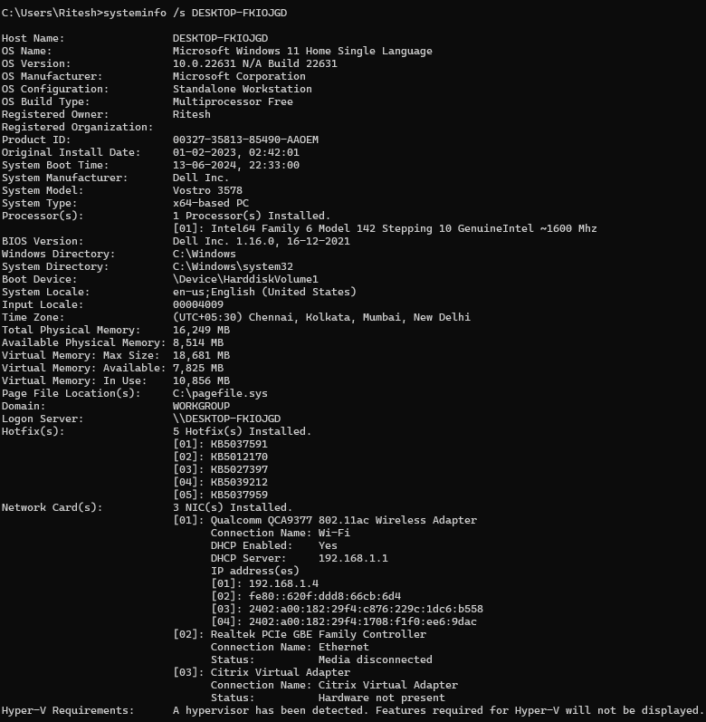

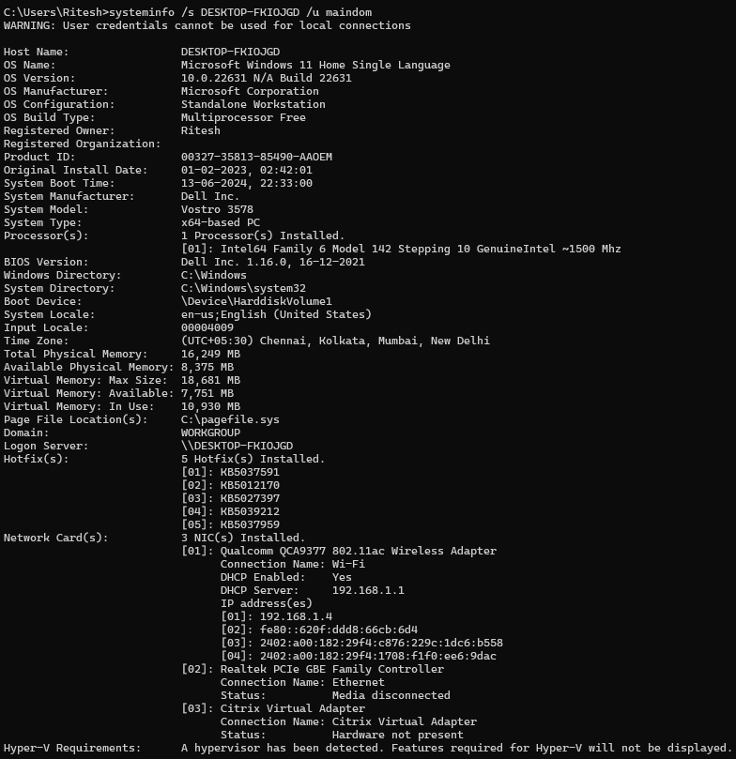

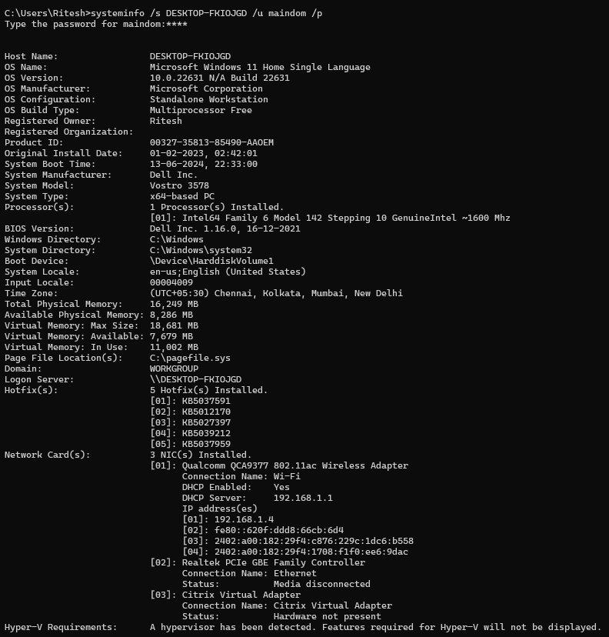

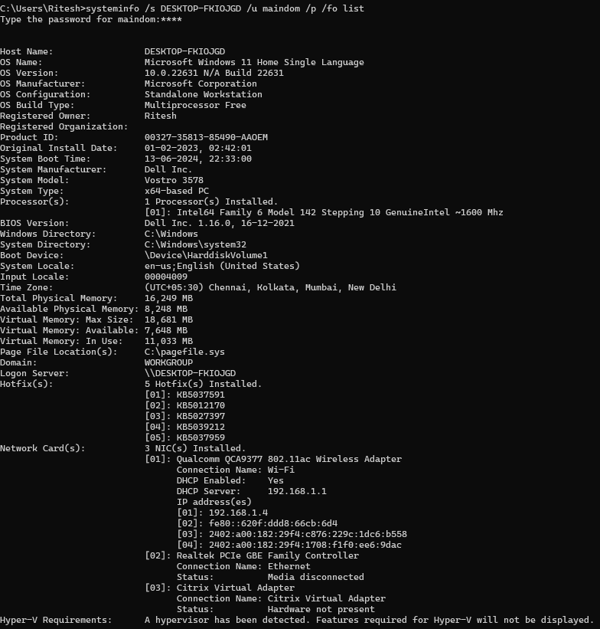

## traceroute/tracert

### Description:

The tracert command is Windows' version of traceroute. It is used for tracing the path between two systems. It will display the different routers or hops needed to travel from the source system to the destination system.

|  |  |  |
| --- | --- | --- |
| **No.** | **Option** | **Description** |
| 1 | -d | Do not resolve addresses to hostnames. |
| **2** | -h | Maximum number of hops to search for target. |
| **3** | -6 | Force using IPv6. |
| **4** | -w | Wait timeout milliseconds for each reply. |
| **5** | -4 | Force using IPv4. |

### Implementation:

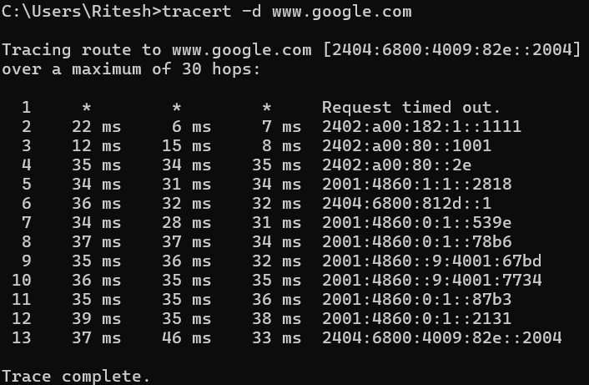

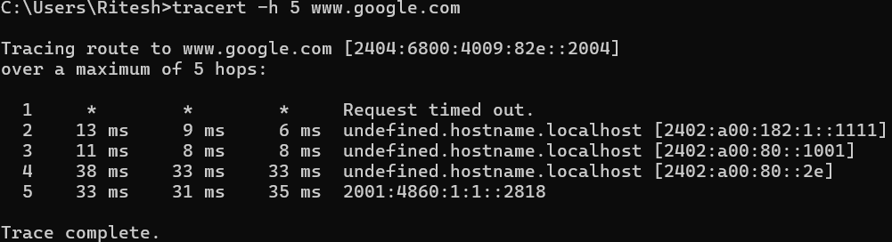

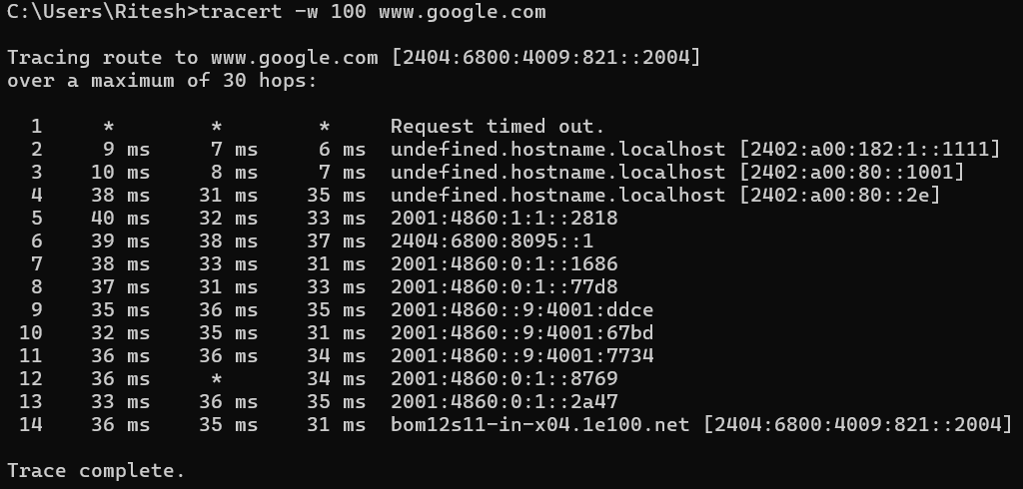

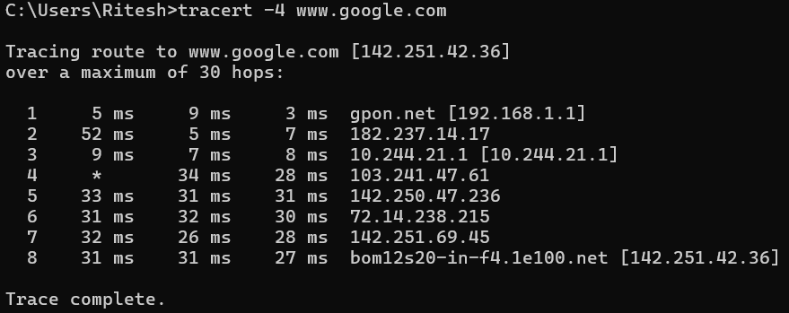

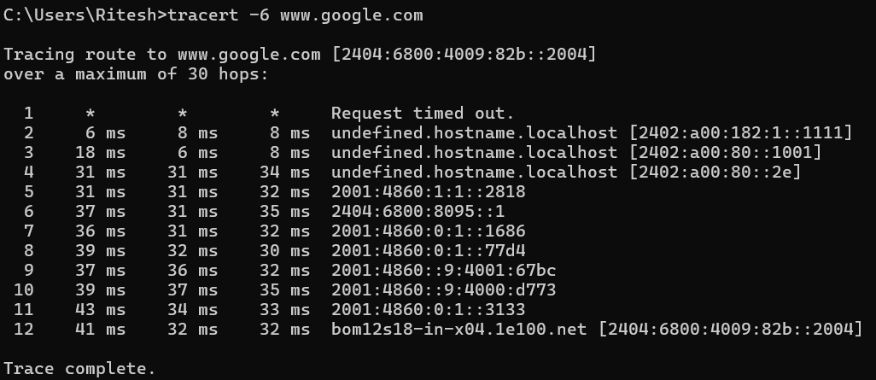

## netstat

### Description:

Displays protocol statistics and current TCP/IP network connections.

|  |  |  |
| --- | --- | --- |
| No. | Option | Description |
| 1 | -a | Displays all connections and listening ports. |
| 2 | -e | Displays Ethernet statistics. This may be combined with the -s option. |
| 3 | -f | Displays Fully Qualified Domain Names (FQDN) for foreign addresses. |
| 4 | -i | Displays the time spent by a TCP connection in its current state. |
| 5 | -n | Displays addresses and port numbers in numerical form. |

### Implementation:

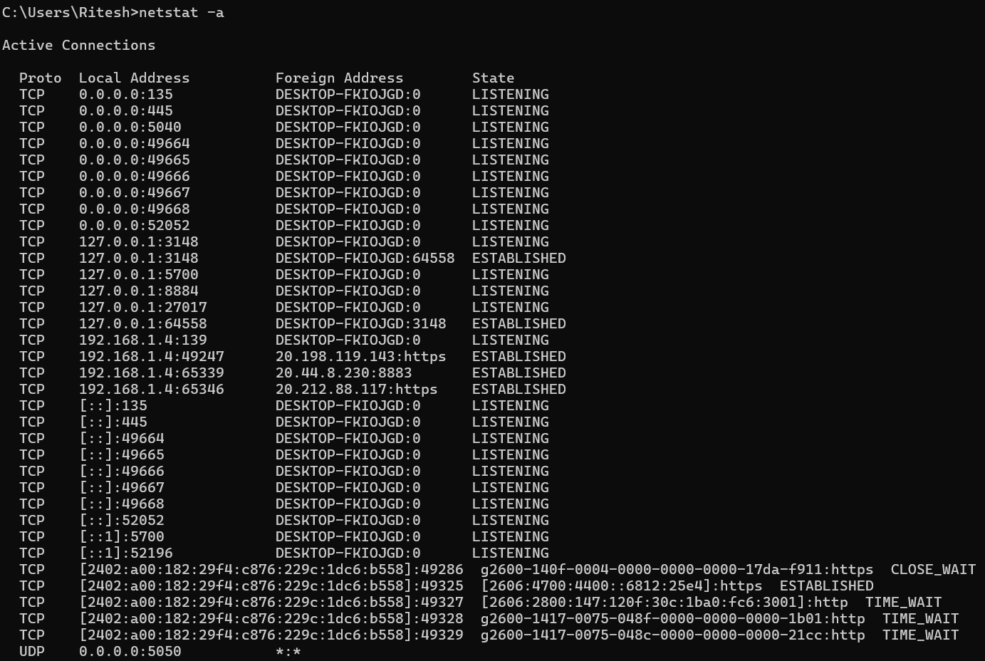

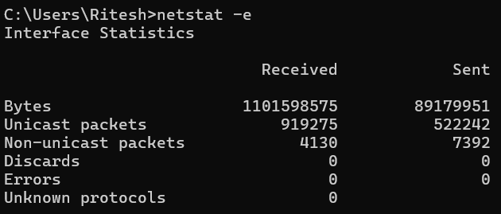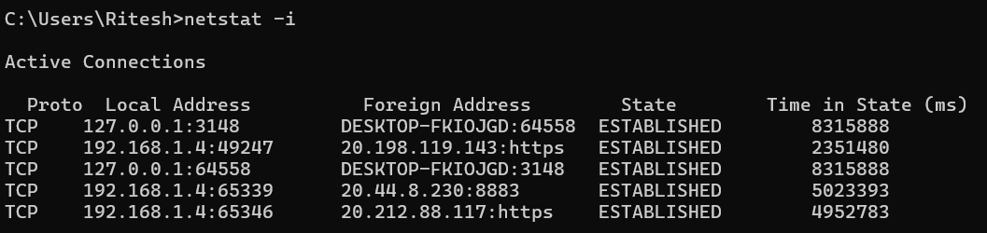

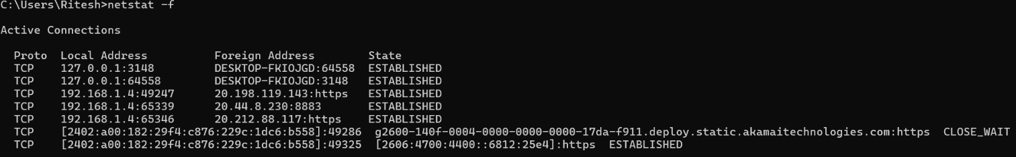

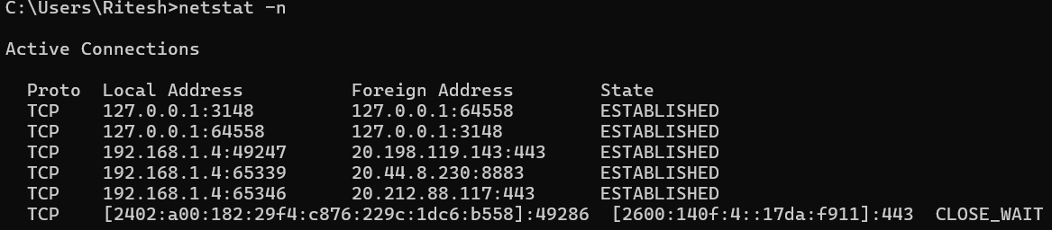

## nslookup

### Description:

Displays information that you can use to diagnose Domain Name System (DNS) infrastructure. Before using this tool, you should be familiar with how DNS works. The nslookup command-line tool is available only if you have installed the TCP/IP protocol.

|  |  |  |
| --- | --- | --- |
| No. | Option | Description |
| 1 | nslookup exit | Exits the nslookup command-line tool. |
| 2 | nslookup finger | Connects with the finger server on the current computer. |
| 3 | nslookup hep | Displays a short summary of subcommands. |
| 4 | nslookup server | Changes the default server to the specified DNS domain. |
| 5 | nslookup ls | Lists information for a DNS domain. |

### Implementation:

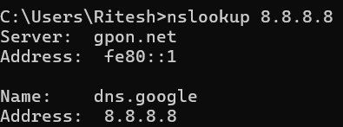

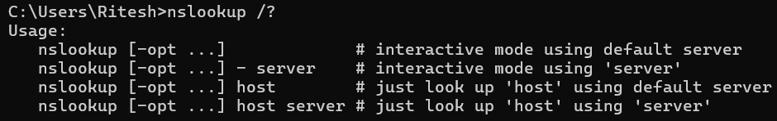

## hostname

### Description:

Print the current name of host.

### Implementation:

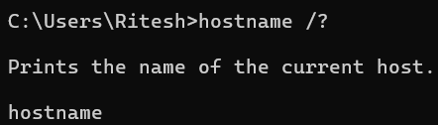



## pathping

### Description:

It is commonly used to troubleshoot network issues, particularly the ones related to latency and network performance. It is considered an alternative to tracert and it combines ping and tracert commands.

|  |  |  |
| --- | --- | --- |
| No. | Option | Description |
| 1 | -n | Does not resolve addresses to hostnames. |
| 2 | -h | Sets the maximum number of hops to search for the target. |
| 3 | -g | Specifies loose source route along the host-list. |
| 4 | -q | Sets the number of queries per hop |
| 5 | -w | Waits the specified number of milliseconds for each reply. |

### Implementation:

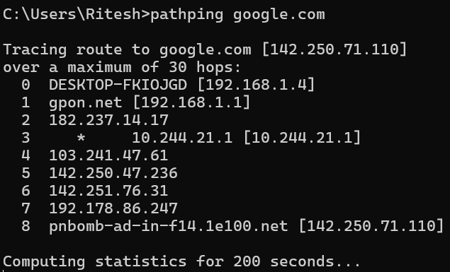

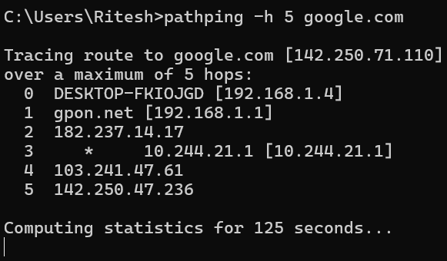

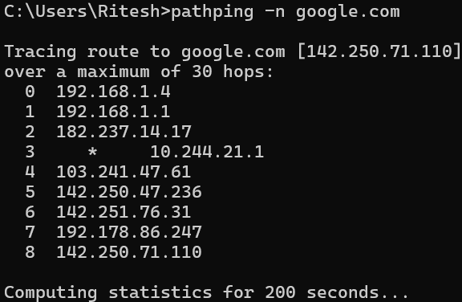

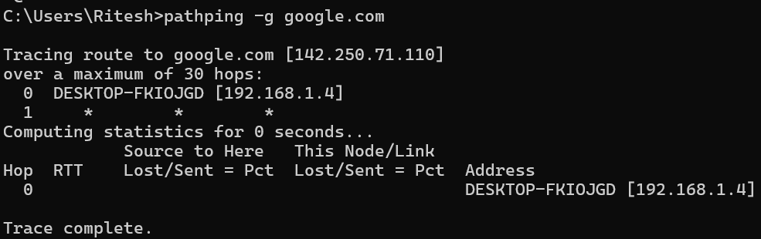

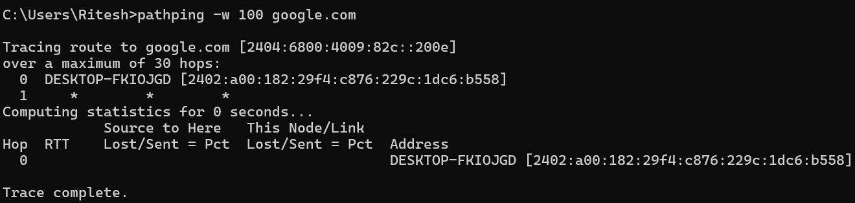

## arp

### Description:

Displays and modifies the IP-to-Physical address translation tables used by address resolution protocol (ARP).

|  |  |  |
| --- | --- | --- |
| No. | Option | Description |
| 1 | -a | Displays current ARP entries by interrogating the current protocol data. If inet_addr is specified, the IP and Physical addresses for only the specified computer are displayed. If more than one network interface uses ARP, entries for each ARP table are displayed. |
| 2 | -g | Same as -a |
| 3 | -v | Displays current ARP entries in verbose mode. All invalid entries and entries on the loop-back interface will be shown. |
| 4 | -d | Deletes the host specified by inet_addr. inet_addr may be wildcarded with * to delete all hosts. |
| 5 | -N | Displays the ARP entries for the network interface specified by if_addr. |

### Implementation:

