**Lab Practical #10:**

Study the concept of routing using packet tracer. (Static Routing)

**Practical Assignment #10:**

1. Connect the two different networks based on the calculated IP addresses and subnet using a packet tracer.

**Static:**

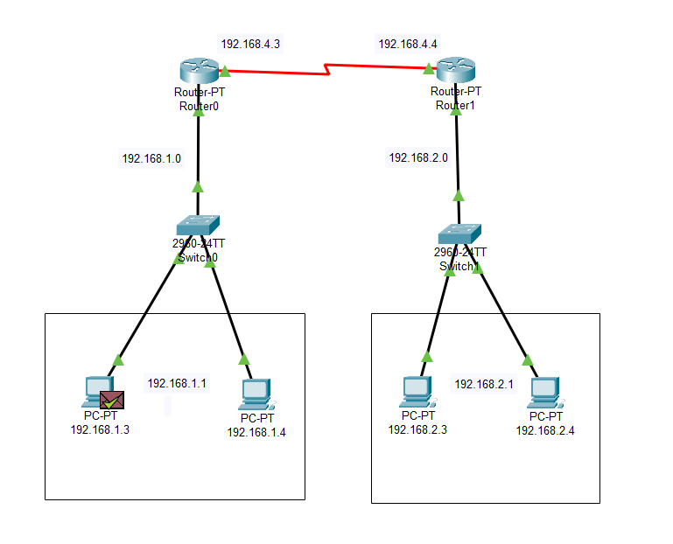

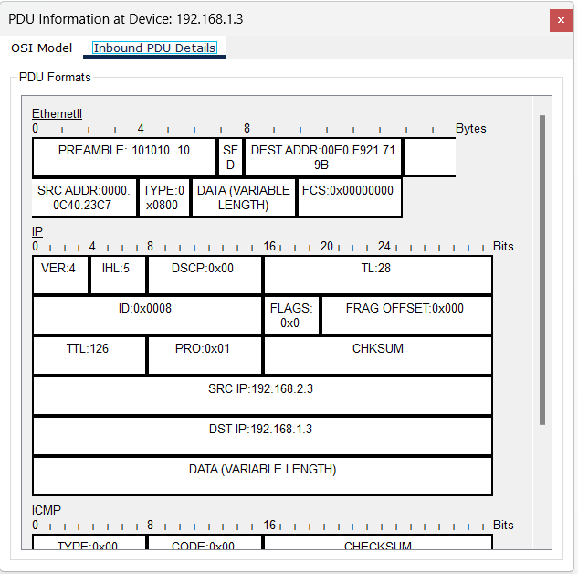

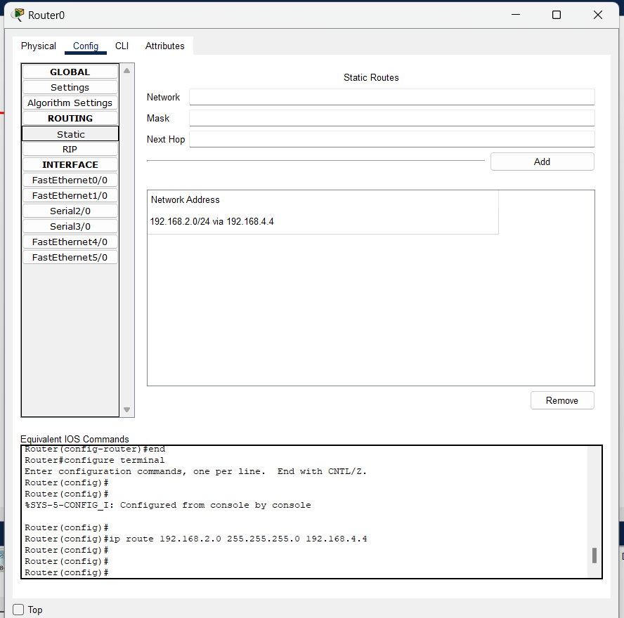

1. Connect the three different networks based on the calculated IP addresses and subnet using a packet tracer.

**Static:**

