**Lab Practical #12:**

To develop network using distance vector routing protocol and link state routing protocol.

**Practical Assignment #12:**

1. **C Program: Distance Vector Routing Algorithm using Bellman Ford's Algorithm.**

**struct** node

{

**unsigned** dist[20];

**unsigned** from[20];

} rt[10];

**int** main()

{

**int** costmat[20][20];

**int** nodes, i, j, k, count = 0;

    printf("\nEnter the number of nodes : ");

    scanf("%d", &nodes);

    printf("\nEnter the cost matrix :\n");

**for** (i = 0; i < nodes; i++)

    {

**for** (j = 0; j < nodes; j++)

        {

            scanf("%d", &costmat[i][j]);

            costmat[i][i] = 0;

            rt[i].dist[j] = costmat[i][j]; // initialise the distance equal to cost matrix

            rt[i].from[j] = j;

        }

    }

**do**

    {

        count = 0;

**for** (i = 0; i < nodes; i++) // We choose arbitary vertex k and we calculate the direct distance from the node i to k using the cost matrix

            // and add the distance from k to node j

**for** (j = 0; j < nodes; j++)

**for** (k = 0; k < nodes; k++)

**if** (rt[i].dist[j] > costmat[i][k] + rt[k].dist[j])

                    { // We calculate the minimum distance

                        rt[i].dist[j] = rt[i].dist[k] + rt[k].dist[j];

                        rt[i].from[j] = k;

                        count++;

                    }

    } **while** (count != 0);

**for** (i = 0; i < nodes; i++)

    {

        printf("\n\n For router %d\n", i + 1);

**for** (j = 0; j < nodes; j++)

        {

            printf("\t\nnode %d via %d Distance %d ", j + 1, rt[i].from[j] + 1, rt[i].dist[j]);

        }

    }

    printf("\n\n");

    getch();

}

**Output:**

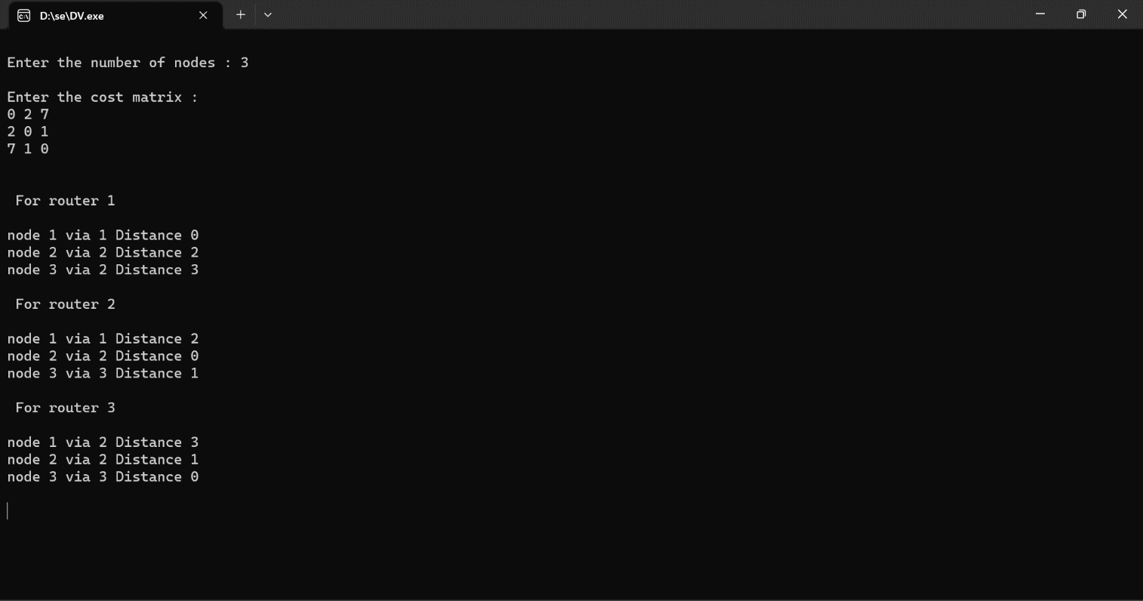

**2. C Program: Link state routing algorithm.**

#include "global.h"

#include <assert.h>

#include <limits.h>

#include <stdlib.h>

#include <stdio.h>

#include <arpa/inet.h>

#include <string.h>

#define INFINITY INT_MAX

#define UNDEFINED (-1)

#define INDEX(x, y, nnodes) ((x) + (nnodes) * (y))

**struct** node_list

{

**char** **nodes;

**int** nnodes;

**int** unsorted;

};

**int** nl_index(**struct** node_list *nl, **char** *node);

**struct** node_list *nl_create(**void**)

{

**return** (**struct** node_list *)calloc(1, sizeof(**struct** node_list));

}

**int** nl_nsites(**struct** node_list *nl)

{

**return** nl->nnodes;

}

**void** nl_add(**struct** node_list *nl, **char** *node)

{

    /* No duplicate nodes.

     */

**if** (nl_index(nl, node) != -1)

    {

**return**;

    }

    /* Create a copy of the site.

     */

**int** len = strlen(node);

**char** *copy = malloc(len + 1);

    strcpy(copy, node);

    /* Add this copy to the list.

     */

    nl->nodes = (**char** **)realloc(nl->nodes, sizeof(**char** *) * (nl->nnodes + 1));

    nl->nodes[nl->nnodes++] = copy;

    nl->unsorted = 1;

}

**int** nl_compare(**const** **void** *e1, **const** **void** *e2)

{

**const** **char** **p1 = (**const** **char** **)e1, **p2 = (**const** **char** **)e2;

**return** strcmp(*p1, *p2);

}

**void** nl_sort(**struct** node_list *nl)

{

    qsort(nl->nodes, nl->nnodes, sizeof(**char** *), nl_compare);

    nl->unsorted = 0;

}

/* Return the rank of the given site in the given site list.

 */

**int** nl_index(**struct** node_list *nl, **char** *node)

{

    /* Sort the list if not yet sorted.

     */

**if** (nl->unsorted)

    {

        nl_sort(nl);

    }

    /* Binary search.

     */

**int** lb = 0, ub = nl->nnodes;

**while** (lb < ub)

    {

**int** i = (lb + ub) / 2;

**int** cmp = strcmp(node, nl->nodes[i]);

**if** (cmp < 0)

        {

            ub = i;

        }

**else** **if** (cmp > 0)

        {

            lb = i + 1;

        }

**else**

        {

**return** i;

        }

    }

**return** -1;

}

**char** *nl_name(**struct** node_list *nl, **int** index)

{

**if** (index < 0)

    {

**return** "UNDEFINED";

    }

**return** nl->nodes[index];

}

**void** nl_destroy(**struct** node_list *nl)

{

**int** i;

**for** (i = 0; i < nl->nnodes; i++)

    {

        free(nl->nodes[i]);

    }

    free(nl->nodes);

    free(nl);

}

/* Set the distance from src to dst.

 */

**void** set_dist(**struct** node_list *nl, **int** graph**[]**, **int** nnodes, **char** *src, **char** *dst, **int** dist)

{

**int** x = nl_index(nl, src), y = nl_index(nl, dst);

**if** (x < 0 || y < 0)

    {

        fprintf(stderr, "set_dist: bad source or destination\n");

**return**;

    }

    graph[INDEX(x, y, nnodes)] = dist;

    // graph[INDEX(y, x, nnodes)] = dist;

}

**char** *addr_to_string(**struct** sockaddr_in addr)

{

**char** *addr_string = malloc(40);

    strcpy(addr_string, inet_ntoa(addr.sin_addr));

    strcat(addr_string, ":");

**char** *port = malloc(12);

    sprintf(port, "%d", ntohs(addr.sin_port));

    strcat(addr_string, port);

    free(port);

**return** addr_string;

}

**struct** sockaddr_in string_to_addr(**char** *string)

{

**char** *port = index(string, ':');

    *port++ = '\0';

**struct** sockaddr_in addr;

    memset((**void** *)&addr, 0, sizeof(addr));

    addr_get(&addr, string, atoi(port));

    *--port = ':';

**return** addr;

}

/*************************************************

    Dijkstra's algorithm

*************************************************/

/* Dijkstra's algorith.  graph[INDEX(x, y, nnodes)] contains the

 * distance of node x to node y.  nnodes is the number of nodes.  src

 * is that starting node.  Output dist[x] gives the distance from src

 * to x.  Output prev[x] gives the last hop from src to x.

 */

**void** dijkstra(**int** graph**[]**, **int** nnodes, **int** src, **int** dist**[]**, **int** prev**[]**)

{

**int** *visited = malloc(sizeof(**int**) * nnodes); // mark whether the node is visited

**int** count, mindistance, nextnode, i, j;

**for** (i = 0; i < nnodes; i++)

    {

        visited[i] = 0;

**if** (graph[INDEX(src, i, nnodes)] == 1 || graph[INDEX(src, i, nnodes)] == 0)

        {

            dist[i] = graph[INDEX(src, i, nnodes)];

            prev[i] = src;

        }

**else**

        {

            dist[i] = INFINITY;

        }

    }

    dist[src] = 0;

    visited[src] = 1;

    prev[src] = UNDEFINED; // src has no prev

**for** (count = 0; count < nnodes; count++)

    {

        mindistance = INFINITY;

**for** (i = 0; i < nnodes; i++)

        {

**if** (dist[i] < mindistance && !visited[i])

            {

                mindistance = dist[i];

                nextnode = i;

            }

        }

        visited[nextnode] = 1;

**for** (j = 0; j < nnodes; j++)

        {

**if** (!visited[j] && (graph[INDEX(nextnode, j, nnodes)] != INFINITY) && dist[nextnode] + graph[INDEX(nextnode, j, nnodes)] < dist[j])

            {

                dist[j] = dist[nextnode] + graph[INDEX(nextnode, j, nnodes)];

                prev[j] = nextnode;

            }

        }

    }

}

Output:

