DARSHAN INSTITUTE OF ENGINEERING & TECHNOLOGY

**Semester 5th | Practical Assignment | Computer Networks (2101CS501)**

**Date: 13/09/2024**

Lab Practical #13:

Study & Survey of Institute organization network infrastructure.

Practical Assignment #13:

1. **Identify type of network in your institute. Draw a design of network in your institute (Any Lab/Floor/Building).**

Lab No: Building Terrace Topology: Star Topology

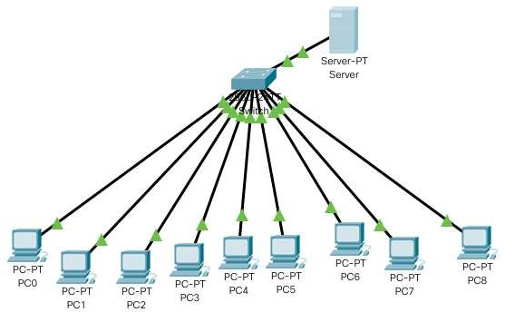

1. **List how many network devices and types of cable used and give its details.**

Total No Of PC: - 9

Total Number of Switch: - 1 Total Server: DHCP Server

Types Of Cable: - Twisted Pair Cable Connectors: RJ-45

Network Type: Lan

**1**

**Enrollment No: - 22010101099**

**| B.Tech. CSE**