**Lab Practical #02:**

Study of different types of network cables & connectors and crimping a LAN.

**Practical Assignment #02:**

1. List various networks cable. Also, write short description.
2. Difference between guided and unguided media.
3. Give cross-wired cable and straight through cable diagram (Color Code wise).

## List various networks cable and connectors. Also, write short description.

* **Cables :**

1. **Unshielded Twisted Pair (UTP):**

* UTP cables have pairs of twisted copper wires without additional shielding. They are widely used in Ethernet networks for both residential and commercial applications due to their flexibility and ease of installation.

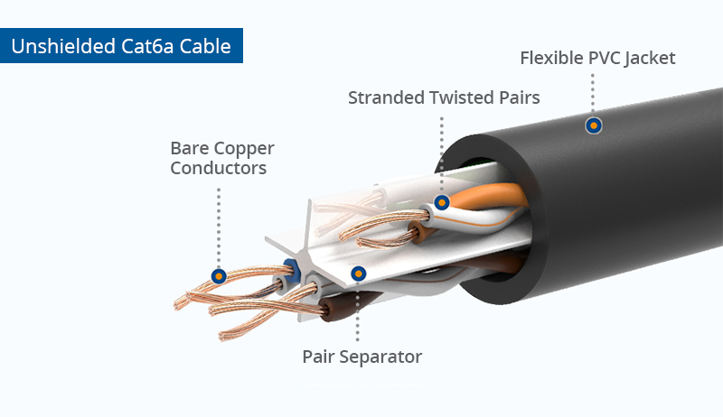

1. **Shielded Twisted Pair (STP):**

* STP cables are similar to UTP but have an additional shielding to protect against electromagnetic interference (EMI) and radio frequency interference (RFI). They are used in environments with high interference.

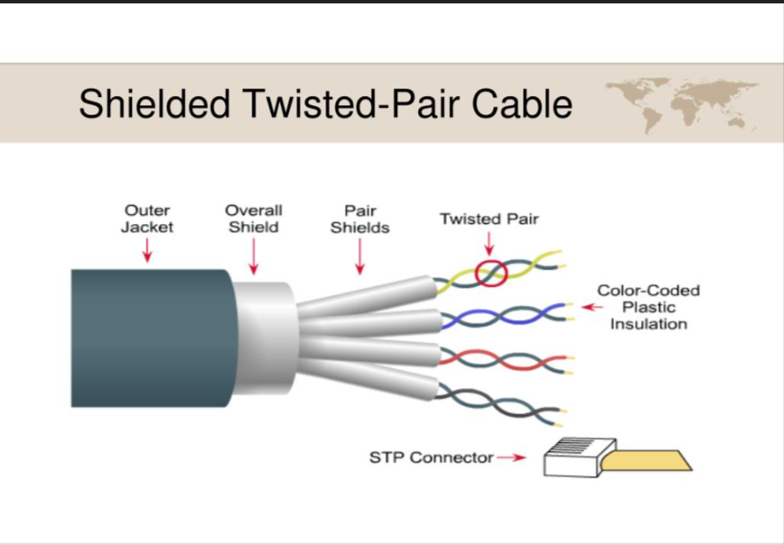

**C) Coaxial Cables:**

* Coaxial cables consist of a central copper conductor, surrounded by a plastic insulating layer, a metallic shield, and an outer insulating layer. They are commonly used for cable television, internet connections, and older Ethernet networks.

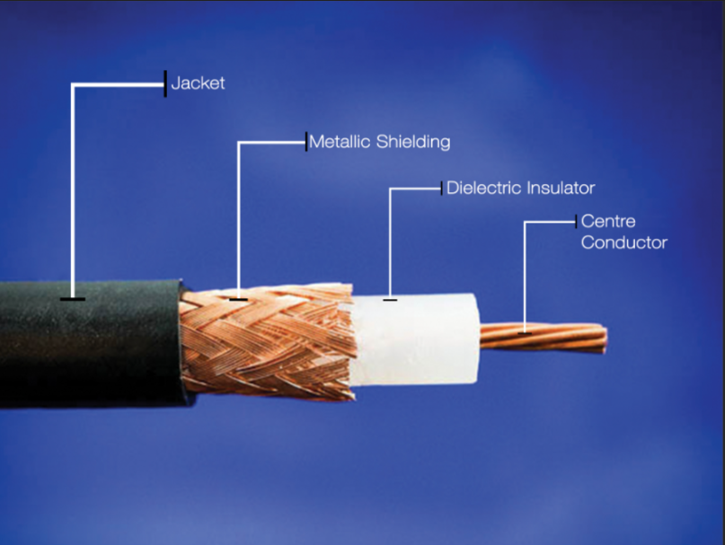

**D) Fiber Optic Cables:**

* Fiber optic cables transmit data as light pulses through thin strands of glass or plastic, allowing for high-speed data transmission over long distances with minimal signal loss. These cables are immune to electromagnetic interference, making them ideal for environments with high electrical noise.

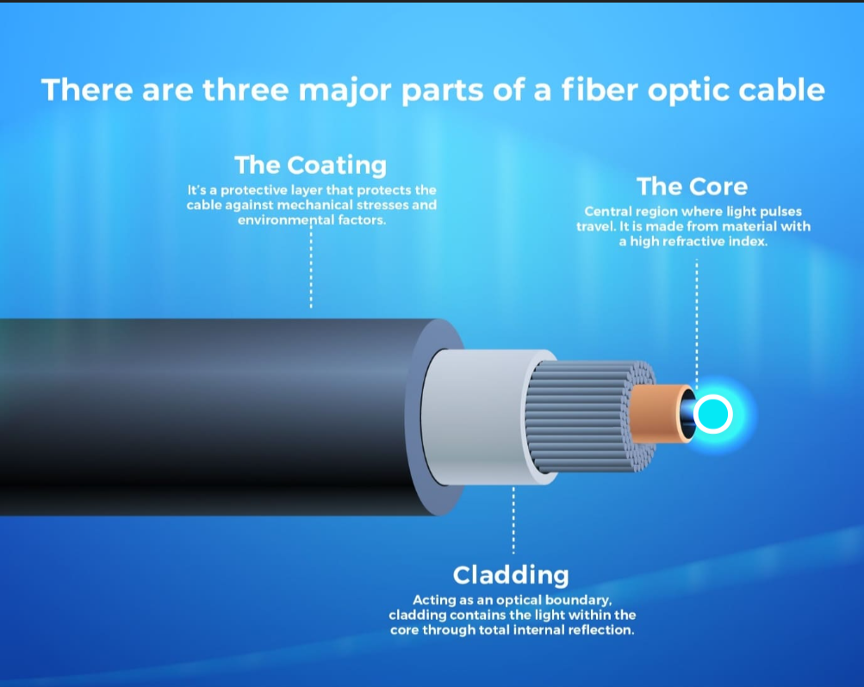

**E) Single-mode Fiber (SMF):**

* Single-mode fiber (SMF) has a small core that allows light to travel in a single path, reducing signal loss and enabling high-speed data transmission over long distances. It is ideal for long-distance communications like telecom and internet backbones.

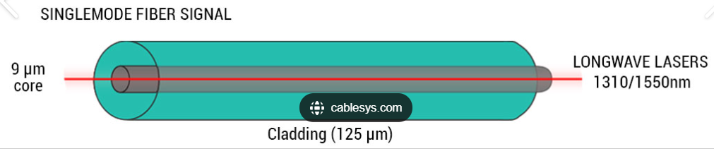

**F) Multi-mode Fiber (SMF):**

* Multi-mode fiber (MMF) has a larger core that allows multiple light paths, making it suitable for short-distance data transmission. It is commonly used in local area networks (LANs) and data centers for applications requiring high-speed connections over shorter distances.



**G) Category 5 (Cat 5):**

* Cat 5 cables are used for Ethernet networks and support speeds up to 100 Mbps. They consist of four twisted pairs of copper wire.

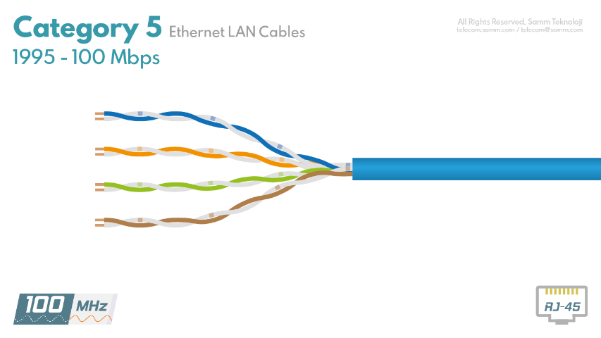

**H) Category 6 (Cat 6):**

* Cat 6 cables support speeds up to 10 Gbps over short distances and are used in Ethernet networks. They offer better performance and reduced crosstalk compared to Cat 5e.

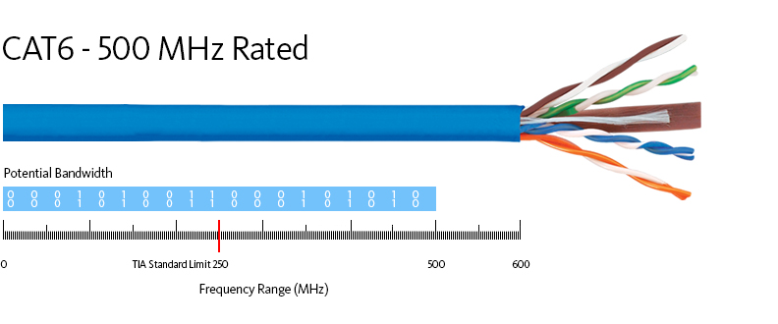

* **Connectors :**

1. **RJ45:**

* A commonly used connector for Ethernet networks, supporting both UTP and STP cables. It features 8 pins and is used for connecting computers, routers, and switches in a local area network (LAN).

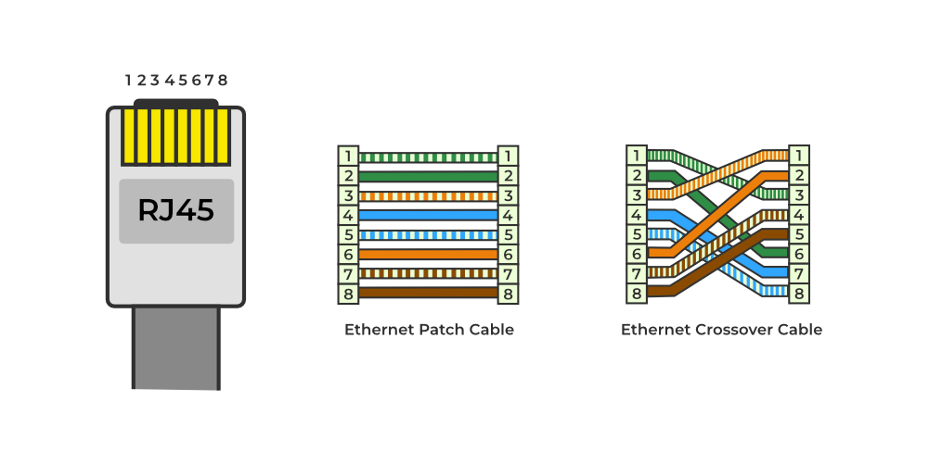

1. **BNC (Bayonet Neill-Concelman):**

* A connector used with coaxial cables, known for its quick connect and disconnect feature. Commonly used in radio, television, and other RF signal applications.

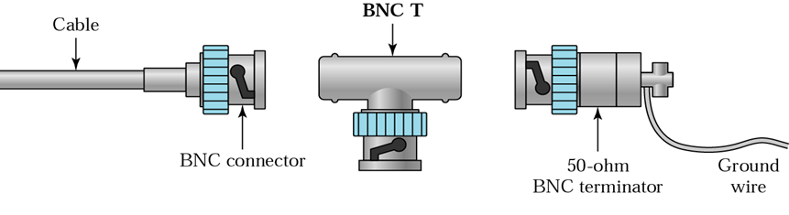

1. **F-Type :**

* A threaded connector used with coaxial cables, primarily for cable television, satellite television, and cable modems. Provides a secure connection.

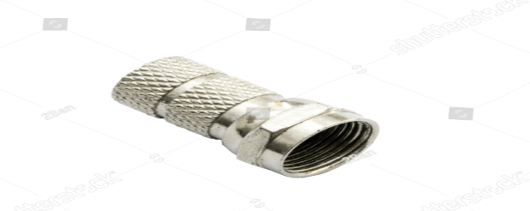

1. **USB ( Universal Serial Bus) :**

* A versatile connector used for connecting a wide range of devices, including keyboards, mice, printers, and external storage devices. Variants include USB-A, USB-B, and USB-C.

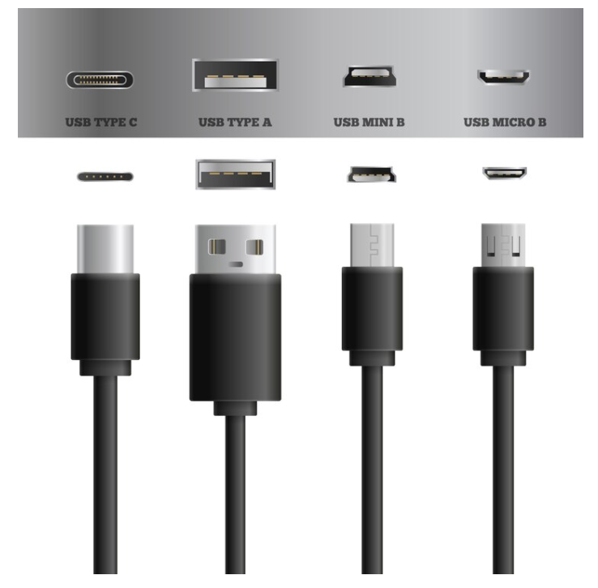

1. **HDMI (High-Definition Multimedia Interface) :**

* A connector used for transmitting high-definition audio and video signals between devices like computers, game consoles, and TVs. Comes in standard, mini, and micro sizes.

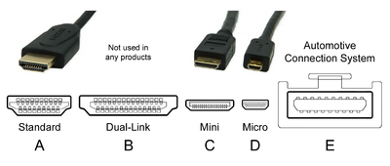

1. **Difference between guided and unguided media.**

* Guided and unguided media are two primary categories of transmission media used in networking and telecommunications. Here's a breakdown of their differences:

### Guided Media

**1. Definition**:

* Guided media refers to transmission media where signals are guided along a physical path.

1. **Types**:

* **Twisted Pair Cables**: Pairs of insulated copper wires twisted together. Examples include Unshielded Twisted Pair (UTP) and Shielded Twisted Pair (STP).
* **Coaxial Cables**: Consists of a central conductor, insulating layer, metallic shield, and outer insulating layer.
* **Fiber Optic Cables**: Use light to transmit data through strands of glass or plastic fibers.

1. **Characteristics**:

* **Physical Confinement**: Signals are confined to the physical pathway.
* **High Bandwidth**: Can support high data rates, especially fiber optic cables.
* **Less Interference**: Protected from external electromagnetic interference, especially with shielded cables.
* **Distance**: Generally suitable for shorter to medium distances, except for fiber optics which can handle long distances effectively.

1. **Use Cases**:

* Local Area Networks (LANs)
* Telephony
* Cable TV
* Internet Backbone (Fiber Optics)
* **Unguided Media**

1. **Definition**:

* Unguided media refers to transmission media where signals are transmitted without a physical path, typically through the air or vacuum.

1. **Types**:

* **Radio Waves**: Used for radio broadcasting, TV, and wireless networking.
* **Microwaves**: Used for satellite communications and long-distance wireless transmission.
* **Infrared**: Used for short-range communication like remote controls and some wireless devices.

1. **Characteristics**:

* **No Physical Confinement**: Signals are not confined to a physical path and can travel freely through space.

1. **Use Cases**:

* Wireless Local Area Networks (WLANs)
* Satellite Communications
* Bluetooth and Infrared Devices
* Mobile Telephony
* **Difference:-**

| **Sr.**  **No.** | **Guided Media** |  | **Unguided Media** |
| --- | --- | --- | --- |
| 1. | The guided media is also called wired communication or bounded transmission media. |  | The unguided media is also called wireless communication or unbounded transmission media. |
| 2. | The signal energy propagates through wires in guided media. |  | The signal energy propagates through the air in unguided media. |
| 3. | Guided media is used for point-to-point communication. |  | Unguided media is generally suited for radio broadcasting in all directions. |
| 4. | It is cost-effective. |  | It is expensive. |
| 5. | Discrete network topologies are formed by the guided media. |  | Continuous network topologies are formed by the unguided media. |

## Give cross-wired cable and straight through cable diagram (Color Code wise).

1. Cross-wired Cable Diagram (Color Code)

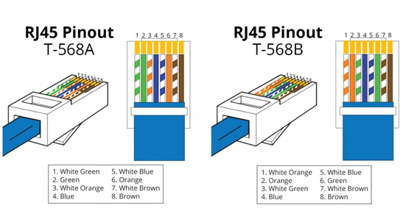

1. Straight Through Cable Diagram (Color Code)

