**Lab Practical #05:**

Study the concept of VLAN using packet tracer.

**Practical Assignment #05:**

1. **Implement the different network structures in VLAN and VLAN trunking. Also check connectivity between them using ping command or PDU utility.**

**Ex: 1**

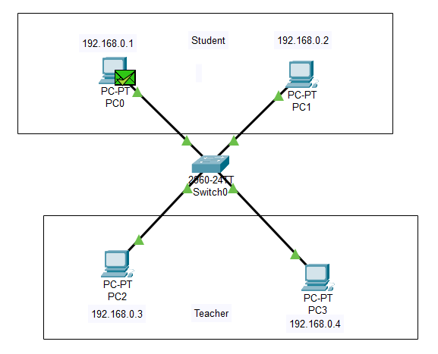

• **Create the Network:**

* Add a switch and four PCs.
* Connect PCs to the switch with Ethernet cables.

• **Assign IP Addresses to PCs:**

* PC0: 192.168.0.1
* PC1: 192.168.0.2
* PC2: 192.168.0.3
* PC3: 192.168.0.4

• **Create VLANs on the Switch:**

* Go to Config tab > VLAN Database.
* Add VLAN 150 (STUDENT), VLAN 200 (Teacher).

• **Assign VLANs to Ports:**

* FastEthernet0/1 (PC0): VLAN 150
* FastEthernet0/2 (PC1): VLAN 150
* FastEthernet0/3 (PC2): VLAN 200
* FastEthernet0/4 (PC3): VLAN 200
* **Test Connectivity:**
* Ping within VLANs (PC0 to PC1 and PC2 to PC3).

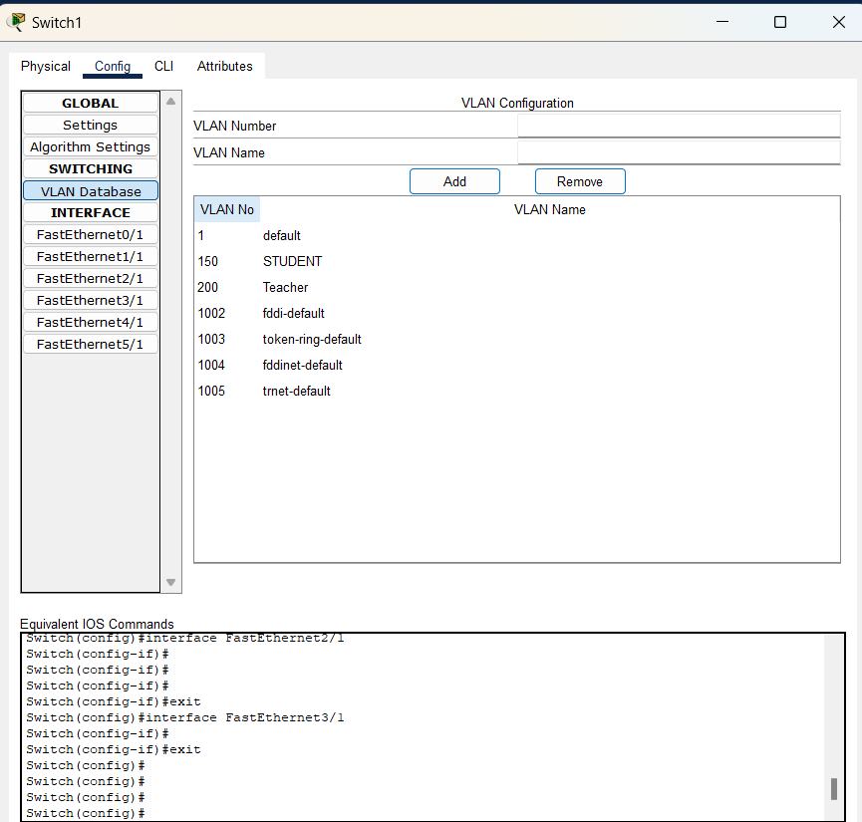

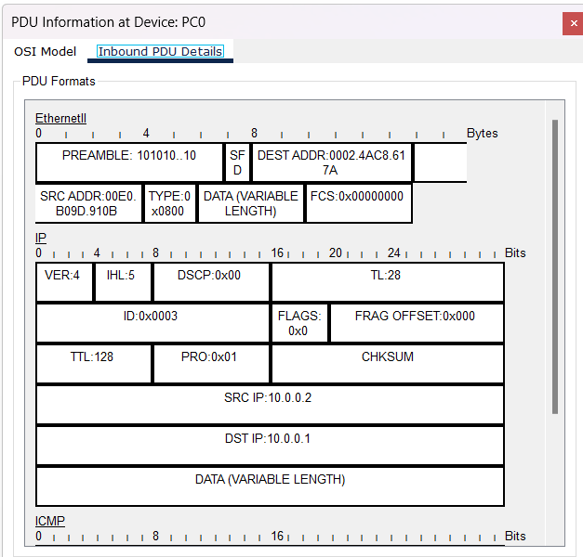

Ex: 2

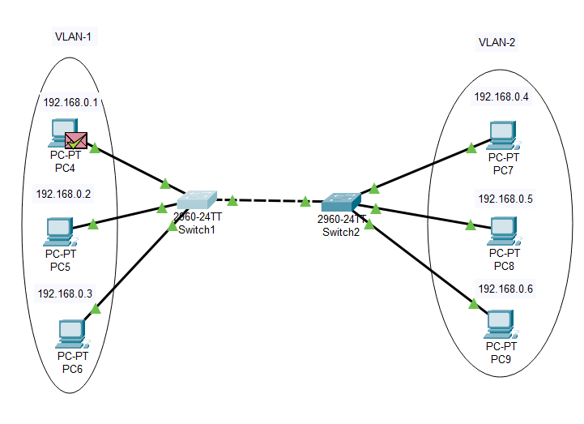

Steps:

• **Create the Network:**

* Add two switch and 6 PCs.
* Connect PCs to the switch with Ethernet cables.
* Also Connect both switches together

• **Assign IP Addresses to PCs:**

* PC4: 192.168.0.1
* PC5: 192.168.0.2
* PC6: 192.168.0.3
* PC7: 192.168.0.4
* PC8: 192.168.0.5
* PC9: 192.168.0.6

• **Create VLANs on the Switch:**

* Go to Config tab > VLAN Database.
* Add VLAN 10 (VLAN1), VLAN 20 (VLAN2).

• **Assign VLANs to Ports:**

* FastEthernet0/1 (PC4): VLAN 10
* FastEthernet0/2 (PC5): VLAN 10
* FastEthernet0/3 (PC6): VLAN 10
* FastEthernet0/4 (PC7): VLAN 20
* FastEthernet0/5 (PC8): VLAN 20
* FastEthernet0/6 (PC9): VLAN 20
* **Test Connectivity:**
* Ping within VLANs (PC4 to PC6).

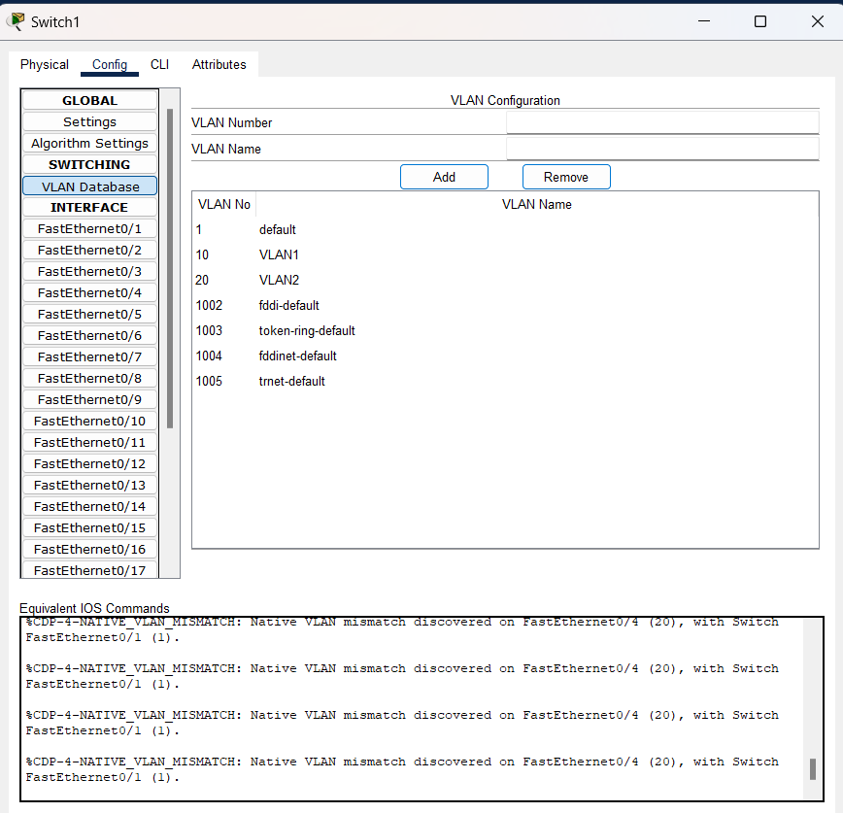

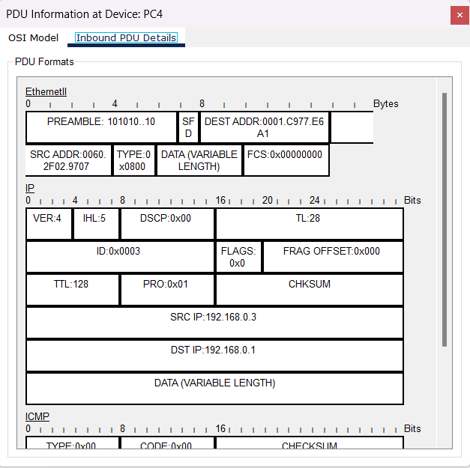

Ex: 3

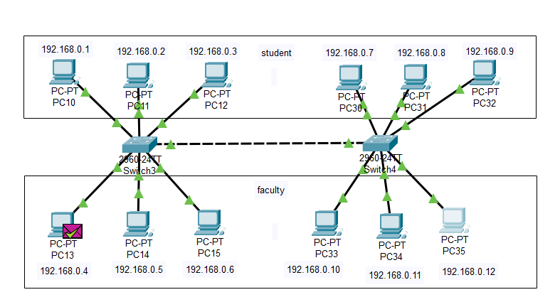

Steps:

• **Create the Network:**

* Add two switch and 12 PCs.
* Connect PCs to the switch with Ethernet cables.
* Also Connect both switches together

• **Assign IP Addresses to PCs:**

* PC10: 192.168.0.1
* PC11: 192.168.0.2
* PC12: 192.168.0.3
* PC13: 192.168.0.4
* PC14: 192.168.0.5
* PC15: 192.168.0.6
* PC30: 192.168.0.7
* PC31: 192.168.0.8
* PC32: 192.168.0.9
* PC33: 192.168.0.10
* PC34: 192.168.0.11
* PC35: 192.168.0.12

• **Create VLANs on the Switch:**

* Go to Config tab > VLAN Database.
* Add VLAN 10 (student), VLAN 20 (faculty).

• **Assign VLANs to Ports:**

* FastEthernet0/1 (PC10): VLAN 10
* FastEthernet0/2 (PC11): VLAN 10
* FastEthernet0/3 (PC12): VLAN 10
* FastEthernet0/4 (PC13): VLAN 20
* FastEthernet0/5 (PC14): VLAN 20
* FastEthernet0/6 (PC15): VLAN 20
* FastEthernet0/2 (PC30): VLAN 10
* FastEthernet0/3 (PC31): VLAN 10
* FastEthernet0/4 (PC32): VLAN 10
* FastEthernet0/5 (PC33): VLAN 20
* FastEthernet0/6 (PC34): VLAN 20
* FastEthernet0/7 (PC35): VLAN 20
* **Test Connectivity:**
* Ping within VLANs (PC13 to PC35).

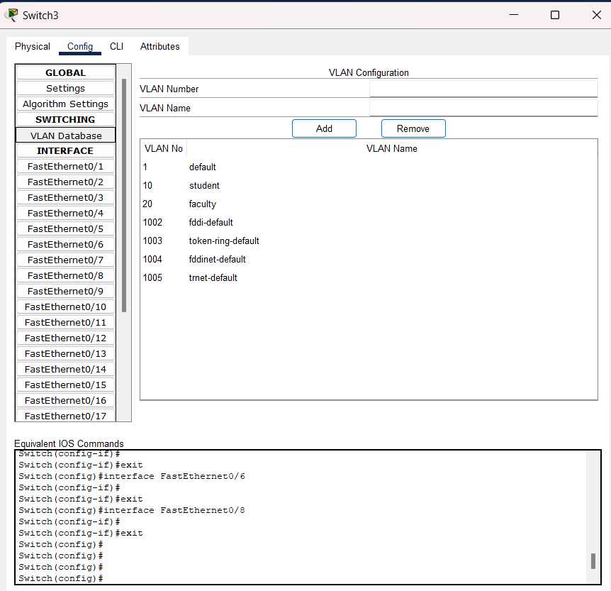

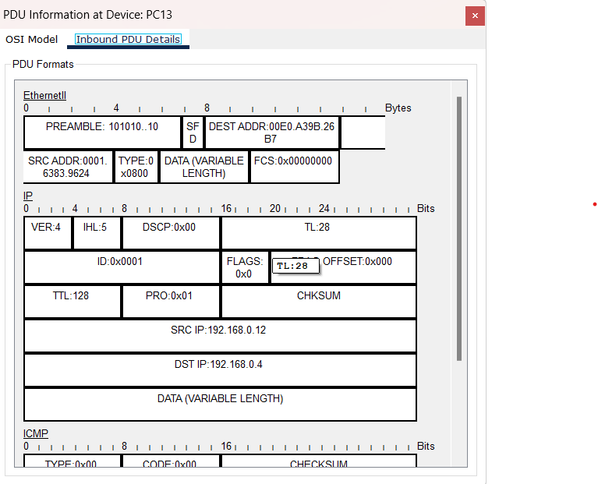

Ex: 4

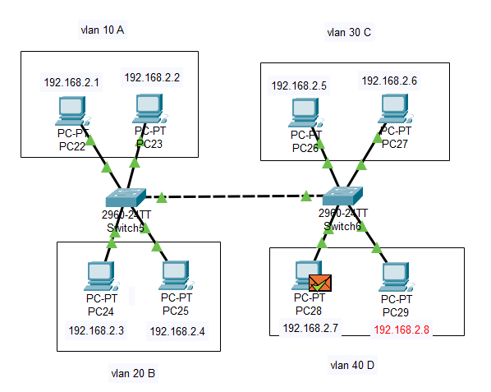

Steps:

• **Create the Network:**

* Add two switch and 2 PCs with different group.
* Connect PCs to the switch with Ethernet cables.
* Also Connect both switches together

• **Assign IP Addresses to PCs:**

* PC22: 192.168.2.1
* PC23: 192.168.2.2
* PC24: 192.168.2.3
* PC25: 192.168.2.4
* PC26: 192.168.2.5
* PC27: 192.168.2.6
* PC28: 192.168.2.7
* PC29: 192.168.2.8

• **Create VLANs on the Switch:**

* Go to Config tab > VLAN Database.
* Add VLAN 10 (A), VLAN 20 (B), VLAN 30 (C), VLAN 40 (D).

• **Assign VLANs to Ports:**

**FOR SWITCH 1:**

* FastEthernet0/1 (PC22): VLAN 10
* FastEthernet0/2 (PC23): VLAN 10
* FastEthernet0/3 (PC24): VLAN 20
* FastEthernet0/4 (PC25): VLAN 20
* FastEthernet0/5 : Trunk VLAN 1-1005

**FOR SWITCH 2:**

* FastEthernet0/1 (PC26): VLAN 30
* FastEthernet0/2 (PC27): VLAN 30
* FastEthernet0/3 (PC28): VLAN 40
* FastEthernet0/4 (PC29): VLAN 40
* FastEthernet0/5 : Trunk VLAN 1-1005
* **Test Connectivity:**
* Ping within VLANs (PC28 to PC29).

