**Lab Practical #07:**

Study Client-Server Socket programming - TCP & UDP

**Practical Assignment #07:**

1. **Write a C/Java code for TCP Server-Client Socket Programming.**
2. **Write a C/Java code for UDP Server-Client Socket Programming.**
3. **For TCP Server-Client: Connection Based Protocol**

**TCP Server Program:**

import java.io.*;

import java.net.*;

public class Server {

private Socket socket = null;

private ServerSocket server = null;

private DataInputStream in = null;

private DataOutputStream out = null;

public Server(int port) {

try {

server = new ServerSocket(port);

System.out.println("Server started");

System.out.println("Waiting for a client ...");

socket = server.accept();

System.out.println("Client accepted");

in = new DataInputStream(new BufferedInputStream(socket.getInputStream()));

out = new DataOutputStream(socket.getOutputStream());

// Thread to listen for incoming messages from the client

Thread receiveThread = new Thread(() -> {

String message;

try {

while (true) {

message = in.readUTF();

System.out.println("Client: " + message);

}

} catch (IOException e) {

System.out.println("Connection closed.");

}

});

receiveThread.start();

// Main thread to send messages to the client

BufferedReader consoleInput = new BufferedReader(new InputStreamReader(System.in));

String message;

while (true) {

message = consoleInput.readLine();

out.writeUTF(message);

}

} catch (IOException e) {

System.out.println(e);

} finally {

try {

socket.close();

in.close();

out.close();

} catch (IOException e) {

System.out.println(e);

}

}

}

public static void main(String[] args) {

Server server = new Server(5000);

}

}

**OUTPUT:**

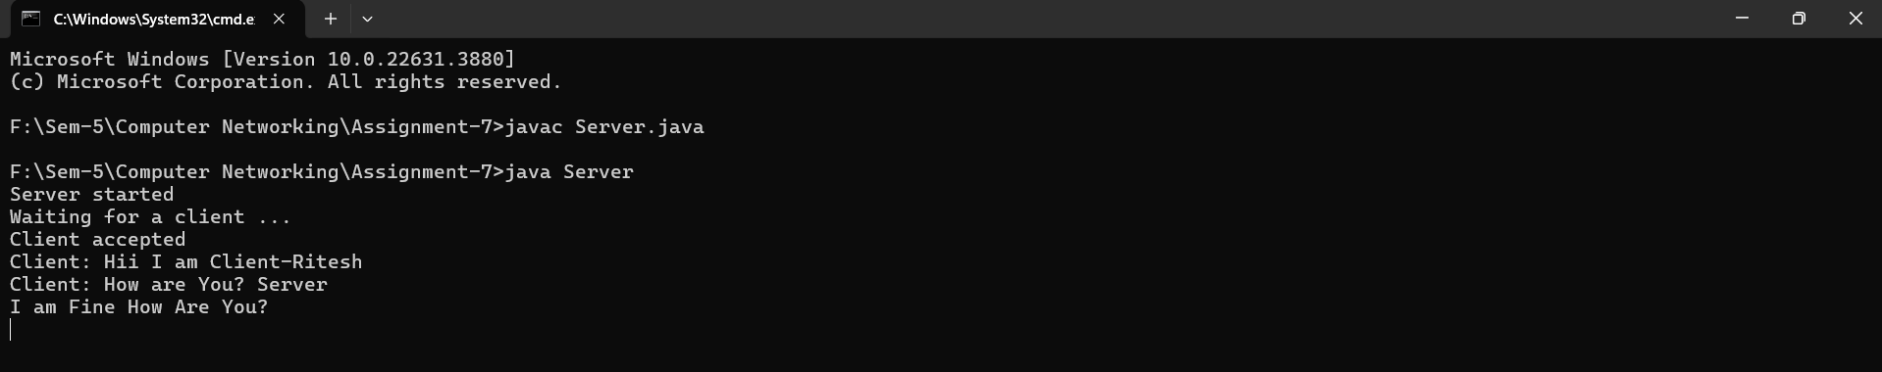

**TCP Client Program:**

import java.io.*;

import java.net.*;

public class ClientTCP {

private Socket socket = null;

private DataInputStream in = null;

private DataOutputStream out = null;

public ClientTCP(String address, int port) {

try {

socket = new Socket(address, port);

System.out.println("Connected to the server");

in = new DataInputStream(socket.getInputStream());

out = new DataOutputStream(socket.getOutputStream());

// Thread to listen for incoming messages from the server

Thread receiveThread = new Thread(() -> {

String message;

try {

while (true)

{

message = in.readUTF();

System.out.println("Server: " + message);

}

}catch (IOException e) {

System.out.println("Connection closed.");

}

});

receiveThread.start();

// Main thread to send messages to the server

BufferedReader consoleInput = new BufferedReader(new InputStreamReader(System.in));

String message;

while (true)

{

message = consoleInput.readLine();

out.writeUTF(message);

}

} catch (UnknownHostException u) {

System.out.println(u);

} catch (IOException e) {

System.out.println(e);

} finally {

try

{

socket.close();

in.close();

out.close();

} catch (IOException e) {

System.out.println(e);

}

}

}

public static void main(String[] args) {

ClientTCP client = new ClientTCP("127.0.0.1", 5000);

}

}

**OUTPUT:**

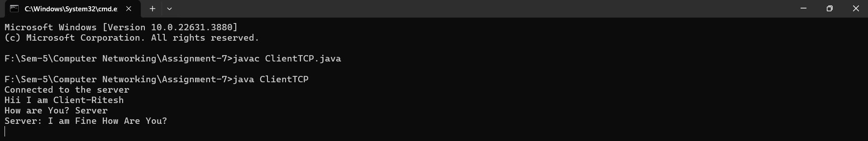

1. **For UDP Server-Client: Connection Less Protocol**

**UDP Server Program:**

import java.io.*;

import java.net.*;

class UDPServer {

public static void main(String[] args) {

try {

DatagramSocket server_socket = new DatagramSocket(1234);

byte[] in_data = new byte[1024];

byte[] out_data;

while (true) {

DatagramPacket Packet2 = new DatagramPacket(in_data, in_data.length);

server_socket.receive(Packet2);

String str = new String(Packet2.getData(), 0, Packet2.getLength());

System.out.println("Received from client: " + str);

InetAddress IP_add1 = Packet2.getAddress();

int port = Packet2.getPort();

BufferedReader server_input = new BufferedReader(new InputStreamReader(System.in));

System.out.print("Enter response: ");

String send_str = server_input.readLine();

out_data = send_str.getBytes();

DatagramPacket Packet3 = new DatagramPacket(out_data, out_data.length, IP_add1, port);

server_socket.send(Packet3);

}

} catch (IOException e) {

e.printStackTrace();

}

}

}

**Output :**

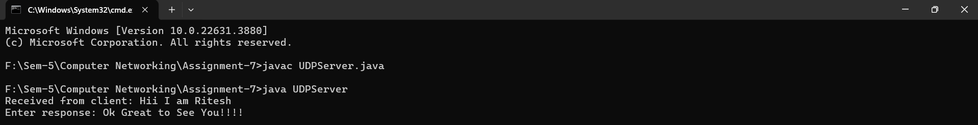

**UDP Client Program:**

import java.io.*;

import java.net.*;

class UDPClient {

public static void main(String[] args) {

try {

BufferedReader user_input = new BufferedReader(new InputStreamReader(System.in));

DatagramSocket client_socket = new DatagramSocket();

InetAddress IP_add = InetAddress.getByName("localhost");

byte[] out_data;

byte[] in_data = new byte[1024];

System.out.print("Enter message: ");

String str = user_input.readLine();

out_data = str.getBytes();

DatagramPacket Packet1 = new DatagramPacket(out_data, out_data.length, IP_add, 1234);

client_socket.send(Packet1);

DatagramPacket Packet4 = new DatagramPacket(in_data, in_data.length);

client_socket.receive(Packet4);

String receive_str = new String(Packet4.getData(), 0, Packet4.getLength());

System.out.println("Server response: " + receive_str);

client_socket.close();

} catch (IOException e) {

e.printStackTrace();

}

}

}

**OUTPUT:**

