**Lab Practical #1:**

* **File and Directory Management**:
* pwd – Show the current working directory.

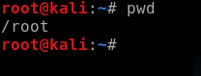

* ls – List files and directories.
  + Example: ls -la (detailed view with hidden files).
* cd – Change directories.
  + Example: cd /etc/ (navigate to the /etc/ directory).
* mkdir – Create a new directory.
  + Example: mkdir test_dir.
* rm – Remove files or directories.
  + Example: rm file.txt or rm -r directory/.
* cp – Copy files or directories.
  + Example: cp source.txt destination.txt.
* mv – Move or rename files.
  + Example: mv oldname.txt newname.txt.

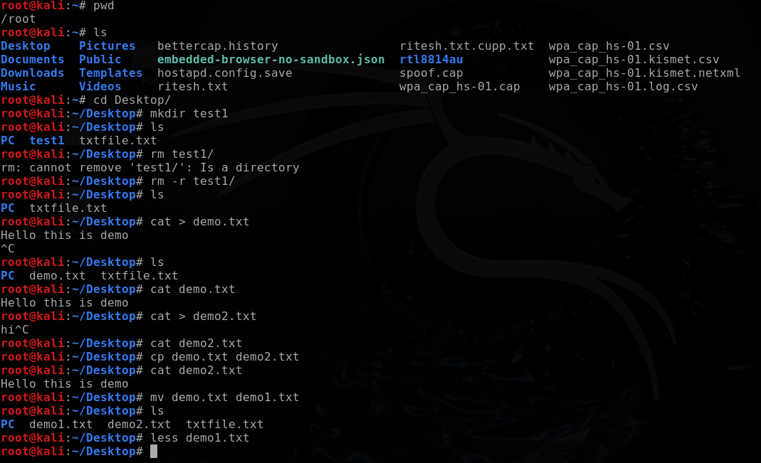

* **File Viewing and Editing**:
  + cat – View file contents.
  + less – View file contents one screen at a time.
  + nano – Simple text editor.
  + vi or vim – Advanced text editor.
  + head – Show the first few lines of a file.
  + tail – Show the last few lines of a file (use tail -f for live updates).

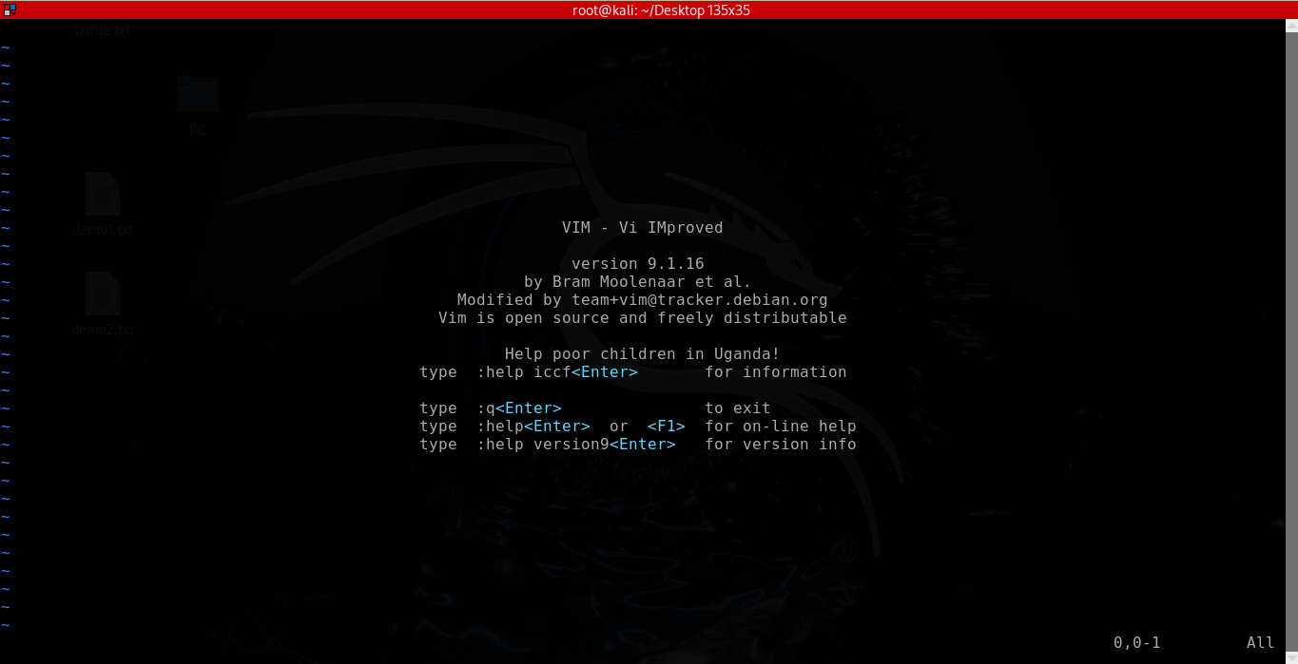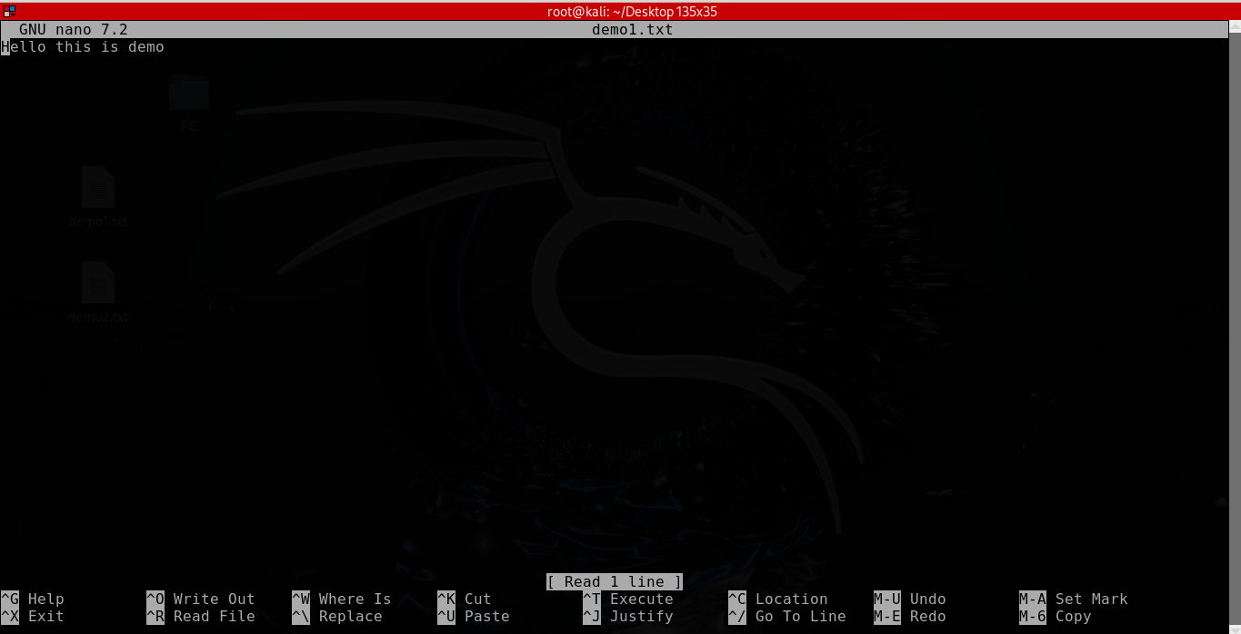

* **File Permissions and Ownership**:
  + chmod – Change file permissions.
    - Example: chmod 755 file.sh.
  + chown – Change file ownership.
    - Example: chown user:group file.txt.
  + ls -l – View permissions and ownership.

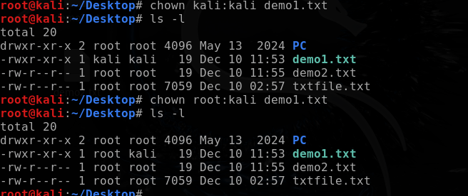

### System Information

* uname -a – Show system information.
* hostname – Display or set the system hostname.
* df -h – Show disk usage in human-readable format.
* du -sh – Show size of a directory.
* free -h – Display memory usage.
* top or htop – Monitor system processes in real-time.
* whoami – Show the current logged-in user.

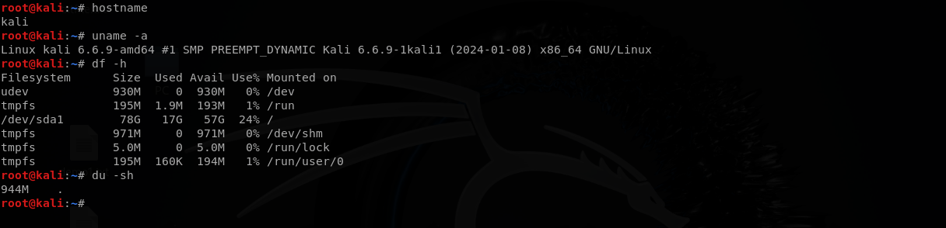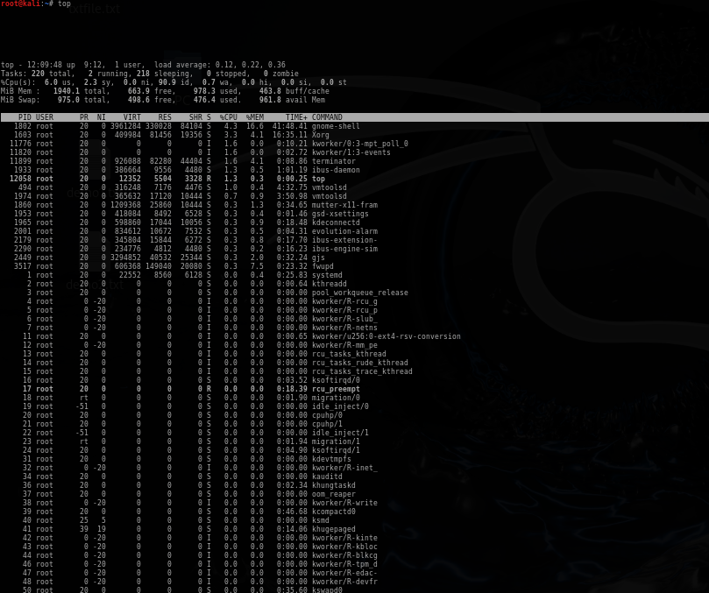

### Networking Commands

* ifconfig / ip addr – Display network interfaces.
* ping – Test network connectivity.
* netstat – Show network connections.
* nmap – Network scanning (pre-installed in Kali Linux).
  + Example: nmap -sS -p 22 192.168.1.1.
* wget – Download files from the internet.
  + Example: wget http://example.com/file.zip.
* curl – Transfer data from URLs.

Example: curl -O <http://example.com/file.zip>

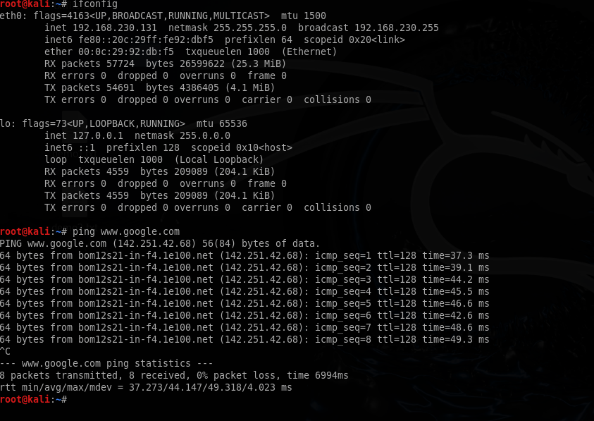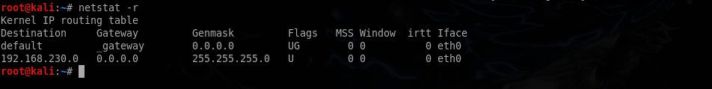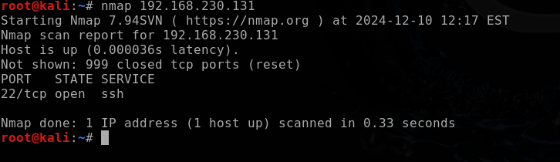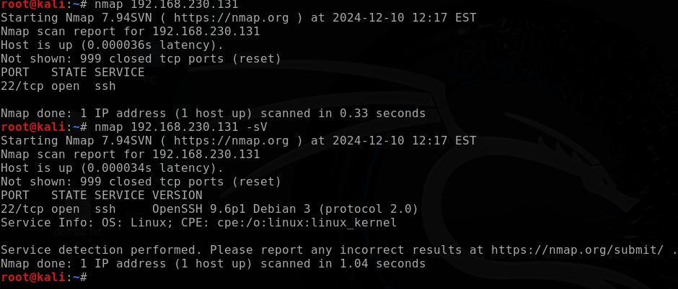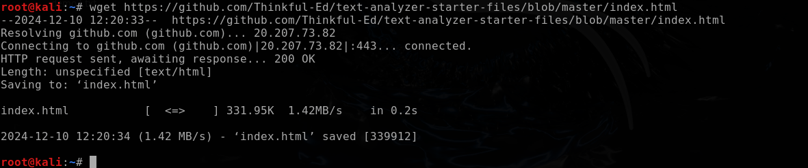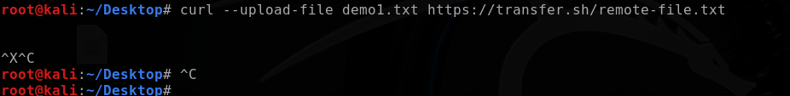

### Package Management

* apt update – Update package lists.
* apt upgrade – Upgrade installed packages.
* apt install <package> – Install a package.
  + Example: apt install nmap.
* apt remove <package> – Uninstall a package.

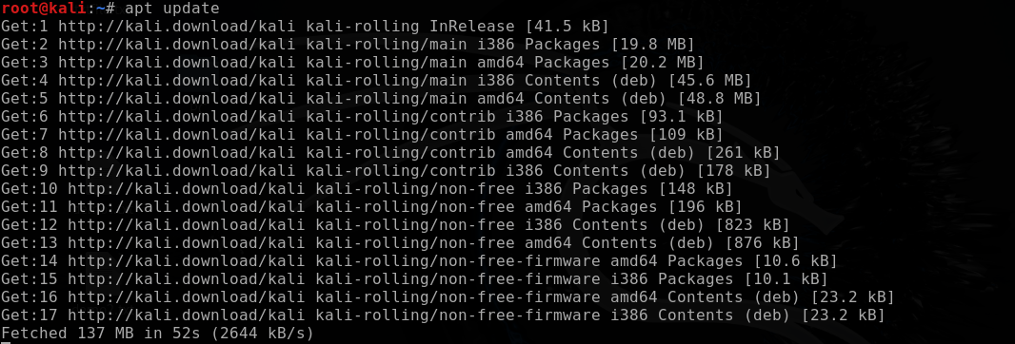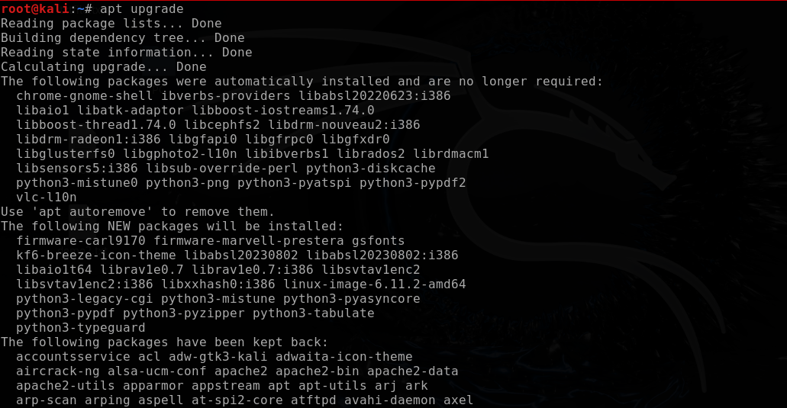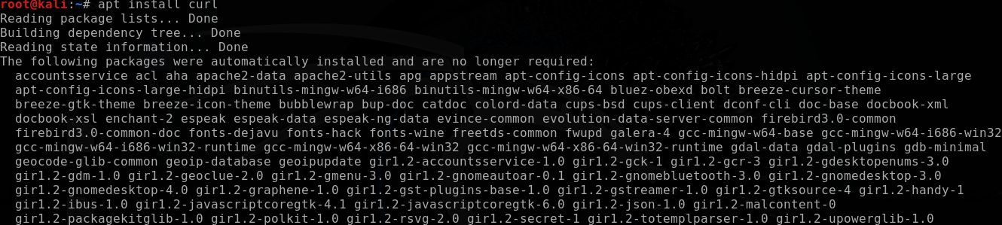

### Process Management

* ps – View running processes.
* kill – Terminate a process.
  + Example: kill -9 <PID>.
* jobs – List background jobs.

bg / fg – Resume jobs in background/foreground

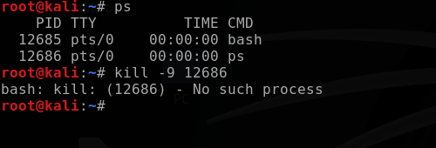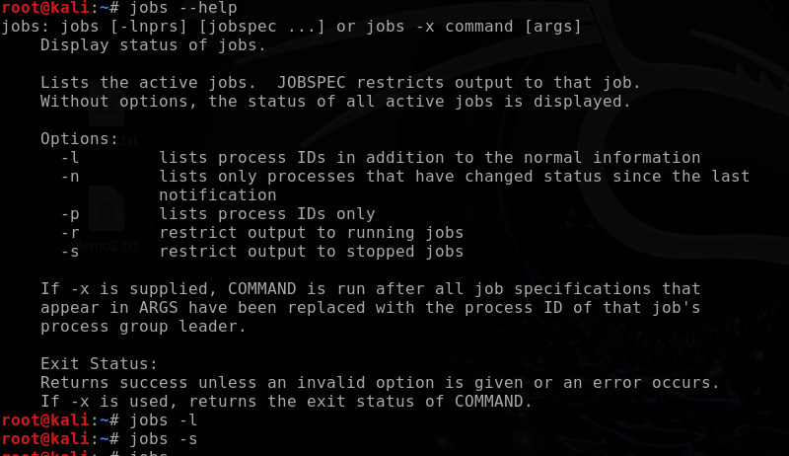



### Scripting and Automation

* bash script.sh – Run a bash script.
* crontab -e – Edit cron jobs for scheduling tasks.
* grep – Search text in files.
  + Example: grep "pattern" file.txt.
* find – Search for files.
  + Example: find / -name "filename".

