**Lab 10. Perform password cracking concept using brute force tools- L0phtCrack and John the ripper.**

1. **Steps to Perform Password Cracking using L0phtCrack 7:**

**Step-1**: Open L0phtCrack 7 and select Windows.

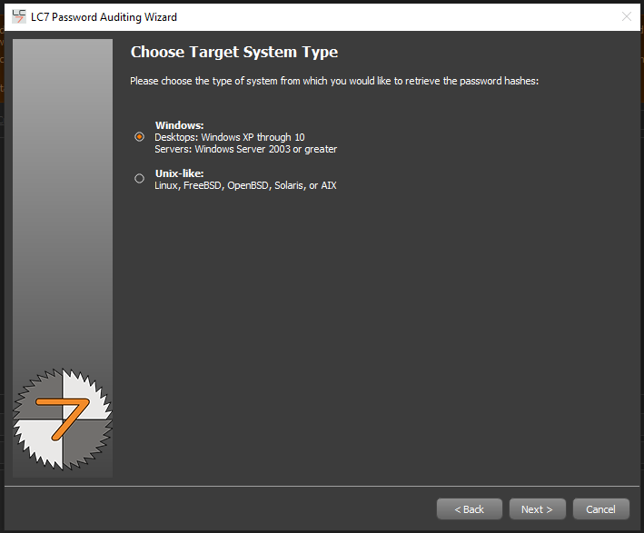

**Step 2:** Choose Local Machine as the target.

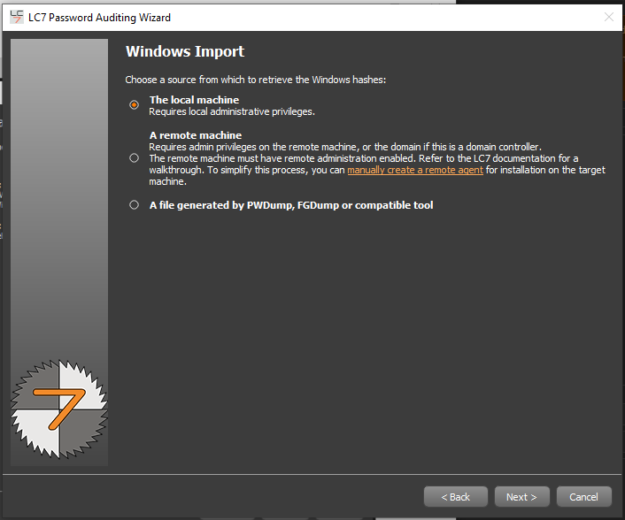

**Step 3:** Enter User Credentials if required.

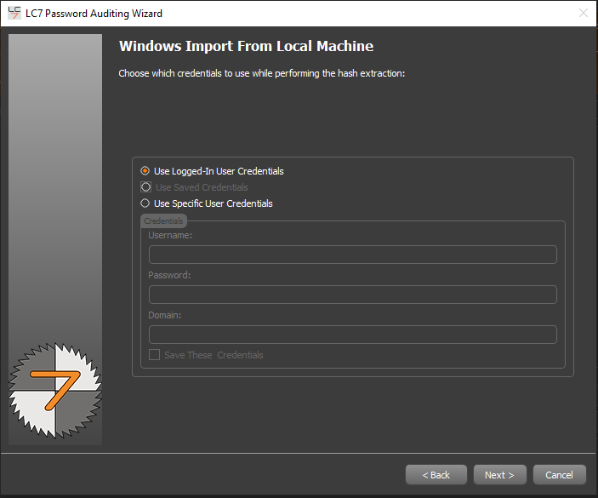

**Step 4:** Select Quick Password Audit to initiate the attack.

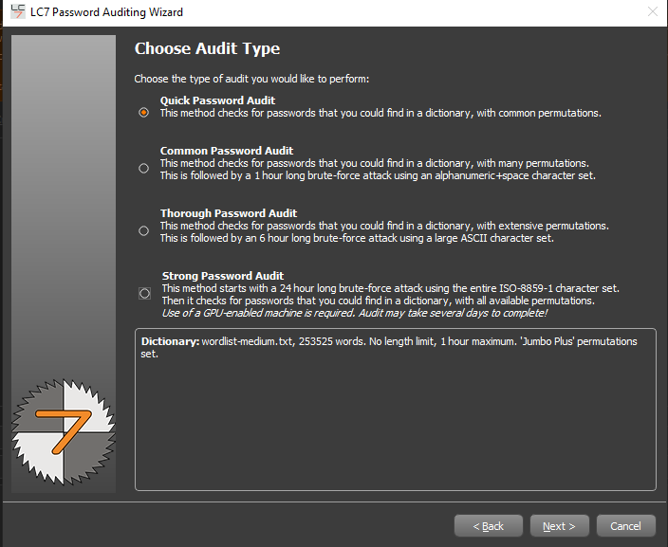

**Step 5:** If you want to generate Report , choose the desired file format.

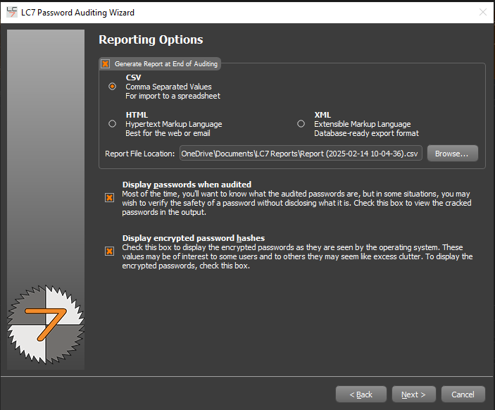

**Step 6:** Configure Job Scheduling (default: immediate execution).

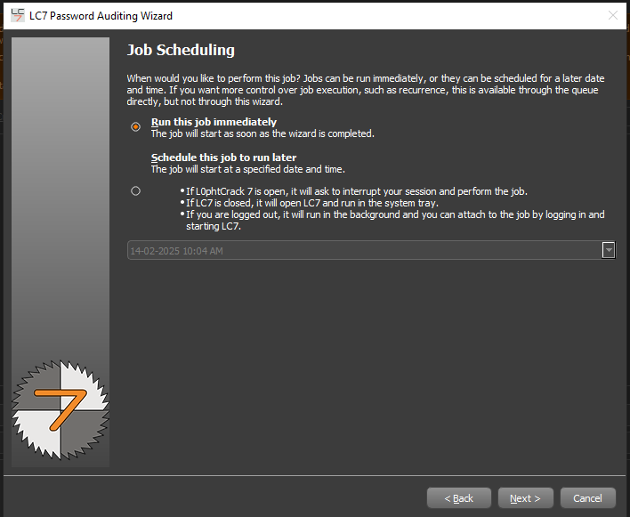

**Step 7:** Click Run to start the password-cracking process.

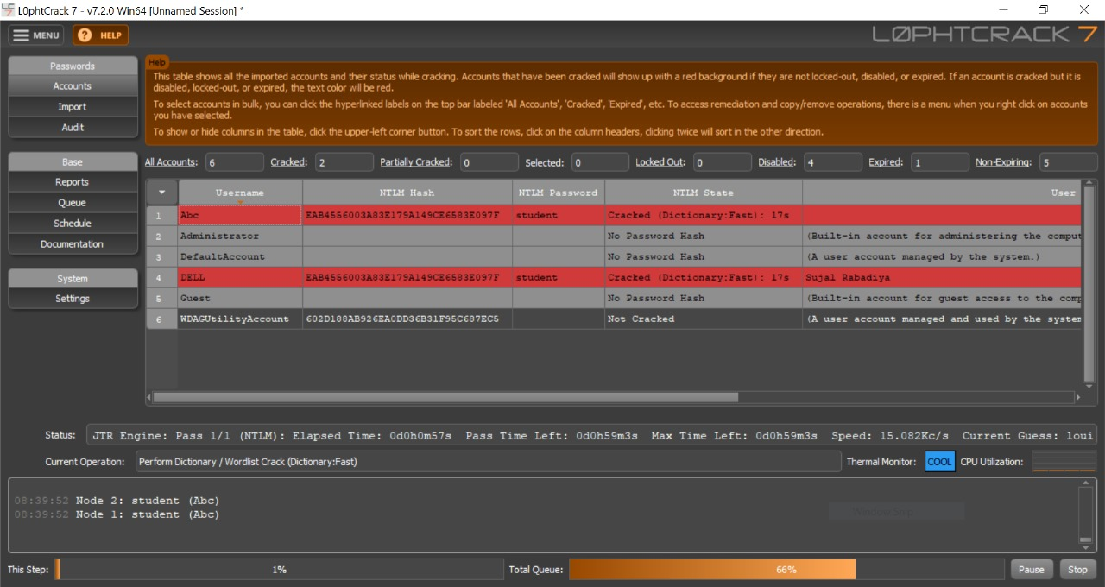

**Output:**

You can see in that Passwords is cracking after some time and its **student.**

1. **Steps to Perform Password Cracking using John the Ripper:**

**Step-1:** Install John the Ripper (if not installed) using sudo apt install john (Linux) or download it from the official site.

-use **Sudo apt install john**

Step-2: Gather the password hash file from the target system.

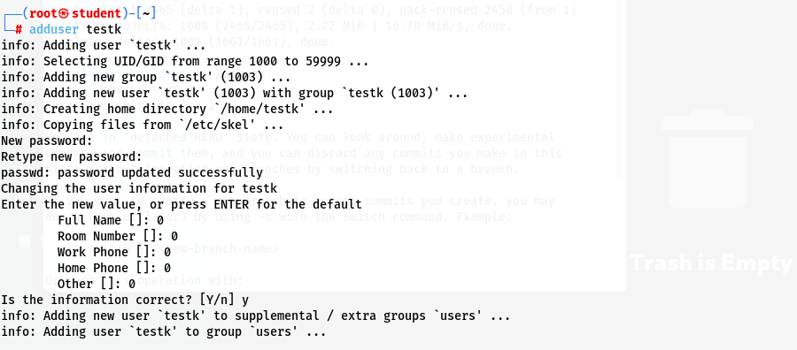

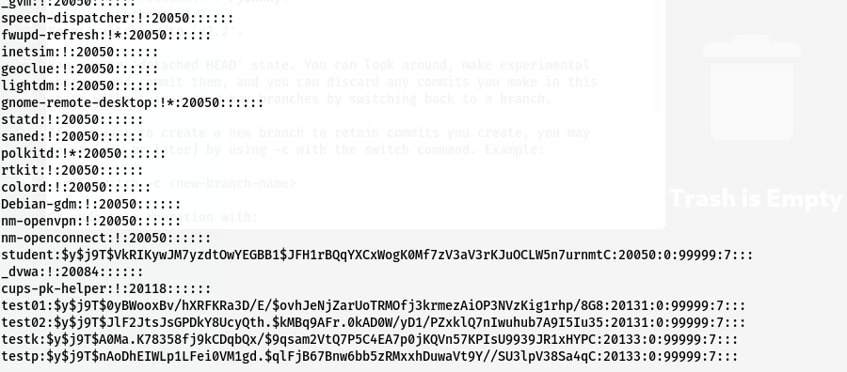

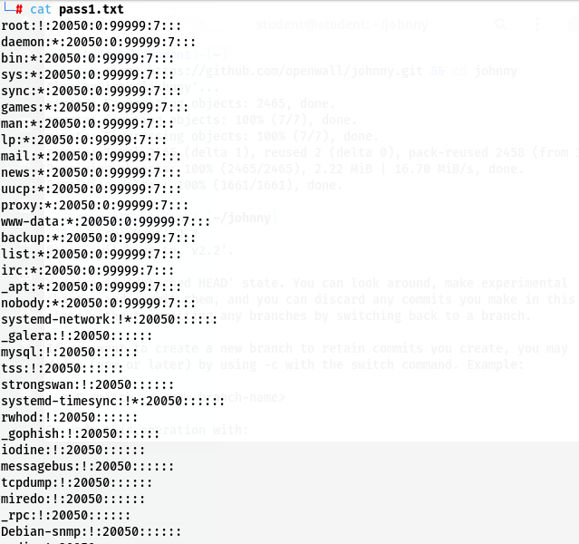

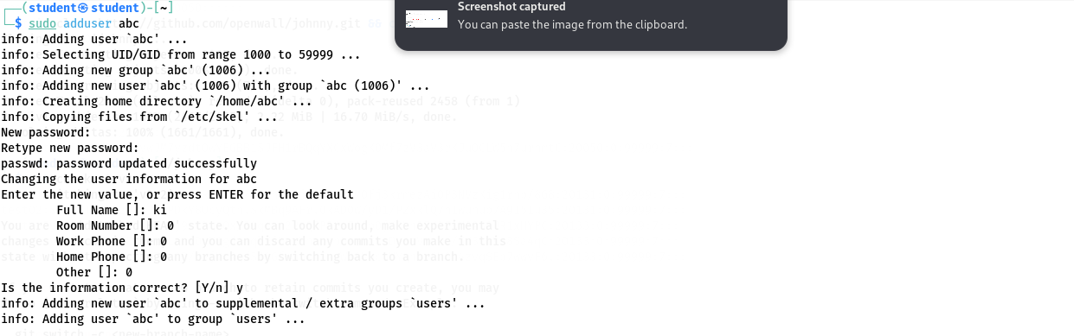

Step-3: Run john --format=<hash-type> <hash-file> to start cracking.

