Name : Ritesh Lakhani

Enrollment No : 22010101099

Metasploit Room

**Task 1** Introduction to Metasploit

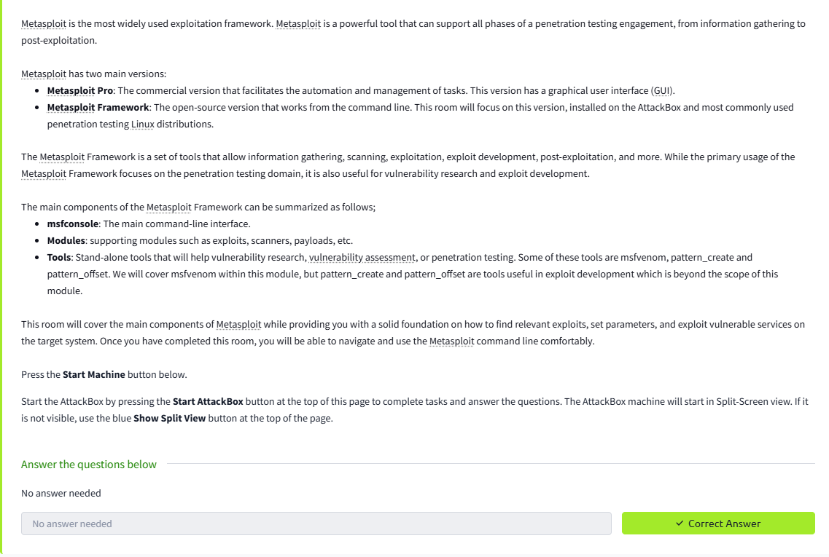

**Task 2** Main Components of Metasploit

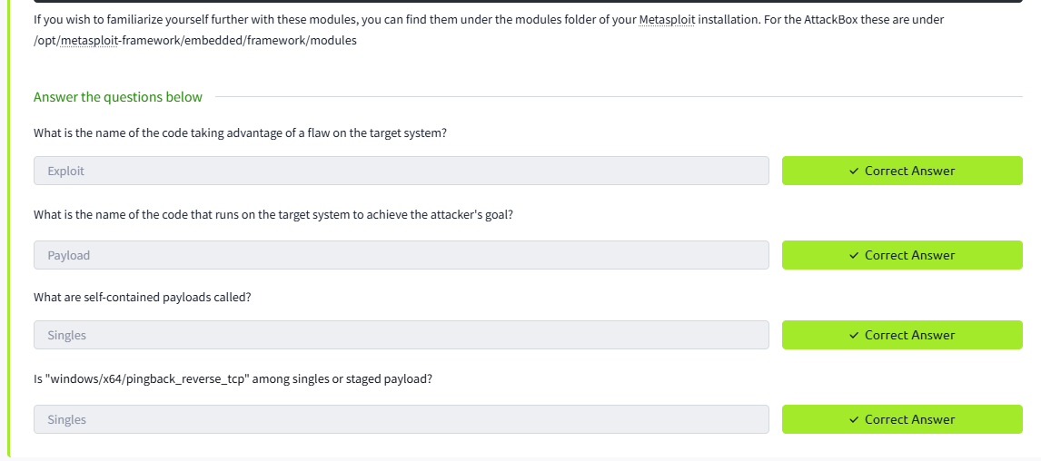

**Task 3** MfsConsole

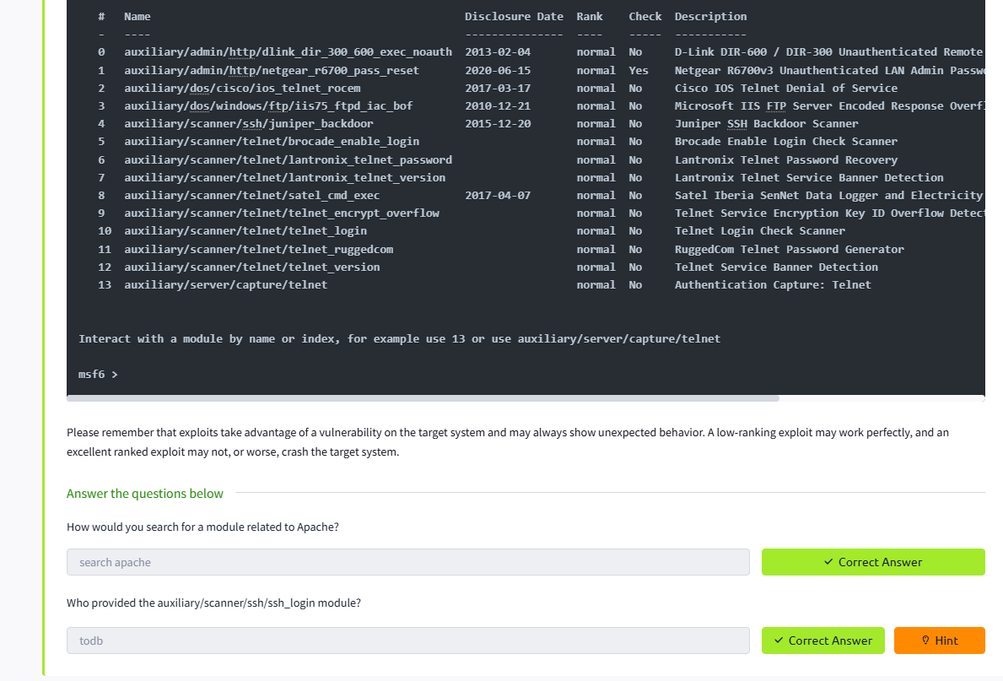

**Task 4** Working With Modules

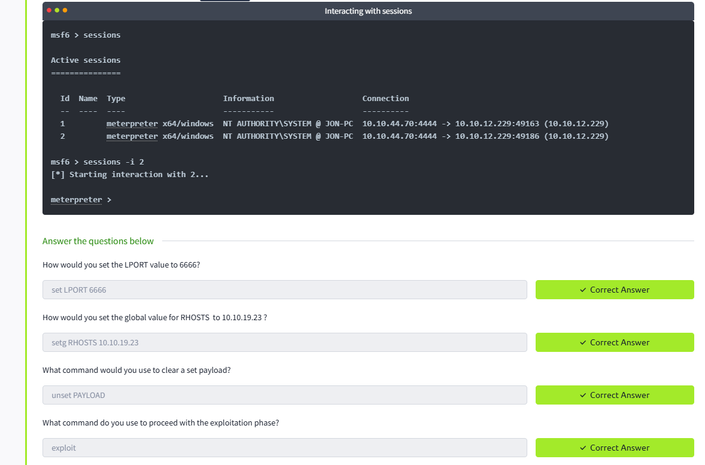

**Task 5** Summary

