Name: Ritesh Lakhani

Enrollment No: 22010101099

**Nessus Tool :**

**Task 1:**

**Introduction about nessus**

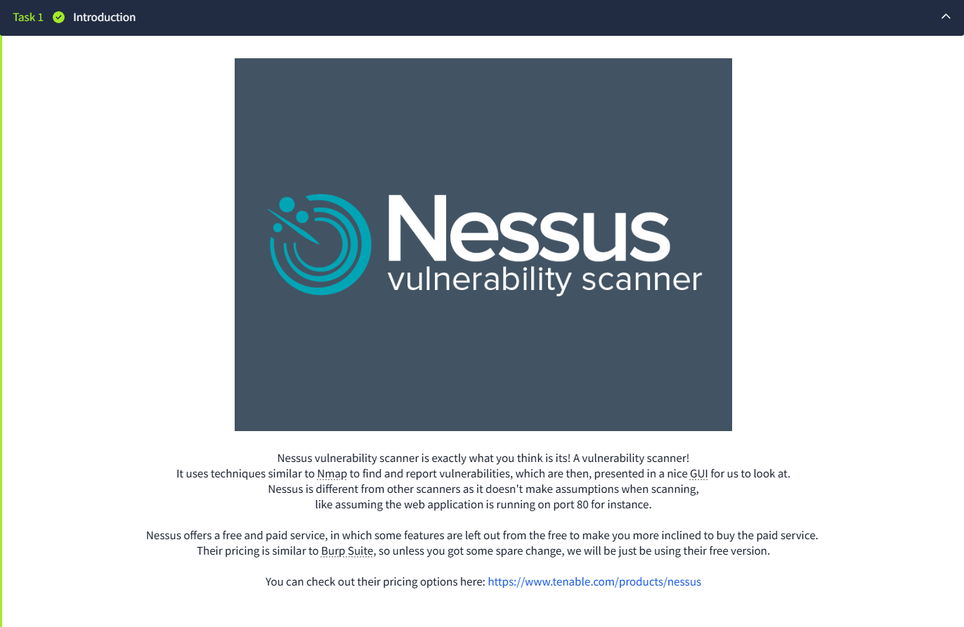

**Task 2:**

**Installation step :**

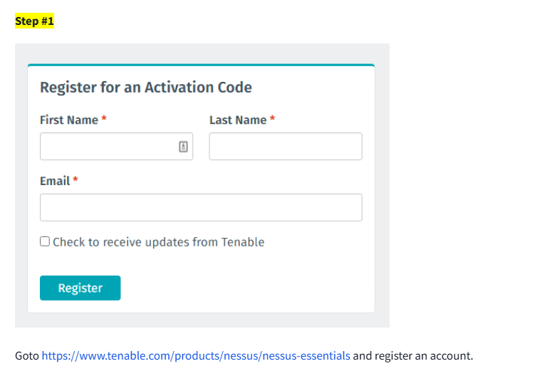

**Click on url and register your self then it shows download button click on it and download the Nessus.**

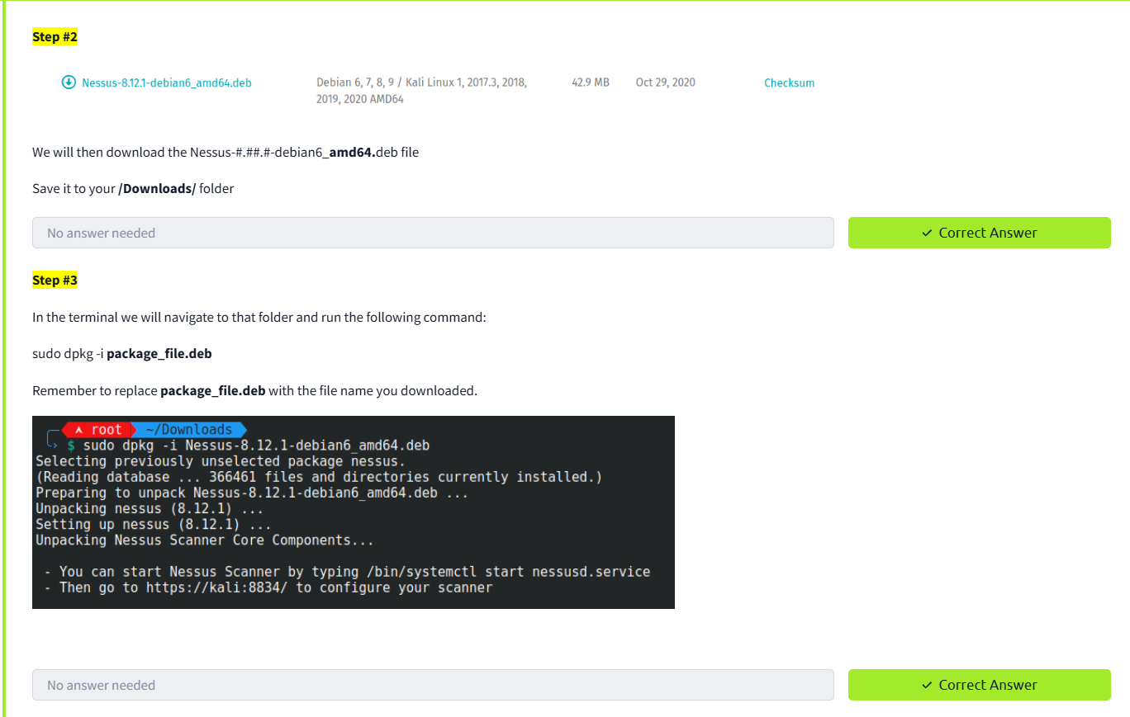

**After downloading perform given command and install Nessus**

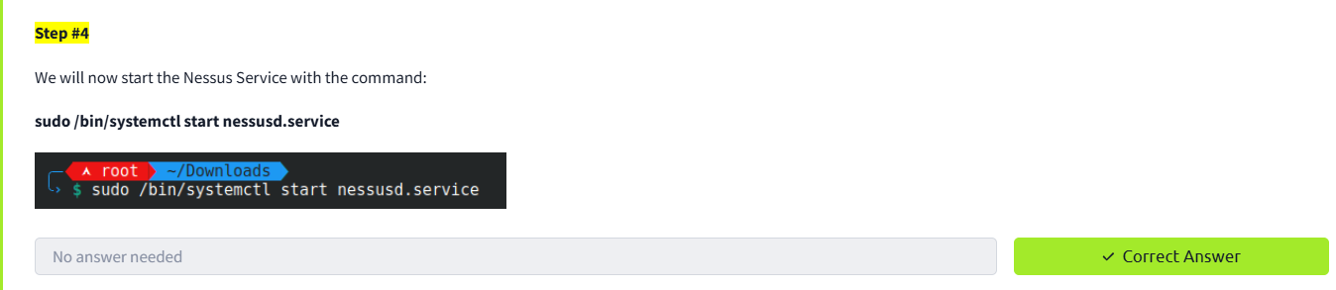

**Now for starting run above code**

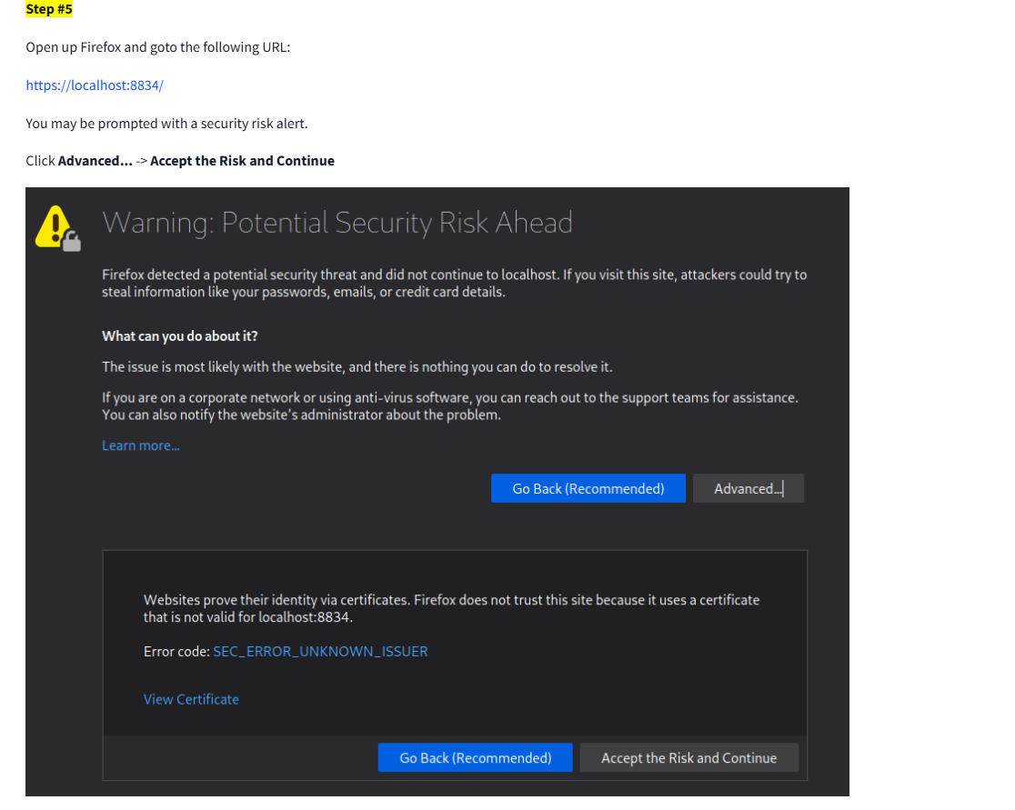

**Now go to that url and start the Nessus**

**Then follow steps accordingly**

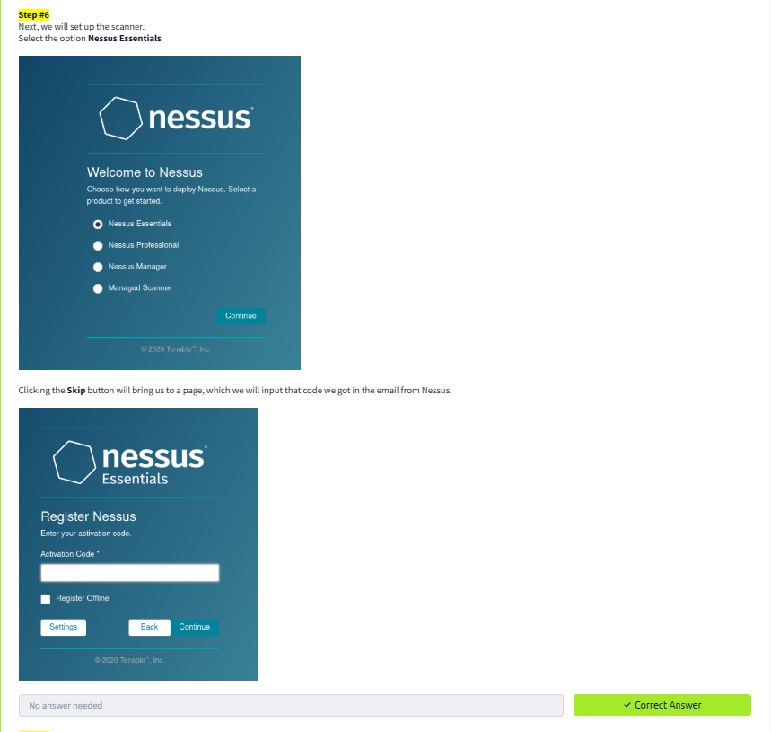

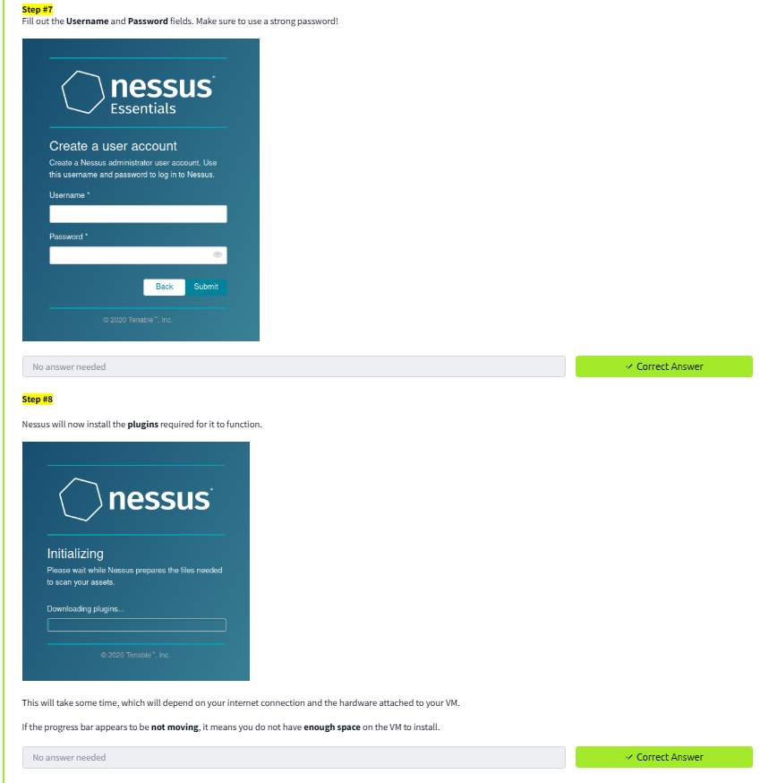

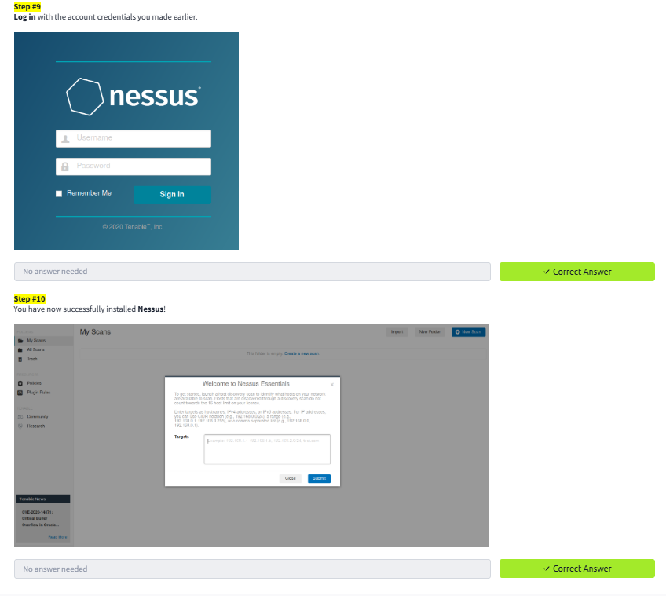

**After this you can see a interface like this**

**Task 3:**

**Navigations and Scans**

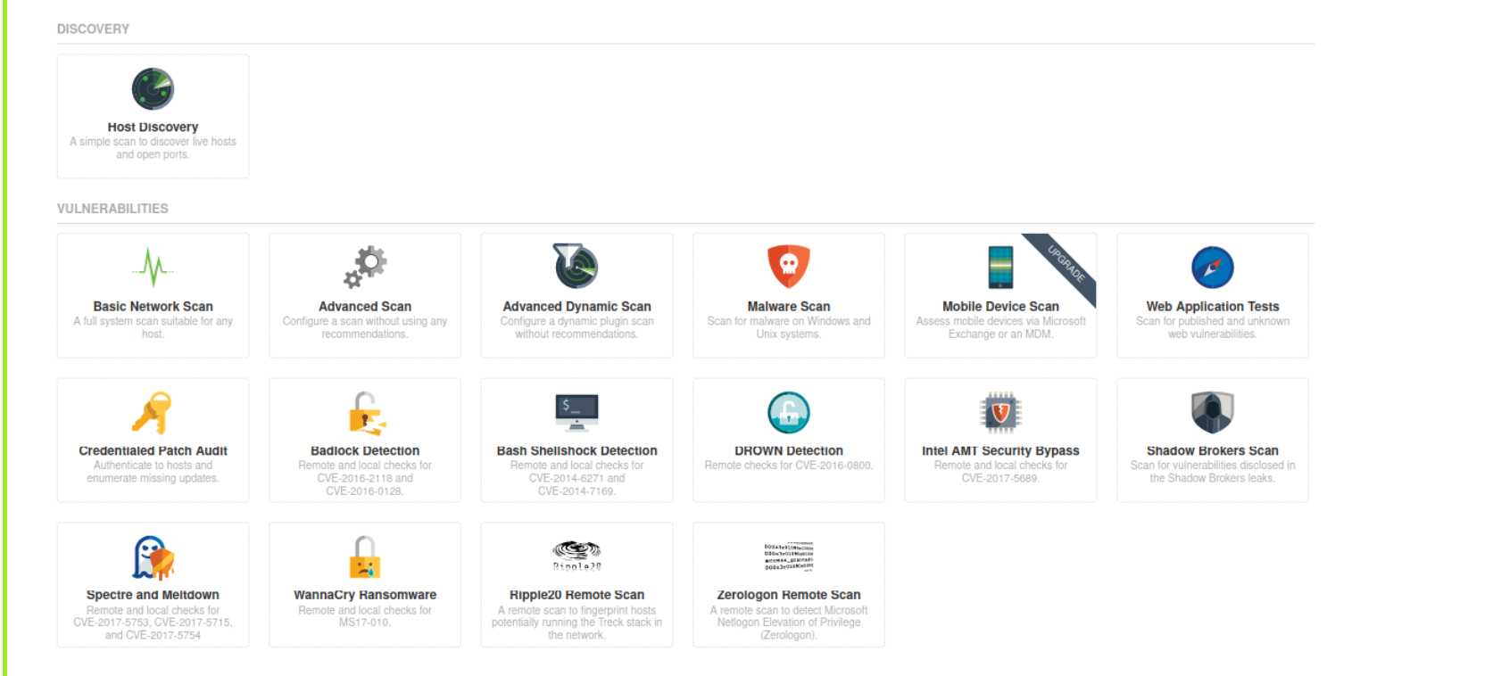

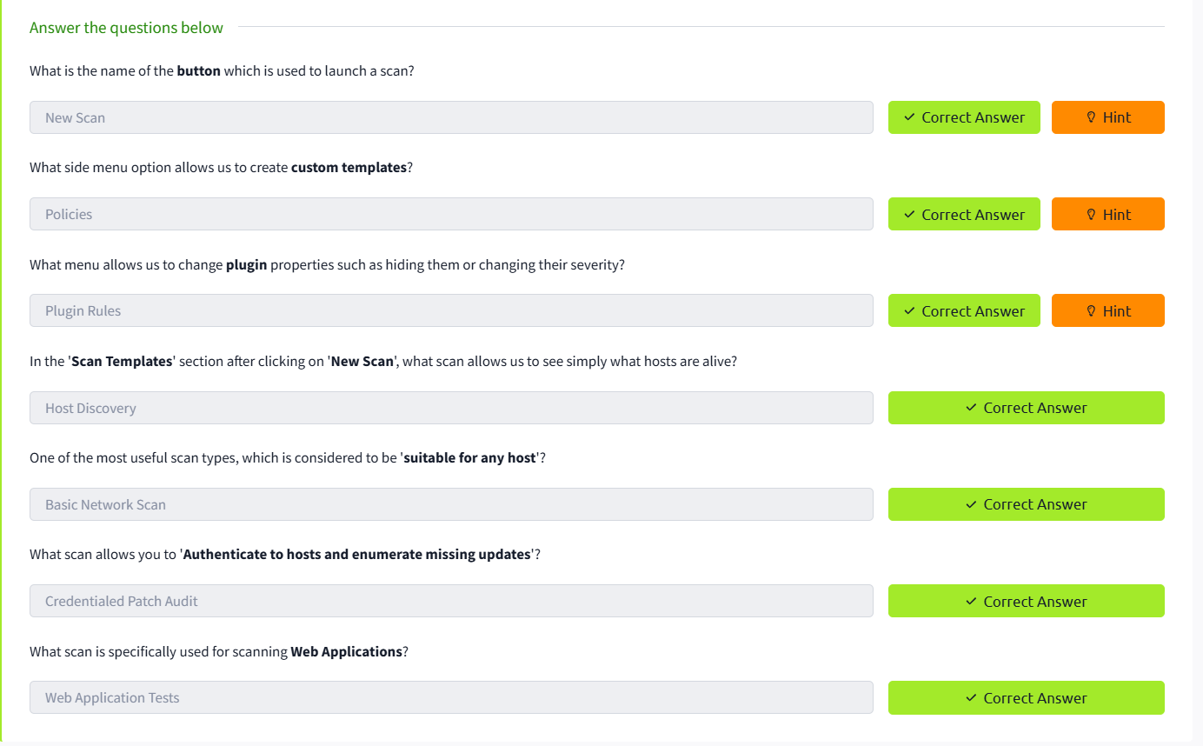

**Task 4: Scanning**

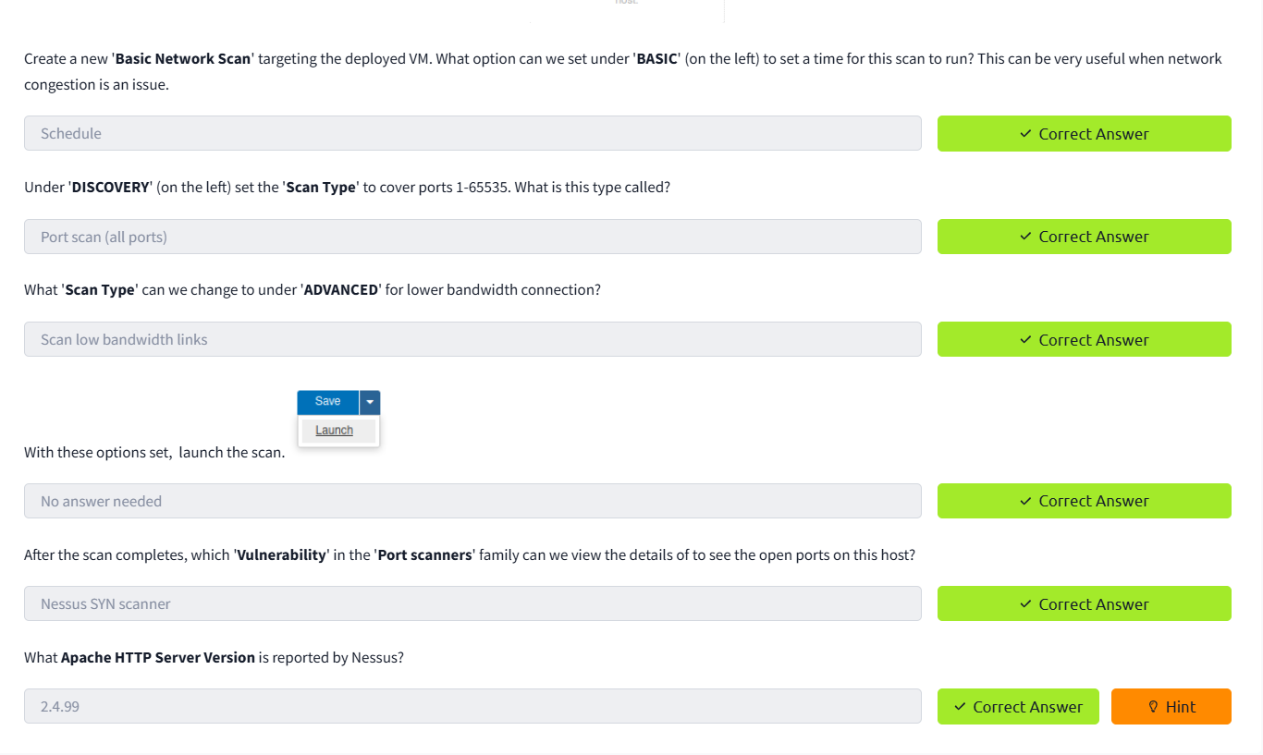

**Task 5 : Scanning A WebApp**

