**Lab Practical #_4:**

**Perform steganography and DOS attack.**

Step 1:- **Steghide : Installation & Usage**

Steghide is a free and open source steganography program that allows you to hide secret files or messages within audio, image, and video files. It works right from the command line interface in Kali Linux. The key advantage of Steghide is that it can embed data without reducing the quality or file size of the original carrier file. This makes it difficult to detect that any hidden information has been added.

To use Steghide, you first need to install it in Kali Linux. You can do this easily by typing the following command :

|  |
| --- |
| sudo apt-get install steghide |

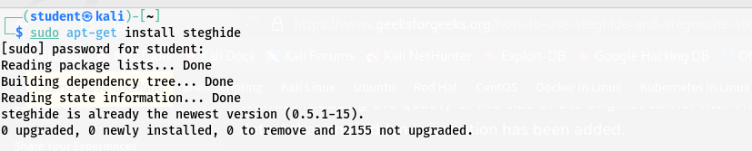

**Step:-2 Steghide is controlled completely through the terminal command line interface in Kali Linux. To start using it, simply open a terminal window and type :**

|  |
| --- |
| Steghide |

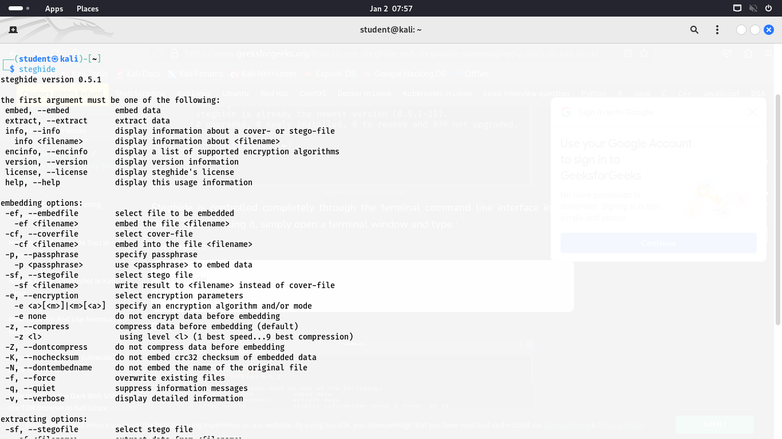

**Step:-3 Create a text file called " secret.txt " and add some simple secret message text to it. Save it in your working directory. Also place the image file you want to use to hide the data, like " gfg.jpg ", in the same folder. Open a terminal window and use the " steghide embed " command to embed " secret.txt " into " bheem.jpg ".**

|  |
| --- |
| steghide embed -ef Secret.txt -cf bheem.jpeg |

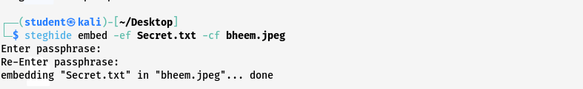

It will ask you to create a password. Choose a strong password and enter it. This will be needed to extract the hidden data later. Steghide will embed "secret.txt" inside "kevinmitnick.jpg" using the password encryption.

Now the image file contains the secret data entirely hidden within it. You can safely share or store the image file like normal. When ready, use the following below command with the password to retrieve the embedded " Secret.txt " file.

**Step:-4 Command to Extract the Data from jpg file**

|  |
| --- |
| steghide extract -sf bheem.jpeg |

|  |
| --- |
| cat Secret.txt |

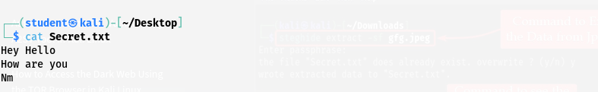

**Step:-5 It will confirm that there is embedded data, and report the encryption algorithm and hidden file size below is the command:**

|  |
| --- |
| steghide info gfg.jpg |

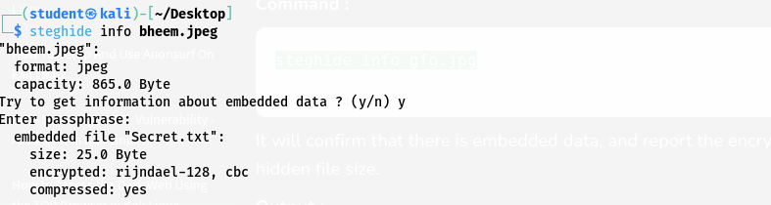

**Step:-6** **StegoSuite : Installation & Usage**

**StegoSuite is another free steganography tool included in Kali Linux. The main difference from Steghide is that StegoSuite provides a graphical interface, making it more user-friendly.**

**To install StegoSuite, open a terminal and type :**

|  |
| --- |
| sudo apt-get install stegosuite |

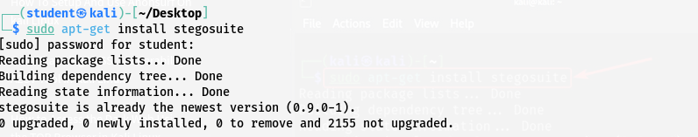

**Step:-7 Once you have installed the StegoSuite package in Kali Linux, you can easily start using the program. Now you just need to type the following command to Launch the StegoSuite Tool.**

|  |
| --- |
| stegosuite gui |

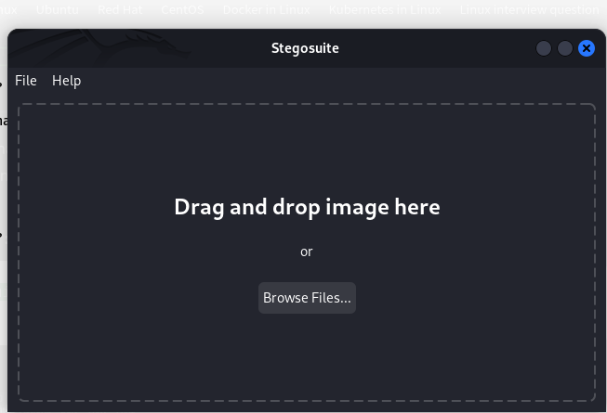

**Step:-8 After Selecting the Image file Enter the secret text Message or Just Drag and Drop the " Secret.txt " file. Then Set the Password to Encrypt the Image file and Click on Embed. Follow the Steps as Shown in the Below GIF file.**

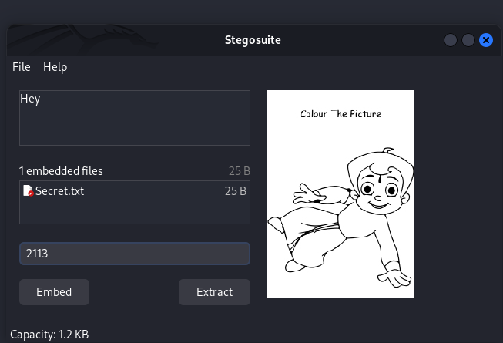

**Step:-9 After that you will see this New file created on the Desktop name " gfg_embed.png " this file include our hidden file in it.**

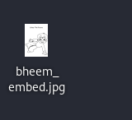

Now the image file contains the secret data entirely hidden within it You can safely share or store the image file like normal. Whenever you want to see the Hidden Text file just use " stegosuite gui " Command and Select the New File that created onto our Desktop and Just type the Password and hit the Extract Button.