**Ritesh Luitel**

**Student ID: s4682841**

Exercise 1:

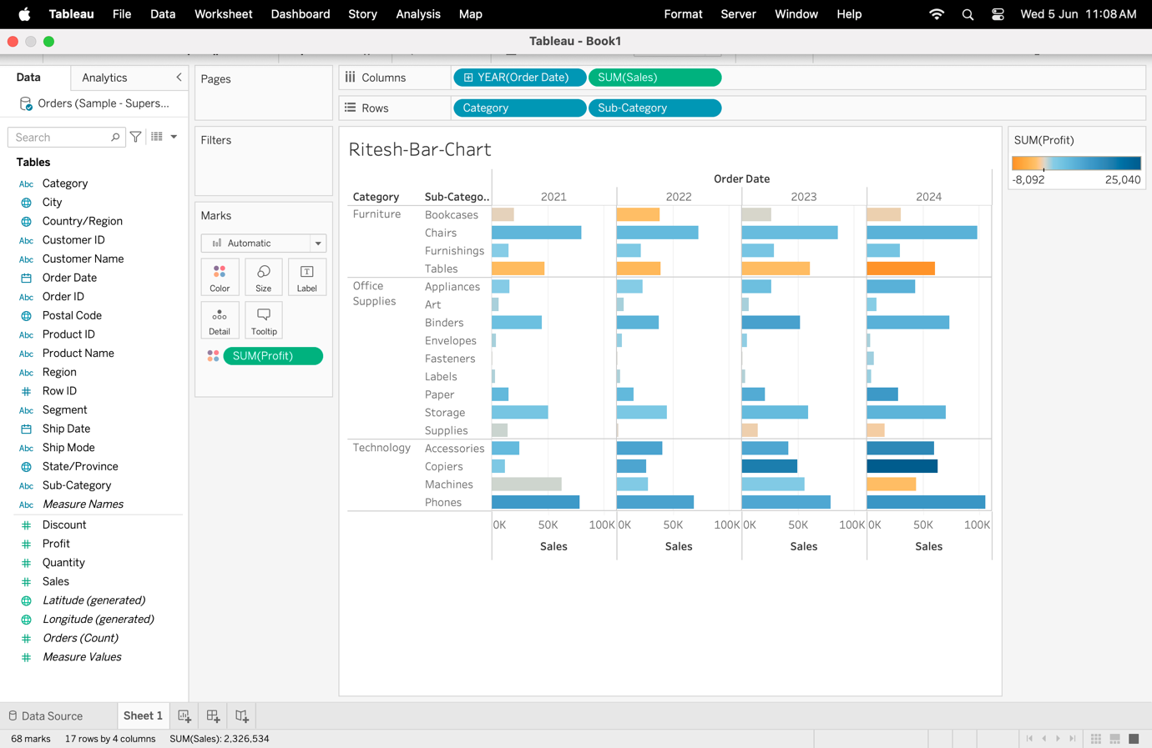

Exercise 2:

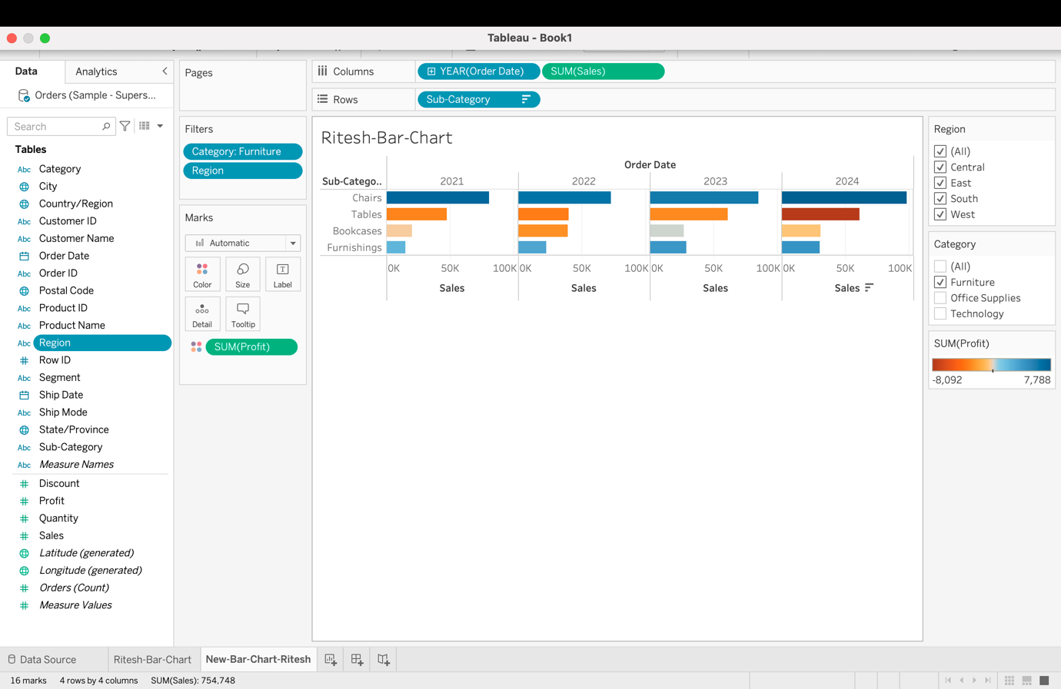

Exercise 3:

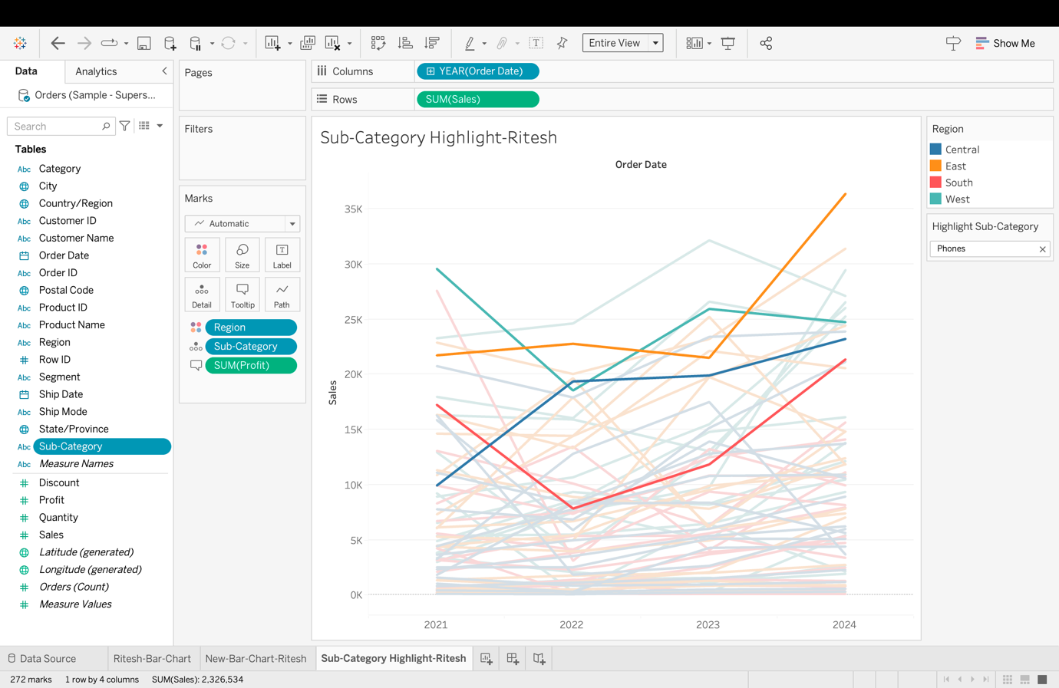

Exercise 4:

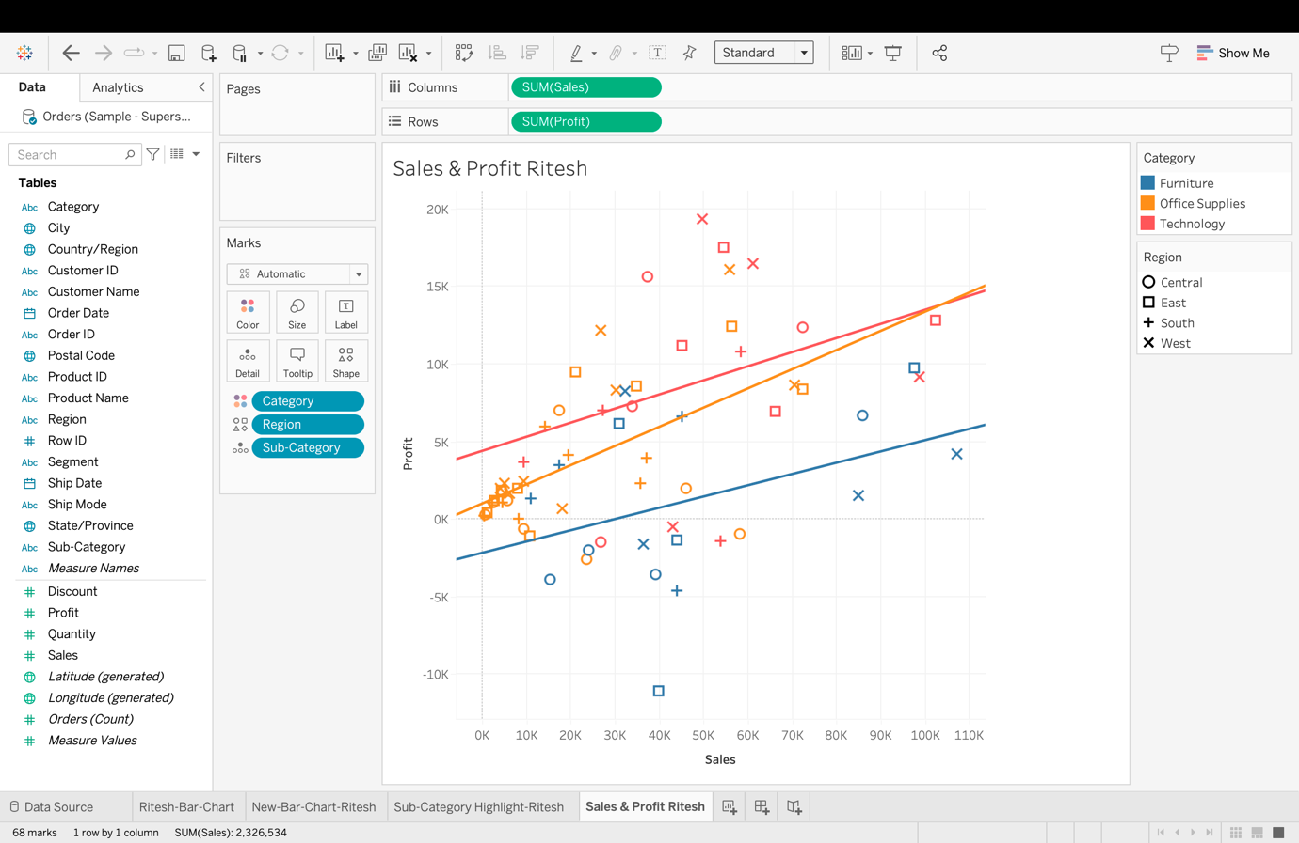

Exercise 5:

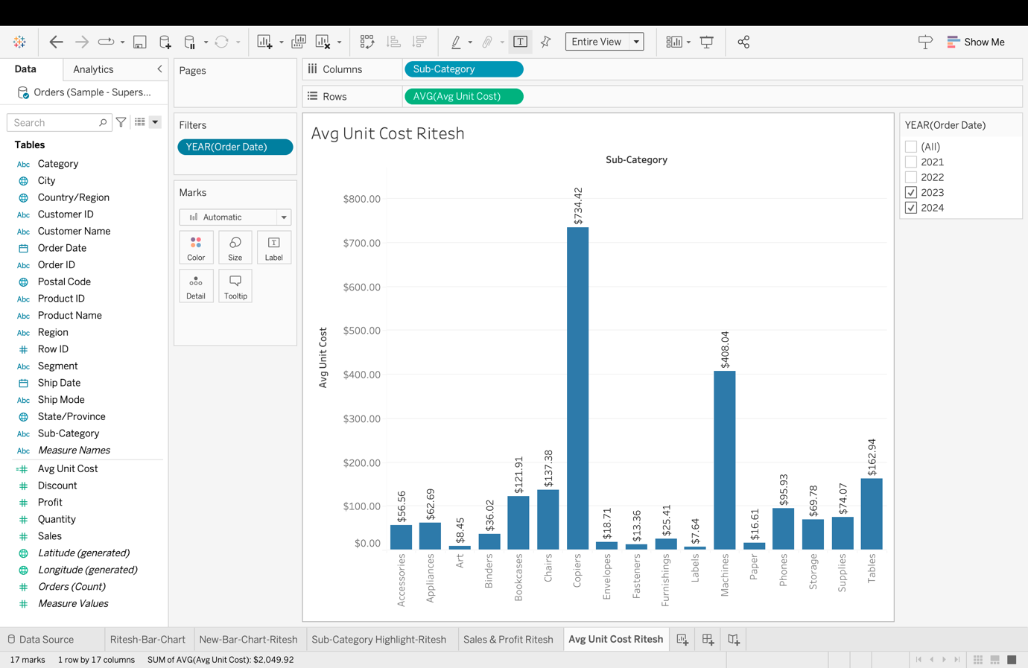

Exercise 6:

Exercise 7:

Exercise 8:

Exercise 9:

Exercise 10:

Exercise 11:

Exercise 12:

Exercise 13:

Exercise 14:

Exercise 15:

