**School of Computer Science**

**UNIVERSITY OF PETROLEUM AND ENERGY STUDIES**

**DEHRADUN, UTTARAKHAND**



**System Provisioning and Configuration Management**

**Lab File (2022-2026)**

# **6th Semester**

|  |  |
| --- | --- |
| *Submitted To:*  ***Dr. Hitesh Kumar Sharma*** | *Submitted By:*  *Madhav Madan*  *(500105699)*  *B Tech CSE*  *DevOps[6th Semester]*  *R2142220265*  *Batch - 1* |

**EXPERIMENT 2**

**Lab Exercise: Working** **With Hosts and Groups**

**Steps to be followed:**

**Objective:** To work with hosts both individually and in groups for streamlined management and deployment across your network infrastructure

**Tools required:** Ubuntu OS

**Prerequisites:** You need to have Ansible, and the nodes connected with it installed to proceed with this demo. Refer Demo 1 of Lesson 3.

1. List the hosts present in your host file
2. Create a file on the host
3. Remove the file from the host
4. Create and remove the file on the hosts using the group
5. Update the hosts using the group

**Step 1: List the hosts present in your host file**

1. Use the following command to list the hosts in your inventory file:

**ansible all --list-hosts**



# **Note:** The host list might change as per your system.

**Step 2: Create a file on the host**

* 1. Use the following command to list the contents of the current working directory:  
     **ansible 172.31.44.85 -a "ls"**



* 1. Use the following command to create a file named **file1** on the host:  
     **ansible 13.126.129.191 -a "touch file1"**

# **Note:** You can create the file on any other host as per your host list.

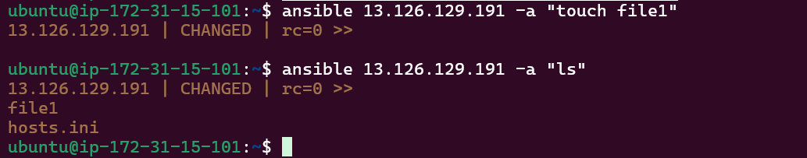

**Step 3: Remove the file from the host**

* 1. Now, run the following command to remove the file from the host:

**ansible 13.126.129.191 -a "rm file1"**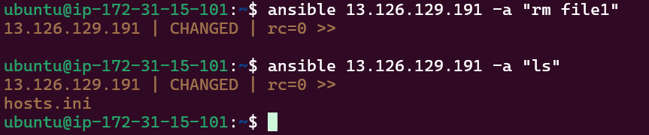

**Step 4: Create and remove the file on the hosts using the group**

* 1. Run the following command to create a new file on both the hosts using the group:

**ansible dbservers -a "touch Ansible_learners"**

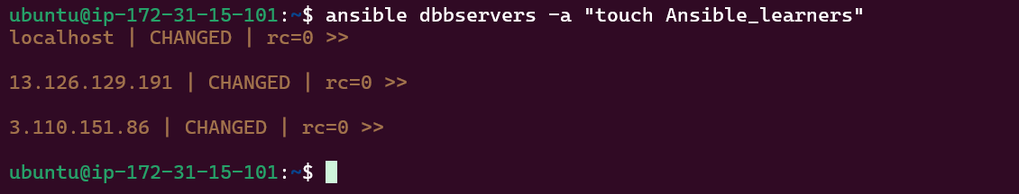

* 1. Use the following command to list the contents of the current working directory of all the hosts present in the group:

**ansible dbservers -a "ls"**

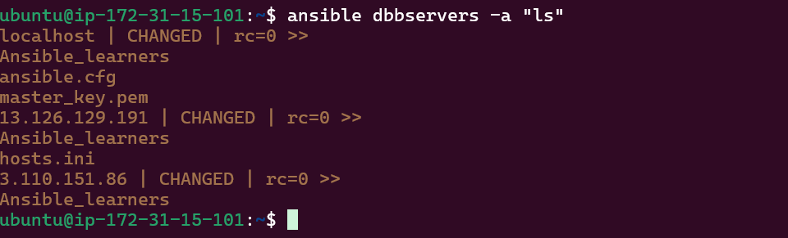

* 1. Run the following command to remove the file on both hosts using the group:

**ansible dbservers -a "rm Ansible_learners"**

