**School of Computer Science**

**UNIVERSITY OF PETROLEUM AND ENERGY STUDIES**

**DEHRADUN, UTTARAKHAND**



**System Provisioning and Configuration Management**

**Lab File (2022-2026)**

# **6th Semester**

|  |  |
| --- | --- |
| *Submitted To:*  ***Dr. Hitesh Kumar Sharma*** | *Submitted By:*  *Madhav Madan*  *(500105699)*  *B Tech CSE*  *DevOps[6th Semester]*  *R2142220265*  *Batch - 1* |

**EXPERIMENT 4**

**Lab Exercise: Executing Ansible Modules**

**Steps to be followed:**

**Objective:** To demonstrate the use of the Ansible module for server configuration and management

**Tools required:** Linux terminal

**Prerequisites:** None

1. Use Ansible modules for server configuration

**Step 1: Use Ansible modules for server configuration**

1. Run the following command using the **setup** module to collect and display detailed system information about the servers: **ansible -m setup dbservers**

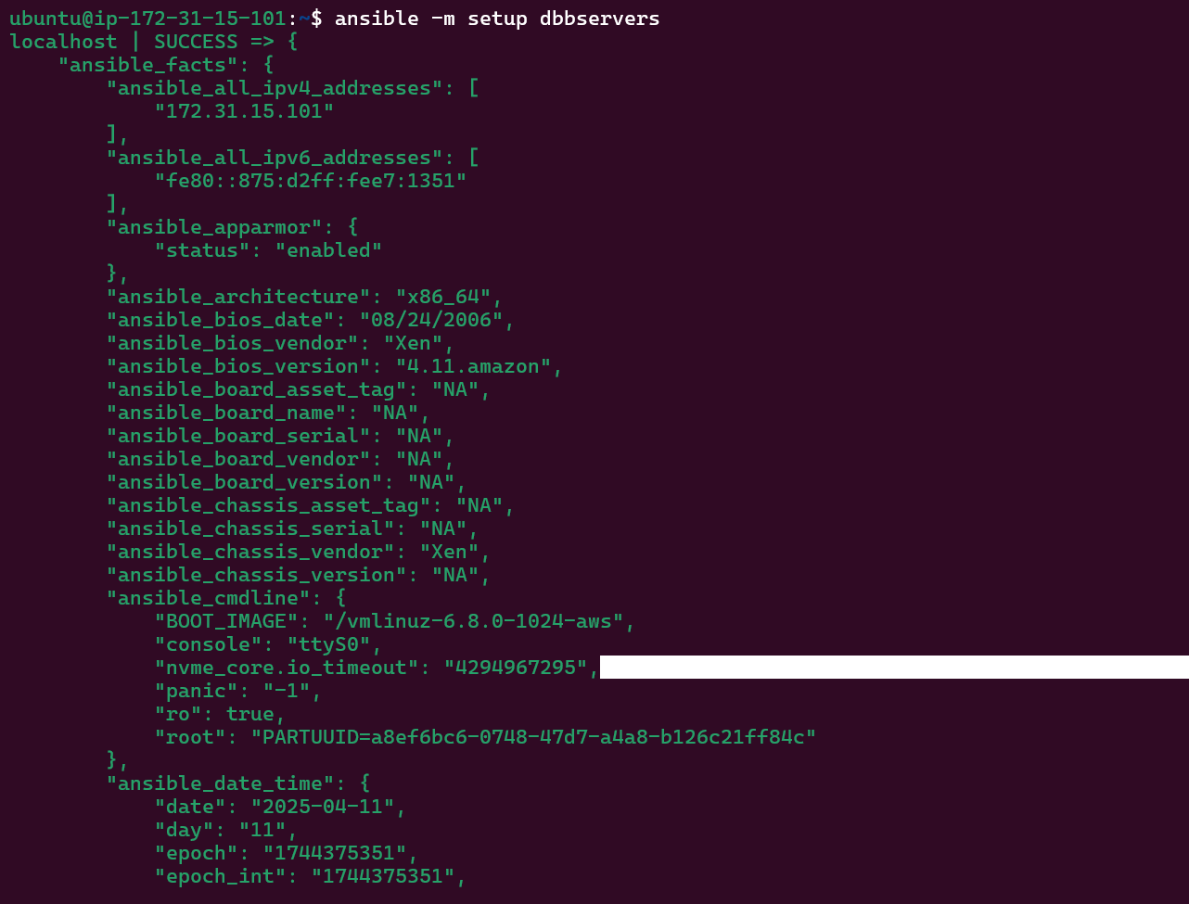

1. Run the following command using the **shell** module to retrieve server hostnames:  
   **ansible dbservers -m shell -a ‘hostname’**

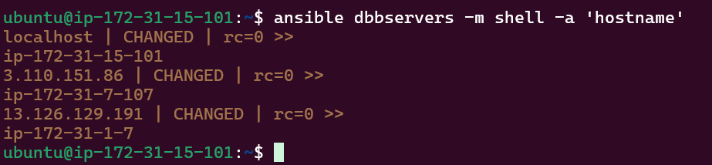

1. Run the following command using the **apt** module to install Git on servers:  
   **ansible dbservers -m yum -a 'name=git state=present' - - become**

